For creating New HTML Page Layout.

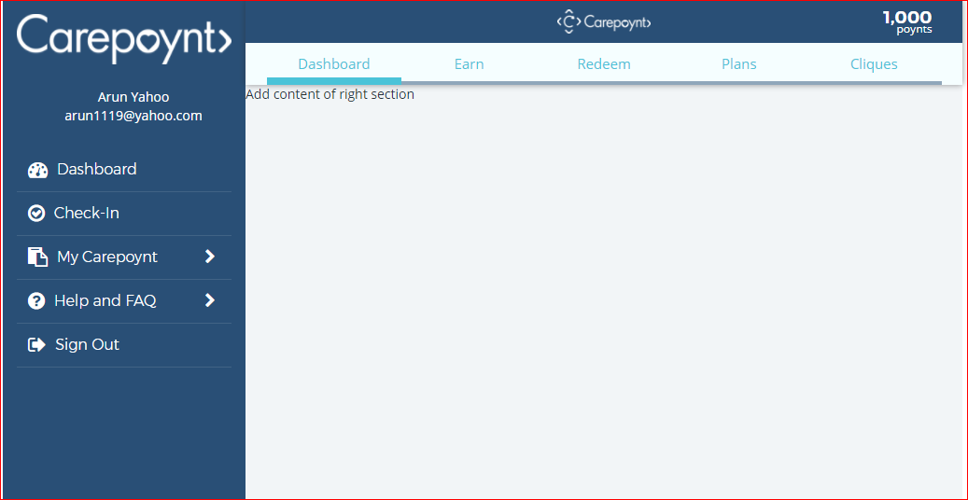

<!DOCTYPE html>

<html lang="en">

<head>

<meta charset="utf-8">

<meta http-equiv="X-UA-Compatible" content="IE=edge">

<meta name="viewport" content="width=device-width, initial-scale=1, maximum-scale=1.0, user-scalable=0">

<!-- The above 3 meta tags *must* come first in the head; any other head content must come *after* these tags -->

<title>carepoynt</title>

<!-- Include css style sheet -->

<link href="node_modules/bootstrap/dist/css/bootstrap.min.css" rel="stylesheet" />

<!-- Required plugin - Animate.css -->

<link rel="stylesheet" href="https://cdnjs.cloudflare.com/ajax/libs/animate.css/3.4.0/animate.min.css">

<link href="css/font-awesome.min.css" rel="stylesheet" />

<link href="css/glyphicon.min.css" rel="stylesheet" />

<link href="css/carepoynt.css" rel="stylesheet" />

<!-- HTML5 shim and Respond.js for IE8 support of HTML5 elements and media queries -->

<!-- WARNING: Respond.js doesn't work if you view the page via file:// -->

<!--[if lt IE 9]>

<script src="https://oss.maxcdn.com/html5shiv/3.7.3/html5shiv.min.js"></script>

<script src="https://oss.maxcdn.com/respond/1.4.2/respond.min.js"></script>

<![endif]-->

</head>

<body>

<div id="wrapper">

<!-- Start Left side bar -->

<div id="left-sidebar" class="close-sidebar">

<div class="left-container">

<img src="images/CP-login-white-navmenu.png" class="img-fluid" />

<div class="detail-section">

<p>Arun Yahoo</p>

<p>arun1119@yahoo.com</p>

</div>

<!-- menu nav bar -->

<ul id="accordion">

<li><a href="#"><i class="fa fa-tachometer fa-lg" aria-hidden="true"></i> Dashboard</a></li>

<li><a href="#"><i class="fa fa-check-circle-o fa-lg" aria-hidden="true"></i> Check-In</a></li>

<li class="card">

<a role="button" data-toggle="collapse" data-parent="#accordion" data-target="#myCarepoynt" aria-expanded="false" aria-controls="collapseOne"

class="collapsed">

<i class="fa fa-clipboard fa-lg" aria-hidden="true"></i> My Carepoynt

<span class="float-right">

<i class="fa fa-chevron-right fa-right-icon"></i>

<i class="fa fa-chevron-down fa-down-icon"></i>

</span>

</a>

<ul id="myCarepoynt" class="sub-menu collapse" role="tabpanel" arialabelledby="headingOne" aria-expanded="false">

<li><a href="#"><i class="fa fa-credit-card" aria-hidden="true"></i> My Purchases</a></li>

<li><a href="#"><i class="fa fa-file-text-o" aria-hidden="true"></i> My Poynts</a></li>

<li><a href="#"><i class="fa fa-user" aria-hidden="true"></i> My Profile</a></li>

</ul>

</li>

<li class="card">

<a role="button" data-toggle="collapse" data-parent="#accordion" data-target="#help_sec" aria-expanded="false" aria-controls="collapseOne"

class="collapsed">

<i class="fa fa-question-circle fa-lg" aria-hidden="true"></i> Help and FAQ

<span class="float-right">

<i class="fa fa-chevron-right fa-right-icon"></i>

<i class="fa fa-chevron-down fa-down-icon"></i>

</span>

</a>

<ul id="help_sec" class="sub-menu collapse" role="tabpanel" aria-labelledby="headingOne" aria-expanded="false">

<li><a href="#"><i class="fa fa-question-circle-o" aria-hidden="true"></i> Contact Us</a></li>

<li><a href="#"><i class="fa fa-user-plus" aria-hidden="true"></i> Refer Business</a></li>

</ul>

</li>

<li class="dropdown">

<a href="#" class="dropdown-toggle" href="#" data-toggle="dropdown"><i class="fa fa-sign-out fa-lg" aria-hidden="true"></i> Sign Out</a>

<ul class="dropdown-menu animated bounceInDown">

<li class="title">Messages</li>

<li><a href="#">Action</a></li>

<li><a href="#">Another action</a></li>

<li><a href="#">About Your Information Another action</a></li>

<li class="notification">See all notifications</li>

</ul>

</li>

</ul>

<!-- end of menu nav bar -->

</div>

</div>

<!-- End of Left side bar -->

<!-- Header start-->

<div class="row-container left-pannel">

<div class="maincontainer">

<header>

<div class="container">

<div class="row row-padding">

<div class="col-2 col-sm-1">

<a href="#" id="main_toggle"><i class="fa fa-bars" aria-hidden="true"></i></a>

</div>

<div class="col-6 col-sm-9 text-center">

<img src="images/CP-logo-white-header.png" />

</div>

<div class="col-4 col-sm-2 text-right mouse-hover">

<span class="points"> 1,000</span><br /> poynts

</div>

</div>

</div>

<nav>

<div class="container">

<div class="row">

<div class="col-12">

<ul class="nav-menu">

<li class="active"><a href="#">Dashboard</a></li>

<li><a href="Earn.html">Earn</a></li>

<li><a href="#">Redeem</a></li>

<li><a href="#">Plans</a></li>

<li><a href="#">Cliques</a></li>

</ul>

</div>

</div>

</div>

</nav>

</header>

</div>

</div>

<!-- End of Header-->

<!-- Start middle section -->

<div class="row-container left-pannel">

<div class="maincontainer">

<!-- Start content section -->

<div id="content_wrapper">

<div>Add content of right section</div>

</div>

<!-- End of content section -->

</div>

</div>

<!-- End of middle section -->

</div>

<!-- jQuery (necessary for Bootstrap's JavaScript plugins) -->

<script src="https://ajax.googleapis.com/ajax/libs/jquery/1.12.4/jquery.min.js"></script>

<!-- Include all compiled plugins (below), or include individual files as needed -->

<script src="node_modules/bootstrap/dist/js/bootstrap.min.js"></script>

<script src="js/custom.js"></script>

</body>

</html>

In above code left nav-section fly in/out, header and top nav-bar has included, If you want to add right section content then further add content inside below div section,

“<div id=’content_wrapper’></div>”

Apart from that, I am also adding comment “Add content of right section” where you start your new HTML page.