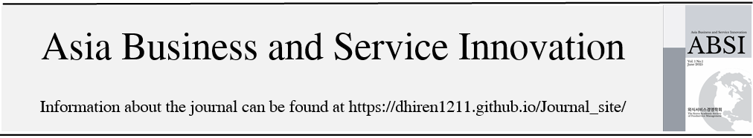
Title of The Paper
Angellie Williady¹, Hak-Seon Kim¹*
¹ Department of Global Business, Kyungsung University, Busan, Republic of Korea
² School of Global Business, Kyungsung University, Busan, Republic of Korea
* Corresponding author: Kims@ks.ac.kr

Abstract
The abstract should not exceed 250 words, summarising the research purpose, method, major findings, and implications. Provide 3–5 keywords in alphabetical order, separated by commas, immediately below the abstract.
Keywords: add; in; one; to; five; key; words

- Introduction
Authors are requested to prepare their manuscripts using this official Journal of Asia Business and Service Innovation template to ensure consistency and professional presentation. The entire manuscript must be written in Times New Roman, font size 12, with 1.5 line spacing.

- Literature Review
Headings should follow the journal’s standardized format:
- Level 1 (Main headings): Bold, 12 pt, left-aligned, Title Case
- Level 2 (Subheadings): Italic, 12 pt, left-aligned, Sentence case
- Level 3 (Sub-subheadings): Regular, 12 pt, left-aligned, Sentence case 123
2.1. Sub-section
Authors should not modify the template’s layout, header, footer, or embedded lines and logos. Editable areas are provided for the title, authors’ names, and affiliations only. Text should automatically wrap within the designated fields without adjusting margins, spacing, or alignment.
2.1.1. Sub-sub-section
Bulleted lists look like this:
- First bullet
- Second
- Third

- Methodology
All figures and tables should be numbered consecutively and cited in the main text as Figure 1, Table 1, and so on. Each table title must be placed above the table, while each figure caption should appear below the figure. Titles and captions should be written in Times New Roman, 11 pt, and clearly describe the content. Ensure all tables and figures are centered, consistent in style, and referenced appropriately within the manuscript.
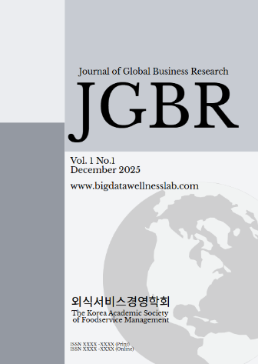
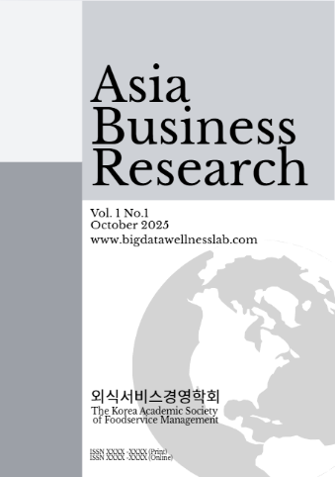
Figure 1. This is a figure.
Table 1. This is a table. Tables should be placed in the main text near to the first time they are cited.
Title 1 | Title 2 | Title 3
entry 1 | data | data
entry 2 | data | data ¹
¹ Tables may have a footer.

Then text continue here

- Results
Manuscripts must be submitted in Microsoft Word (.docx) format. PDF files are not accepted. Authors are encouraged to check grammar and style before submission.

- Conclusion
For further questions or clarification regarding manuscript formatting or template usage, please contact the editorial office at [globalbusinessresearch.journal@gmail.com]. The editorial team will be pleased to provide additional guidance to ensure your submission meets the journal’s formatting standards.

Supplementary Materials: The following supporting information can be downloaded at: https://www.mdpi.com/article/doi/s1, Figure S1: title; Table S1: title; Video S1: title.
Author Contributions: For research articles with several authors, a short paragraph specifying their individual contributions must be provided. The following statements should be used “Conceptualization, X.X. and Y.Y.; methodology, X.X.; software, X.X.; validation, X.X., Y.Y. and Z.Z.; formal analysis, X.X.; investigation, X.X.; resources, X.X.; data curation, X.X.; writing—original draft preparation, X.X.; writing—review and editing, X.X.; visualization, X.X.; supervision, X.X.; project administration, X.X.; funding acquisition, Y.Y. All authors have read and agreed to the published version of the manuscript.” Please turn to the CRediT taxonomy for the term explanation. Authorship must be limited to those who have contributed substantially to the work reported.
Funding: Please add: “This research received no external funding” or “This research was funded by NAME OF FUNDER, grant number XXX” and “The APC was funded by XXX”. Check carefully that the details given are accurate and use the standard spelling of funding agency names at https://search.crossref.org/funding. Any errors may affect your future funding.
Institutional Review Board Statement: In this section, please add the Institutional Review Board Statement and approval number for studies involving humans or animals. You might choose to exclude this statement if the study did not require ethical approval. Please note that the Editorial Office might ask you for further information. Please add “The study was conducted in accordance with the Declaration of Helsinki, and approved by the Institutional Review Board (or Ethics Committee) of NAME OF INSTITUTE (protocol code XXX and date of approval).” for studies in-volving humans. OR “The animal study protocol was approved by the Institutional Review Board (or Ethics Committee) of NAME OF INSTITUTE (protocol code XXX and date of approval).” for studies involving animals. OR “Ethical review and approval were waived for this study due to REASON (please provide a detailed justification).” OR “Not applicable” for studies not involving humans or animals.
Informed Consent Statement: Any research article describing a study involving humans should contain this statement. Please add “Informed consent was obtained from all subjects involved in the study.” OR “Patient consent was waived due to REASON (please provide a detailed justification).” OR “Not applicable.” for studies not involving humans. You might also choose to exclude this statement if the study did not involve humans.
Data Availability Statement: We encourage all authors of articles published in GBR journals to share their research data. In this section, please provide details regarding where data supporting reported results can be found, including links to publicly archived datasets analyzed or generated during the study. Where no new data were created, or where data is unavailable due to privacy or ethical restrictions, a statement is still required.
Acknowledgments: In this section, you can acknowledge any support given which is not covered by the author contribution or funding sections. This may include administrative and technical support, or donations in kind (e.g., materials used for experiments). Where GenAI has been used for purposes such as generating text, data, or graphics, or for study design, data collection, analysis, or interpretation of data, please add “During the preparation of this manuscript/study, the author(s) used [tool name, version information] for the purposes of [description of use]. The authors have reviewed and edited the output and take full responsibility for the content of this publication.”
Conflicts of Interest: Declare conflicts of interest or state “The authors declare no conflicts of interest.” Authors must identify and declare any personal circumstances or interest that may be perceived as inappropriately influencing the representation or interpretation of reported research results. Any role of the funders in the design of the study; in the collection, analyses or interpretation of data; in the writing of the manuscript; or in the decision to publish the results must be declared in this section. If there is no role, please state “The funders had no role in the design of the study; in the collection, analyses, or interpretation of data; in the writing of the manuscript; or in the decision to publish the results”.

References
All references must follow the APA 7th edition referencing style. Citations in the text should include the author’s last name and year of publication (e.g., Kim, 2021 or Lee & Park, 2020). The reference list should appear at the end of the manuscript in alphabetical order by the first author’s surname, using Times New Roman, 12 pt, 1.5 line spacing. Ensure consistency in punctuation, capitalization, and italicization according to APA 7 standards.
Kim, H.-S. (2021). Smart tourism technologies and visitor experience in cultural destinations. Tourism Management, 84, 104252. https://doi.org/10.xxxx/xxxxxx
Lee, J., & Park, S. (2020). Understanding global consumer behavior through digital footprints: A cross-cultural perspective. Journal of Global Marketing, 33(5), 355–372. https://doi.org/10.xxxx/xxxxxx
Williady, A., & Kim, H.-S. (2024). Gamification and personalization in smart tourism: Strategies to mitigate overtourism challenges. Global Business Research, 2(1), 45–60. https://doi.org/10.xxxx/xxxxxx

