Babu Banarasi Das University



Student Performance Analysis
Using Hadoop

Case Study
ON

Submitted By:-
Name 1 – Abhishek Ray
Roll Number – 1240258024
Name 2 – Aman Verma
Roll Number – 1240258068
Section – BCADS21

Submitted To:-
Mr. Vikash (IBM)

PROJECT

Student Performance Analysis Practical

- Architecture:

- The architecture of this project follows a standard Big Data pipeline
using Hadoop ecosystem components.

- Data Flow:

- Raw Dataset → HDFS → MapReduce Processing → Processed Data →
Hive Analysis → Insights

- Explanation:

- Raw dataset (student data) is first stored in HDFS
- MapReduce is used to process the data
- Processed data is stored back in HDFS
- Hive is used to perform analytical queries
- Final insights are generated from the results

- Tools Used:

- Hadoop Distributed File System (HDFS)
- MapReduce (Hadoop Streaming using Python)
- Hive (for data analysis)
- Linux Terminal
- ChatGPT (Generative AI tool)

- Technologies:

- Python (for mapper and reducer)
- CSV dataset
- Hadoop Ecosystem

- Use of Generative AI in the Project:

- In this project, Generative AI tools were used to assist in
development and understanding of Big Data concepts.

- Areas Where AI Was Used:

- Code Generation

- Generative AI was used to generate MapReduce programs (mapper and reducer).

- Debugging

- Errors in code were identified and fixed using AI assistance.

- Query Writing

- Hive queries were generated and optimized using AI.

- Concept Understanding

- AI helped in understanding:
- HDFS architecture
- MapReduce workflow
- Hive operations

- Benefits of Using AI:

- Faster development
- Reduced coding errors
- Better understanding of concepts
- Improved efficiency

- Validation:

- All AI-generated code was manually tested and verified before execution.

- Dataset Description:

- The dataset contains narcotics seizure records from Indian states spanning 6 years (2018–2023). It includes 30 records covering 5 states and 5 drug types. The data is stored in CSV (Comma Separated Values) format and is used for analysis using Hadoop.

- Dataset Structure:

- The dataset consists of the following columns:
- Year - Year the narcotics case was registered (2018–2023)
- State - Indian state where the case was registered
- Drug_Type - Type of narcotic seized (Heroin, Cocaine, Opium, Cannabis, Methamphetamine)
- Cases - Number of cases registered
- Quantity_kg - Quantity of drug seized in kilograms
- Arrests - Number of arrests made in connection with the case

- Sample Data:

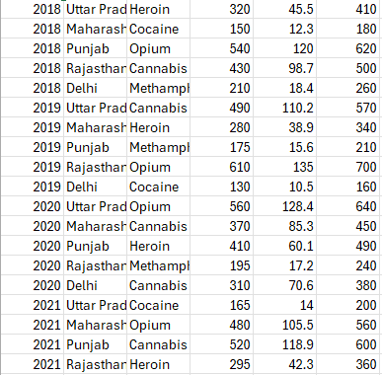

- Conclusion:

- In this project, a complete Big Data pipeline was successfully implemented using Hadoop ecosystem components.

- The dataset was stored in HDFS, processed using MapReduce to calculate average marks, and analyzed using Hive to extract meaningful insights such as top-performing subjects.

- The project helped in understanding the working of distributed data processing and data analysis techniques.

- Generative AI acted as a smart assistant throughout the project by helping in code generation, debugging, and understanding complex concepts.

- Generative AI was used not only for code generation but also as a learning assistant to understand Big Data workflows and improve overall efficiency.

