Build an app, step by step.
Product overview · Atomic / Abstract Machines · Updated 30 October 2026 · atomicapp.dev

Build in conversation.
Atomic is an AI app builder from Abstract Machines that turns plain-language ideas into web applications, with visual editing, previews, source access and publishing.
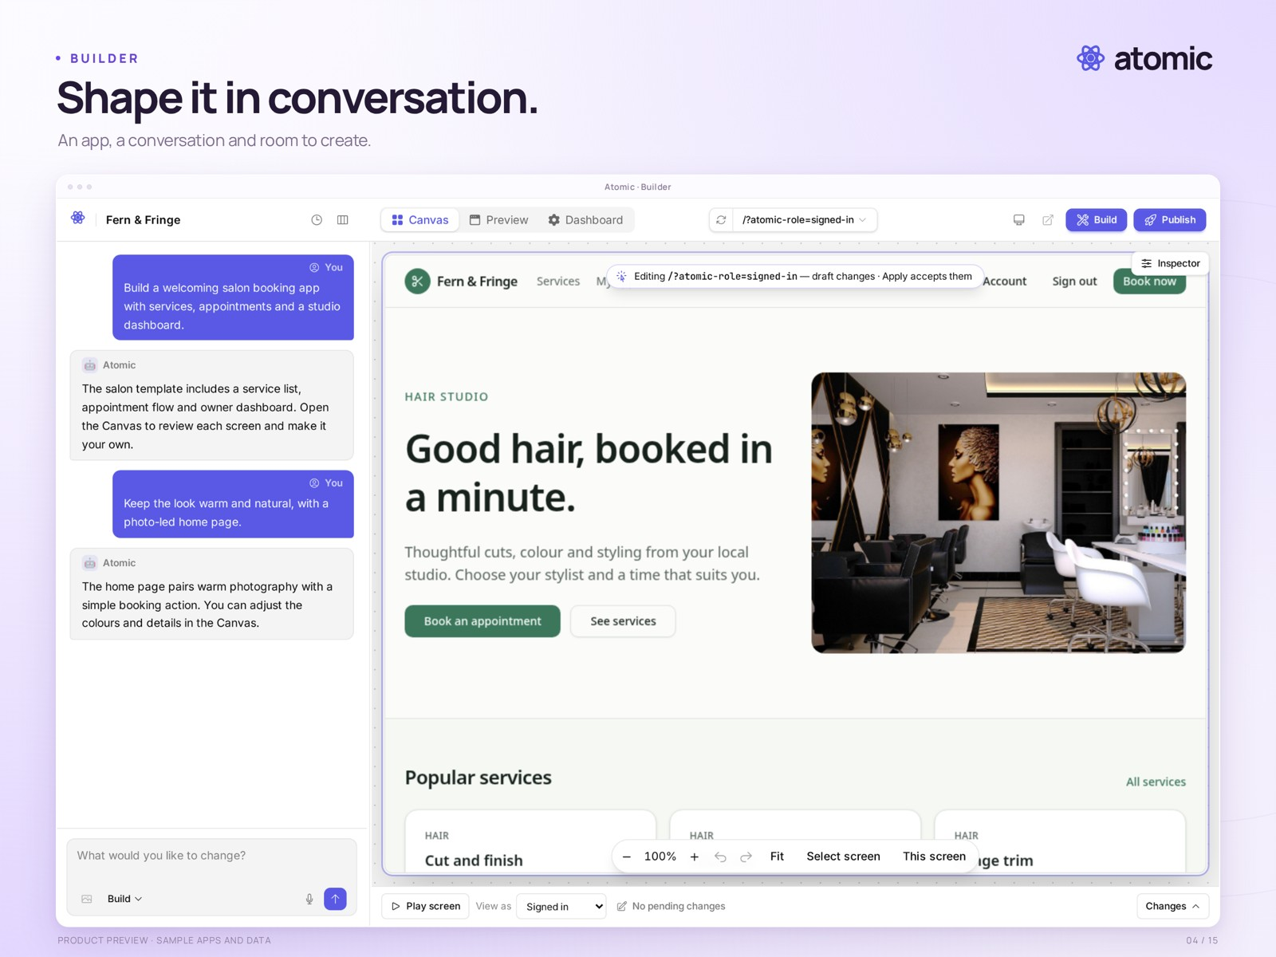
Builder · a working preview beside a staged sample conversation

The builder is the centre of the workflow
Describe what the app should do, review the working preview and refine it through conversation. Start from an idea or a template, then keep the brief and the result together as you build.
The example is a salon booking app with services, appointments and a studio workflow.
atomicapp.dev · Press room and complete media kit

Your code, in view.
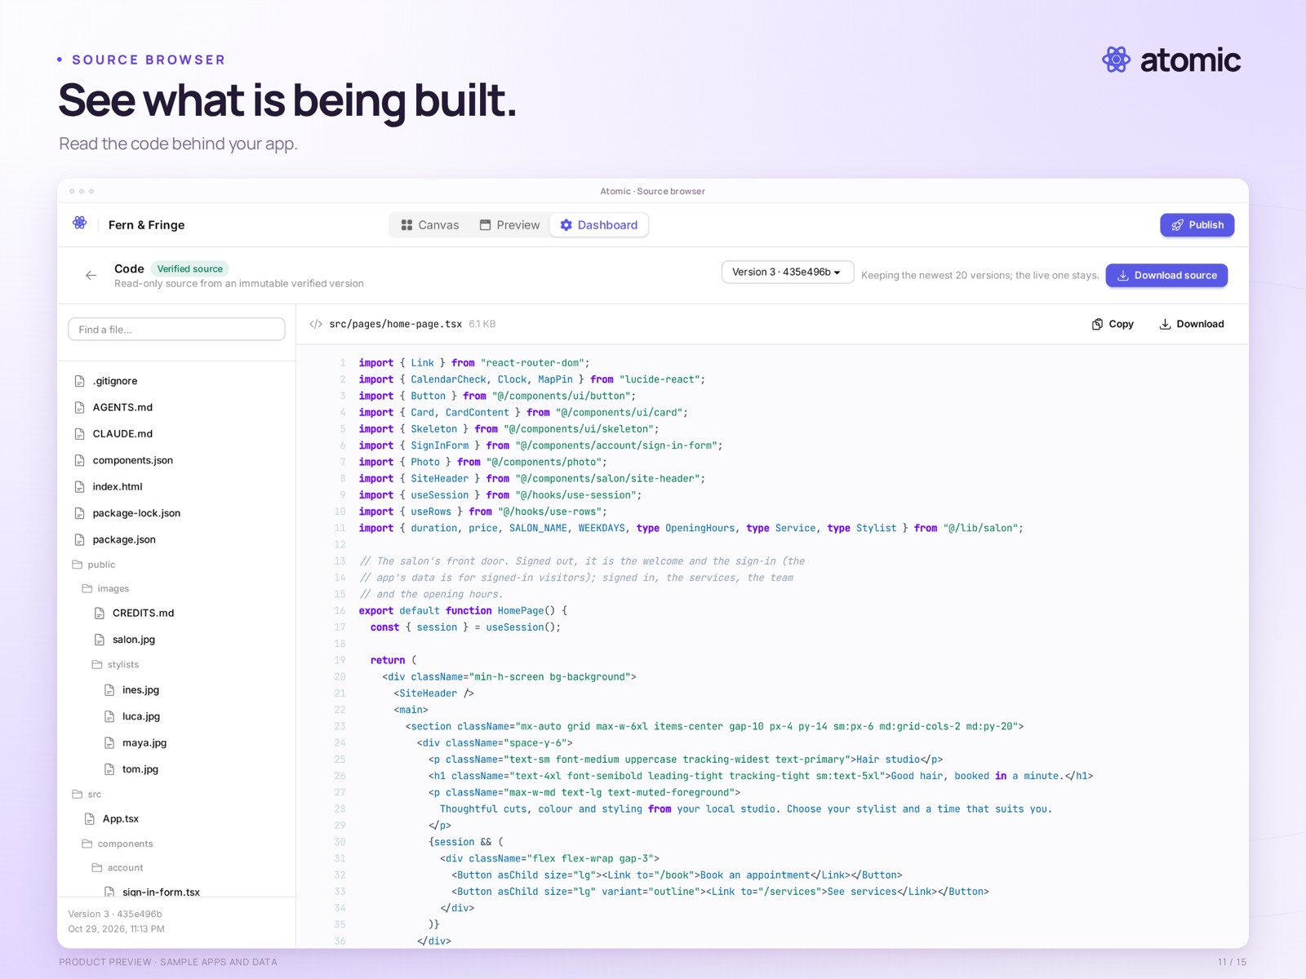
Source browser · app files, component code, a version selector and download controls

Inspect the code. Download the source.
Open the file tree, read the generated code and inspect the version you are working with. Source browsing is available on every plan. Builder and Pro let you download the app’s source code.
The download contains code. App users, business data and hosting infrastructure are separate; the archive is not a complete portable deployment package.
atomicapp.dev · Press room and complete media kit

Explore the whole Canvas.
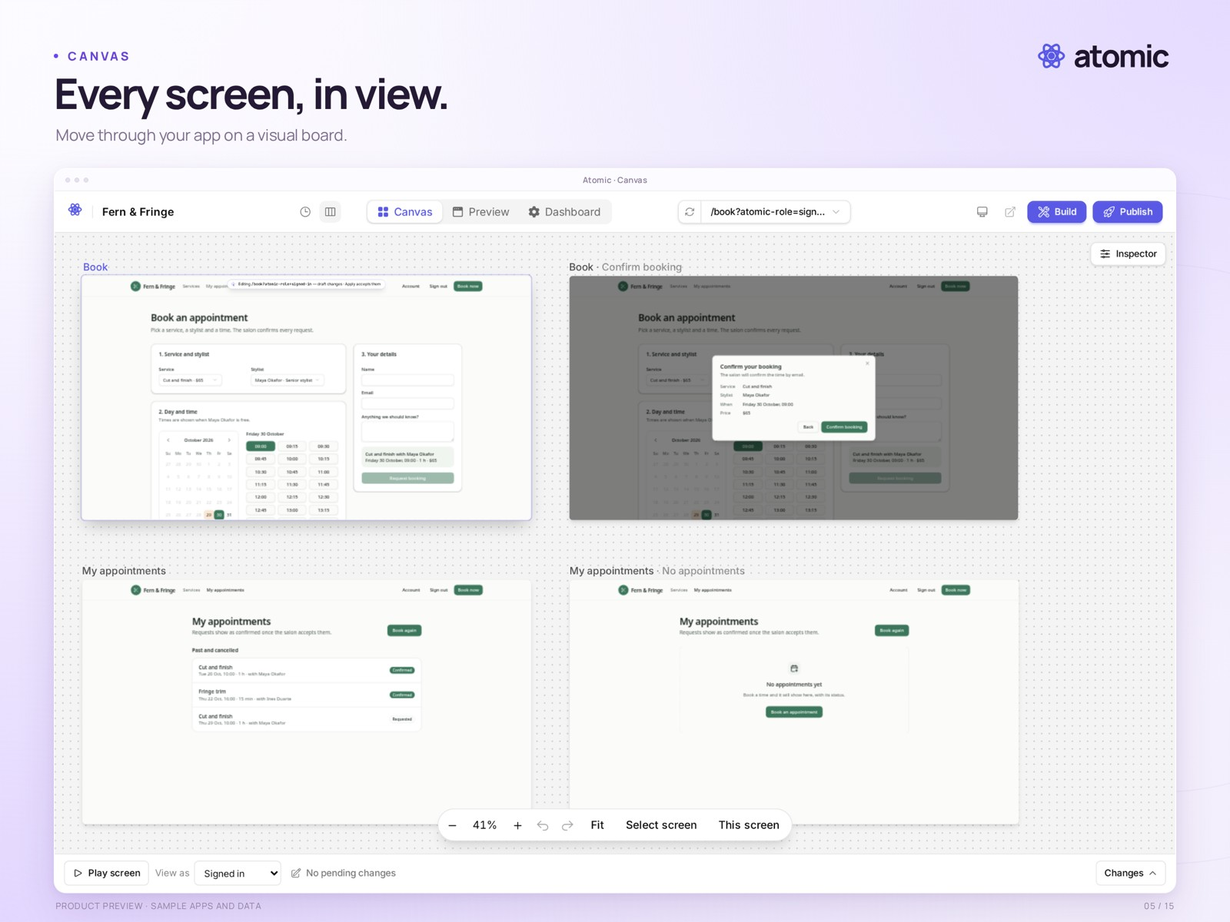
Canvas · booking screens, a confirmation dialog and appointment views

See how the screens fit together
Navigate the visual board, zoom into a screen and review the states that make up a complete flow. A booking journey includes more than its landing page: choices, confirmation and the next appointment all need attention.
Preview the app at different sizes and test the paths your users will take.

Make it your own.
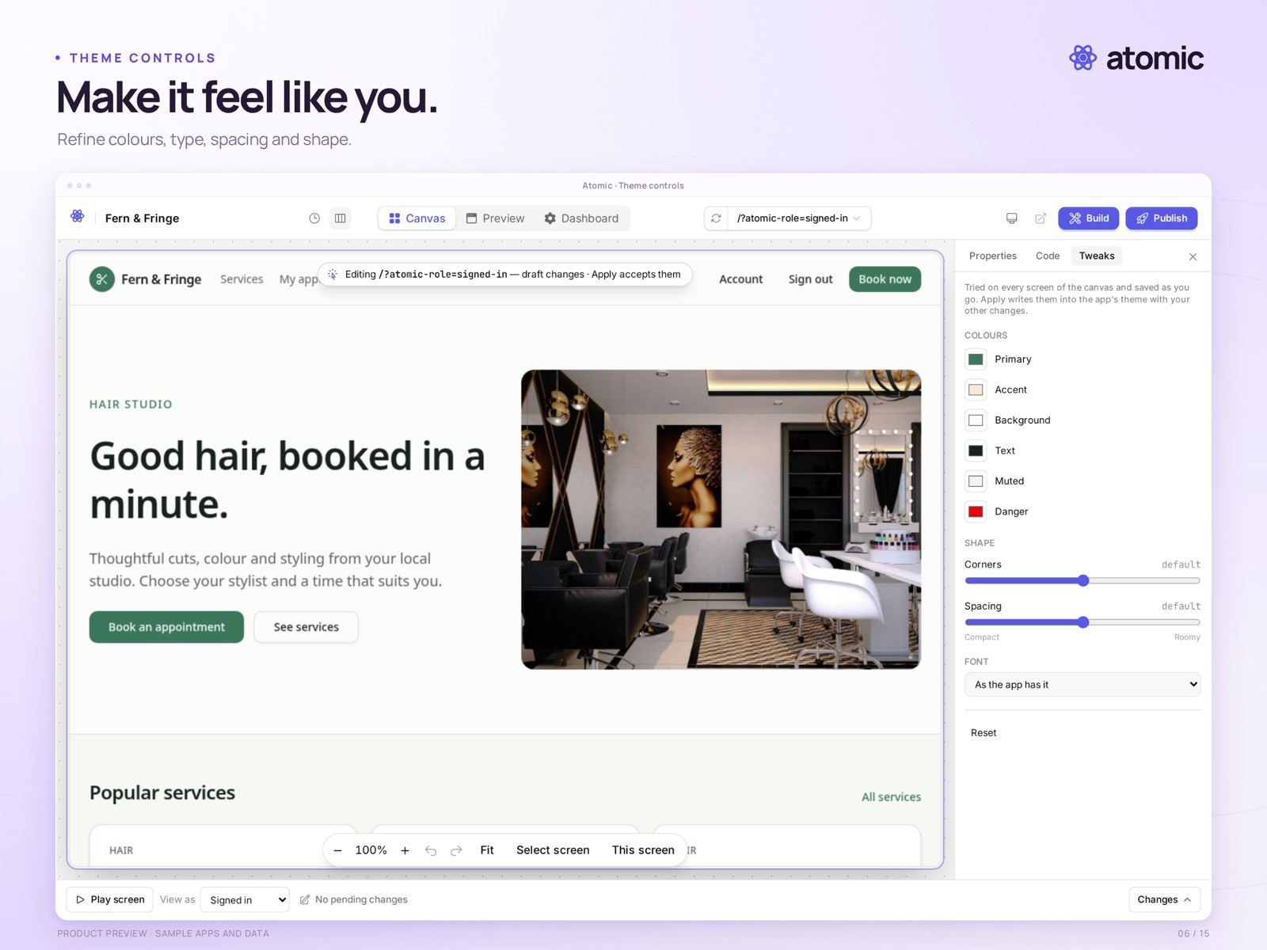
Theme controls · colours, typography, spacing and shape

Shape the whole app, then refine the details
Tune the overall style on the Canvas. Select an individual element to inspect its properties, and attach feedback to the part you mean. Builder and Pro support collaboration with teammates.
The gallery also includes element editing and an element-linked comment draft.

Keep track of every version.
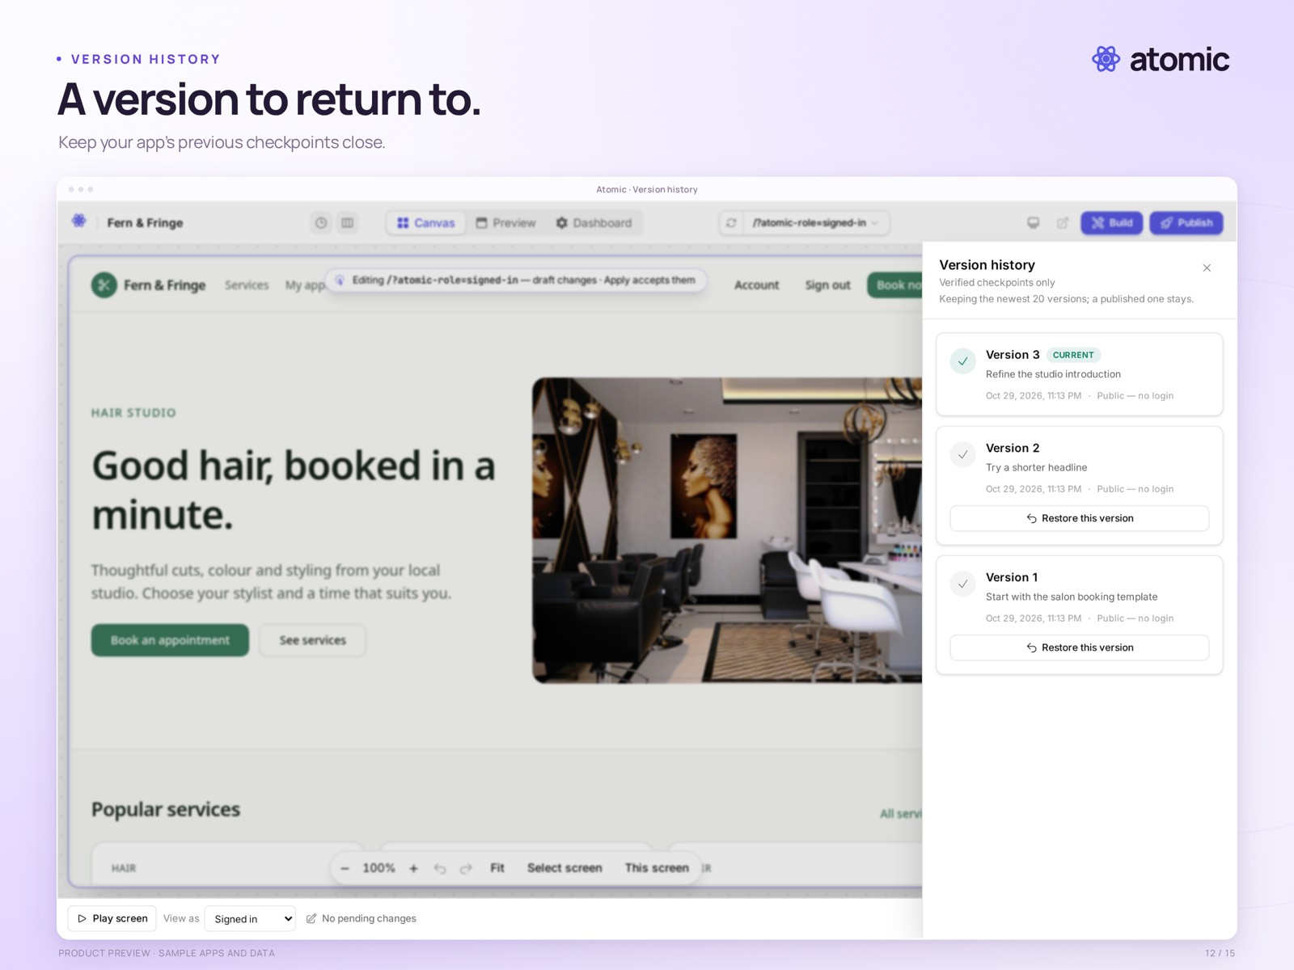
Version history · prepared sample revisions for a local demo app

Review the work behind each change
Inspect the source and move through version history before choosing what to release. Source browsing is available on all plans; Builder and Pro also include source downloads.
Restoring source or rolling back a publication concerns code, not business data. Publication rollback depends on compatibility with applied data migrations. Downloads exclude users, business data and hosting infrastructure.

Review. Publish. Manage.
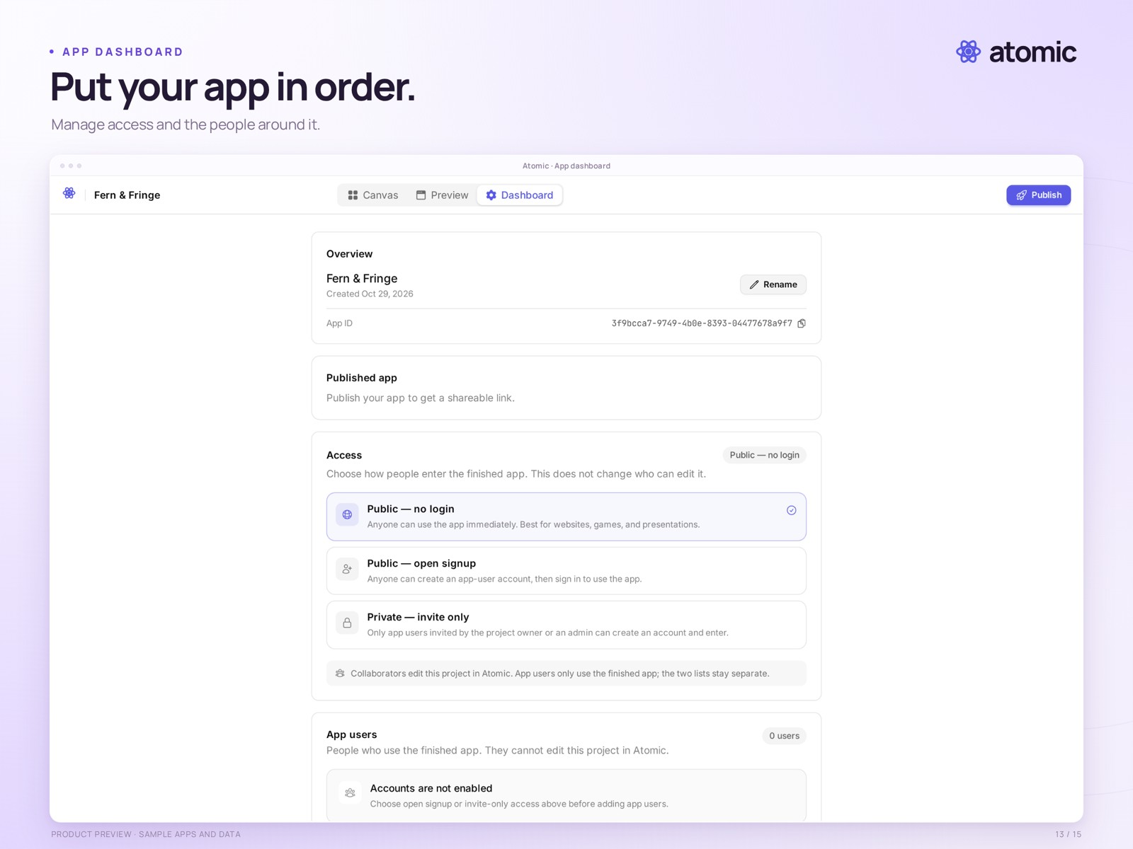
Publishing and app dashboard · publication, access and app-user settings

Choose who can use the finished app
Review the version, choose the access model and publish. The dashboard brings publication and app-user settings together, including public access, open signup and invitation-only entry.
Workspace collaborators edit the project; app users use the finished app. These are separate roles. This local sample has not been publicly deployed.

See what is happening.
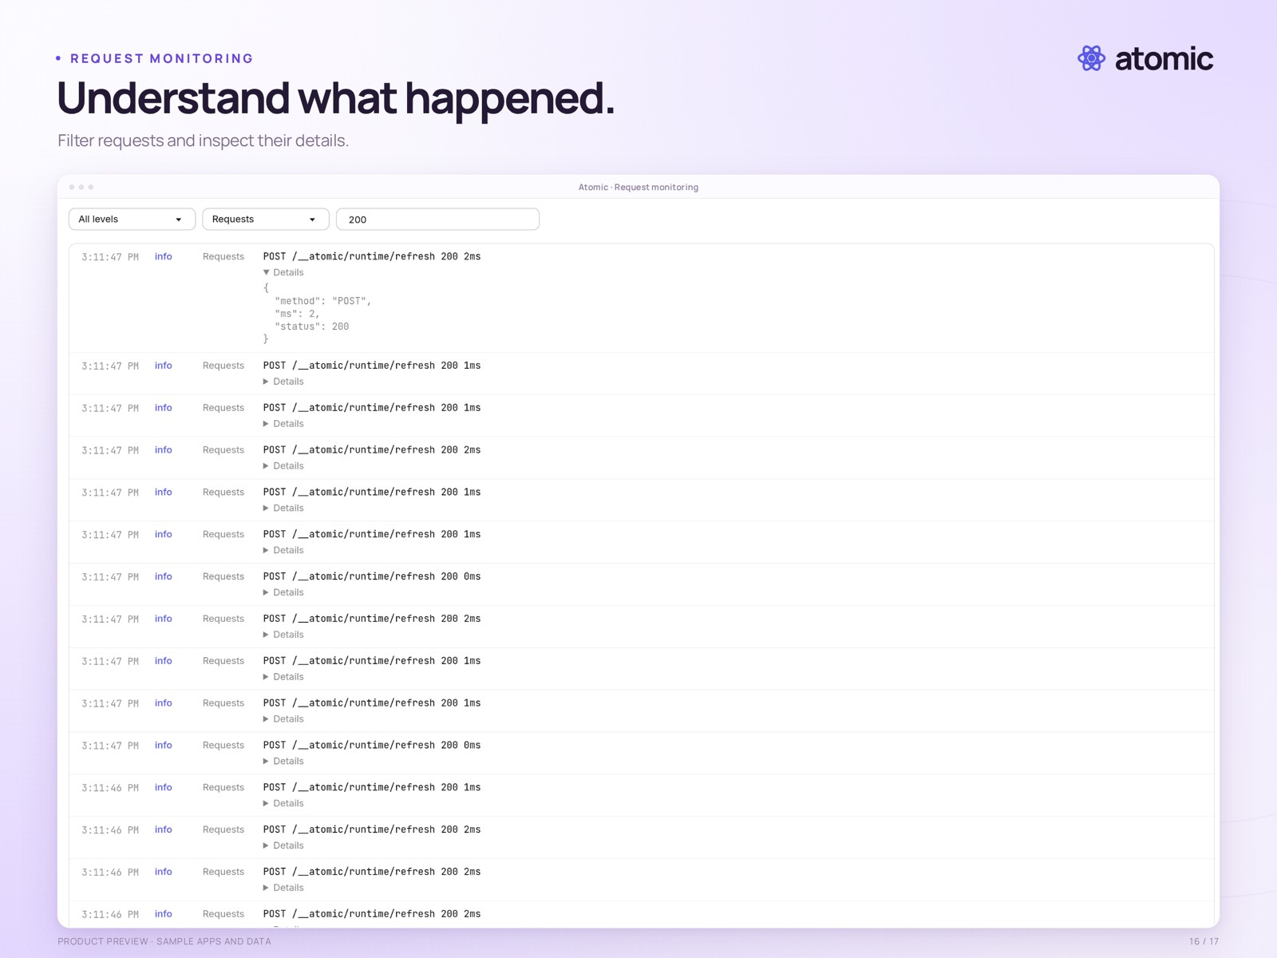
Request monitoring · a filtered log and expanded request details

Inspect activity in the preview
Searchable preview logs on Builder and Pro let you filter requests and inspect individual entries when investigating app behaviour. The usage view provides another perspective: recent building sessions, credits used and time spent.
Shown traffic and usage are local demonstration data. Atom provides the underlying identities, permissions and application data.
Watch the 35-second launch film · Square and vertical versions are available in the press room.

