The current product gallery.
Screenshot captions · Atomic / Abstract Machines · Updated 30 October 2026 · atomicapp.dev
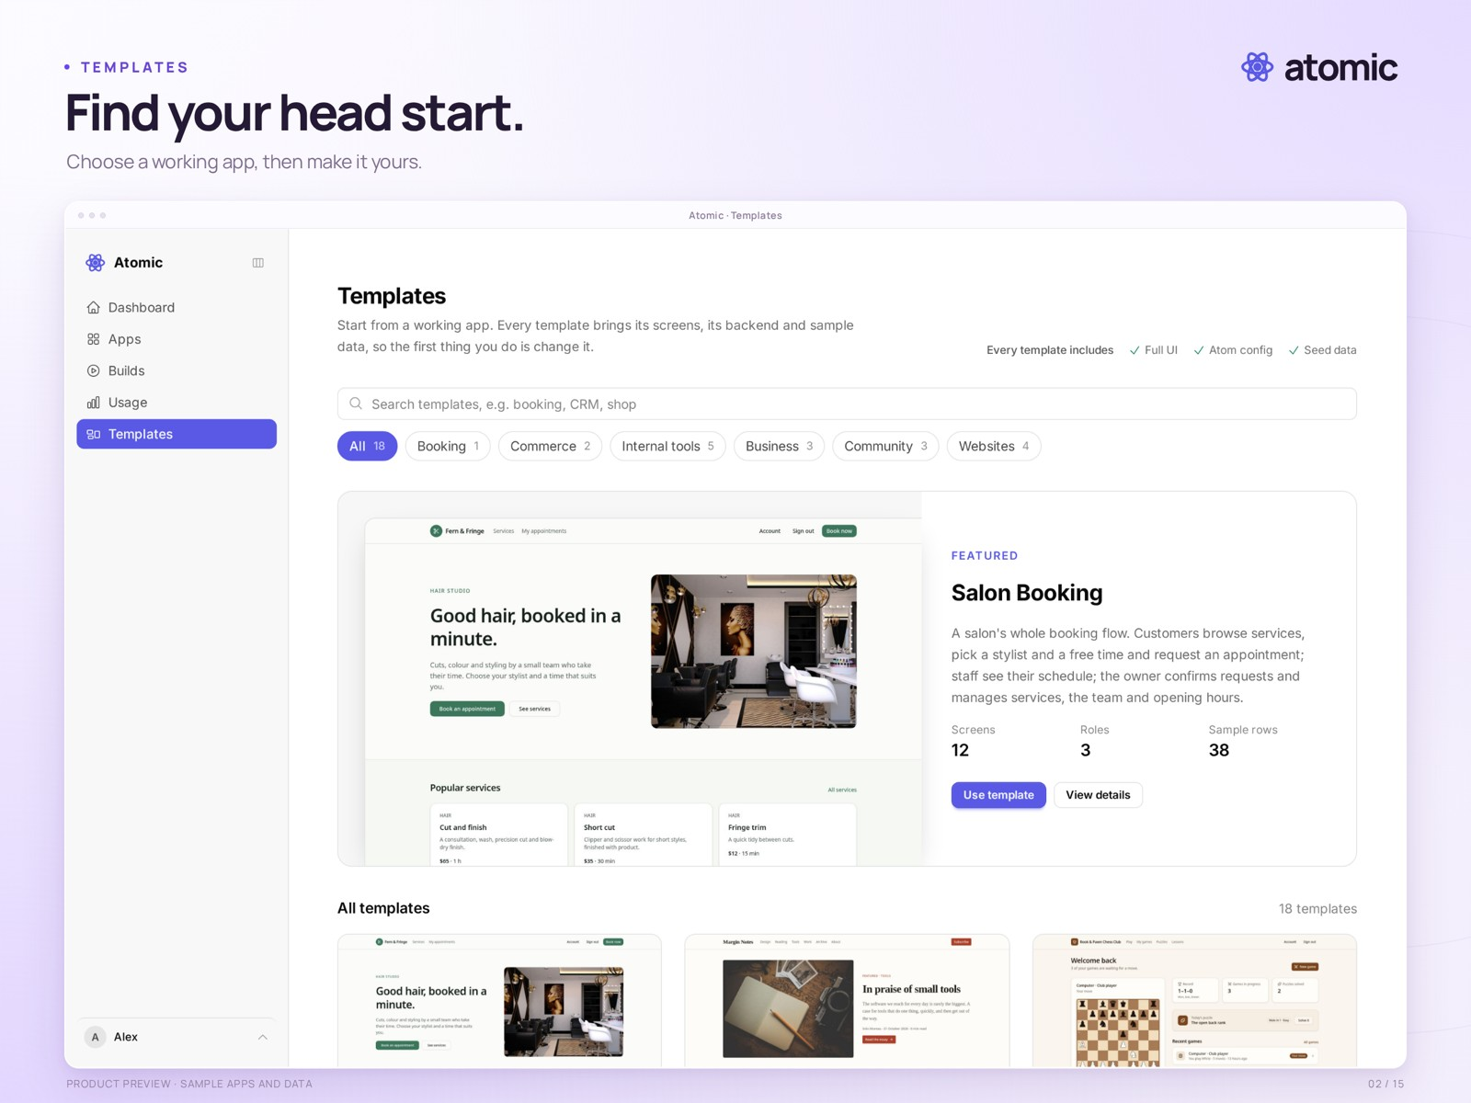
Templates · choose a starting point for the app you want to build

Choose images to support the story
First impression | 01 home · 02 templates · 03 template preview
Build and refine | 04 builder · 05 Canvas · 06 theme · 07 element editing · 08 collaboration
Publish and manage | 09 applications · 10 billing · 13 publication and app dashboard
Inspect and review | 11 source · 12 versions
Operate and investigate | 16 request monitoring · 17 usage
Finished experience | 14 sample salon app · 15 responsive preview
Each numbered page that follows contains the current presentation image, its caption and the clean-capture filename. Presentation PNGs are 2560 × 1920; raw captures keep their native dimensions. Monitoring and usage presentations use detail crops for readability, with the original full captures also included. Capture dates describe the original screenshots, not this document revision.
atomicapp.dev · Press room and complete media kit

Home
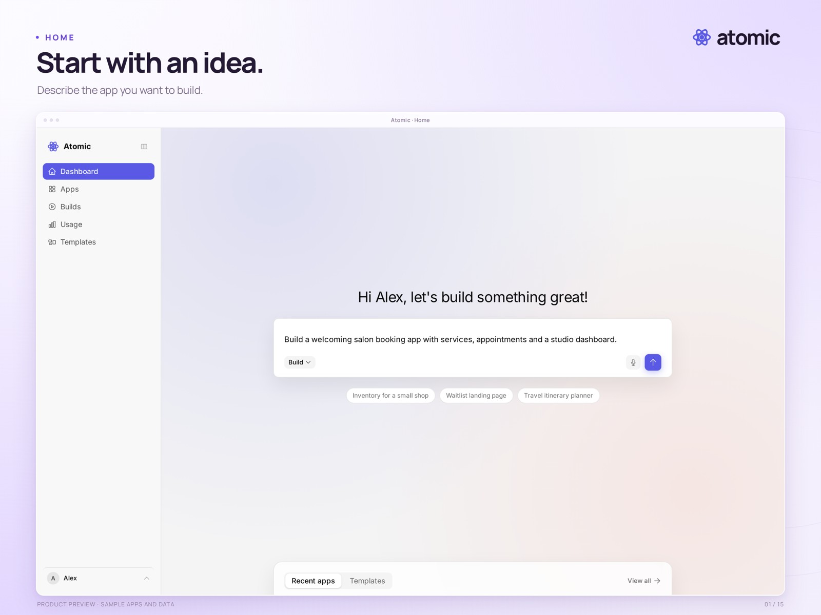
Start with an idea.
The Atomic home screen with a drafted salon-booking prompt. The prompt has not been submitted.
Real product capture from a local demonstration workspace, with an external branded presentation frame. Sample apps and data.
Presentation file | 01-home.png · 2560 × 1920
Clean capture | raw/01-home.png · 2880 × 1800
Captured | 2026-10-29
Credit | Courtesy of Atomic / Abstract Machines

Templates
Find your head start.
The template catalogue, including a photo-based salon booking template and other starting points.
Real product capture from a local demonstration workspace, with an external branded presentation frame. Sample apps and data.
Presentation file | 02-templates.png · 2560 × 1920
Clean capture | raw/02-templates.png · 2880 × 1800
Captured | 2026-10-29
Credit | Courtesy of Atomic / Abstract Machines

Template preview
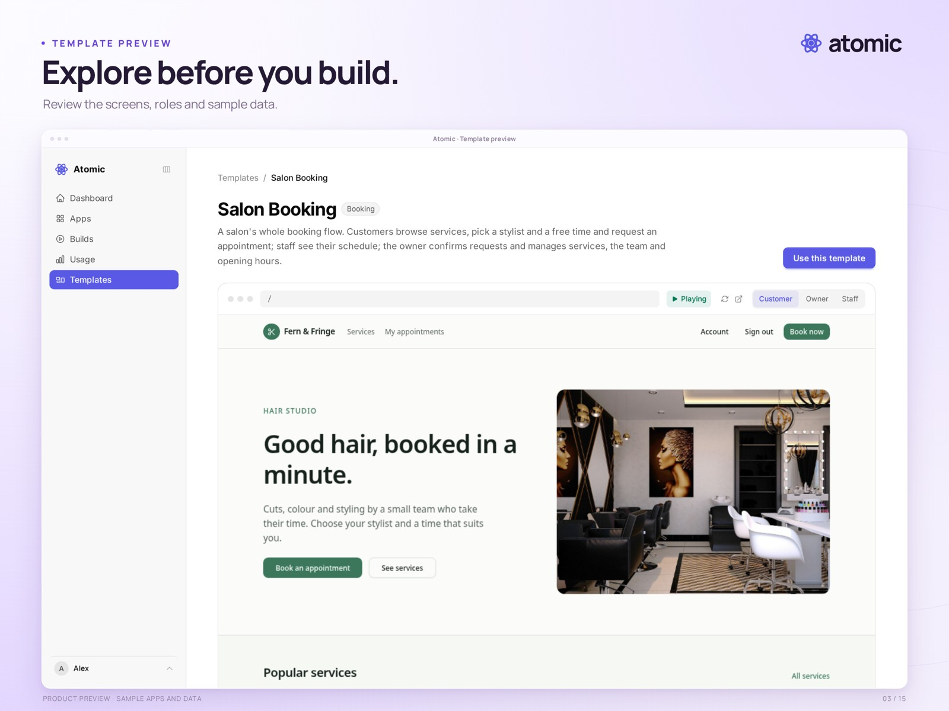
Explore before you build.
The salon booking template detail page, with its interactive preview and screen navigation.
Real product capture from a local demonstration workspace, with an external branded presentation frame. Sample apps and data.
Presentation file | 03-template-preview.png · 2560 × 1920
Clean capture | raw/03-template-preview.png · 2880 × 1800
Captured | 2026-10-29
Credit | Courtesy of Atomic / Abstract Machines

Builder
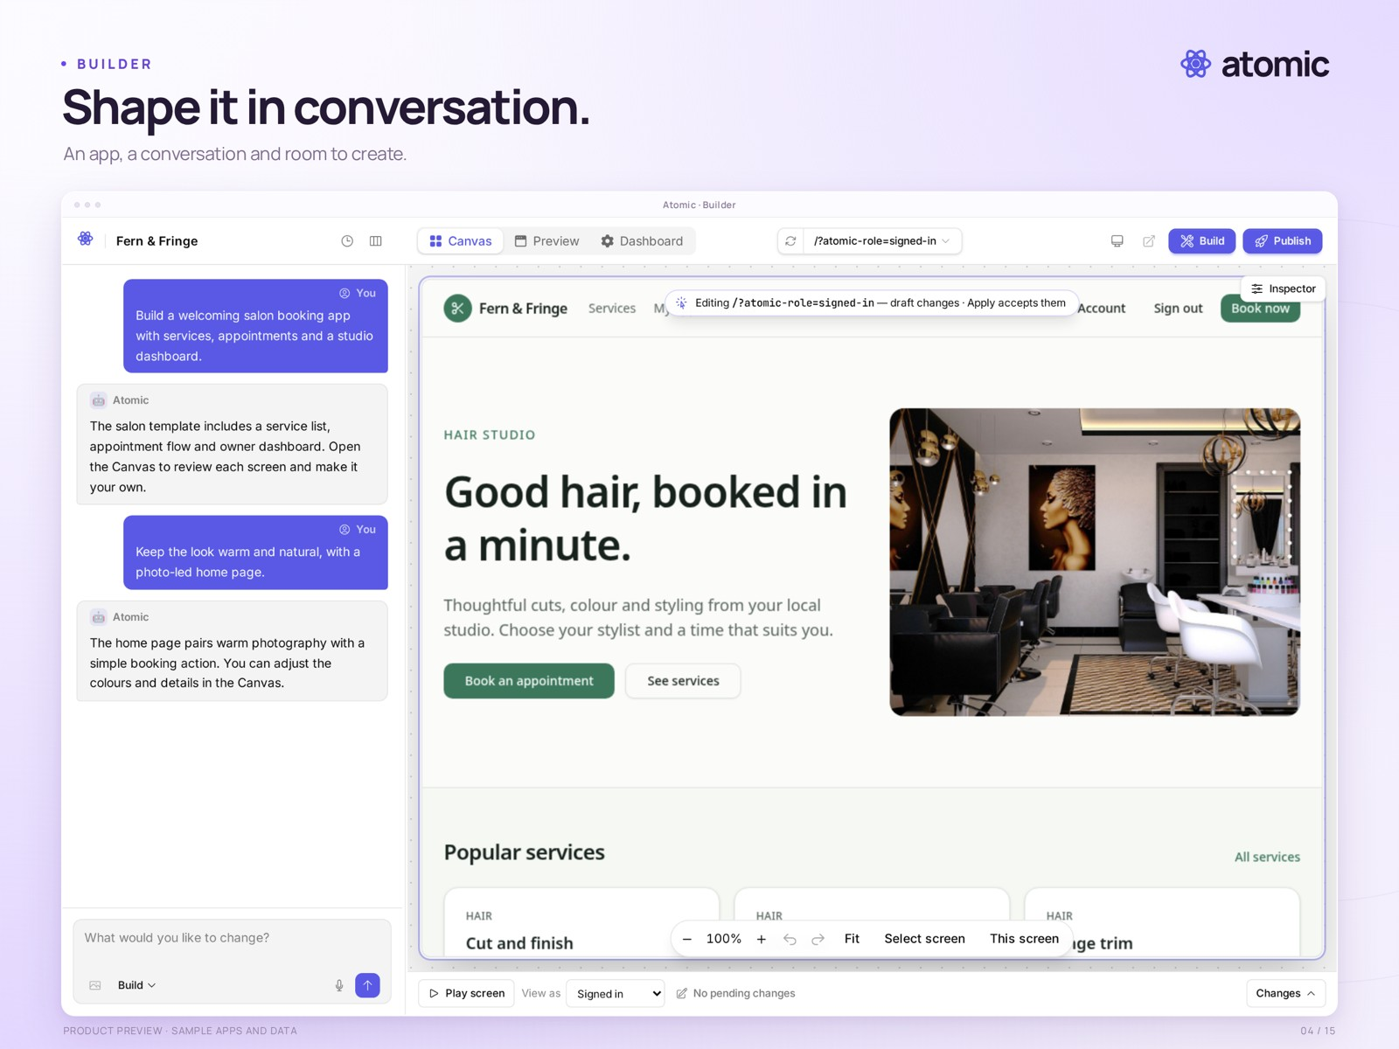
Shape it in conversation.
The builder pairs a sample salon application with a staged demonstration conversation.
Real product capture from a local demonstration workspace, with an external branded presentation frame. Sample apps and data.
Presentation file | 04-builder.png · 2560 × 1920
Clean capture | raw/04-builder.png · 2880 × 1800
Captured | 2026-10-29
Credit | Courtesy of Atomic / Abstract Machines

Canvas
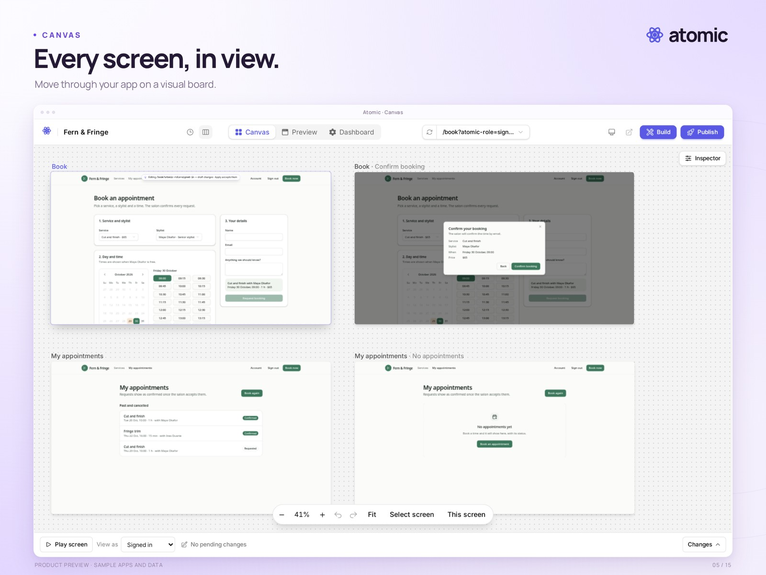
Every screen, in view.
The Canvas shows the booking flow, confirmation dialog and appointment screens together at a readable zoom level.
Real product capture from a local demonstration workspace, with an external branded presentation frame. Sample apps and data.
Presentation file | 05-canvas.png · 2560 × 1920
Clean capture | raw/05-canvas.png · 2880 × 1800
Captured | 2026-10-29
Credit | Courtesy of Atomic / Abstract Machines

Theme controls
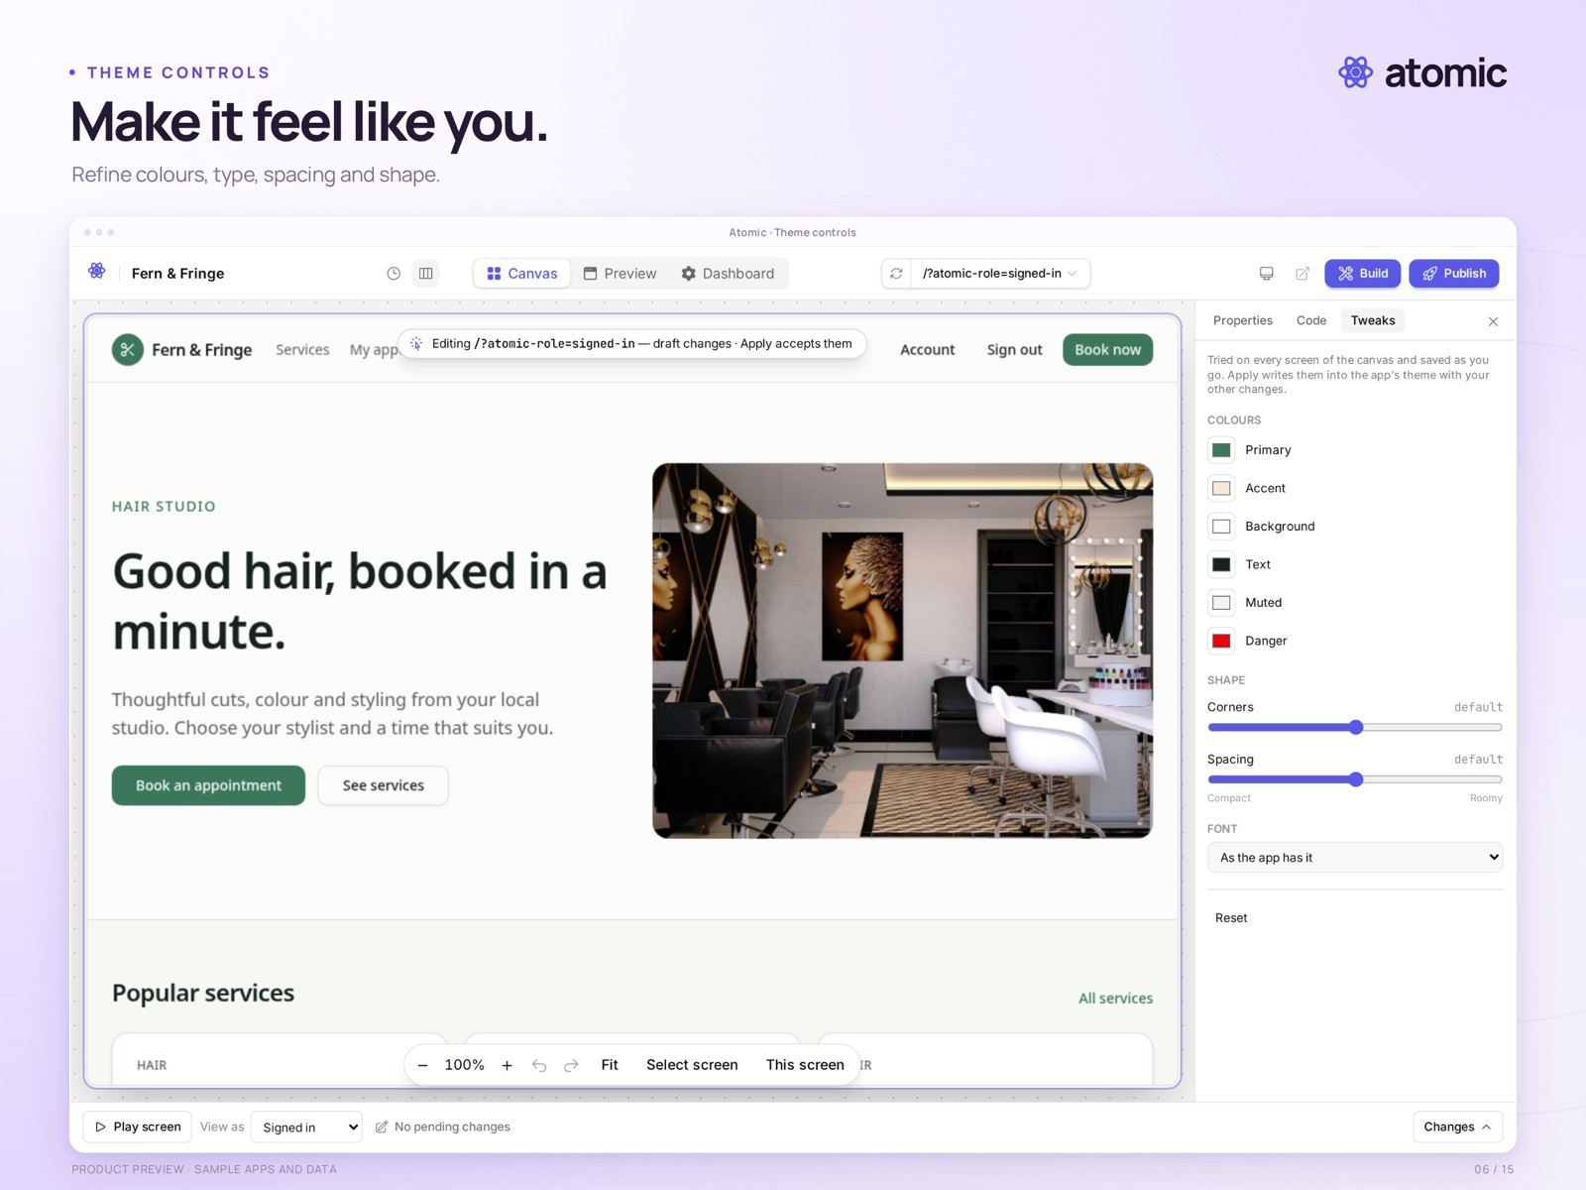
Make it feel like you.
Whole-app theme controls are open beside the sample app on the Canvas.
Real product capture from a local demonstration workspace, with an external branded presentation frame. Sample apps and data.
Presentation file | 06-theme.png · 2560 × 1920
Clean capture | raw/06-theme.png · 2880 × 1800
Captured | 2026-10-29
Credit | Courtesy of Atomic / Abstract Machines

Element editing
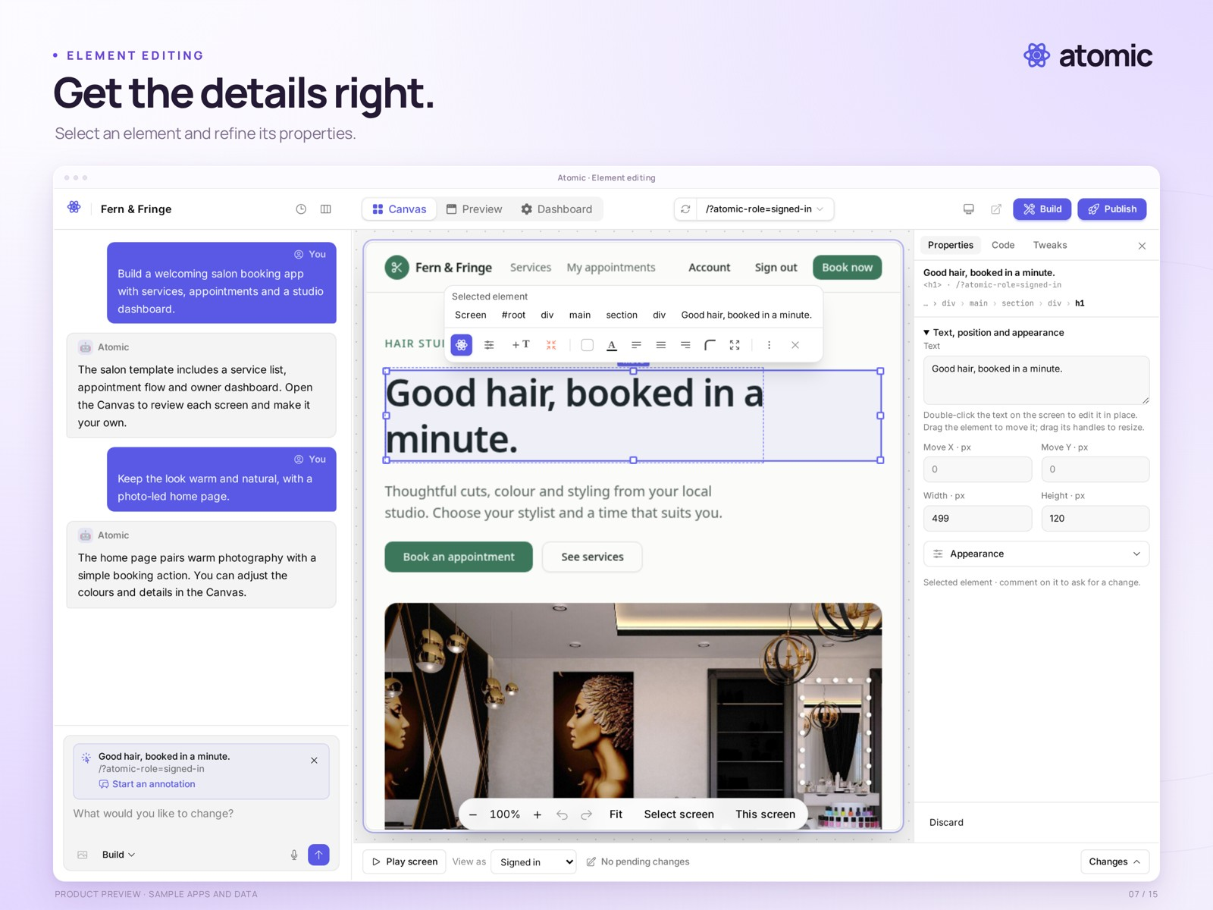
Get the details right.
A headline is selected on the Canvas, with the Properties inspector open.
Real product capture from a local demonstration workspace, with an external branded presentation frame. Sample apps and data.
Presentation file | 07-element.png · 2560 × 1920
Clean capture | raw/07-element.png · 2880 × 1800
Captured | 2026-10-29
Credit | Courtesy of Atomic / Abstract Machines

Collaboration
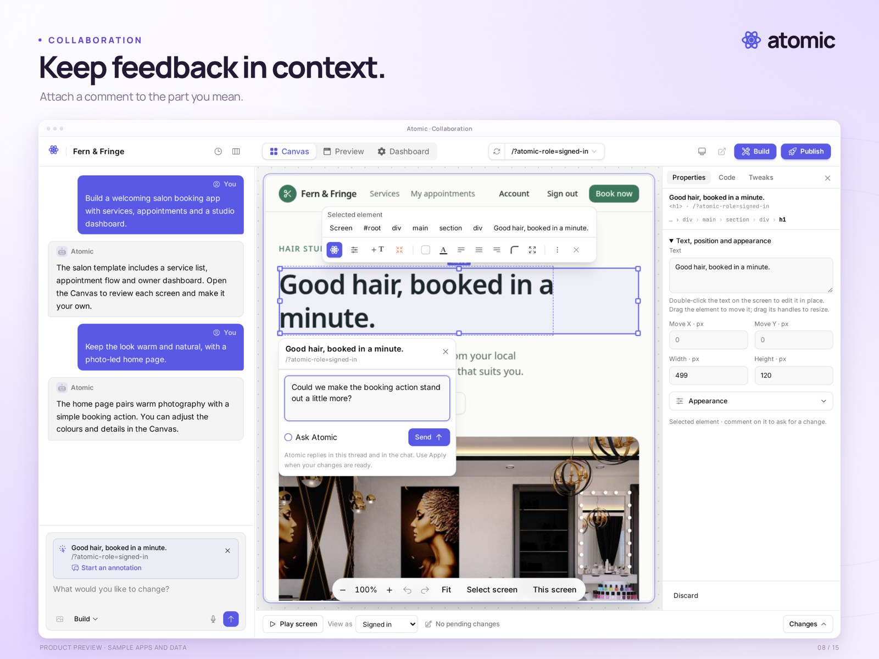
Keep feedback in context.
An element-linked comment composer is open on the Canvas. This is an unsent draft; no AI change has been requested.
Real product capture from a local demonstration workspace, with an external branded presentation frame. Sample apps and data.
Presentation file | 08-collaboration.png · 2560 × 1920
Clean capture | raw/08-collaboration.png · 2880 × 1800
Captured | 2026-10-29
Credit | Courtesy of Atomic / Abstract Machines

Applications
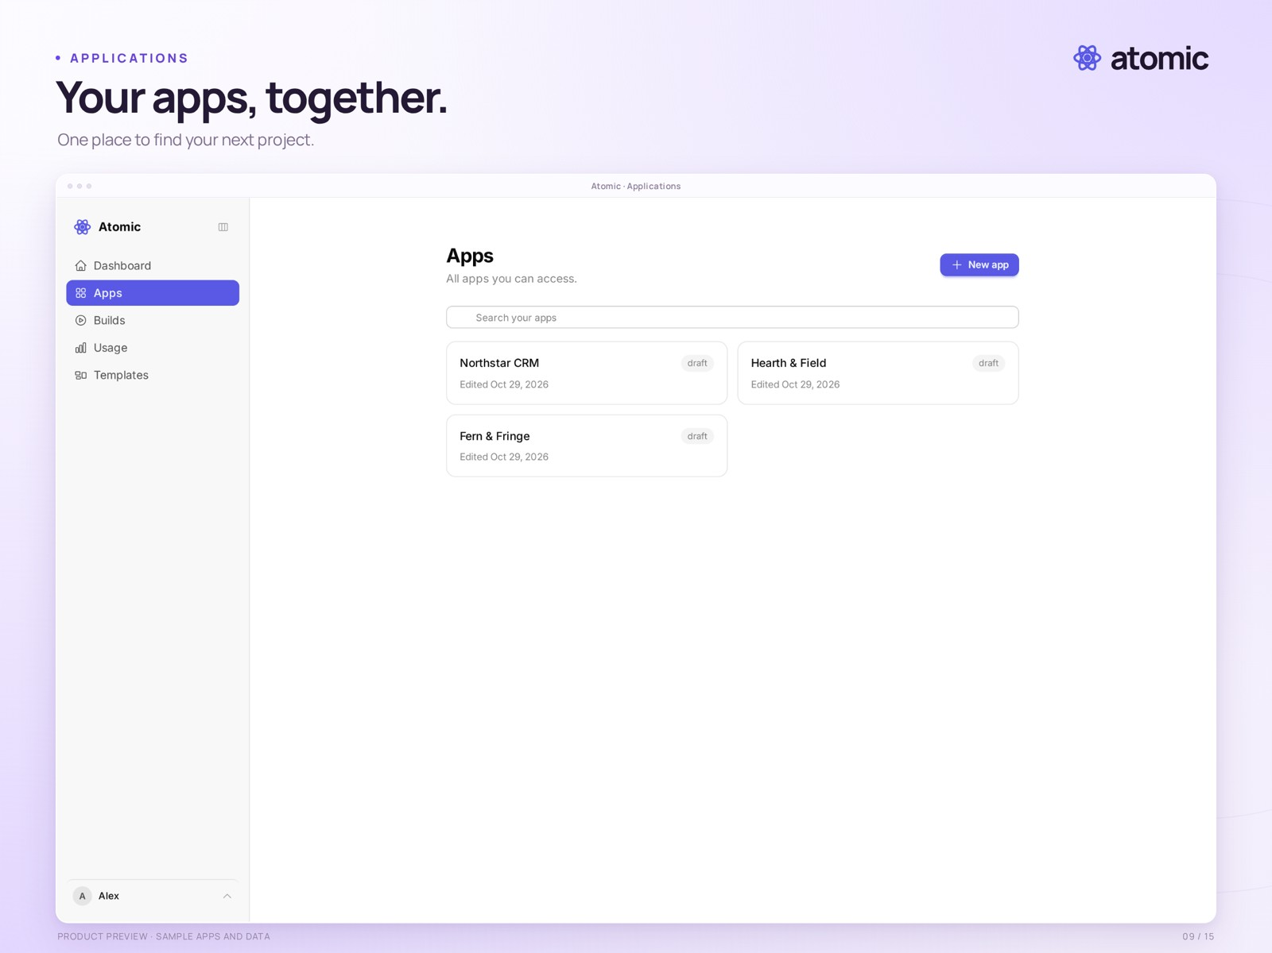
Your apps, together.
The applications list shows three local sample projects: Fern & Fringe, Hearth & Field and Northstar CRM.
Real product capture from a local demonstration workspace, with an external branded presentation frame. Sample apps and data.
Presentation file | 09-applications.png · 2560 × 1920
Clean capture | raw/09-applications.png · 2880 × 1800
Captured | 2026-10-29
Credit | Courtesy of Atomic / Abstract Machines

Billing
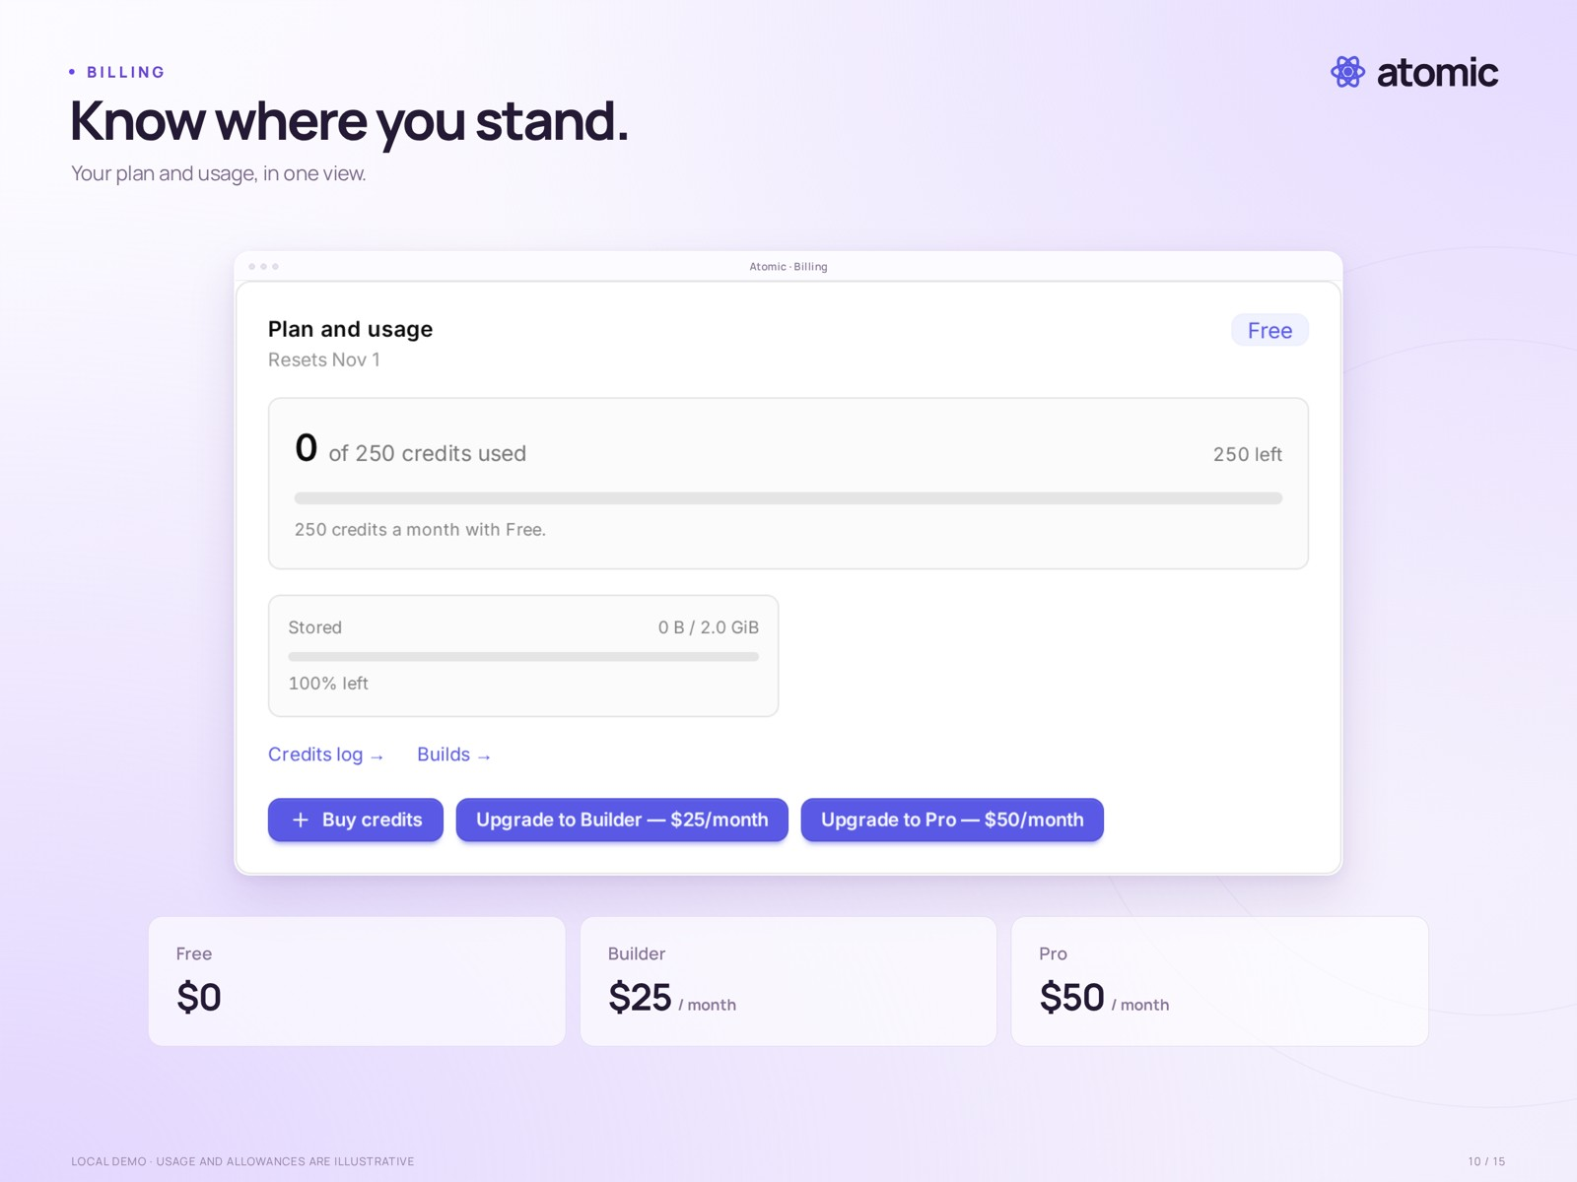
Know where you stand.
The account billing panel shows plan, credits, storage and upgrade controls. This is a local demo account; usage and allowances are illustrative, not confirmed launch entitlements.
Real product capture from a local demonstration workspace, with an external branded presentation frame. Sample apps and data.
Presentation file | 10-billing.png · 2560 × 1920
Clean capture | raw/10-billing.png · 1424 × 764
Captured | 2026-10-29
Credit | Courtesy of Atomic / Abstract Machines

Source browser
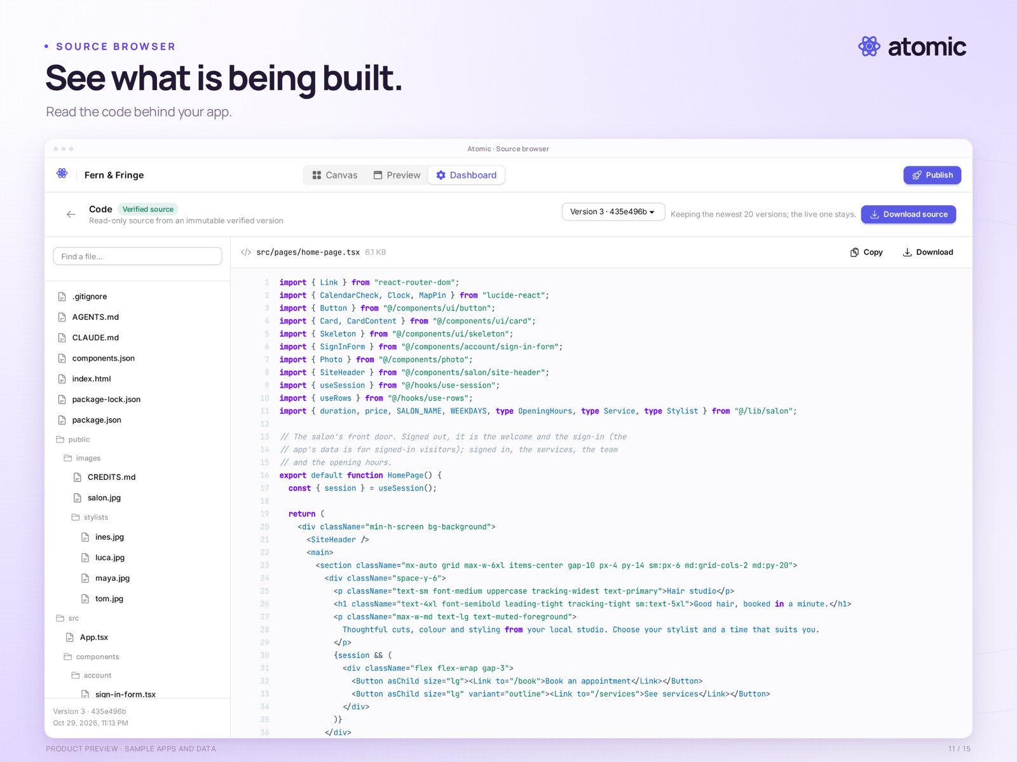
See what is being built.
The source browser displays the sample app’s home-page component, file tree and version selector. Source downloads exclude users, business data and hosting infrastructure.
Real product capture from a local demonstration workspace, with an external branded presentation frame. Sample apps and data.
Presentation file | 11-source.png · 2560 × 1920
Clean capture | raw/11-source.png · 2880 × 1800
Captured | 2026-10-29
Credit | Courtesy of Atomic / Abstract Machines

Version history
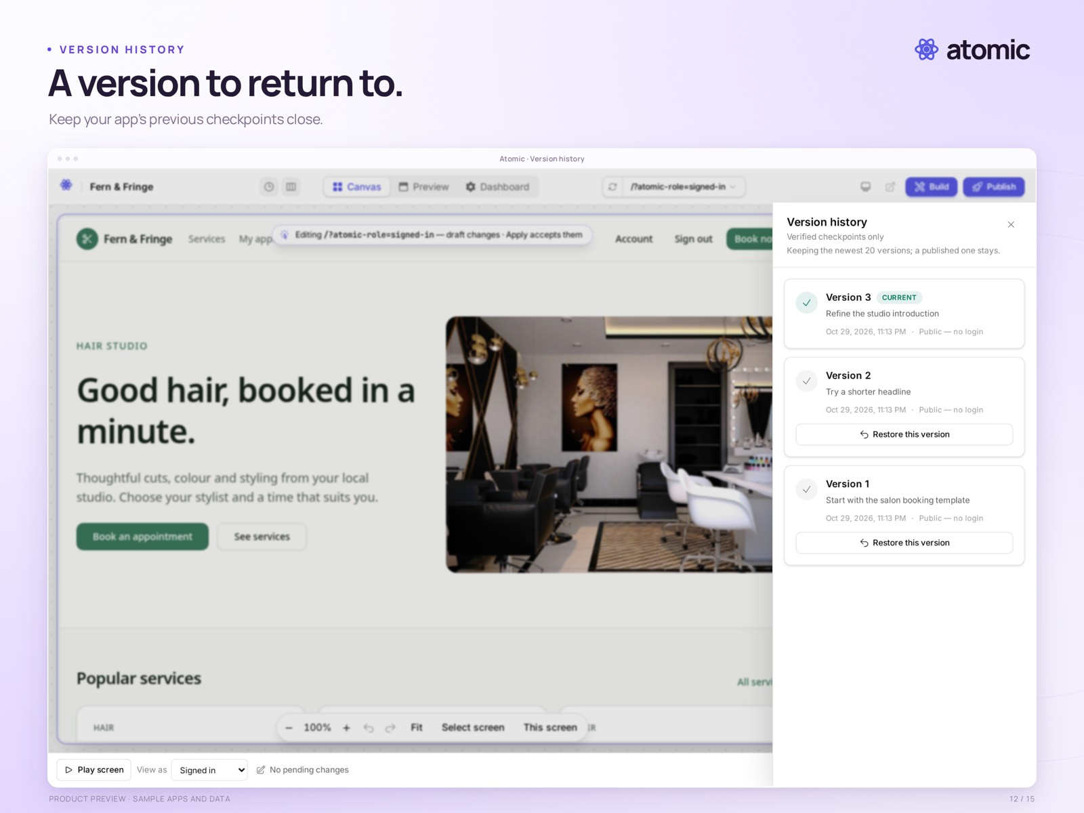
A version to return to.
Version history shows locally prepared sample revisions. These are compiled demonstration checkpoints; the capture does not show a restore being performed.
Real product capture from a local demonstration workspace, with an external branded presentation frame. Sample apps and data.
Presentation file | 12-versions.png · 2560 × 1920
Clean capture | raw/12-versions.png · 2880 × 1800
Captured | 2026-10-29
Credit | Courtesy of Atomic / Abstract Machines

App dashboard
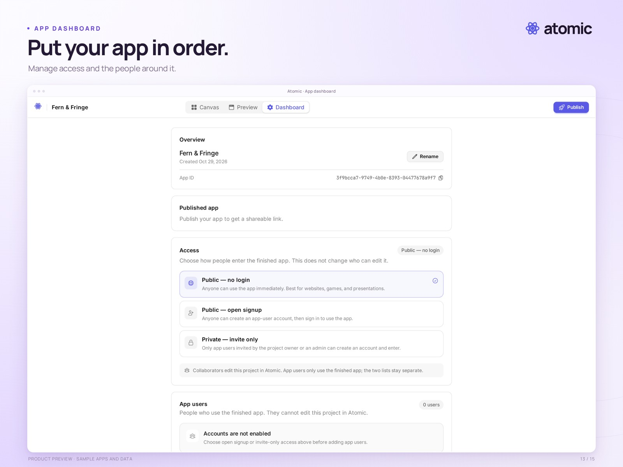
Put your app in order.
The app dashboard shows publication, access and app-user settings for the local salon demo. The app has not been publicly deployed.
Real product capture from a local demonstration workspace, with an external branded presentation frame. Sample apps and data.
Presentation file | 13-dashboard.png · 2560 × 1920
Clean capture | raw/13-dashboard.png · 2880 × 1800
Captured | 2026-10-29
Credit | Courtesy of Atomic / Abstract Machines

Sample application
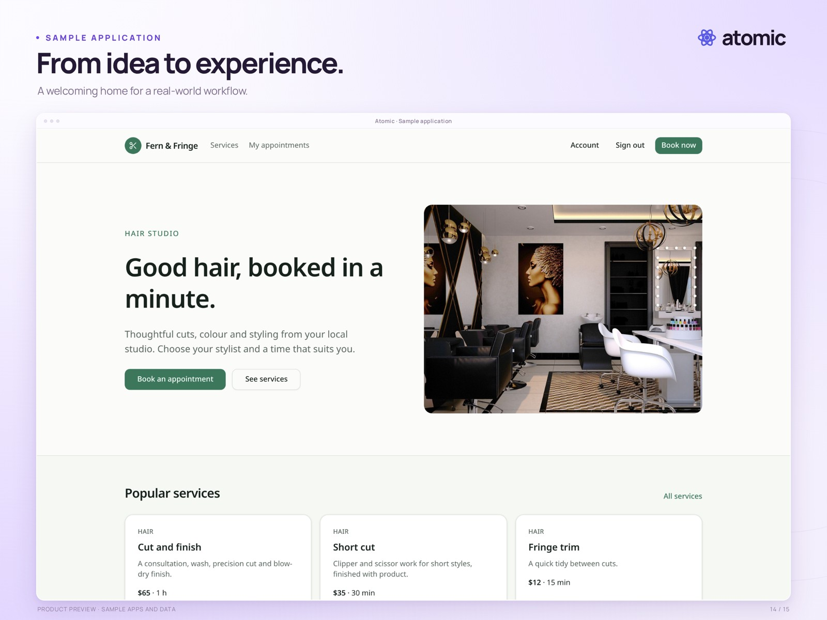
From idea to experience.
Fern & Fringe, a photo-based sample salon application, shown as a standalone preview with local demonstration data.
Real local sample-app preview with external branded framing. Business names, photographs and content illustrate the template; they are not customer claims.
Presentation file | 14-salon-app.png · 2560 × 1920
Clean capture | raw/14-salon-app.png · 2880 × 1800
Captured | 2026-10-29
Credit | Courtesy of Atomic / Abstract Machines

Responsive preview
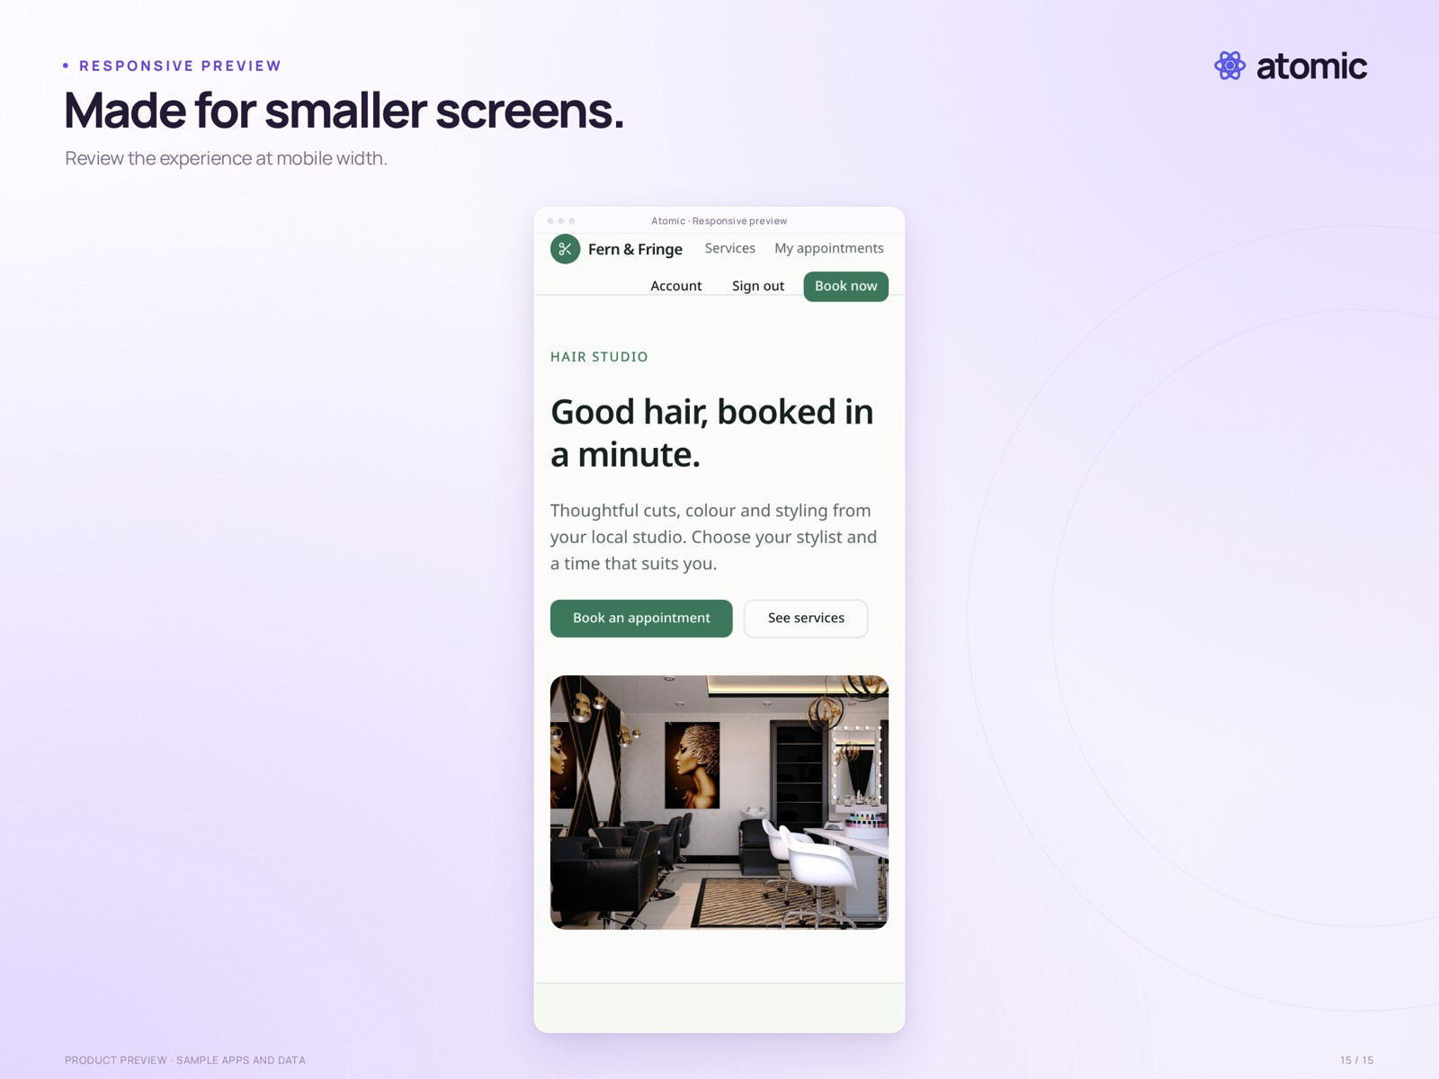
Made for smaller screens.
The sample salon application at a 390-pixel mobile viewport. This is a responsive web-app preview, not a native mobile-app export.
Real local sample-app preview with external branded framing. Business names, photographs and content illustrate the template; they are not customer claims.
Presentation file | 15-responsive.png · 2560 × 1920
Clean capture | raw/15-responsive.png · 780 × 1688
Captured | 2026-10-29
Credit | Courtesy of Atomic / Abstract Machines

Request monitoring
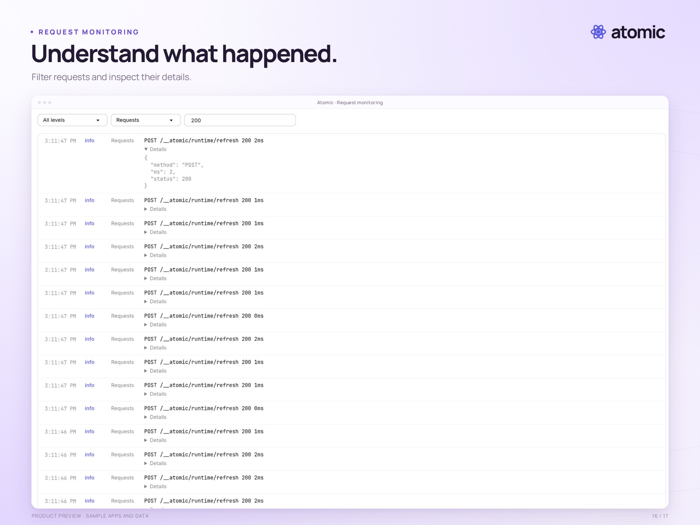
Understand what happened.
The request log is filtered to status 200, with one request expanded to show its method, duration and response status. This is local demonstration traffic, not a performance benchmark.
Detail crop of a supplied product screenshot, with external branded framing. The full unaltered capture is included in raw/. Local sample data.
Presentation file | 16-monitoring.png · 2560 × 1920
Clean capture | raw/16-monitoring.png · 5120 × 2880
Captured | 2026-10-27
Credit | Courtesy of Atomic / Abstract Machines

Usage
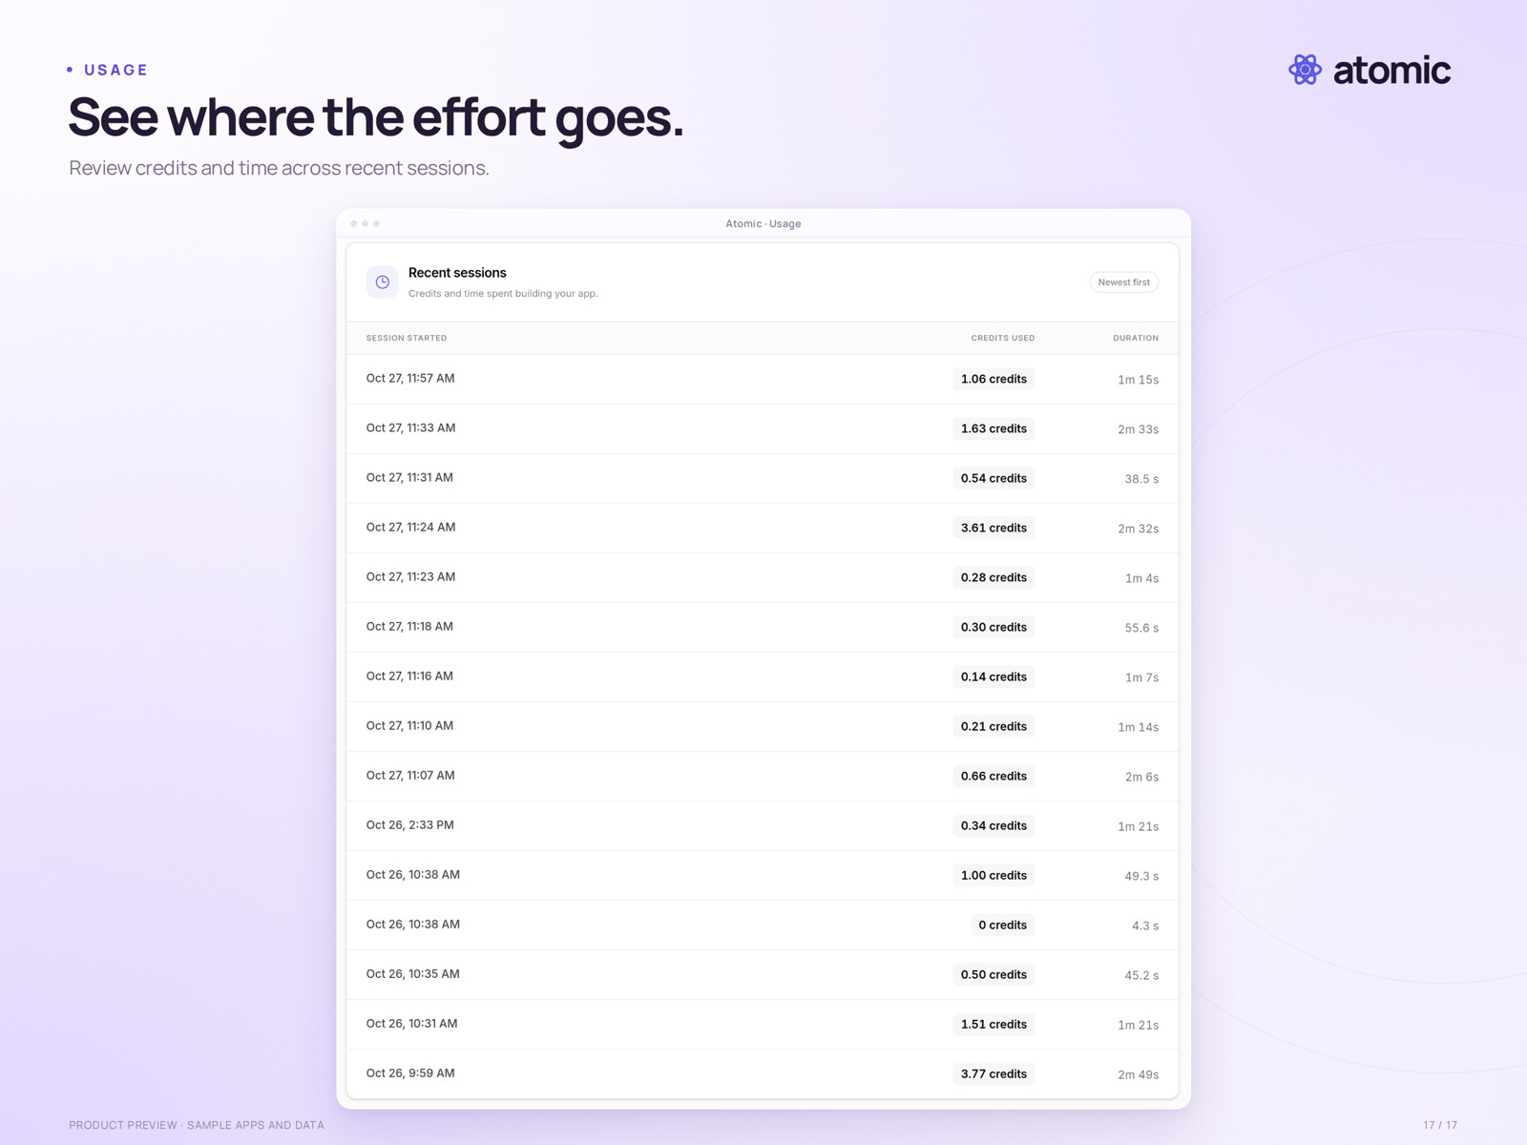
See where the effort goes.
The app usage view lists recent building sessions, credits used and duration. Values come from a local demonstration workspace and do not describe plan entitlements.
Detail crop of a supplied product screenshot, with external branded framing. The full unaltered capture is included in raw/. Local sample data.
Presentation file | 17-usage.png · 2560 × 1920
Clean capture | raw/17-usage.png · 5120 × 2880
Captured | 2026-10-27
Credit | Courtesy of Atomic / Abstract Machines

