Atomic, at a glance.
Facts & reusable copy · Atomic / Abstract Machines · October 2026
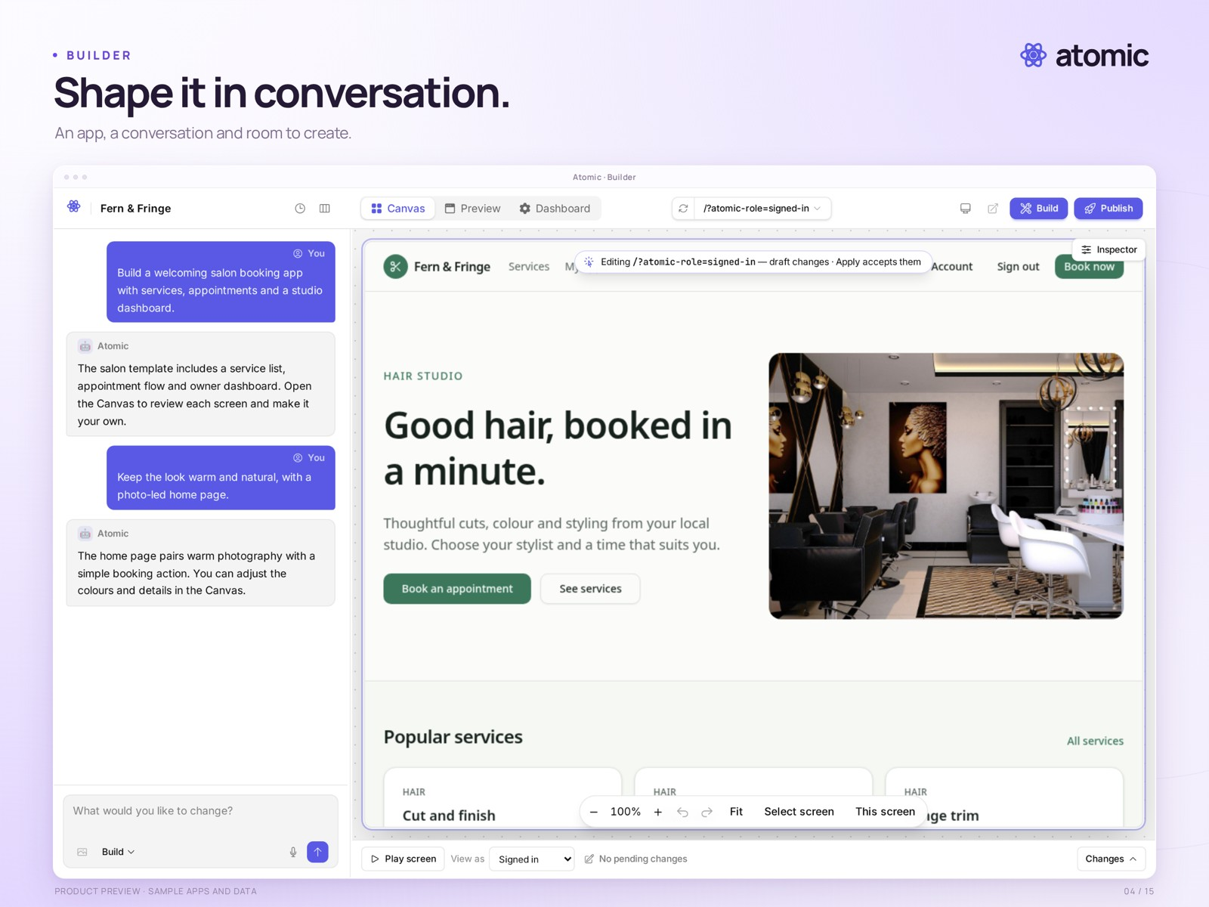
Conversation and a working preview · staged local demonstration
Product | Atomic · AI web-application builder
Company | Abstract Machines · Paris, France
Launch | Tuesday, 3 November 2026
Plans | Free ($0), Builder at $25/month, and Pro at $50/month.
For | Founders, freelancers and small businesses
Examples | Bookings, shops, client portals and internal tools
Media contact | Drasko Draskovic · drasko@absmach.eu

One sentence
Atomic is an AI app builder from Abstract Machines that turns plain-language ideas into web applications, with visual editing, previews, source access and publishing.

Short description
Atomic helps founders, freelancers and small businesses turn an idea into a web application. Start with a prompt or template, refine the result in conversation and on the Canvas, inspect the source, and publish a reviewed version. Atom, the open-source backend from the same team, provides application identities, permissions and data.

Company boilerplate
Abstract Machines is a Paris-based applied AI company building intelligent software and the infrastructure behind it. Its work combines application development, open-source engineering and research across connected systems, identity and confidential computing. Atomic is its AI app builder; Atom is the open-source backend providing identity, permissions and application data.
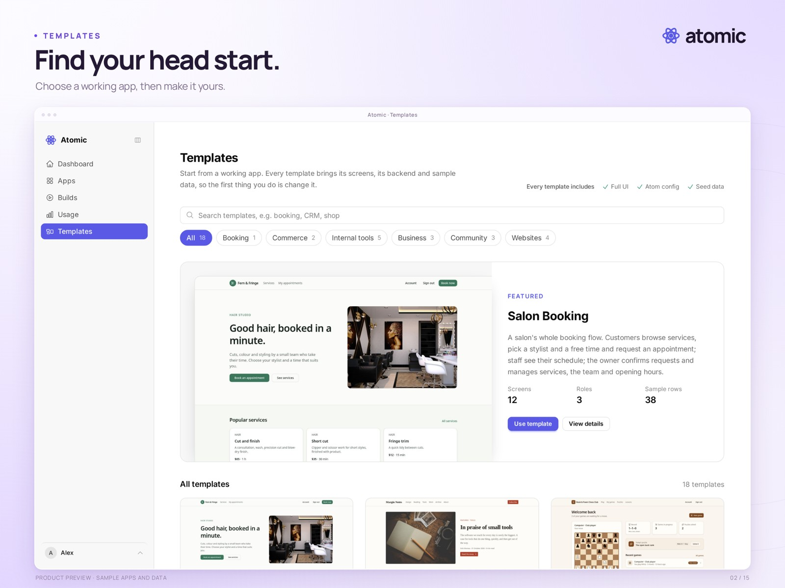
Start from a working template · photo-based sample apps

Names and language
Write “Atomic” for the product and “Abstract Machines” for the company. “Atom” is the backend. Screenshots show sample applications and data; they are not customer claims.

