Questions worth answering.
Press FAQ · Atomic / Abstract Machines · October 2026

What is Atomic?
Atomic helps founders, freelancers and small businesses turn an idea into a web application. Start with a prompt or template, refine the result in conversation and on the Canvas, inspect the source, and publish a reviewed version. Atom, the open-source backend from the same team, provides application identities, permissions and data.

Do I need to know how to code?
You can start by describing what you want to build. Atomic provides a preview and tools for refining it through conversation and visual editing. You should still review and test the workflows before sharing the application.

What can I build?
Typical starting points include booking apps, online shops, client portals and internal tools. Templates provide examples that can be previewed and adapted. The commerce starter workflow records order requests; it does not by itself collect payments.

What does the Canvas do?
The Canvas lets builders navigate screens and states, select elements, adjust styling and leave contextual comments. Whole-app theme controls include colours, shape, spacing and fonts.

Can I work with other people?
Atomic supports shared workspaces and app collaborators. Workspace builders and the people who use a finished app have separate accounts and access flows.

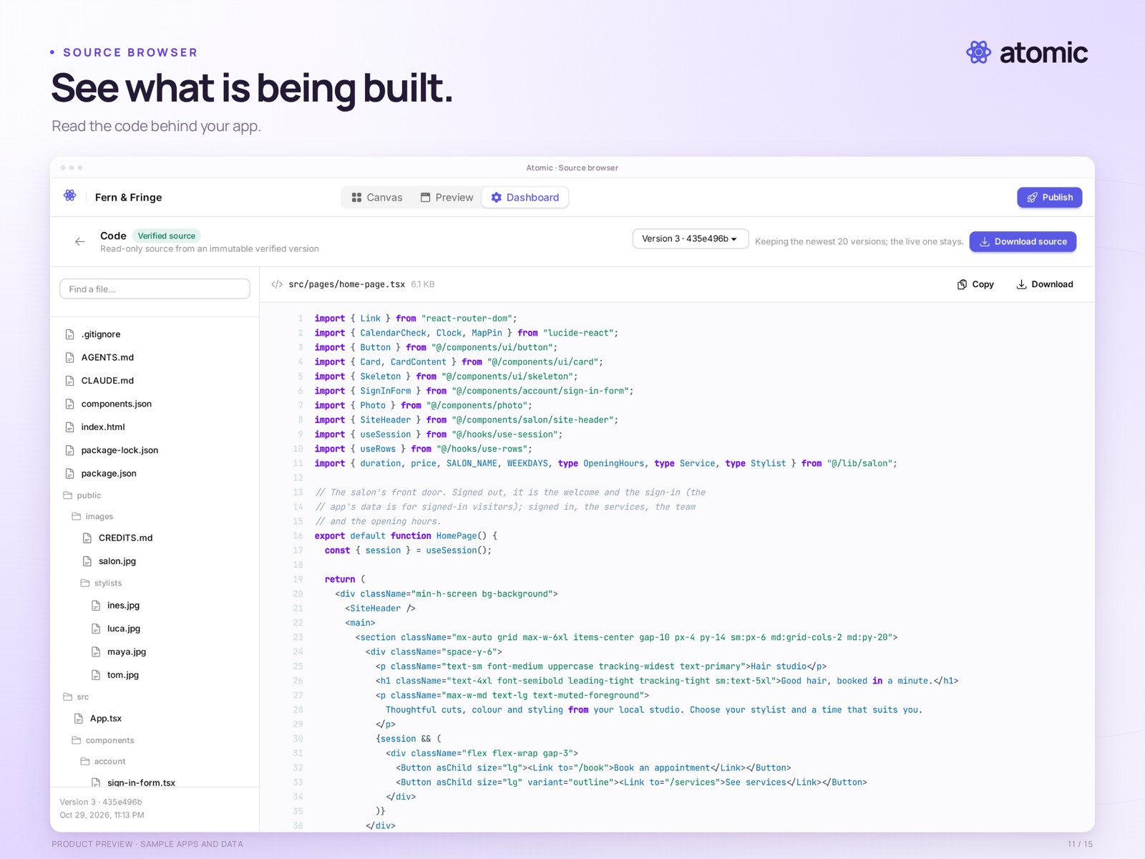
Inspect the generated source · local sample application

Can I inspect and download the code?
Yes. Atomic exposes the generated source and supports source downloads and verified version history. A source archive does not include app users, business data or hosting infrastructure, and is not a complete portable deployment package.

What does “Verified” mean?
It identifies a version that passed Atomic’s configured automated checks, including build and browser smoke checks. It is not a guarantee that every business workflow is correct or that an application has passed an independent security audit.

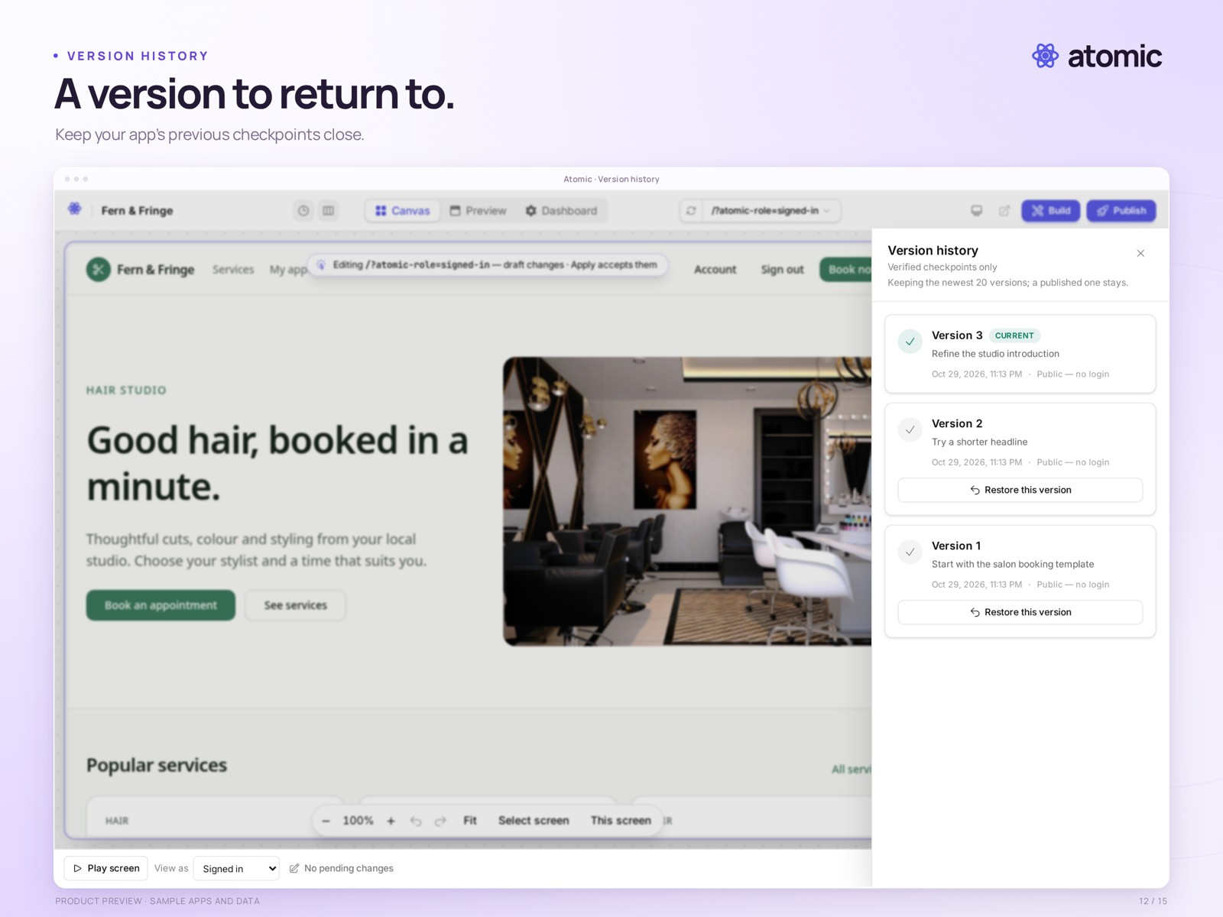
Review earlier checkpoints · compiled local demonstration revisions

Can I restore an earlier version?
Atomic provides source history and publication history. Restoring source and rolling back an application release concern code; they do not restore business data. Publication rollback also depends on compatibility with applied data migrations.

Is Atomic open source?
Atom, the backend used for application identities, permissions and data, is open source. This should not be read as a claim that the Atomic builder itself is open source.

When does it launch, and what will it cost?
Atomic launches Tuesday, 3 November 2026. Launch plans: Free ($0), Builder at $25/month, and Pro at $50/month.

How do I arrange an interview or demo?
Contact Drasko Draskovic at drasko@absmach.eu. General enquiries can also go to info@absmach.eu.

