Product views, with context.
Screenshot captions · Atomic / Abstract Machines · October 2026

Start with an idea.
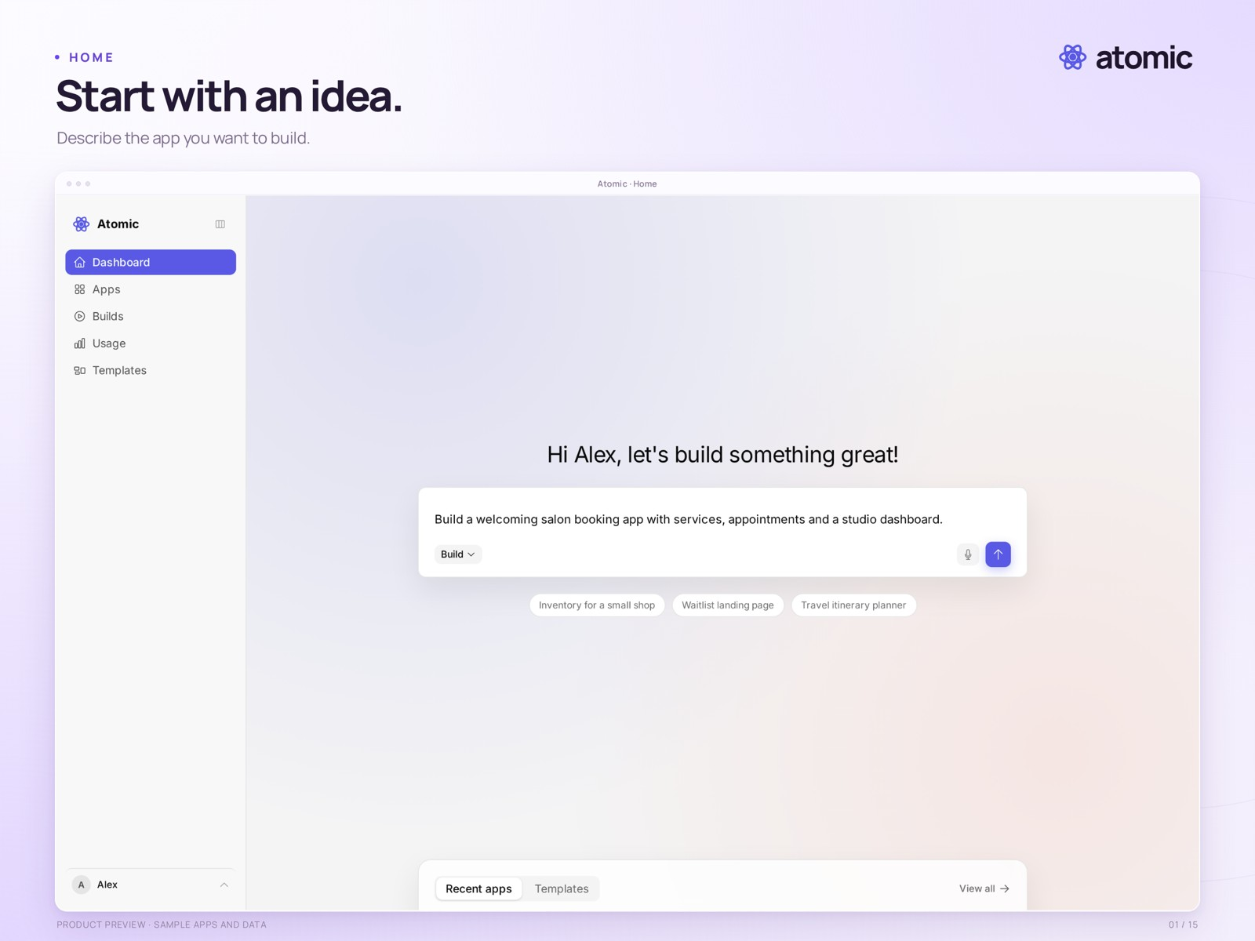
01-home.png
The Atomic home screen with a drafted salon-booking prompt. The prompt has not been submitted.
Real product capture from a local demonstration workspace, with an external branded presentation frame. Sample apps and data. Presentation: 2560 × 1920 pixels.
Clean capture: raw/01-home.png · 2880 × 1800 pixels.

Find your head start.
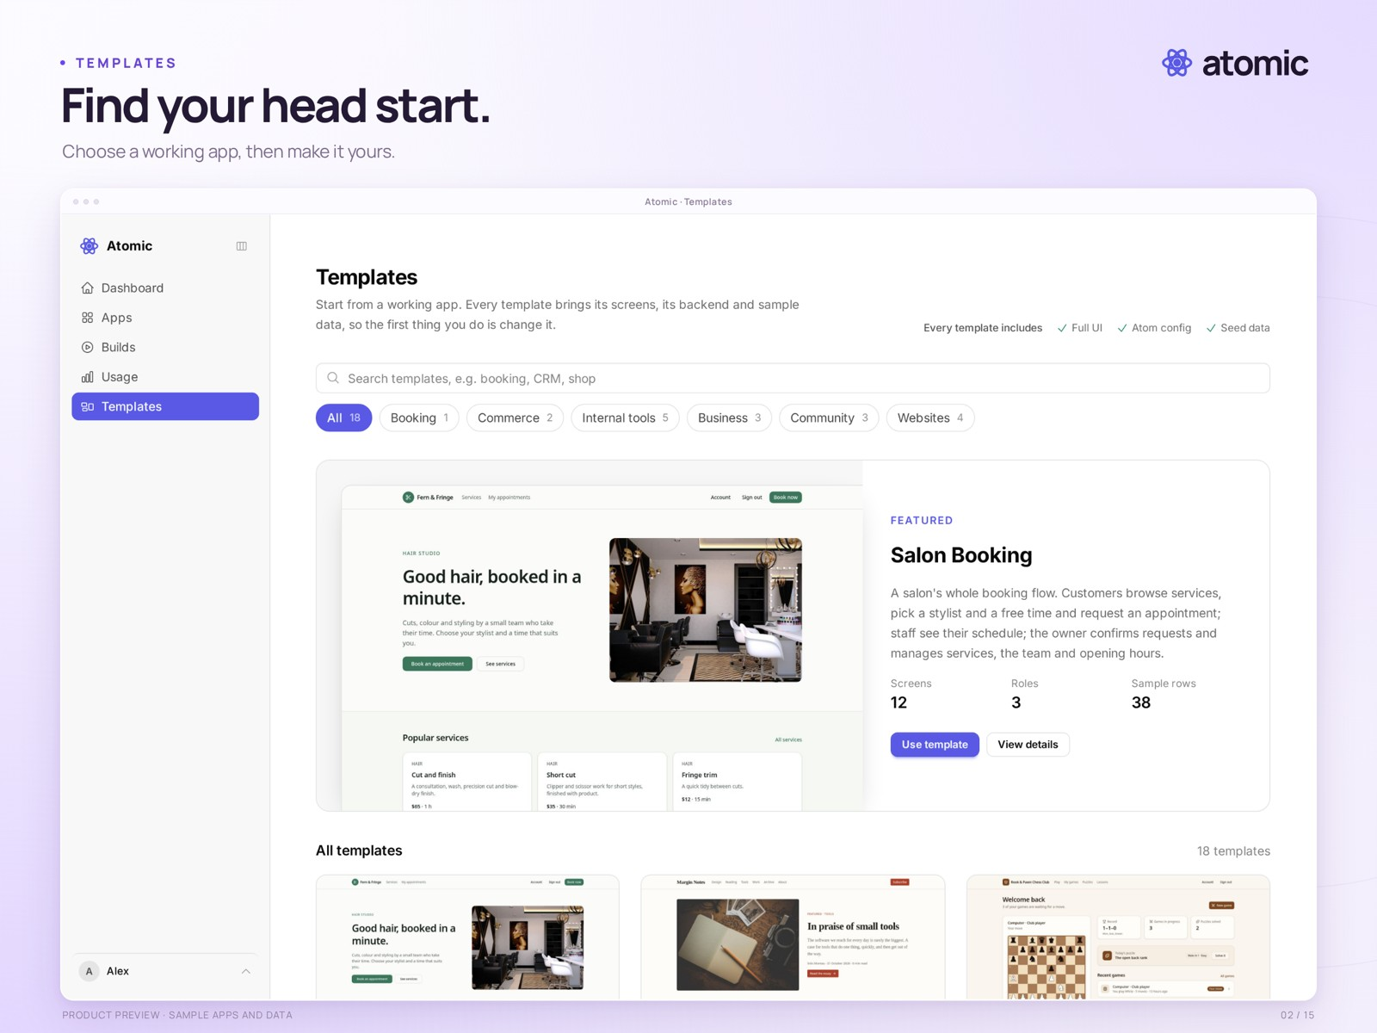
02-templates.png
The template catalogue, including a photo-based salon booking template and other starting points.
Real product capture from a local demonstration workspace, with an external branded presentation frame. Sample apps and data. Presentation: 2560 × 1920 pixels.
Clean capture: raw/02-templates.png · 2880 × 1800 pixels.

Explore before you build.
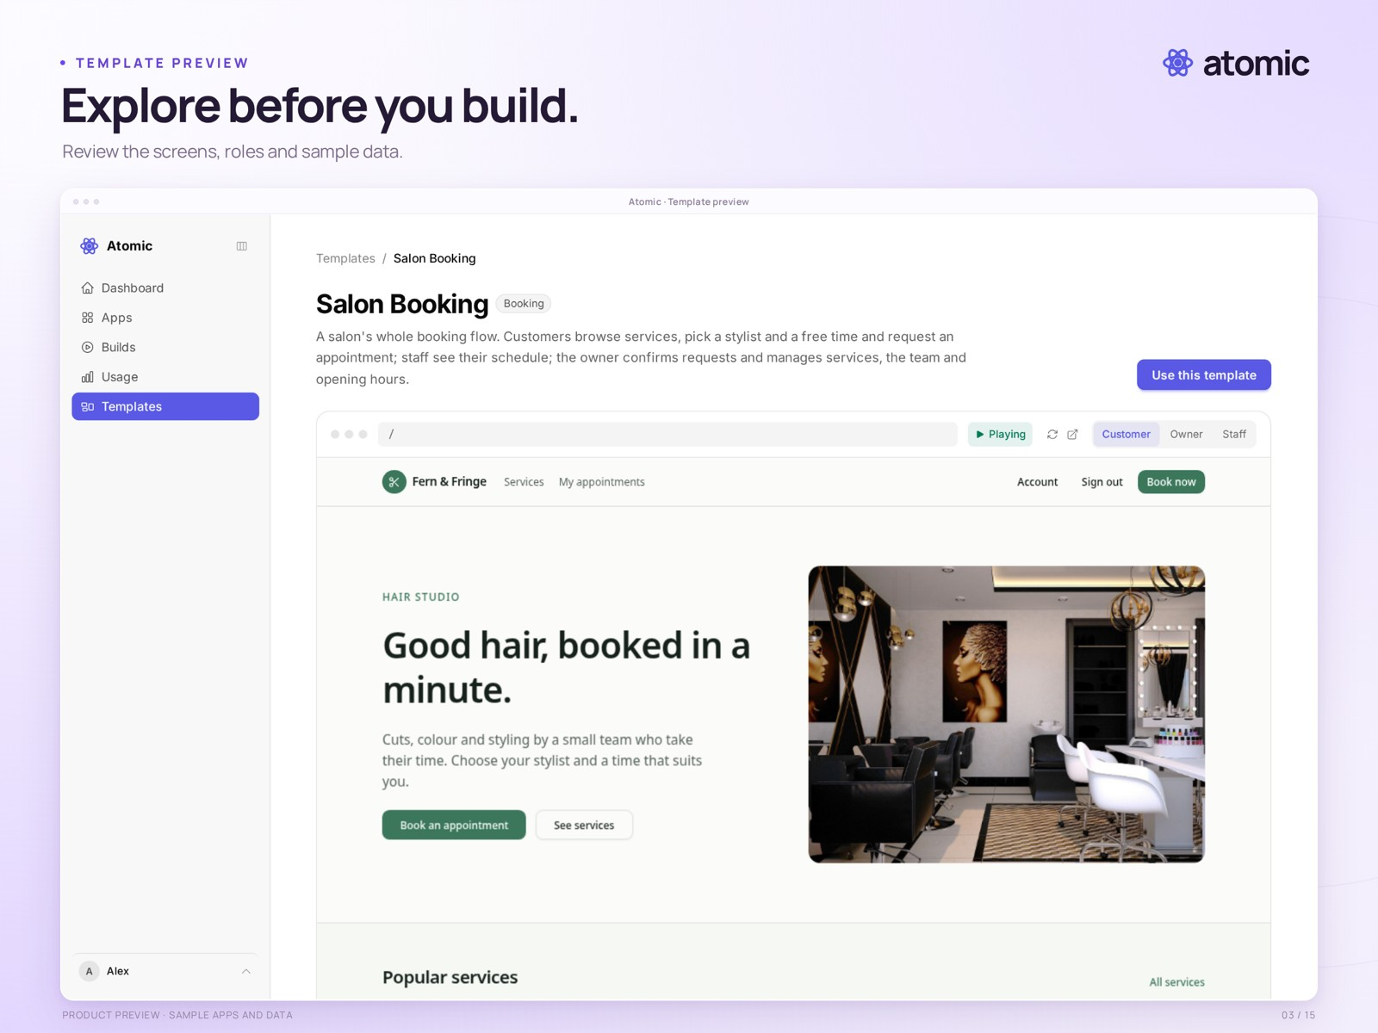
03-template-preview.png
The salon booking template detail page, with its interactive preview and screen navigation.
Real product capture from a local demonstration workspace, with an external branded presentation frame. Sample apps and data. Presentation: 2560 × 1920 pixels.
Clean capture: raw/03-template-preview.png · 2880 × 1800 pixels.

Shape it in conversation.
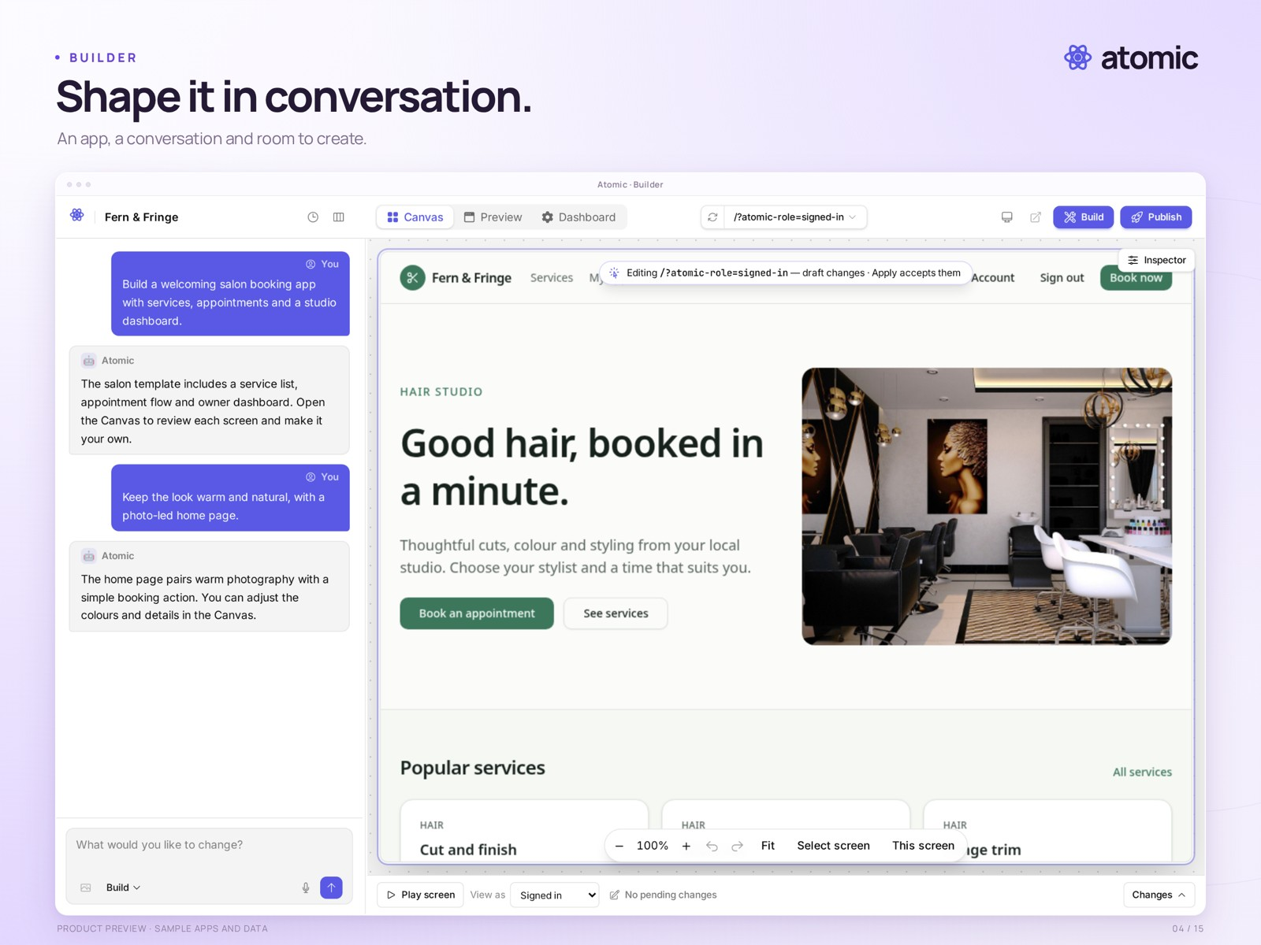
04-builder.png
The builder pairs a sample salon application with a staged demonstration conversation.
Real product capture from a local demonstration workspace, with an external branded presentation frame. Sample apps and data. Presentation: 2560 × 1920 pixels.
Clean capture: raw/04-builder.png · 2880 × 1800 pixels.

Every screen, in view.
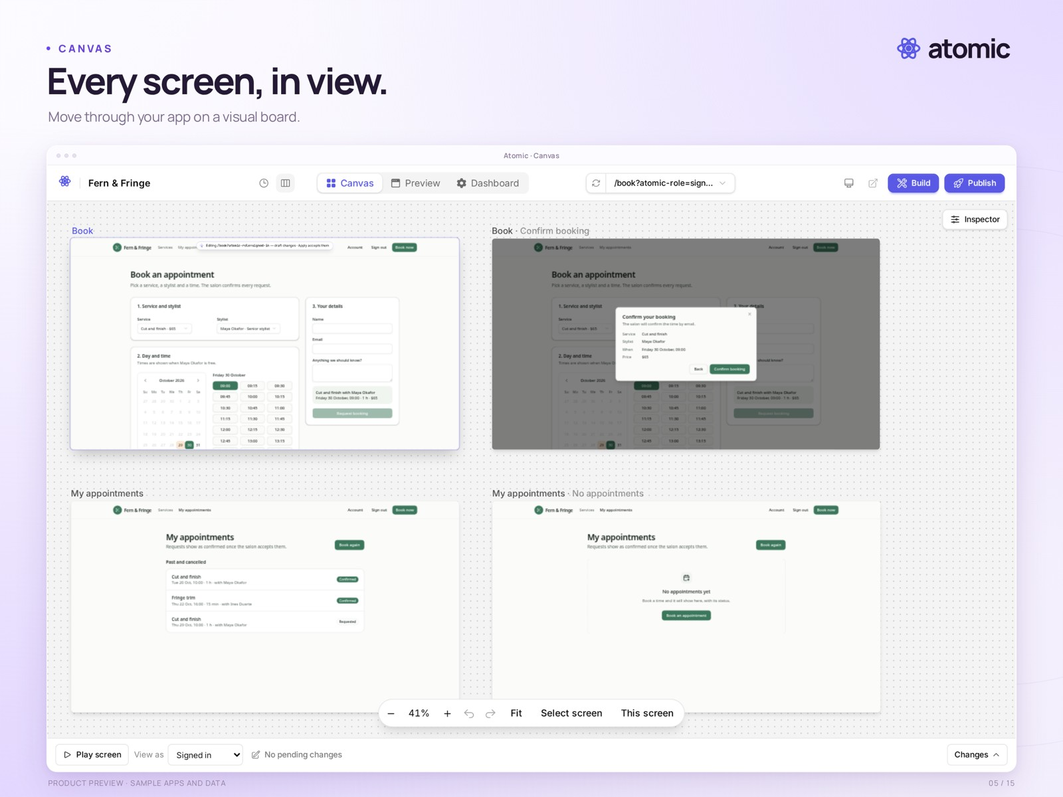
05-canvas.png
The Canvas shows the booking flow, confirmation dialog and appointment screens together at a readable zoom level.
Real product capture from a local demonstration workspace, with an external branded presentation frame. Sample apps and data. Presentation: 2560 × 1920 pixels.
Clean capture: raw/05-canvas.png · 2880 × 1800 pixels.

Make it feel like you.
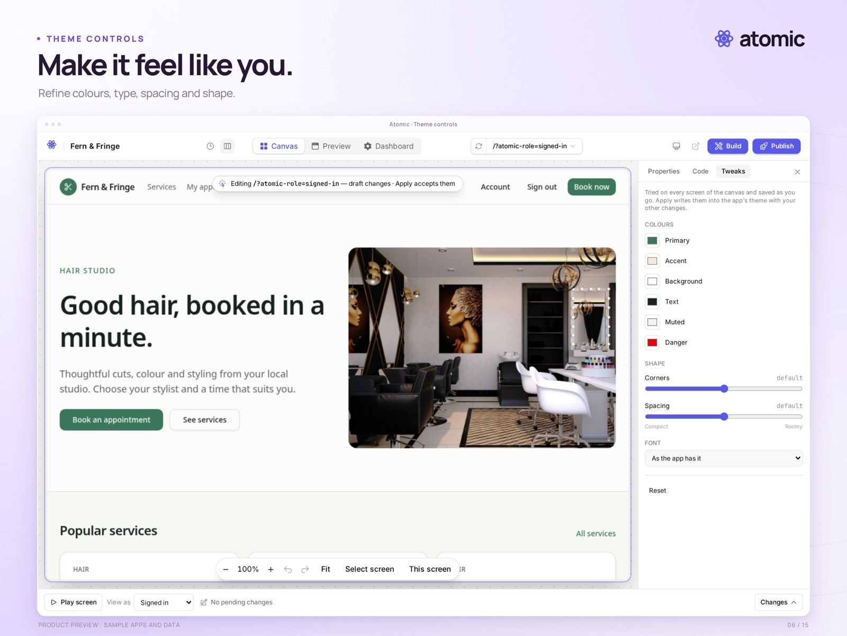
06-theme.png
Whole-app theme controls are open beside the sample app on the Canvas.
Real product capture from a local demonstration workspace, with an external branded presentation frame. Sample apps and data. Presentation: 2560 × 1920 pixels.
Clean capture: raw/06-theme.png · 2880 × 1800 pixels.

Get the details right.
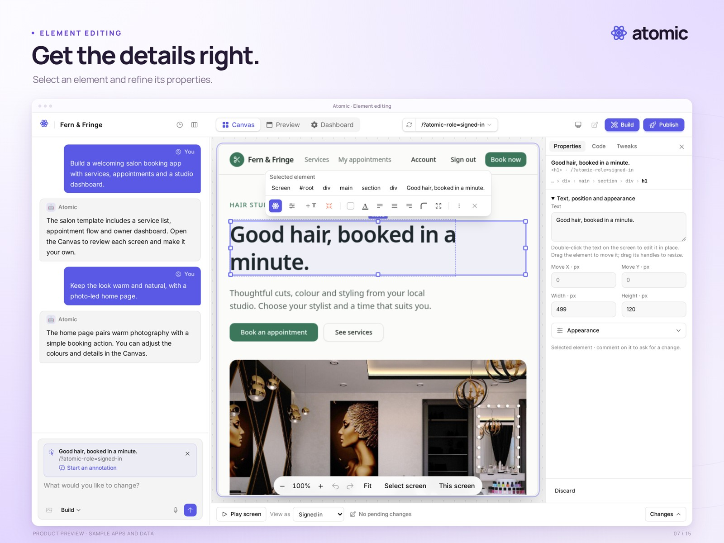
07-element.png
A headline is selected on the Canvas, with the Properties inspector open.
Real product capture from a local demonstration workspace, with an external branded presentation frame. Sample apps and data. Presentation: 2560 × 1920 pixels.
Clean capture: raw/07-element.png · 2880 × 1800 pixels.

Keep feedback in context.
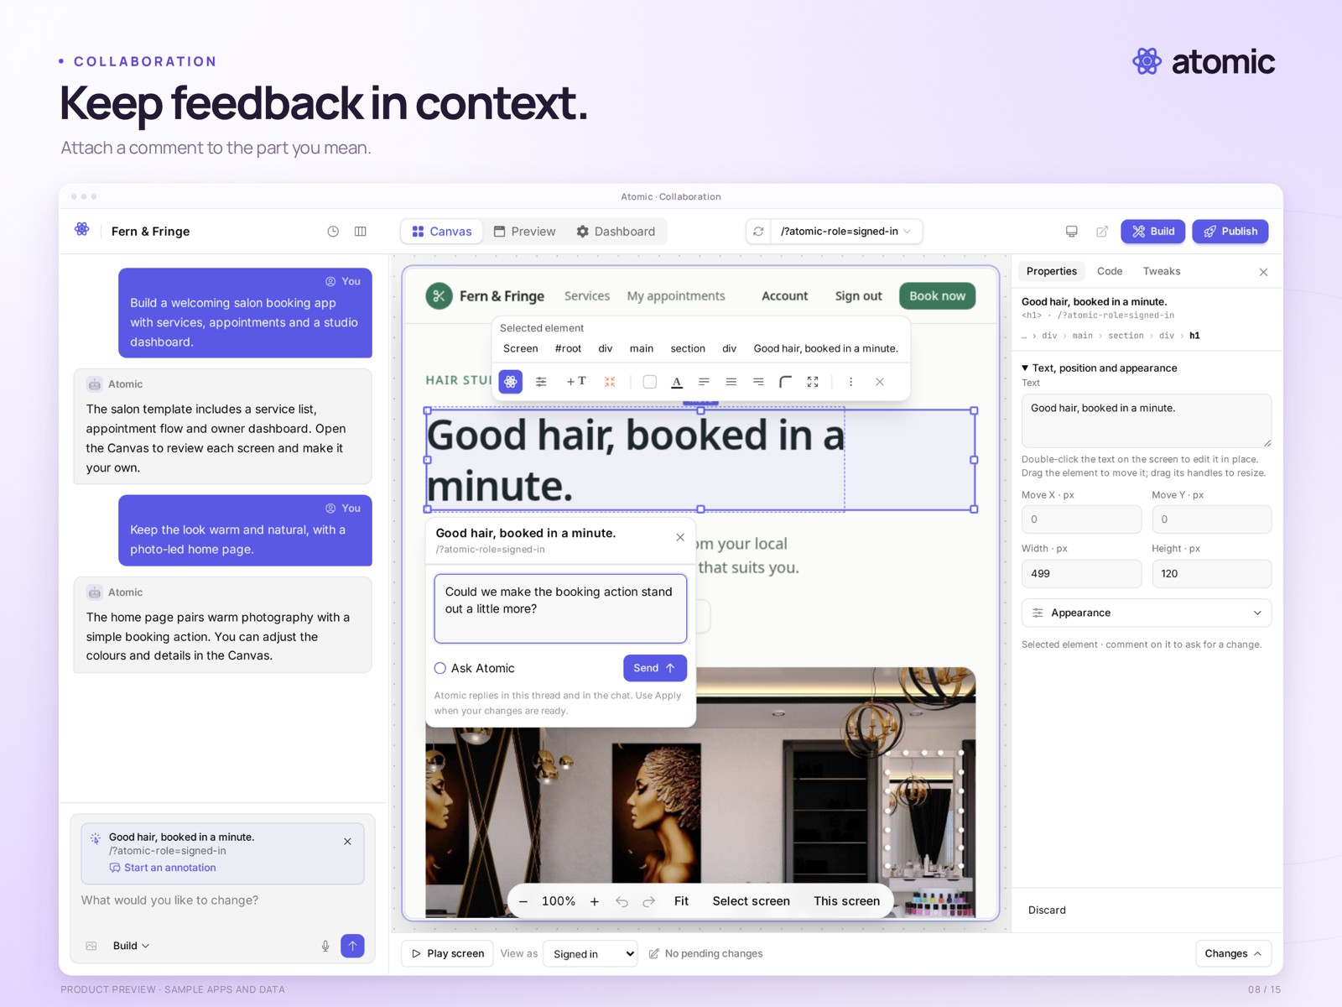
08-collaboration.png
An element-linked comment composer is open on the Canvas. This is an unsent draft; no AI change has been requested.
Real product capture from a local demonstration workspace, with an external branded presentation frame. Sample apps and data. Presentation: 2560 × 1920 pixels.
Clean capture: raw/08-collaboration.png · 2880 × 1800 pixels.

Your apps, together.
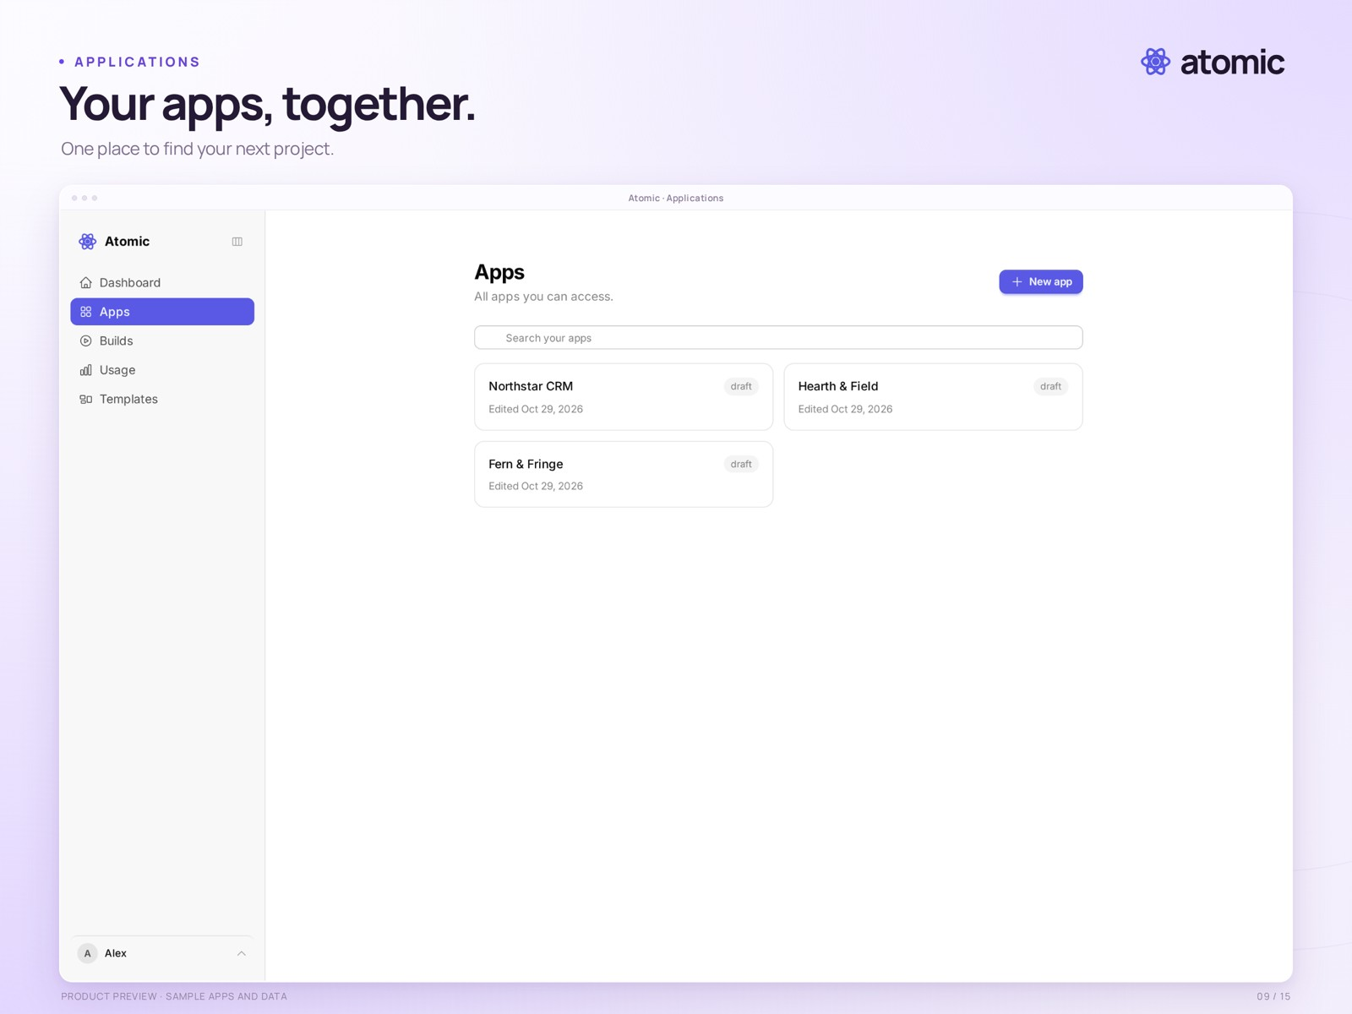
09-applications.png
The applications list shows three local sample projects: Fern & Fringe, Hearth & Field and Northstar CRM.
Real product capture from a local demonstration workspace, with an external branded presentation frame. Sample apps and data. Presentation: 2560 × 1920 pixels.
Clean capture: raw/09-applications.png · 2880 × 1800 pixels.

Know where you stand.
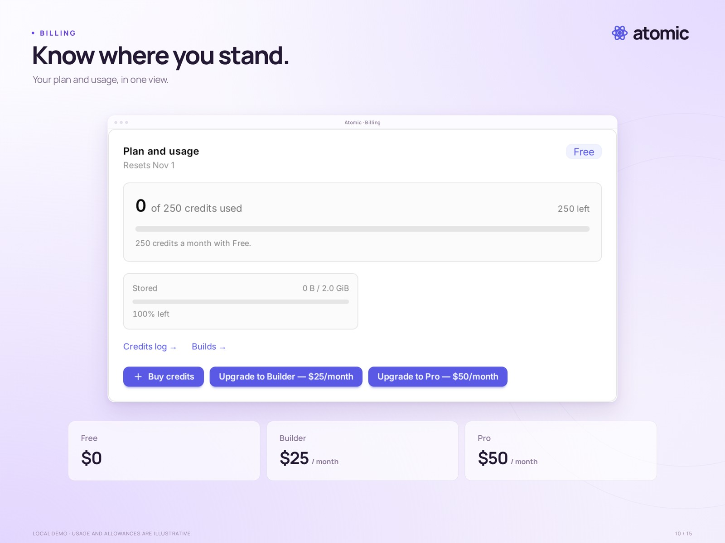
10-billing.png
The account billing panel shows plan, credits, storage and upgrade controls. This is a local demo account; usage and allowances are illustrative, not confirmed launch entitlements.
Real product capture from a local demonstration workspace, with an external branded presentation frame. Sample apps and data. Presentation: 2560 × 1920 pixels.
Clean capture: raw/10-billing.png · 1424 × 764 pixels.

See what is being built.
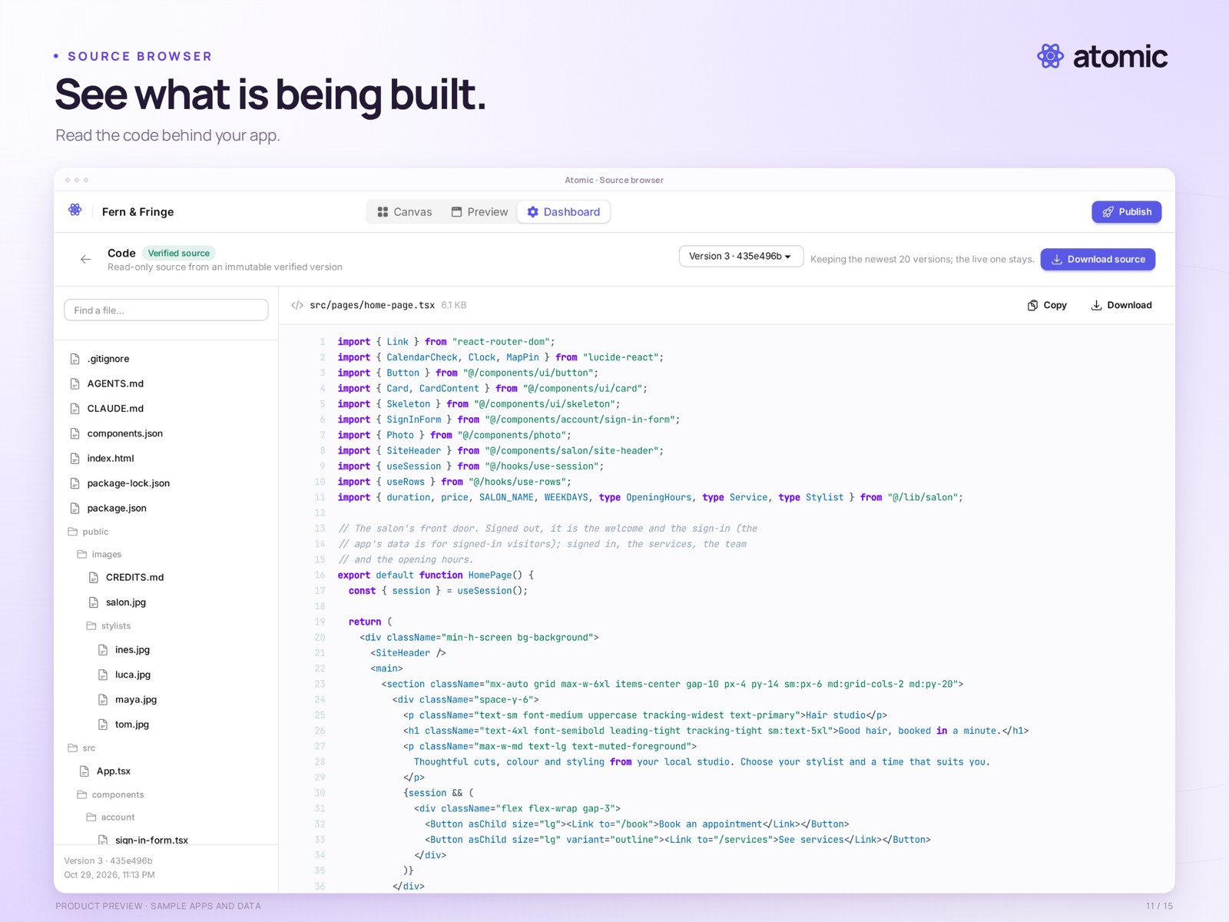
11-source.png
The source browser displays the sample app’s home-page component, file tree and version selector. Source downloads exclude users, business data and hosting infrastructure.
Real product capture from a local demonstration workspace, with an external branded presentation frame. Sample apps and data. Presentation: 2560 × 1920 pixels.
Clean capture: raw/11-source.png · 2880 × 1800 pixels.

A version to return to.
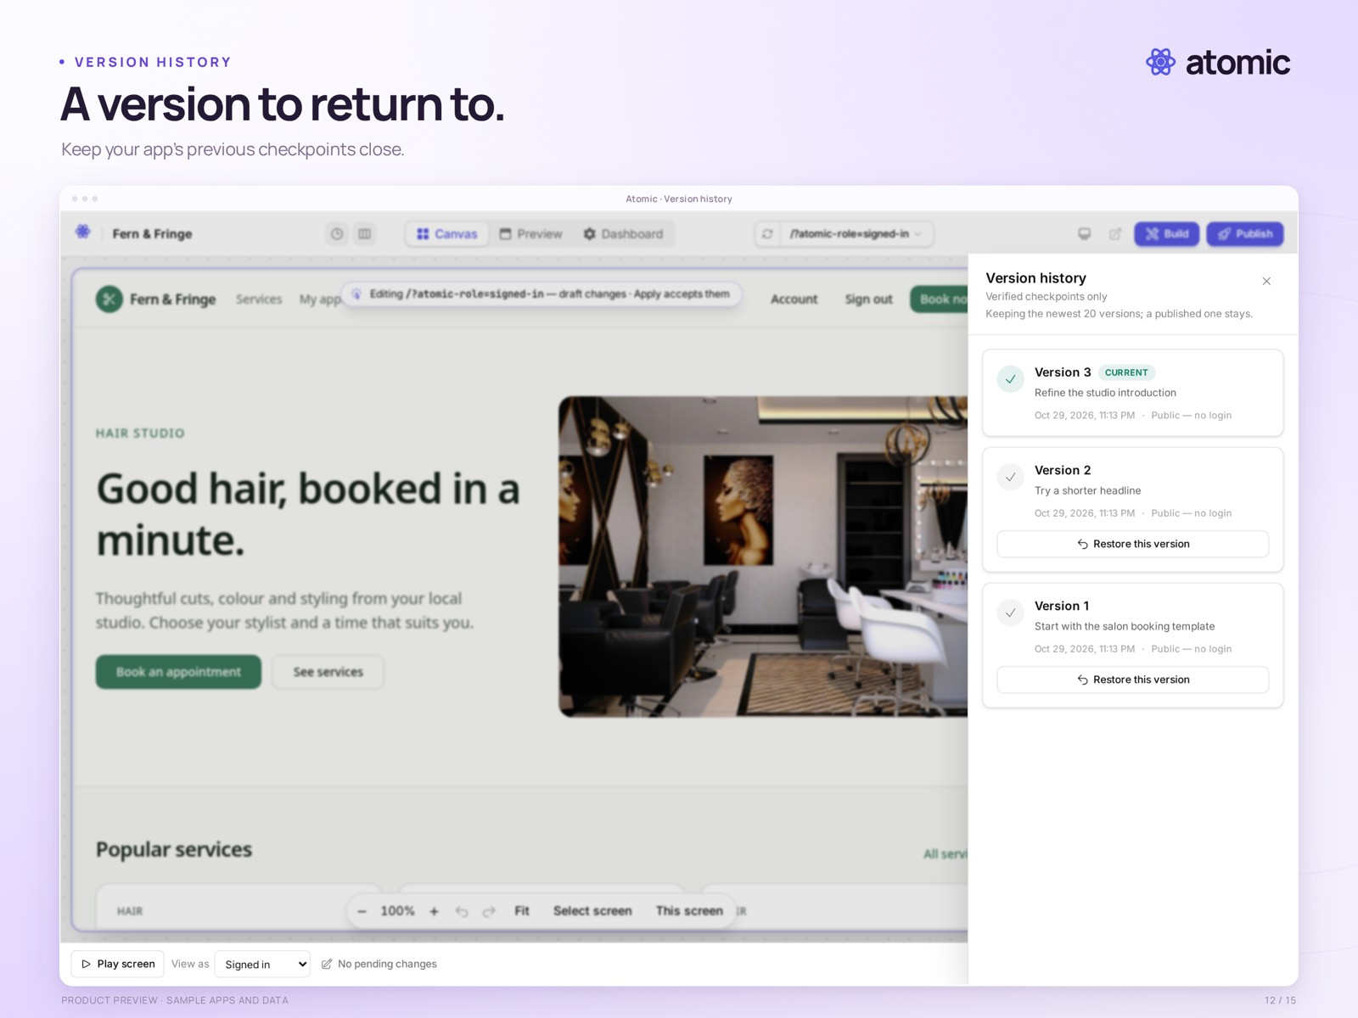
12-versions.png
Version history shows locally prepared sample revisions. These are compiled demonstration checkpoints; the capture does not show a restore being performed.
Real product capture from a local demonstration workspace, with an external branded presentation frame. Sample apps and data. Presentation: 2560 × 1920 pixels.
Clean capture: raw/12-versions.png · 2880 × 1800 pixels.

Put your app in order.
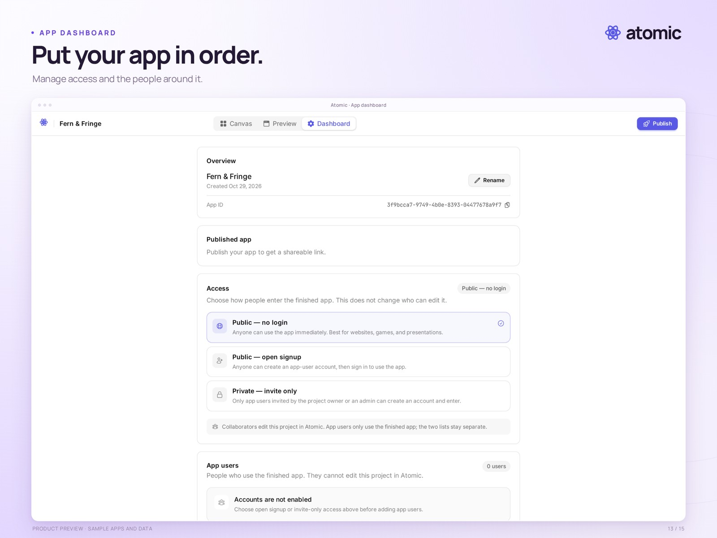
13-dashboard.png
The app dashboard shows publication, access and app-user settings for the local salon demo. The app has not been publicly deployed.
Real product capture from a local demonstration workspace, with an external branded presentation frame. Sample apps and data. Presentation: 2560 × 1920 pixels.
Clean capture: raw/13-dashboard.png · 2880 × 1800 pixels.

From idea to experience.
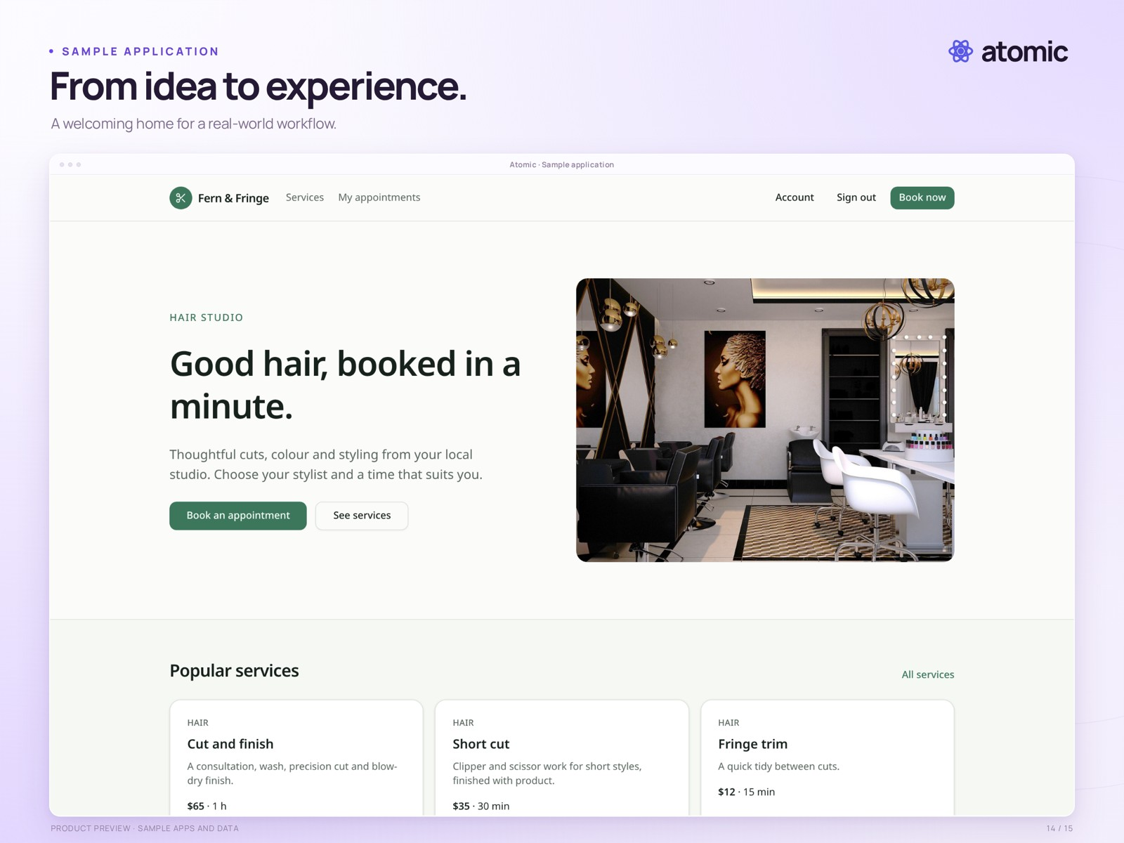
14-salon-app.png
Fern & Fringe, a photo-based sample salon application, shown as a standalone preview with local demonstration data.
Real local sample-app preview with external branded framing. Business names, photographs and content illustrate the template; they are not customer claims. Presentation: 2560 × 1920 pixels.
Clean capture: raw/14-salon-app.png · 2880 × 1800 pixels.

Made for smaller screens.
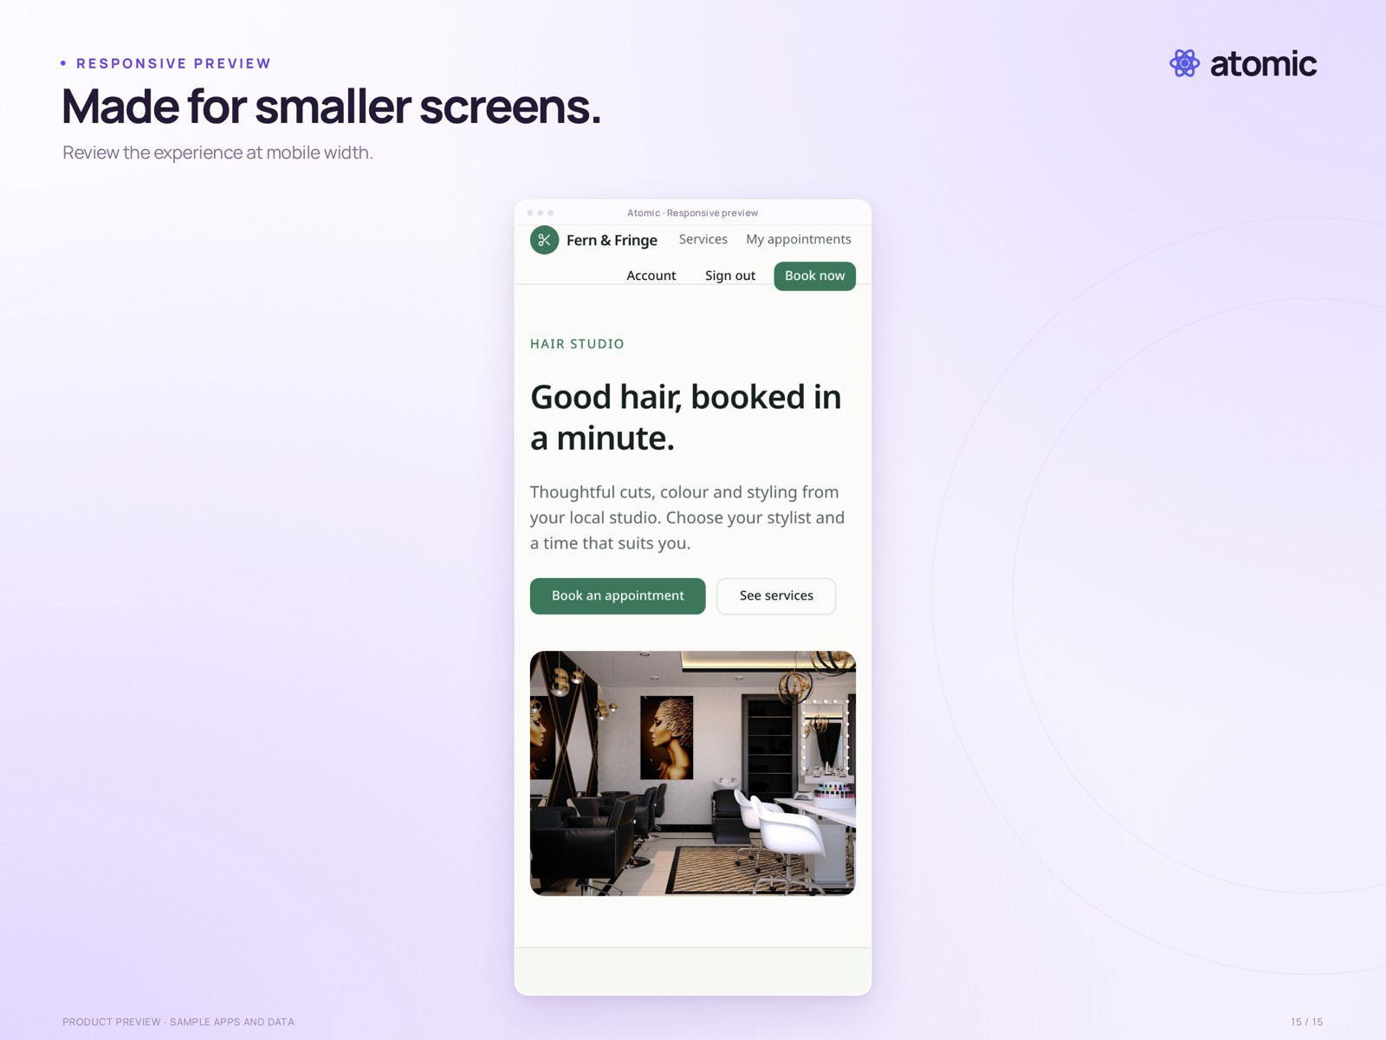
15-responsive.png
The sample salon application at a 390-pixel mobile viewport. This is a responsive web-app preview, not a native mobile-app export.
Real local sample-app preview with external branded framing. Business names, photographs and content illustrate the template; they are not customer claims. Presentation: 2560 × 1920 pixels.
Clean capture: raw/15-responsive.png · 780 × 1688 pixels.

