Meet the people behind Atomic.
People · Atomic / Abstract Machines · Updated 30 October 2026 · atomicapp.dev
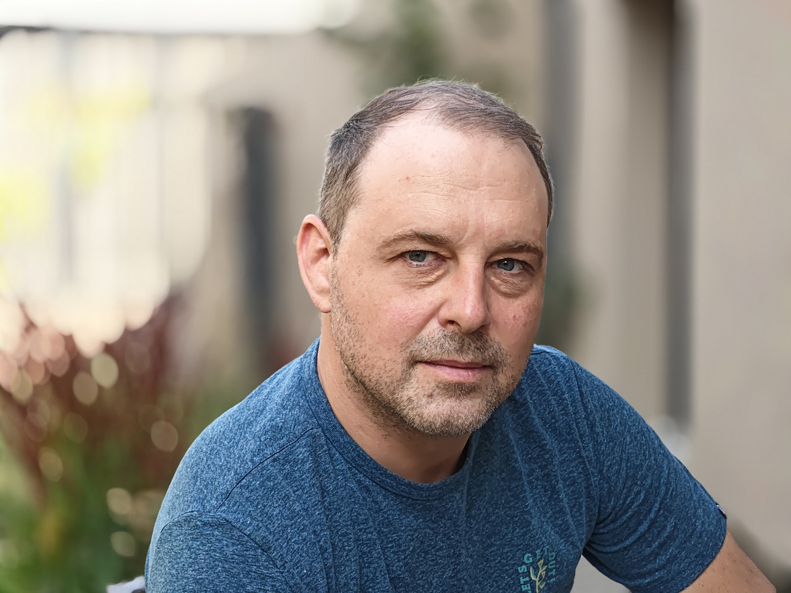
Drasko Draskovic · Founder & CEO

Drasko Draskovic
Founder & CEO · Paris, France
Drasko Draskovic is the founder of Abstract Machines and the founder and CEO behind Atomic. A deep-tech entrepreneur and systems engineer, he brings more than 20 years of experience in IoT and cloud-computing systems. His background includes work at Texas Instruments, Alcatel-Lucent, Nokia, Sequans and Devialet. He co-founded Datapace with George Saleh as an internal venture at Nokia, where he served as CTO. His work spans open-source infrastructure and the identity, data and execution systems that support applications.

Short bio
Drasko Draskovic is the founder of Abstract Machines and the founder and CEO behind Atomic. He is a systems engineer and entrepreneur with more than 20 years of experience in IoT and cloud computing.

Interview topics
- Taking an app from a plain-language idea through Canvas editing to a reviewed release.
- Why application identity, permissions and data matter in AI app building.
- Source visibility and open-source infrastructure.
Drasko Draskovic · Founder & CEO
drasko@absmach.eu · General enquiries: info@absmach.eu
atomicapp.dev

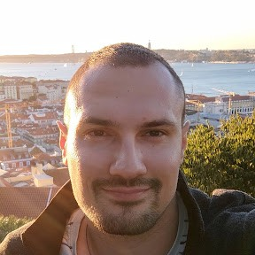

Dusan Borovcanin
Technical leadership
Dusan Borovcanin is Tech Lead at Abstract Machines, with more than 10 years of experience in distributed systems. His work includes confidential-computing infrastructure for AI and the engineering foundations behind Atomic. He previously built cocos-ai alongside Drasko Draskovic at Ultraviolet.
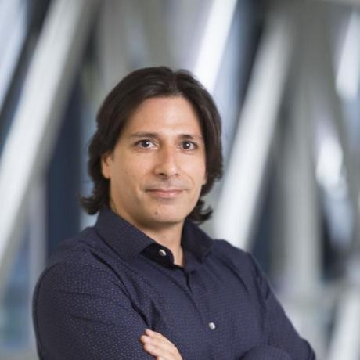

George Saleh
Finance & Operations
George Saleh leads finance and operations for Atomic. He brings more than 27 years of technology-leadership experience spanning AI, blockchain, enterprise architecture and digital transformation. He co-founded Datapace with Drasko Draskovic as an internal venture at Nokia. His background includes Distinguished Member of Technical Staff standing at Nokia.

Portraits included
Drasko Draskovic | 4096 × 3072 JPEG · original supplied photograph
Dusan Borovcanin | 288 × 288 PNG · supplied profile portrait
George Saleh | 460 × 460 JPEG · supplied profile portrait
Portraits are supplied at their original resolution. Dusan’s and George’s files are suitable for small digital placements; ask the press contact for larger publication requirements. Suggested credit: Courtesy of Abstract Machines. Photographer names were not supplied.

Pair portraits with the product story
Introduce Atomic with the main page, followed by the builder, Canvas editing, publishing, request logs and source access. The current 35-second launch film and matching covers are available in the press room. Portraits remain the supplied originals.
atomicapp.dev · Press room and complete media kit

