Evergreen social copy.
Social copy · Atomic / Abstract Machines · Updated 30 October 2026 · atomicapp.dev
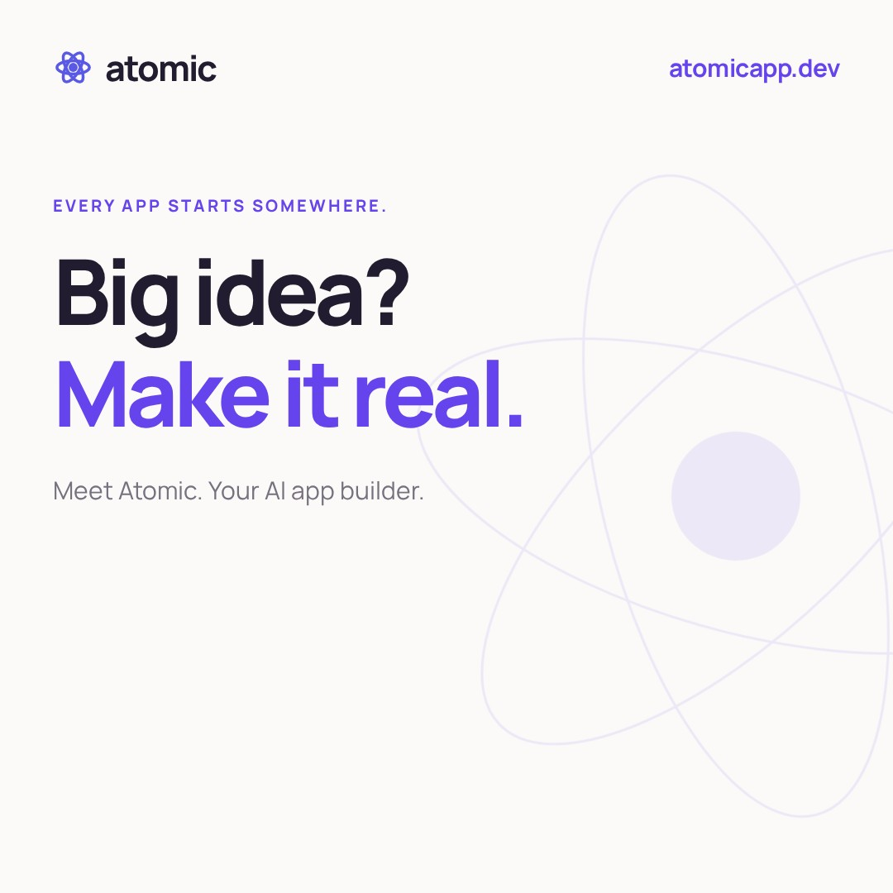
Launch cover · square · “Big idea? Make it real.”

LinkedIn
A booking app for your business. A portal for your clients. An idea you want to explore.
Atomic helps you get started with a prompt or template, refine the result through conversation and visual editing, and publish an app you’ve reviewed.
Watch the workflow in 35 seconds.
Big idea? Make it real.
atomicapp.dev
What would you build?
#Atomic #BuildWithAI

Pair with this media
atomic-launch-square.mp4 · 1080 × 1080 · 35 seconds
atomic-launch-square-cover.png · matching opening cover
Upload the MP4 with its matching cover where supported. The film already includes English captions. Keep the website link in the post.

Launch cover · square · “Big idea? Make it real.”

X / Twitter
Your idea. Your app.
Start with a prompt or template. Shape it with AI. Review it. Publish it.
Big idea? Make it real.
atomicapp.dev

Pair with this media
atomic-launch-square.mp4 · 1080 × 1080 · 35 seconds
atomic-launch-square-cover.png · matching opening cover

Alternative short copy
That app you keep thinking about?
Make it real with Atomic.
From your first prompt to the finishing touches.
atomicapp.dev
The square file is shared with LinkedIn. Use one of these captions with the uploaded video. English captions are built into the film.

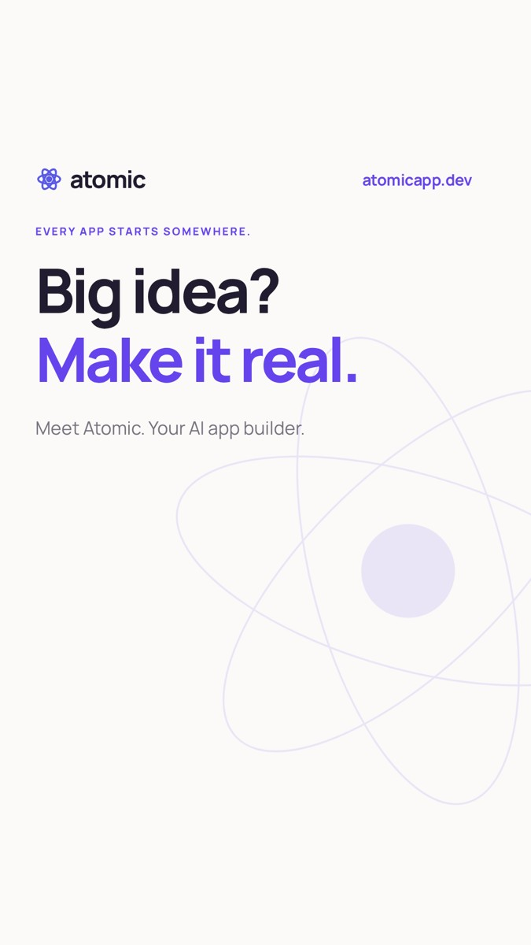
Launch cover · vertical · “Big idea? Make it real.”

Instagram Reels
Big idea? Make it real.
From your first prompt to the finishing touches.
Build with Atomic.
atomicapp.dev
What would you build?
#Atomic #BuildWithAI

Pair with this media
atomic-launch-vertical.mp4 · 1080 × 1920 · 35 seconds
atomic-launch-vertical-cover.png · matching opening cover
Choose the prepared vertical cover and review its crop before posting. The film includes English captions. Keep the website address in the caption and relevant profile link.

