Your idea. A working app.
Product overview · Atomic / Abstract Machines · October 2026
Atomic is an AI app builder from Abstract Machines that turns plain-language ideas into web applications, with visual editing, previews, source access and publishing.
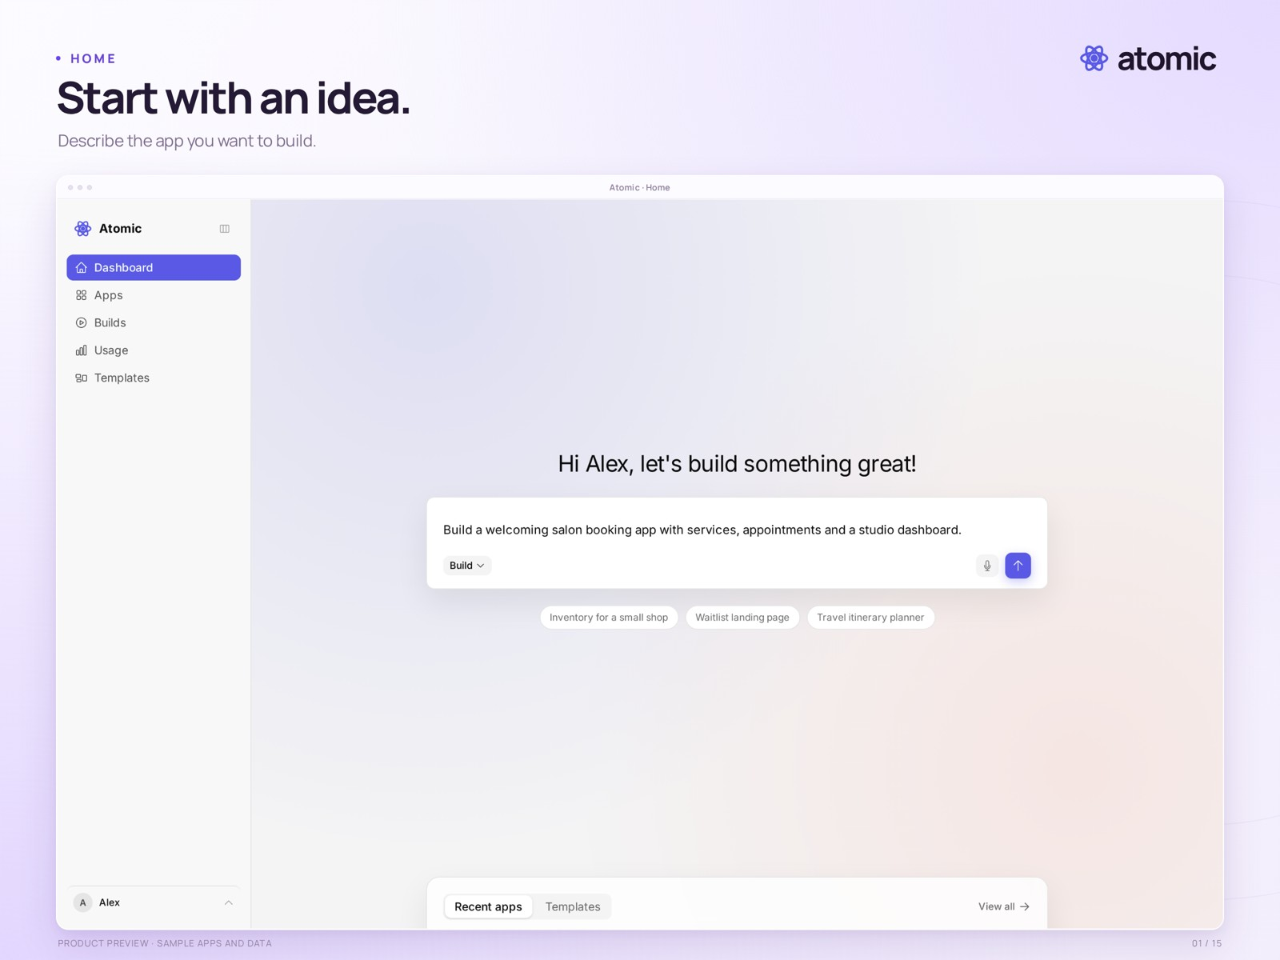
Start with a description · draft prompt in a local demo workspace

An idea is all it takes
Describe your app or choose a template. Review the result, shape the details and publish a version you have checked.

Built for your next project
For founders, freelancers and small businesses creating booking apps, shops, client portals and internal tools.

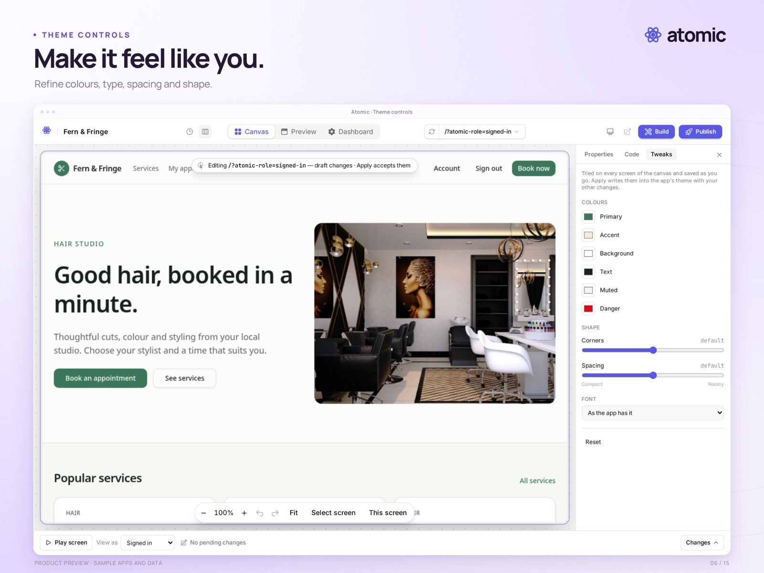
Shape the app on the Canvas · sample salon application

From the first draft to the details
- Refine the app through conversation and visual editing.
- Navigate its screens, adjust selected elements and tune the whole-app theme.
- Leave feedback in context; work with teammates.
- Inspect source, revisit versions and publish a reviewed release.
Atom provides identities, permissions and application data. Source downloads include code, not app users, business data or hosting infrastructure.

