Your idea. A working app.
Product overview · Atomic / Abstract Machines · Updated 30 October 2026 · atomicapp.dev
Atomic is an AI app builder from Abstract Machines that turns plain-language ideas into web applications, with visual editing, previews, source access and publishing.
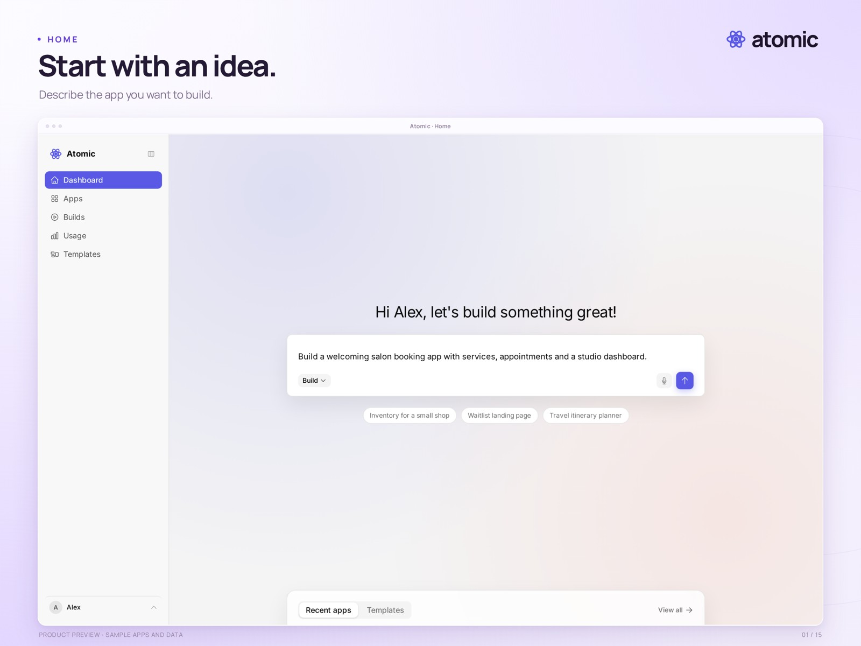
The Atomic home screen · a drafted prompt in a sample workspace

Start with the app you have in mind
Describe a booking service, shop, client portal or internal tool. Start from your own words or explore a working template, then review and refine the result.
atomicapp.dev · Press room and complete media kit

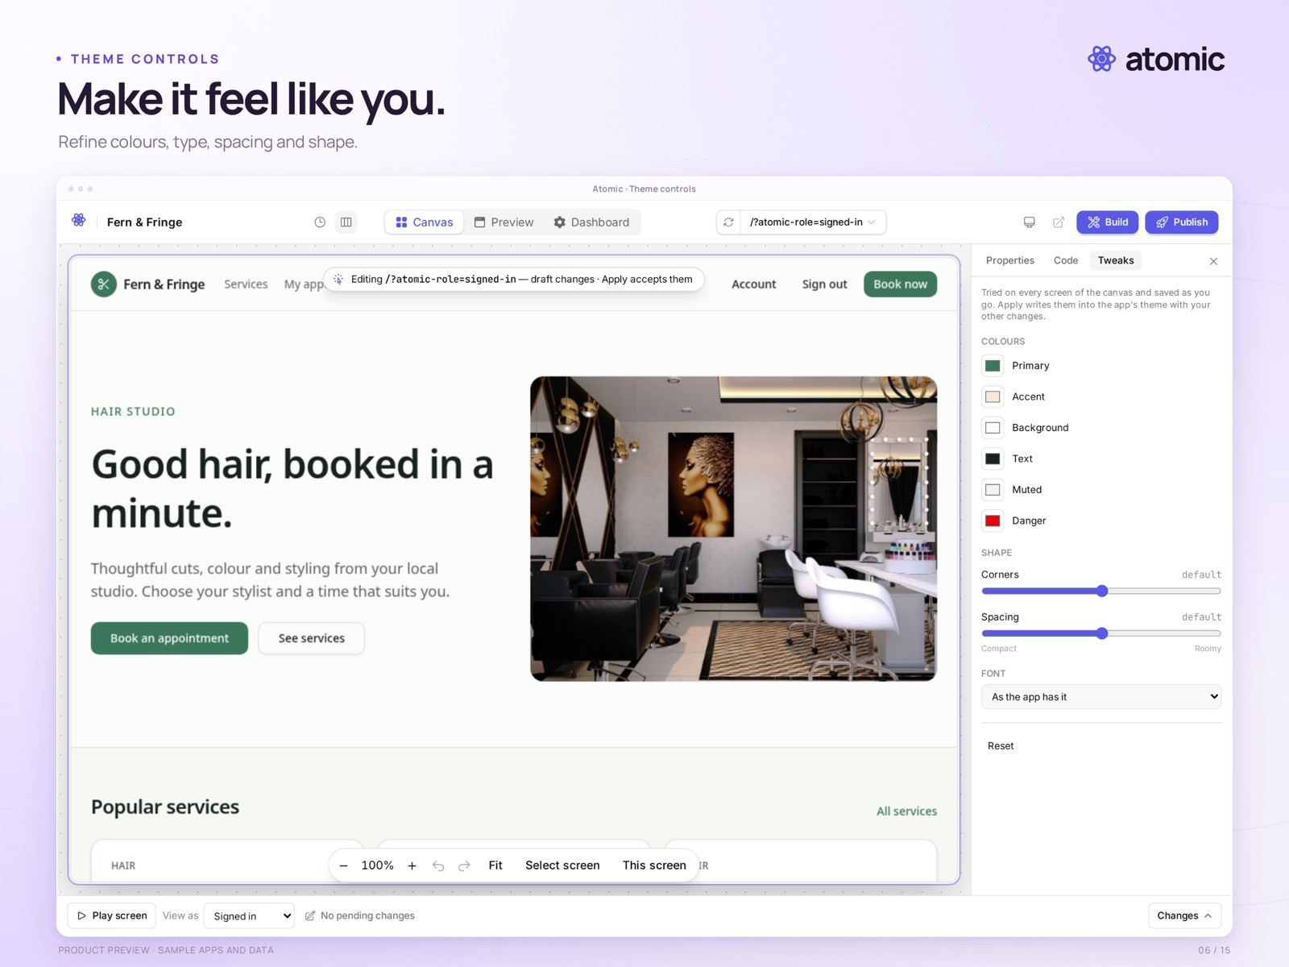
Canvas theme controls · shape the appearance of a sample salon app

Describe. Shape. Publish.
- Build and refine through conversation; preview the result as you work.
- Explore screens on the Canvas, edit selected elements and tune colours, type, spacing and shape.
- Leave feedback in context and collaborate with your team.
- Inspect source and version history, then publish a release you have reviewed.
Atom provides identities, permissions and application data. A source download contains code; it does not export app users, business data or hosting infrastructure.
Watch the 35-second launch film · Square and vertical versions are available in the press room.

