The current product gallery.
Screenshot captions · Atomic / Abstract Machines · Updated 30 October 2026 · atomicapp.dev
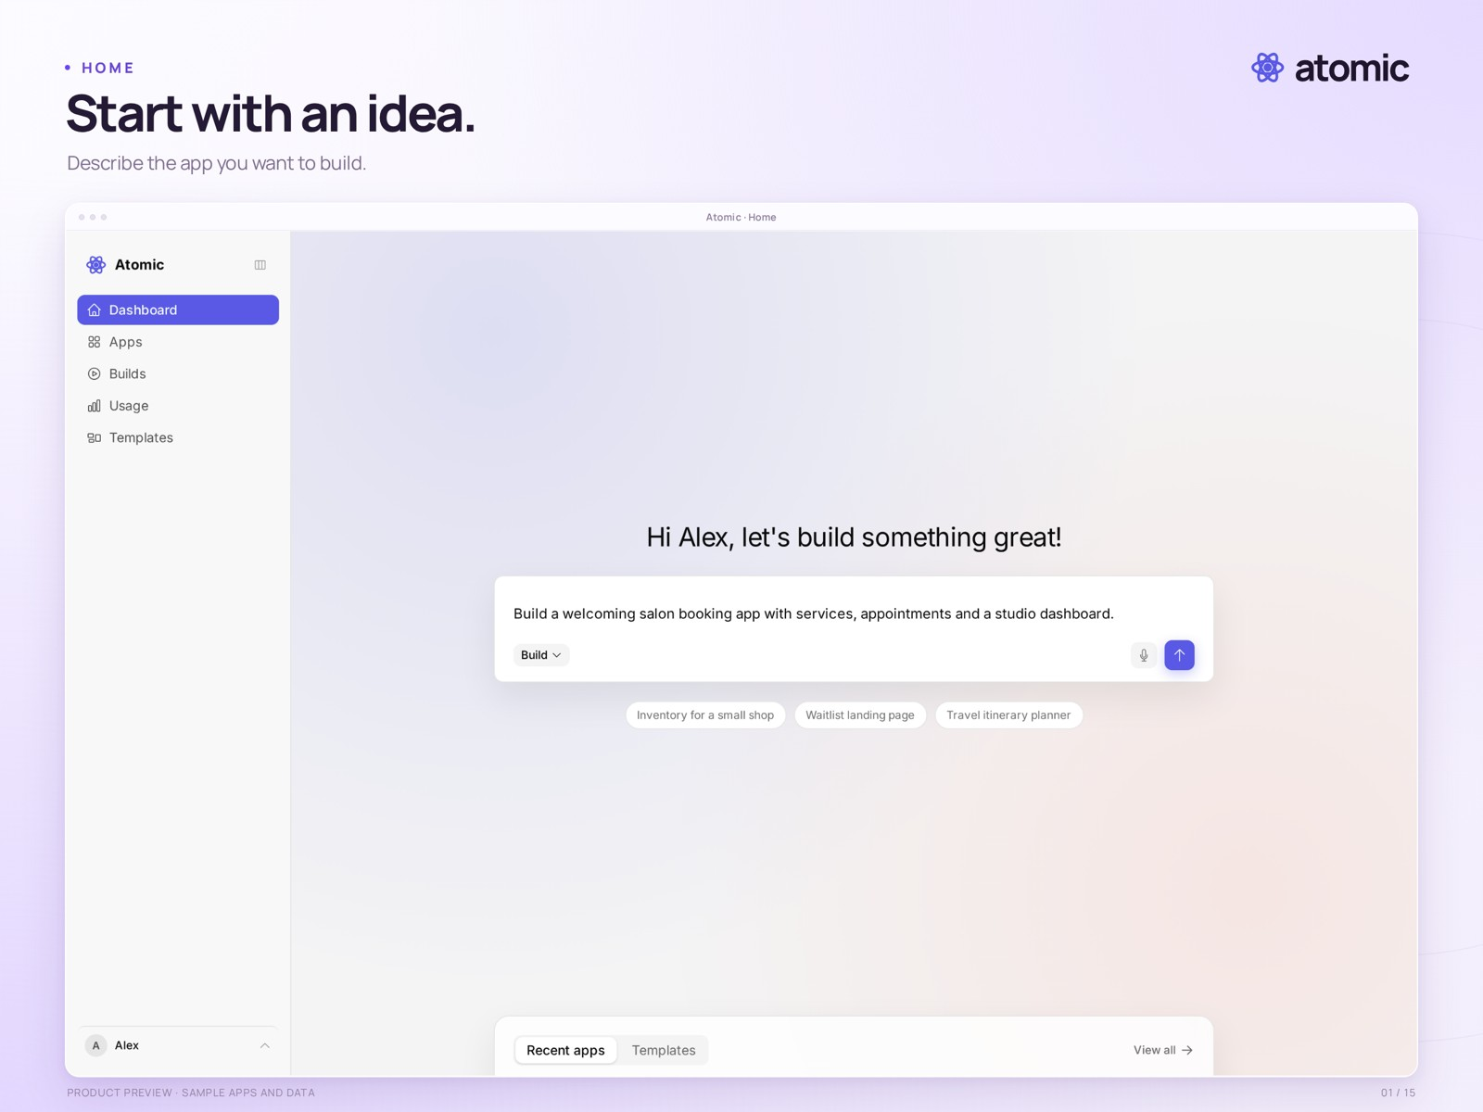
Recommended lead image · start with the Atomic homepage

Choose images to support the story
First impression | 01 home · 02 templates · 03 template preview
Build and refine | 04 builder · 05 Canvas · 06 theme · 07 element editing · 08 collaboration
Manage the workspace | 09 applications · 10 billing · 13 app dashboard
Inspect and review | 11 source · 12 versions
Finished experience | 14 sample salon app · 15 responsive preview
Each numbered page that follows contains the current presentation image, its caption and the clean-capture filename. Presentation PNGs are 2560 × 1920; raw captures keep their native dimensions. Capture dates describe the original screenshots, not this document revision.
atomicapp.dev · Press room and complete media kit

Home
Start with an idea.
The Atomic home screen with a drafted salon-booking prompt. The prompt has not been submitted.
Real product capture from a local demonstration workspace, with an external branded presentation frame. Sample apps and data.
Presentation file | 01-home.png · 2560 × 1920
Clean capture | raw/01-home.png · 2880 × 1800
Captured | 2026-10-29
Credit | Courtesy of Atomic / Abstract Machines

Templates
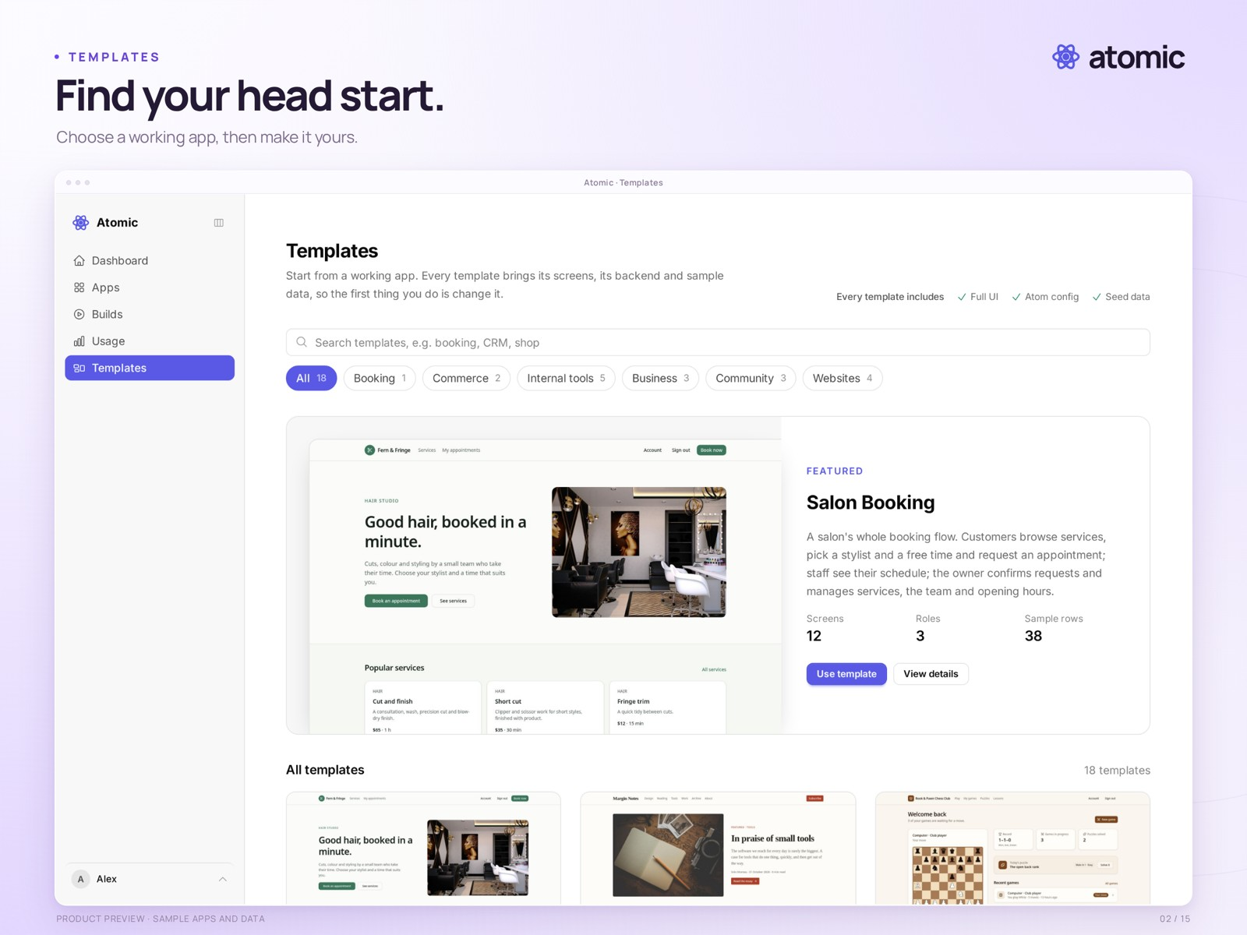
Find your head start.
The template catalogue, including a photo-based salon booking template and other starting points.
Real product capture from a local demonstration workspace, with an external branded presentation frame. Sample apps and data.
Presentation file | 02-templates.png · 2560 × 1920
Clean capture | raw/02-templates.png · 2880 × 1800
Captured | 2026-10-29
Credit | Courtesy of Atomic / Abstract Machines

Template preview
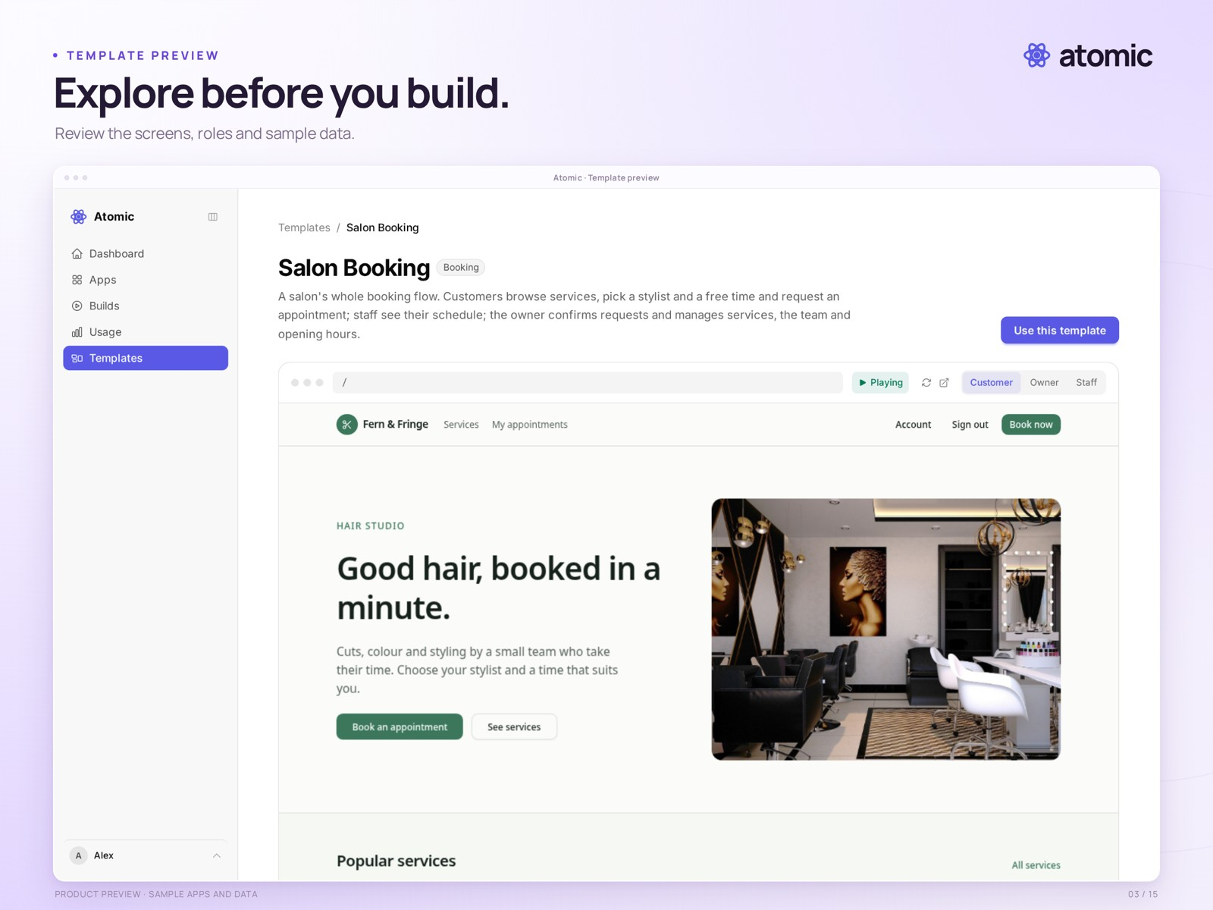
Explore before you build.
The salon booking template detail page, with its interactive preview and screen navigation.
Real product capture from a local demonstration workspace, with an external branded presentation frame. Sample apps and data.
Presentation file | 03-template-preview.png · 2560 × 1920
Clean capture | raw/03-template-preview.png · 2880 × 1800
Captured | 2026-10-29
Credit | Courtesy of Atomic / Abstract Machines

Builder
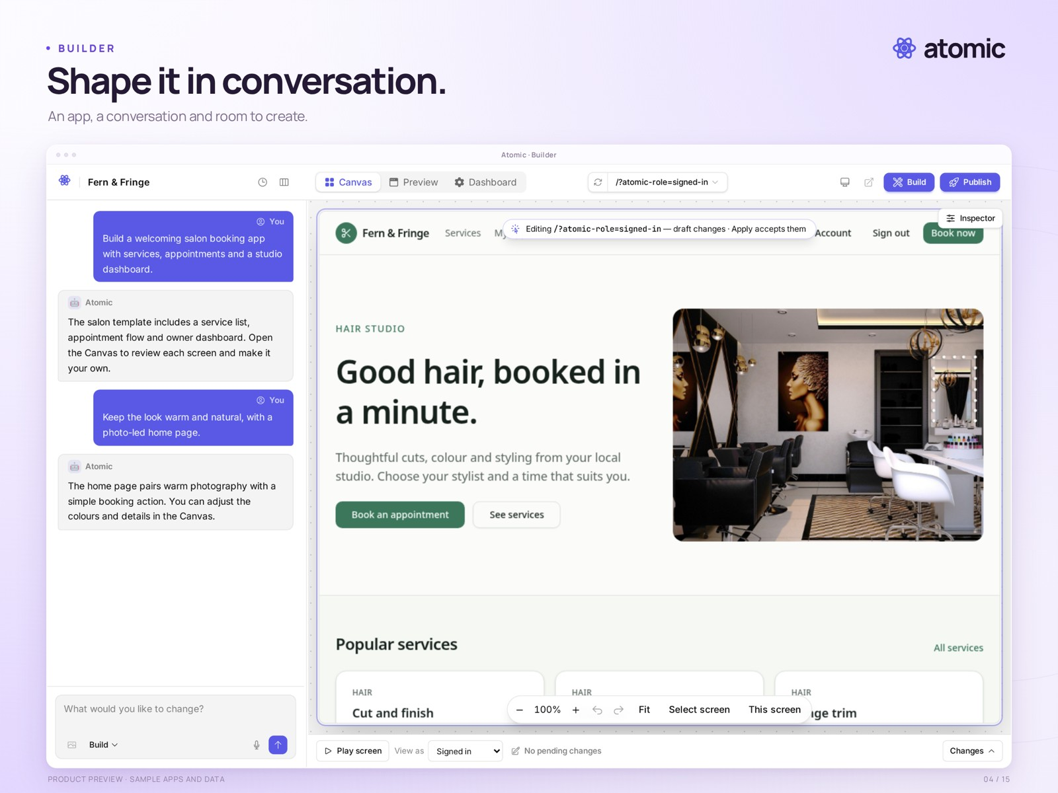
Shape it in conversation.
The builder pairs a sample salon application with a staged demonstration conversation.
Real product capture from a local demonstration workspace, with an external branded presentation frame. Sample apps and data.
Presentation file | 04-builder.png · 2560 × 1920
Clean capture | raw/04-builder.png · 2880 × 1800
Captured | 2026-10-29
Credit | Courtesy of Atomic / Abstract Machines

Canvas
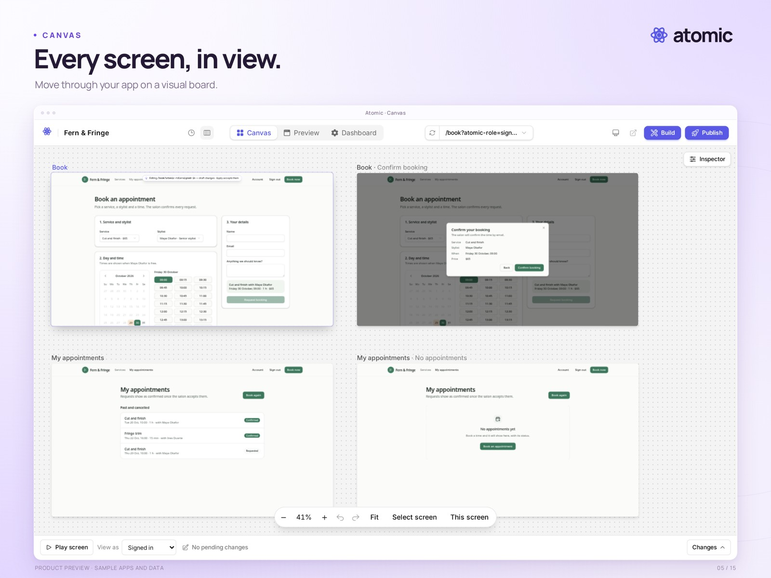
Every screen, in view.
The Canvas shows the booking flow, confirmation dialog and appointment screens together at a readable zoom level.
Real product capture from a local demonstration workspace, with an external branded presentation frame. Sample apps and data.
Presentation file | 05-canvas.png · 2560 × 1920
Clean capture | raw/05-canvas.png · 2880 × 1800
Captured | 2026-10-29
Credit | Courtesy of Atomic / Abstract Machines

Theme controls
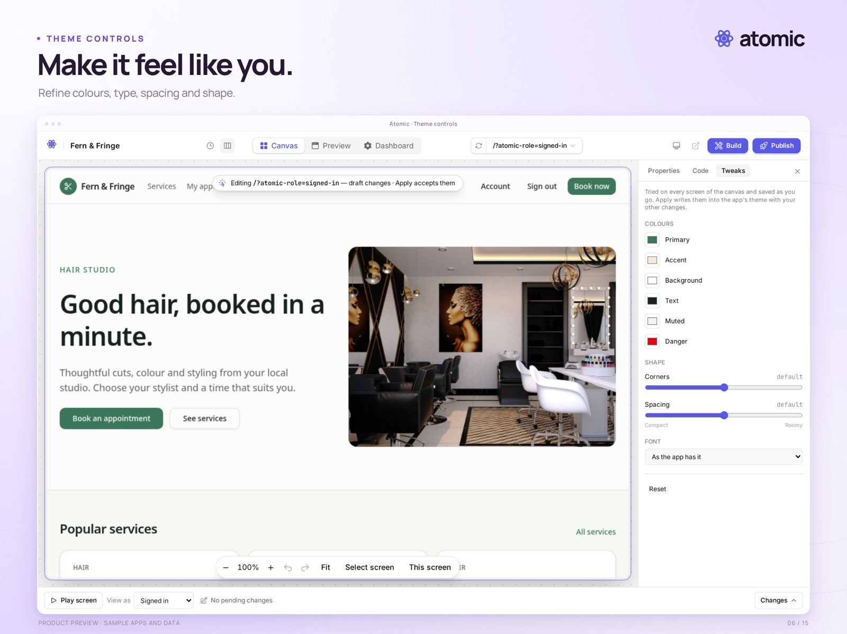
Make it feel like you.
Whole-app theme controls are open beside the sample app on the Canvas.
Real product capture from a local demonstration workspace, with an external branded presentation frame. Sample apps and data.
Presentation file | 06-theme.png · 2560 × 1920
Clean capture | raw/06-theme.png · 2880 × 1800
Captured | 2026-10-29
Credit | Courtesy of Atomic / Abstract Machines

Element editing
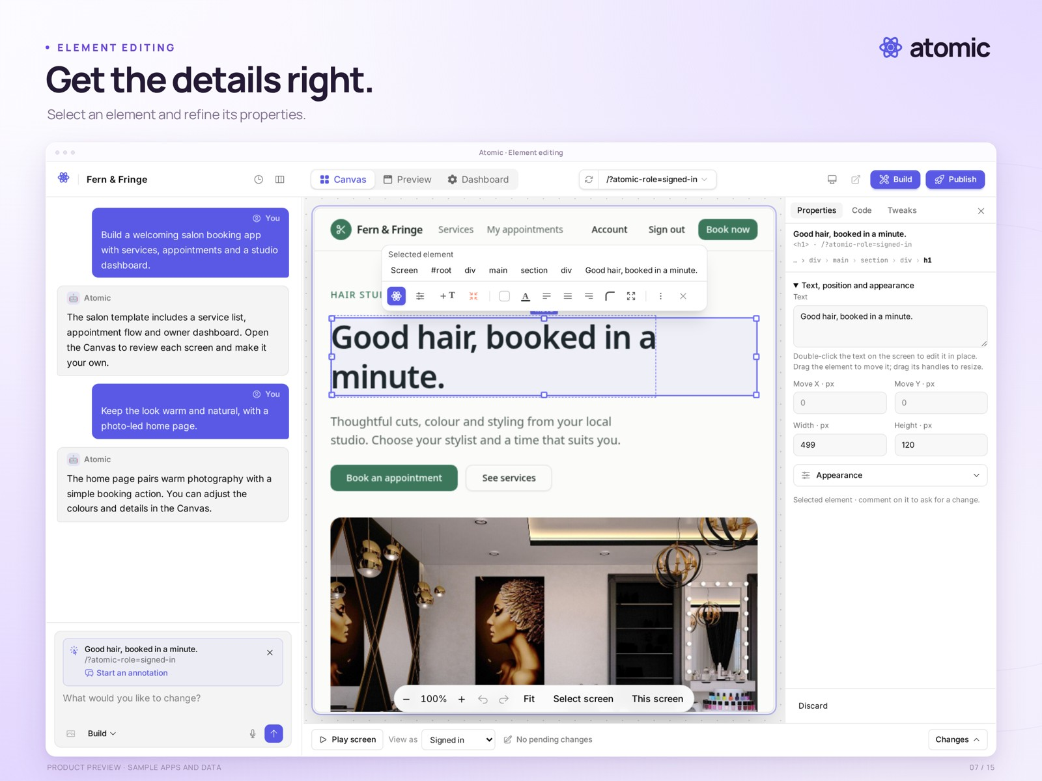
Get the details right.
A headline is selected on the Canvas, with the Properties inspector open.
Real product capture from a local demonstration workspace, with an external branded presentation frame. Sample apps and data.
Presentation file | 07-element.png · 2560 × 1920
Clean capture | raw/07-element.png · 2880 × 1800
Captured | 2026-10-29
Credit | Courtesy of Atomic / Abstract Machines

Collaboration
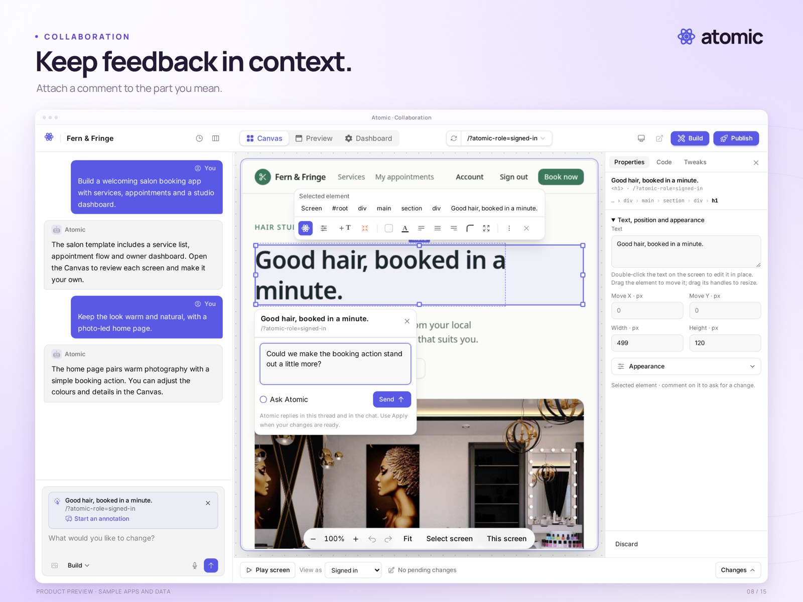
Keep feedback in context.
An element-linked comment composer is open on the Canvas. This is an unsent draft; no AI change has been requested.
Real product capture from a local demonstration workspace, with an external branded presentation frame. Sample apps and data.
Presentation file | 08-collaboration.png · 2560 × 1920
Clean capture | raw/08-collaboration.png · 2880 × 1800
Captured | 2026-10-29
Credit | Courtesy of Atomic / Abstract Machines

Applications
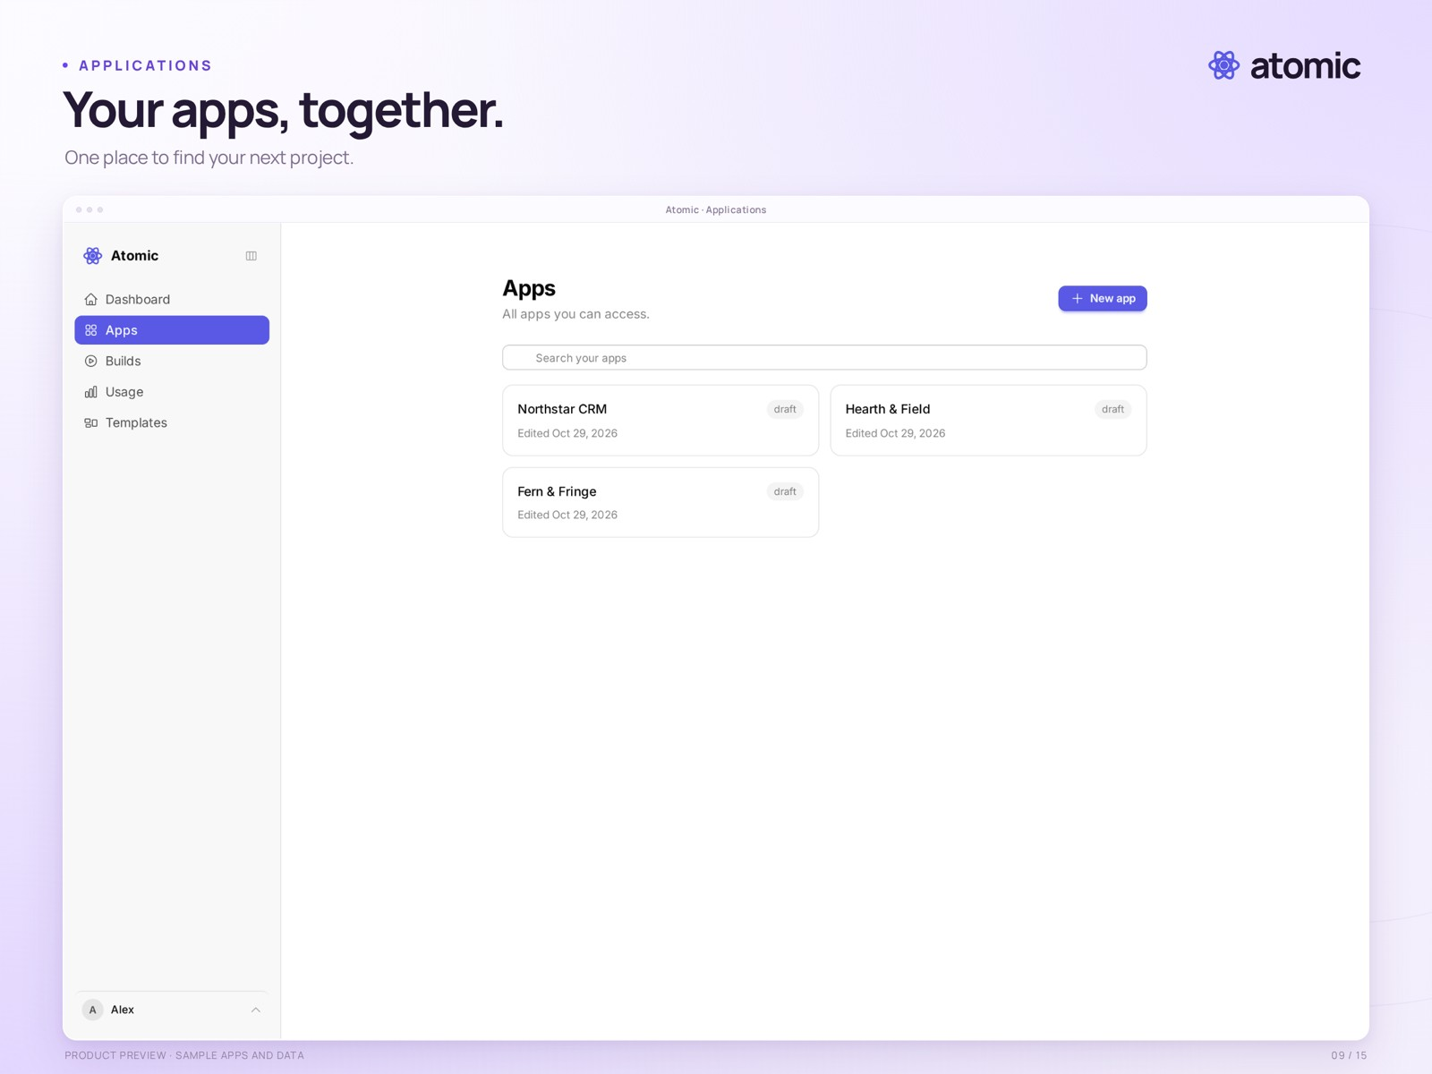
Your apps, together.
The applications list shows three local sample projects: Fern & Fringe, Hearth & Field and Northstar CRM.
Real product capture from a local demonstration workspace, with an external branded presentation frame. Sample apps and data.
Presentation file | 09-applications.png · 2560 × 1920
Clean capture | raw/09-applications.png · 2880 × 1800
Captured | 2026-10-29
Credit | Courtesy of Atomic / Abstract Machines

Billing
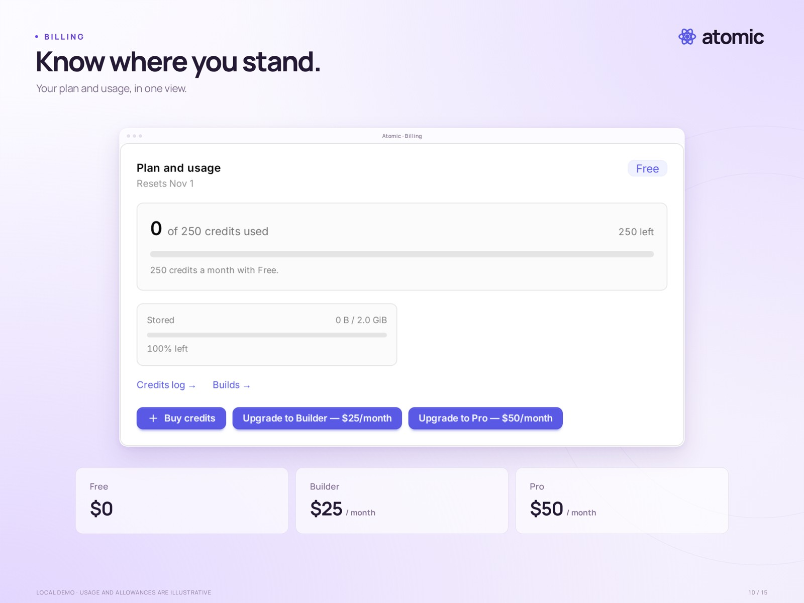
Know where you stand.
The account billing panel shows plan, credits, storage and upgrade controls. This is a local demo account; usage and allowances are illustrative, not confirmed launch entitlements.
Real product capture from a local demonstration workspace, with an external branded presentation frame. Sample apps and data.
Presentation file | 10-billing.png · 2560 × 1920
Clean capture | raw/10-billing.png · 1424 × 764
Captured | 2026-10-29
Credit | Courtesy of Atomic / Abstract Machines

Source browser
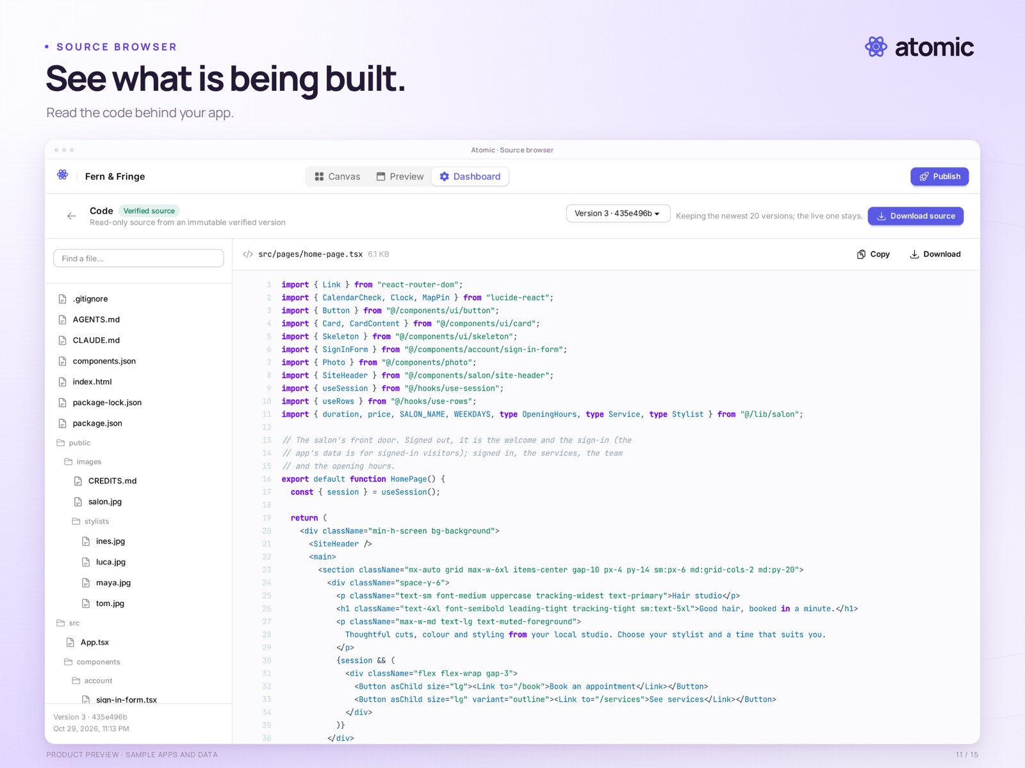
See what is being built.
The source browser displays the sample app’s home-page component, file tree and version selector. Source downloads exclude users, business data and hosting infrastructure.
Real product capture from a local demonstration workspace, with an external branded presentation frame. Sample apps and data.
Presentation file | 11-source.png · 2560 × 1920
Clean capture | raw/11-source.png · 2880 × 1800
Captured | 2026-10-29
Credit | Courtesy of Atomic / Abstract Machines

Version history
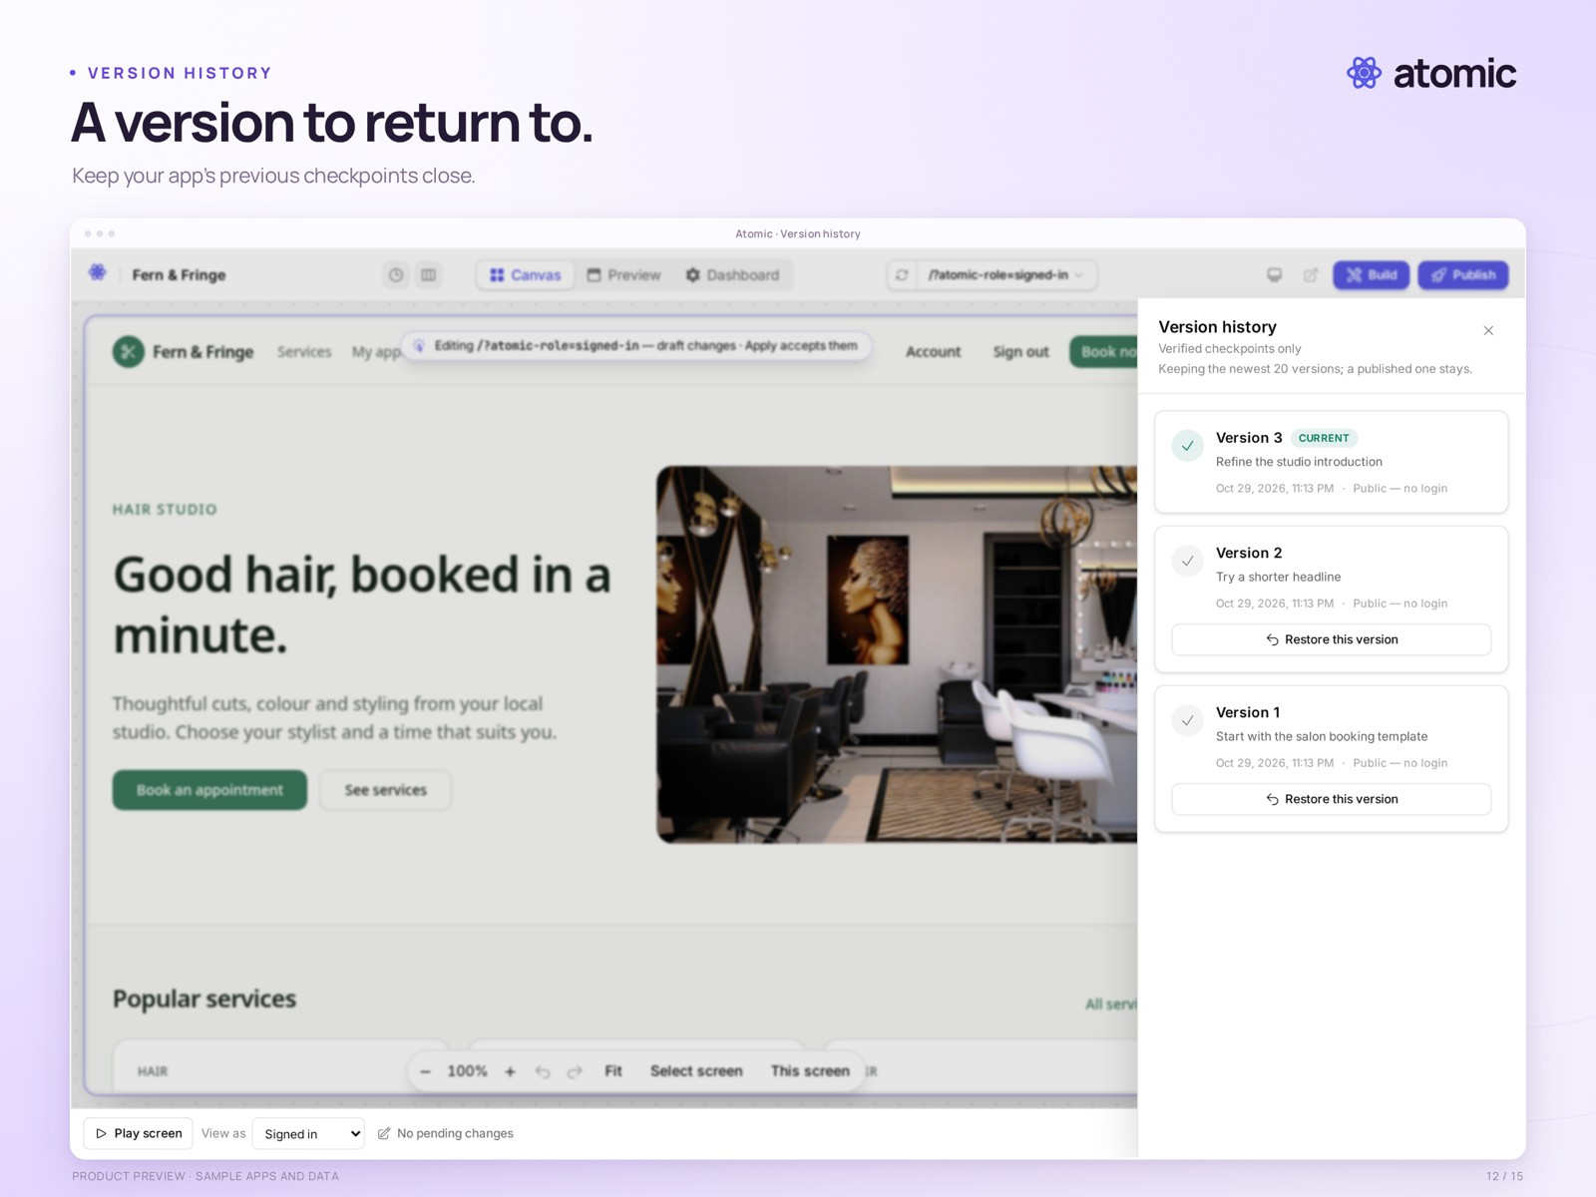
A version to return to.
Version history shows locally prepared sample revisions. These are compiled demonstration checkpoints; the capture does not show a restore being performed.
Real product capture from a local demonstration workspace, with an external branded presentation frame. Sample apps and data.
Presentation file | 12-versions.png · 2560 × 1920
Clean capture | raw/12-versions.png · 2880 × 1800
Captured | 2026-10-29
Credit | Courtesy of Atomic / Abstract Machines

App dashboard
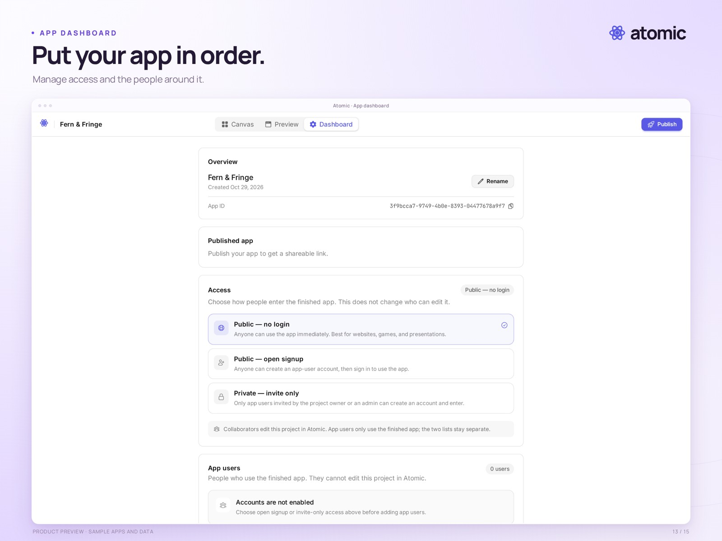
Put your app in order.
The app dashboard shows publication, access and app-user settings for the local salon demo. The app has not been publicly deployed.
Real product capture from a local demonstration workspace, with an external branded presentation frame. Sample apps and data.
Presentation file | 13-dashboard.png · 2560 × 1920
Clean capture | raw/13-dashboard.png · 2880 × 1800
Captured | 2026-10-29
Credit | Courtesy of Atomic / Abstract Machines

Sample application
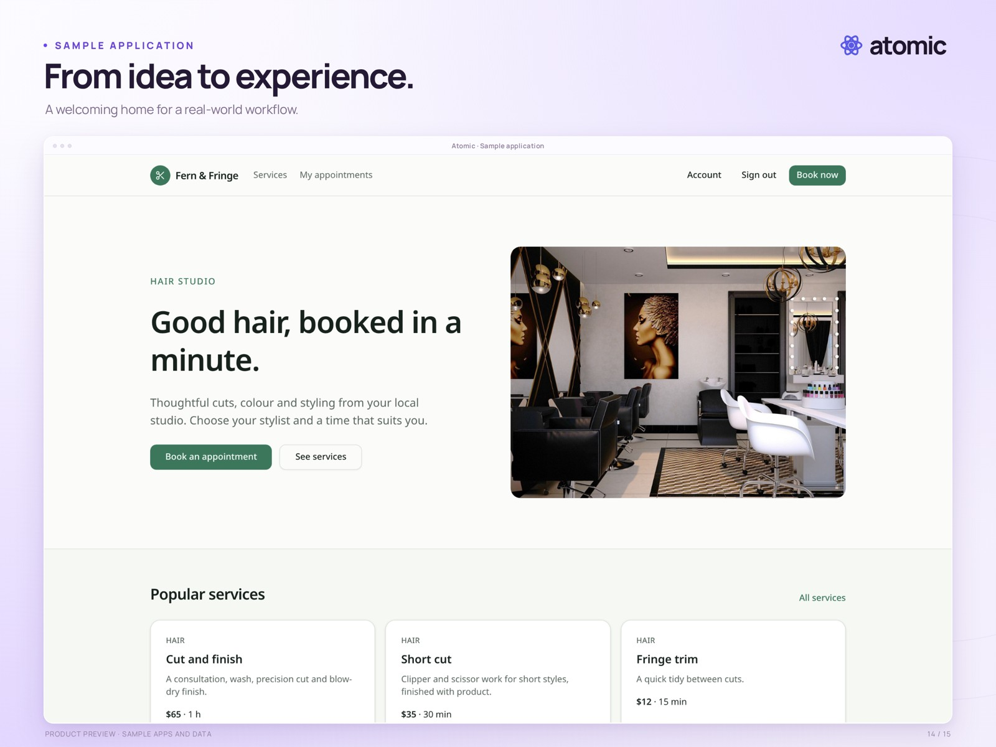
From idea to experience.
Fern & Fringe, a photo-based sample salon application, shown as a standalone preview with local demonstration data.
Real local sample-app preview with external branded framing. Business names, photographs and content illustrate the template; they are not customer claims.
Presentation file | 14-salon-app.png · 2560 × 1920
Clean capture | raw/14-salon-app.png · 2880 × 1800
Captured | 2026-10-29
Credit | Courtesy of Atomic / Abstract Machines

Responsive preview
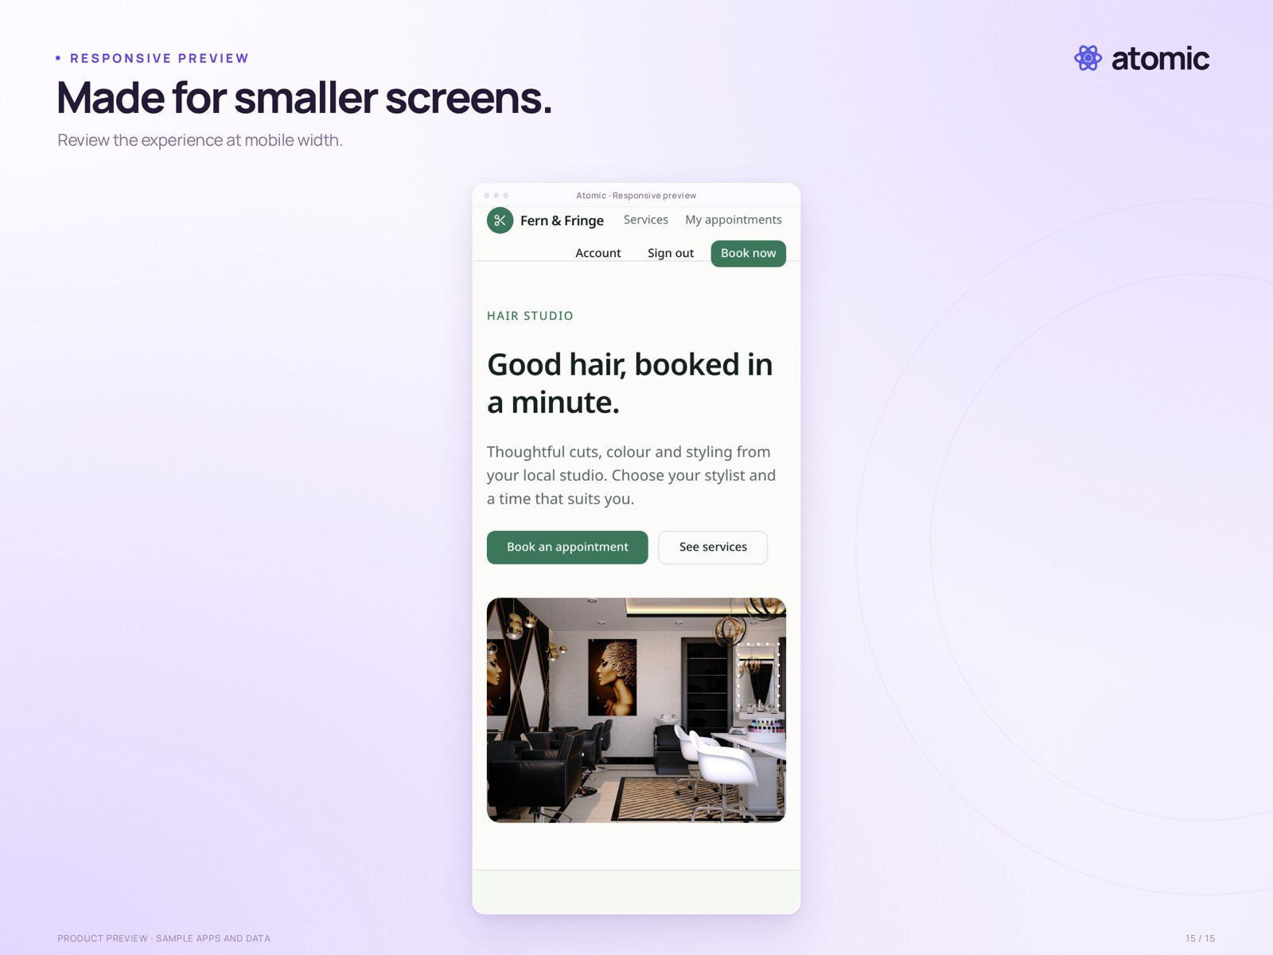
Made for smaller screens.
The sample salon application at a 390-pixel mobile viewport. This is a responsive web-app preview, not a native mobile-app export.
Real local sample-app preview with external branded framing. Business names, photographs and content illustrate the template; they are not customer claims.
Presentation file | 15-responsive.png · 2560 × 1920
Clean capture | raw/15-responsive.png · 780 × 1688
Captured | 2026-10-29
Credit | Courtesy of Atomic / Abstract Machines

