Questions worth answering.
Press FAQ · Atomic / Abstract Machines · Updated 30 October 2026 · atomicapp.dev
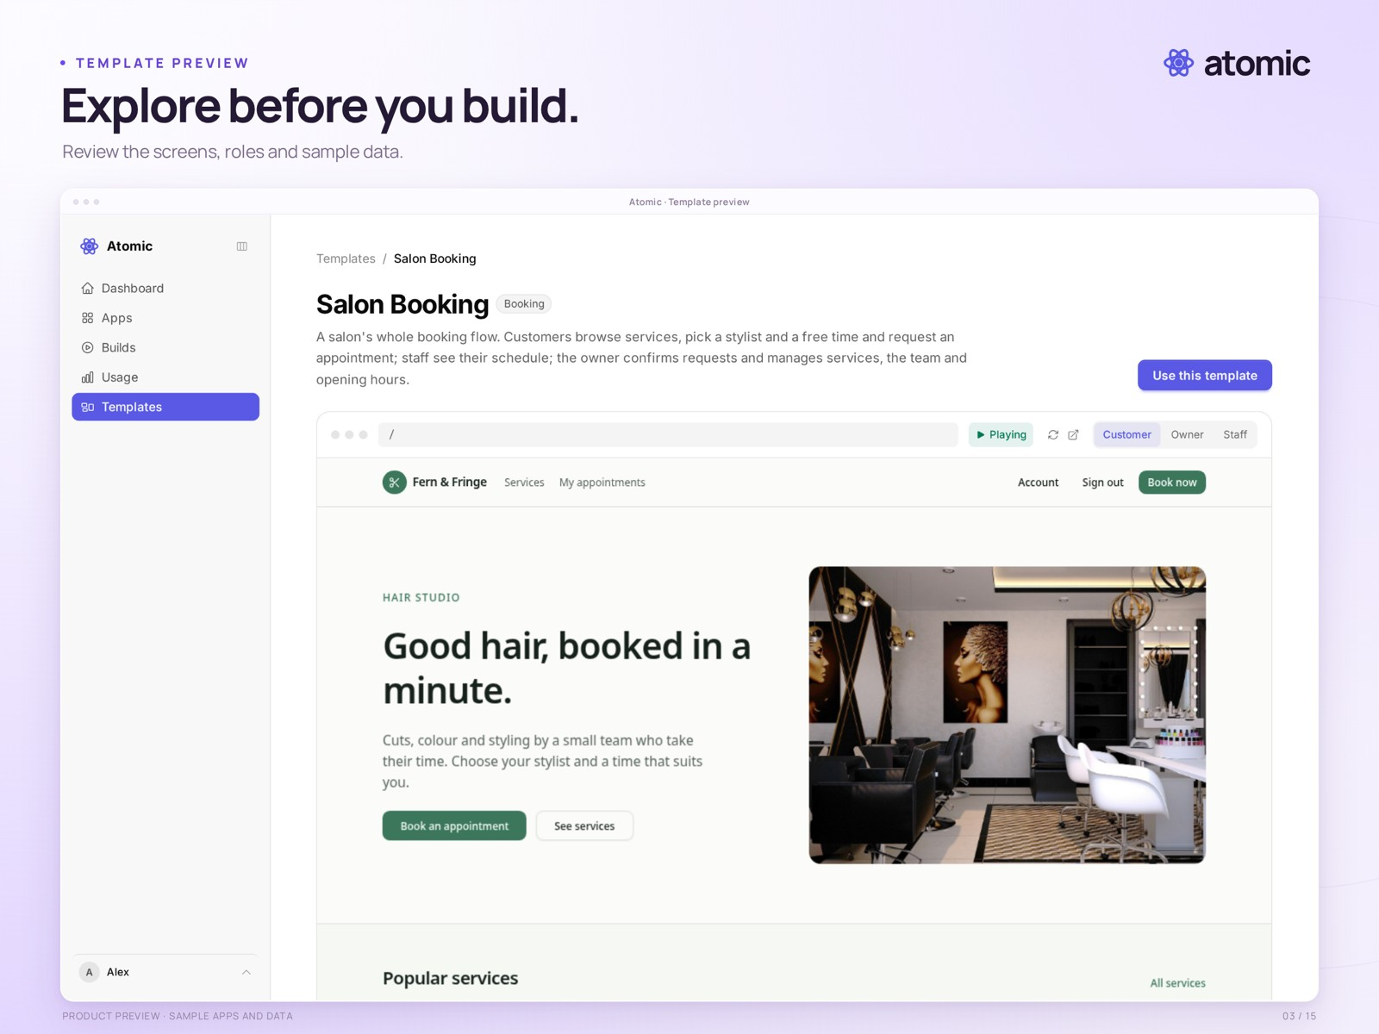
A template can be explored before it is adapted

What is Atomic?
Atomic helps founders, freelancers and small businesses turn an idea into a web application. Start with a prompt or template, refine the result in conversation and on the Canvas, inspect the source, and publish a reviewed version. Atom, the open-source backend from the same team, provides application identities, permissions and data.

Do I need to know how to code?
Start by describing the app you want. Review the preview and refine it through conversation or visual editing. You should still test the workflows before sharing it.

What can I build?
Booking apps, online shops, client portals and internal tools are typical starting points. The commerce starter records order requests; it does not by itself collect payments.

What does the Canvas do?
Navigate screens and states, select elements, tune whole-app styling and leave contextual comments. Builder and Pro support shared workspaces; workspace builders and finished-app users have separate accounts and access flows.

Can I inspect and download the code?
All plans support source browsing. Source downloads are available on Builder and Pro. An archive contains code, not app users, business data or hosting infrastructure; it is not a complete portable deployment package.

What does “Verified” mean?
It identifies a version that passed the configured automated checks, including build and browser smoke checks. It is not a guarantee that every business workflow is correct or an independent security audit.

Can I restore an earlier version?
Source history and publication history concern code. Restoring source or rolling back a release does not restore business data; publication rollback also depends on compatibility with applied data migrations.

Is Atomic open source?
Atom, the backend for identities, permissions and application data, is open source. This does not mean the Atomic builder itself is open source.

What plans does Atomic offer?
Free ($0), Builder at $25/month, and Pro at $50/month. Free includes 250 credits once, used at up to 50 a day. Source downloads, searchable preview logs and collaboration require Builder or Pro. Product information: atomicapp.dev.

Where are the current screenshots and films?
Press room and complete media kit provides 17 captioned product views, three 35-second launch-film formats and matching opening covers. Contact drasko@absmach.eu for interviews.

