Meet the people behind Atomic.
People · Atomic / Abstract Machines · Updated 1 November 2026 · atomicapp.dev
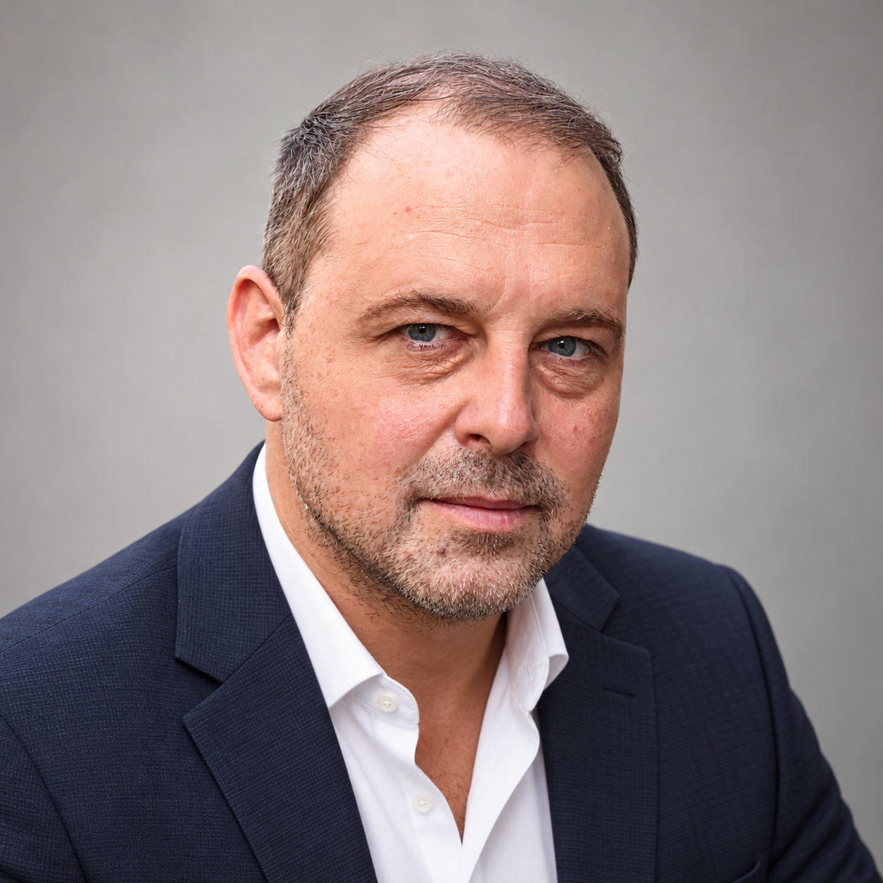
Drasko Draskovic · Founder & CEO

Drasko Draskovic
Founder & CEO · Paris, France
Drasko Draskovic is the founder of Abstract Machines and the founder and CEO behind Atomic. A deep-tech entrepreneur and systems engineer, he brings more than 20 years of experience in IoT and cloud-computing systems. His background includes work at Texas Instruments, Alcatel-Lucent, Nokia, Sequans and Devialet. He co-founded Datapace as an internal venture at Nokia, where he served as CTO. His work spans open-source infrastructure and the identity, data and execution systems that support applications. LinkedIn · X

Short bio
Drasko Draskovic is the founder of Abstract Machines and the founder and CEO behind Atomic. He is a systems engineer and entrepreneur with more than 20 years of experience in IoT and cloud computing.

Interview topics
- Taking an app from a plain-language idea through Canvas editing to a reviewed release.
- Why application identity, permissions and data matter in AI app building.
- Source visibility and open-source infrastructure.
Drasko Draskovic · Founder & CEO
drasko@absmach.eu · General enquiries: info@absmach.eu
atomicapp.dev

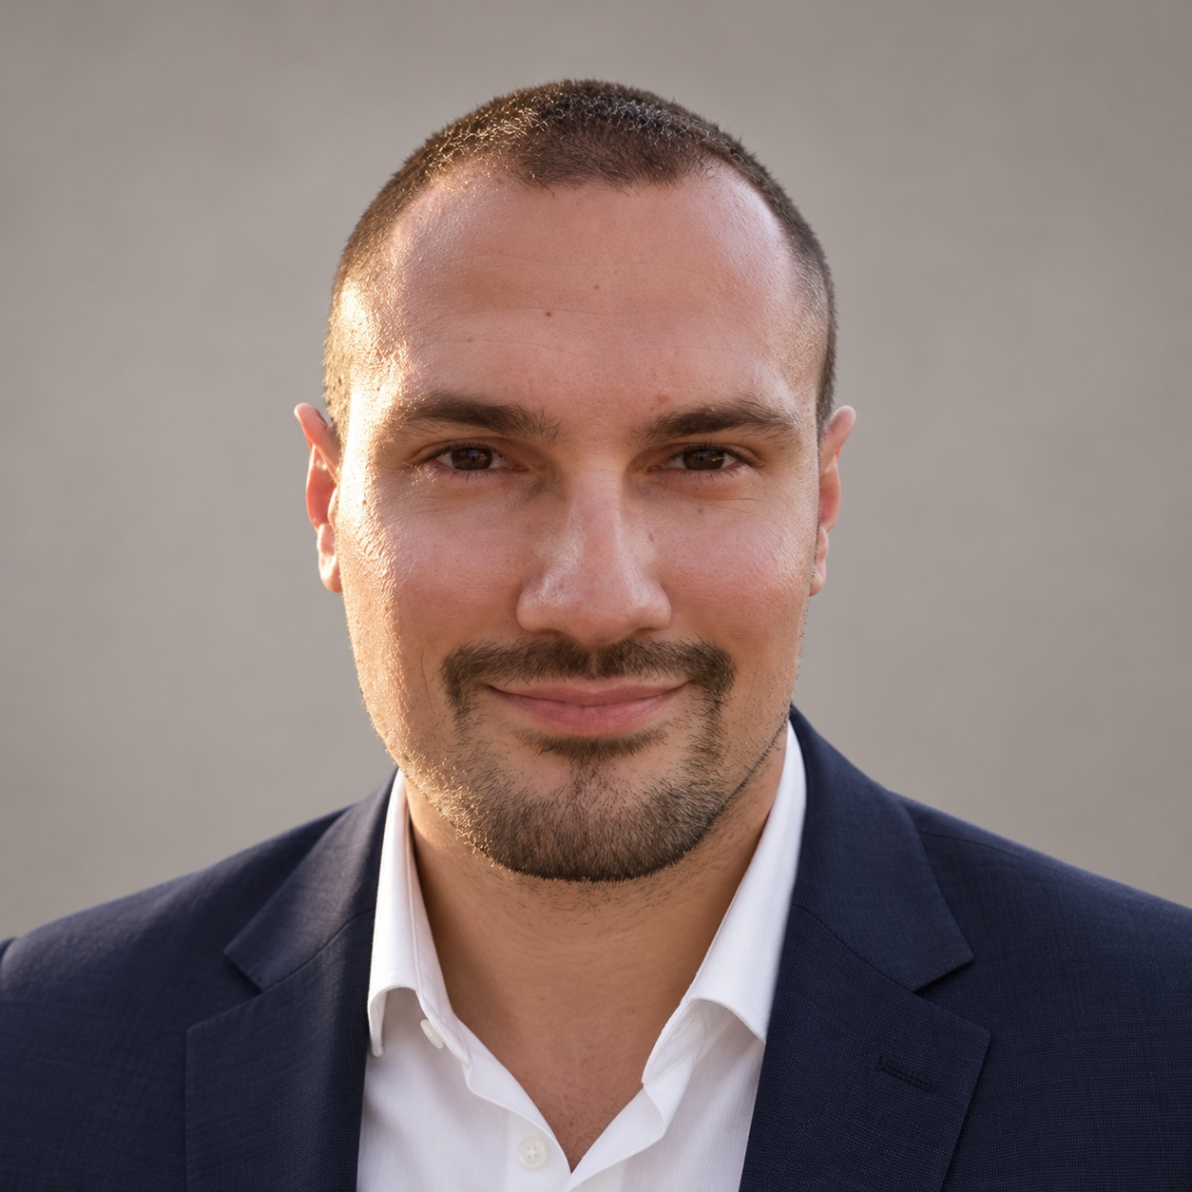

Dusan Borovcanin
Technical leadership
Dusan Borovcanin is Tech Lead at Abstract Machines, with more than 10 years of experience in distributed systems. His work includes confidential-computing infrastructure for AI and the engineering foundations behind Atomic. He previously built cocos-ai alongside Drasko Draskovic at Ultraviolet. LinkedIn · X
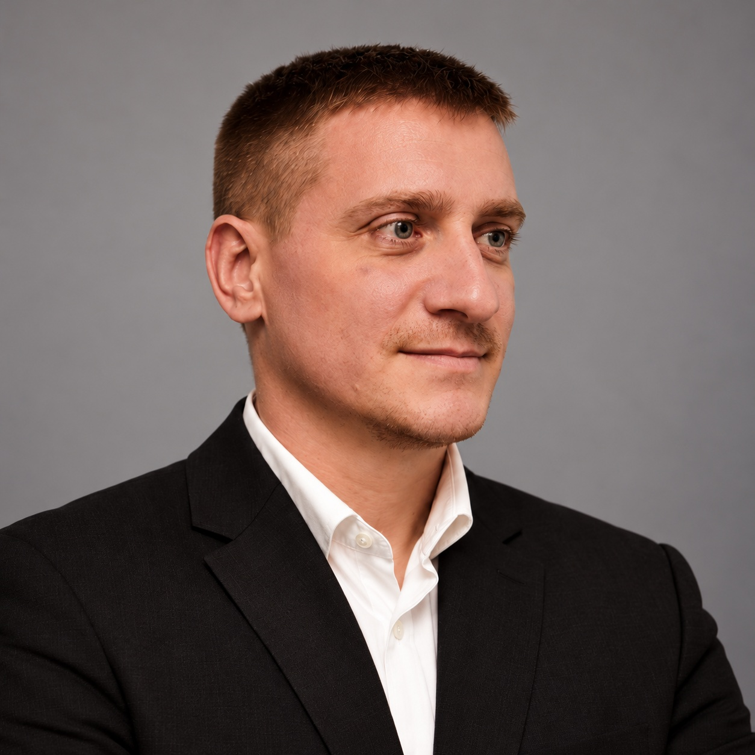

Filip Bugarski
Finance & Operations
Filip Bugarski coordinates and organizes company-wide operations at Ultraviolet, an Abstract Machines subsidiary focused on cybersecurity in Eastern Europe. He also oversees the financial operations of Abstract Machines France. LinkedIn · X
atomicapp.dev · Press room and complete media kit

