Atomic / Abstract Machines · Updated 2 November 2026 · atomicapp.dev
Facts & reusable copy

Atomic, at a glance.
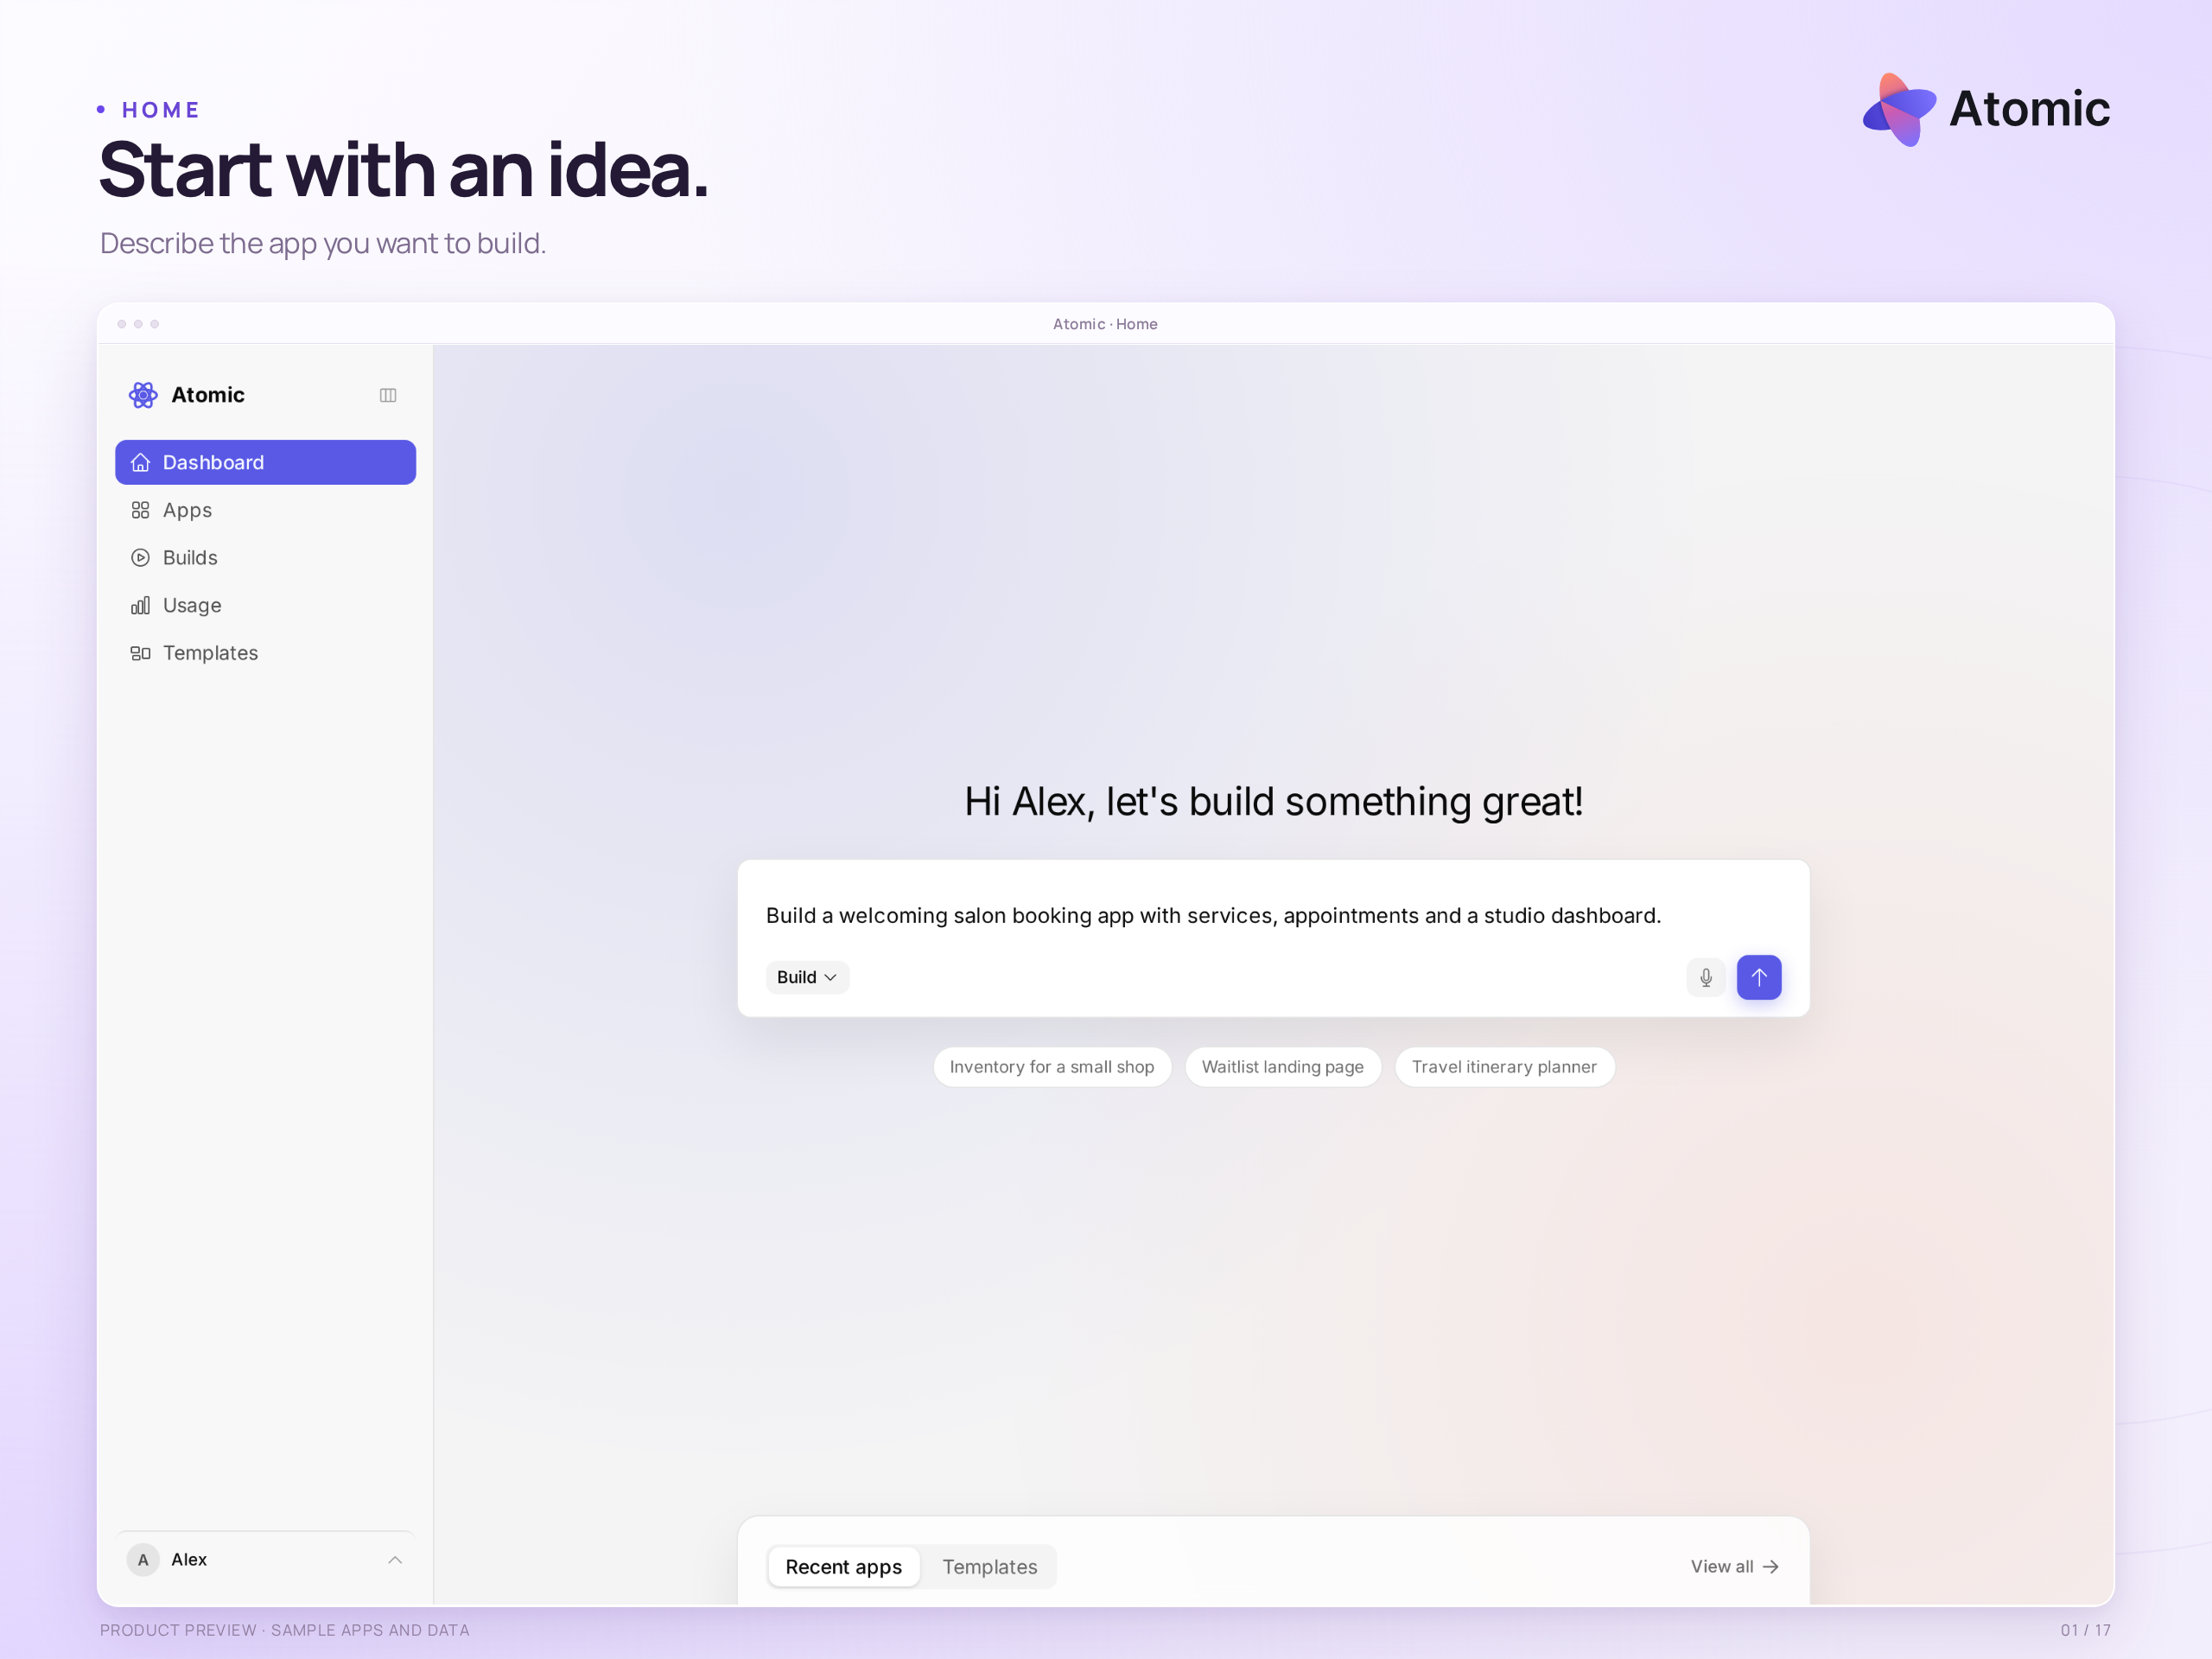
Main page · the starting point for building an app with Atomic
Product | Atomic · AI web-application builder
Company | Abstract Machines · Paris, France
Website | atomicapp.dev
Launch date | 3 November 2026
Plans | Free ($0), Builder at $25/month, and Pro at $50/month.
Free allowance | 250 credits once, used at up to 50 a day
Paid-plan features | Source downloads, searchable preview logs and collaboration: Builder / Pro
For | Founders, freelancers and small businesses
Examples | Bookings, shops, client portals and internal tools
Media | 17 product views · 3 launch-film formats · 3 matching covers
Press contact | Drasko Draskovic · drasko@absmach.eu

Facts & reusable copy

Atomic, at a glance.

One sentence
Atomic is an AI app builder from Abstract Machines that turns plain-language ideas into web applications, with visual editing, previews, source access and publishing.

Short description
Atomic helps founders, freelancers and small businesses turn an idea into a web application. Start with a prompt or template, refine the result in conversation and on the Canvas, inspect the source, and publish a reviewed version. Atom, the open-source backend from the same team, provides application identities, permissions and data.

Company boilerplate
Abstract Machines is a Paris-based applied AI company building intelligent software and the infrastructure behind it. Its work combines application development, open-source engineering and research across connected systems, identity and confidential computing. Atomic is its AI app builder; Atom is the open-source backend providing identity, permissions and application data.
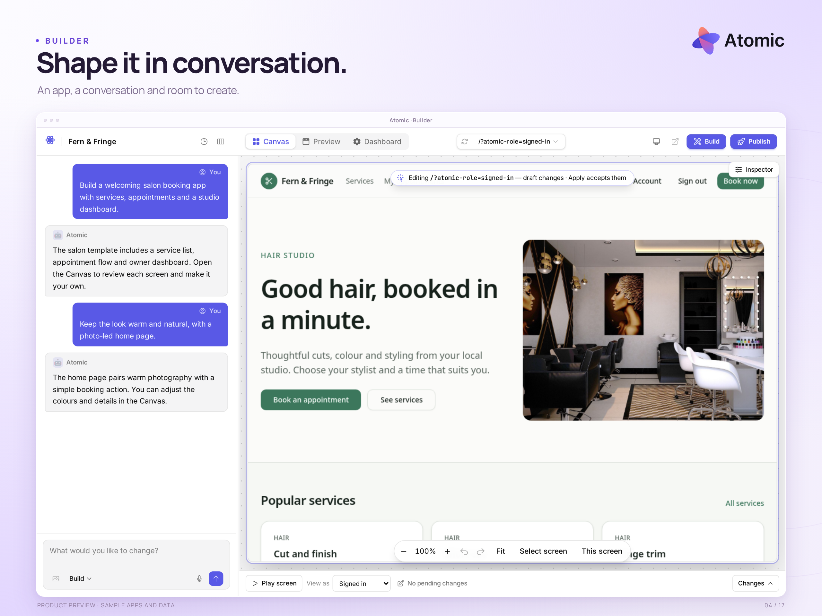
Builder · a working app and its demonstration conversation

Names and image context
Write “Atomic” for the product, “Abstract Machines” for the company and “Atom” for the backend. Product views use local sample applications and data. The builder conversation is staged. Use the confirmed plan prices above for editorial copy.

