Without api:

JUPYTER NOTEBOOK

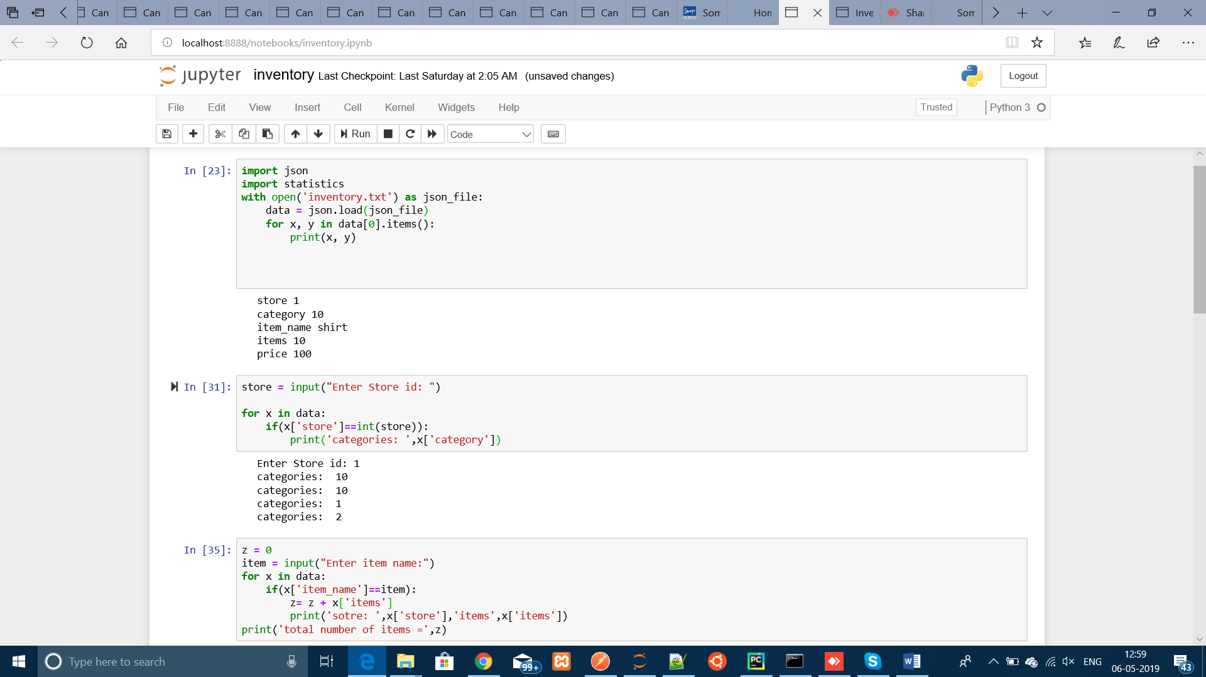

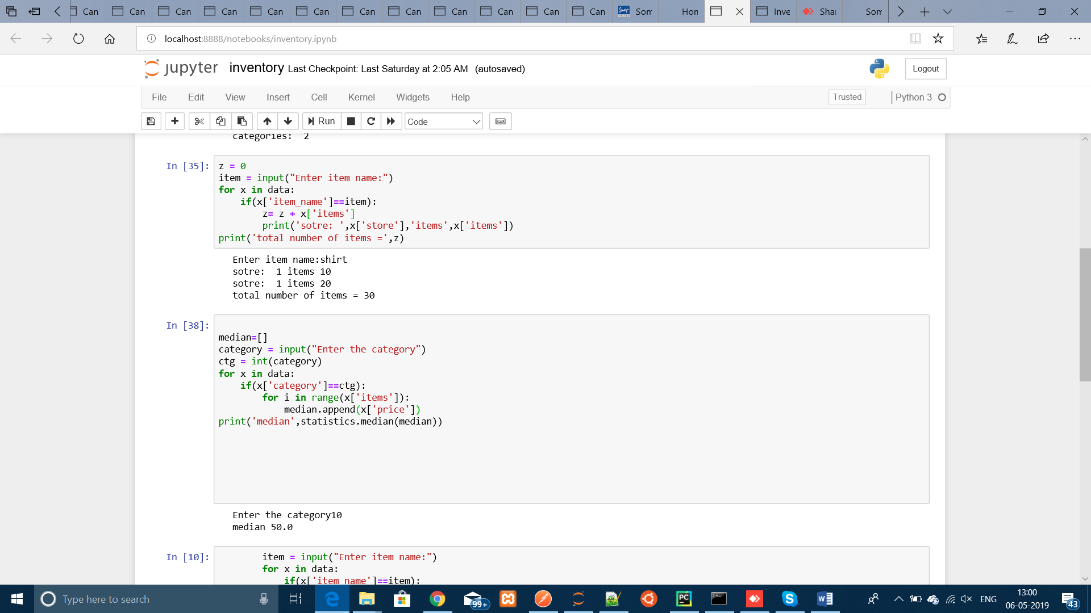

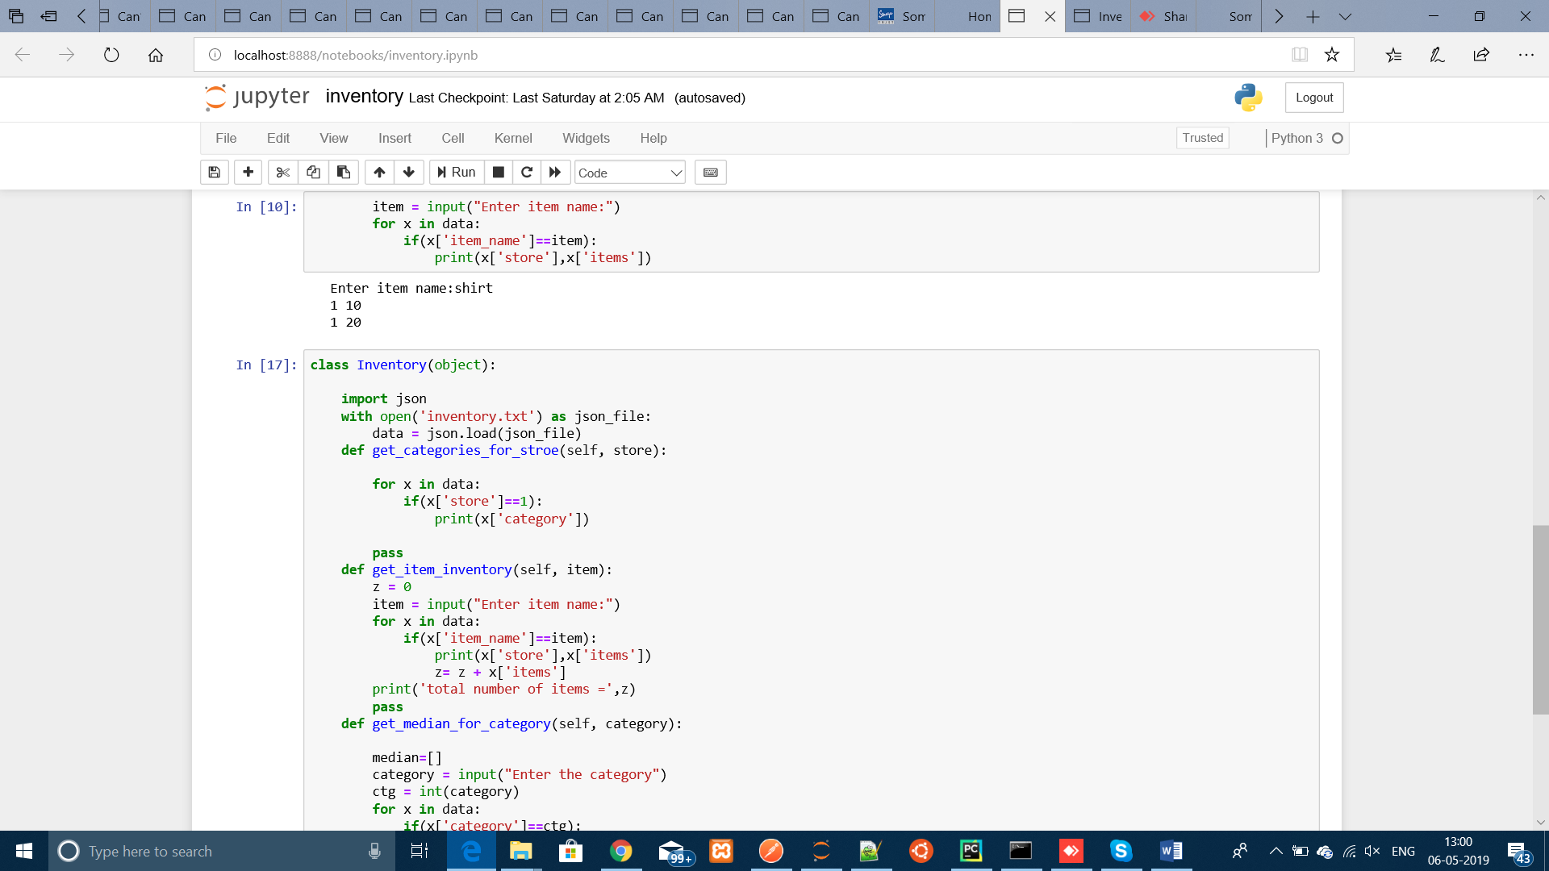

**QUESTION 2:**

With api:

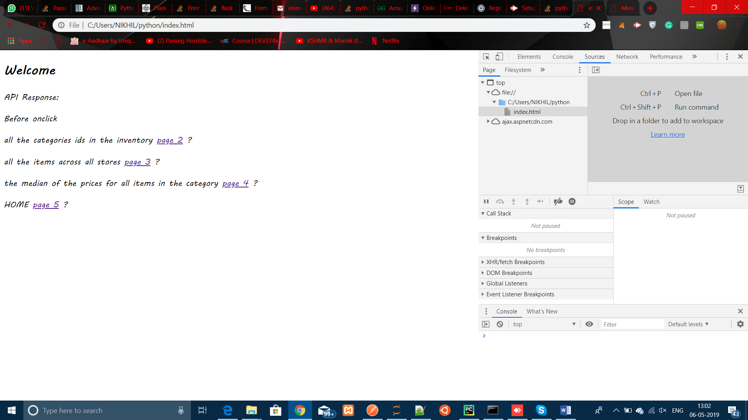

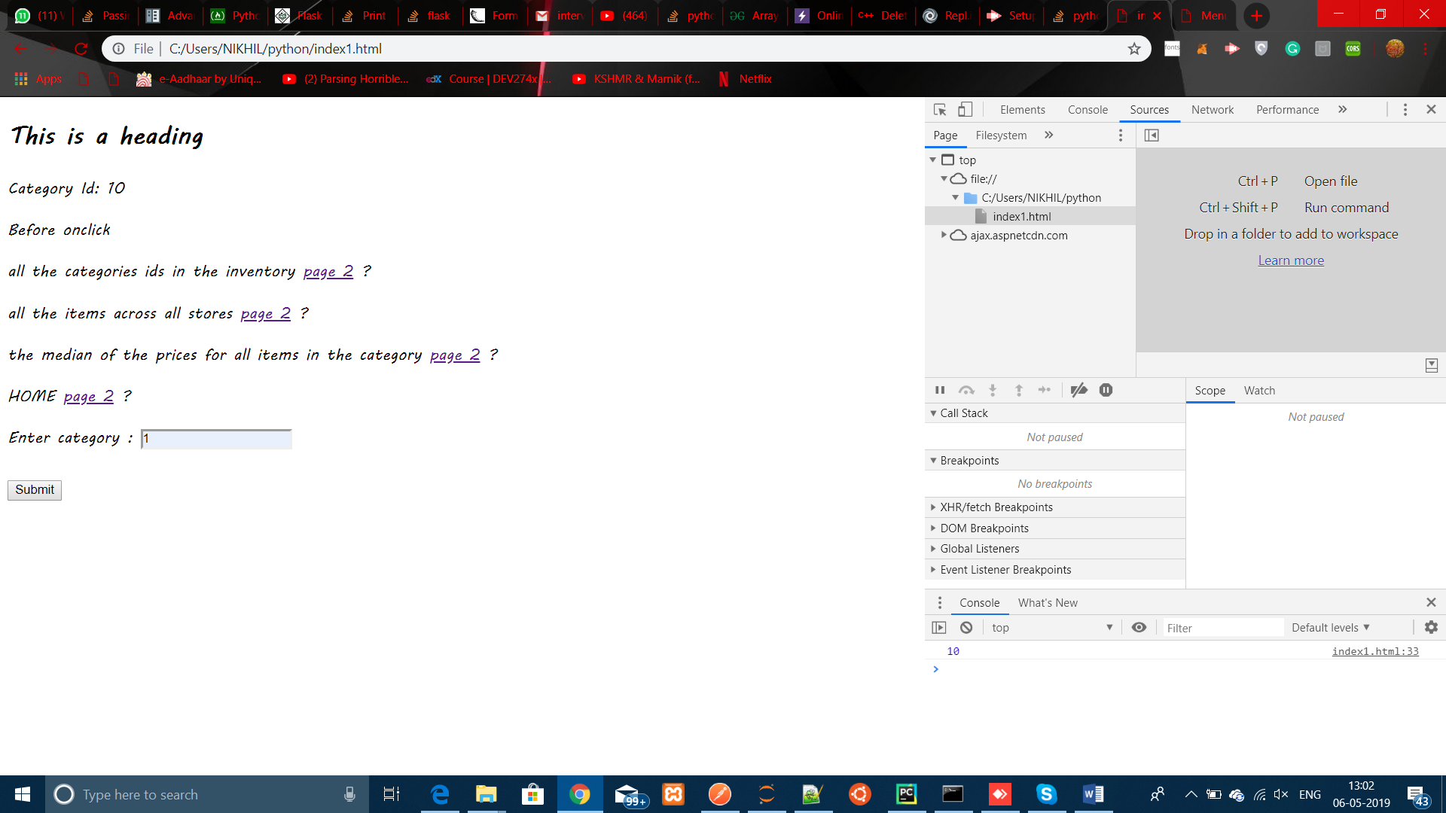

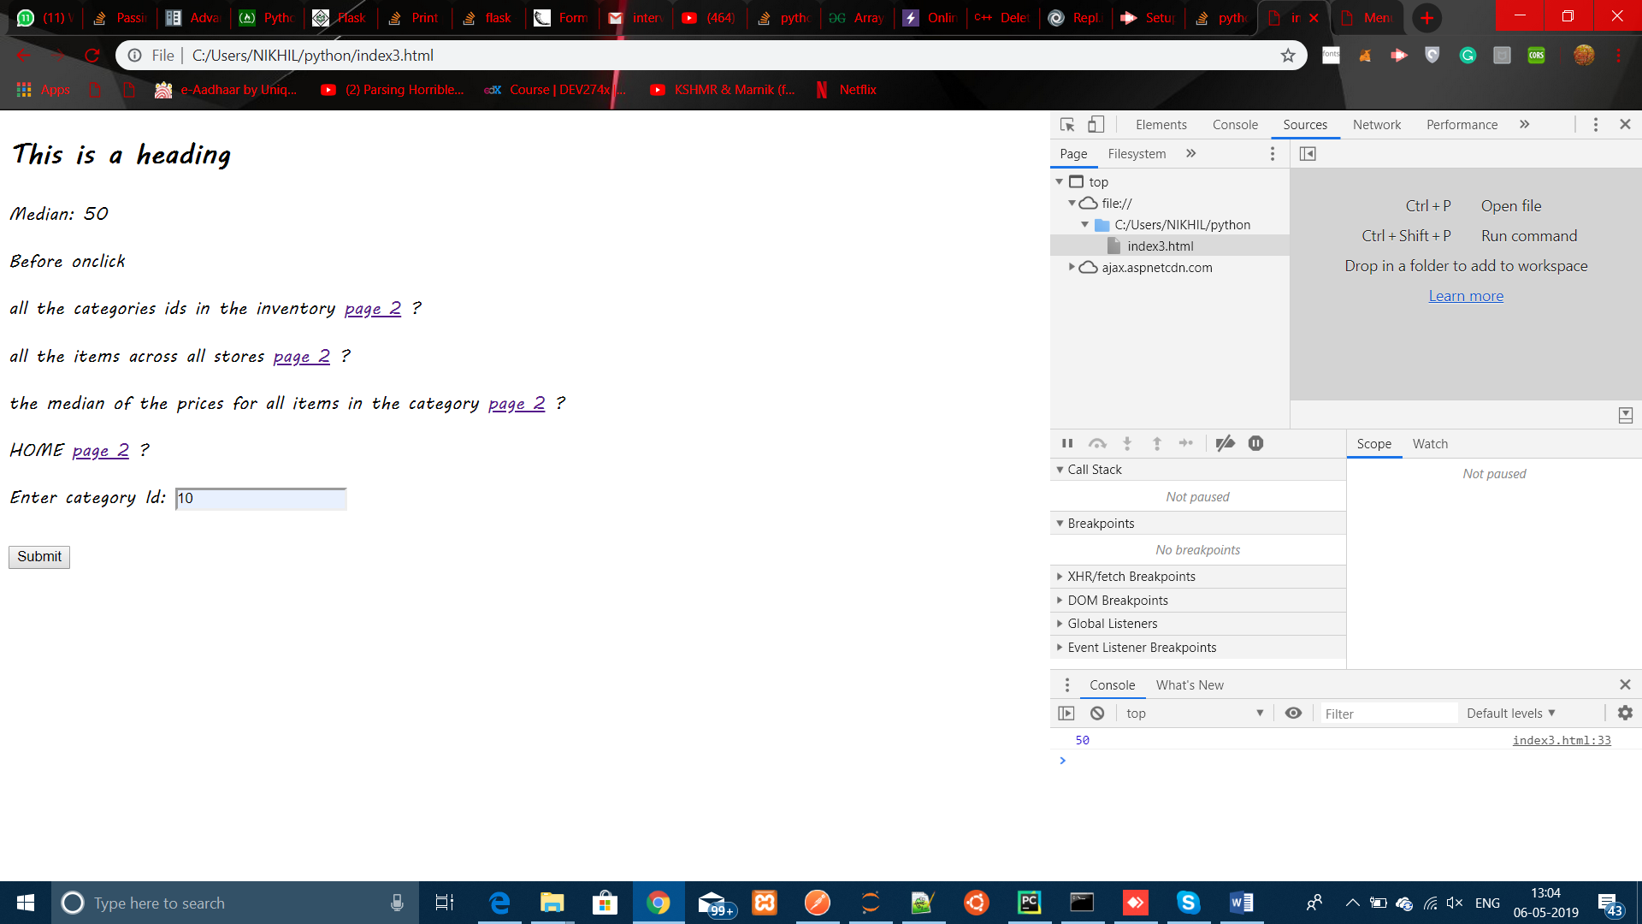

Asynchronous implementation will ensure that application can service many users with less number of connections. Its implemented in attached files.

let settings = {

"async": true,

"crossDomain": true,

"url": "http://localhost:8090/",

"method": "POST",

"headers": {

"Content-Type": "application/json",

"cache-control": "no-cache"

},

"processData": false,

"data": "{}"

}