Brett Haines
Oct 25, 2016
CS6310 Assignment 6

UML Model Changes
The UML diagram underwent a few small changes while implementing the lastest requirements. The class that changed the most was the RequestEnrollment association class. This saw the removal of the isGranted boolean in favor of a RequestReason, an enum that allows the class to track the status of the request. Additionally, the position integer was removed, since it was found to be unnecessary. Also, the Course and Student attributes are now explicitly listed. Finally, the grantRequest function has been replaced by the processRequest function, meaning the class will now determine the status of the request automatically, as opposed to faculty having to hand-enter the new status of the reuqest.
Related to the previous change, the RequestReason enum has been added. This allows the RequestEnrollment class to accurately track the status of the request and allows additional statuses to be added easily.
The Course class got 3 new attributes: students, instructors, and requests, each a List of their synonymous classes. This allows the system to easily traverse a list of each without having to also traverse each Section of the course. Additionally, since Sections were not given in the example data, this would have been impossible to implement anyway.
As a side note, I have stopped adding in all of each classes’ getters and setters, since this would make the diagram bloated and unwieldy.

UML Diagram – Old
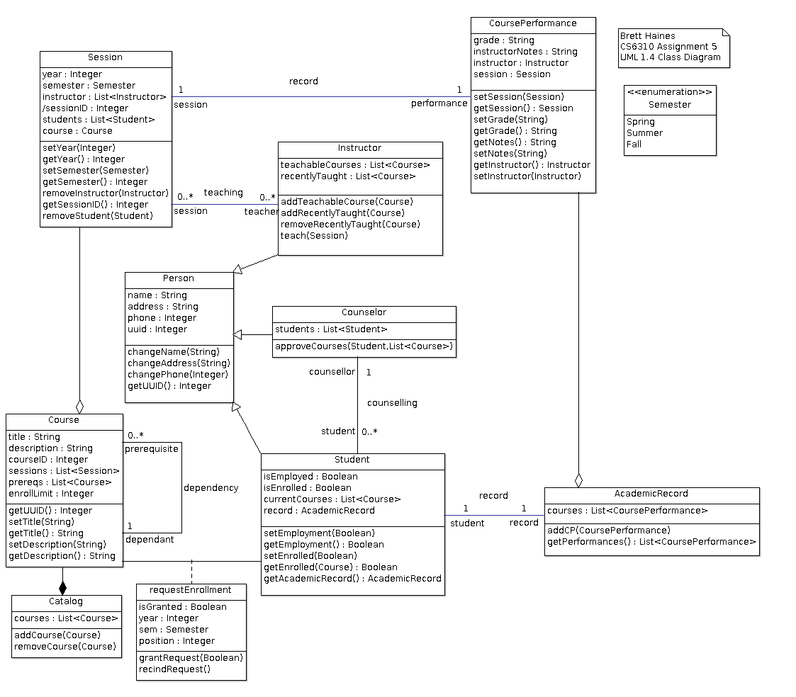

UML Diagram – Updated
