Author: Matthew McDermott
Date: October 26,2016
Assignment: #6 - Course Management System – Next Design Phase (v3)

add_seats,<courseID>,<numToAdd>
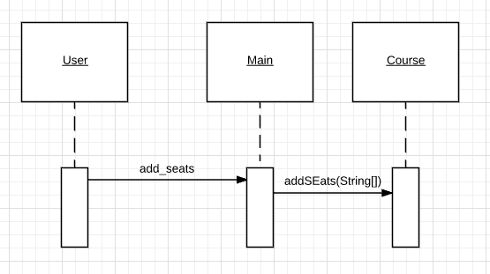
add_record,<studentID>,<courseID>,<instructorID>,<Comments>,<Grade>
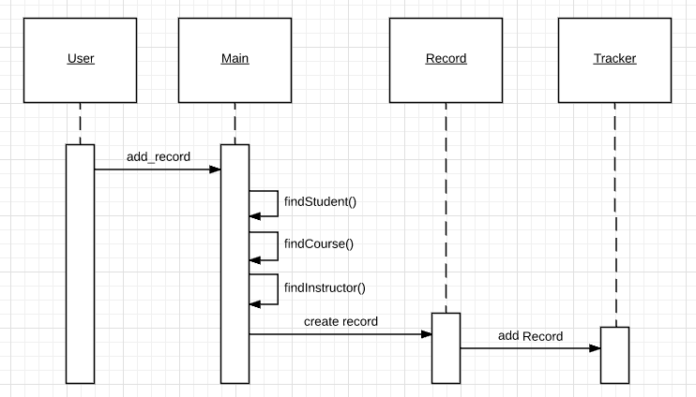

check_request,<studentID>,<courseID>
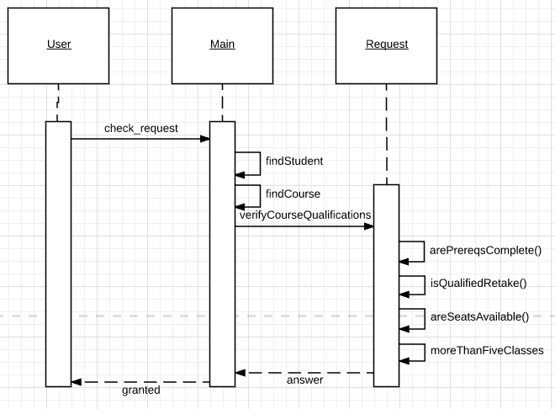
display_records
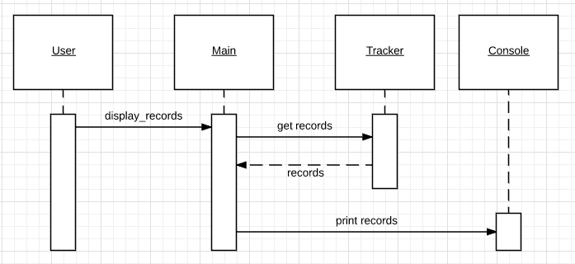

display_seats
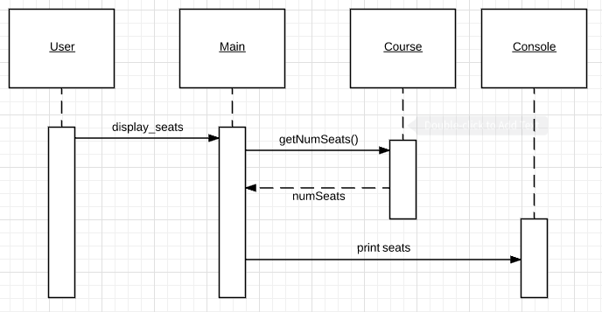
display_requests
