**MULTI-Seq Barcoding and Library Preparation Protocol**

Chris McGinnis and David Patterson

Zev Gartner Lab, UCSF Department of Pharmaceutical Chemistry

**Notes:**

* Protocol was designed for use with the **10x Genomics V2 3’ reagent kit,** but we have added notes on adapting the protocol for use with the 10x V3 kit. It can also be optimized for use with many sequencing platforms.
* Store Anchor and Co-Anchor as you would any other single-stranded oligonucleotide:
  + Room temp —> hours to days
  + 4 °C —> weeks to months
  + 20 °C —> a couple years
* Ensure that cells are resuspended in buffer at single cell suspension prior to addition of barcodes. LMOs partition quickly into cells. Cells must be in suspension prior to labeling or heterogeneous labeling can occur.
* Labeling is robust to most media components. Avoid FBS or BSA because they sequester LMOs and prevent effective cell labeling.
* Keep cells on ice immediately after labeling. Labeling can be done on ice or up to 37 °C, but barcodes are lost more rapidly if cells are maintained at higher temperatures post-labeling.
* Actual labeling volumes and concentrations can be adjusted depending on number of cells or plate surface area. Adjust to fit your experimental conditions.
* Effective barcoding can be tested using a fluorescent oligo complimentary to the anchor with analysis by flow cytometry.
* Nuclei are isolated using the protocol provided by 10x Genomics. Once single nuclei isolation is obtained, the barcoding protocol is the same as for live cells.
* For nuclei labeling, we recommend using cholesterol-modified oligos (CMOs) due to presence of BSA in nuclei resuspension buffer. BSA binds fatty acids on lipid-modified oligos (LMOs), but not cholesterol on CMOs.
* During post GEM-RT cleanup the aqueous layer will be cloudy due to the higher BSA concentration we use during our post-barcoding rinses. The BSA helps to quench excess LMO barcodes and limit off-target labeling. This does not cause any issues or negatively affect results.
* Bioanalyzer
  + Barcode peak size can vary. Increase rounds of amplification, if necessary.
  + Occasional low MW peak contaminants are present. They do not appear to negatively affect sequencing.
* Step 2.3 of V3 kit: Endogenous transcript cDNA that carries over from SPRI bead separation of barcodes and endogenous transcripts can interfere with barcode library preparation. This is caused by SPRI bead saturation and is mainly a problem we’ve seen when “super-loading” lanes of the 10x Genomics 3’ V3 kit. To solve,
  + Simply repeat the SPRI purification a second time (0.6X 🡪 remove supernatant 🡪 3.2X 🡪 elute) OR…
  + Double the volume of SPRI used (100 µL cDNA amplification, 100 µL water, 120 µL SPRIselect) for 0.6X cDNA purification. Save the supernatant and double the subsequent volumes for 3.2X SPRI selection (Step 12 below). Elution volume does not change **(Step 19 below)**.
* In V3 kit, cDNA amplification PCR is altered from V2. You can add 1 µL additive primer (final volume = 101 µL) or choose to omit MULTI-seq additive primer entirely. We have obtained successful results without the MULTI-seq additive primer in two separate experiments. Enough barcode appears to be generated by the template-switching reaction for successful sample classification.
* See Chris McGinnis’s [GitHub page on MULTI-seq](https://github.com/chris-mcginnis-ucsf/MULTI-seq) for analysis protocol and code

**Design Considerations:**

***Super-loading***: We typically recommend a target capture rate of ~25,000 cells. From a microfludiics standpoint you can super-load as much as you want as long as you don’t clog the chip. Clogging will be sample-dependent. However, as you increase the cell loading, you increase the number of doublets you will sequence. All of that is wasted sequencing since we discard doublets from analysis. We think ~25,000 is a good number to maximize cell throughput without wasting too many sequencing reads on doublets based on Kang *et al. Nat. Biotechnol.* **2018**, 36, 89 🡪 <https://doi.org/10.1038/nbt.4042>

*See also Satija website* for calculating cost/cell 🡪 <https://satijalab.org/costpercell>

***#Cells per Sample***: Assuming your cell count is accurate (we count cells AFTER pooling all samples), your per sample cell recovery will typically fall between 0.5X and 2X of your target. For example, if you want to get 500 cells per sample in a 96-sample experiment, you need to aim for 48,000 total cells. Then you load two 10x lanes with a target recovery of 24,000 cells per lane. This should result in roughly 250-1000 cells recovered per sample. This is assuming you don’t have underlying biological reasons for sample dropouts (e.g. sample with low viability). One way to check for biologically variability is to do a quick scan under the microscope prior to sample preparation. Below is a histogram of cells recovered per sample of a 96-plex experiment that we ran. The target cells per sample is normalized to one.

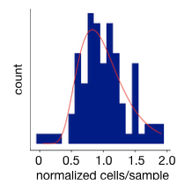

***Choosing #Cells per Sample:*** Be sure to consider the complexity of your sample when deciding on the number of cells per sample to target. Consider how many cells you hope to obtain from the lowest abundance cell type in your sample and calculate from there. For example, if you want an average of 50 cells from a cell type that makes up ~5% of your sample, then you would need to target 1000 cells per sample to obtain 25-100 cells per sample of your rare cell type.

***#Cells per LMO labeling reaction****:* We optimized the labeling conditions in our protocol for 500k cells per sample. More or less cells can be labeled with the same barcode, it just requires scaling up the amount of LMO used. That said, we get so much label on our samples that some variability in cell numbers in either direction isn’t much of an issue.

***Low cell input experiments****:* We have a number of users working on experiments with low cell input and we will update this protocol as we get new information. Our current best advice is to scale down the amount of LMO label, quenching by diluting samples with a large volume of 1% BSA in PBS, and pooling samples prior to centrifugation and washing. This has worked to varying degrees of success and requires further optimization.

***Doublet detection rate****:* Cell doublets are detected by the presence of two sample indices associated with a single cell barcode. The doublet detection is directly proportional to the number of samples run. For example, doublets in an experiment with 12 sample barcodes have a 1 in 12 chance of having the same sample barcode. Therefore, the theoretical max detection rate is 11 in 12 or 91.7%. In an experiment we performed using 12 barcodes we successfully identified 85% of expected human-mouse doublets.

**Additional Equipment and Reagents Needed:**

* 50 µM Anchor and Co-Anchor (provided by Gartner Lab)
* 10 µM Barcodes
* 10 µM MULTI-seq additive primer
* 10 µM Universal I5 primer
* 10 µM TruSeq RPI primers
* Magnetic rack capable of handling 1.5-mL microcentrifuge tubes
* 100% Isopropanol
* Kapa HiFi HotStart ReadyMix (2X) (Fisher Scientific Cat# NC0295239)

Anchor LMO: 5’-TGGAATTCTCGGGTGCCAAGGgtaacgatccagctgtcact-{Lipid}-3’

Co-Anchor LMO: 5’-{Lipid}-AGTGACAGCTGGATCGTTAC-3‘

Barcode Oligo: 5’-CCTTGGCACCCGAGAATTCCA**NNNNNNNN**A30-3’

MULTI-seq Primer: 5’-CTTGGCACCCGAGAATTCC-3’

TruSeq RPIX: 5’-CAAGCAGAAGACGGCATACGAGAT**NNNNNN**GTGACTGGAGTTCCTTGGCACCCGAGAATTCCA-3’

Universal I5: 5’-AATGATACGGCGACCACCGAGATCTACACTCTTTCCCTACACGACGCTCTTCCGATCT-3’

**Preparation:**

* Mix anchor and barcode strands in 1:1 molar ratio in PBS, trypsin or desired medium (without FBS or BSA).
  + Make one unique barcode solution per sample
  + 22 µL per sample
  + 2 µM concentration (10X stock)
* Make a 10X solution of the Co-Anchor in the same medium.
  + 22 µL per sample
  + 2 µM final concentration (10X stock)
* Prepare 1% BSA in PBS and place on ice.

**Barcoding Protocol:**

1. Culture cells or obtain tissue. (~500k or fewer cells per labeling condition)
2. Wash cells with PBS-CMF twice.
   1. If adherent – rinse and aspirate on plate.
   2. If suspension cells – centrifuge and rinse in tubes.
3. Dissociate or lift cells to obtain single cell suspension (will vary depending on sample type)
4. Barcoding:
5. Suspend cells in 180 µL ­of PBS (or desired buffer without BSA or serum)
6. Add 20 µL 10X Anchor:Barcode solution and pipette gently to mix.
7. Incubate on ice for 5 minutes.
8. Add 20 µL Co-Anchor solution and pipette gently to mix.
9. Incubate 5 minutes longer.
10. Add 1 mL of 1% BSA in PBS (ice cold).
11. Transfer each cell sample to its own well of a 96-well round bottom plate or microcentrifuge tube. Keep on ice for remainder of procedure.
12. Centrifuge cells at 4°C. Wash at least 2 times with ice cold 1% BSA in PBS.
13. Combine all samples and filter through cell strainer.
14. Count cells and continue with scRNA-seq procedure according to instructions for endogenous transcripts.

**Library Preparation (amounts correspond to cDNA from single lane of 10X):**

1. Follow 10X workflow up until cDNA amplification.
2. Make the following cDNA amplification master-mix (volumes per lane):
   1. 7 µL nuclease-free water
   2. 50 µL 10X amplification master mix
   3. 5 µL 10X cDNA additive
   4. 2 µL 10X cDNA primer mix
   5. 1 µL 2.5 µM MULTI-seq primer
3. Perform cDNA amplification and 0.6X SPRI clean-up according to 10X workflow

*** SAVE THE SUPERNATANT! THIS IS YOUR BARCODE FRACTION! ***

1. Endogenous transcript cDNA is bound to the SPRI beads. Continue protocol for endogenous transcripts without change.
2. Transfer supernatant to fresh 1.5 mL Eppendorf tube(s), add 260 µL SPRI (for a final ratio of 3.2X) and 180 µL 100% isopropanol (for a final ratio of 1.8X). Pipette mix 10 times, incubate at room temperature for 5 minutes.
3. Place tube on magnetic rack and wait for solution to clear.
4. Remove and discard supernatant.
5. Wash beads twice on magnet with 500 µL of 80% ethanol and allow to stand for 30 seconds between washes.
6. After second wash, briefly centrifuge beads and place on magnetic rack.
7. Remove remaining ethanol with P10 micropipette.
8. Air-dry beads on magnet for 2 minutes. Do NOT exceed 2 minutes.
9. Remove from magnet, resuspend beads in 50 µL buffer EB and pipette mix thoroughly to resuspend.
10. Incubate at room temperature for 2 minutes.
11. Return to magnet and wait for solution to clear.
12. Transfer supernatant to PCR strip tube (Note: avoid transferring beads).
13. Quantify barcode DNA concentration using Qubit (typical range is 0.5 - 5 ng/µL).
14. Make the following library preparation PCR master-mix (volumes per 10X lane):
    1. 26.25 µL Kapa HiFi HotStart ReadyMix (2X)
    2. 2.5 µL – 10 µM Universal I5 primer
    3. 2.5 µL – 10 µM RPI primer *(choose unique RPI for each sample from 10X lane)*
    4. 3.5 ng barcode DNA *(volume based on concentration from Qubit)*
    5. Nuclease-free water to 50 µL final volume
15. Perform library preparation PCR:
    1. 95 °C – 5 min
    2. 98 °C – 15 sec
    3. 60 °C – 30 sec
    4. 72 °C – 30 sec
    5. Repeat steps II-IV (8-12 times)
    6. 72 °C – 1 min
    7. 4 °C hold
16. Add 80 µL (1.6X) SPRI to each PCR product, pipette mix thoroughly.
17. Incubate at room temperature for 5 minutes.
18. Place tube on magnet (HIGH), wait for solution to clear.
19. Remove and discard supernatant.
20. Wash beads twice on magnet (HIGH) with 200 µL of 80% ethanol and allow to stand for 30 seconds between washes.
21. After second wash, briefly centrifuge beads and place on magnetic rack (LOW).
22. Remove remaining ethanol with P20 micropipette.
23. Air-dry beads on magnet for 2 minutes. Do NOT exceed 2 minutes.
24. Remove from magnet, resuspend beads in 25 µL buffer EB and pipette mix thoroughly to resuspend.
25. Incubate at room temperature for 2 minutes.
26. Return to magnet (LOW), wait for solution to clear, and transfer supernatant to PCR strip tube.
27. Quantify barcode library concentration (1:5) using Bioanalyzer High Sensitivity DNA analysis. See representative electropherogram below.

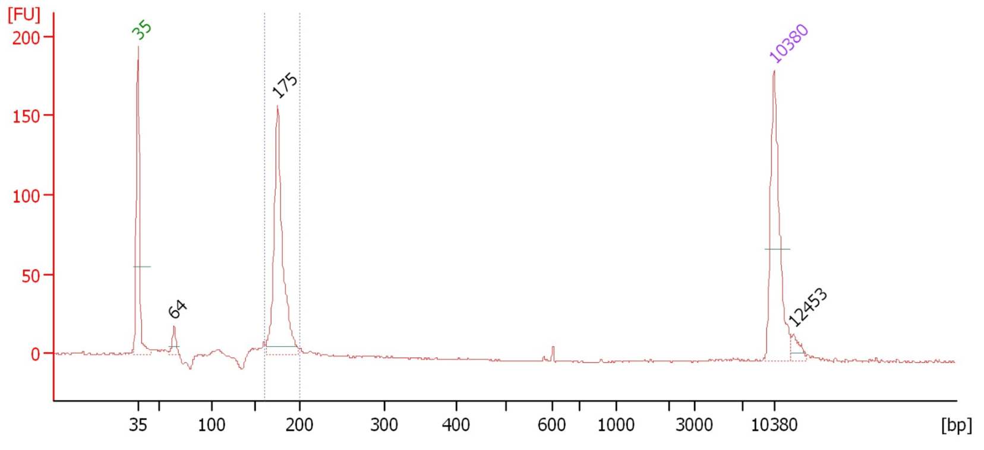

1. Sequencing:
   1. Barcodes can be sequenced independently or as fraction of endogenous cDNA library.
   2. Target 3000-5000 barcode reads per cell.
2. Analysis 🡪 <https://github.com/chris-mcginnis-ucsf/MULTI-seq>