1. Is your browser running HTTP version 1.0 or 1.1? What version of HTTP is the server running?

The browser is running HTTP 1.1 as it is requesting it.

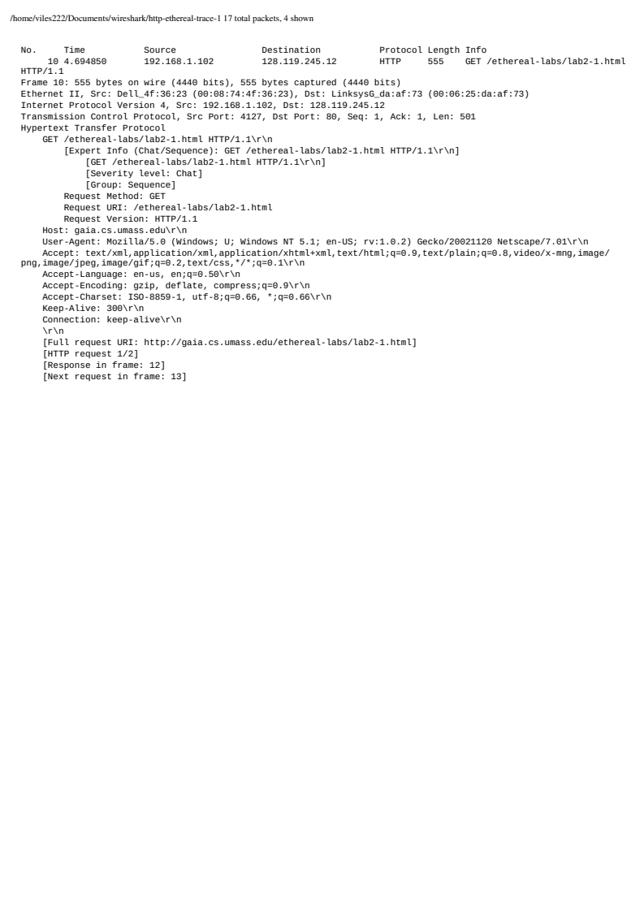

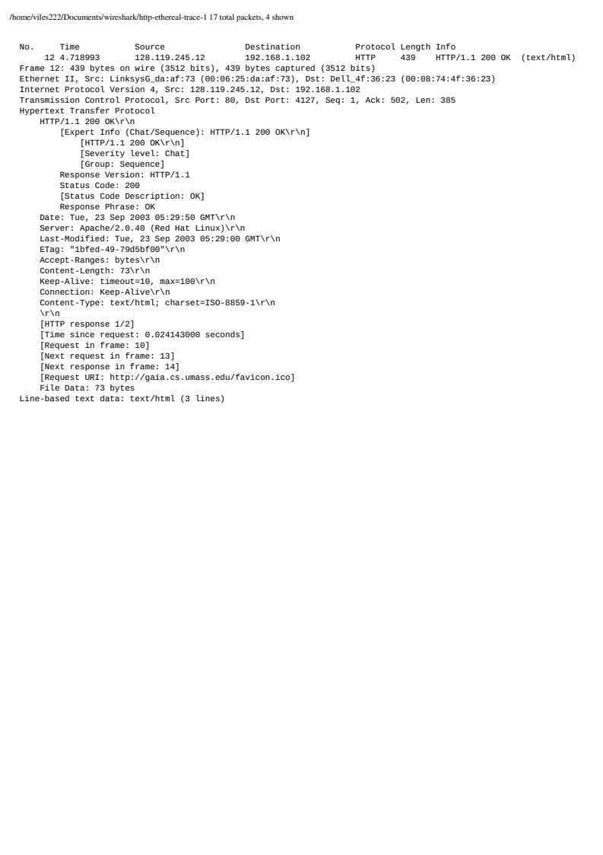The server is running HTTP 1.1 aswell.

1. What languages (if any) does your browser indicate that it can accept to the server? In the captured session, what other information (if any) does the browser provide the server with regarding the user/browser?

The browser accepts american - english language as seen at the blue line.

It also provides information on the users browser, browser version and operating system.

1. What is the IP address of your computer? Of the gaia.cs.umass.edu server?

The computer has the ip adress of 192.168.1.102 as seen in green which is its private ip adress provided by its router, unless set manually, probably not. The server has the ip adress of 128.119.245.12 as seen in black.

1. What is the status code returned from the server to your browser?

Status code 200, meaning OK, as seen in purple.

1. When was the HTML file that you are retrieving last modified at the server?

From the downloaded trace the last modification is from 05:29:00 23 september 2003.

1. How many bytes of content are being returned to your browser?

73 bytes of content are sent from the server to the user.

1. By inspecting the raw data in the packet content pane, do you see any HTTP headers within the data that are not displayed in the packet-listing window? If so, name one.

There is tcp data included in the HTTP header ass well.

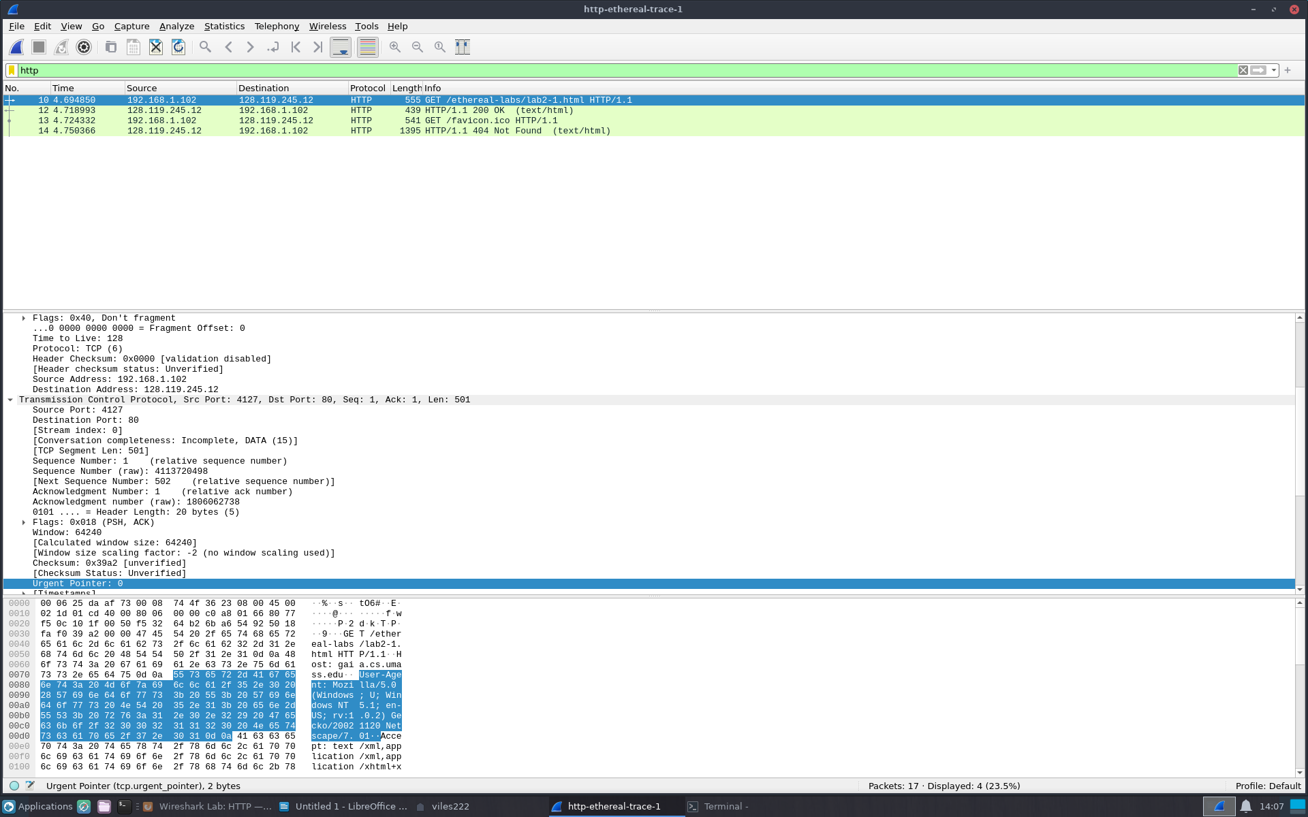

**Task A:** For questions 1-7, first write a brief but precise answer for each of the above questions, then write a (combined) paragraph explaining and discussing your observations from the above practice questions. Note that your answer may benefit from explaining and/or referring to some of your observations explicitly.

Both the browser and server seems to be running HTTP 1.1 with the browser acceptring only enslish language. With the user running windows with netscape as browser. The user has the local ip address of 192.168.1.102 and the server having the public ip of 128.119.245.12.

My observations

1. 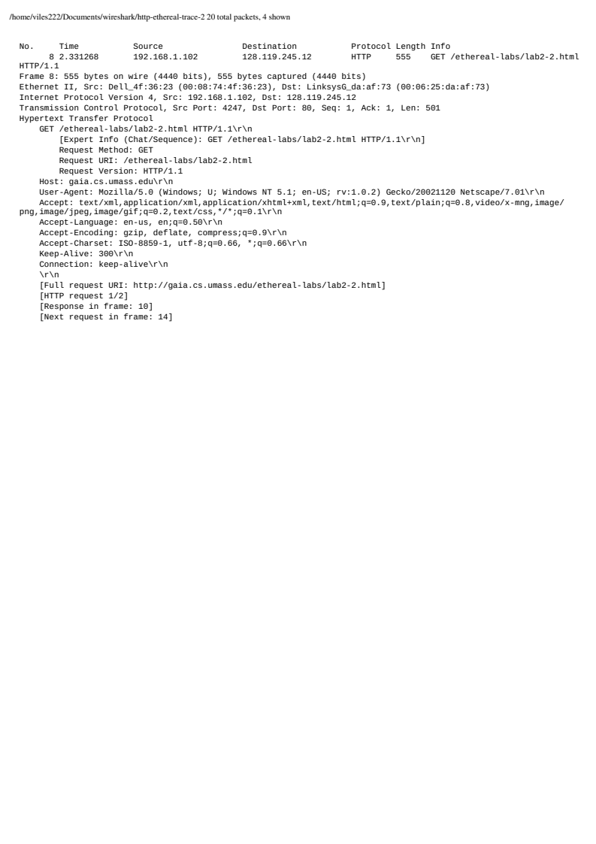Inspect the contents of the first HTTP GET request from your browser to the server. Do you see an “IF-MODIFIED-SINCE” line in the HTTP GET?

There is no if-modified line in the first request to the server.

1. Inspect the contents of the server response. Did the server explicitly return the contents of the file? How can you tell?

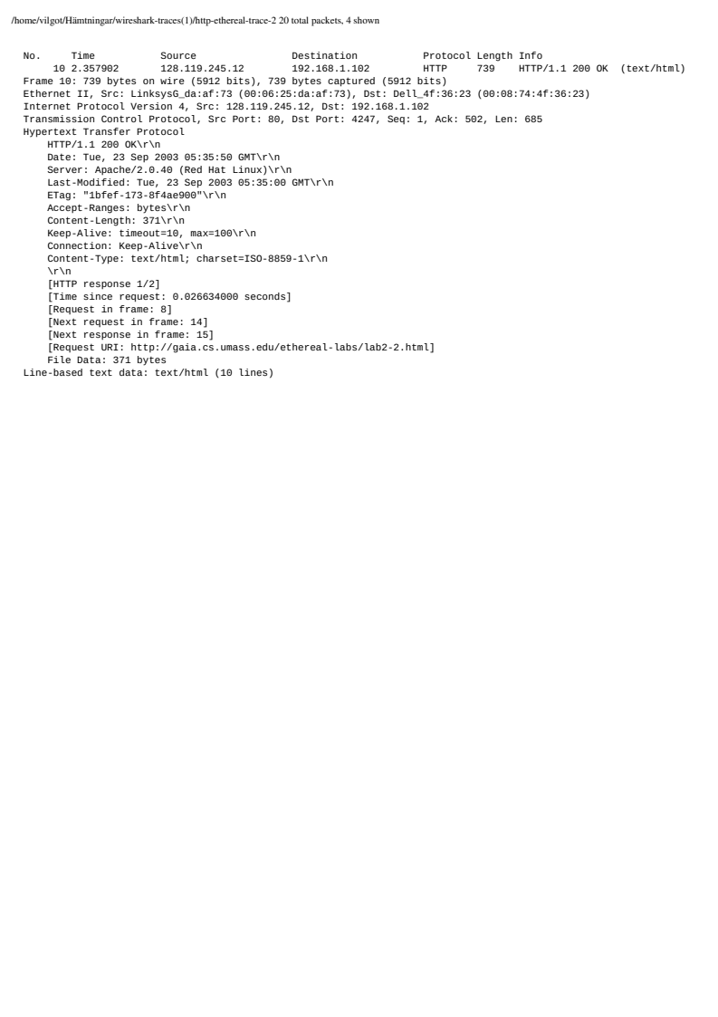Yes, this can be seen in the http header of ”Line-based text data” of 10 lines as seen in blue.

1. Now inspect the contents of the second HTTP GET request from your browser to the server. Do you see an “IF-MODIFIED-SINCE:” line in the HTTP GET? If so, what information follows the “IF-MODIFIED-SINCE:” header?

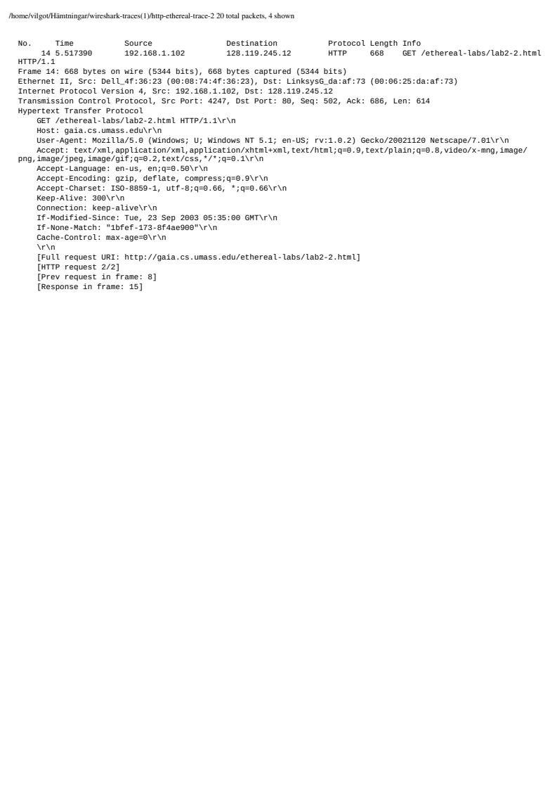

Yes, the information that follows is the last time the website was modified as seen in black.

1. What is the HTTP status code and phrase returned from the server in response to this second HTTP GET? Did the server explicitly return the contents of the file? Explain.

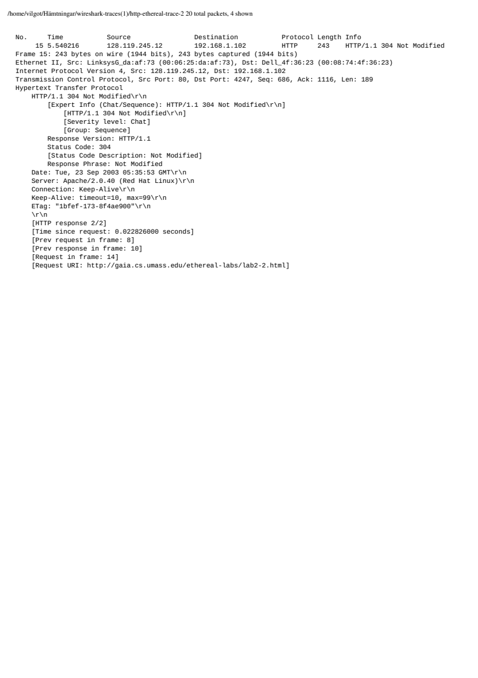

It gave return code of 304 meaning that the file requested has not been modified since last time.

It did not return the contents of the file since it has been locally cached on the computer and it hasn’t been modified since the last time requesting the file.

**Task B:** For questions 8-11, first write a brief but precise answer for each of the above questions, then write a (combined) paragraph explaining and discussing your observations from the above practice questions. Note that your answer may benefit from explaining and/or referring to some of your observations explicitly.

1. How many HTTP GET request messages did your browser send? Which packet number in the trace contains the GET message for the Bill or Rights?

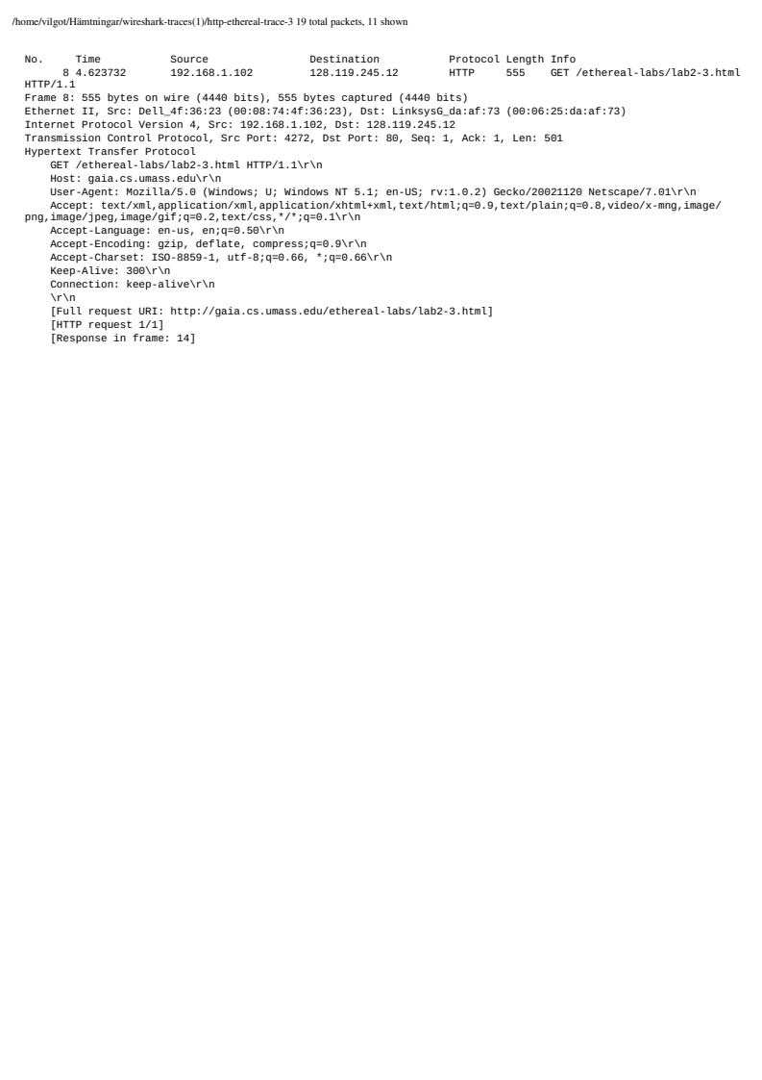The browser sent one HTTP get request seen in blue. Packet number 8 contains the get message as seen in blue.

1. Which packet number in the trace contains the status code and phrase associated with the response to the HTTP GET request? What is the status code and phrase in the response?

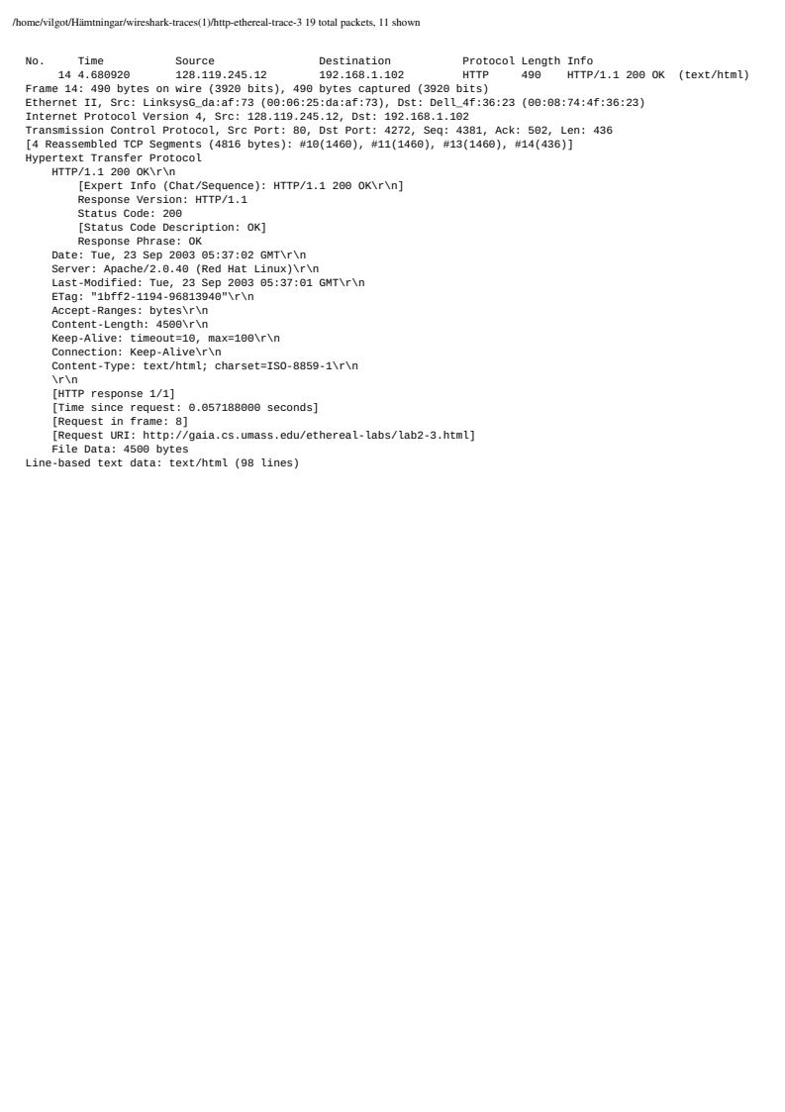

Packet number 14 seen in blue contains the status code of 200 meaning OK seen in red.

1. How many data-containing TCP segments were needed to carry the single HTTP response and the text of the Bill of Rights?

There were 4 TCP segments needed to carry the response as seen in green in the previous question.

1. Is there any HTTP header information in any of the transmitted data packets associated with TCP segmentation? For this question you may want to think about at what layer each protocol operates, and how the protocols at the different layers interoperate.

**Task C:** For questions 12-15, first write a brief but precise answer for each of the above questions, then write a (combined) paragraph explaining and discussing your observations from the above practice questions. Note that your answer may benefit from explaining and/or referring to some of your observations explicitly.