LAB 3
TDTS04

hugho678 & viles222
Answer the following questions (short answers):
- What are the first and last packets for the POST request? Hint: Look for where the POST request is first initiated in the TCP stream; it often starts earlier in the trace than where 'POST' is explicitly labeled.

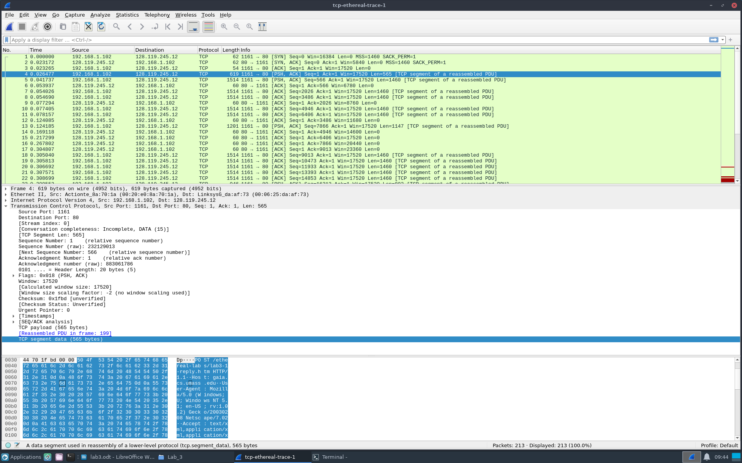
The first packet is of the Post request is frame 4 and the last one is frame 199.
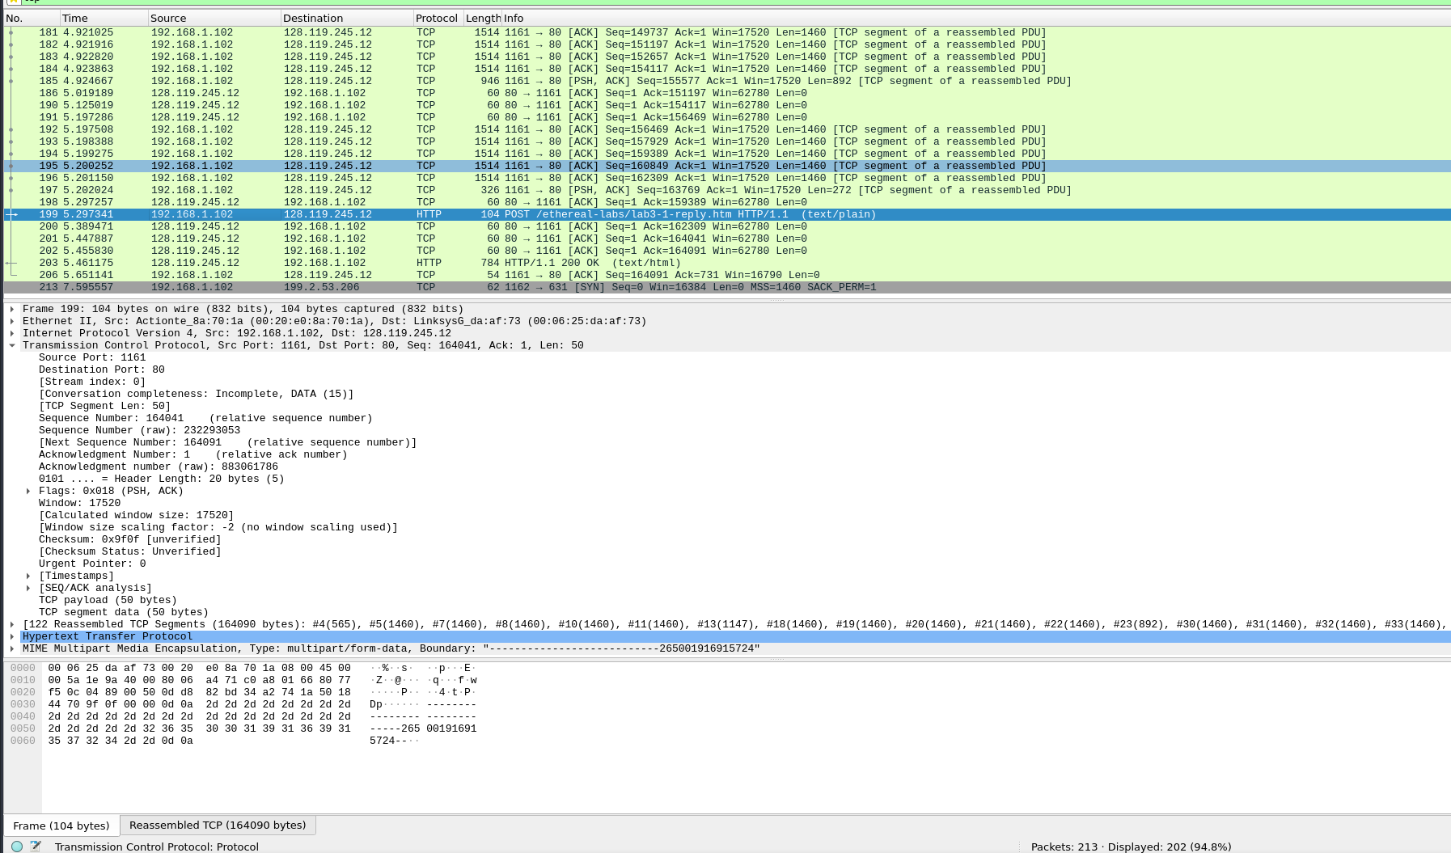

- What is the IP address and the TCP port number used by the client computer (source) that is transferring the file to gaia.cs.umass.edu?
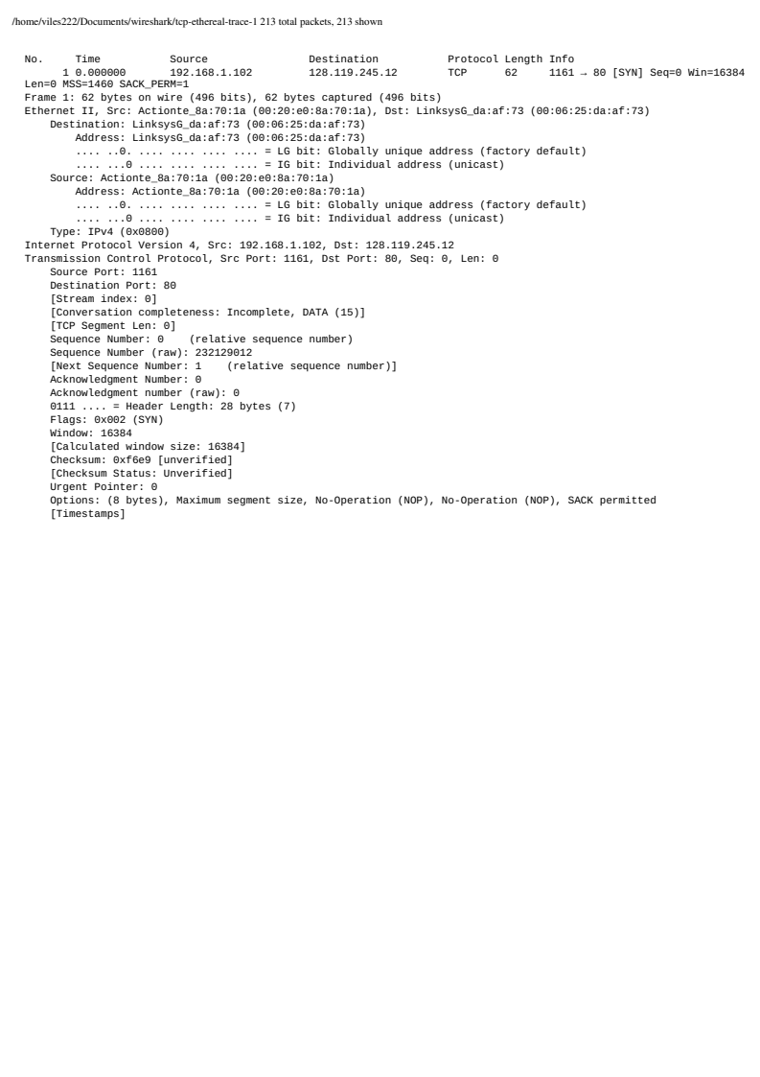
The source ip address is 192.168.1.102 and the sending and reciving port number is 1161 as seen in blue.

- What is the IP address of gaia.cs.umass.edu? On what port number is it sending and receiving TCP segments for this connection?
The ip address of gaia.cs.umass.edu is 128.119.245.12 and the port being used is 80 as seen in red.

- What is the sequence number of the TCP SYN segment that is used to initiate the TCP connection between the client computer and gaia.cs.umass.edu? What is it in the segment that identifies the segment as a SYN segment?
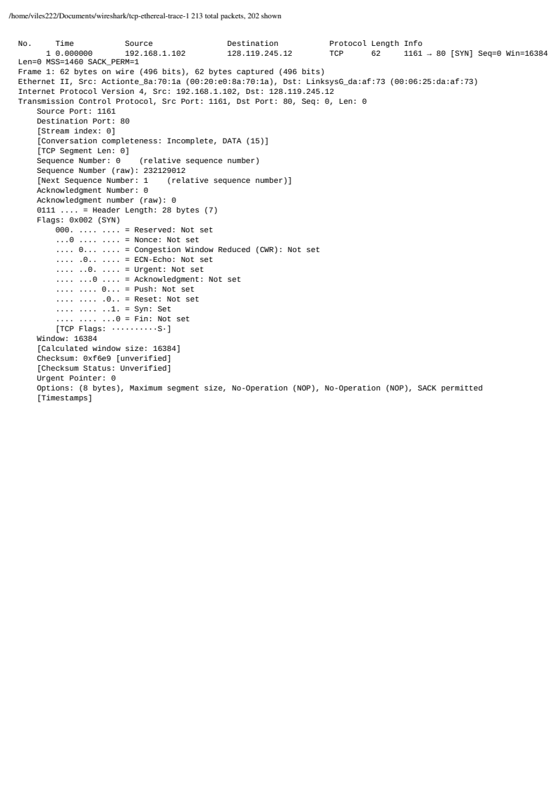
The sequence number for the TCP SYN segment is 232129012 and in the segment there is a syn flag set to identify it as a SYN segment as seen in blue.

- What is the sequence number of the SYNACK segment sent by gaia.cs.umass.edu to the client computer in reply to the SYN? What is the value of the ACKnowledgement field in the SYNACK segment? How did gaia.cs.umass.edu determine that value? What is it in the segment that identifies the segment as a SYNACK segment?
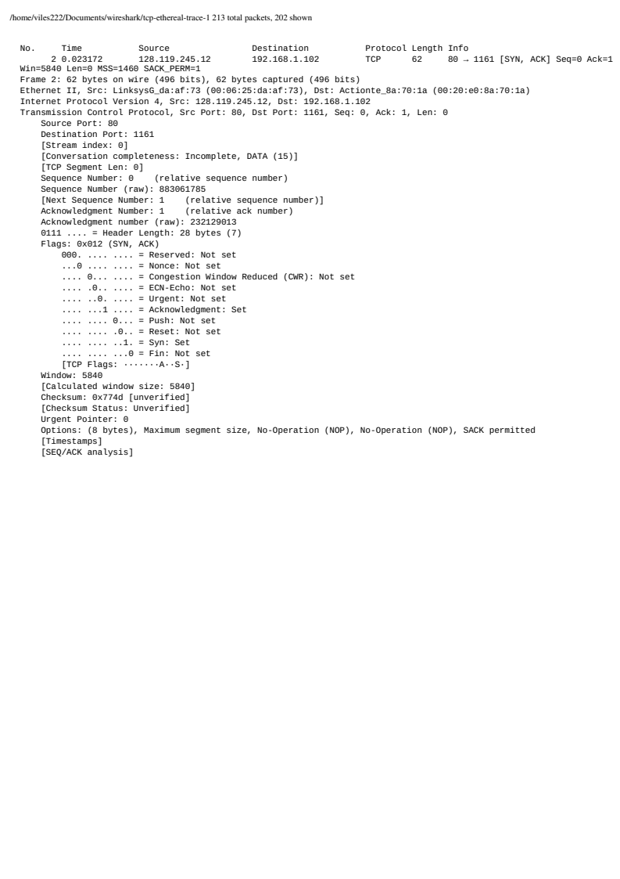

The sequence number sent by the server is 883061785. In the SYNACK segment the ACK value is 232129013, which is the TCP syn value incremented once as to identify it as a synack segment

- What is the sequence number of the TCP segment containing the HTTP POST command?
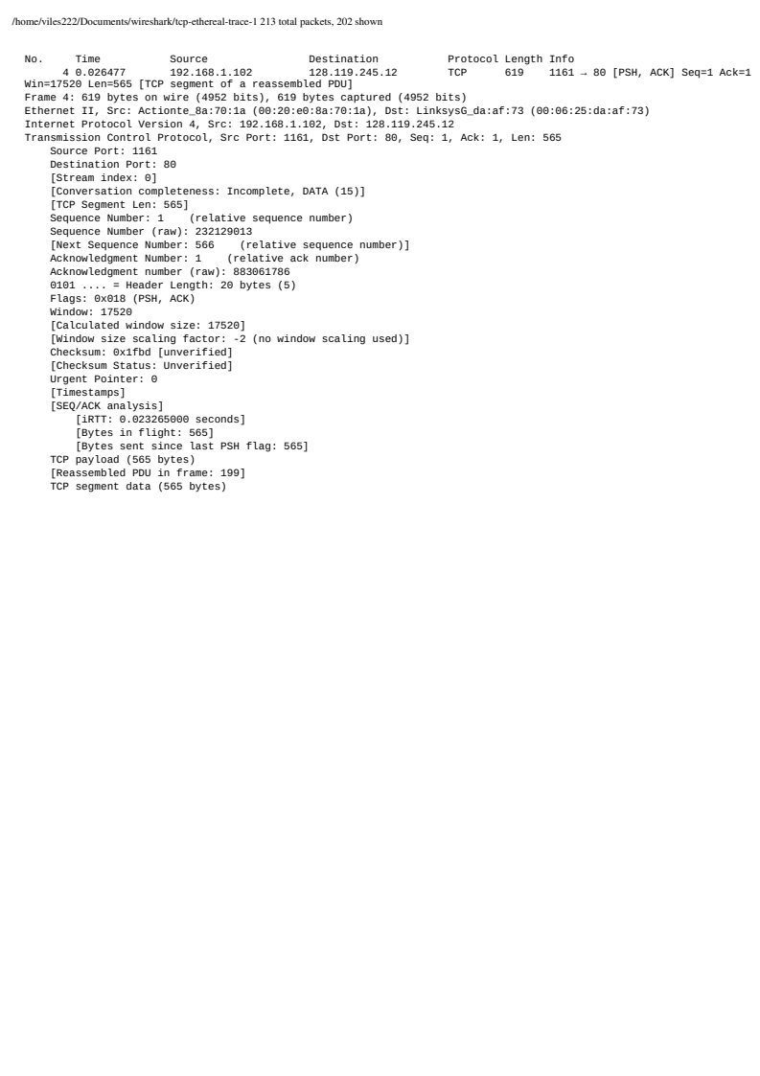

The sequence number of the TCP segment containing the HTTP POST command is 232129013 as seen in blue.

- Consider the TCP segment containing the HTTP POST as the first segment in the TCP connection. What are the sequence numbers of the first six segments in the TCP connection (including the segment containing the HTTP POST)?
At what time was each segment sent?
When was the ACK for each segment received?
Given the difference between when each TCP segment was sent, and when its acknowledgement was received, what is the RTT value for each of the six segments?
What is the EstimatedRTT value (see Section 3.5.3, page 269 in text) after the receipt of each ACK? Assume that the value of the EstimatedRTT is equal to the measured RTT for the first segment, and then is computed using the EstimatedRTT equation on page 270 for all subsequent segments.

Note: Wireshark has a nice feature that allows you to plot the RTT for each of the TCP segments sent. Select a TCP segment in the “listing of captured packets” window that is being sent from the client to the gaia.cs.umass.edu server. Then select: Statistics->TCP Stream Graph->Round Trip Time Graph.

Frame | Segment number | Time segment sent | ACK recived | RTT | Estimated  RTT
4 | 232129013 | 0,026477 | 0,053937 | 0,02746 | 0,02746
5 | 232129578 | 0,041737 | 0,077294 | 0,035557 | 0,02847
7 | 232131038 | 0,054026 | 0,124085 | 0,070059 | 0,03367
8 | 232132498 | 0,05469 | 0,169118 | 0,114428 | 0,04376
10 | 232133958 | 0,077405 | 0,217299 | 0,139894 | 0,05578
11 | 232135418 | 0,078157 | 0,267802 | 0,189645 | 0,07251

- What is the length of each of the first six TCP segments?
Frame 4 is 565 bytes as seen in green in question 6 and the rest of the segments are 1460 bytes long as seen in red.
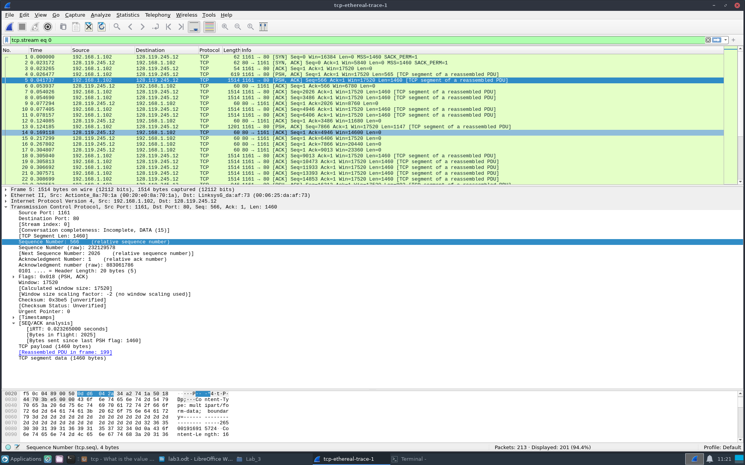

- What is the minimum amount of available buffer space advertised at the receiver for the entire trace?
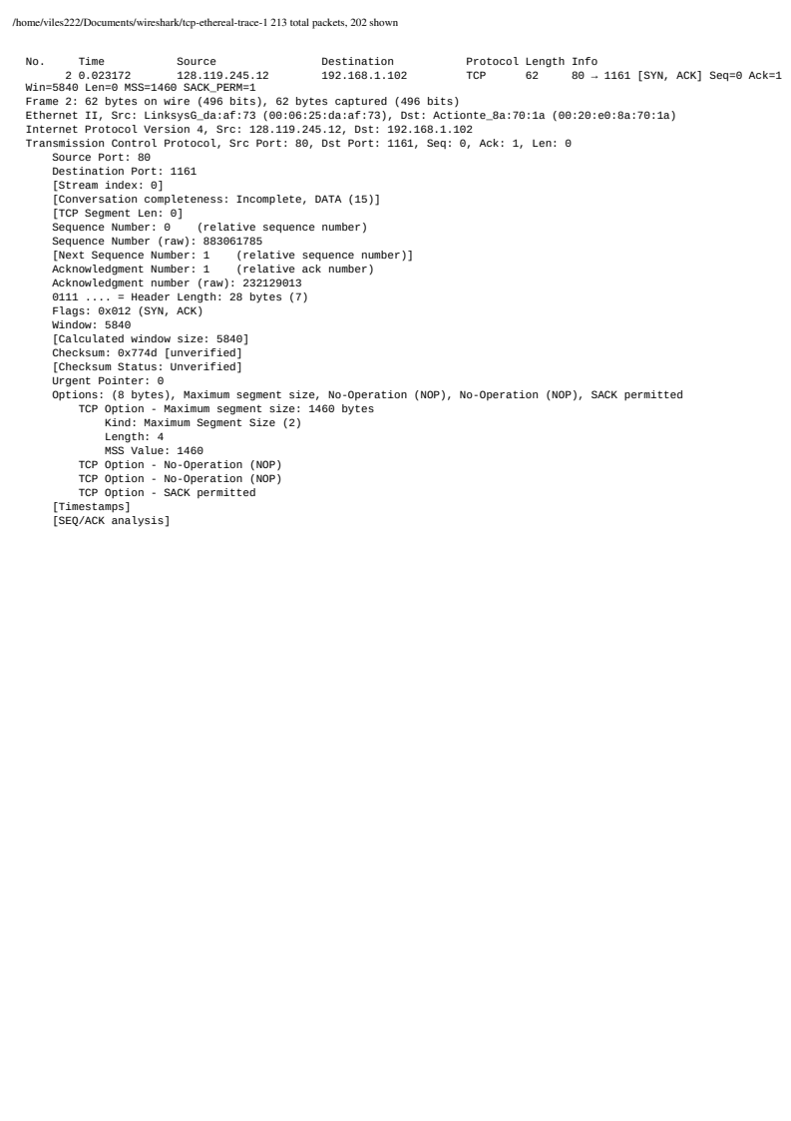
The mimimum amount of available buffer space is found in the TCP SYN ACK in frame 2 where the window size is 5840 bytes.

- Are there any retransmitted segments in the trace file? What did you check for (in the trace) in order to answer this question?
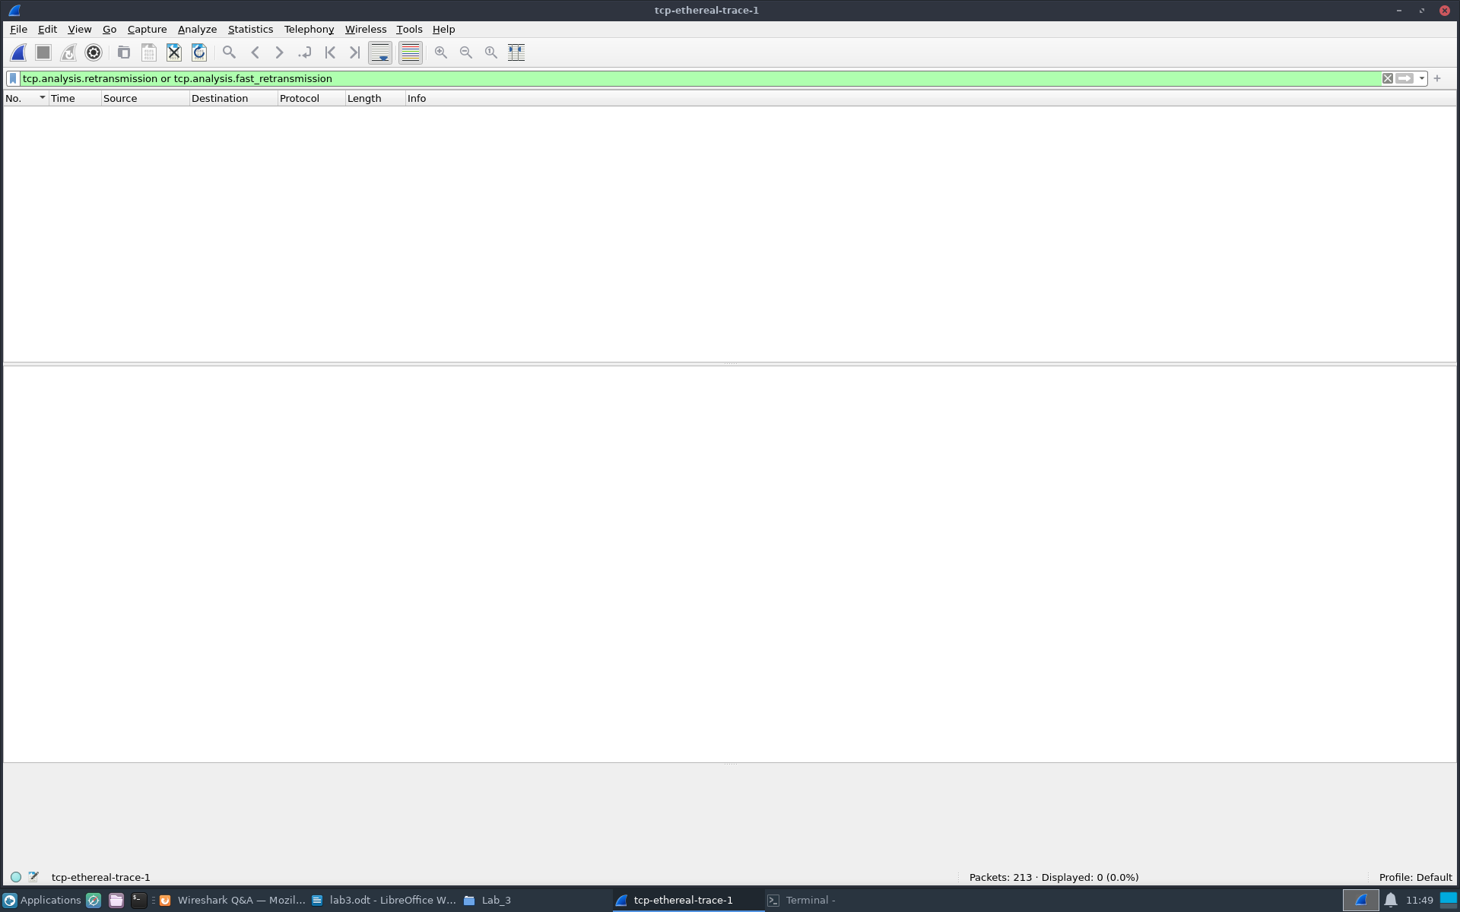
There are no retransmitted segment in the trace file. To check in the trace we would look for duplicated segment numbers and duplicated ACKs.

- How much data does the receiver typically acknowledge in an ACK? Identify instances in the packet trace where the receiver acknowledges two segments instead of one. Hint: Examine the sequence and ACK numbers to detect this pattern (see Table 3.2 on page 278 in the text).
The reciver typically ACKs 1460 bytes. An instance where the reciver acks two segments is for example in frame 80 where two 1460 packets are ACK ed once.
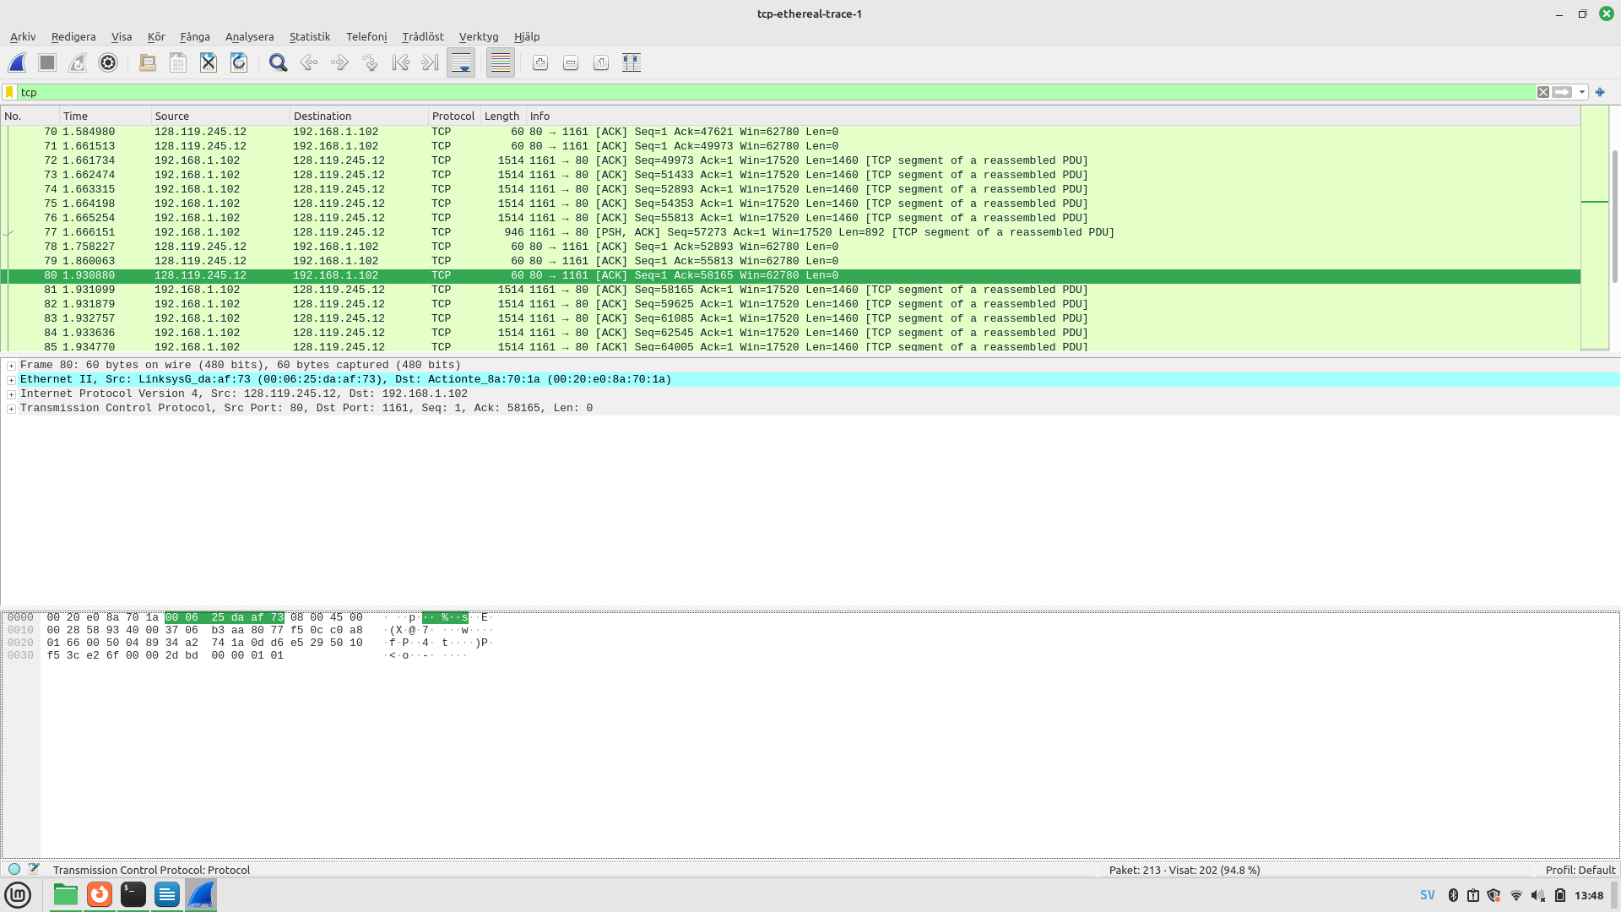

- What is the throughput (bytes transferred per unit time) for the TCP connection? Explain how you calculated this value.

Throughout = total sent bytes in tcp connection / time = 29036,773 bytes per second.

time = 0.026477 – 5.65111
total sent bytes == 164090

Task A: Now, based on questions 1-12, please write two paragraphs explaining and discussing your observations from the above questions. One paragraph should describe and discuss the connections at a high level. The second paragraph should discuss the impact of RTT estimates, packet losses, and interpreted packet loss events. Note that your answer may benefit from explaining and/or referring to some of your observations from the practice questions explicitly. Note that, similar to previous assignments, you are expected to convince us that you understand these aspects of TCP.

Disscussing the connections at a highlevel, the tcp connection begins in frame 4 and ends in frame 199. With a local computer transfering data to gaia.umass.edu through http port 80. After the syn ack is completed the tcp connection is realized and the client starts sending 560 and 1460 bytes size packes of data over to the server.

Disscussing the impact of RTT estimates, packet losses and interpreted packet loss events
Our RTT estimated did deviate by a significant bit from the real values. In the TCP connection there were no packet losses or packet loss events as there are no ack duplicates found at all in the trace.

13. Use the Time-Sequence-Graph (Stevens) plotting tool to view the sequence number versus time plot of segments being sent from the client to the gaia.cs.umass.edu server. Can you identify any indications of packet loss in this communication. What patterns in the sequence numbers suggest lost packets?
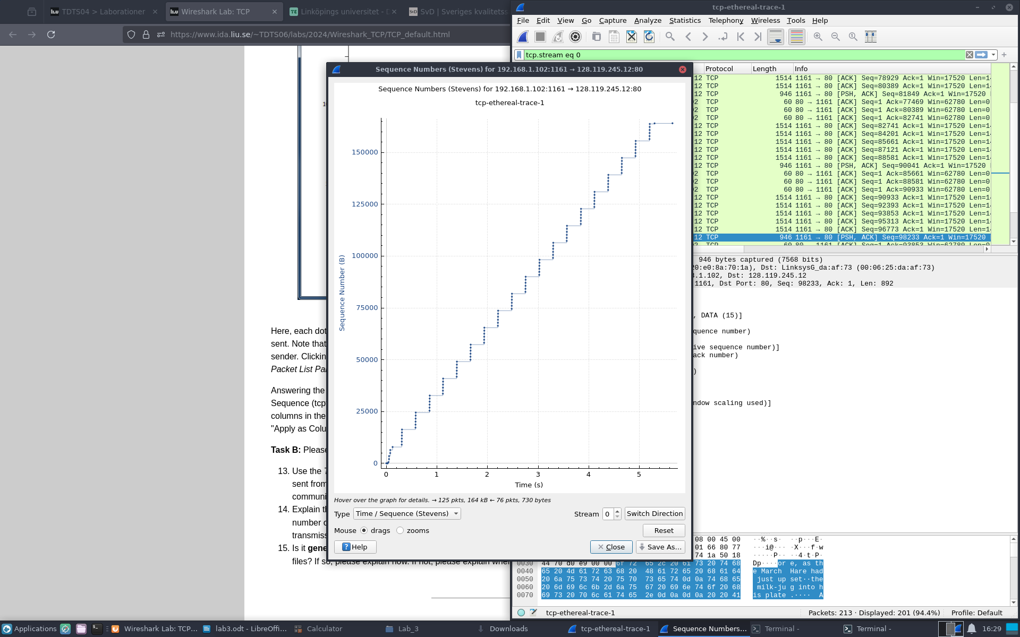

There are no indications of packet loss as if so there would be a pattern of repeated ACKs sent.

14. Explain the relationship between (i) the congestion window (cwnd), (ii) the receiver advertised window (rwnd), (iii) the number of unacknowledged bytes, and (iv) the effective window at the sender (i.e., the window effectively limiting the data transmission).

(i). The congestion window is variable the sender maintains for congestion control which is used to give the sender an idea of how much free buffer space is avaviable at the receiver and will dynamically adjust for network conditions. While the rwnd (ii) is the amount of buffer space avaviable at the reviver and is advertised in the tcp header. It is used to prevent the sender from sending too much data at once. (iii) The number of unacknowledged bytes is the amount of data the sender has sent but has not yet been acknowlaged for by the reciver. The sender will keep the amount unacknowlaged data less than the value of rwnd to prevent itself from overflowing the buffer of the reciver. (iv) The effective window at the sender is the smaller value of the congestion windon and the rwnd minus the unack:ed bytes and is the value limiting the transmission.

15. Is it generally possible to find the congestion window size (cwnd) and how it changes with time, from the captured trace files? If so, please explain how. If not, please explain when and when not. Motivate your answer and give examples.

It is now generally possible to find the cnwd value from a captured trace as it is a variable maintanied at the sender and is not transmitted explicitly in the tcp package headers. Yet it can be estimate its behaviour from observations as retransmissions, duplicate acknolagements or packet losses where the cwnd adjust and from which one can infer the cwnd indirectly.

16. What is the throughput of each of the connections in bps (bits per second)? What is the total bandwidth of the host on which the clients are running? Discuss the TCP fairness for this case.

Connection | Total transferred bytes | Duration (in seconds) | RTT (in milliseconds) | average throughput of connection
1 | 165095720 | 521 | 12 | 2535059,0403071
2 | 165842766 | 521 | 12 | 2546529,99616123
3 | 165458792 | 514 | 12 | 2575234,11673152
4 | 163235772 | 512 | 12 | 2550558,9375

17.What is the throughput of each of the connections in bps (bits per second)? What is the total bandwidth of the host on which the clients are running? Discuss the TCP fairness for this case.

Connection | Total transferred bytes | Duration (in seconds) | RTT (in milliseconds) | average throughput of connection in mega bits per second | Total bandwith of host in Mbits per sec
1 | 261319130 | 90 | 13 | 23,2250123870996 | 93,8862172519062
2 | 175995832 | 90 | 35 | 15,6379925140223
3 | 151894552 | 90 | 68 | 13,4915443442732
4 | 140388568 | 90 | 73 | 12,4688701830737
5 | 108610702 | 90 | 49 | 9,64903126075803
6 | 70644690 | 90 | 33 | 6,27722635033821
7 | 65744938 | 90 | 135 | 5,83524162644921
8 | 43212876 | 90 | 326 | 3,82728127006621
9 | 39222524 | 90 | 322 | 3,4740173158256

A tcp connection is considered fair if each connection gets and equal share of the bandwidth.

18. Discuss the TCP fairness for this case. How does it differ from the previous cases, and how is it affected by the use of BitTorrent?

Connection | Total transferred bytes | Duration (in seconds) | RTT (in milliseconds)
1 | 108851134 | 58 | 40
2 | 90435681 | 58 | 36
3 | 57971584 | 53 | 100
4 | 32000012 | 29 | 68
5 | 32557334 | 35 | 31
6 | 27199361 | 31 | 33
7 | 26329578 | 31 | 122
8 | 38834490 | 56 | 146
9 | 23571761 | 35 | 74
10 | 36252962 | 55 | 66

For this case it is harder to discuss tcp fairness as the RTT and the duration differs a lot for most of the connection. Connections 1 and 2, and 4 and 9 have similar durations and similar RTT but different amounts of transferred bytes hinting on TCP unfairness. This might be the cause of the use of bittorrents use of multiple TCP connections at once which might make the connections compete with each single connections tcp running at the same time.

For all of these questions you must take a closer look at the relationships between the characteristics of the different connections and discuss your findings in the context of the different experiments. You are expected to show that you understand the concept of TCP fairness and how the different scenarios may impact the throughput relationships that you observe and those that you may expect in general. To help the discussion you may for example want to create a scatter plot that show the estimated round trip time (RTT) and throughput against each other (for the different connections). You also want to carefully examine and discuss the above throughput equation and how it may apply to each scenario.

