Document details
Title ÖBB DOSTO Neu Software / Firmware Package Release Plan
Purpose Define how SW/FW packages are defined, gated, and delivered to the fleet
Issued to ÖBB – Österreichische Bundesbahnen
Document Reference ND-DEL-OBB-035-RM-001-01
Version Number 01
Last updated 14 July 2026
Author Abbas Rizvi
Approver Andrey Fomin
Number of pages 11

This document and any related documents contain strictly confidential information intended only
for the designated recipient(s). Any unauthorised disclosure, dissemination, distribution or copying of this
document or any related documents in any form is strictly prohibited.

Document control
Version | Revision date | Summary of edits | Created By | Approved By
1 | 14 July 2026 | First version of the document | Abbas Rizvi | Andrey Fomin

Disclaimer of liability
The information in this document is subject to change without notice and should not be construed as a commitment by Nomad Digital Ltd. While reasonable precautions have been taken, Nomad Digital Ltd assumes no responsibility for technical inaccuracies or typographical errors that may appear in this document. Nomad Digital Ltd reserves the right to revise this publication without obligation to provide notification of such revisions.

Contents
Document details 1
Document control 1
Disclaimer of liability 2
Contents 3
1. Introduction 5
1.1 Document Purpose 5
1.2 Why a package, and why one window 5
1.3 Scope 5
2. How packages bind to delivery milestones 6
2.1 The two rules 6
2.2 The gate chain 6
2.3 What each gate produces 7
2.4 Approval of firmware and configuration via the bench gate 7
3. Current fleet baseline 8
4. Gate status and schedule (illustrative example) 8
4.1 Gate status 8
4.2 Indicative schedule 9
4.3 Managing the window's dependency on its slowest component 9
4.4 The rollout window itself 9
4.5 The one operational condition 10
4.5.1 How availability is established 10
5. Dependencies outside the package 11
5.1 ÖBB 11
5.2 Stadler 11

1. Introduction

1.1 Document Purpose
This document defines how Nomad software and firmware reach the ÖBB DOSTO Neu fleet.
It replaces a per-component view — in which each switch configuration, firmware image and platform release is rolled out on its own schedule — with a package model: a versioned set of components, tested together, released together, and installed on each vehicle in a single rollout window.
The purpose is to answer two questions:
- What is in each package, and what is deliberately not.
- Which delivery milestones gate that package, and therefore what must be complete before it may be installed on a vehicle.

1.2 Why a package, and why one window
All updates are installed remotely. Software and firmware are pushed from the Nomad CCU over the vehicle's own network — no attendance at the train, no depot booking, no withdrawal from service for the work itself. This applies to every component within a package: the switch configuration, the switch firmware and the platform release.
Because installation is remote, the case for packaging is not about saving visits. It is about what reaches the fleet, and in what state:
One tested combination. Components are validated together, so the combination installed on the train is the combination that was tested. Rolling components out independently produces a fleet in which no two vehicles necessarily carry the same combination — and a combination that was never tested as a whole.
One approval. ÖBB approve a package, not a stream of individual changes.
A defined fleet baseline. After the window, every vehicle reached is at a known, identical baseline — which is what makes the fleet supportable and the next change assessable.
One scheduling exercise. Each installation still requires a slot when the vehicle is not carrying passengers (§4.4). Packaging means agreeing one such slot per vehicle rather than one per component.
The cost of this model is that a window is gated by its slowest component: nothing rolls out until everything in that package is ready. §4.3 states how that is managed within a package.

1.3 Scope
All four DOSTO Neu platform variants: nv4 (4734, 4-car, 25 trainsets), nv6 (4736, 6-car, 20), fv5 (4705, CAT 5-car, 3) and fv6 (4706, FV 6-car, 3) — 51 trainsets.

2. How packages bind to delivery milestones

2.1 The two rules
A package is bound to the delivery milestones by two rules.
Rule 1 — Entry gate. A package may not be installed on a vehicle until every one of its gate milestones is complete. The gates are cumulative: all must pass, in order.
Rule 2 — Content freeze. When the package content is frozen, its contents stop changing. Any component not ready at freeze does not delay the package — it waits for the next window. This is what prevents a single unready component from holding the whole fleet.
Together these mean a package has exactly two states: not yet released (a gate is open) or released (all gates passed, contents frozen, installing). There is no partial release.

2.2 The gate chain
Each package runs a defined gate chain, anchored on its own design freeze.
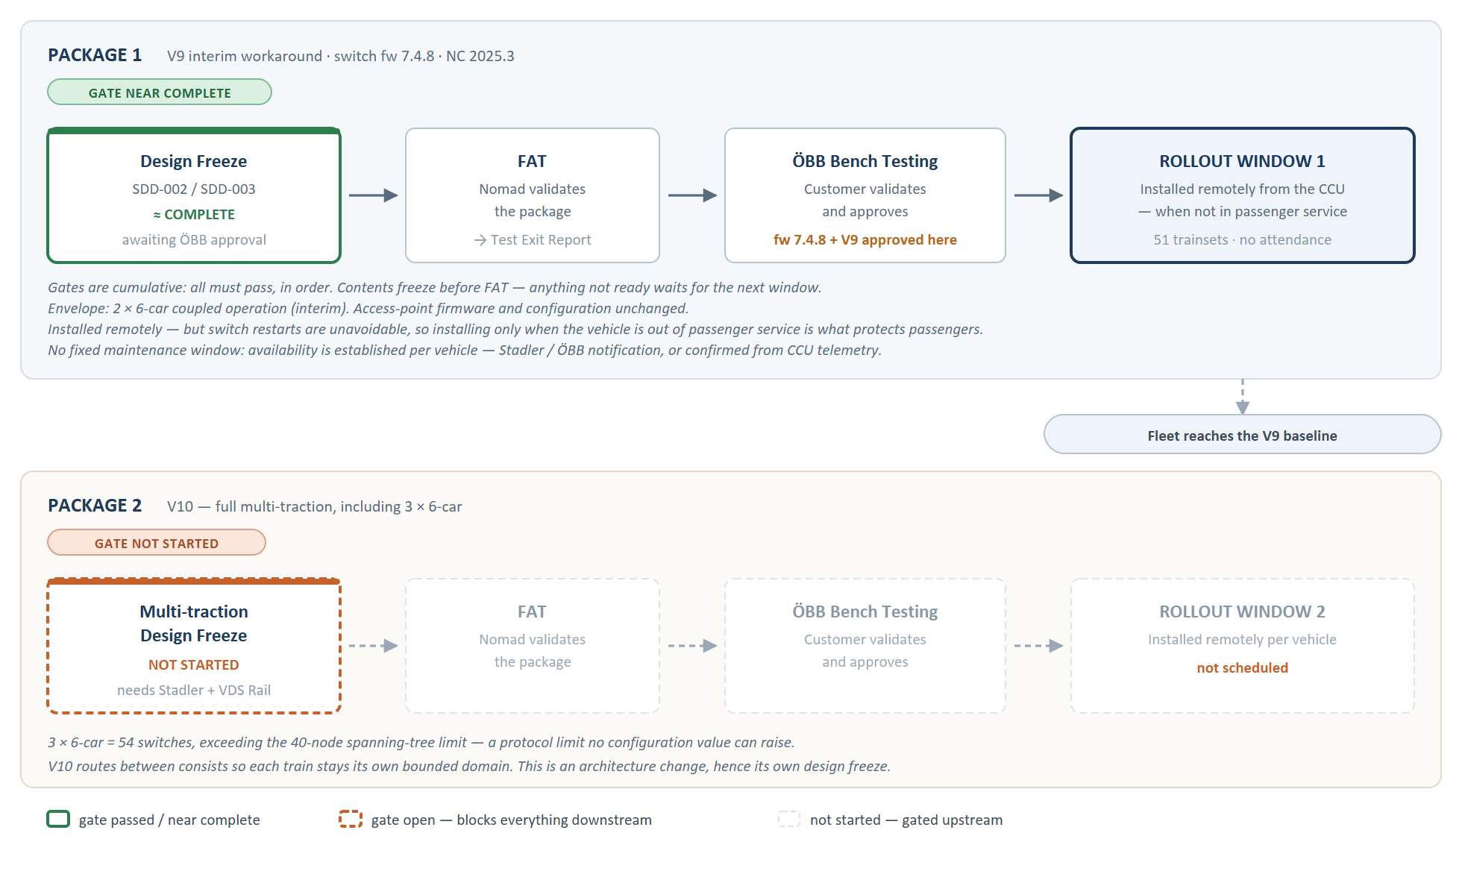
Figure 1 — Examples of package gate chains, anchored on its own design freeze.

Gate | Owner | What it establishes | Why it precedes the next
Design Freeze | ÖBB (approval); Nomad (documents) | The agreed design against which the package is built and tested. | Testing against an unfrozen design is not evidence — a later design change invalidates the test result.
FAT | Nomad | The package works as an integrated whole in Nomad's environment. | Presenting an unvalidated package for customer testing wastes the customer's bench time.
ÖBB Bench Testing | ÖBB | The customer has validated the package and approves it for their fleet. | This is the approval. Fleet installation without it is a change to the customer's fleet that the customer has not accepted.
Rollout Window | Nomad + ÖBB (scheduling) | — | —

2.3 What each gate produces
Gates are evidenced by documents, not by assertion:
Gate | Evidence
Design Freeze | SDD-002 and SDD-003 approved by ÖBB
Package content freeze | This document, revised to state the frozen contents
FAT | Test Exit Report(s) (TER) for the package components
ÖBB Bench Testing | ÖBB approval of the package
Rollout | HW & SW Release Note (ND-DEL-OBB-035-RN-001-01) revised to the new baseline

2.4 Approval of firmware and configuration via the bench gate
Firmware and configuration changes are approved through the ÖBB bench-testing gate, not before it. They enter the package as candidates; the bench gate is the mechanism by which they become approved for the fleet.
This is stated explicitly because it is the clearest illustration of how the package model differs from a per-component one. Under a per-component model, each item would need its own approval before rollout. Under this model, the package is tested as a whole and approved as a whole — which is both fewer approvals for ÖBB and a stronger guarantee, because what is approved is the combination that will actually be installed.
Until that gate passes, the fleet target remains the current baseline (§3.1).

3. Current fleet baseline
As recorded in the HW & SW Release Note (ND-DEL-OBB-035-RN-001-01):
Component | Current version
VDS Rail Consist Switch firmware | 7.4.2
VDS Rail Consist Switch configuration | V8
Westermo RT610LV access point firmware | 6.11.2-0 (IbexOS)
Nomad Connect / onboard-network engine (nd-obn) | 2.2.23
CCU platform image (Nomad Connect) | 2025.2.1
Nomad NMS | 2026.1.2

Rollout position: 25 of 51 trainsets are commissioned to this baseline. The remainder are at various stages, dependent on vehicle availability and on Stadler-side cabling work (§5.2).

4. Gate status and schedule (illustrative example)

4.1 Gate status
# | Gate | Owner | Status | Evidence required
1 | Design Freeze (V8 scope — SDD-002 / SDD-003) | ÖBB | (Example) Awaiting ÖBB approval of the final design documents. | Design documents approved by ÖBB
2 | Package content freeze | Nomad | (Example) Project Release notes | Project release notes template is filled
3 | FAT | Nomad | Not started — gated on 1 | Test Exit Report(s)
4 | ÖBB Bench Testing | ÖBB | Not started — gated on 3 | ÖBB approval of the package
5 | Rollout Window opens | Nomad + ÖBB | Not started — gated on 4 | —

Critical path: Gate 1 → 3 → 4 → 5. Design Freeze is typically the long pole; everything downstream waits on ÖBB approval of the frozen design.

4.2 Indicative schedule
Dates to be confirmed. The targets below are placeholders pending agreement with ÖBB and DevOps. The gate logic is fixed; the dates are not, and each is conditional on the preceding gate.
Milestone | Owner | Target | Depends on
Design Freeze — ÖBB approval | ÖBB | (TBD) | Design documents (Nomad side complete)
Package content freeze | Nomad | (TBD) | Design Freeze
Platform Test Exit Report | Nomad DevOps | (TBD) | Package content freeze
FAT — package validated | Nomad | (TBD) | TER; Design Freeze
ÖBB Bench Testing | ÖBB | (TBD) | FAT
ÖBB package approval | ÖBB | (TBD) | ÖBB Bench Testing
Rollout Window opens | Nomad + ÖBB | (TBD) | ÖBB package approval
Rollout Window closes | Nomad + ÖBB | (TBD) | Vehicle availability

4.3 Managing the window's dependency on its slowest component
The package model's cost (§1.2) is that the window waits for its slowest component. This is managed by the content freeze:
At content freeze, any component not ready is removed from the package rather than allowed to delay it.
A removed component becomes a candidate for the next window.
The freeze decision is a Nomad recommendation, confirmed with ÖBB.
The practical consequence: if one component is not ready to enter FAT at content freeze, the package proceeds without it, and that component moves to a second window. The reverse also applies.

4.4 The rollout window itself
The rollout window is a scheduling window, not a visit window. Each vehicle receives the full package remotely, in one installation:
Installed remotely from the CCU. No attendance at the vehicle.
Installed when the vehicle is not carrying passengers. This is what protects passenger service, and it is the one operational condition the package depends on. There is no fixed maintenance window — availability is established per vehicle, see §4.5.
All package components are installed in one sequence, in a defined order so that a device restart does not isolate devices behind it.
The vehicle is verified against the package's target baseline after installation.
The vehicle's state is recorded, so an installation interrupted by loss of connectivity resumes from a known point rather than restarting.
Vehicles are taken into the window as they become available — either on notification from Stadler / ÖBB, or when telemetry shows the vehicle parked and reachable (§4.5). The window closes when all reachable vehicles carry the package.

4.5 The one operational condition
Applying a switch configuration or firmware image restarts the switch — this is how the change is persisted, and it is unavoidable. While a switch restarts, the passenger Wi-Fi and Stadler devices it serves are briefly unavailable.
Remote installation does not remove this. It changes only how the work is delivered, not what happens on the train when it lands. The protection is therefore timing:
Package installations are performed when the vehicle is not in passenger service — never during revenue operation.
This is stated plainly because it is a condition, not a property. The package is safe for passenger service because of when it is installed, not because of anything intrinsic to the changes. If a vehicle were updated in service, passengers would see Wi-Fi interruptions as each switch restarted. This condition is what keeps the package safe for passenger service.

4.5.1 How availability is established
There is no fixed maintenance window on this project. Vehicle availability is established per vehicle, from either of two sources:
Source | How it works
Notification | Stadler or ÖBB advise Nomad that a vehicle is available for work.
Telemetry | Nomad confirms from the CCU that the vehicle is parked and not in service before initiating the installation.

The two are complementary rather than alternatives: a notification tells Nomad a vehicle should be available; telemetry confirms it is, at the moment of installation. Where both are present, telemetry is the check that immediately precedes the push.
This makes vehicle availability a shared dependency, not solely a Nomad one. Nomad cannot create availability; it can only use it when it arises or is advised. Rollout pace therefore follows vehicle availability, which is why §4.2 offers no fixed rollout duration.
Connectivity dependency. Because installation is remote, it depends on the vehicle being reachable over its cellular link for the duration. Vehicles that are powered down or out of coverage are not reached and are picked up on a later occasion — an unreachable vehicle is a deferral, not a failure. In practice a proportion of the fleet is unreachable at any given time, and the rollout is planned on that basis.

5. Dependencies outside the package

5.1 ÖBB
Approval of the final Technical Description (design freeze) — typically the critical-path gate.
Bench testing and package approval.
Notification of vehicle availability for installation, where known in advance (§4.5). There is no fixed maintenance window, so each installation depends on a vehicle being out of passenger service and reachable. Nomad also confirms this from CCU telemetry, but advance notice from ÖBB or Stadler materially improves rollout pace.

5.2 Stadler
Stadler-side activities, outside Nomad's scope, which do not gate the package but affect per-vehicle completion:
Open cabling faults. Physical cabling and port-assignment faults identified during Nomad health checks require Stadler action. Tracked and reported separately. A vehicle with an open cabling fault can still receive the package; the fault remains open.
Firewall commissioning on the transit link, incomplete on some trainsets. Does not affect the Nomad onboard-network baseline.
Scope boundary: Nomad provides the configuration of the switch ports serving Stadler devices. The testing of those devices is Stadler's responsibility.

