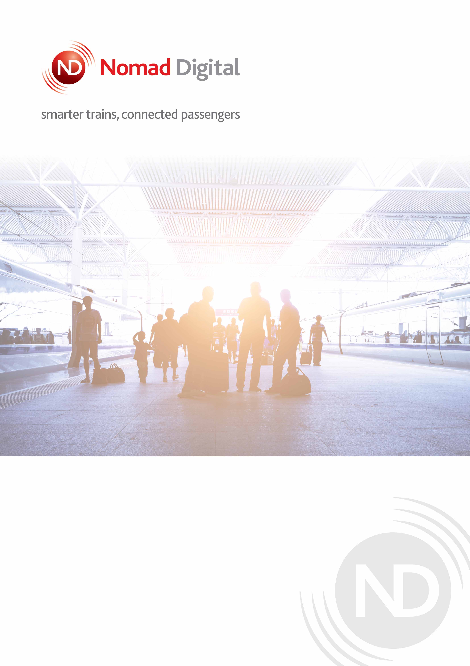

Nomad Connect – Train to Ground Tunnel Architecture

document history
Date | Issue | Comment | Author
V1.0 | 18.03.2026 | Added Section 3: Nomad Connect train-to-ground connectivity (MAR5 tunnel) | Abbas Rizvi

Contents
1 Nomad Connect — Train-to-Ground Connectivity 4
1.1 Overview 4
1.2 Tunnel Protocol: MAR5 5
1.3 Security 5
1.4 Vaneza Backend Endpoints (Home Agents) 6

Nomad Connect — Train-to-Ground Connectivity
This section describes the architecture and technical parameters of the Nomad Connect tunnel between each vehicle-side CCU and the Nomad Customer Data Centre (CDC). It addresses the connectivity questions raised by Siemens regarding the Nomad tunnel layer within the Vaneza Internet on Board (IoB) system.

Overview
Each train in the Vaneza fleet is equipped with one R5001C CCU (NIMD 1138) running Nomad Connect. The CCU establishes an outbound encrypted tunnel over the available cellular (4G/5G) or wayside Wi-Fi bearers to a set of dedicated Home Agent (HA) virtual machines hosted at the NextLayer data centre in Vienna, Austria. All connections are initiated by the CCU — no inbound ports need to be opened at the vehicle side.
The Nomad Connect tunnel is independent of the other tunnel layers present in the Vaneza on-board system (Televic Tunnel, Train Server Tunnel). The three tunnels run in parallel and serve distinct purposes. This section covers the Nomad tunnel only.
The Nomad Connect Tunnel architecture can be visualized with the illustration below:
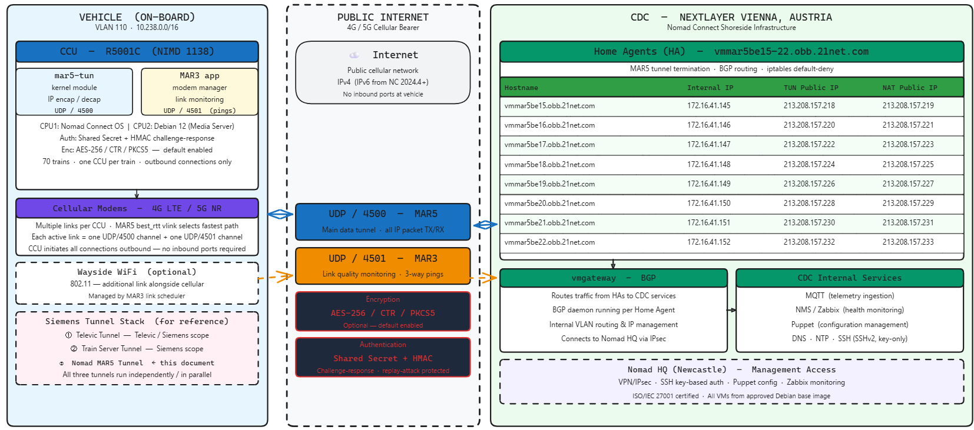

Tunnel Protocol: MAR5
Nomad Connect uses a proprietary tunnel protocol called MAR5 for all train-to-ground IP transport. MAR5 is an evolution of the earlier MAR3 protocol. It implements IP packet encapsulation and decapsulation directly in a Linux kernel module running on the CCU (the mar5-tun device), providing high throughput on the embedded platform. The MAR3 application layer continues to run alongside MAR5 and is responsible for modem management, link selection, and link quality monitoring.
MAR5 and MAR3 run as a two-channel stack on every active modem link:
Channel | UDP Port | Purpose
MAR5 | 4500 | Main data tunnel — all IP packet TX/RX between CCU and Home Agent
MAR3 | 4501 | Link quality monitoring — three-way pings, modem management, link scheduling
The CCU selects the best available link for each new session using the best_rtt virtual link (vlink) algorithm, which continuously evaluates round-trip time across all active modems and assigns new sessions to the lowest-latency path.
Transport layer: UDP over IPv4. IPv6 carrier support is available from Nomad Connect version 2024.4 onwards.

Security
Authentication:
The CCU and the Home Agent share a pre-configured shared secret. On connection, the HA issues a random challenge. The CCU hashes the challenge together with the shared secret using HMAC and returns the result. The HA independently verifies the hash. This mechanism provides mutual authentication and protects against replay attacks.
Encryption:
Tunnel payload is encrypted using AES-256 in CTR mode with PKCS5 padding. This is the default configuration applied to all Vaneza production CCUs.
Firewall posture:
All ports on the CCU and CDC virtual machines are disabled by default (iptables default-deny). Only the two UDP ports listed in Section 3.2 are opened for tunnel traffic. All internal service traffic — including NMS/MQTT telemetry, Puppet configuration management, NTP, and DNS — is carried inside the established tunnel and does not require additional open ports.

Vaneza Backend Endpoints (Home Agents)
The Vaneza project is served by eight Home Agent virtual machines hosted at NextLayer, Vienna, Austria. Each CCU connects outbound to the TUN Public IP of its assigned Home Agent over UDP port 4500 (MAR5) and UDP port 4501 (MAR3). The NAT Public IP is used for CCU internet traffic that exits directly via the CDC in the classic tunnel configuration.
Hostname | Internal IP | TUN Public IP | NAT Public IP
vmmar5be15.obb.21net.com | 172.16.41.145 | 213.208.157.218 | 213.208.157.219
vmmar5be16.obb.21net.com | 172.16.41.146 | 213.208.157.220 | 213.208.157.221
vmmar5be17.obb.21net.com | 172.16.41.147 | 213.208.157.222 | 213.208.157.223
vmmar5be18.obb.21net.com | 172.16.41.148 | 213.208.157.224 | 213.208.157.225
vmmar5be19.obb.21net.com | 172.16.41.149 | 213.208.157.226 | 213.208.157.227
vmmar5be20.obb.21net.com | 172.16.41.150 | 213.208.157.228 | 213.208.157.229
vmmar5be21.obb.21net.com | 172.16.41.151 | 213.208.157.230 | 213.208.157.231
vmmar5be22.obb.21net.com | 172.16.41.152 | 213.208.157.232 | 213.208.157.233

Traffic arriving at the Home Agent from the tunnel is forwarded to a vmgateway virtual machine running a BGP daemon, which routes it to the appropriate internal CDC service (NMS, telemetry, management). Configuration of all CDC virtual machines is managed via Puppet. All VM access uses SSHv2 with key-based authentication only.

