Directions to run the automation:

### Install and Run Jupyter Notebook

1. Download Anaconda from [here](https://www.anaconda.com/download/)
2. Open the downloaded .exe or .dmg file
3. Follow the directions on-screen to install
4. Once the installation is complete, open Anaconda application, you should see a screen something like this:

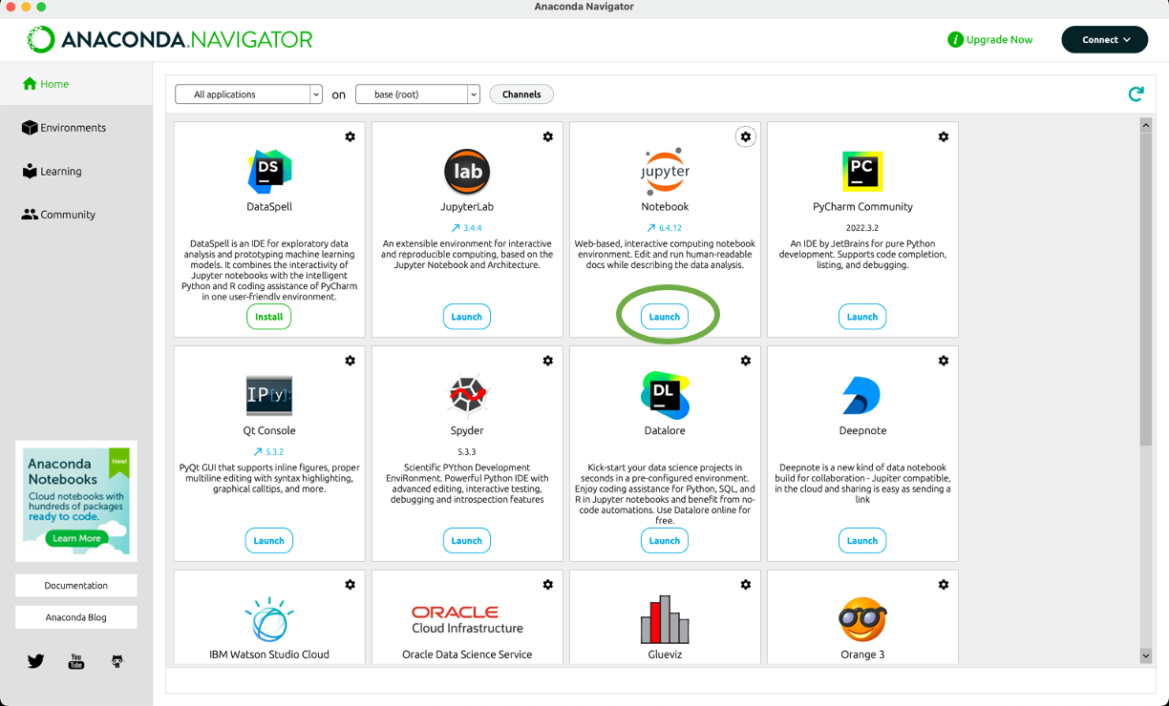

1. Click on “Launch” button for jupyter notebook. As indicated with a green oval above
2. You should see a window like this:

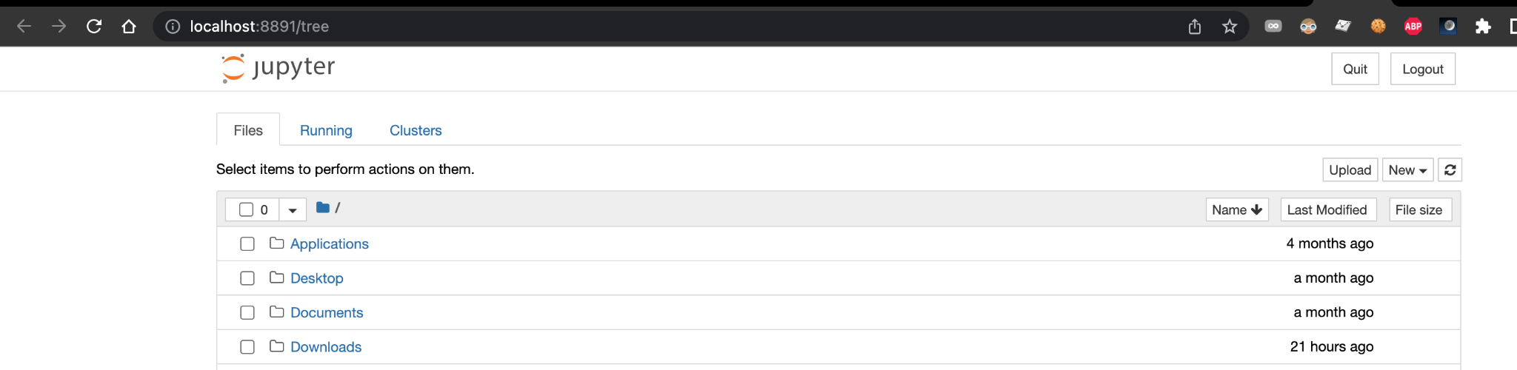

### Download the automation from GitHub

1. Visit [this](https://github.com/abss123/automated_job_application) link
2. Click on the “Code” button in the top right of the screen as indicated below:

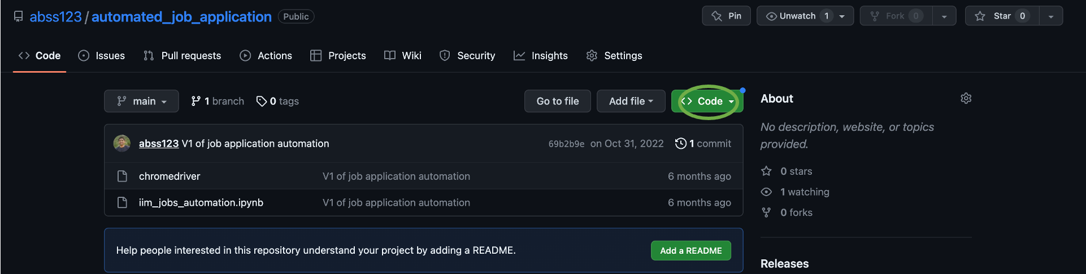

1. Click on “Download Zip” to download the files and unzip the file into a folder in your local device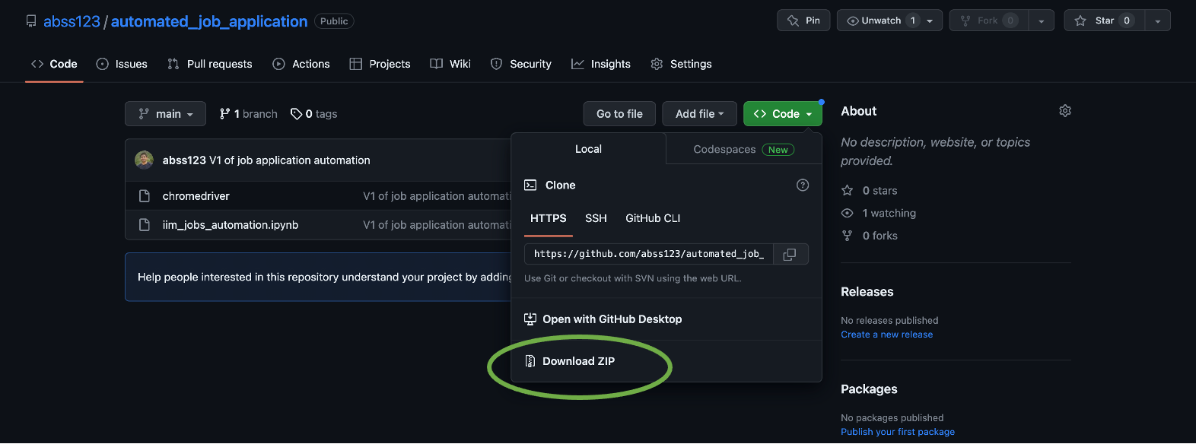

### Open the .ipynb notebook on Jupyter

1. Reach your working folder until you see the notebook and the chromedriver files like this:

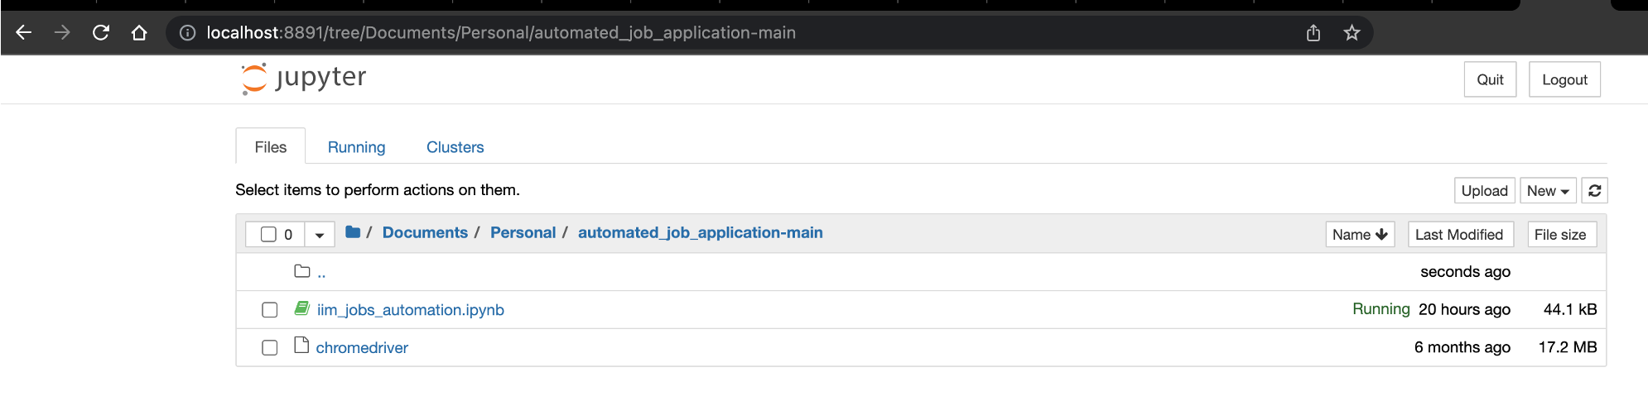

1. Open the iim_jobs_automation.ipynb file

### Run the .ipynb notebook on Jupyter

1. Update your iimjobs username and password in the third cell of the code as shown below:

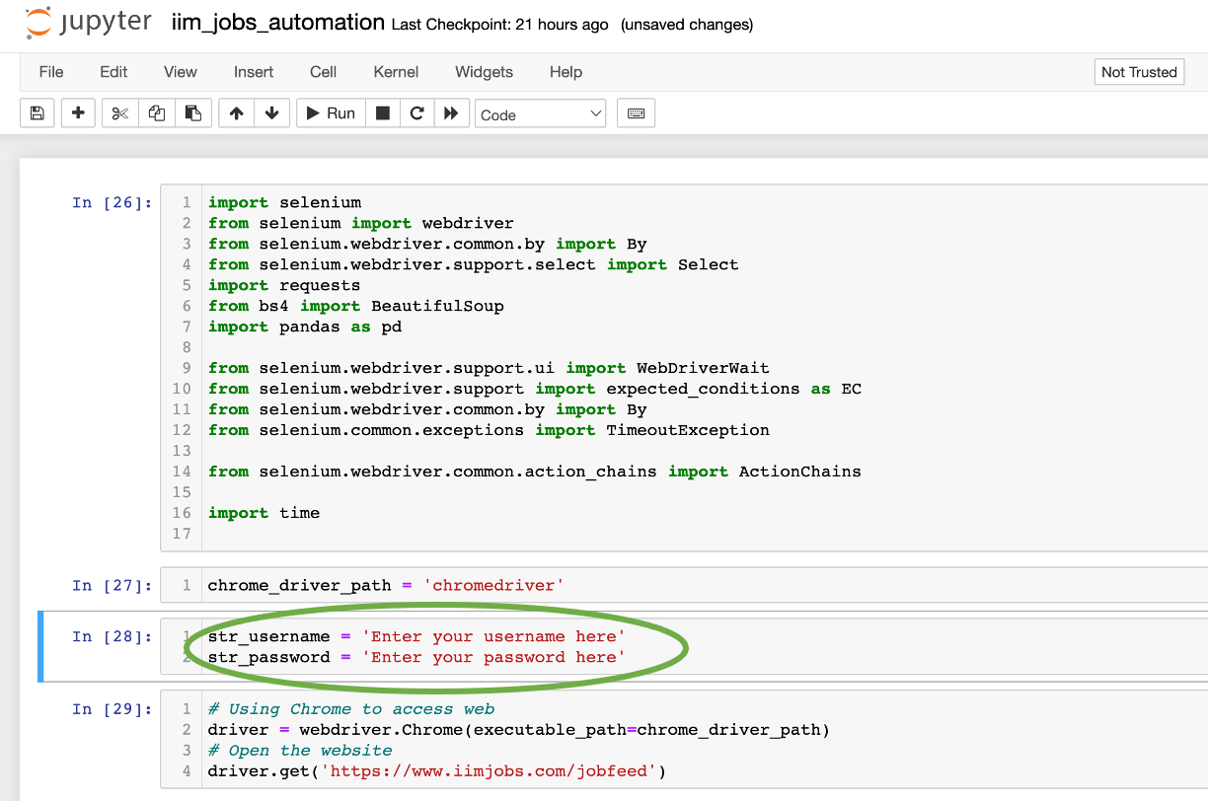

1. Click on the “Cell” option in the top menu bar. Then click on “Run All” option as indicated below:

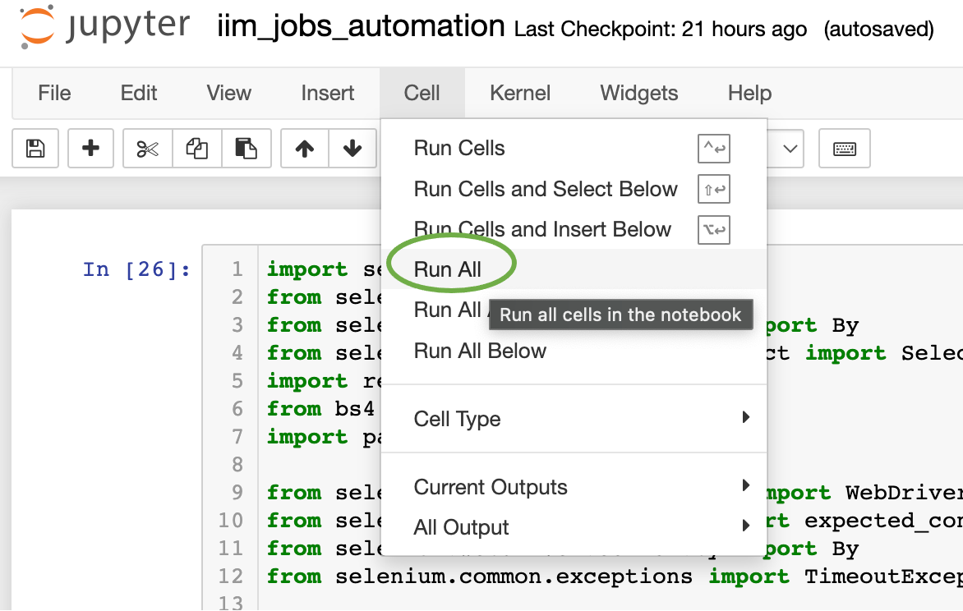

### Raise an issue if something fails

1. If something fails, please feel free to raise an issue in GitHub itself [here](https://github.com/abss123/automated_job_application/issues) or drop me a mail at [jobautomation.help@gmail.com](mailto:jobautomation.help@gmail.com)