/\*

ASSIGNMENT NO. 2

NAME- ABRAR SHAIKH ROLL NO. - 23570

TOPIC- Circular Queue

\*/

#include <iostream>

#define MAXSIZE 3

using namespace std;

int queue[MAXSIZE], rear=-1,front=-1;

void display()

{

cout<<endl;

if(front==-1)

cout<<endl<<"Queue is empty";

else

{

for(int i=front; i<=rear; i++)

{

cout<<queue[i]<<" is present at "<<i<<endl;

}

}

}

void insert(int ele)

{

if(front==(rear+1)%MAXSIZE)

cout<<"Queue is full";

else

{

if(front==-1)

front=0;

rear=(rear+1)%MAXSIZE;

queue[rear]=ele;

}

}

void del()

{

int s;

if(front==-1)

cout<<endl<<"Queue is empty";

else

{

if ((front == -1) || (front > rear))

{

cout<<"Queue is Empty"<<endl;

}

else

{

int element = queue[front];

front = (front + 1) % MAXSIZE;

cout<<"The element "<<element<<" has been deleted from the queue"<<endl;

if (rear == (MAXSIZE - 1) && (front == 0) || (front > rear))

{

front = -1;

rear = -1;

}

}

}

}

int main()

{

int ele,size,ch;

do

{

cout<<endl<<"1. Insert \n2. Delete \n3. Display \n4. Exit";

cout<<endl<<"Enter your choice:";

cin>>ch;

switch(ch)

{

case 1:

cout<<endl<<"Enter element:";

cin>>ele;

insert(ele);

break;

case 2:

del();

break;

case 3:

display();

break;

case 4:

return 0;

default:

cout<<endl<<"Invalid choice";

break;

}

}while(ch!=4);

return 0;

}

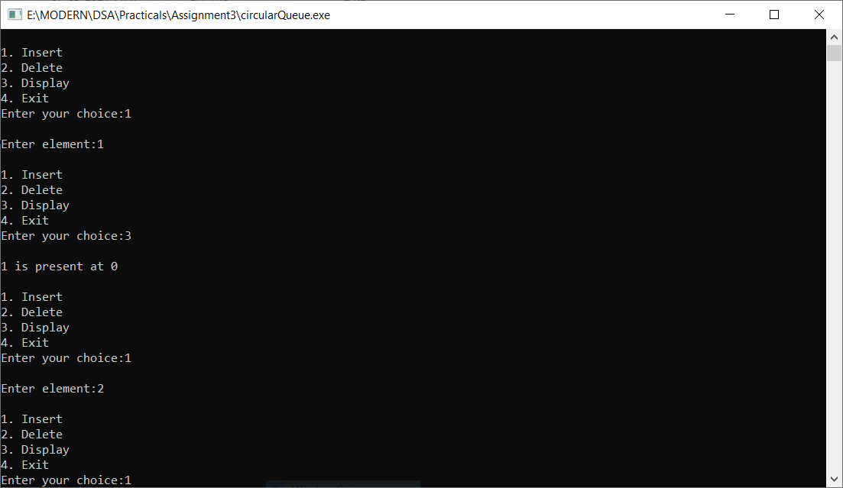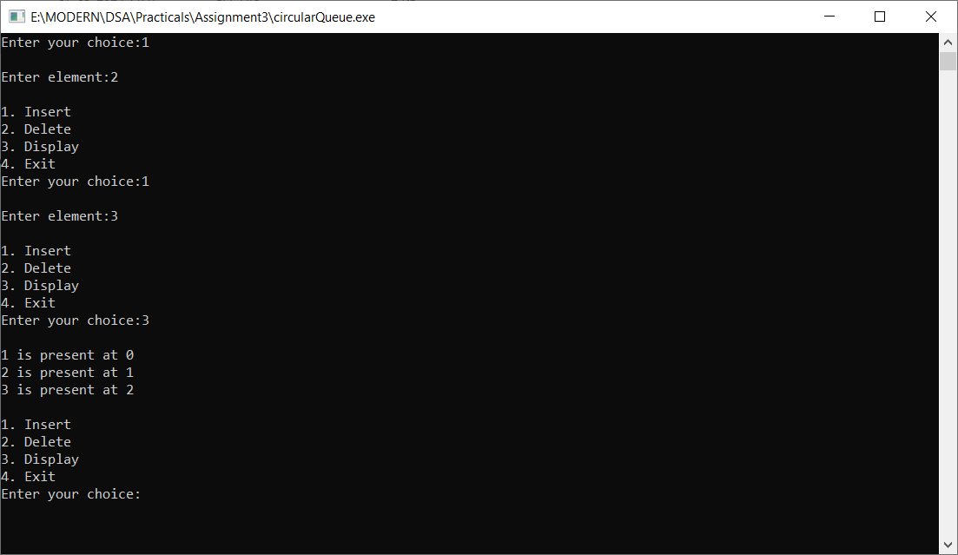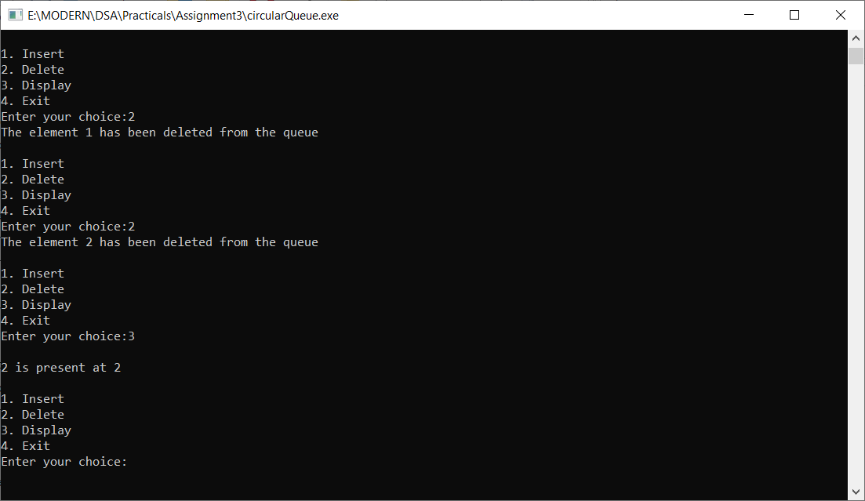

Github Repo:

https://github.com/abssha/DSA.git