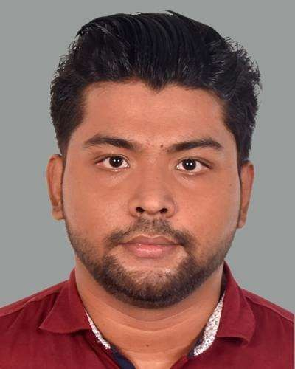

**Abu BAKKAR Siddik**

Full Stack Web Designer and Developer

# PROFILE

I’m **Abu Bakkar Siddik**, a Computer Science and Engineering student at **Northern University Bangladesh**. I’m passionate about Full Stack Web Development and skilled in HTML, CSS, JavaScript, React, Node.js, and database management.

# Educational Qualifications

* Bachelor’s :

University Northern University Bangladesh Dependent Computer Science and

Engineering

Status Ongoing

* Higher Secondary Certificate : Collage Pallabi Government Collage Group Science

Status Passed in 2022

* **Secondary School Certificate:**

School Kazi Kamar Uddin Government Institution

Group Science

Status Passed in 2020

# SKILLS

* Frontend: HTML5, CSS3, JavaScript (ES6+), Bootstrap
* Backend: Node.js, Express.js, PHP (basic)
* Version Control: Git, GitHub
* Soft Skills: Problem-solving, teamwork, adaptability, communication

Projects and Experience

* Fresher – Seeking Internship/Job Opportunities
* Currently learning Full Stack Development at **Shikhbe Shobai IT**
* Laptop Selling Shop Management System (C Project)
* Coffee Shop Ordering System (C Project)
* Personal Portfolio Website ( HTML , CSS , JS )

**Signature**

# Contact

## Address:

Naddapara, Dakshinkhan, Dhaka-1230

## Phone:

+8801560015358

## Email:

[Info.absshoyeb@gmail.com](mailto:Info.absshoyeb@gmail.com)

# LANGUAGES

Bangali - Native English – Fluent

# HOBBIES

* Playing Football
* Watching Movies and animes
* Cooking Cuisine