Q0. Flight departures and Arrivals collected directly from official Aiport sites for September 24th-25th, 2026

Q1.

vcount(airports) # resulted in 30 nodes
ecount(airports) # resulted in 105 edges

Q2.
airports <- graph_from_data_frame(edges, nodes, directed=FALSE)
plot(airports,
vertex.size=10,
vertex.label.cex=0.3,
edge.arrow.size=5,
area=vcount(airports)^2.3,
layout=layout_nicely) # Nicely layout

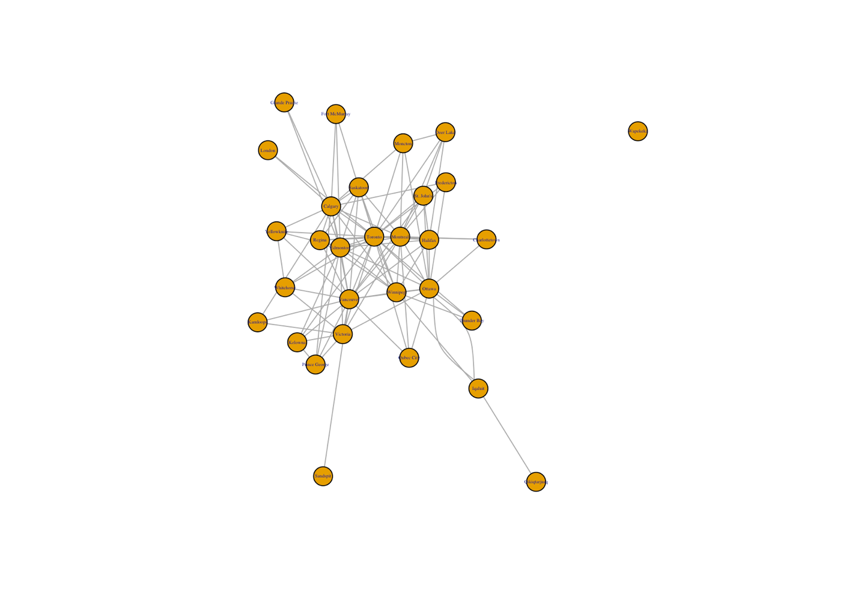

Q3.
deg <- degree(airports)
deg
mean(deg)
#Mean degree: 7
#Most Connected Nodes: Toronto and Vancouver
#Least connected Nodes: Wapekeka, Sandspit and Qikiqtarjuaq
#I found this out by running “deg” and looking at the rankings

Q4.

hist(deg,
breaks=10,
main="Degree Distribution of Canadian Airports",
xlab="Degree",
ylab="Frequency")

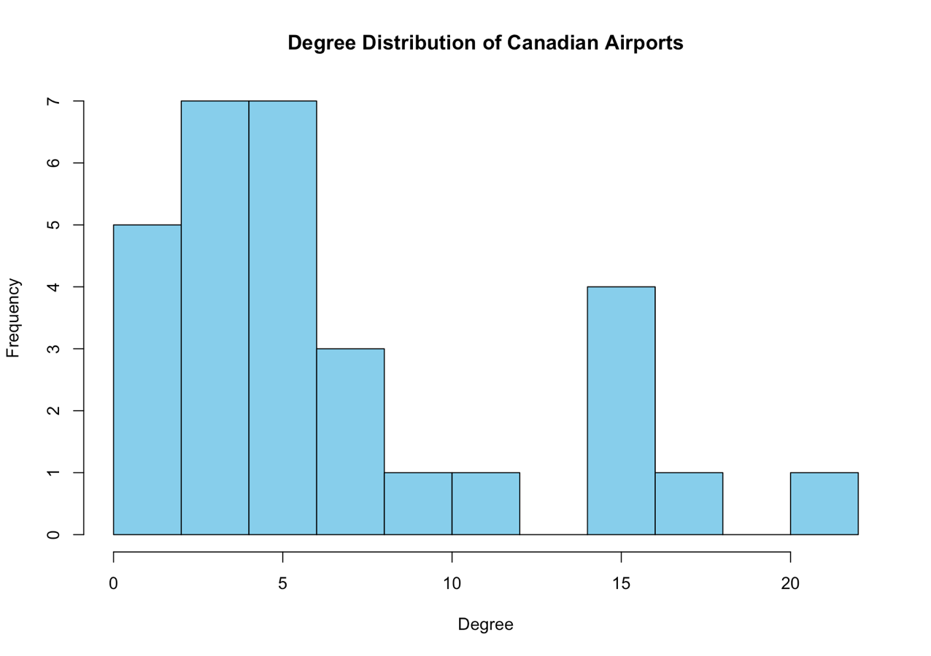

Q5.
A <- as.matrix(as_adjacency_matrix(airports))
isSymmetric(A) #Returned TRUE
A

# Toronto Vancouver Montreal Calgary Edmonton Ottawa
Toronto 0 1 1 1 1 1
Vancouver 1 0 1 1 1 1
Montreal 1 1 0 1 1 1
Calgary 1 1 1 0 1 0
Edmonton 1 1 1 1 0 1
Ottawa 1 1 1 0 1 0
Winnipeg 1 1 1 1 1 1
Halifax 1 1 1 0 1 1
Qubec City 1 1 1 0 0 1
Saskatoon 1 1 1 1 1 0
Kelowna 1 1 0 0 1 0
Victoria 1 1 1 0 1 1
Regina 1 1 1 1 1 0
St. John's 1 1 1 0 0 1
Thunder Bay 1 0 0 0 0 1
London 1 0 0 1 0 0
Charlottetown 1 0 1 0 0 1
Moncton 1 0 1 1 0 1
Whitehorse 1 1 0 0 1 0
Fort McMurray 1 0 0 1 1 0
Kamloops 0 1 0 1 0 0
Fredericton 1 0 1 1 0 1
Yellowknife 1 1 0 1 1 0
Prince George 0 1 0 1 1 0
Deer Lake 1 0 1 0 0 0
Iqaluit 0 0 0 0 0 2
Grande Prairie 0 0 0 1 1 0
Sandspit 0 1 0 0 0 0
Qikiqtarjuaq 0 0 0 0 0 0
Wapekeka 0 0 0 0 0 0
Winnipeg Halifax Qubec City Saskatoon Kelowna
Toronto 1 1 1 1 1
Vancouver 1 1 1 1 1
Montreal 1 1 1 1 0
Calgary 1 0 0 1 0
Edmonton 1 1 0 1 1
Ottawa 1 1 1 0 0
Winnipeg 0 1 0 1 0
Halifax 1 0 0 0 0
Qubec City 0 0 0 0 0
Saskatoon 1 0 0 0 0
Kelowna 0 0 0 0 0
Victoria 0 0 0 0 1
Regina 1 0 0 1 0
St. John's 0 1 0 0 0
Thunder Bay 1 0 0 0 0
London 0 0 0 0 0
Charlottetown 0 0 0 0 0
Moncton 0 0 0 0 0
Whitehorse 0 0 0 0 0
Fort McMurray 0 0 0 0 0
Kamloops 0 0 0 0 0
Fredericton 0 0 0 0 0
Yellowknife 0 0 0 0 0
Prince George 0 0 0 0 1
Deer Lake 0 1 0 0 0
Iqaluit 1 0 0 0 0
Grande Prairie 0 0 0 0 0
Sandspit 0 0 0 0 0
Qikiqtarjuaq 0 0 0 0 0
Wapekeka 0 0 0 0 0
Victoria Regina St. John's Thunder Bay London
Toronto 1 1 1 1 1
Vancouver 1 1 1 0 0
Montreal 1 1 1 0 0
Calgary 0 1 0 0 1
Edmonton 1 1 0 0 0
Ottawa 1 0 1 1 0
Winnipeg 0 1 0 1 0
Halifax 0 0 1 0 0
Qubec City 0 0 0 0 0
Saskatoon 0 1 0 0 0
Kelowna 1 0 0 0 0
Victoria 0 0 0 0 0
Regina 0 0 0 0 0
St. John's 0 0 0 0 0
Thunder Bay 0 0 0 0 0
London 0 0 0 0 0
Charlottetown 0 0 0 0 0
Moncton 0 0 0 0 0
Whitehorse 1 0 0 0 0
Fort McMurray 0 0 0 0 0
Kamloops 1 0 0 0 0
Fredericton 0 0 0 0 0
Yellowknife 0 0 0 0 0
Prince George 1 0 0 0 0
Deer Lake 0 0 1 0 0
Iqaluit 0 0 0 0 0
Grande Prairie 0 0 0 0 0
Sandspit 0 0 0 0 0
Qikiqtarjuaq 0 0 0 0 0
Wapekeka 0 0 0 0 0
Charlottetown Moncton Whitehorse Fort McMurray
Toronto 1 1 1 1
Vancouver 0 0 1 0
Montreal 1 1 0 0
Calgary 0 1 0 1
Edmonton 0 0 1 1
Ottawa 1 1 0 0
Winnipeg 0 0 0 0
Halifax 0 0 0 0
Qubec City 0 0 0 0
Saskatoon 0 0 0 0
Kelowna 0 0 0 0
Victoria 0 0 1 0
Regina 0 0 0 0
St. John's 0 0 0 0
Thunder Bay 0 0 0 0
London 0 0 0 0
Charlottetown 0 0 0 0
Moncton 0 0 0 0
Whitehorse 0 0 0 0
Fort McMurray 0 0 0 0
Kamloops 0 0 0 0
Fredericton 0 0 0 0
Yellowknife 0 0 1 0
Prince George 0 0 0 0
Deer Lake 0 1 0 0
Iqaluit 0 0 0 0
Grande Prairie 0 0 0 0
Sandspit 0 0 0 0
Qikiqtarjuaq 0 0 0 0
Wapekeka 0 0 0 0
Kamloops Fredericton Yellowknife Prince George
Toronto 0 1 1 0
Vancouver 1 0 1 1
Montreal 0 1 0 0
Calgary 1 1 1 1
Edmonton 0 0 1 1
Ottawa 0 1 0 0
Winnipeg 0 0 0 0
Halifax 0 0 0 0
Qubec City 0 0 0 0
Saskatoon 0 0 0 0
Kelowna 0 0 0 1
Victoria 1 0 0 1
Regina 0 0 0 0
St. John's 0 0 0 0
Thunder Bay 0 0 0 0
London 0 0 0 0
Charlottetown 0 0 0 0
Moncton 0 0 0 0
Whitehorse 0 0 1 0
Fort McMurray 0 0 0 0
Kamloops 0 0 0 0
Fredericton 0 0 0 0
Yellowknife 0 0 0 0
Prince George 0 0 0 0
Deer Lake 0 0 0 0
Iqaluit 0 0 0 0
Grande Prairie 0 0 0 0
Sandspit 0 0 0 0
Qikiqtarjuaq 0 0 0 0
Wapekeka 0 0 0 0
Deer Lake Iqaluit Grande Prairie Sandspit
Toronto 1 0 0 0
Vancouver 0 0 0 1
Montreal 1 0 0 0
Calgary 0 0 1 0
Edmonton 0 0 1 0
Ottawa 0 2 0 0
Winnipeg 0 1 0 0
Halifax 1 0 0 0
Qubec City 0 0 0 0
Saskatoon 0 0 0 0
Kelowna 0 0 0 0
Victoria 0 0 0 0
Regina 0 0 0 0
St. John's 1 0 0 0
Thunder Bay 0 0 0 0
London 0 0 0 0
Charlottetown 0 0 0 0
Moncton 1 0 0 0
Whitehorse 0 0 0 0
Fort McMurray 0 0 0 0
Kamloops 0 0 0 0
Fredericton 0 0 0 0
Yellowknife 0 0 0 0
Prince George 0 0 0 0
Deer Lake 0 0 0 0
Iqaluit 0 0 0 0
Grande Prairie 0 0 0 0
Sandspit 0 0 0 0
Qikiqtarjuaq 0 1 0 0
Wapekeka 0 0 0 0
Qikiqtarjuaq Wapekeka
Toronto 0 0
Vancouver 0 0
Montreal 0 0
Calgary 0 0
Edmonton 0 0
Ottawa 0 0
Winnipeg 0 0
Halifax 0 0
Qubec City 0 0
Saskatoon 0 0
Kelowna 0 0
Victoria 0 0
Regina 0 0
St. John's 0 0
Thunder Bay 0 0
London 0 0
Charlottetown 0 0
Moncton 0 0
Whitehorse 0 0
Fort McMurray 0 0
Kamloops 0 0
Fredericton 0 0
Yellowknife 0 0
Prince George 0 0
Deer Lake 0 0
Iqaluit 1 0
Grande Prairie 0 0
Sandspit 0 0
Qikiqtarjuaq 0 0
Wapekeka 0 0

