Library Management System
Structured Systems Analysis and Design (SSAD) Documentation
Objective: To help students understand how SSAD breaks a complex system into structured, verifiable stages.
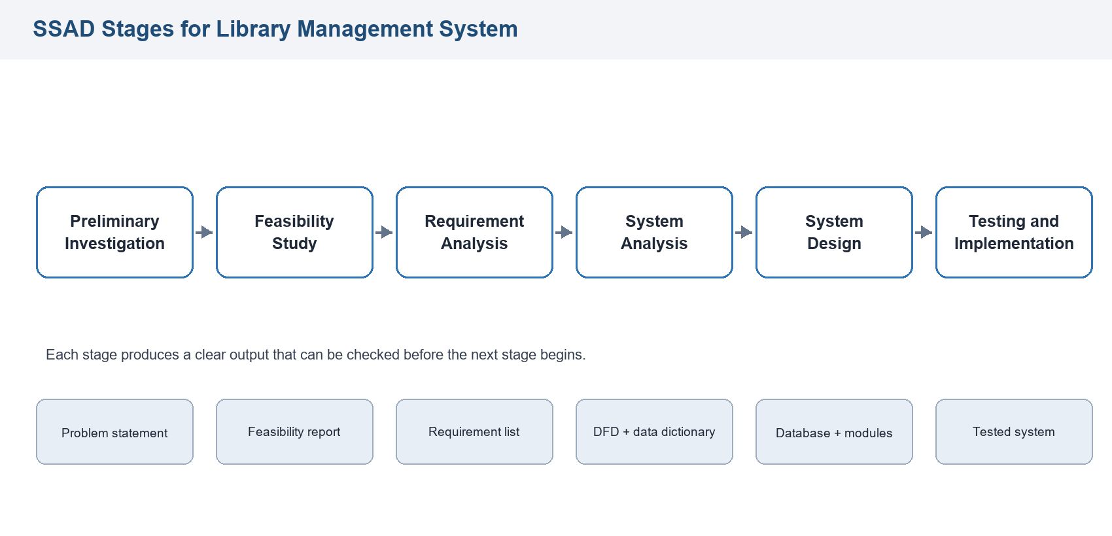
Figure 1: SSAD stage flow used for the Library Management System.

Table of Contents
- Introduction
- Scope of the System
- Existing System
- Proposed System
- SSAD Stages Applied
- Requirement Analysis
- System Analysis and Diagrams
- Data Dictionary
- Database and Module Design
- Process Specifications
- Input and Output Design
- Verification, Validation, and Testing
- Security and Controls
- Conclusion

1. Introduction
A Library Management System is a software system used to manage library activities such as book registration, member registration, book issue, book return, fine calculation, and report generation. In a manual library system, records are often maintained in registers or spreadsheets, which can cause delay, duplication, and calculation errors.
Structured Systems Analysis and Design (SSAD) is a formal method for studying a system and designing a solution through clear stages. It helps students understand how a large system can be divided into smaller, logical, and verifiable parts.
Document objective: This document explains the Library Management System using SSAD so that each stage, diagram, data item, and verification activity can be understood clearly.

2. Scope of the System
The proposed system covers the main academic library operations listed below.
- Student/member registration
- Book entry and catalog management
- Book searching by title, author, category, or book ID
- Book issue and return
- Fine calculation for late returns
- Report generation for books, members, issues, returns, and fines
The system does not include online payment, digital book reading, barcode hardware integration, or advanced recommendation features.

3. Existing System
In the existing manual system, the librarian maintains book records, member details, and issue/return details using registers or spreadsheets. Book availability is checked manually, and fine calculation is performed by comparing issue, due, and return dates.

Problems in the Existing System
- Book search is time-consuming.
- Large records are difficult to maintain and verify.
- Duplicate or incorrect entries may occur.
- Issue and return activities may be delayed.
- Fine calculation may contain manual errors.
- Reports are difficult to prepare quickly.
- Book availability status is not immediately visible.

4. Proposed System
The proposed Library Management System will automate the major operations of the library. It will maintain structured records for books, members, librarians, issue transactions, returns, and fines. The librarian can add books, register members, issue books, accept returns, calculate fines, and generate reports through the system.

Benefits of the Proposed System
- Faster book search and issue process
- Improved accuracy and consistency of records
- Automatic fine calculation
- Easy generation of daily and monthly reports
- Better tracking of issued and available books
- Reduced paperwork
- Improved data security and backup control

5. SSAD Stages Applied
SSAD breaks the development of the Library Management System into planned stages. Each stage produces a clear output that can be checked before the next stage starts.
SSAD Stage | Purpose in Library System | Output
Preliminary Investigation | Identify the main problems in the existing library process. | Problem statement
Feasibility Study | Check whether the system is technically, operationally, economically, and schedule-wise feasible. | Feasibility report
Requirement Analysis | List what the system must do and how well it must perform. | Functional and non-functional requirements
System Analysis | Study data movement, users, inputs, outputs, and processes. | DFDs and data dictionary
System Design | Design database, modules, forms, reports, and controls. | System design specification
Testing and Implementation | Verify the system against requirements and prepare it for use. | Tested and accepted system

6. Requirement Analysis

Functional Requirements
- The system shall allow the librarian to add, update, and delete book records.
- The system shall allow student/member registration and member record updates.
- The system shall allow book search using title, author, category, or book ID.
- The system shall check book availability before issuing a book.
- The system shall record book issue details with issue date and due date.
- The system shall record book return details and update book status.
- The system shall calculate fines for late returns.
- The system shall generate reports for books, members, issued books, returned books, and fines.

Non-Functional Requirements
- The system should be simple and easy to use.
- The system should provide accurate and reliable information.
- The system should protect data from unauthorized access.
- The system should respond quickly to searches and transactions.
- The system should support regular backup of important records.

7. System Analysis and Diagrams
System analysis identifies the external users, main inputs, main processes, outputs, and data stores of the Library Management System.
Element | Details
External entities | Student/Member, Librarian, Administrator
Main inputs | Book details, member details, issue request, return request, fine payment details
Main processes | Manage books, manage members, issue book, return book, calculate fine, generate reports
Main outputs | Book availability status, issue confirmation, return confirmation, fine details, library reports

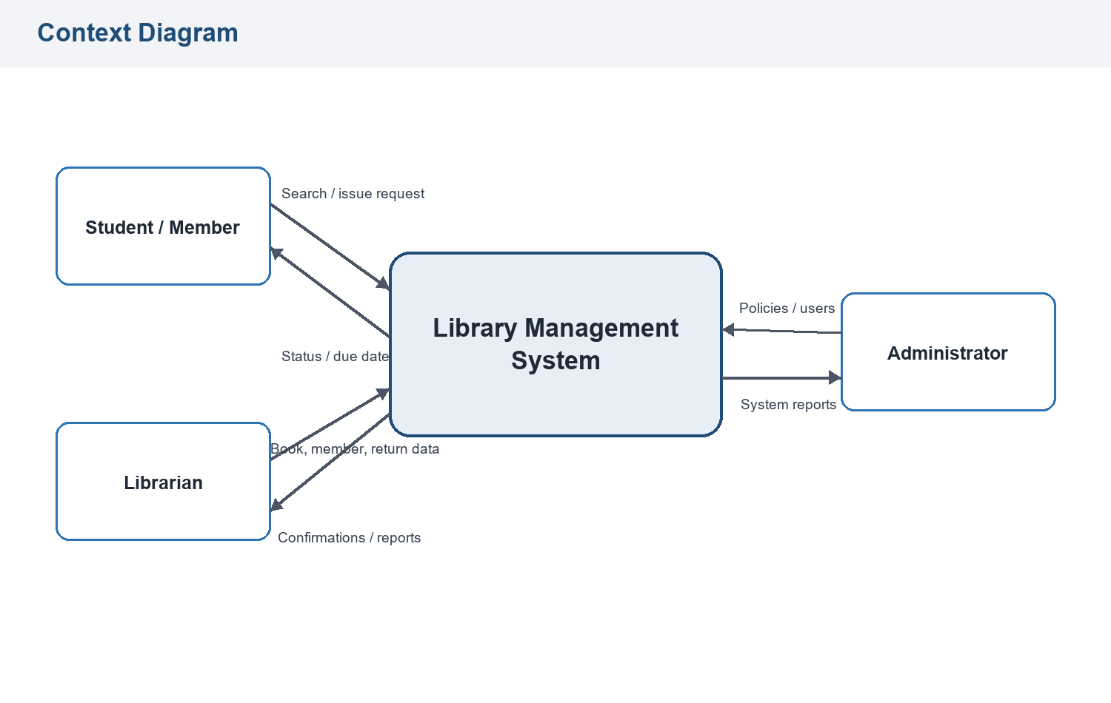
Figure 2: Context diagram showing the system boundary and external entities.
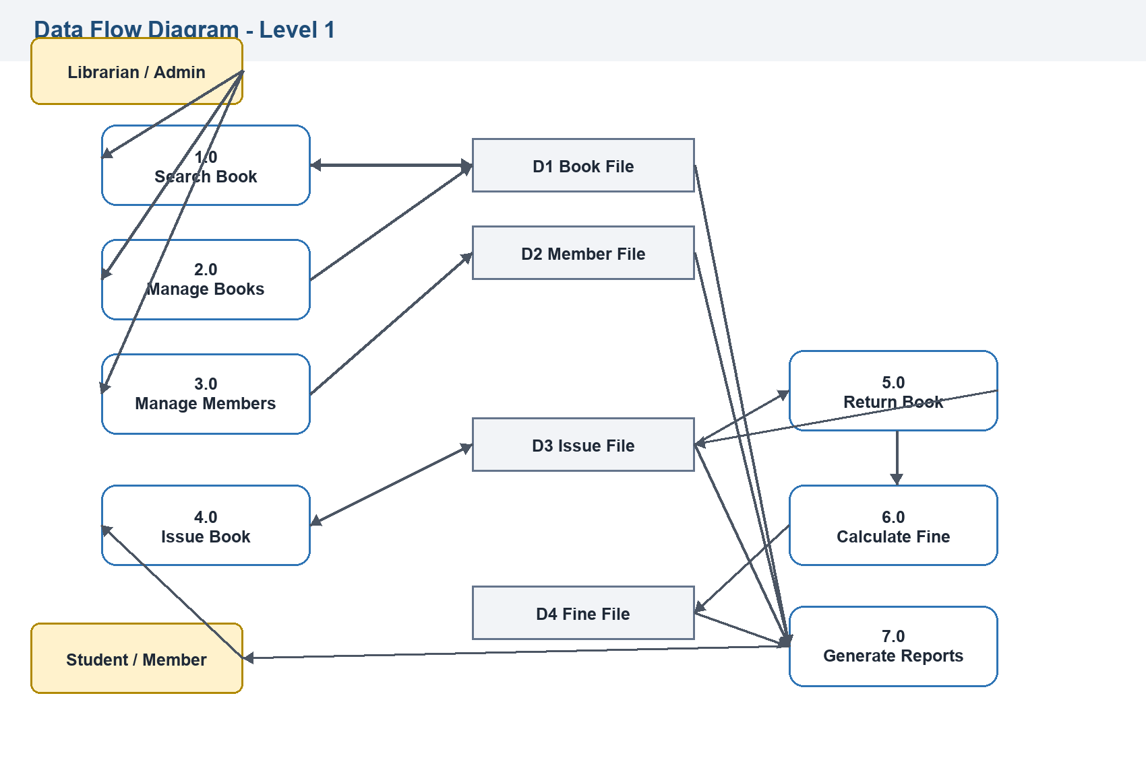
Figure 3: Level 1 DFD showing main processes and data stores.
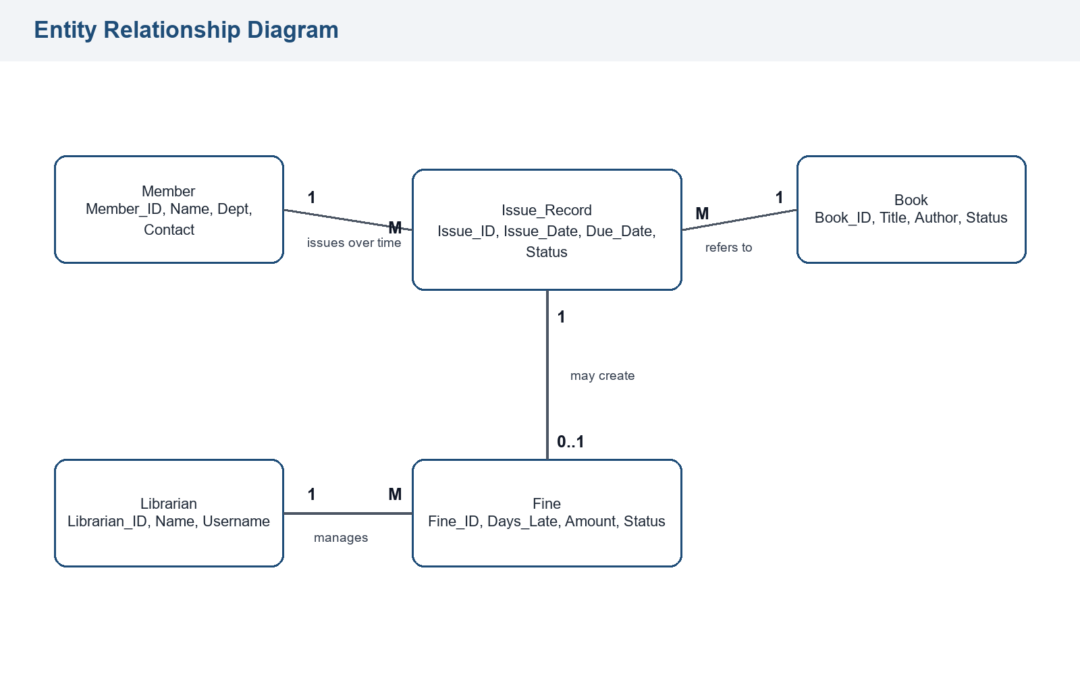
Figure 4: ER diagram showing major entities and relationships.

8. Data Dictionary
The data dictionary defines important data items used in the system. It helps verify that data used in diagrams, forms, reports, and database design is consistent.

Book
Field Name | Description | Data Type
Book_ID | Unique identification number of the book | Integer/String
Title | Name of the book | Text
Author | Author of the book | Text
Publisher | Publisher name | Text
Category | Subject or category of book | Text
Status | Available or issued | Text

Member
Field Name | Description | Data Type
Member_ID | Unique identification number of member | Integer/String
Name | Name of student/member | Text
Department | Department or class | Text
Contact | Contact number or email | Text
Membership_Date | Date of registration | Date

Issue Record
Field Name | Description | Data Type
Issue_ID | Unique issue transaction number | Integer/String
Book_ID | Book issued to member | Integer/String
Member_ID | Member who borrowed the book | Integer/String
Issue_Date | Date of book issue | Date
Due_Date | Last date for return | Date
Status | Issued or returned | Text

Fine
Field Name | Description | Data Type
Fine_ID | Unique fine record number | Integer/String
Issue_ID | Related issue transaction | Integer/String
Days_Late | Number of late days | Integer
Fine_Amount | Total fine amount | Decimal
Payment_Status | Paid or unpaid | Text

9. Database and Module Design

Database Tables
Table | Main Fields
Books | Book_ID, Title, Author, Publisher, Category, Status
Members | Member_ID, Name, Department, Contact, Membership_Date
Librarians | Librarian_ID, Name, Username, Password
Issue_Records | Issue_ID, Book_ID, Member_ID, Librarian_ID, Issue_Date, Due_Date, Return_Date, Status
Fine_Records | Fine_ID, Issue_ID, Days_Late, Fine_Amount, Payment_Status

Module Design
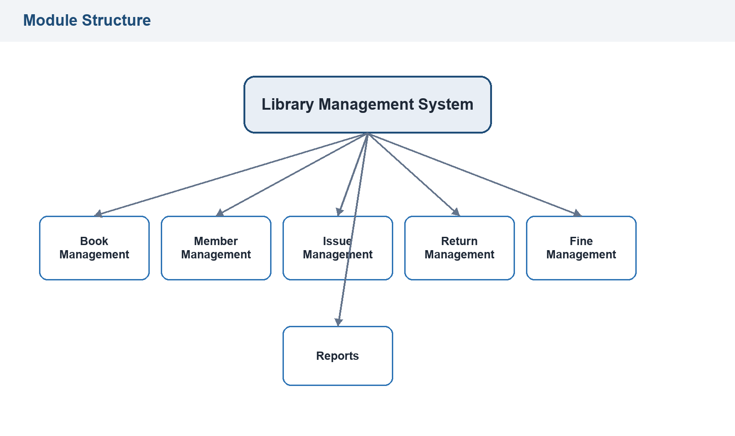
Figure 5: Module structure of the proposed Library Management System.
Module | Responsibility
Book Management | Add, update, delete, and search book records.
Member Management | Register members and maintain member records.
Issue Management | Issue books after checking member eligibility and book availability.
Return Management | Accept returned books and update book status.
Fine Management | Calculate and record fines for late returns.
Report Management | Generate reports for books, members, issues, returns, and fines.

10. Process Specifications
Process | Input | Main Processing | Output
Add Book | Book details | Validate and save the book record. | Book record confirmation
Register Member | Member details | Validate details and assign member ID. | Member registration confirmation
Issue Book | Book ID and Member ID | Check availability and eligibility, then create issue record. | Issue confirmation with due date
Return Book | Issue ID or Book ID | Update return details and change book status to available. | Return confirmation
Calculate Fine | Due date and return date | Compare dates and calculate fine for late days. | Fine amount
Generate Reports | Report type and date range | Fetch and format required records. | Selected report

11. Input and Output Design

Input Forms
- Book entry form
- Member registration form
- Book issue form
- Book return form
- Fine payment form
Each input form should include validation so that incomplete, duplicate, or incorrect data is not accepted.

Output Reports
- Book availability list
- Issued book report
- Returned book report
- Member list
- Fine report
- Daily or monthly transaction report

12. Verification, Validation, and Testing
SSAD supports verification at every stage. This helps confirm that the system design remains correct, complete, and traceable to the requirements.
Stage | Verification Activity
Requirement Analysis | Check whether all library needs are listed clearly.
Data Flow Diagram | Check whether data movement is logical and complete.
Data Dictionary | Check whether all data items are defined.
Database Design | Check whether tables match system requirements.
Module Design | Check whether each module has a clear purpose.
Testing | Check whether the system works according to requirements.

Testing Plan
Test Case | Input | Expected Output
Add book | Valid book details | Book saved successfully
Search book | Book title or ID | Matching book details displayed
Register member | Valid member details | Member ID generated
Issue available book | Valid Book ID and Member ID | Book issued and due date shown
Issue unavailable book | Already issued Book ID | Issue request rejected
Return book on time | Return before or on due date | Book returned with no fine
Return book late | Return after due date | Fine calculated
Generate report | Report type selected | Required report displayed

13. Security and Controls
- Only authorized librarians and administrators should access management features.
- Passwords should not be shared or stored in plain text.
- Important records should be backed up regularly.
- The system should validate all inputs.
- User activities should be recorded where necessary.
- Role-based access should separate student, librarian, and administrator functions.

14. Conclusion
The Library Management System designed using SSAD shows how a complex system can be divided into structured stages such as preliminary investigation, feasibility study, requirement analysis, system analysis, system design, testing, and implementation.
By following SSAD, students can clearly understand how each stage produces useful outputs that support the next stage. The diagrams, data dictionary, database design, module design, and testing plan make the system easier to verify, maintain, and improve.

