Name: Manish Giri
University: Brainware University [LinkedIn]
Program: MCA Email: manishgiri8101@gmail.com

Problem Statement: Imagine you are building an AI system for and e-commerce platform like Amazon or Flipkart. The system should be able to understand a product using image.
Task:
- Inputs: Product Image
- Outputs: Product category, Product description
- Model Selection:
  - BLIP (Image Captioning)
  - SentenceTransofrmer(all-MiniLM-L6-v2) – [Mini Language model lightweight version of BERT)
  - FAISS Vector DB
  - LLM for final description generate.
- System Desing (High-Level):
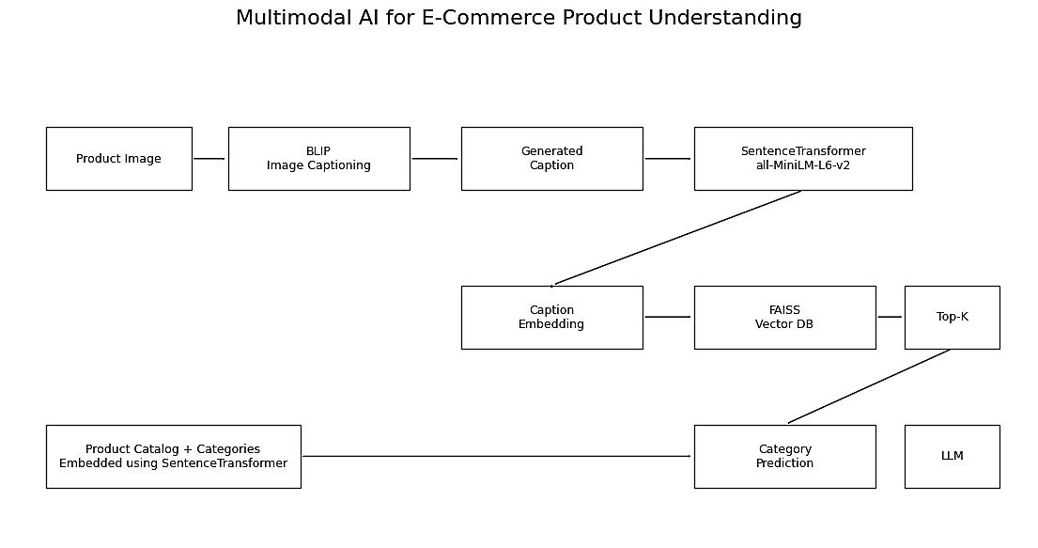
- Architectural Diagram:
- Workflow:
- Product Image: The input image Uploaded by the customer.
- BLIP Image Captioning Model: Analyzes the image and generates a textual description of the product.
- Generated Caption: The text representation of the product generated by BLIP, like “A pair of blue running shoes.”
- SentenceTransformer: Converts the caption into a numerical embedding that captures semantic meaning.
- Caption Embedding: The vector representation of the product caption used for similarity search.
- Product catalog + Categories: A database containing product information and category labels. Each product description is also converted into embeddings.
- FAISS VDB: Stores product embeddings and performs fast similarity search to find the most relevant products or categories.
- Top-K similarity: Retrieves the k=3 or k = 5 similar products from the catalog based on embedding similarity.
- Category Prediction: Determines the most appropriate category using the retrieved similar products.
- LLM: Uses the retrieved information and image caption to generate a detailed product description.
- Final Output: Returns the predicted product with category and description.
Note:
- Why Choose BLIP over CLIP?
This model is the simplest and most logical choice because the final output requires human-readable description, not just classification. It well in generates text captioning, good for description generation, and also it trained on approx 129M image-text dataset. While CLIP good for generate image embeddings and image classifications.
- Uses FAISS over ChromaDB?
For Faster, Open-Source, lower memory required and no need to store the metadata.

- Evaluation: Accuracy matrix, Precision, Recall, F1-Score, BLEU

- Business Value:
For Sale Person’s: Automatic product listing, less effort require.
For Customer’s: Better search, Improve satisfaction.
For Stakeholder’s: Easy to track growth, easy to manage.

- Company already used:
AMAZON-Nova: Works for Smart AI agent like navigate web-pages, check inventory, Virtual Try & Visuals, Making interactive shopping experiences. [reference]
Before Amazon-Nova amazon uses “Rufus”: A GenAI Shopping Assistant, It trained on Amazon’s huge product catalog, customer reviews, web data, and Q&A to answer customer’s questions.

