# MANISH GIRI

# SOFTWARE DEVELOPER

+91- 8101652731 | <manishgiri8101@gmail.com>

Dantan, Paschim Medinipur, 721426.

[Portfolio](https://abstracted-m7.github.io/portfolio/) | [linkedin](http://www.linkedin.com/in/manish-giri-46a529254/) | [GitHub](https://github.com/abstracted-m7)

# Career Objective

# I am a skilled programmer with expertise in Java, Database and also intermediate level of Data Structures and Algorithms. As a team player with strong leadership abilities, I adapt quickly to new challenges and am driven to solve complex problems, contributing effectively to any project.

# Academic Details

# BCA - 94% ( Aggregate till semester IV )

# Brainware University

# Intermediate 10+2 - 63.24%

# Dantan HS School

# Intermediate – 43.85 %

# Dantan HS School

# Computer Skills

* Programming Language – **Java, JS , HTML**
* Database- **MySQL, MongoDB**
* IDE- **Vs Code, Jupiter, Google Collab**
* Soft Skills – **Team work, Communicating, Adaptable, Leadership.**

# Project Details

* **Non-Scientific Calculator**
* Programming Language: **Java, Python**
* Students can use it for doing normal calculations like addition, subtraction, multiplication and division.
* **Restaurant Management System [**[**Link**](https://github.com/abstracted-m7/Projects/tree/main/Restaurent_Management_system)**]**
* Programming Language : **Python**
* This application can be used for managing the restaurant’s orders and stored all orders in a CSV file which provide us to easily tracking of total month end orderbooks and money collections.
* **ATM Facilities || Banking System [**[**Link**](https://github.com/abstracted-m7/java_Assignments/blob/main/Java%20Projects/ATM_Consol.java) **||** [**Link**](https://github.com/abstracted-m7/java_Assignments/blob/main/Java%20Projects/BankingSystem.java)**]**
* Programming Language : **Java**
* This is a Console based using application. Here Banking facilities such as Deposit, Withdrawal, Login, Create Account can be done.
* **OPOC (One Person One Card) [**[**Link**](https://github.com/abstracted-m7/OPOC-CARD)**]**
* Programming Language : **Python with Pandas**
* This project is determinate that a single person has a single card and in this card the all cards (Voter, Pan, Ration) are merged. So that we can fetched all documents by a single card.

**Internship :-**

* **InternPe – (Feb 2023 to March 23)** 
  + **Domain** : Web Development
  + **Description :** Here I created a basic responsive projects likes Responsive Calculator, E-Commerce Web Site, To-Do List.
* **Oasis Infobyte – (Jul 2024 to Aug 2024)**
  + **Domain** : Python Development
  + **Description :** I’ve learned about multiple packages throughout that internship. Also learn about API connectivity by creating a Weather Application, and other projects.

**Languages: -**

* Bengali, English, Hindi

**Hobbies:-**

* 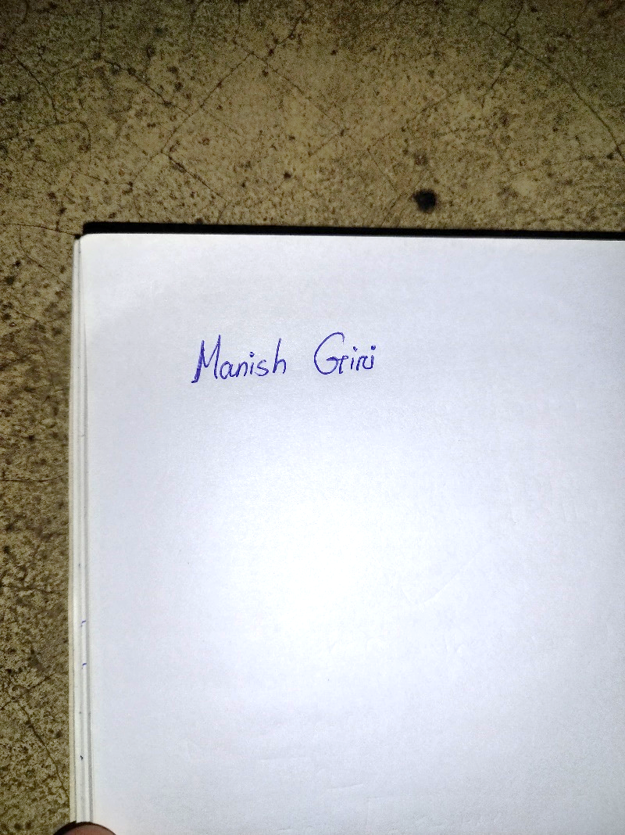Cricket, Reading Adventures Books.