LESSON 1
Orientations
In this lesson
• Welcome
• Mission and Vision
• Core Values and Directions
• College and BSIT Objectives
• Class Policies
SLIDE 1
Class Orientation
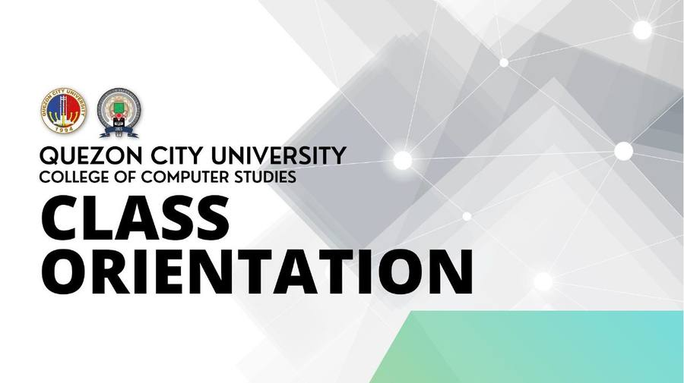
SLIDE 2
QCU Mission and Vision
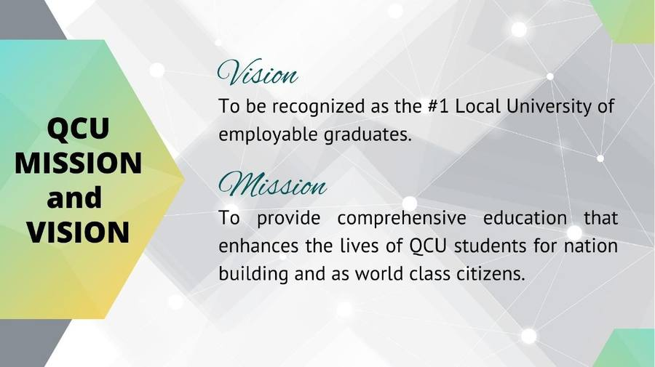
SLIDE 3
Core Values
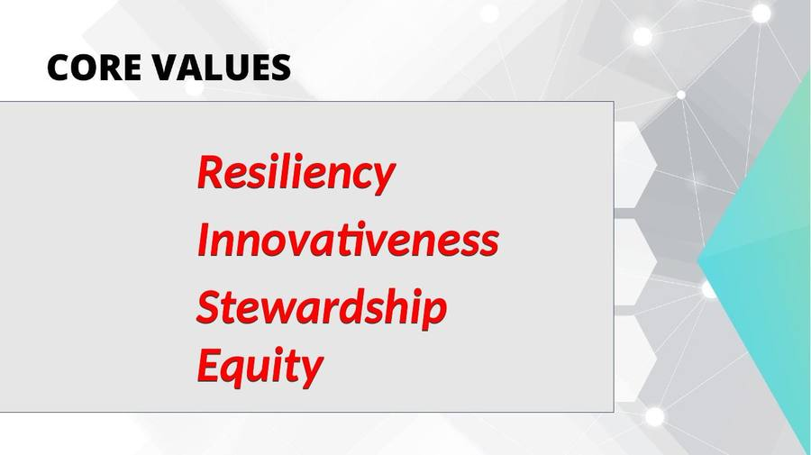
SLIDE 4
Strategic Directions
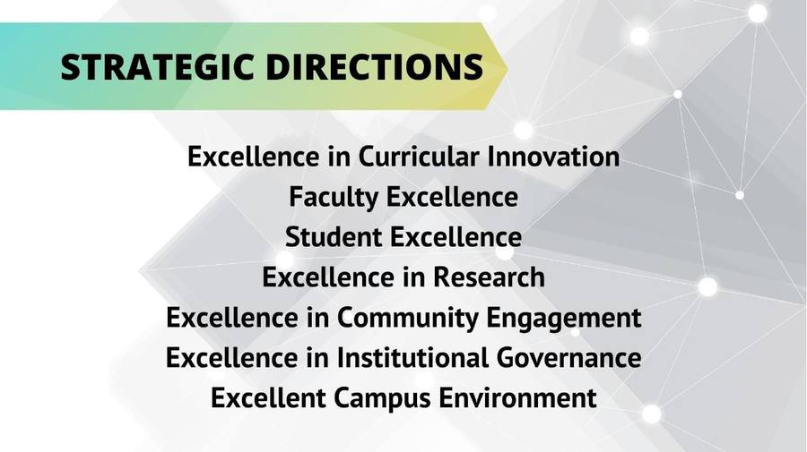
SLIDE 5
Institutional Learning Outcomes
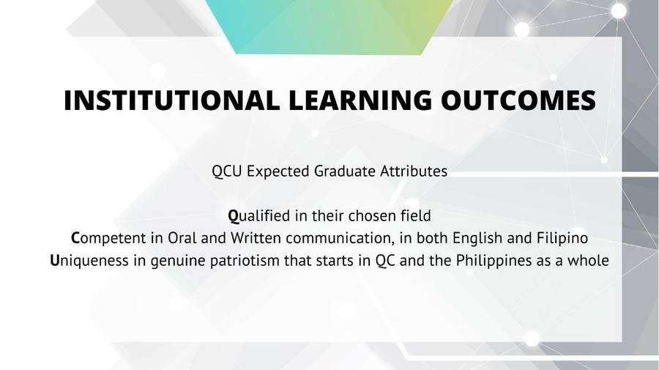
SLIDE 6
College Vision and Mission
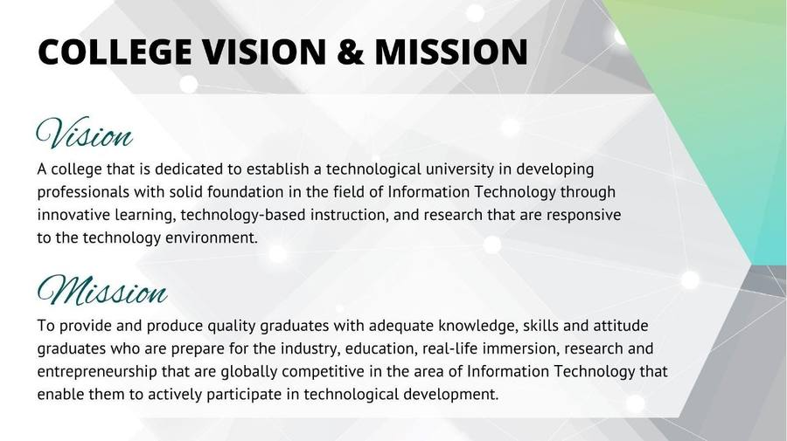
SLIDE 7
BSIT Program Educational Objectives
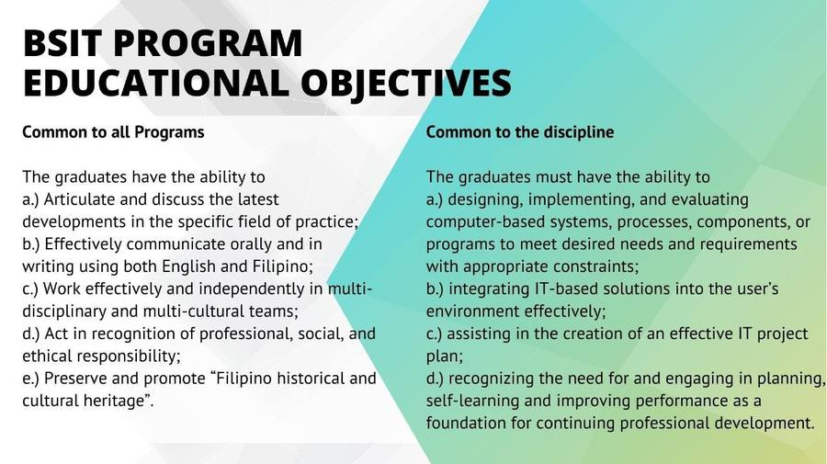
SLIDE 8
Class Policies
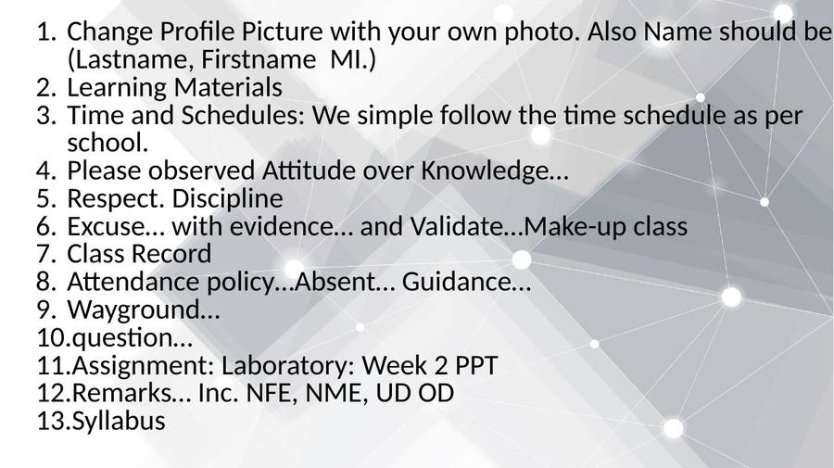
SLIDE 9
Student Handbook Policies
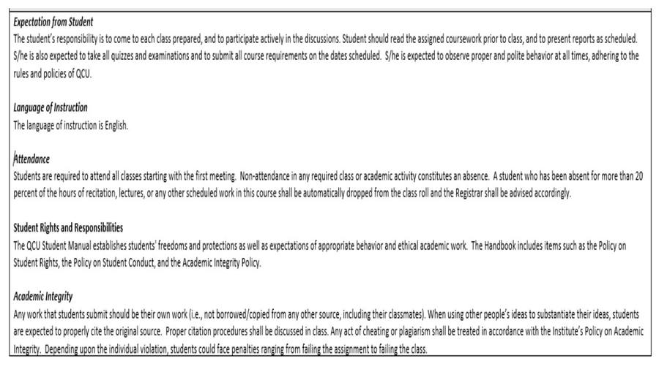
— End of Lesson 1 —

