LESSON 3
Getting Started with Microsoft Visual Basic .NET
In this lesson
• Programming Basics
• Programming Languages
• What a Program Is Made Of
• Translators
• Exploring the IDE
• IDE Windows
• Docking Windows
• Console Application
SLIDE 2
Learning Outcomes
• At the end of the session, the students should be able to:
• 1. Define Computer Programming and Translator of Programming languages;
• 2. Describe the Integrated Development Environment;
• 3. Demonstrate how to use classes in Visual Basic.NET
SLIDE 3
What is Computer Programming?
• Computers can only follow instructions
• A computer program is a set of instructions on how to solve a problem or perform a task
• Computer programming is the process of developing and implementing various sets of instructions to enable a computer to do a certain task. These instructions are considered computer programs and help the computer to operate smoothly.
SLIDE 4
Programming Languages
• The steps in an algorithm must be stated in a form the computer understands
• The CPU processes a series of 1’s and 0’s called machine language instructions
• This is a tedious and difficult format for people
• Programming languages allow us to use words instead of numbers
• Special software called a compiler converts the programming language statements to machine language instructions
SLIDE 5
Popular Programming Languages
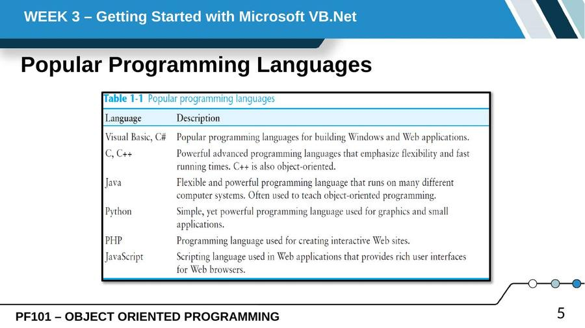
SLIDE 6
What is a Program Made Of?
• Keywords (Reserved Words)
– Words with special meaning that make up a high-level programming language, cannot be used for any other purpose
• Operators
– Special symbols that perform various operations on data
• Variables
– Used to store data in memory, named by the programmer
SLIDE 7
What is a Program Made Of? (cont.)
• Syntax
– Set of rules
– Similar to the syntax (rules) of a spoken language, such as English, but must be strictly followed
– If even a single syntax error appears in a program, it will not compile or execute
• Statements
– Instructions made up of keywords, variables, and operators.
– Called source code, or simply code
SLIDE 8
What is a Program Made Of? (cont.)
• Procedures
– Set of programming statements that perform a specific task
• Comments (Remarks)
– Ignored when the program runs, help human reader understand the purpose of programming statements
– In Visual Basic, any statement that begins with an apostrophe (')
SLIDE 9
Translation of Programming Languages
• A translator or programming language processor is a computer program that performs the translation of a program written in a given programming language into a functionally equivalent program in another computer language (the target language), without losing the functional or logical structure of the original code (the "essence" of each program).
SLIDE 10
Exploring the IDE
• An integrated development environment (IDE) is a software application that provides comprehensive facilities to computer programmers for software development. An IDE normally consists of a source code editor, build automation tools, and a debugger.
SLIDE 11
The start page
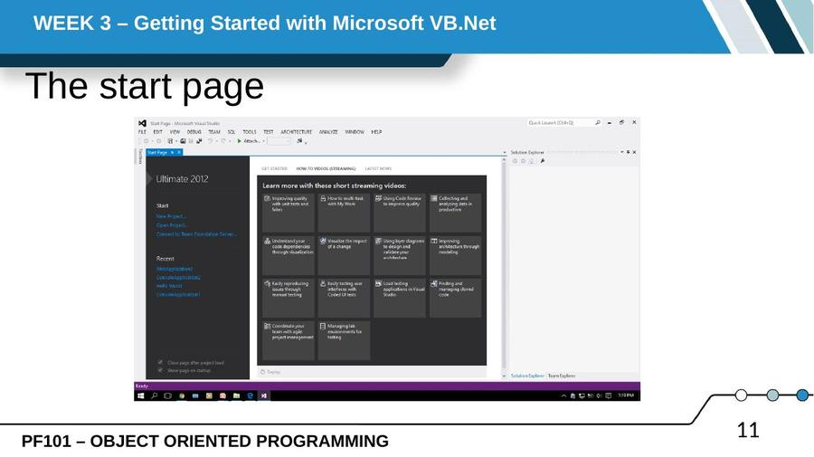
SLIDE 12
Starting a new project
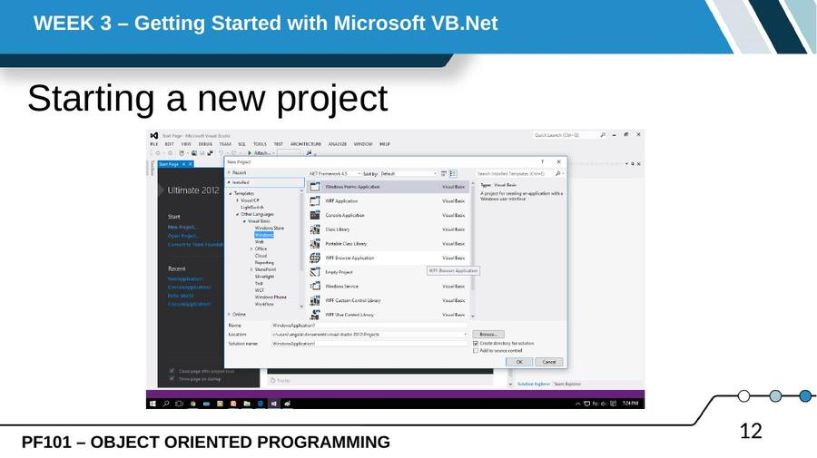
SLIDE 13
Starting a new project (cont.)
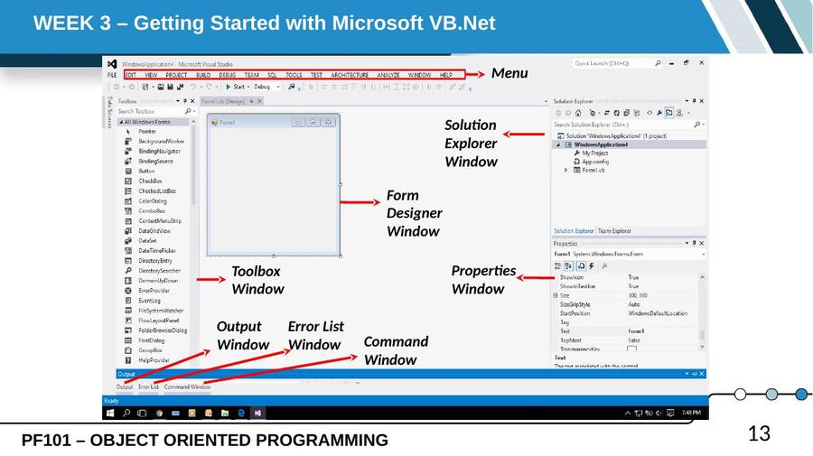
SLIDE 14
The Menu Bar
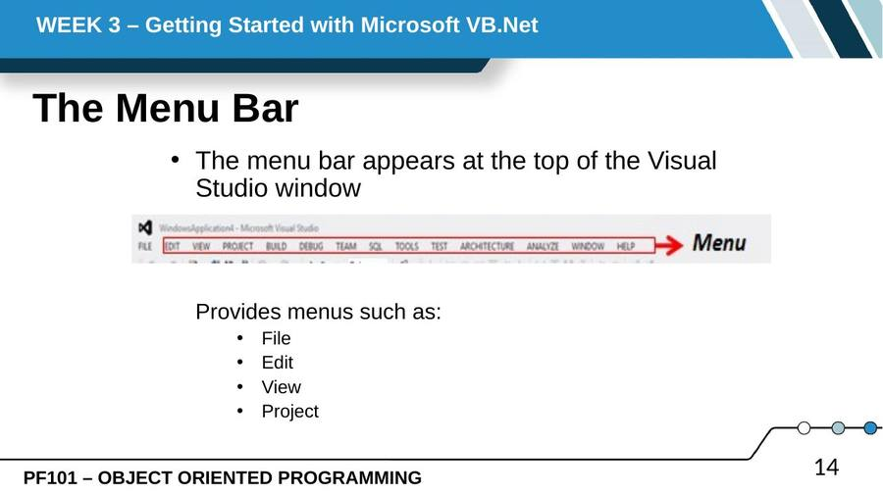
SLIDE 15
The Standard Toolbar
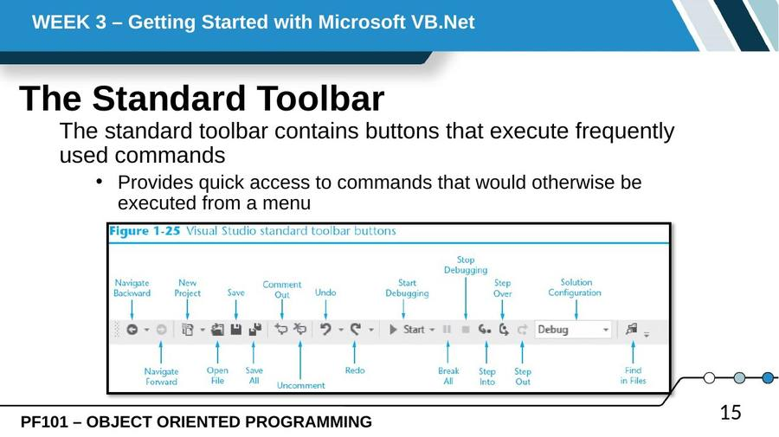
SLIDE 16
The Toolbox
• The Toolbox is a window for selecting controls to use in an application’s user interface
– Divided into sections such as All Windows Forms and Common Controls
– To open a section, click on its name tab
– To close a section, click on its name tab again
– Move a section to the top by dragging its name with the mouse
SLIDE 17
The Toolbox (cont.)
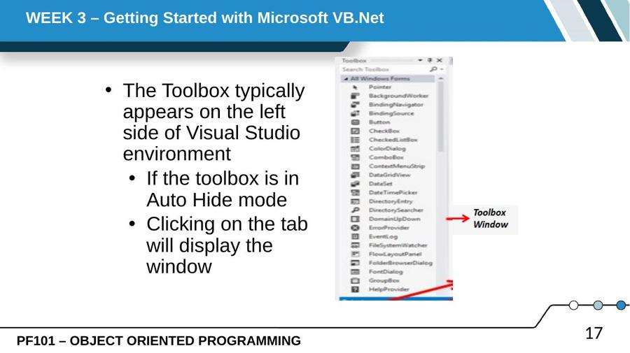
SLIDE 18
Solution Explorer window
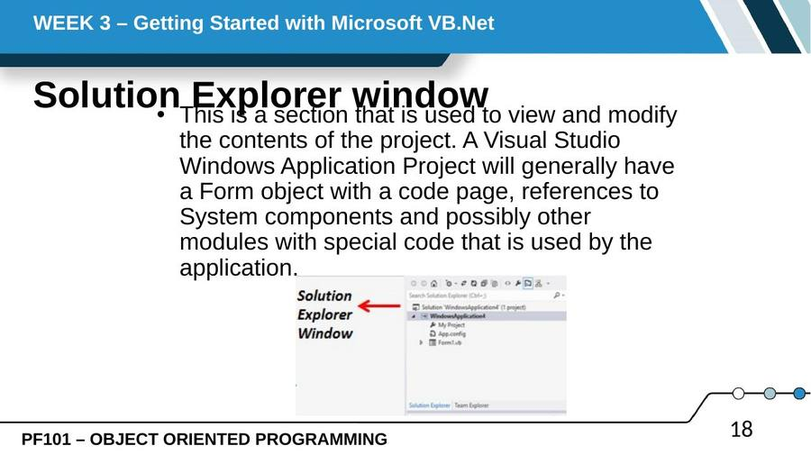
SLIDE 19
Properties Window
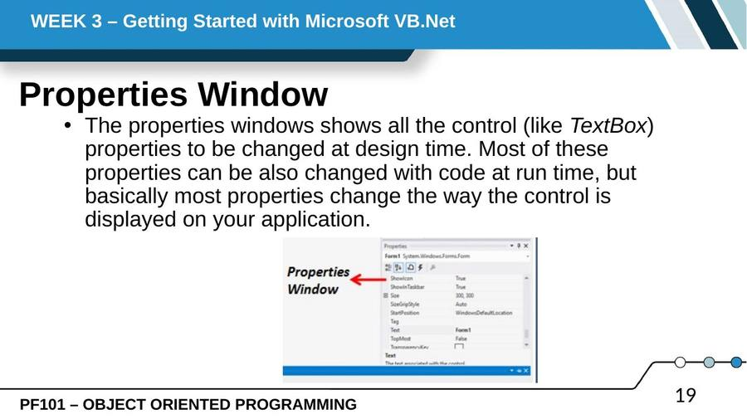
SLIDE 20
Form Designer Window
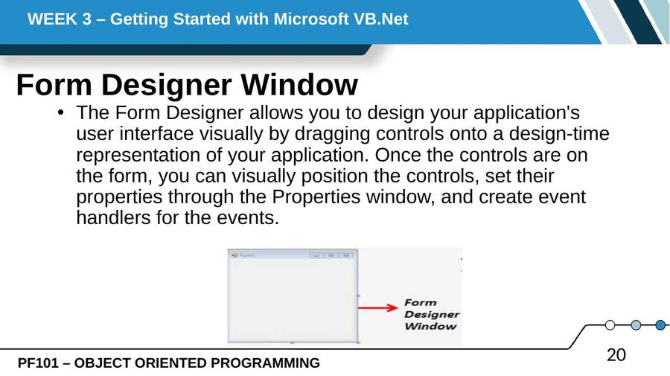
SLIDE 21
Output, Error List and Command Window
• The Output window can display status messages for various features in the integrated development environment (IDE). To open the Output window, on the menu bar, choose View/Output (or click CTRL + ALT + O).
• The Error List displays information about a specific error message. You can copy the error number or error string text from the Output window. To display the Output window, press Ctrl+Alt+O.
SLIDE 22
Output, Error List and Command Window (cont.)
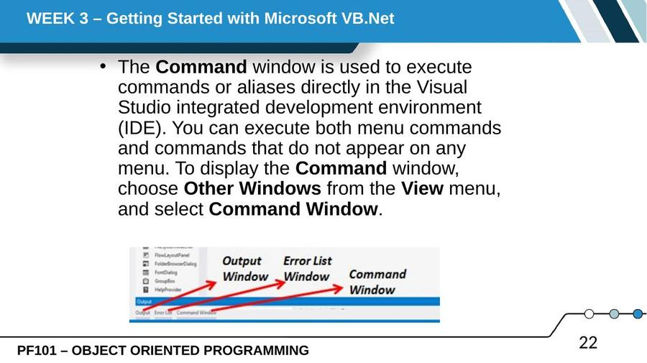
SLIDE 23
Auto Hide
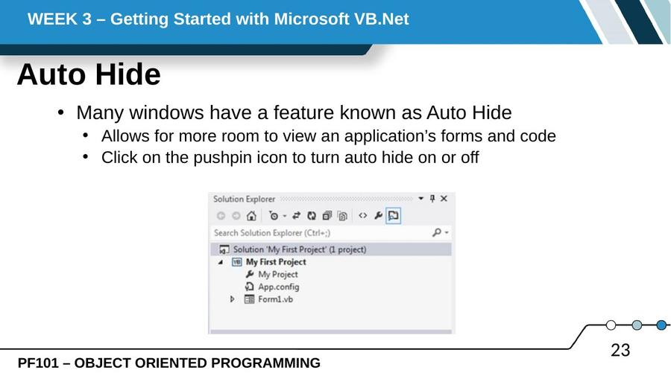
SLIDE 24
Using ToolTips
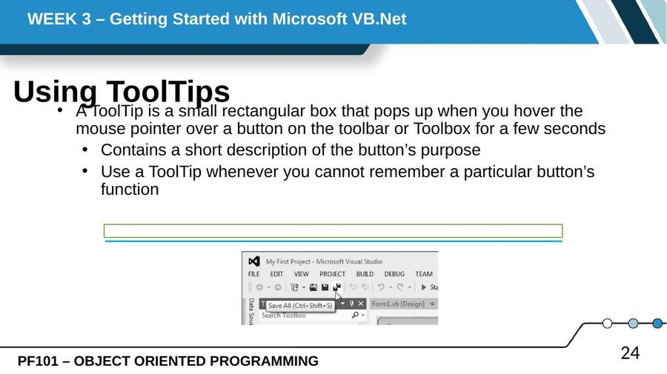
SLIDE 25
Docked and Floating Windows
• When a window is docked
– It is attached to one of the edges of the Visual Studio environment
• When a window is floating
– You can resize the window as well as click and drag it by its title bar
– Right-click a window’s title bar and select Float or Dock to change between floating or docked
SLIDE 26
Floating Toolbox, Solution Explorer, and Properties Windows
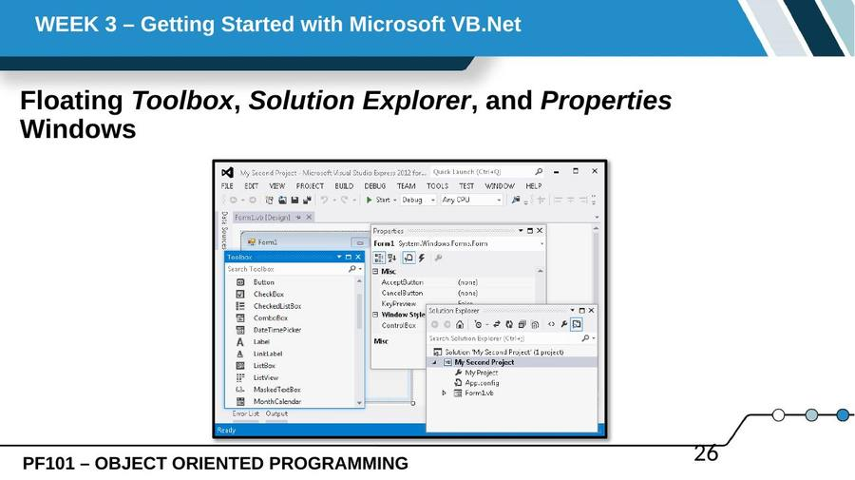
SLIDE 27
Console Application
• Console Applications have recently been introduced in Visual Basic .NET, they are command-line based applications. Console Applications allow us to write data to the console read data from the console, and run in within a DOS Shell. They do not support Windows GUI's. Console Applications are supported by the system. Console namespace.
SLIDE 28
Building a Console Application
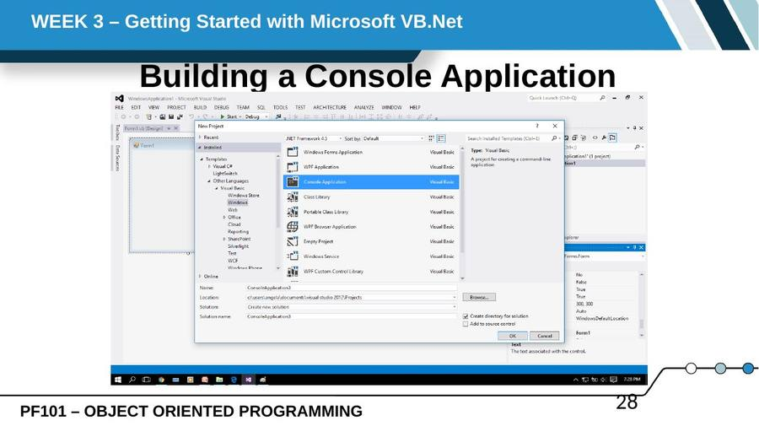
SLIDE 29
Building a Console Application (cont.)
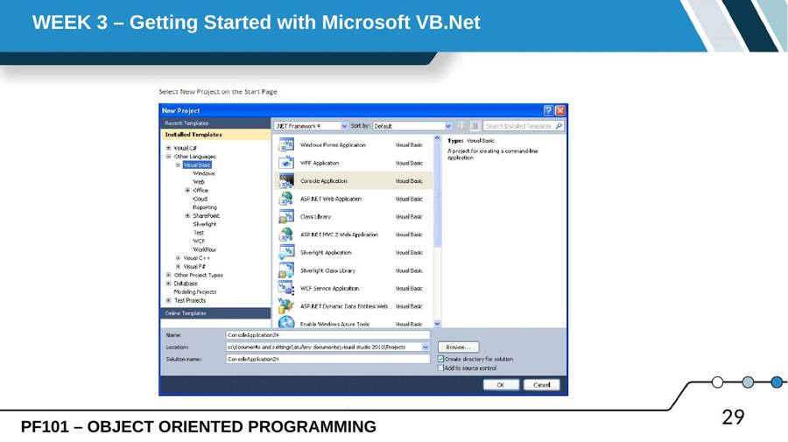
SLIDE 30
Building a Console Application (cont.)
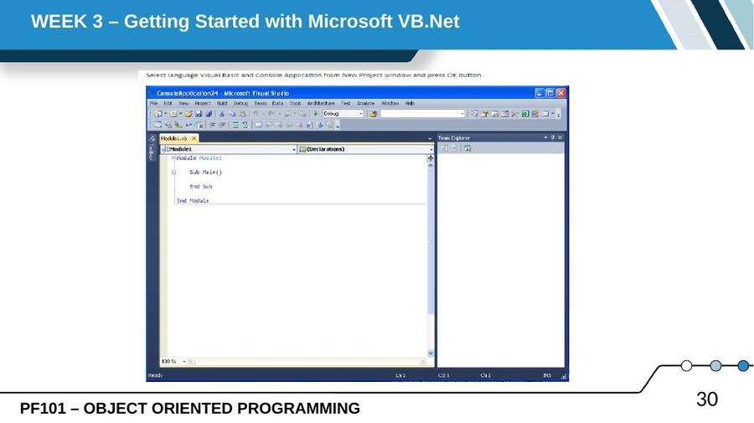
SLIDE 31
Building a Console Application (cont.)
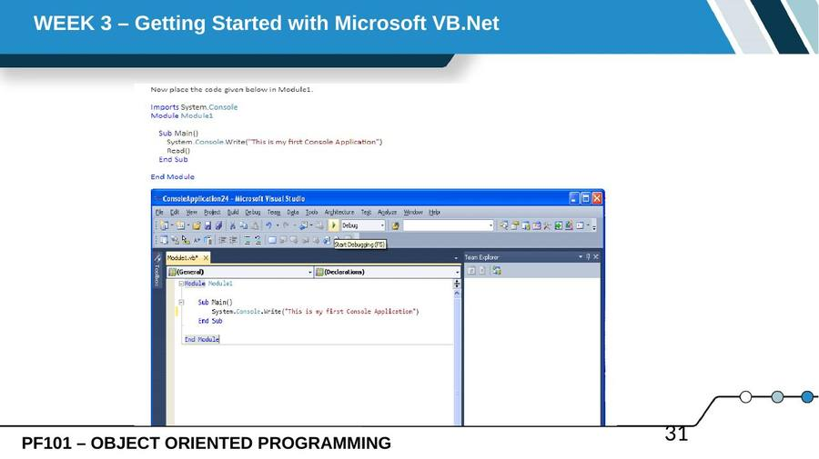
SLIDE 32
Building a Console Application (cont.)
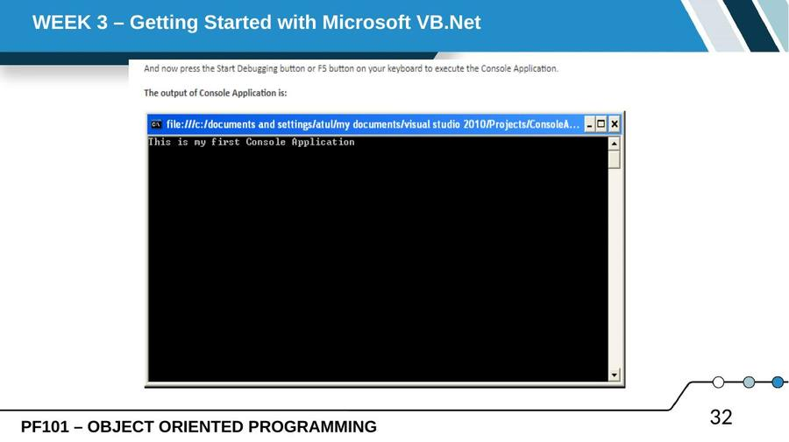
— End of Lesson 3 —

