LESSON 4
Planning Applications and Designing Interfaces
In this lesson
• Basic Controls
• Control Properties
• Control Methods
• Control Events
• Common Controls
• Appearance of Forms
• Tab Order
• Anchoring and Docking
SLIDE 2
Learning Outcomes
• At the end of the session, the students should be able to:
• 1. Identify different tools in VB.NET Windows Form
• 2. Demonstrate the different uses of each basic controls in VB.Net
• 3. Execute Debugging Applications and Compiling Visual Basic.Net
• 4. Explain how to control different Forms Properties
• 5. Define Visual Basic.NET Event Handling
SLIDE 3
VB.Net Basic Controls
• An object is a type of user interface element you create on a Visual Basic form by using a toolbox control. In fact, in Visual Basic, the form itself is an object. Every Visual Basic control consists of three important elements:
• Properties which describe the object,
• Methods cause an object to do something and
• Events are what happens when an object does something
SLIDE 4
Control Properties
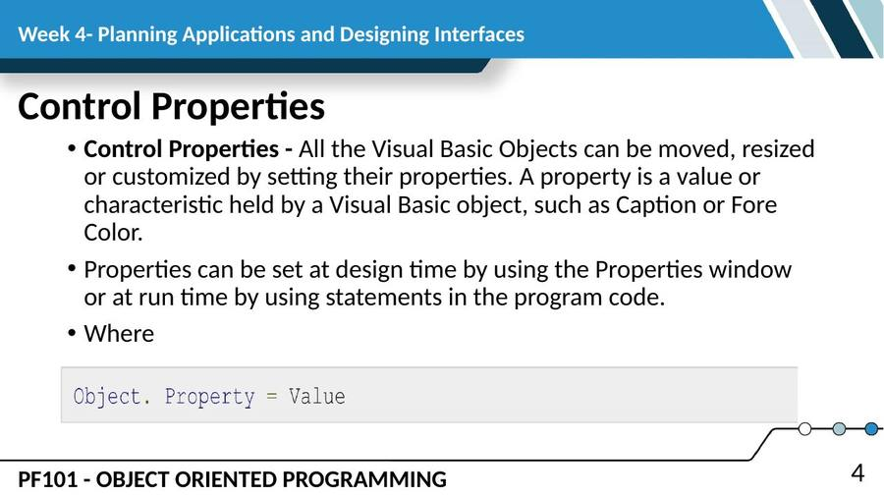
SLIDE 5
Control Properties (cont.)
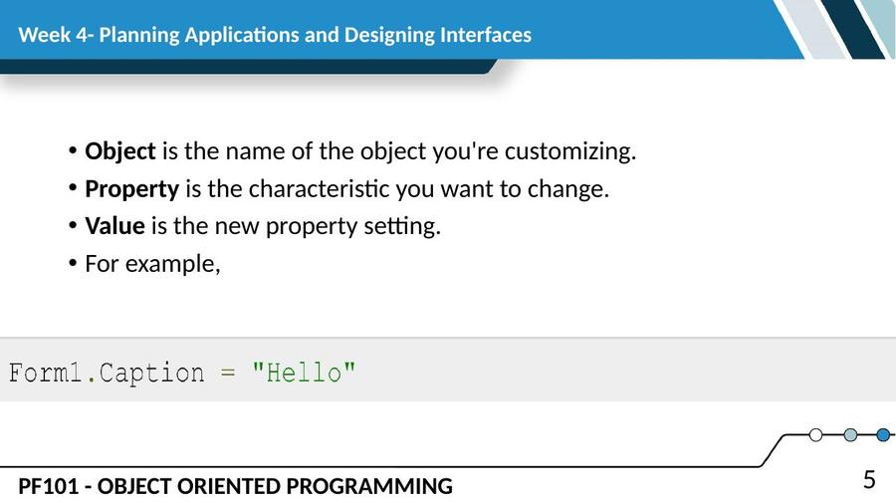
SLIDE 6
Control Methods
• A method is a procedure created as a member of a class and they cause an object to do something. Methods are used to access or manipulate the characteristics of an object or a variable. There are mainly two categories of methods you will use in your classes:
• If you are using a control such as one of those provided by the Toolbox, you can call any of its public methods. The requirements of such a method depend on the class being used.
• If none of the existing methods can perform your desired task, you can add a method to a class.
SLIDE 7
MessageBox.Show(“Hello, World”)
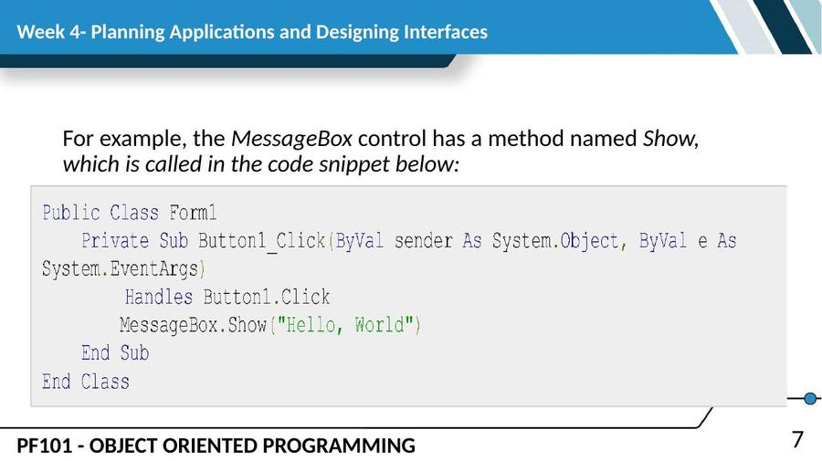
SLIDE 8
Control Events
• An event is a signal that informs an application that something important has occurred.
• For example, when a user clicks a control on a form, the form can raise a Click event and call a procedure that handles the event.
• . There are various types of events associated with a Form like click, double click, close, load, resize, etc.
SLIDE 9
Control Events (cont.)
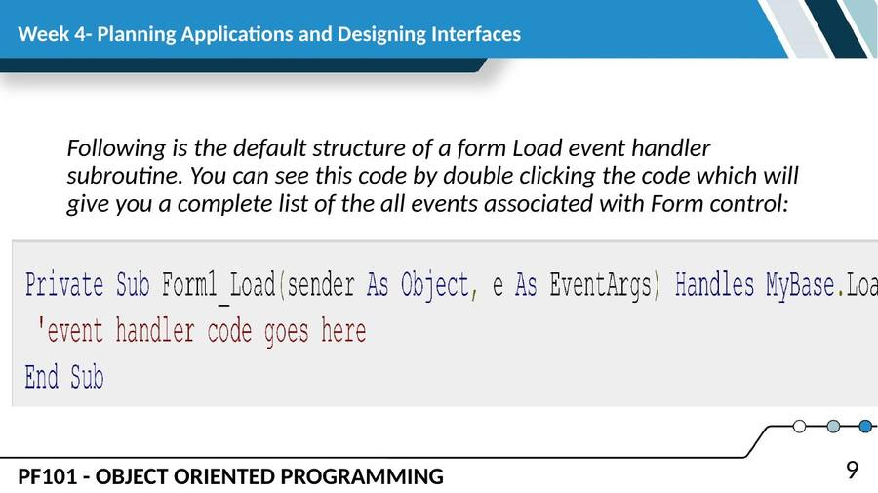
SLIDE 10
Control Events (cont.)
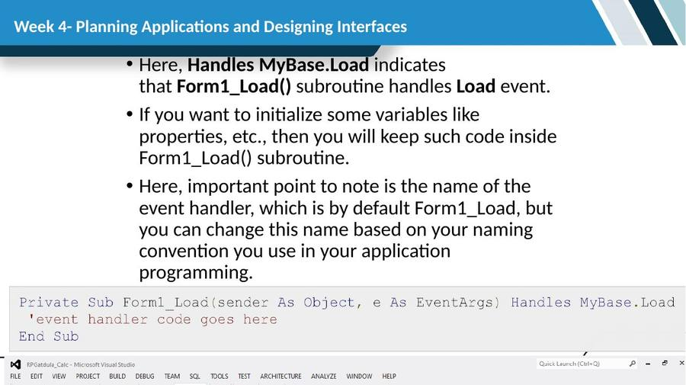
SLIDE 11
Basic Controls
• VB.Net provides a huge variety of controls that help you to create rich user interface. Functionalities of all these controls are defined in the respective control classes. The control classes are defined in the System.Windows.Forms namespace.
SLIDE 12
Basic Controls (cont.)
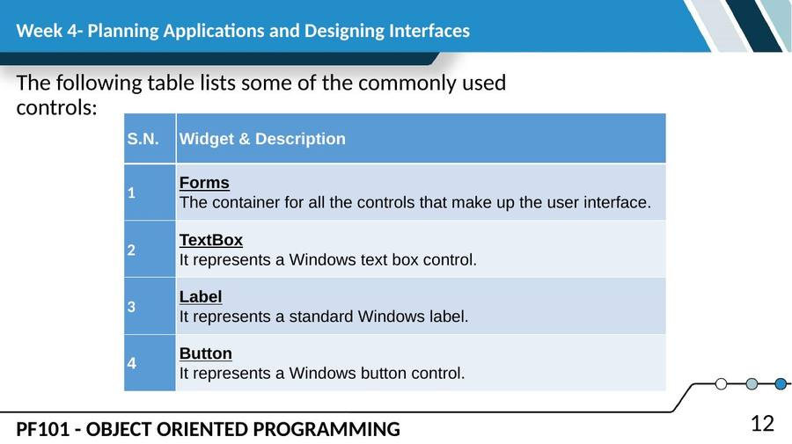
SLIDE 13
Basic Controls (cont.)
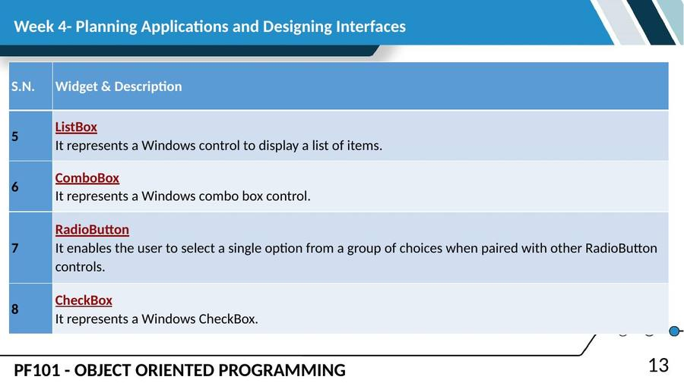
SLIDE 14
Basic Controls (cont.)
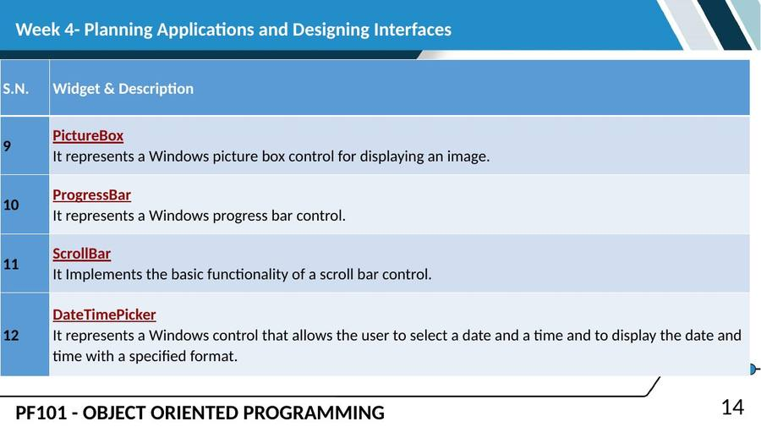
SLIDE 15
Appearance of Forms
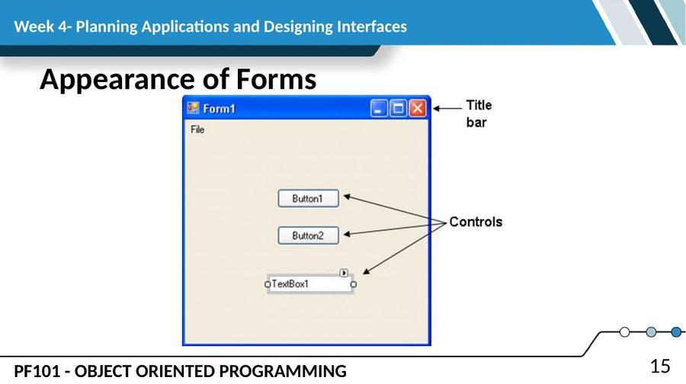
SLIDE 16
Properties of the form object
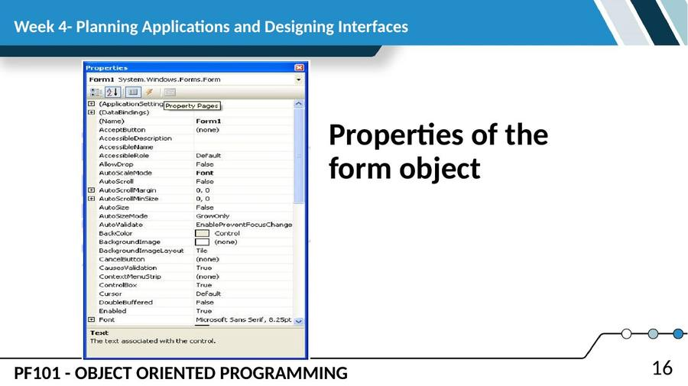
SLIDE 17
Form Properties
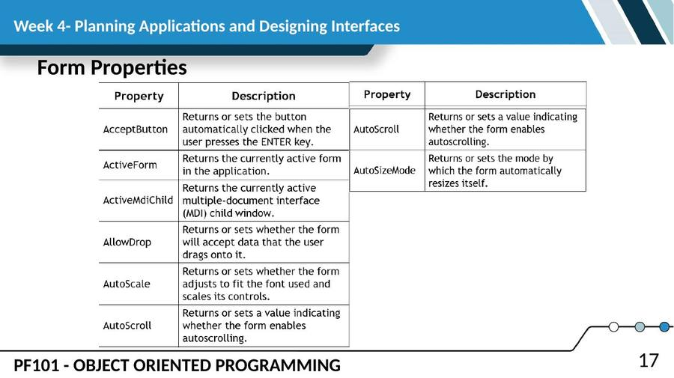
SLIDE 18
Form Properties
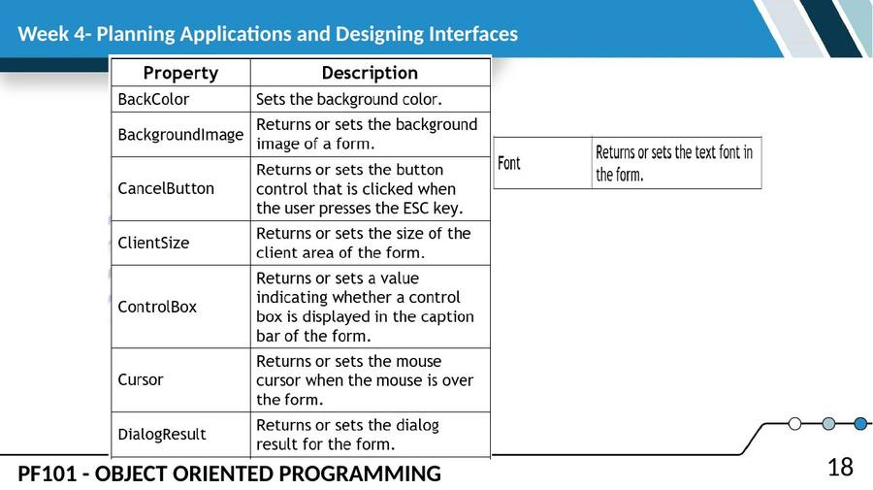
SLIDE 19
Form Properties (cont.)
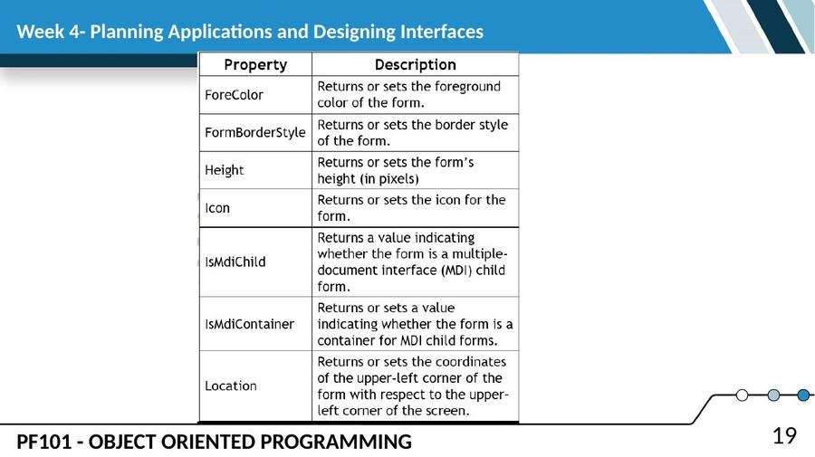
SLIDE 20
Form Properties (cont.)
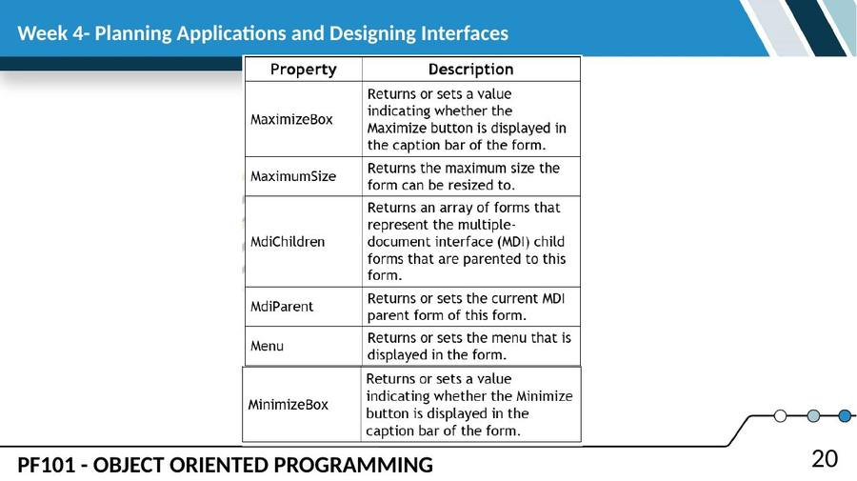
SLIDE 21
Form Properties (cont.)
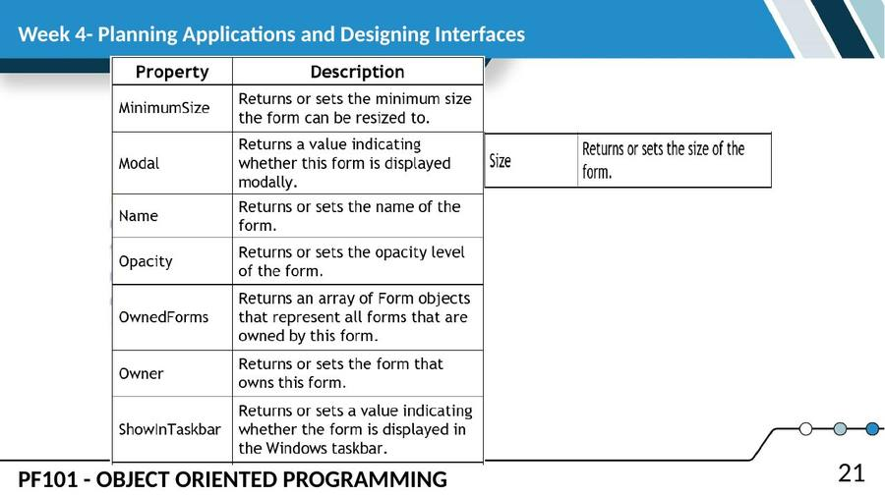
SLIDE 22
Form Properties (cont.)
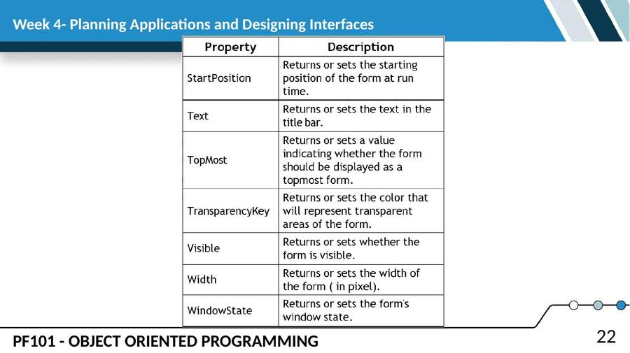
SLIDE 23
Setting the tab index property
• A tab index can consist of any valid integer greater than or equal to zero, lower numbers being earlier in the tab order. If more than one control on the same parent control has the same tab index, the z-order of the controls determines the order to cycle through the controls.
• For a control to be included in the tab order, its TabStop property must be set to true.
SLIDE 24
Example
• The following code example adds a Button to a form and sets some of its common properties. The example anchors the button to the bottom-right corner of the form so it keeps its relative position as the form is resized. Next it sets the BackgroundImage and resizes the button to the same size as the Image. The example then sets the TabStop to true and sets the TabIndex property. Lastly, it adds an event handler to handle the Click event of the button. This example requires that you have an ImageList named imageList1.
SLIDE 25
Example (cont.)
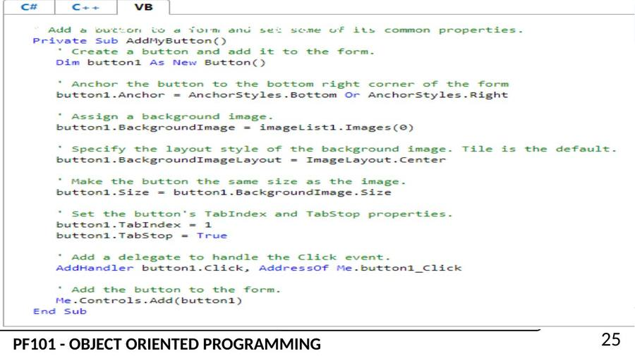
SLIDE 26
Anchoring and Docking
• The Anchor and Dock properties of a form are two separate properties. Anchor refers to the position a control has relative to the edges of the form. A textbox, for example, that is anchored to the left edge of a form will stay in the same position as the form is resized. Docking refers to how much space you want the control to take up on the form. If you dock a control to the left of the form, it will stretch itself to the height of the form, but its width will stay the same.
SLIDE 27
Anchoring
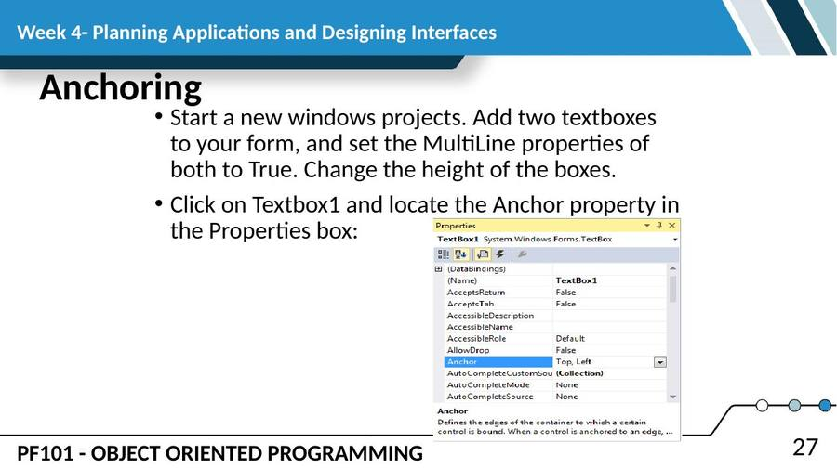
SLIDE 28
Anchoring (cont.)
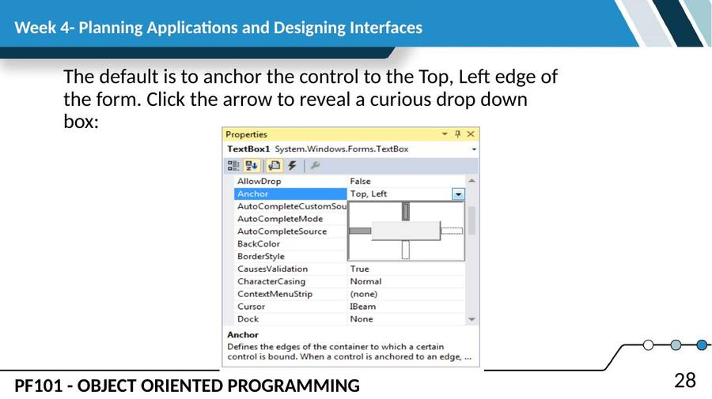
SLIDE 29
Docking
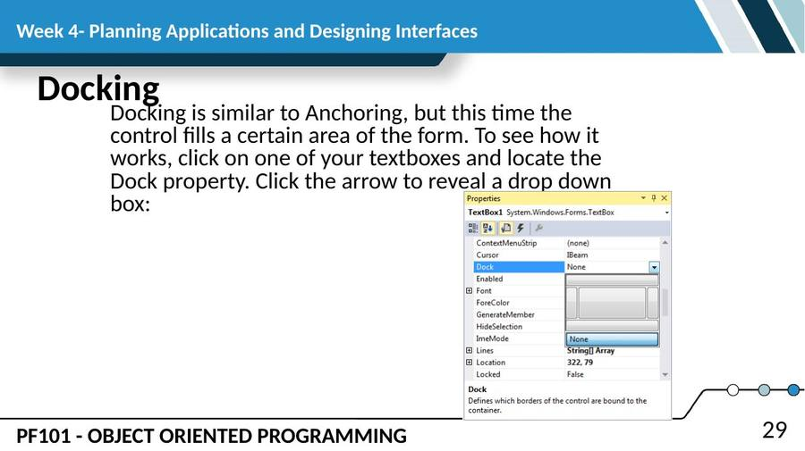
— End of Lesson 4 —

