LESSON 6
Coding With Variables Name Constants and Calculations
In this lesson
• Decision Statements
• Relational Operators
• Nested If
• Select Case
• Logical Operators
• Working with Strings
• Loops
SLIDE 2
Learning Outcomes
• At the end of the session, the students should be able to:
• 1. Identify different conditional statements
• 2. Demonstrate how to use if, if else, and if elseif else statement
• 3. Organize different looping statements
• 4. Describe for next loop, do while loop, while loop and nested control structures.
• 5. Use Date and Time and Exit and Continue Statements
SLIDE 3
Decision Statements
• If statement
• An If statement implements branching logic based on a testable condition – example:
• The left pane of this table shows pseudo code – a combination of VB and English to help you organize program logic.
• The right pane shows a program flowchart – a logic diagram that can also help you organize program logic.
SLIDE 4
Decision Statements (cont.)
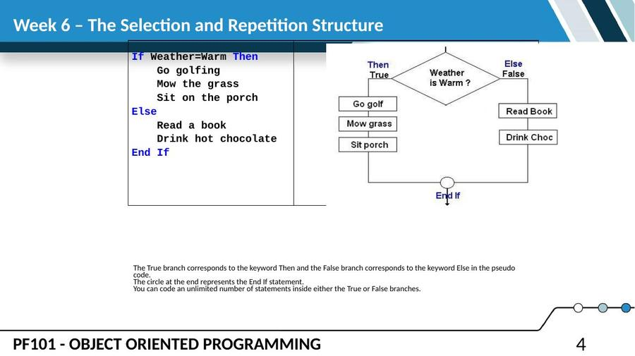
SLIDE 5
The If…Then…ElseIf Statement
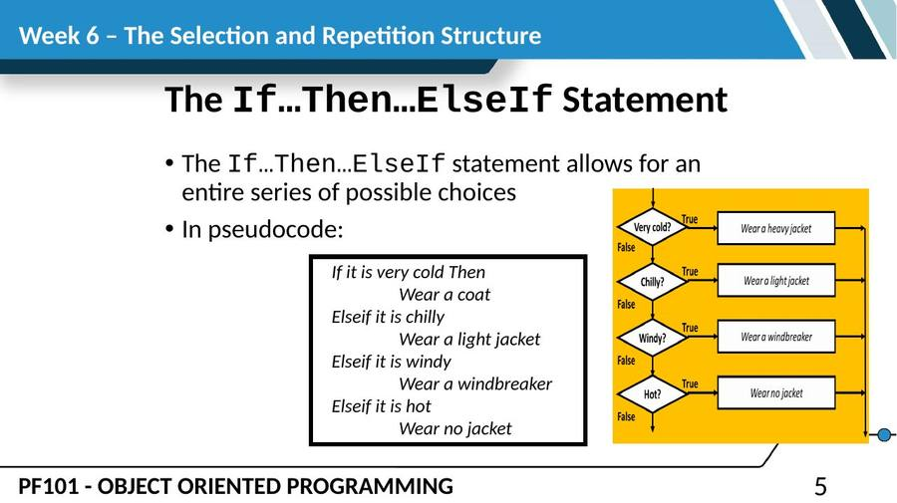
SLIDE 6
The If…Then…ElseIf Statement (cont.)
• The general format of the Block If statement:
• If <condition> Then
• (condition is true - do all of the actions
• coded in this branch)
• Else
• (condition is false - do all of the actions
• coded in this branch)
• End If
SLIDE 7
The If…Then…Else Statement
• If the expression is True
• Execute the statements between If…Then and Else
• If the expression is False
• Execute the statements between Else and End If
If expression Then
statement
(more statements may follow)
Else
statement
(more statements may follow)
End If
SLIDE 8
The If…Then…Else Statement (cont.)
• Learn these rules:
• A block If statement must always end with an End If statement.
• The key word Then must appear on the same line as the word If.
• The key words Else and End If must appear on lines by themselves.
• The Else branch is optional (see example below). Only use an Else statement if there is a False branch.
• Visual Basic automatically indents 4 spaces inside the True and False branches to make the statement easier to read.
SLIDE 9
Relational Operators
• Usually a condition is formed using a relational operator
• A relational operator determines if a specific relationship exists between two values
> Greater than
< Less than
= Equal to
<> Not equal to
>= Greater than or equal to
<= Less than or equal to
SLIDE 10
Boolean Expressions
• Relational operators are binary – meaning they use two operands, for example:
• length > width Is length greater than width?
• size <= 10 Is size less than or equal 10?
• Relational operators are used in Boolean expressions which yield a True or False result
• IF GRD >65.4 OR GRD < 69.5 then GRD = 2.75
SLIDE 11
Putting It All Together
• If…Then statement examples:
If decSales > 50000 Then
MessageBox.Show("You've earned a bonus!")
End If
If decSales > 50000 Then
MessageBox.Show("You've earned a bonus!")
decCommissionRate = 0.12
intDaysOff = intDaysOff + 1
End If
SLIDE 12
Using Relational Operators with Math Operators
• Math operators are evaluated before relational operators
• intX + intY and intA - intB are evaluated first
• Most programmers prefer to use parentheses to clarify the order of operations
If intX + intY > intA - intB Then
lblMessage.Text = "It is true!"
End If
If (intX + intY) > (intA – intB) Then
lblMessage.Text = "It is true!"
End If
SLIDE 13
Using Function Calls with Relational Operators
• Either or both relational operator operands may be function calls
• The return value of the function call is compared to the value using the relational operator
If CInt(txtInput.Text) < 100 Then
lblMessage.Text = "It is true!"
End If
SLIDE 14
Using Boolean Variables as Flags
• A flag is a Boolean variable that signals when some condition exists in the program
• Since a Boolean variable is either True or False, it can be used as the condition of an If…Then statement
• Since a Boolean variable already evaluates to True or False, an = operator is not required
If blnQuotaMet Then
lblMessage.Text = "You have met your sales quota"
End If
SLIDE 15
Nested If Statements
• If Statements Within If Statements
• Any type of statement may be used inside a set of Then, Else, or ElseIf statements of an If
This includes other If statements
• If statements within If statements create a more complex decision structure called a Nested If
• IF(AH17="","",IF(AH17>=97.5,1,IF(AH17>=94.5,1.25,IF(AH17>=91.5,1.5,IF(AH17>=88.5,1.75,IF(AH17>=85.5,2,IF(AH17>=82.5,2.25,IF(AH17>=97.5,2.5,IF(AH17>=76.5,2.75,IF(AH17>=74.5,3,5))))))))))
SLIDE 16
Examining the Nested If Statement
If dblSalary > 30000 Then
If intYearsOnJob > 2 Then
lblMessage.Text = "Applicant qualifies."
Else
lblMessage.Text = "Applicant does not qualify."
End If
Else
If intYearsOnJob > 5 Then
lblMessage.Text = "Applicant qualifies."
Else
lblMessage.Text = "Applicant does not qualify."
End If
End If
SLIDE 17
Flowchart of Nested If Statements
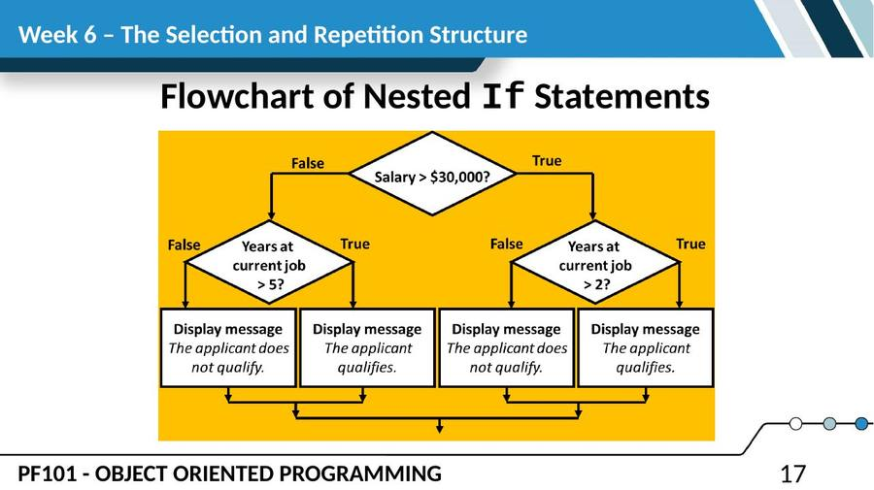
SLIDE 18
The Select Case Statement
Similar to If…Then…ElseIf
Performs a series of tests
• Conditionally executes the first true condition
• Select Case is different in that:
• A single test expression may be evaluated
• The test expression is listed once
• The possible values of the expression are then listed with their conditional statements
Case Else may be included and executed if none of the values match the expression
SLIDE 19
Select Case General Format
Select Case TestExpression
[Case ExpressionList
[one or more statements]]
[Case ExpressionList
[one or more statements]]
' Case statements may be repeated
' as many times as necessary.
[Case Else
[one or more statements]]
End Select
SLIDE 20
Select Case Statement Example
Select Case CInt(txtInput.Text)
Case 1
MessageBox.Show("Day 1 is Monday.")
Case 2
MessageBox.Show("Day 2 is Tuesday.")
Case 3
MessageBox.Show("Day 3 is Wednesday.")
Case 4
MessageBox.Show("Day 4 is Thursday.")
Case 5
MessageBox.Show("Day 5 is Friday.")
Case 6
MessageBox.Show("Day 6 is Saturday.")
Case 7
MessageBox.Show("Day 7 is Sunday.")
Case Else
MessageBox.Show("That value is invalid.")
End Select
SLIDE 21
Visual Basic Logical Operators
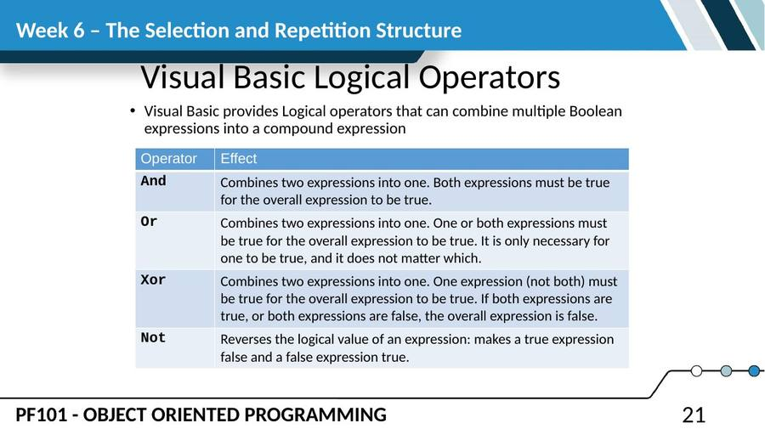
SLIDE 22
The And Operator
• The And operator combines two expressions into one
• The following If statement uses the And operator:
If intTemperature < 20 And intMinutes > 12 Then
lblMessage.Text = "The temperature is in the danger zone."
End If
SLIDE 23
The And Operator (cont.)
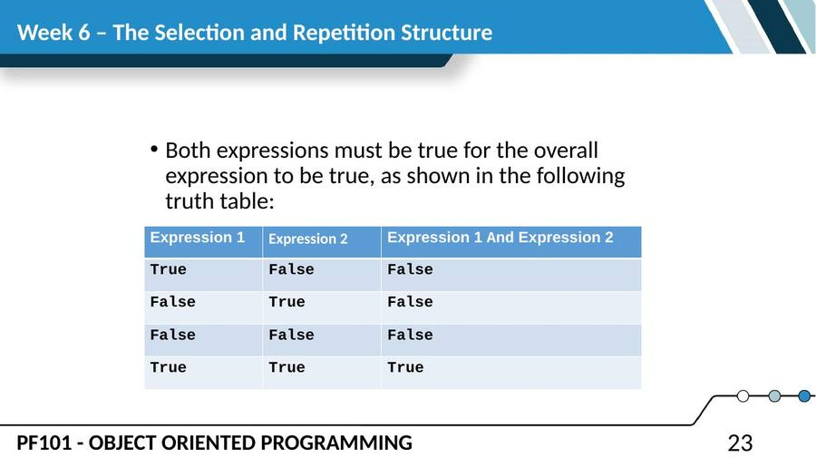
SLIDE 24
Short-Circuit Evaluation with AndAlso
• When using the And operator, if the first expression is false, then the entire expression will be false
• If there is no need to evaluate the second expression, it can be skipped using a method called short-circuit evaluation
• In Visual Basic you use the AndAlso operator to achieve short-circuit evaluation
SLIDE 25
Short-Circuit Evaluation with AndAlso (cont.)
• In the following example, assuming that dblX is less than or equal to zero, CheckValue is not called and "Expression is False" is displayed:
If dblX > 0 AndAlso CheckValue(dblX) Then
lblResult.Text = "Expression is True"
Else
lblResult.Text = "Expression is False"
End If
SLIDE 26
The Or Operator
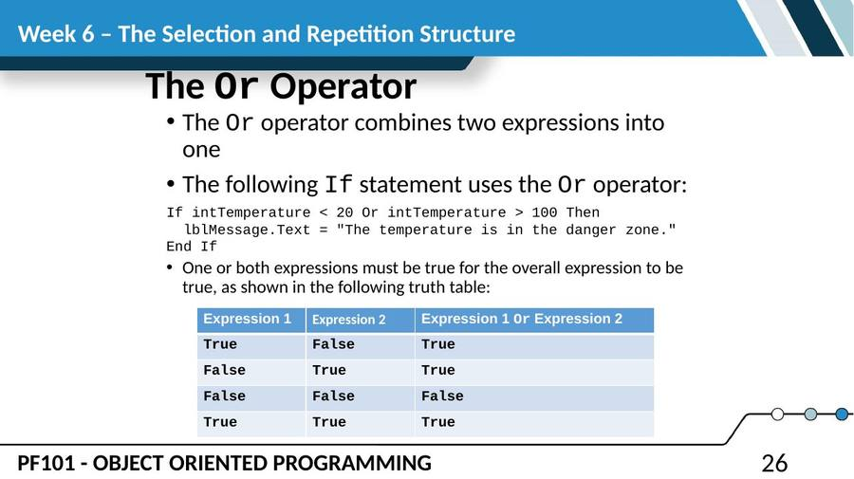
SLIDE 27
Short Circuit-Evaluation with OrElse
• When using the Or operator, if the first expression is true, then the entire expression will be true
• If there is no need to evaluate the second expression, it can be skipped using short-circuit evaluation with the OrElse operator
SLIDE 28
Short Circuit-Evaluation with OrElse (cont.)
• In the following example, if dblX is equal to zero, CheckValue is not called and "Expression is True" is displayed:
If dblX = 0 OrElse CheckValue(dblX) Then
lblResult.Text = "Expression is True"
End If
If CheckBox1.Checked = True Then
SLIDE 29
The Xor Operator
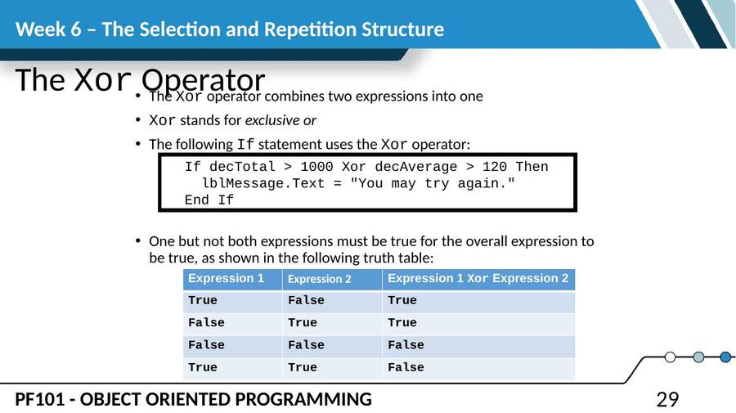
SLIDE 30
The Not Operator
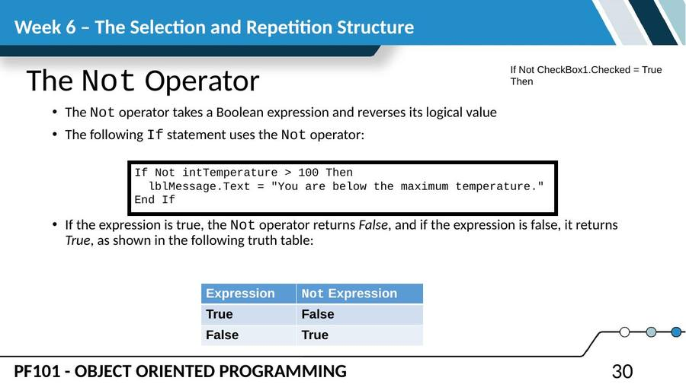
SLIDE 31
Precedence of Logical Operators
• Logical operators have an order of precedence just as arithmetic operators do
From highest to lowest precedence
Not
And
Or
Xor
• As with arithmetic operations, parentheses are often used to clarify order of operations
SLIDE 32
Precedence of Logical Operators
• For example, in the statement
If x < 0 And y > 100 Or z = 50
• x < 0 And y > 100 is evaluated first
• If the And condition is true, we then evaluate
True Or z = 50
• If the And condition is false, we then evaluate
False Or z = 50
• If the Or condition is to be evaluated first, parentheses must be used
If x < 0 And (y > 100 Or z = 50)
SLIDE 33
Math, Relational, & Logical Operators
• Evaluate the following if: a=5, b=7, x=100, y=30
If x > a * 10 And y < b + 20
• Evaluating the math operators leaves us with
If x > 50 And y < 27
Evaluating the relational operators leaves
• If True And False
Evaluating the logical operators leaves
False
• Parentheses make order of operations clear
If (x > (a * 10)) And (y < (b + 20))
SLIDE 34
Comparing, Testing, and Working with Strings
• Relational operators can be used to compare strings and string literals
strName1 = "Mary"
strName2 = "Mark"
If strName1 = strName2 Then
lblMessage.Text = " Names are the same"
Else
lblMessage.Text = " Names are NOT the same"
End If
If strMonth <> "October" Then
' statement
End If
SLIDE 35
How Are Strings Compared?
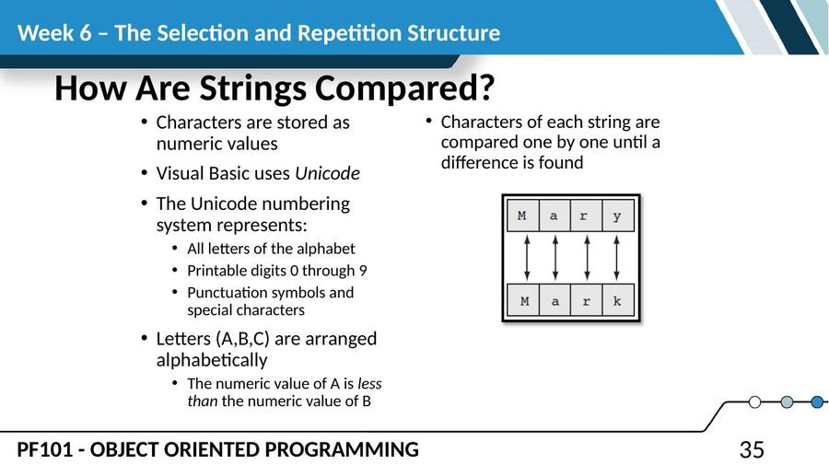
SLIDE 36
Testing for No Input
• The predefined constant String.Empty represents an empty string, which is a string that contains no characters
• Useful for determining whether the user has provided input for a required field before performing operations on that field
If txtInput.Text = String.Empty Then
lblMessage.Text = "Please enter a value"
Else
' The txtInput control contains input, so
' perform an operation with it here.
End If
• empty(txtInput.text) = null
• txtInout.text =”” = null
• txtInout.text =” ” !null
SLIDE 37
The ToUpper and ToLower Methods
• The ToUpper method can be applied to a string
• Results in a string with lowercase letters converted to uppercase
• The original string is not changed
• General Format:
• In the following example, strBigWord is assigned the string "HELLO" using the ToUpper method:
• The ToLower method can be applied to a string
• Results in a string with uppercase letters converted to lowercase
• The original string is not changed
• General Format:
• In the following example, strLittleTown is assigned the string "new york" using the ToLower method:
StringExpression.ToUpper()
strLittleWord = "Hello"
strBigWord = strLittleWord.ToUpper()
StringExpression.ToLower()
strBigTown = "NEW YORK"
strLittleTown = strBigTown.ToLower()
SLIDE 38
The IsNumeric Function
• This function accepts a string as an argument and returns True if the string contains a number
• Use IsNumeric function to determine if a given string contains numeric data
Dim strNumber As String
strNumber = "576"
If IsNumeric(strNumber) ' Returns true
strNumber = "123abc"
If IsNumeric(strNumber) ' Returns false
SLIDE 39
Determining the Length of a String
• The Length property, a member of the String class, returns the number of characters in a string
• In the following example, the intNumChars variable contains the value 6:
• You can also determine the length of a control's Text property, as shown in the following code:
Dim strName As String = "Herman"
Dim intNumChars As Integer
intNumChars = strName.Length
If txtInput.Text.Length > 20 Then
lblMessage.Text = "Please enter no more than 20 characters."
End If
SLIDE 40
Trimming Spaces from Strings
• There are three methods that remove spaces from strings:
TrimStart - removes leading spaces
TrimEnd - removes trailing spaces
• Trim - removes leading and trailing spaces
• Here is the general format for each method:
• An example with three leading and trailing spaces, using each method:
StringExpression.TrimStart()
StringExpression.TrimEnd()
StringExpression.Trim()
strGreeting = " Hello "
lblMessage1.Text = strGreeting.TrimStart() ' "Hello "
lblMessage2.Text = strGreeting.TrimEnd() ' " Hello"
lblMessage3.Text = strGreeting.Trim() ' "Hello"
SLIDE 41
Looping Statement
• A repetition structure, or loop causes one or more statements to repeat
• Each repetition of the loop is called an iteration
• Visual Basic has three types of loops:
Do While variable = value
Do Until
For… Next
• The difference among them is how they control the repetition
SLIDE 42
Looping Statement (cont.)
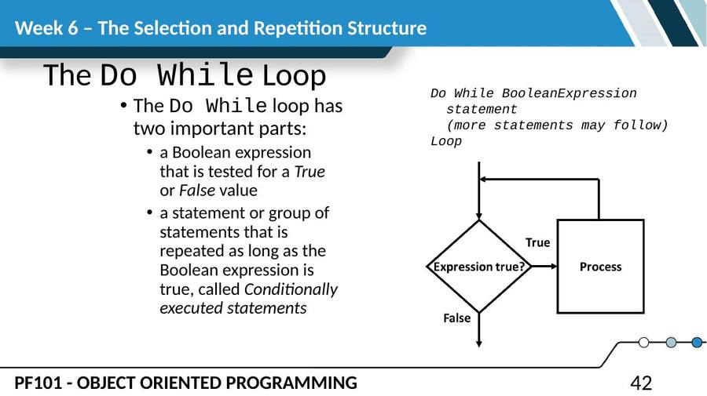
SLIDE 43
Looping Statement (cont.)
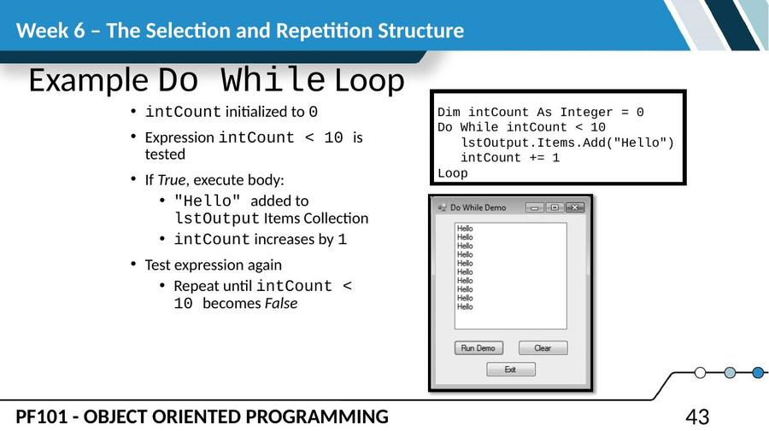
SLIDE 44
Looping Statement (cont.)
Example of For…Next Loop
• Step 1: intCount is set to 1 (the start value)
• Step 2: intCount is compared to 10 (the end value)
• If intCount is less than or equal to 10
Continue to Step 3
Otherwise the loop is exited
Step 3: The MessageBox.Show("Hello") statement is executed
• Step 4: intCount is incremented by 1
• Step 5: Go back to Step 2 and repeat this sequence
For intCount = 0 To 9
MessageBox.Show("Hello")
Next
SLIDE 45
Nested Loop
• A nested loop is a loop inside another loop
• The hands of a clock make a good example
– The hour hand makes 1 revolution for every 60 revolutions of the minute hand
– The minute hand makes 1 revolution for every 60 revolutions of the second hand
– For every revolution of the hour hand the second hand makes 36,000 revolutions
SLIDE 46
Nested Loop (cont.)
• Nested Loop Example
For intHours = 0 To 23
lblHours.Text = intHours.ToString()
For intMinutes = 0 To 59
lblMinutes.Text = intMinutes.ToString()
For intSeconds = 0 To 59
lblSeconds.Text = intSeconds.ToString()
Next
Next
Next
• Hours (outer loop)
• Minutes (middle loop)
• Seconds (inner loop)
SLIDE 47
Nested Loop (cont.)
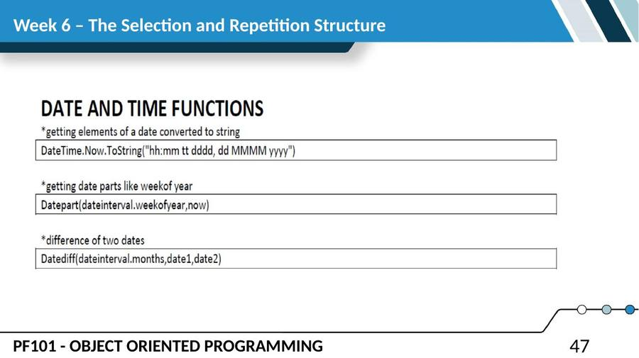
— End of Lesson 6 —

