LESSON 7
Arrays
In this lesson
• What Is an Array
• Declaring Arrays
• One-Dimension Arrays
• Two-Dimensional Arrays
• Three Dimensions and Beyond
• Arrays and Procedures
• Laboratory Activity
SLIDE 2
Learning Outcomes
• At the end of the session, the students should be able to:
• 1. Define syntax of array
• 2. Define two types of array
• 3. Discuss array initialization
SLIDE 3
Arrays
• Arrays are like groups of variables that allow you to store sets of similar data
– A single dimension array is useful for storing and working with a single set of data
– A multidimensional array can be used to store and work with multiple sets of data
• Array programming techniques covered
– Summing and averaging all the elements in an array
– Summing all the columns in a two-dimensional array
– Searching an array for a specific value
– Using parallel arrays
SLIDE 4
Array Characteristics
• An array stores multiple values of same type
– Like a group of variables with a single name
• For example, the days of the week might be:
– A set of 7 string variables
– With a maximum length of 9 characters
• All variables within an array are called elements and must be of the same data type
• You access the elements in an array through a subscript
SLIDE 5
Declaring an Array
• Declare an array much like a regular variable
– ArrayName is the name of the array
– UpperSubscript is the value of the array's highest subscript
– Must be a positive Integer
– Positive Integer named constant
– Integer variable containing a positive number
– DataType is a Visual Basic data type
Dim ArrayName (UpperSubscript) As DataType
SLIDE 6
Declaring an Array (cont.)
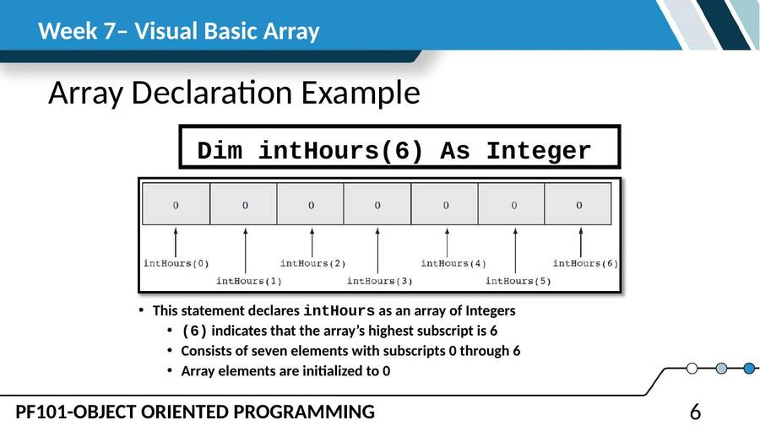
SLIDE 7
Default Initialization
• All elements of an Integer array are initialized to zero
• Same initialization as an integer variable
• Each array element is initialized exactly the same as a simple variable of that data type
Decimal elements are initialized to zero (0.0)
• String elements are initialized to the special value Nothing
SLIDE 8
Default Initialization (cont.)
• Implicit Array Sizing and Initialization
• An array can be initialized when declared
• Example:
This array is implicitly sized
• Upper subscript value is left blank
• Number of elements implied from initialization
• Upper subscript of 5 implied by this example
• This results in a 6 element array
• Elements are assigned the values shown
Dim intNumbers() As Integer = { 2, 4, 6, 8, 10, 12 }
SLIDE 9
Using Named Constants as Subscripts in Array Declarations
• A named constant may be used as an array's highest subscript instead of a number
• This is a common use for named constants
– Highest subscript is often used multiple times
– If highest subscript changes, use of a named constant allows it to be changed in one place
Const intMAX_SUBSCRIPT As Integer = 100
Dim intArray(intMAX_SUBSCRIPT) As Integer
SLIDE 10
One Dimension Array
• An Array is a listof values – all values in an array are referenced by using the same name.
• An array is like a ListBox without the box where the list of values are all stored in memory.
• Arrays are also called tables.
• Arrays are based on the System.Array object – a type of collection object. Arrays can store almost any type of data such as integer, string, decimal, etc.
• Element – this is the term used to refer to an individual part of an array.
• Index: 0 1 2 3 4 5
• Value: 2 4 6 8 10 12
SLIDE 11
One Dimension Array (cont.)
• Each element is numbered beginning with the number zero. Example, 0, 1, 2, 3, etc.
• The number referring to an array elementis placed inside parentheses and is called a subscript or index. This is the general format for an array reference.
• ArrayName(ElementNumber)
• Example references to array elements:
• Element 4 of the array named AmountDecimal – remember that arrays start with 0 so the 4th element is numbered 3
• AmountDecimal(3)
SLIDE 12
Two-Dimensional Arrays
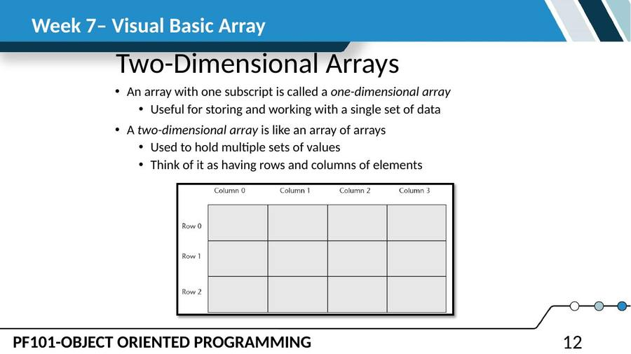
SLIDE 13
Declaring a Two-Dimensional Array
• A two-dimensional array declaration requires two sets of upper subscripts
• First upper subscript is for the rows
• Second upper subscript for the columns
• ArrayName is the name of the array
• UpperRow is the value of the highest row subscript
Must be a positive integer
• UpperColumn is the value of the highest column subscript
Must be a positive integer
• DataType is the Visual Basic data type
• Example declaration with three rows and four columns:
Dim ArrayName (UpperRow,UpperColumn) As DataType
Dim dblScores (2, 3) As Double
SLIDE 14
Processing Data in Two-Dimensional Arrays
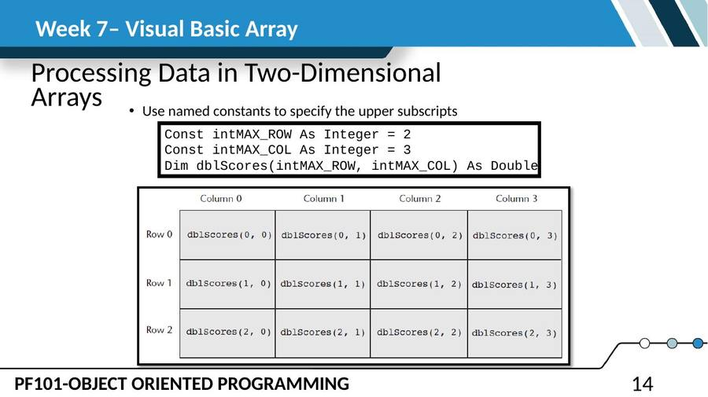
SLIDE 15
Processing Data in Two-Dimensional Arrays (cont.)
• Example of storing a number in a single element
• Example of prompting the user for input, once for each element
• Example of displaying all of the elements in the array
dblScores(2, 1) = 95
For intRow = 0 To intMAX_ROW
For intCol = 0 To intMAX_COL
dblScores(intRow, intCol) =
CDbl(InputBox("Enter a score."))
Next
Next
For intRow = 0 To intMAX_ROW
For intCol = 0 To intMAX_COL
lstOutput.Items.Add(dblScores(intRow, intCol).ToString())
Next
Next
SLIDE 16
Three-Dimensional Arrays and Beyond
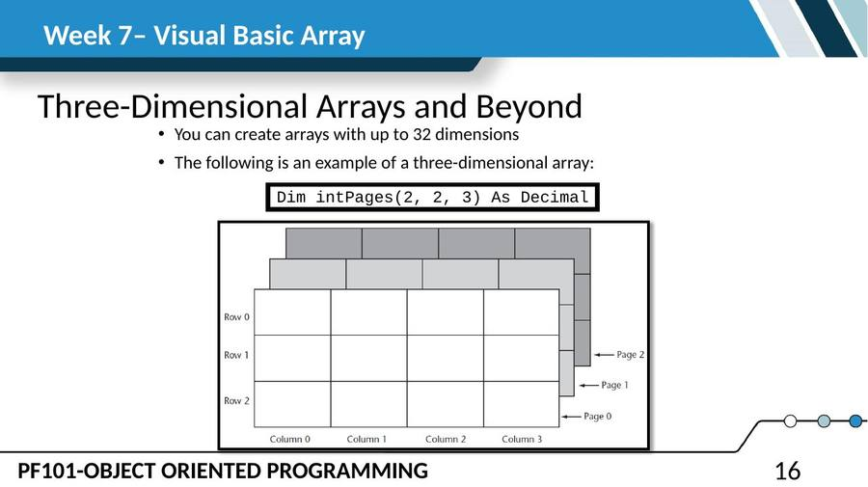
SLIDE 17
Three-Dimensional Arrays and Beyond (cont.)
• Arrays with more than three dimension are difficult to visualize
– Useful in some programming applications
– For example:
– A factory warehouse where cases of widgets are stacked on pallets, an array of four dimensions can store a part number for each widget
– The four subscripts of each element can store:
– Pallet number
– Case number
– Row number
– Column number
– A five dimensional array could be used for multiple warehouses
SLIDE 18
Functions
Declaring a Function
New keyword Function
• Also new is As DataType which states the data type of the value to be returned
Return value is specified in a Return expression
[AccessSpecifier] Function FunctionName ([ParameterList]) As DataType
[Statements]
End Function
SLIDE 19
Functions (cont.)
The Sum function
• Passes the variables dblValue1 and dblValue2 as arguments
• Data types must agree with parameter list
• Assigns the value returned by the Sum function to the variable dblTotal, agrees with return value
dblTotal = Sum(dblValue1, dblValue2)
Function Sum(ByVal dblNum1 As Double, ByVal dblNum2 As Double)
As Double
Return dblNum1 + dblNum2
End Function
SLIDE 20
Functions (cont.)
• Returning Nonnumeric Values
• Functions can return nonnumeric values, such as strings and Boolean values
strCustomer = FullName("John", "Martin")
Function FullName(ByVal strFirst As String,
ByVal strLast As String) As String
' Local variable to hold the full name
Dim strName As String
' Append the last name to the first
' name and assign the result to strName.
strName = strFirst & " " & strLast
' Return the full name.
Return strName
End Function
SLIDE 21
Procedures and Functions That Work with Arrays
• Procedures can be written to process the data in arrays
– Store data in an array
– Display an array’s contents
– Sum or average the values in an array
• Usually such procedures accept an array as an argument
– Pass the name of the array as the argument to the procedure or function
• Passing Arrays as Arguments
' The DisplaySum procedure displays the
' sum of the elements in the argument array.
Sub DisplaySum(ByVal intArray() As Integer)
Dim intTotal As Integer = 0 ' Accumulator
Dim intCount As Integer ' Loop counter
For intCount = 0 To (intArray.Length - 1)
intTotal += intArray(intCount)
Next
MessageBox.Show("The total is " &
intTotal.ToString())
End Sub
Dim intNumbers() As Integer =
• { 2, 4, 7, 9, 8, 12, 10 }
DisplaySum(intNumbers)
SLIDE 22
Returning an Array from a Function
• demonstrates passing an array to procedures and functions
' Get three names from the user and return
' them as an array of strings.
Function GetNames() As String()
Const intMAX_SUBSCRIPT As Integer = 2
Dim strNames(intMAX_SUBSCRIPT) As String
Dim intCount As Integer
For intCount = 0 To 3
strNames(intCount) = InputBox("Enter name " &
(intCount.ToString())
Next
Return strNames
End Function
Dim strCustomers() As String
strCustomers = GetNames()
SLIDE 24
Returning an Array from a Function (cont.)
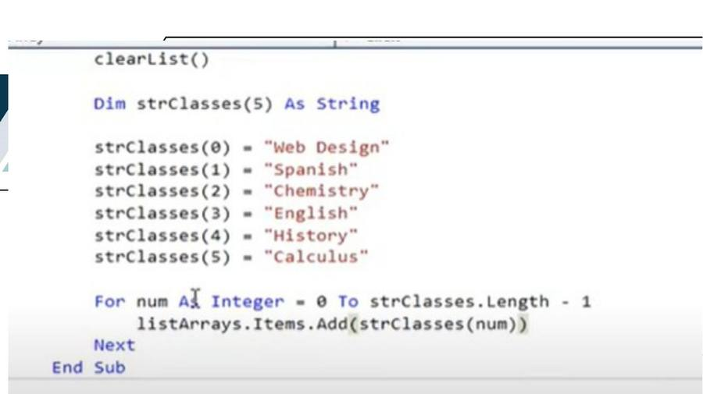
SLIDE 25
Returning an Array from a Function (cont.)
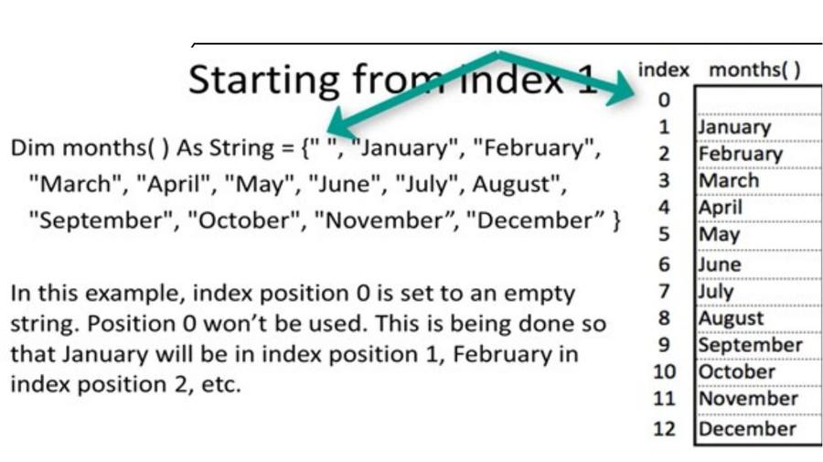
SLIDE 26
Returning an Array from a Function (cont.)
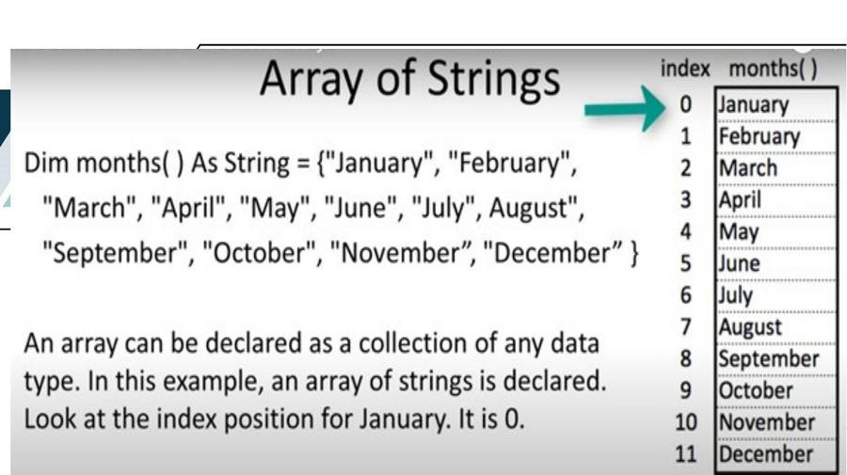
SLIDE 27
Returning an Array from a Function (cont.)
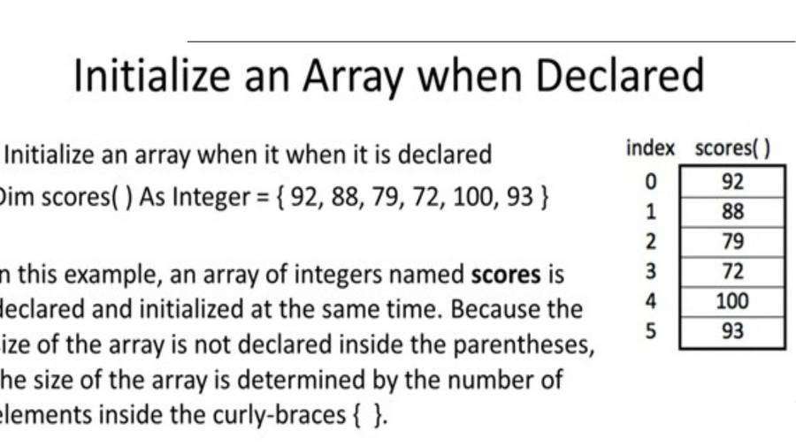
SLIDE 28
Take a picture and upload to your personal folder under midterm.
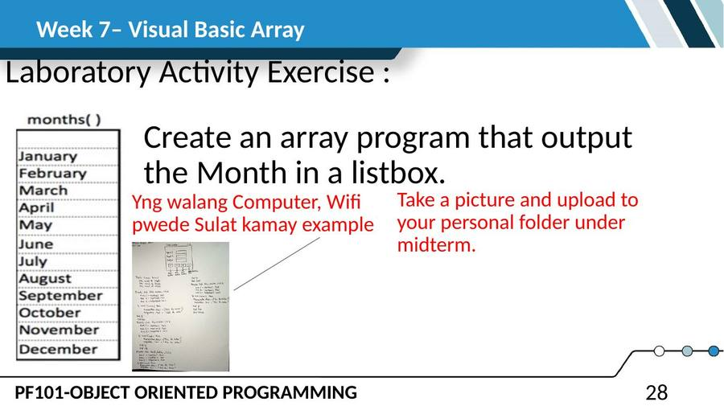
— End of Lesson 7 —

