COL-764 Information Retrieval and Web Search
Assignment -2

1. Rocchio Methods -

Preprocessing data -
- Tokenizing of word using – nltk word_tokenizer
- Using Porter Stemmer from nltk
- Also removing stopwords using list from nltk.corpus

Choice of SUM(d_R) and SUM(d_NR)-
- For sum of relevent documents for a query I took the top 100 queries which we got. (lets call it Sum{d_R}).
- For the sum of Non Relevent documents I took the documents given in 40*100 queries (i.e docs retrieved for all queries let it be = Sum{d}) – relevent docs for that query.
=> Sum{d_NR} = Sum{d} – Sum{d_R}
- Because of this choice we don’t need to process the entire data which will take a huge amount of time just for calculating the sum of non relevent docs.

Reading the data (Common to rm1 and rm2)-

Using Method - read_metadata()
Initially I am reading the complete metadata.csv file and storing the paths for pdf and pmc files along with title and abstract.

Later while generating the vocabulary and vector of all 40*100 documents and 40 queries, using method contents_for_cord_id() I am reading the pdf json for documents and pcm json (if there is no data in pdf json) and using them to make the vocabulary (using method – process_ranked_docs())

Performing Reranking-

I am generating the new query using query, sum of relevent docs and sum of non relrevent docs, with parameters (alpha, beta and gamma)

The reranking() method executes for every query and then calculate the similarity, between new query and documents (cosine similarity)

For calculating similarity Tf-Idf represenattion is used, tf = (frequency of that terem in doc), and idf = log(N/f) ( where - f = Number of docs having that term, N = total number of docs)
So a vector of document will have ith term as = tf_i*idf_i

This result is written in the output file provided.

Results-

The parameters alpha and beta are calculatd using grid search method and the method train_hp() has the implementation (this does not run when you execute the code, as the path for relevence docs is not provided)(but its possible to uncommend it and use it)

Using the values --
alpha = 1
beta = 0.03
gamma = 0.01

Values got -
MAP = 0.061
nDCG values -
nDGC @ 5 : 22.774771
nDGC @ 10: 22.351907
nDGC @ 50: 25.515809

While tuning --
For values -
alphas = [1, 0.7, 0.5]
betas = [0.03, 0.3, 0.5, 0.7]

Map scores | Beta = 0.03 | Beta = 0.3 | Beta = 0.5 | Beta = 0.7
Alpha = 1 | 0.061 | 0.0589 | 0.0588 | 0.0587
Alpha = 0.7 | 0.0602 | 0.0588 | 0.0587 | 0.0586
Alpha = 0.5 | 0.0596 | 0.0587 | 0.0586 | 0.0586

2. Language Models Reranking -

Preprocessing data -

- Tokenizing of word using – nltk word_tokenizer
- Using Porter Stemmer from nltk
- Also removing stopwords using list from nltk.corpus

Reading the data (additional tweaks)-

All of the bookkeeping is done using the method process_ranked_docs() like sizes of documents, top docs to use as models, docs (dictionary of vector doc representations), etc.

Selecting Models -

Since selecting models is basically selecting documents for each query so using models_size variable I am selecting documents with rank <= models_size, which gives only top (m) docs for model representation

Currently choosing top 15 docs for representing models for each queries

For RM1 and RM2 -

Pw_dj() Method is for calculating P(w| Dj) or P(w|Mj) using Dirichlet Smoothing
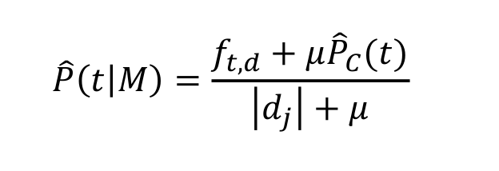

Approx Timings --
RM1 took around 2hrs to complete processing in my local system
RM2 took around 3hrs to complete processing in my local system

Although I have written the code to decrease the time of computation by picking random values (10K) and selecting top x words for expanding the term but it decreases the evaluation values (map – 0.0551, nDGC @ 5 : 21.118493, nDGC @ 10 : 19.02152) ans took only about 15-20 mins for rm1 and rm2 each. (Values are for RM1)
But not using this.

Only for RM1-

Class rm1 handles everything for rm1.
P(w|R) = P(w|q1,q2,...) is calculated using method P_w_q()

Expansion Terms for a query -
Using method expansion_term() the expansions terms are calculated.
- Going through all the words in vocabulary and finding P(w|R) for all words
- Selecting top x terms with max probability, this is done using variable top_x_terms, giving our expanded query
- Calculating the similarity score (using kl divergence) for all the documents using the expanded query. This step is optimized as for Kl divergence we need to calculate sum over vocabulary but since if that term not exist in expanded query kl_div for it will be zero (i.e if foe w – P(w|R) = 0 (then dont calculate P(w|D) )
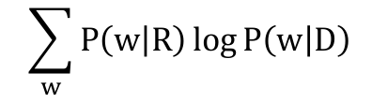

So instead of going through all vocabulary terms I am only processing top_x_terms.

For all Queries -
The same processs is repeated for all the queries and the result is saved in the output and extensions files provided along with run command.

Only for RM2-

Class rm2 handles everything for rm2-

P(w) – This is calculated using the method P_word(),i.e for all models P(w|Mi) and P(Mi) s are Equally Likely so P(Mi) = 1/total models

P(qi|W) – This is calculated using method P_qi_given_word(), This is by computing sum over all the models P(Mi|w)*P(qi|Mi)
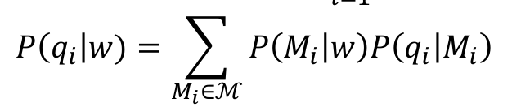
Also
P(Mi|w) = P(w|Mi)*P(Mi)/P(w)

P(w,q1,q2,...)/P(w|R)- This is calculated using P(qi|W) for all terms in query and miltiplying by P(w), This is implemented using method P_word_givn_R()
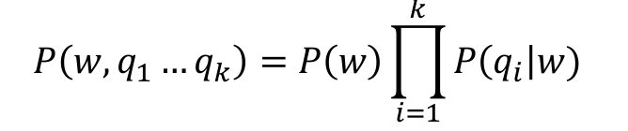

Expansion Term for query-
- This is calculated using method expansion_term(), I calculate P(w|R) for all the words in vocabulary.
- Then selecting the top x (using 10 right now) terms
- Then I used the similar way to calculate the similarity score using kl divergence (fasster way as mentioned for rm1)

For All Queries-
The same processs is repeated for all the queries and the result is saved in the output and extensions files provided along with run command.

Results-
The trec_eval was not showing values for nDCG so make a script for nDCG (eval_rms.py ) using sklearn. (this will not be executed if you run the normal code as no prelevent path there)
The evaluation is done using trec_eval (bundled along the submittion) and the method evaluate() has the implementation of this (this does not run when you execute the code, as the path for relevence docs is not provided), although you can unconnent and provide path of relrevence doc to print the result on console

RM1--
At mu = 0.5
We can see that these is some improvement in map value 0.0650, as compared to original
The main difference is visible in Precisions as initial levels as we see a major improvements

Mu Values | Map | nDCG@5 | nDCG@10 | nDCG@50
0.1 | 0.0643 | 25.143396 | 24.625631 | 25.825309
0.5 | 0.0650 | 25.646965 | 24.712289 | 26.1519327

---------------------------------------------------------
RM2 -
At mu = 0.1
We can see that thers is some improvement in map value 0.0604 as compared to original
Although there is more difference in nDCG values at initial levels, therefore because of slightly more (nDCG@5) mu = 0.1 seems a better option

Mu values | Map | nDCG@5 | nDCG@10 | nDCG@50
0.05 | 0.0604 | 21.9420838 | 21.7574259 | 23.9818007
0.1 | 0.0604 | 22.0164267 | 21.7903726 | 24.0477083
0.5 | 0.0604 | 21.94621 | 21.8202528 | 24.1011951

-----------------------------------------------------------

Result Dump for RM1-
For Complete data and with mu = 0.5
runid all Harsh_rm1
num_q all 40
num_ret all 4000
num_rel all 22724
num_rel_ret all 1841
map all 0.0650
gm_map all 0.0311
Rprec all 0.0856
bpref all 0.0834
recip_rank all 0.8002
iprec_at_recall_0.00 all 0.8293
iprec_at_recall_0.10 all 0.2063
iprec_at_recall_0.20 all 0.0179
iprec_at_recall_0.30 all 0.0000
iprec_at_recall_0.40 all 0.0000
iprec_at_recall_0.50 all 0.0000
iprec_at_recall_0.60 all 0.0000
iprec_at_recall_0.70 all 0.0000
iprec_at_recall_0.80 all 0.0000
iprec_at_recall_0.90 all 0.0000
iprec_at_recall_1.00 all 0.0000
P_5 all 0.7150
P_10 all 0.6800
P_15 all 0.6600
P_20 all 0.6512
P_30 all 0.6250
P_100 all 0.4602
P_200 all 0.2301
P_500 all 0.0920
P_1000 all 0.0460

Result Dump for MR2 -
with mu = 0.1
runid all Harsh_rm2
num_q all 40
num_ret all 4000
num_rel all 22724
num_rel_ret all 1841
map all 0.0604
gm_map all 0.0287
Rprec all 0.0856
bpref all 0.0829
recip_rank all 0.7408
iprec_at_recall_0.00 all 0.7959
iprec_at_recall_0.10 all 0.1982
iprec_at_recall_0.20 all 0.0175
iprec_at_recall_0.30 all 0.0000
iprec_at_recall_0.40 all 0.0000
iprec_at_recall_0.50 all 0.0000
iprec_at_recall_0.60 all 0.0000
iprec_at_recall_0.70 all 0.0000
iprec_at_recall_0.80 all 0.0000
iprec_at_recall_0.90 all 0.0000
iprec_at_recall_1.00 all 0.0000
P_5 all 0.6350
P_10 all 0.6025
P_15 all 0.6217
P_20 all 0.6012
P_30 all 0.5817
P_100 all 0.4602
P_200 all 0.2301
P_500 all 0.0920
P_1000 all 0.0460

---------------------------END---------------------

