
SELECTED CASES

Initiating Change in the Manufacturing and Distribution Division of PolyProd

Information management has become a critical competency in modern high-technology firms. These companies simply cannot afford to waste time reinventing or re-justifying existing method ologies, and costly errors-even injuries-can re sult from not having and following appropriate operating procedures. Yet, the burgeoning quan tity of data, information, and knowledge that must be retrieved and used has begun to tax some companies' abilities to keep up. In addition, many of the people within these organizations are not trained properly or willing to deal with formal in formation systems.
You are Roberta Jackson, a concerned, experi
enced first-level project manager working at the headquarters site of the manufacturing and distri bution division (M&DDiv) of PolyProd, a corpora tion that develops, markets, and manufactures a variety of high technology products for industry and home use. You are convinced, based on your experience and some informal information that you have collected, that failing to improve the cur rent information management practices will cost PolyProd millions of dollars in direct expenses and could contribute to long-term market share de clines in PolyProd products. As a result, you be lieve that it is necessary to change M&DDiv's documentation processes and procedures. These processes govern the creation and use of the speci fications and formal procedures required by the
five locations around the world. The headquar ters organization is located in the United States. It centrally manages the other four sites in Canada, Asia, Africa, and Europe, but also allows them a lot of autonomy in decision-making. Each loca tion houses both manufacturing and distribution processes.
The variety and complexity of M&DDiv's prod ucts have increased markedly, as have the speed, intricacy, and expense of the unique high-volume automated manufacturing processes that produce the products. As a result, M&DDiv has been grow ing rapidly during its entire 11-year history, expe riencing exponential increases in locations, sales, capital equipment, product lines, and personnel. Support systems, such as the information and knowledge management system, have struggled to keep up with the growth. Moreover, the required hiring of many inexperienced or temporary per sonnel has stretched the ability of M&DDiv to maintain the culture of PolyProd. These trends are expected to continue unabated for the foreseeable future.
The company's business strategy charters the headquarters site with designing products and their manufacturing methodologies, and then with transferring the maturing manufacturing processes offshore to take advantage of the lower tax rates and cheaper labor at the four production locations. The key success factors for the head

manufacturing organization.
You anticipate that the undertaking will involve change and project management techniques tradi tional in large engineering firms, and that it should proceed along well-trodden paths: you will plan the project, "sell" it to ma11agement and obtain the authority to begin, and then allocate resources and monitor progress until you can declare victory. The following sections describe the M&DDiv's organi zation, the documentation system, and other fac tors contributing to the current situation.

THE M&DDIV ORGANIZATION AND CULTURE
M&DDiv manufactures aJ1d distributes a small but lucrative subset of PolyProd's products and has
SELECTED CASES
quarters site are rapid design innovation and time-to-volume-manufacturability. The priorities of the production sites are shippable-product vol ume, quality, and cost-effectiveness.
Over the last several years, the friction devel oping between headquarters and the other loca tions. has been increasing. The sites are generally dissatisfied with what they regard as a patronizing and demanding attitude, and resent policies and assignments unilaterally sent out by headquar ters. Headquarters, in turn, resents the fierce and sometimes unnecessary individualism of the other locations. Throughout M&DDiv, there is a subtle but strong resistance to large-scale or ex ternally initiated change. This is especially true when the change involves converging all sites to
209

a single process or technology. Much of this is due to the pressures of maintaining high produc tion levels; unproven change is simply too risky. Historically, any attempt to institute a change by dictate has been doomed to failure. For example, announced changes typically take three to five years to institutionalize, and even after that time, there is considerable residual resistance or mali cious compliance. It is not uncommon for other wise successful projects to wither and die due to lack of implementation support.
Headquarters has its own internal issues. First, it has a long-standing tradition of conservatism and hardened reluctance to change. Second, it is still reeling from the rapid growth that has trans formed it from a small, independent factory into the hub of a global business. Finally, it is suffering from a discontinuity in its own cultural history: Rapid hiring and promotion, insufficient mentor ing, heavy outsourcing and downsizing of certain competencies, and extensive use of a temporary workforce in non-engineering areas has put ex treme pressures on the once homogenous and in tensely loyal culture.
In a static and stable environment, the rela tionship between headquarters and the other lo cations might be considered an acceptable cost of doing business. In M&DDiv, however, the stakes are far too high to allow it to continue. The antic ipated continued growth will magnify all prob lems exponentially, and the seriousness of the problems could very well inhibit or halt that growth. Because M&DDiv's revenue represents a significant portion of PolyProd's bottom line, much of PolyProd's total growth is contingent on M&DDiv's continued expansion. If M&DDiv fal ters, PolyProd could well follow.

THE DOCUMENTATION PROBLEM
In PolyProd, quality is everything. The company simply cannot allow bad products to reach the customer, but neither can it afford to scrap good products that may have failed too-stringent tests. The precision high-volume manufacturing pro cesses used by all M&DDiv sites utilize rigorous quality control procedures to ensure the highest yield of good products and the lowest scrap. This is achieved by statistical analyses of interim re sults and by standardizing tasks and tooling as much as possible. This, in turn, hinges on a huge quantity of documentation, including material and process specifications, operating instructions, maintenance information, replication data (bills
of materials, assembly and checkout instructions, etc.), and the like. In summary, good products re quire either good documentation or expensive workarounds and corrections.

- The documentation system. The documentation "system" consists of a number of compo nents: an electronic "vault" where a variety of documents are kept, the computer systems and networks that allow access to the vault, the documents (electronic files) themselves, the protocols for routing and approving revi sions, and perhaps most critical and most dangerous, all of the people who interact with these components. To be effective, a documentation system has to be carefully de-• veloped, actively maintained, and closely protected from inappropriate alteration. Since products and their production equip ment migrate between sites, the documenta tion must also be portable and useable without extensive revision.
When a new product design is initiated, a suite of drawings and other specifications is created immediately and remains with the project for its whole life. The design engi neer's early sketches and notes are entered into an electronic "vault" where they are protected against loss and inadvertent change. As experiments are done and proto types are created, test results and design re finements are added to the vault. As the design moves into the pre-manufacturing stage, parts lists, materials specifications, as sembly instructions, test procedures, and quality criteria are added to the file. When the automated equipment to produce the product in volume is designed, its informa tion joins the product's information in the vault.
The vault provides functions other than safekeeping. Accessed through workstations throughout the site, the vault allows engi neers to "sign out" documents for revision, printing, or on-line viewing. Every time a change is made, the vault's software tracks the differences between the old and new ver sions, records who made the changes, and routes the revised documentation by e-mail through an approval team. Once approved, the revised document replaces the original version, which is then automatically archived to provide an audit trail. Throughout its life,
2

210 PART 2 The Process of Organization Development
I , ,JI U , - I I " ''-• " " "-' ' " •-
Distributed Without Permission

a document may be entirely electronic and viewed only on-line, printed and bound, printed when needed and then discarded, or some combination of these media.
Virtually every department in the factory
uses these documents. R&D designs the prod uct, manufacturing engineering uses the product specifications to design production equipment, materials engineering uses the same specifications to select the plastics and metals used to make the product, materials procurement uses the materials engineering documents to order the supplies for the pro duction line, capital purchasing uses the manufacturing engineering documents to get contracts for the production lines, technical writing groups use all of these documents to create user manuals and other printed mate rials to ship with the final product, and traffic combs through the data to estimate the num ber and types of shipping containers and vehicles that will be needed. When the prod uct is actually manufactured, the production departments continuously refer to the docu mentation for instructions on how to oper ate, test, and repair their equipment; how to order and load raw materials into the ma chinery; how to test the products; and how to judge the product's quality.
When headquarters prepares to send a product and its production equipment to one of the other locations, the documentation is supposed to be sent first. The documentation is used at the new location to train employ ees, to guide the preparation of the new facil ity, and to ensure that all of the supply chain components are in place to provide raw ma terials and outbound shipping. Much of the documentation is translated into the local language for use by semi-skilled production workers once the production line is running at the new location.
Every department at every location is both a consumer and a producer of documenta tion, and all are completely interdependent. A single error in a specification can cascade into a multimillion dollar disaster in the form of incorrect raw materials, a product that passes tests but doesn't work for the cus tomer, a production line that won'tfit inside the factory building, or a huge fine from US Customs for mistakenly exporting restricted technology.

SELECTED CASES
- The current situation. Various departments within M&DDiv have invested heavily in the human resources, tools, and time needed to create and maintain the documentation process. Despite this investment, M&DDiv's documentation is still regarded as unsatisfac tory by the majority of employees and man agement. For example, there is widespread dissatisfaction with the documentation sys tem in the design departments at headquar ters. Because of past bad experiences with outdated or incorrect documentation, users distrust all documentation's accuracy, and find the vault hard to access. The quality de partment is distressed by the delays in the correction and update cycle. Technical writ ers are unhappy with the general usability of the required word processors, graphics pro grams, and the vault; they also feel artisti cally constrained when asked to use standard templates or designs for their documents. They get little cooperation from the subject matter experts and reviewers they rely on for information, and feel that creating a finished document can take four to five times as much time and effort as it should take. I,
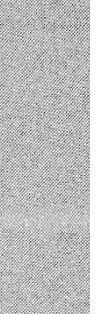
The headquarters document control super visors and technical-writing supervisors also are frustrated. Their personal workloads have ballooned to unmanageable levels as they added staff to keep up with the increasing documentation requirements of M&DDiv's growing number of products. At the same time, they are permitted to hire only tempo rary resources; qualified candidates became increasingly hard to find, and they take every thing they have learned away with them when their finite-length contracts end.
The production sites share all these con cerns and have unique issues of their own. They are frustrated by their inability to get correct and complete documentation when a manufacturing process transfers from head quarters, even though the documentation is supposed to arrive long before the manufac turing process. They often must convert un usual file formats or struggle to rewrite United States-idiomatic information to meet the needs of their local users. They also often feel that they need to invent their own docu ment designs because global designs are still pending or are too specific to another loca tion's needs.

211


CONTRIBUTING FACTORS
As your early interes·t in overcoming these prob lems increased, you conducted an informal analysis based on interviews and observations at all five locations. You have concluded that there are a number of interrelated causes producing M&DDiv's documentation problems.
The primary issue is the lack of an overriding vision or strategy to guide the creation of a full and robust documentation system. To be fair, sev eraI years ago, M&DDiv's senior management chartered a documentation quality effort. How ever, this was only partially implemented, and the project lost momentum after some early successes. This sent a signal-to both the headquarters site and the production locations-that documenta tion was not really so i.mportant after all, much to the relief of those who considered documentation related tasks a distraction from their "real work." As the rigor of document-creation and -mainte nance rules began to wane, the quality of the doc uments and the processes they supported began to deteriorate again. This continuing gradual slide at each of the locations is exacerbated by the lack of coordination between them. Decisions are made independently, based on local or perceived larger scope needs, or occasionally on policies that were developed during the short-lived documentation quality project. Few people consider a time hori zon farther out than one year, and even fewer look forward with a global perspective.
There are severe integration problems be tween the different locations. The production en tities are concerned with document control and simplicity. Headquarters has difficulty in simply collecting the information in the first place, and with keeping it up-to-date and complete as the subject matter rapidly evolves during the design and tuning phases. Headquarters often uses the documentation as repositories of historical or jus tification information; this serves only to confuse and annoy the production sites, which require only the minimum information necessary to manufacture products.
There also are internal integration problems within each individual location. Responsibility for different aspects of the documentation falls within several organizations: creation and storage technology in one, the formal processes for ac quisition and control in another, best practice consulting in a third, and technical writers scat tered throughout several other departments with
their "customers" (e.g., some writers sit within R&D, some work with manufacturing engineer ing, and still others are in the quality depart ment). There are no rewards for communicating or collaborating, and the groups frequently de velop similar or conflicting solutions to what turn out to be common problems.
Day-to-day operation is also less than optimal. The majority of involved personnel have little or no training or experience in the field of documen tation. This has led to quality problems, arbitrary decision-making, inappropriate prioritizing of tasks and objectives, and several "blind alley" proj ects (i.e., projects that start successfully but then run into insurmountable barriers and are aban doned). Many writers and document controllers are former production line operators who show little interest or aptitude during times of high need. Few of the external temporary personnel have formal technical writing experience; most are recently graduated English majors or journal ists. The technical writing supervisors all moved laterally from production, and received no special training or mentoring; this results in inefficiency and quality problems within their departments.
Generally, each of the problems and frustra tions outlined above is restricted to the immedi ately affected departments. The various symptoms are highly distributed, are frequently noticeable only at the lowest levels of the organization, and are often concealed beneath their effects. For example, raw material rejection in the receiving department might increase without anyone ques tioning whether the inspection checklist itself was incorrect, or growing headcount in the support department might not be linked with a particular manufacturing location's use of an obsolete adjust ment procedure. These problems would usually be examined by the immediate department supervi sor without regard to a larger context, and would seldom be escalated to a point of visibility to upper management or someone with a less parochial viewpoint.
Until you began talking with people at all sites, most people were aware only of their own diffi culties with the documentation, and were sur prised by your interest. You found that the overall sense of "shared pain" in the organization was very low, and that upper management was completely unaware of the magnitude, fre quency, and very real cost of the issues.
Aside from a few informal networks and coun cils, there a.re no worldwide activities working to

212 PART 2 The Process of Organization Development

resolve these problems from a system perspec tive. Most of the separate organizations do recog nize the local aspects of the problems, and some have projects in place to improve their own processes in isolation. However, there is no movement toward a larger-scale solution.
It is clear that M&DDiv is in a state of uneasy stasis and that external stimulus-you-will be needed to begin a resolution.

YOUR PLAN TO INITIATE CHANGE
You have decided to conduct an informal discus sion with Stewart Jones, the M&DDiv executive you deem to be the most likely potential spon sor for the project, to get a preliminary opinion on whether your project would be worth proposing formally. You have planned your ap proach carefully.
Because of the engineering-intense environ ment in M&DDiv, you know that you must fol low a defined, rational project management methodology-overt "touchy-feely" techniques would be rejected out of hand. However, you also understand that changing the documentation process will be equal parts cultural change and process improvement.
You also understand the dynamics of M&DDiv management: They seem powerless to force change upon the different geographical locations, and they also are unable and unwilling to spend much time attempting to reach a consensus on the need for standardizing anything. "Going to the top" won't help. Because you are dealing with many branches of a very large organization you must face a "Catch-22" situation: when you appeal up the organization chart to a level that has the power to command all relevant organiza tions, that individual is so removed from the problem that he or she is unwilling to consider it unless it has huge demonstrable impact.

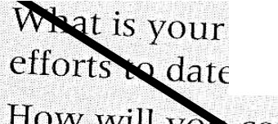
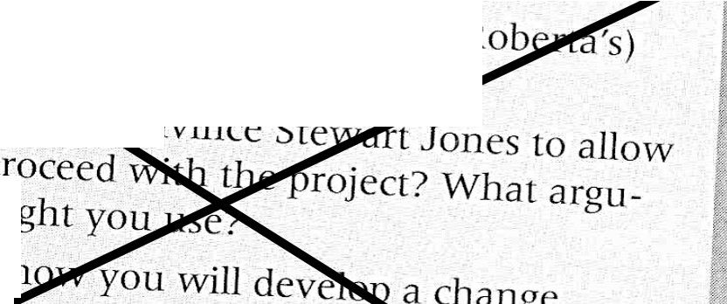
ur assessment of your
?
- How
you to ments
- Des • nge
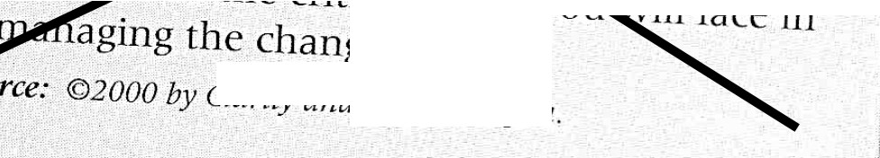

critical issu g the change.

5

SELECTED CASES

Distributed Without Permission213

