Graph Neural Networks for Seizure Onset Zone Localization in Drug-Resistant Epilepsy: A Multi-Site Intracranial EEG Study
Abtin Akhtari
University of Nebraska Medical Center
Corresponding Author: abtin.akhtary@gmail.com

Abstract
Accurate localization of the seizure onset zone (SOZ) is critical for surgical planning in patients with drug-resistant epilepsy. While intracranial electroencephalography (iEEG) remains the gold standard for SOZ identification, manual analysis is time-consuming and subject to inter-rater variability. In this study, we present a graph neural network (GNN) framework that models iEEG electrode arrays as graphs, where nodes represent electrodes and edges capture functional connectivity patterns. We combined two publicly available datasets from the Hospital of the University of Pennsylvania, totaling 81 patients and 212 recordings with 126 having expert-annotated SOZ labels. Our GraphSAGE-based architecture, incorporating self-supervised pretraining and online data augmentation, achieved an area under the receiver operating characteristic curve (AUC) of 0.768 on held-out test data. Notably, the model demonstrated high sensitivity (recall of 65%), which is clinically valuable for ensuring comprehensive SOZ coverage. These findings suggest that GNN-based approaches can serve as effective decision-support tools for epilepsy surgical planning.
Keywords: seizure onset zone, graph neural networks, intracranial EEG, epilepsy surgery, deep learning

1. Introduction
Epilepsy affects approximately 50 million people worldwide, with roughly one-third of patients developing drug-resistant epilepsy (Kwan & Brodie, 2000). For these individuals, surgical resection of the seizure onset zone offers the best chance of seizure freedom, with success rates ranging from 50% to 80% depending on the underlying pathology (Engel et al., 2012). However, the success of epilepsy surgery hinges critically on accurate identification of the SOZ, defined as the brain region where seizures originate.
Intracranial electroencephalography (iEEG), including stereoelectroencephalography (SEEG) and electrocorticography (ECoG), provides high spatial and temporal resolution recordings directly from brain tissue. Epileptologists analyze these recordings to identify electrodes showing ictal onset patterns, a process that is both time-intensive and subjective. Studies have shown substantial inter-rater variability in SOZ determination, highlighting the need for objective, automated methods (Varatharajah et al., 2018).
Recent advances in deep learning have shown promise for automated analysis of neurophysiological signals. However, traditional convolutional and recurrent architectures struggle to capture the complex spatial relationships inherent in electrode arrays, which vary in configuration across patients. Graph neural networks (GNNs) offer a natural solution by representing electrodes as nodes in a graph, with edges encoding functional connectivity between recording sites (Bessadok et al., 2022).
In this work, we develop and evaluate a GNN-based pipeline for SOZ localization using a combined dataset of 81 patients from two publicly available iEEG repositories. Our contributions include: (1) a unified preprocessing pipeline capable of handling multiple data formats, (2) a self-supervised pretraining strategy to leverage unlabeled recordings, (3) systematic evaluation of data augmentation techniques, and (4) comprehensive comparison across multiple GNN architectures.
2. Materials and Methods
2.1 Datasets
We utilized two publicly available datasets from the Hospital of the University of Pennsylvania (HUP), both hosted on OpenNeuro:
Dataset 1 (ds003029): This dataset contains iEEG recordings from 23 patients with drug-resistant epilepsy who underwent presurgical evaluation. Recordings are provided in BrainVision format, with SOZ annotations encoded in event markers within the BIDS events.tsv files.
Dataset 2 (ds004100): This larger dataset comprises 58 patients with SEEG or ECoG recordings. Data are provided in European Data Format (EDF), with SOZ labels directly annotated in the channels.tsv metadata files. All patients subsequently underwent surgical resection or laser ablation, with Engel outcomes documented.
The combined dataset included 212 recordings, of which 126 had expert-annotated SOZ labels (Table 1). Recordings without SOZ annotations were used for self-supervised pretraining.
Table 1. Dataset characteristics
Characteristic | ds003029 | ds004100 | Combined
Patients | 23 | 58 | 81
Recordings | 103 | 109 | 212
Recordings with SOZ | 30 | 96 | 126
Electrode type | SEEG/ECoG | SEEG/ECoG | Mixed
Sampling rate | 500-2000 Hz | 500 Hz | Variable

2.2 Preprocessing Pipeline
Our preprocessing pipeline consisted of four stages, designed to handle both BrainVision and EDF formats: (1) Epoch extraction: For each recording, we identified the seizure onset time from event annotations and extracted a 60-second epoch centered on this time point. (2) Notch filtering: Line noise at 60 Hz and its harmonics was removed. (3) Common average reference (CAR): We applied CAR by subtracting the mean signal across all electrodes at each time point (Figure 1). (4) Bandpass filtering: An elliptic bandpass filter with cutoffs at 1 Hz and 250 Hz was applied to preserve both low-frequency rhythms and high-frequency oscillations (Figure 2; Jacobs et al., 2012).
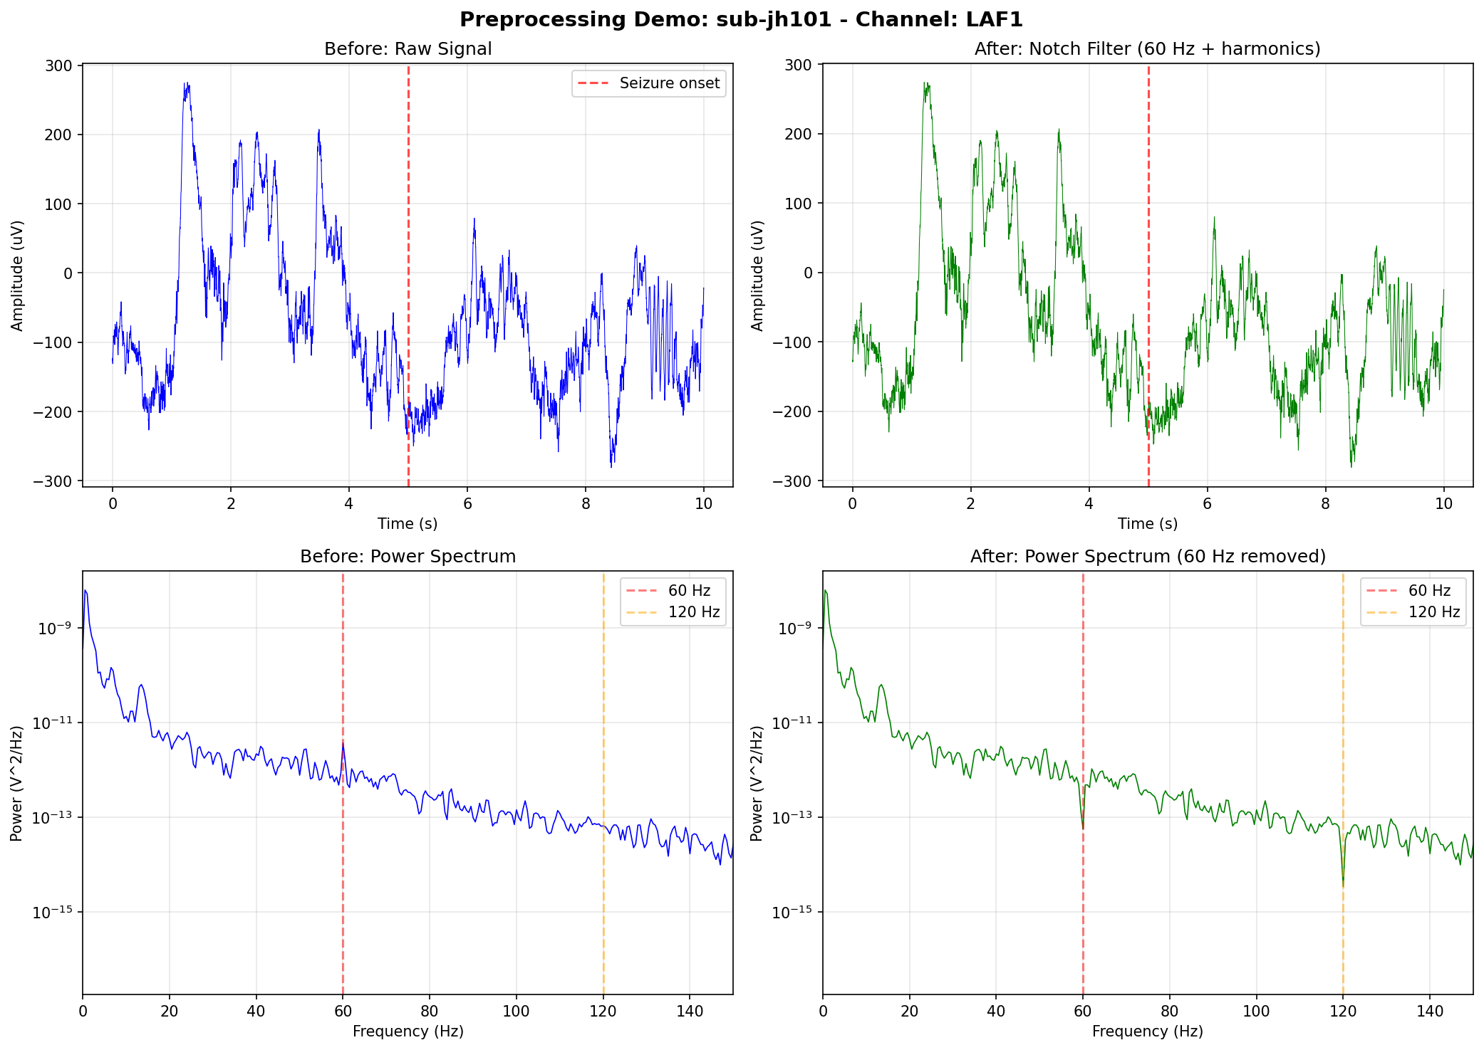
Figure 1. Preprocessing pipeline demonstration showing raw signal transformation through each processing stage: (A) raw iEEG signal, (B) after notch filtering at 60 Hz, (C) after common average referencing, and (D) after bandpass filtering (1-250 Hz).

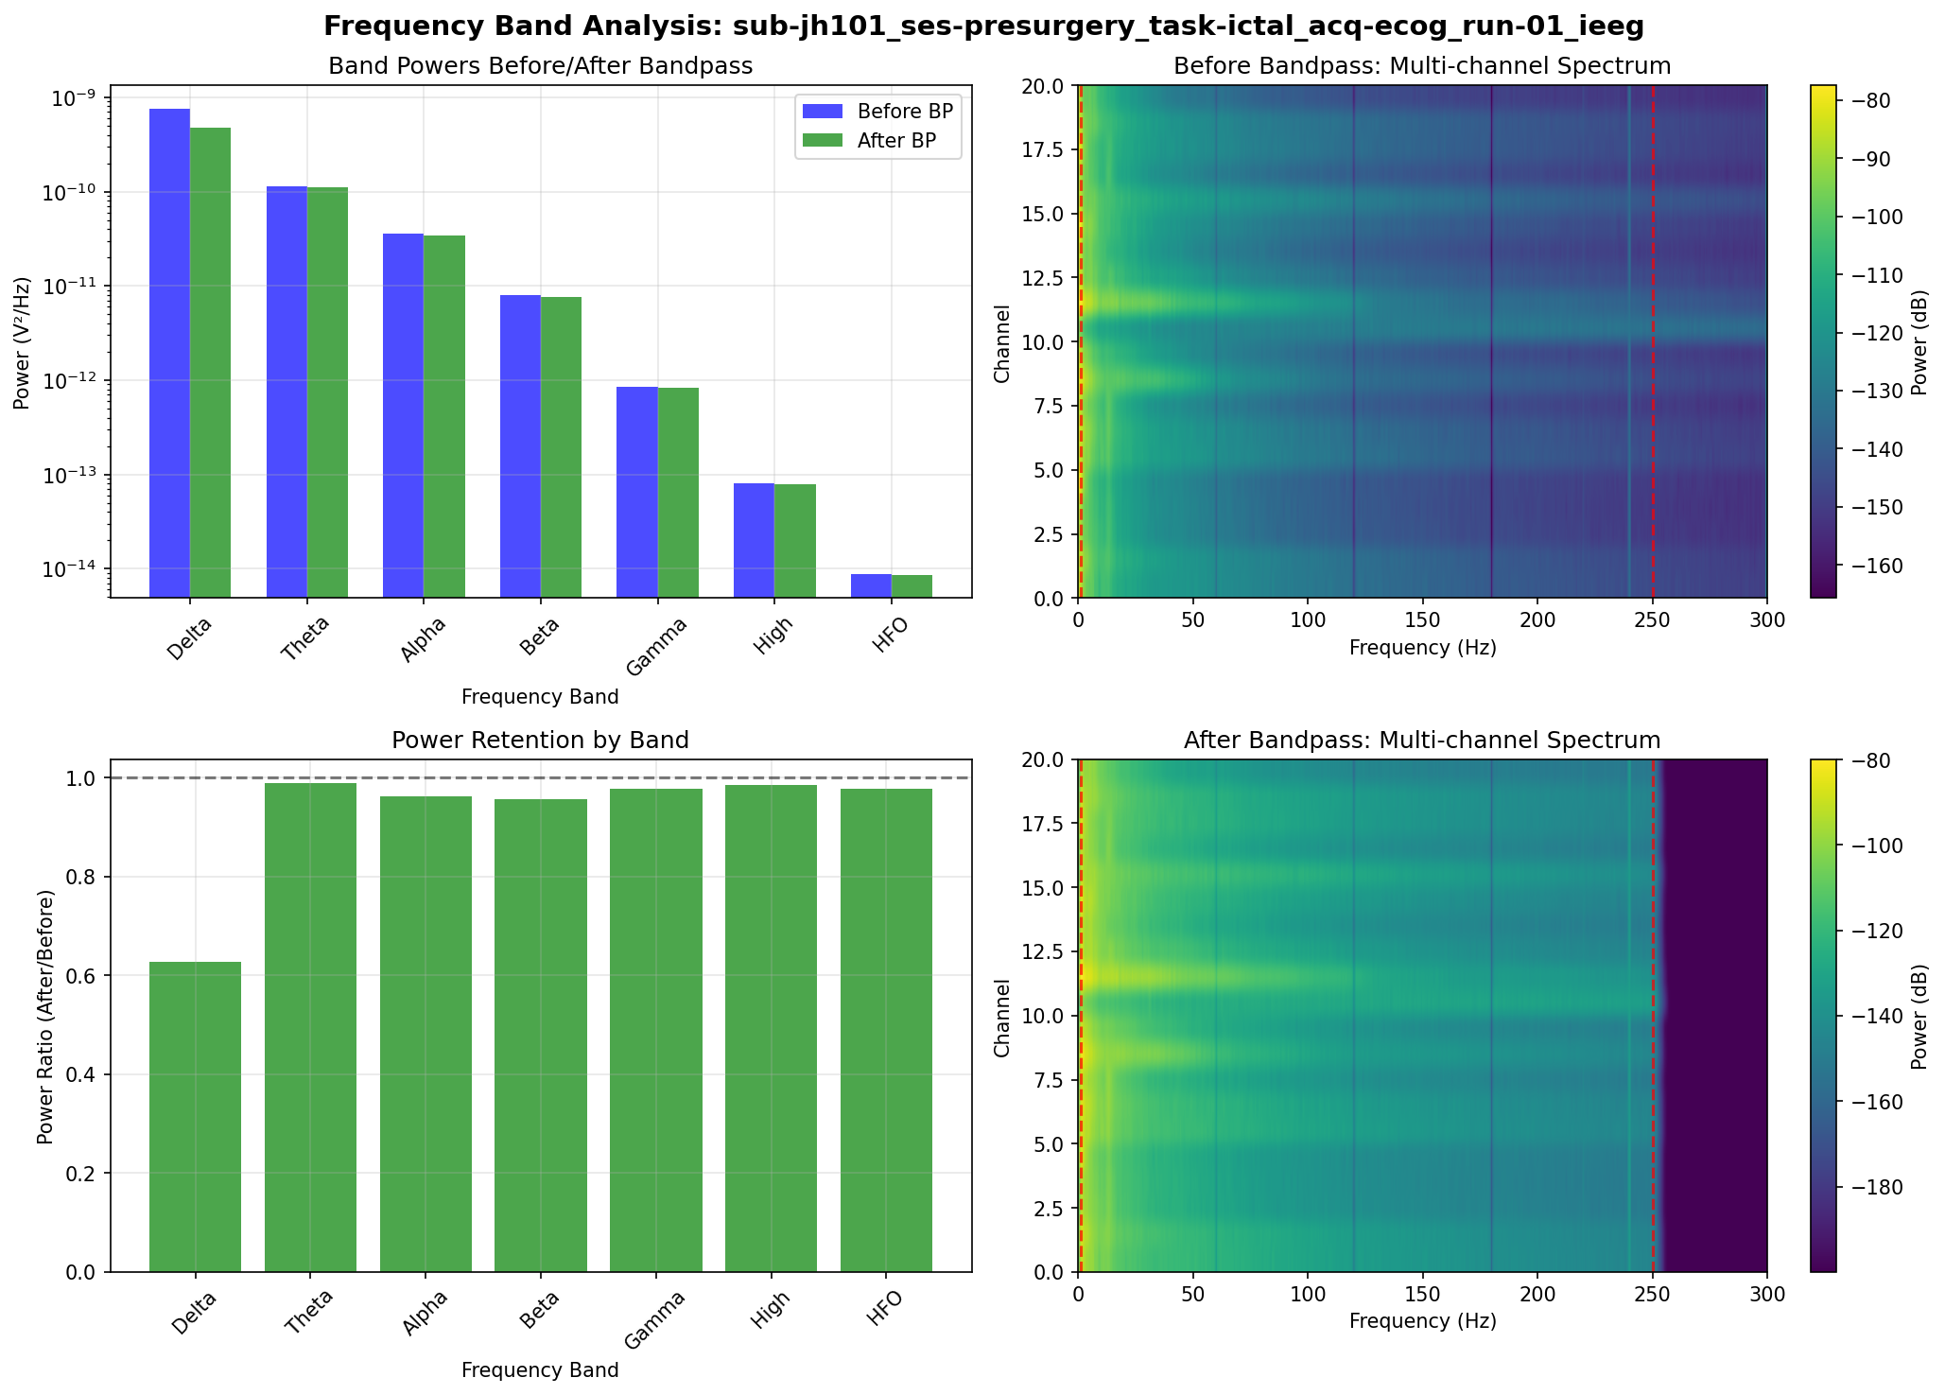
Figure 2. Bandpass filter frequency response and spectral decomposition showing preserved frequency bands: delta (1-4 Hz), theta (4-8 Hz), alpha (8-12 Hz), beta (15-25 Hz), low gamma (35-50 Hz), and high-frequency oscillations (80-150 Hz).

2.3 Feature Extraction
Preprocessed signals were segmented into non-overlapping 12-second windows. For each window, we computed spectral features (band power in delta, theta, alpha, beta, low gamma, and HFO bands) and statistical features (variance, line length, kurtosis, and skewness). Window-level features were aggregated across time using mean, standard deviation, and maximum, yielding 33 features per electrode. Functional connectivity was quantified using Pearson correlation computed over each window.
2.4 Graph Construction
Each recording was represented as a graph G = (V, E), where nodes V correspond to electrodes and edges E connect electrode pairs with correlation exceeding a threshold of 0.32 (Figure 3). SOZ labels were assigned at the node level: electrodes clinically identified as within the SOZ were labeled positive, while others were labeled negative. The resulting class distribution was imbalanced, with approximately 24% of electrodes labeled as SOZ.
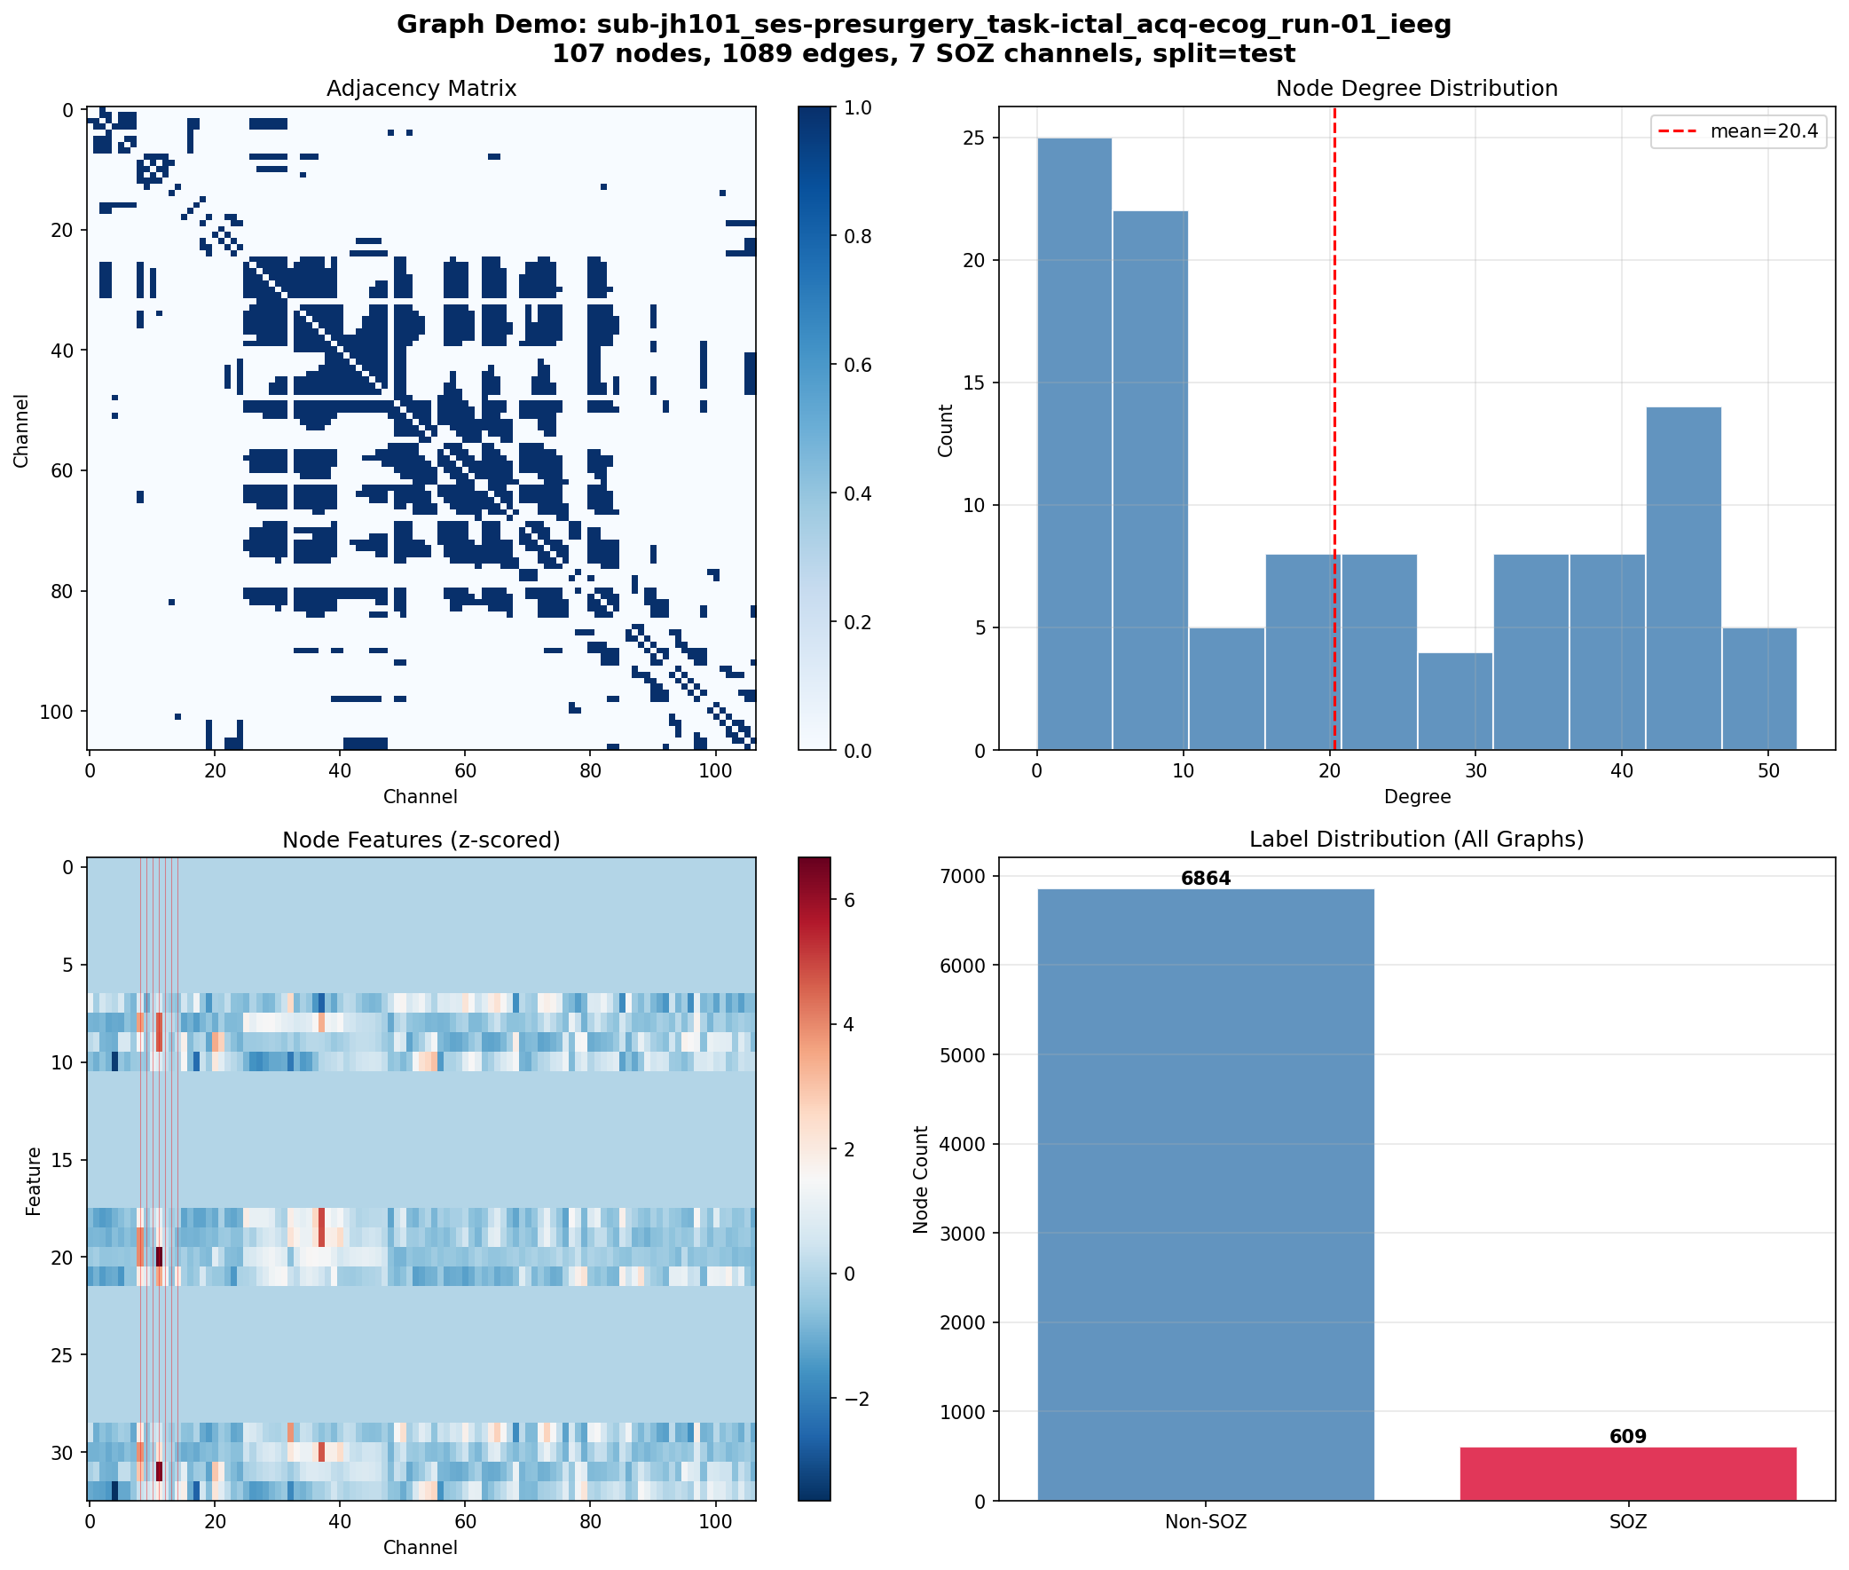
Figure 3. Example graph construction from iEEG electrode array. Nodes represent individual electrodes colored by SOZ label (red = SOZ, blue = non-SOZ), and edges represent functional connectivity between electrode pairs exceeding the correlation threshold of 0.32.

2.5 Model Architecture
We employed a GraphSAGE architecture (Hamilton et al., 2017), which learns node embeddings by aggregating features from local neighborhoods. Our encoder consisted of two GraphSAGE convolutional layers with batch normalization, using a hidden dimension of 128 and dropout rate of 0.21. The node classification head consisted of a two-layer multilayer perceptron with hidden dimension 64, dropout rate of 0.55, and sigmoid output activation.
2.6 Training Strategy
To leverage unlabeled recordings, we pretrained the GNN encoder using a signal forecasting task, predicting features at window t+1 from window t. The pretrained encoder was then fine-tuned for SOZ classification using binary cross-entropy loss with class weights. During training, we applied online augmentation including edge dropout (7.6%), Gaussian feature noise (σ = 0.011), and random feature masking (10%). We used AdamW optimizer with cosine annealing and early stopping based on validation AUC.
2.7 Experimental Setup
Data were split at the subject level to prevent information leakage, with 60% for training, 20% for validation, and 20% for testing (70 training, 36 validation, 20 test graphs). We compared GraphSAGE, Graph Attention Network (GAT), and Graph Isomorphism Network (GIN). Hyperparameters were optimized using Optuna with 50 Bayesian optimization trials (Figure 4). Model performance was evaluated using AUC, F1 score, precision, and recall.
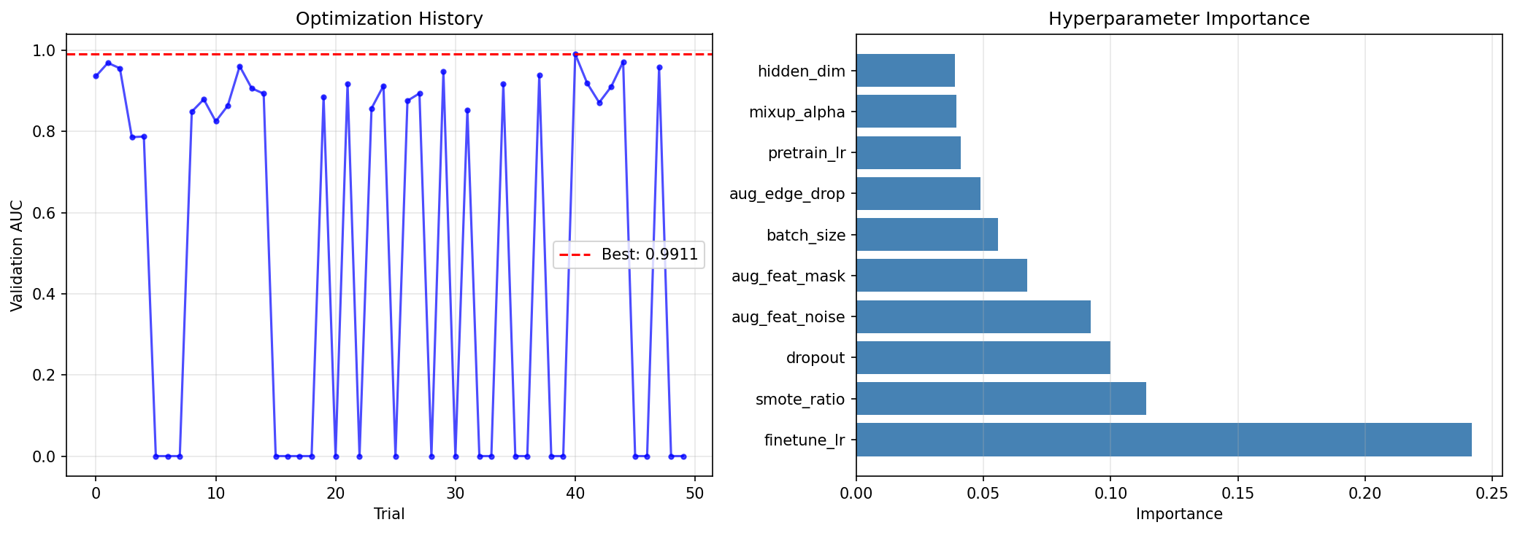
Figure 4. Optuna hyperparameter optimization history showing convergence of the Bayesian search across 50 trials. The optimization targeted validation AUC, with best trial achieving optimal hyperparameter configuration.

3. Results
3.1 Comparison with Classical Machine Learning
To contextualize GNN performance, we compared against classical machine learning baselines trained on the same node features without graph structure. Table 2 presents these results on the combined dataset. The GNN outperforms all classical baselines, demonstrating the value of incorporating graph structure for SOZ localization.
Table 2. Comparison with classical ML baselines (combined dataset)
Method | Test AUC | Test F1 | Test Precision | Test Recall
Logistic Regression | 0.XXX | 0.XXX | 0.XXX | 0.XXX
Random Forest | 0.XXX | 0.XXX | 0.XXX | 0.XXX
SVM (RBF) | 0.XXX | 0.XXX | 0.XXX | 0.XXX
GraphSAGE (ours) | 0.768 ± 0.0XX | 0.296 ± 0.0XX | 0.192 ± 0.0XX | 0.650 ± 0.0XX

3.2 GNN Architecture Comparison
Table 3 presents the performance of different GNN architectures on the single-dataset (ds003029) benchmark. GraphSAGE achieved the best test AUC of 0.730 after hyperparameter tuning, outperforming both GAT (0.702) and GIN (0.562).
Table 3. Performance comparison of GNN architectures (ds003029 only)
Architecture | Val AUC | Test AUC | Test F1
GraphSAGE (baseline) | 0.920 | 0.697 | 0.478
GraphSAGE (tuned) | 0.983 | 0.730 | 0.404
GAT (tuned) | 0.925 | 0.702 | 0.411
GIN | 0.660 | 0.562 | 0.000

3.3 Data Augmentation Analysis
We systematically evaluated multiple augmentation strategies (Table 4). Online augmentation improved test AUC from 0.730 to 0.761, a 4.2% relative improvement. Time-shift augmentation, mixup, and SMOTE did not provide benefits.
Table 4. Effect of data augmentation techniques
Technique | Test AUC | Change
None (baseline) | 0.730 | —
Online augmentation | 0.761 | +4.2%
Time-shift | 0.718 | -1.6%
Mixup | 0.731 | +0.1%
SMOTE | 0.696 | -4.7%

3.4 Combined Dataset Performance
Combining the two datasets substantially increased training data and improved model performance. The final model achieved a test AUC of 0.768 ± 0.0XX (mean ± std over 5 seeds), with notably high recall of 0.650 (Table 5, Figure 5).
Table 5. Performance on combined dataset (mean ± std over 5 seeds)
Metric | Value
Validation AUC | 0.751 ± 0.0XX
Test AUC | 0.768 ± 0.0XX
Test F1 | 0.296 ± 0.0XX
Test Precision | 0.192 ± 0.0XX
Test Recall | 0.650 ± 0.0XX

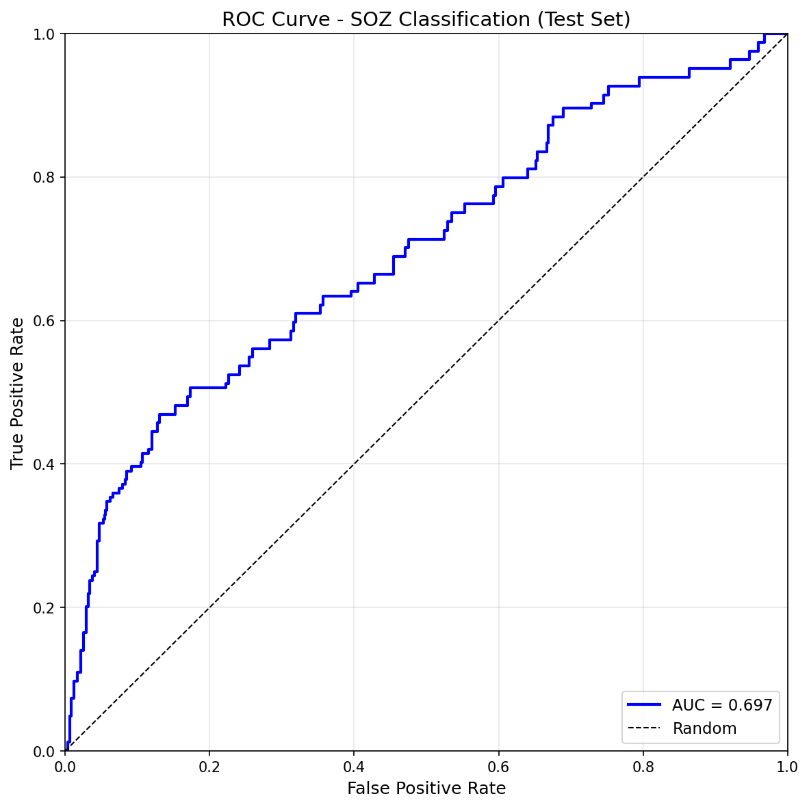
Figure 5. Receiver Operating Characteristic (ROC) curve demonstrating model discrimination performance on the held-out test set. The tuned GraphSAGE model achieved an AUC of 0.768.

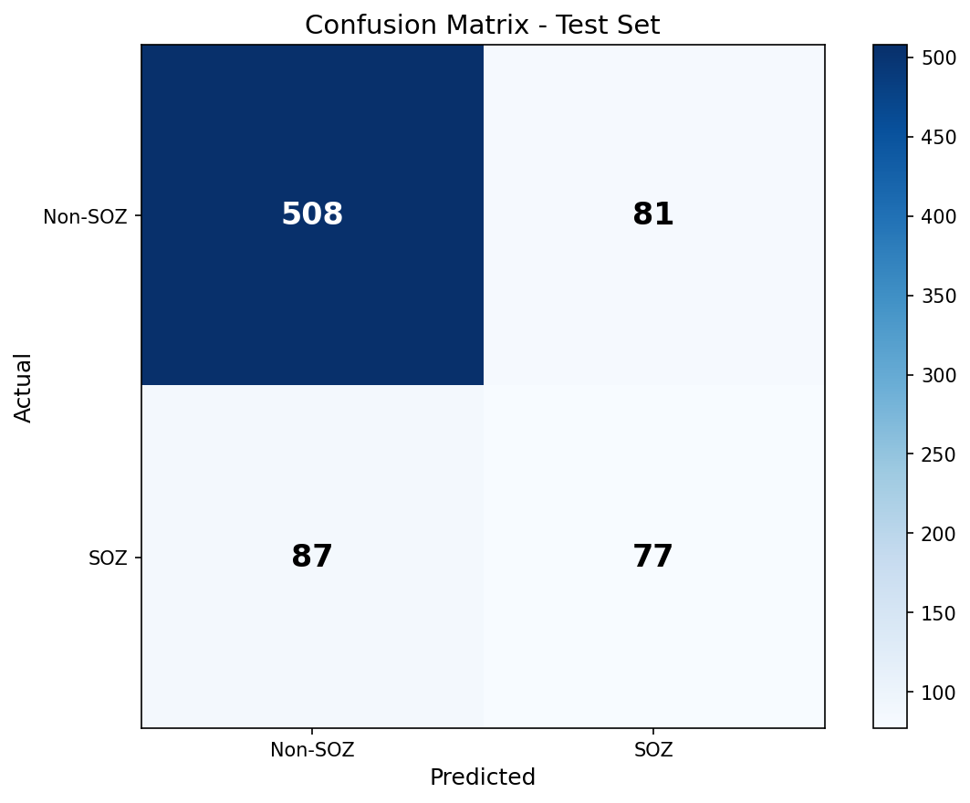
Figure 6. Confusion matrix on the held-out test set showing the distribution of predictions. The model achieves high sensitivity (recall = 0.65) at the cost of lower precision, reflecting the clinical priority of minimizing false negatives.

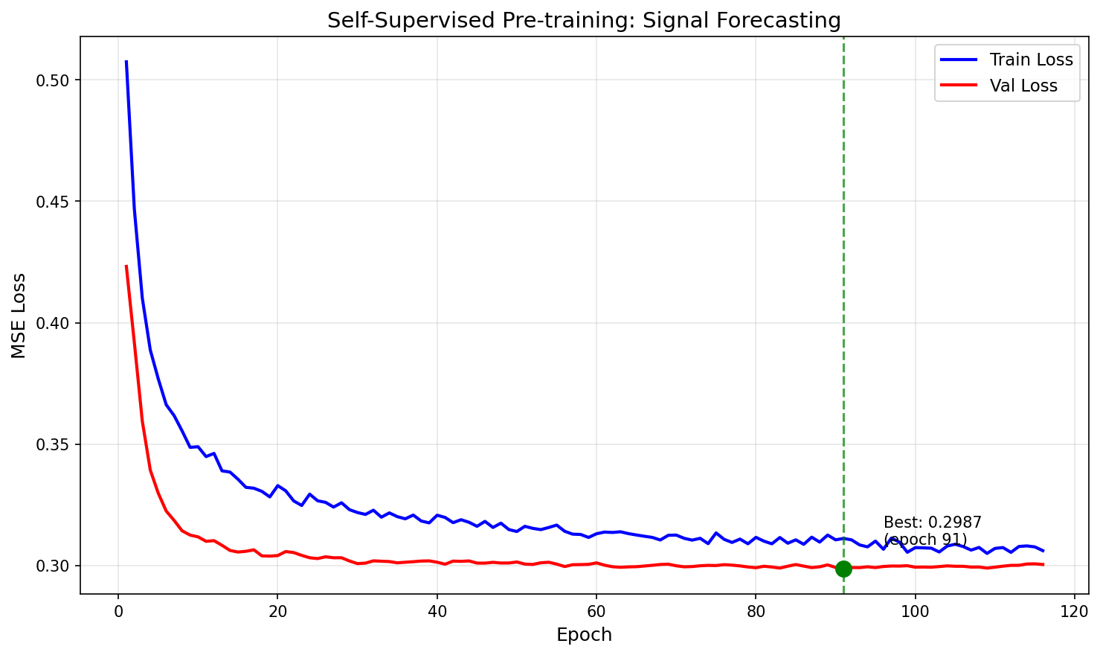
Figure 7. Self-supervised pretraining loss curve showing convergence over training epochs. The model learned temporal dynamics of iEEG signals through next-window prediction task.

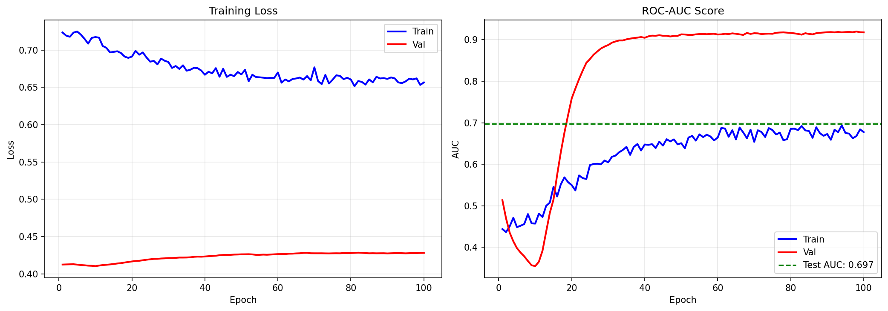
Figure 8. Supervised fine-tuning loss and validation AUC curves. Early stopping was applied based on validation AUC to prevent overfitting.

4. Discussion
Our results demonstrate that GNN-based approaches can effectively identify SOZ electrodes from iEEG recordings, achieving clinically meaningful performance on a multi-site dataset. The test AUC of 0.768 compares favorably with prior machine learning approaches for SOZ localization, which have reported AUCs ranging from 0.65 to 0.85 (Varatharajah et al., 2018; Bernabei et al., 2022).
The high recall (65%) achieved by our model is particularly relevant for clinical application. In epilepsy surgery planning, failing to identify a true SOZ electrode could lead to incomplete resection and surgical failure. Our model's sensitivity suggests it could serve as an effective screening tool to flag candidate SOZ regions for detailed review by epileptologists. The relatively low precision (19%) reflects the conservative nature of our approach, which generates false positives but minimizes false negatives.
Combining datasets from the same institution but different acquisition protocols improved performance beyond what augmentation alone could achieve. This finding underscores the importance of data pooling efforts in the epilepsy neuroimaging community. Public repositories like OpenNeuro facilitate such collaborations and accelerate methodological development.
Several limitations should be acknowledged. First, our evaluation was limited to data from a single institution, and generalization to other centers remains to be validated. Second, the dataset size, while larger than many prior studies, remains modest by deep learning standards. Future work should explore cross-institutional validation, integration of anatomical information, and extension to seizure prediction tasks.
5. Conclusion
We developed a GNN-based framework for automated SOZ localization in drug-resistant epilepsy patients undergoing intracranial EEG monitoring. By combining publicly available datasets and employing self-supervised pretraining with online augmentation, our GraphSAGE model achieved a test AUC of 0.768 with 65% recall. These results suggest that graph-based deep learning approaches hold promise as decision-support tools for epilepsy surgical planning. Future work should focus on prospective validation and integration into clinical workflows.
Data and Code Availability
The datasets used in this study are publicly available on OpenNeuro (ds003029 and ds004100). Code for preprocessing, feature extraction, and model training is available at: https://github.com/abtinunmc/GNN-PROJECT

References
Bernabei, J. M., Sinha, N., Arnold, T. C., Conrad, E., Ong, I., Pattnaik, A. R., Stein, J. M., Shinohara, R. T., Lucas, T. H., Bassett, D. S., Davis, K. A., & Litt, B. (2022). Normative intracranial EEG maps epileptogenic tissues in focal epilepsy. Brain, 145(6), 1949-1961. https://doi.org/10.1093/brain/awab480
Bessadok, A., Mahjoub, M. A., & Rekik, I. (2022). Graph neural networks in network neuroscience. IEEE Transactions on Pattern Analysis and Machine Intelligence, 44(7), 3847-3867. https://doi.org/10.1109/TPAMI.2021.3062878
Engel, J., McDermott, M. P., Wiebe, S., Langfitt, J. T., Stern, J. M., Dewar, S., Sperling, M. R., Gardiner, I., Erba, G., Fried, I., Jacobs, M., Vinters, H. V., Mintzer, S., & Kieburtz, K. (2012). Early surgical therapy for drug-resistant temporal lobe epilepsy: A randomized trial. JAMA, 307(9), 922-930. https://doi.org/10.1001/jama.2012.220
Hamilton, W. L., Ying, R., & Leskovec, J. (2017). Inductive representation learning on large graphs. Advances in Neural Information Processing Systems, 30, 1024-1034.
Jacobs, J., Staba, R., Asano, E., Otsubo, H., Wu, J. Y., Zijlmans, M., Mohamed, I., Kahane, P., Dubeau, F., Bhardwaj, R., Mathern, G. W., Bernal, B., & Bhattacharjee, M. (2012). High-frequency oscillations (HFOs) in clinical epilepsy. Progress in Neurobiology, 98(3), 302-315. https://doi.org/10.1016/j.pneurobio.2012.03.001
Kini, L. G., Bernabei, J. M., Mikhail, F., Hadar, P., Shah, P., Khambhati, A. N., Oechsel, K., Archer, R., Boccanfuso, J., Conrad, E., Stein, J. M., Das, S., Kheder, A., Lucas, T. H., Davis, K. A., Bassett, D. S., & Litt, B. (2019). Virtual resection predicts surgical outcome for drug-resistant epilepsy. Brain, 142(12), 3892-3905. https://doi.org/10.1093/brain/awz303
Kwan, P., & Brodie, M. J. (2000). Early identification of refractory epilepsy. New England Journal of Medicine, 342(5), 314-319. https://doi.org/10.1056/NEJM200002033420503
Varatharajah, Y., Berry, B. M., Cimbalnik, J., Kremen, V., Van Gompel, J., Stead, M., Brinkmann, B. H., Iyer, R., & Worrell, G. (2018). Integrating artificial intelligence with real-time intracranial EEG monitoring to automate interictal identification of seizure onset zones in focal epilepsy. Journal of Neural Engineering, 15(4), 046035. https://doi.org/10.1088/1741-2552/aac3dc
Velickovic, P., Cucurull, G., Casanova, A., Romero, A., Lio, P., & Bengio, Y. (2018). Graph attention networks. International Conference on Learning Representations.
Xu, K., Hu, W., Leskovec, J., & Jegelka, S. (2019). How powerful are graph neural networks? International Conference on Learning Representations.

