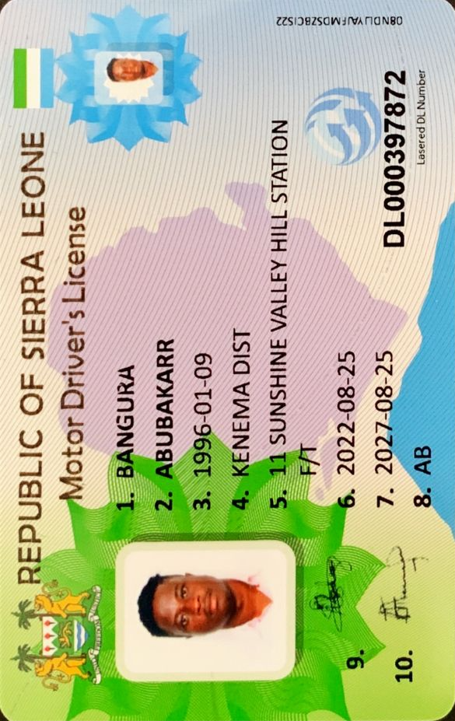



I am writing to express my interest in the position of Junior Software Developer iLaunch.

With a bachelor’s degree in Software Engineering and a determination to be one of the best in the field, I am the right applicant for this position. For the past two years, I worked as a Junior Software Developer for a Government of Sierra Leone where I have gained valuable insight on how a successful company operates.

I have the skills and training needed to help develop and maintain software programs and to make improvements that will enhance functionality. I have outstanding problem skills with the ability to work with technical and abstract concepts efficiently. I also have extensive knowledge of JavaScript, C++ and HTML.

I have excellent communication skills with the ability to work directly with clients to provide outstanding customer service. After talking with the clients, I can determine ways to improve performance, speed and usability and then relay this information to senior programmers. I have also acquired the ability to troubleshoot technical issues to find the cause and to implement a solution to problems as they arise.

I have the skills to explain functionality and other technical issues to other professionals and non-technical users. I pay close attention to details and I have the ability to stay focused on the task at hand for long periods to get the job done. I stay updated on all the latest changes that take place in the industry and I am a perfect match for this position.