Oscars & IMDb Movie Analytics Project

Dataset Name:
Oscars & IMDb Movie Analytics Dashboard

Dataset Source:
Custom dataset created for analyzing Oscars, IMDb ratings, directors, genres, and box office performance.
Dataset loaded into Power BI from CSV/Excel sources.

Fields Included:
• Movie Title
• Director
• Genre(s)
• IMDb Rating
• Metacritic Score
• Year
• Language
• Oscar Wins
• Rank
• Box Office Collection

Problem Statement:
This project aims to analyze movies using IMDb ratings, Oscars won, genres, director performance, and box office results. The goal is to identify patterns across genres, director success rates, movie ratings, and yearly performance. Using Power BI, the dataset is visualized to provide insights into movie performance trends.

Solution Using Power BI:

Data Modeling:
The dataset consists of a structured movie data table. No complex relationships were required. Calculated measures were created for ratings and summarizations.

Dashboard Visualization:
• 1. Pie Chart – IMDb Rating by Genres
• 2. Donut Chart – IMDb Rating by Directors
• 3. KPI – Total Oscars Won
• 4. Bar Chart – Oscars Won by Director
• 5. Yearly Box Office Table
• 6. Horizontal Bar Chart – IMDb Rating by Movies
• 7. KPI – Metacritic Score

Screenshot of the Project:
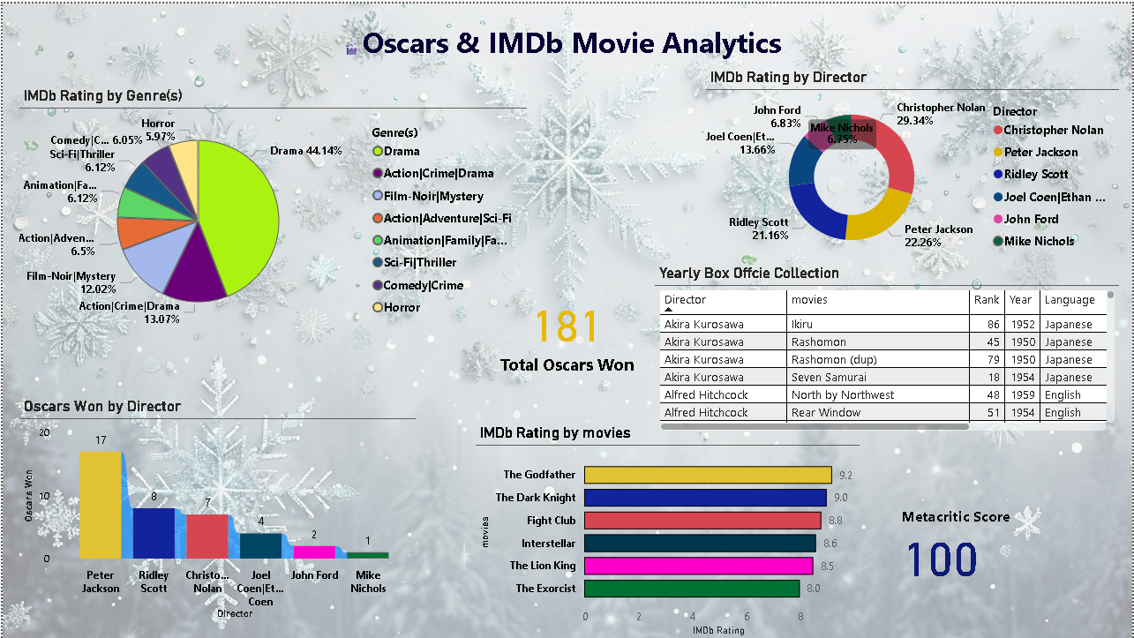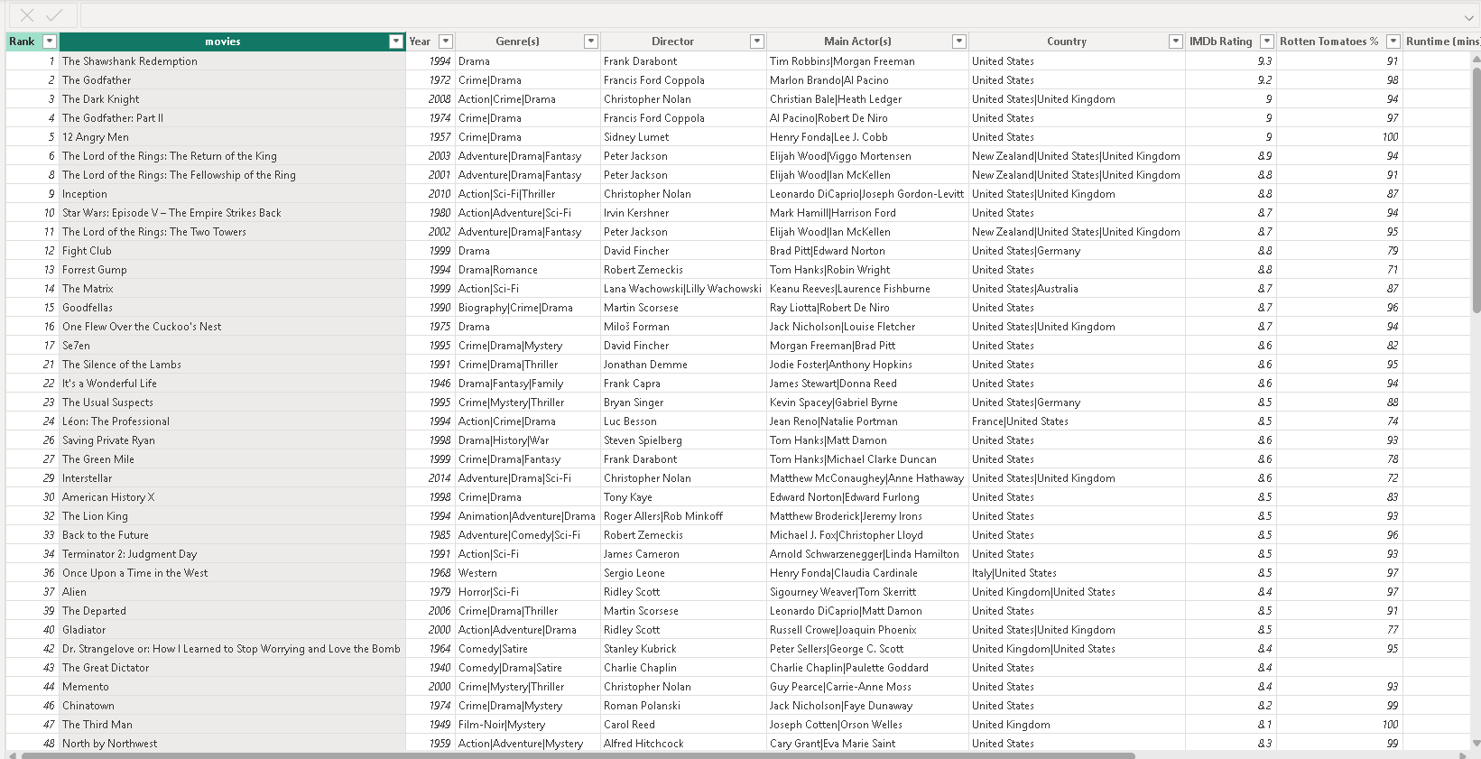

Conclusion:
This Power BI dashboard provides a comprehensive overview of major film performance indicators. It highlights genre-based rating patterns, director rating contributions, Oscars won, and movie rankings. The report helps users quickly understand key performance trends in the film industry.

Additional Dashboard Screenshot:
