Saldao-8 Banking System (Beta)

Manual

D0018D, Objektorienterad programmering i Java

Laboration: Inlämningsuppgift 4

**Salim Daoud**

[**saldao-8@student.ltu.se**](mailto:saldao-8@student.ltu.se) **/** [**salim_daoud@hotmail.com**](mailto:salim_daoud@hotmail.com)

2019-01-31

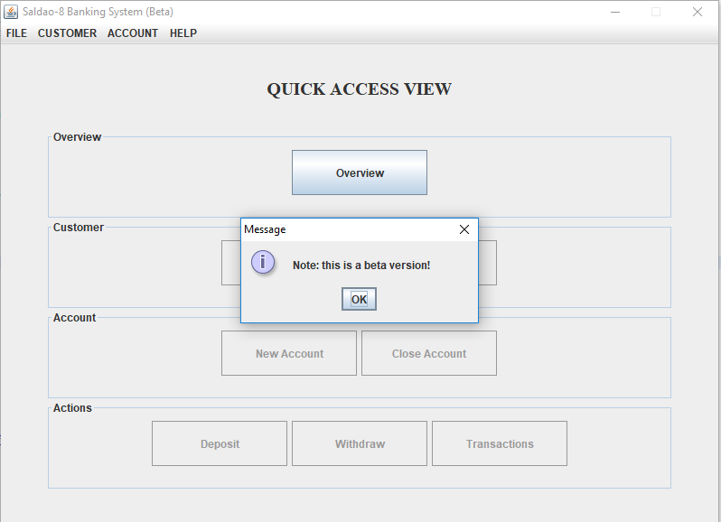

Table of content

Introduction 1

Start-up 1

Add a customer 1

Change a customers name 1

Delete a customer 2

Add an account 2

Deposit to / Withdraw from account 3

View and save transactions 3

Delete account 4

Save and load all customer information 4

Exit program 4

Introduction

This is a beta version and therfore some functionality is not enabled yet. You can though get a peak of what is intended to be supported. Watch out for future updates!

Start-up

1. Launch the program
2. Click on the ”OK” button when the pop-up window appears (“this is a beta version”)
3. Click on the “Overview” button to start using the bank system

Add a customer

1. Fill in the customer information in the text fields (note: if the text fields are already filled with information you can first click on the “Clear” button)
2. Click on the ”Add” button (note: the customer should now been added to the customer list)

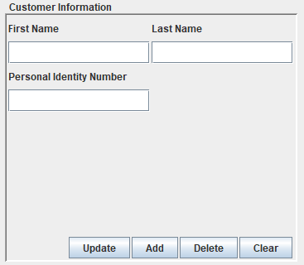

Change a customers name

1. Click on the customer you would like to update
2. Change the name of the customer
3. Click on the “Update” button to submit the change

Delete a customer

1. Select the customer you would like to delete from the customer list
2. Click on the “Delete” button located at the “Customer Information” section
3. A pop-up window should appear. Click on the “Yes” button to proceed with the deletion

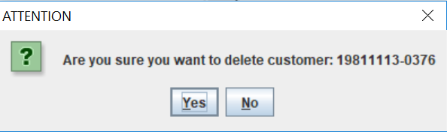

Add an account

1. Select the customer you would like to add an account to (mandatory)
2. Click on the “Add Account” button located at the “Account Information” section (note: a pop-up window should appear)
3. Choose account type from the drop-down list in the pop-up window
4. Click on the “Create” button (note: the account should now been added to the account list)

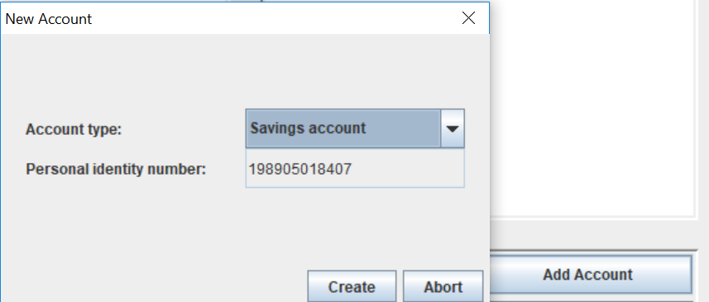

Deposit to / Withdraw from account

1. Select the customer in question (mandatory)
2. Select the account in question (mandatory)
3. Click on the “Deposit”/”Withdraw” button (note: a pop-up window should appear)
4. Type amount in the text field of the pop-up window
5. Click on the “Deposit”/”Withdraw” button to submit

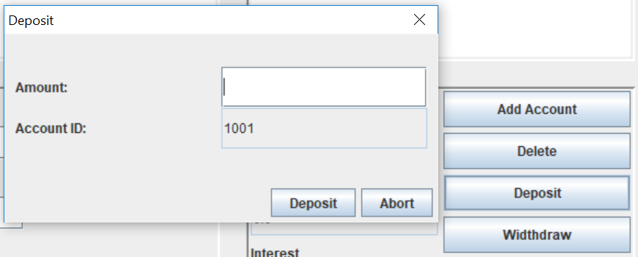

View and save transactions

1. Select the customer in question (mandatory)
2. Select the account in question (mandatory)
3. Click on the “View Transactions” button (note: a pop-up window should appear)
4. Save the transaction history to a file by clicking on the button “Save to file”

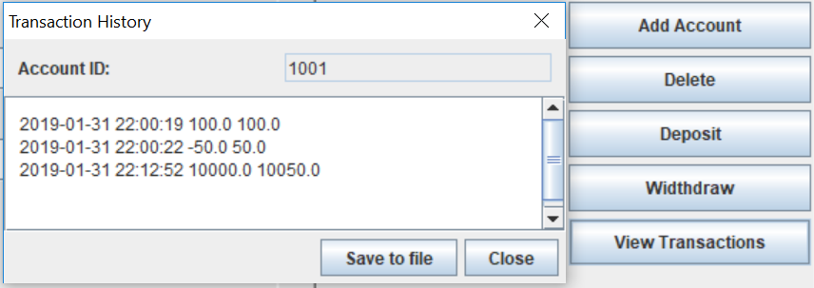

Delete account

1. Select the customer in question (mandatory)
2. Select the account in question (mandatory)
3. Click on the “Delete” button
4. A pop-up window should appear. Click on the “Yes” button to proceed with the deletion

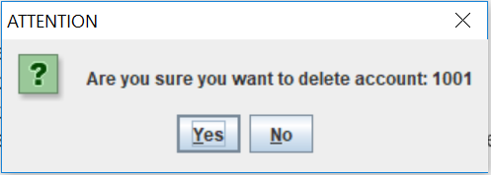

Save and load all customer information

1. Open the File menu
2. Click on option “Save” or “Load”

Exit program

1. Open the File menu
2. Choose option “Exit” (note: you might want to save all customer information before you exit the program in order to be able to load this information next time you open this application)

