Q1.

Create a sample table in postgres/mysql with following columns **(15 Marks)**

Table Name : cdac_power_bi

Column

Name - varchar

Id- integer

Age- integer

Dob - date

Insert 5 dummy rows into it and then connect to superset and populate

1. Table Chart

2. Card chart showing max age

Solution1.

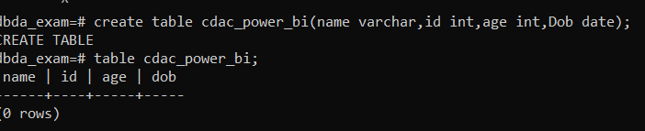

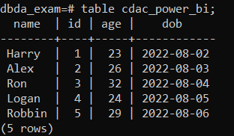

**Importing PostgreSQL Dataset:**

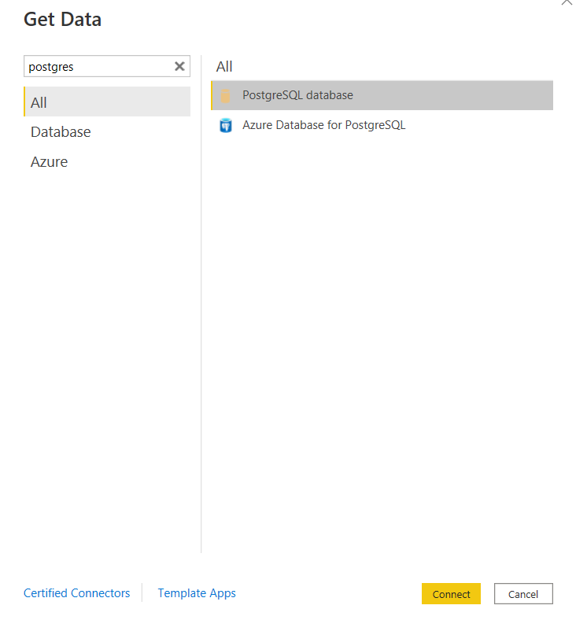

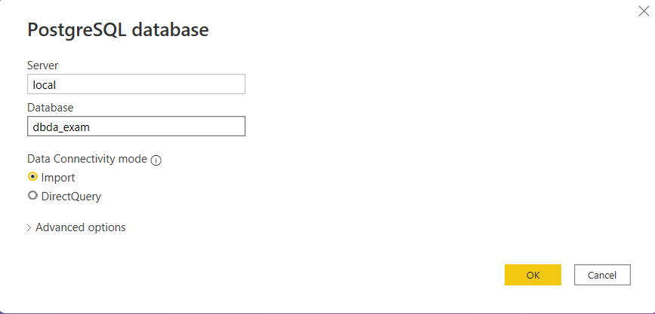

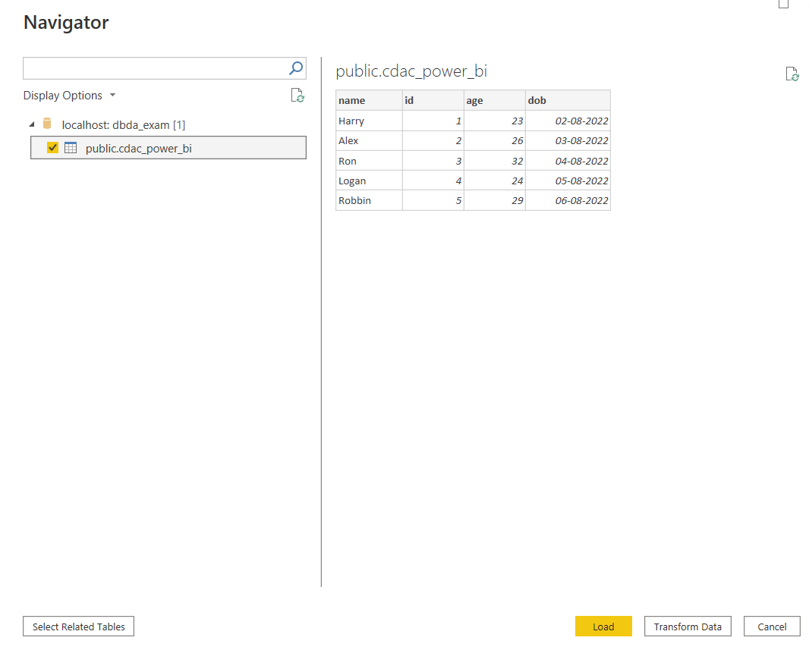

**1. Table Chart**

**2. Card chart showing max age**

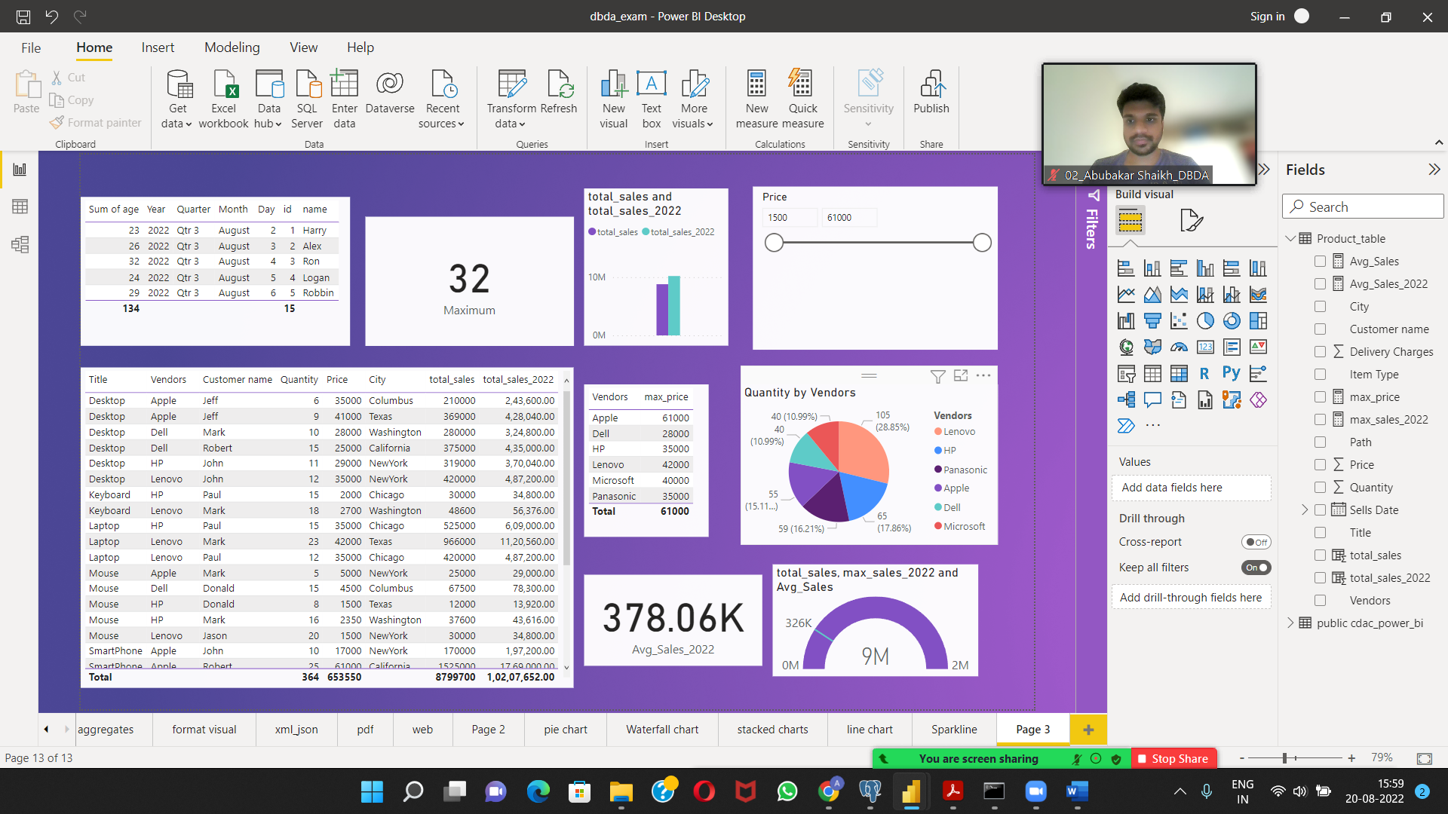

Q2.

On product_table data set do the following **(25 Marks)**

● Create table chart with title , vendor,customer name,quantity,price,city

● Add new calculated column naming **total_sales** which is derived from quantity * price

● Add new measure naming max_price to get max of price column and then display every vendor max price in table chart

● Create pie chart showing the value and percentage of quantity by vendors

● Create one more column naming **total_sales_2022** which is derived from quantity * price * 1.16

● Create clustered column chart showing both **total_sales** and **total_sales_2022**

● Create a slicer chart of price

● Calculate avg sales and show in tile

○ Create gauge chart with value as total_sales

○ Maximum value as max of **total_sales_2022**

○ Target Value as average of total_sales

Solution2.

● Create table chart with title , vendor,customer name,quantity,price,city

● Add new calculated column naming **total_sales** which is derived from quantity * price

● Create one more column naming **total_sales_2022** which is derived from quantity * price * 1.16

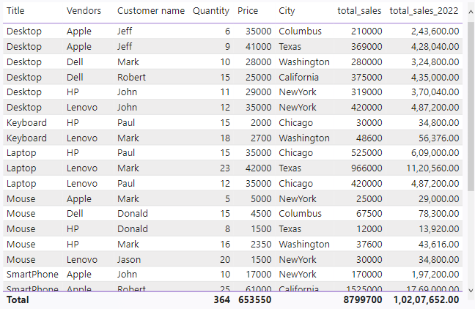

● Add new measure naming max_price to get max of price column and then display every vendor max price in table chart

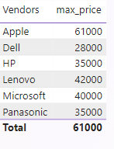

● Create pie chart showing the value and percentage of quantity by vendors

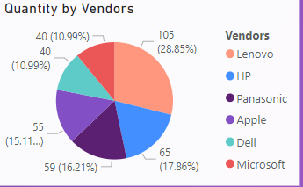

● Create clustered column chart showing both **total_sales** and **total_sales_2022**

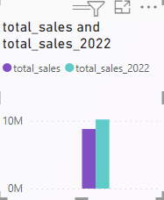

● Create a slicer chart of price

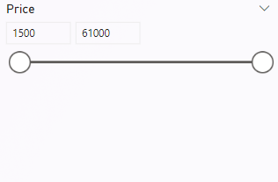

● Calculate avg sales and show in tile

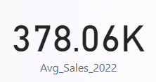

○ Create gauge chart with value as total_sales

○ Maximum value as max of **total_sales_2022**

○ Target Value as average of total_sales

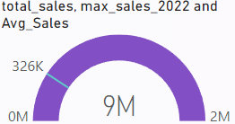

**Final Report:**

