JOINS

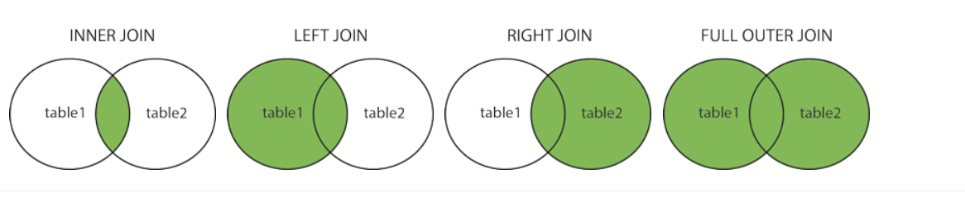

TABLE 1

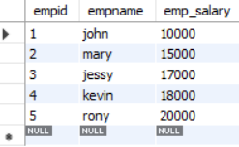

TABLE 2



INNER JOIN

SELECT employee.empid, employee.empname, hr.designation

FROM employee INNER JOIN hr ON employee.empid=hr.empid;

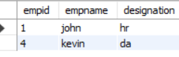

LEFT JOIN

SELECT employee.empid, employee.empname, hr.designation

FROM employee

left JOIN hr ON employee.empid=hr.empid;

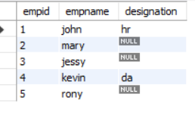

RIGHT JOIN

SELECT employee.empid, employee.empname, hr.designation

FROM employee

right JOIN hr ON employee.empid=hr.empid;

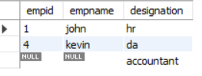

FULLOUTERJOIN

SELECT employee.empid, employee.empname, hr.designation

FROM employee

LEFT JOIN hr ON employee.empid=hr.empid

UNION

SELECT employee.empid, employee.empname, hr.designation

FROM employee

right JOIN hr ON employee.empid=hr.empid ;

