THE ULTIMATE GLOBAL
CAREER BLUEPRINT
The Complete Field Manual for Landing High-Ticket International Roles, Expat Relocation Packages, and Inbound Headhunter Demand via LinkedIn & ATS Engineering
————————————————————————————
MD ZIAUL KADER
International Job Hunting Strategist & Executive Career Consultant
Former Head of Product / Operations (Qatar, Delivery Hero, Snoonu)
Global Edition • Specially Crafted for Western Professionals Relocating to the GCC & Developing World Talent Transitioning Internationally

DEDICATION
To my beloved parents, whose relentless sacrifices and prayers paved the foundation of my journey;
To my cherished wife and children, my unwavering anchors across every transition of our expat life;
And to every driven, ambitious professional across the globe—
Whether you are enduring the punitive tax burdens of Western capitals and yearning for a sovereign, family-aligned haven in the Gulf,
Or striving against systemic economic friction in the developing world to establish your rightful global footprint:
This blueprint is dedicated to your sovereignty, your international mobility, and your pursuit of noble, barakah-infused prosperity.

Author's Preface: From Friction to Global Sovereignty
— Md Ziaul Kader (International Job Hunting Strategist & Executive Career Consultant) —
In the name of Allah, the Most Gracious, the Most Merciful. All praise belongs to the Almighty, who guides us through obscurity, provides sustenance from quarters unimagined, and grants the wisdom to navigate the highest corridors of international corporate enterprise.
I was not born into privilege. I did not graduate from Harvard, Oxford, or an Ivy League institution. My career originated in Dhaka, Bangladesh—a developing market characterized by intense competition, limited institutional prestige, and systemic economic friction. Like millions of ambitious professionals worldwide, I dreamed of leading complex enterprise initiatives, earning in strong reserve currencies, and granting my family unshakeable financial peace.
Yet early on, reality proved merciless. For years, I engaged in the same soul-crushing ritual that drains 99% of global job seekers: I submitted thousands of cold applications through job portals. I clicked LinkedIn's 'Easy Apply' until my fingers went numb. The outcome? Absolute silence. Hundreds of automated rejection emails clogged my inbox. Headhunters ignored my messages. I was trapped in the agonizing spiral of self-doubt, wondering if the international corporate game was rigged exclusively for Western passport holders.
I had no executive mentor. No international career coach intervened. Every breakthrough I achieved was carved out of trial, error, and intense reverse-engineering. And through that relentless process, I unearthed a profound, immutable truth: I was not underqualified. My failure stemmed entirely from my ignorance of the invisible algorithms, systemic economics, and psychological filtering mechanisms of global executive recruitment!
The conventional methods taught in local universities or mainstream career blogs are completely obsolete in international hiring. Enterprise headhunters in Doha, Dubai, Riyadh, London, and Singapore do not manually sift through resumes. They utilize sophisticated enterprise software—LinkedIn Recruiter (RPS), algorithmic boolean query engines, and strict risk-mitigation economics. Once I decoded this hidden architecture—transforming my digital footprint from a passive resume into an irresistible inbound sales funnel—the narrative reversed overnight.
Senior headhunters and corporate leaders from Qatar, the UAE, and global tech enterprises began pitching me directly. I secured tier-1 leadership roles (including Head of Product & Operations across venture-backed giants like Delivery Hero, Snoonu, and Qatar Insurance Group), complete with seven-figure compensation, comprehensive family executive relocation, and tax-free sovereignty.
💎 The Strategic Promise of This Manual
"I refuse to allow ambitious professionals to bleed through years of blind trial and error as I once did. The exact systems, architectural blueprints, ATS templates, and headhunter outreach scripts that my private executive coaching clients pay thousands of dollars to access are laid bare in this book without reservation. This is not motivational rhetoric; it is a battle-tested enterprise playbook."

Why This Manual Matters Now: A Tale of Two Global Audiences
We are living through an unprecedented macro-economic reorganization. Depending on where you stand today, this manual addresses the most urgent financial and personal challenge of your lifetime:
Audience A: Western Professionals Seeking Middle East Relocation
If you are currently living in the United States, the United Kingdom, Canada, or Western Europe, you are feeling the crushing weight of high marginal income taxes (often 40% to 55%), exploding property prices, soaring childcare costs, and cultural erosion. Highly skilled tech leaders, doctors, consultants, and financiers are watching their real purchasing power deteriorate year after year.
Meanwhile, the Arabian Gulf—spearheaded by Qatar (Doha), the UAE (Dubai, Abu Dhabi), and Saudi Arabia (Riyadh, NEOM)—has engineered the world's most dynamic, safe, and capital-abundant economic miracle. Zero income tax, world-class private British and American international schools, state-of-the-art infrastructure, virtually zero violent crime, and a deep societal respect for family and faith. However, landing a competitive expat package from the West requires navigating GCC headhunter psychology, local labor laws, and executive positioning. This book is your bridge to Gulf sovereignty.
Audience B: Developing World Talent Transitioning Internationally
If you are operating out of South Asia, Southeast Asia, Africa, or Latin America, you face runaway inflation, currency depreciation, and glass ceilings in local compensation. Your challenge is breaking the 'local candidate bias' and proving to multinational recruiters that your talent justifies thousands of dollars in relocation costs, visa quotas, and flights.
This manual deconstructs the '100-Day vs. 10-Day Onboarding Economics'—the mathematical equation that makes foreign enterprises eager to sponsor and relocate you, bypassing regional bias through quantifiable excellence.
The Financial Anatomy of an Expat Relocation Package
Many professionals mistakenly evaluate international offers solely on gross monthly salary. In truth, an elite Gulf or global enterprise package covers 70% to 80% of your family's annual living expenditures directly. Examine the financial blueprint:
1. 100% Tax-Free Base Salary: In Qatar, UAE, or Saudi Arabia, mid-to-senior executives command 18,000 to 45,000+ QAR/AED/SAR monthly ($60,000 to $160,000+ USD net take-home annually)—equivalent to a $220,000+ gross salary in London or Toronto.
2. Fully Furnished Family Housing / Allowance: High-end executive accommodation in premium districts (The Pearl, West Bay, Dubai Marina, Downtown) fully funded (valued at $25,000 to $50,000 annually).
3. Comprehensive Private Health Coverage: 100% cashless premium medical, dental, and hospitalization for you, your spouse, and all dependent children across elite private hospitals.
4. International School Tuition Allowance: Full coverage for British, American, or IB curriculum schooling for your children (valued at $8,000 to $20,000 per child annually).
5. Annual Family Business/Economy Flights: Round-trip flight tickets for the entire family to your home country every year.
6. Full Relocation Shipping & Settling-in Grant: Complete cargo container shipping for personal belongings, plus temporary 5-star hotel accommodation upon arrival.
7. End-of-Service Gratuity (ESB): A mandatory, tax-free lump-sum wealth accumulation fund accrued annually under statutory GCC labor law.
Strategic Roadmap: The 12-Chapter Architecture across 5 Parts
This master manual is organized into 5 cohesive parts and 12 deep chapters, engineered to take you from foundational positioning to signed executive contract:
• Part I: Global Mindset & Headhunter Psychology (Chapters 1–2) — Enterprise Niche Definition, The 100-Day vs. 10-Day Value Equation, and Decoding the LinkedIn Recruiter (RPS) Algorithm.
• Part II: LinkedIn Profile Architecture (Chapters 3–6) — The 3-Second Visual Hook Banner, The Magnetic Headline Formula, The Enterprise About Funnel, and The 8 Experience Bullet Frameworks.
• Part III: International Resume, AI Applications & The Spiritual Blueprint (Chapters 7–8) — Harvard ATS 1-Page Resume Architecture, The 90-Day Transition Action Plan, and The 8 Spiritual Pillars of Sustenance (Barakah).
• Part IV: Executive Networking, Cold Outreach & Social Selling (Chapters 9–10) — Inbound Recruiter Messaging, Tier-1 Agency Penetration, and The 10-Million View Thought Leadership Blueprint.
• Part V: Executive Interview Mastery, Salary Negotiation & Expat Relocation (Chapters 11–12) — The 5X ROI Value Anchoring, High-Stakes Expat Contract Negotiation, Embassy Attestation Pipelines, and Account Protection Protocols.
Approach this manual not as a casual read, but as an operational laboratory. Complete the audits, implement the frameworks, and follow the sequence. Within 90 to 180 days of disciplined execution, your career trajectory will fundamentally transform.

PART I: THE GLOBAL MINDSET & RECRUITER PSYCHOLOGY
Chapter 1: Global Niche Architecture & Market Validation (The Niche Blueprint)
— Establishing Irreplaceable Enterprise Value Positioning in the International Corporate Marketplace —
1.1 The Generalist Trap: Why 500 Cold Applications Yield Zero Inbound Calls
The overwhelming majority of professionals seeking international employment—whether aspiring to relocate from developing nations or pivoting from high-tax Western markets to the Gulf—begin their search with a catastrophic strategic flaw. When I review candidate profiles, I routinely encounter an agreeable but fatal self-conception: "I am a versatile, hardworking professional capable of doing anything. Give me an opportunity in any domain, and I will prove myself."
While this sentiment sounds humble and eager, in the ruthless arena of cross-border corporate recruitment, it is the single fastest guarantee of total invisibility. I call this pathology 'The Generalist Trap.' A generalist logs into LinkedIn, navigates to the job board, and indiscriminately hammers the 'Easy Apply' button across banks, logistics operators, oil & gas conglomerates, e-commerce scale-ups, and cloud software consultancies. Today they apply for a Business Analyst role in retail banking; tomorrow for a Project Coordinator position in energy infrastructure; and by the weekend for an Operations Manager vacancy at a consumer tech start-up.
The inevitable outcome is soul-draining frustration: 300 to 500 applications submitted over six months, met with dead silence or automated rejection letters. The candidate inevitably concludes that the global market is closed to outsiders, or that international roles require political lobbying and personal nepotism. The reality is far more objective: the problem is not your luck; it is your economic positioning.
Consider the perspective of an executive corporate recruiter in Doha, Dubai, London, or Singapore. When an enterprise opens an international hiring requisition, they are taking a multi-thousand-dollar risk. They are not looking for a well-meaning jack-of-all-trades whom they must train from scratch. They are seeking a surgical specialist who has solved their exact business bottlenecks multiple times before. When you claim you can do everything, the recruiter's pattern-matching brain registers you as an expert in nothing.
1.2 The Economic Engine of Sponsorship: The 100-Day vs. 10-Day Onboarding Arbitrage
Why does a multinational corporation or sovereign enterprise in the GCC spend $10,000 to $20,000 in visa fees, relocation logistics, and international flights to hire someone from abroad rather than hiring locally? In my executive masterclasses, I unveil the underlying mathematical arbitrage: 'The 100-Day vs. 10-Day Onboarding Economics.'
Imagine an enterprise logistics corporation in Qatar seeking a Senior Cold-Chain Operations Lead. Two distinct candidates present themselves:
• Candidate A (The Local Generalist): Already based in Doha, holding a transferable visa. His background is 5 years in commercial retail showroom management. He is diligent, personable, and willing to accept a modest salary of $3,500/month. However, he has never managed international pharmaceutical cold-chain compliance, automated temperature telematics, or customs clearance protocols. To train him to operational competence will consume 3 to 4 months (approximately 100 business days).
• Candidate B (The Global Domain Specialist): Based in South Asia, the UK, or Southeast Asia, requiring full expat sponsorship. His compensation expectation is $6,500/month, plus $6,000 in one-off visa and relocation costs. However, he has spent the last 6 years orchestrating complex enterprise cold-chain operations for global logistics networks.
Now observe how an experienced Chief Operating Officer or Chief Financial Officer evaluates this equation on a spreadsheet: Training Candidate A over 100 days diverts senior leadership hours, exposes the supply chain to catastrophic regulatory errors, and generates between $30,000 and $50,000 in hidden operational drag and lost enterprise efficiency. In stark contrast, when Candidate B steps off the flight at Hamad International Airport and enters the office, by Day 10 he has audited the telematics infrastructure, restructured operational bottlenecks, and generated immediate business velocity! His relocation expense is not a corporate cost—it is an investment yielding 500% ROI within the first quarter.
💡 Golden Rule of Global Employability
"International enterprises do not sponsor visas or pay six-figure tax-free expat salaries for your degree or your hard work. They sponsor you to compress their onboarding latency from 100 days down to 10 days. When your domain expertise is undeniable, your relocation package is not an expense—it is the company's most profitable operational hedge."

1.3 The 4 Immutable Pillars of Global Niche Positioning
Constructing a high-converting global niche is an architectural science governed by four interlocking pillars:
Pillar 1: Industry Vertical Specialization
Your primary objective is selecting an unambiguous industry vertical. Are you dedicated to FinTech & Digital Payments? Healthcare & Life Sciences? Cloud Infrastructure & Enterprise SaaS? Oil, Gas & Renewable Energy? Or Freight Logistics & Supply Chain? Choosing an industry does not imply you are incapable of broader work; it means your market positioning clearly identifies you as the authority in solving that vertical's mission-critical problems. Never straddle two disparate industries on the same public profile.
Pillar 2: The Target Company Portfolio (The 20-to-50 Rule)
Cease wandering across the infinite expanse of the internet. You must assemble an exhaustive, curated database of 20 to 50 target enterprises that operate within your chosen vertical, have healthy balance sheets, and possess a demonstrated history of international hiring.
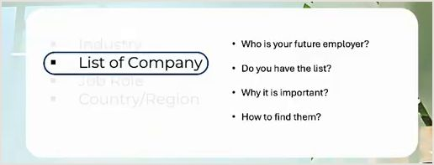
Figure 1.1: Pillar 2 — Target Company Portfolio Framework (Lecture Reference: 10:15)
Figure 1.1 Breakdown: The 4 Strategic Company Discovery Queries
1. Who is your future employer?: Identify your employers with granular precision instead of blasting resumes to hundreds of anonymous job listings.
2. Do you have the list?: Maintain a dedicated spreadsheet containing the official company name, headquarters, regional GCC/Western offices, and core software stack.
3. Why it is important?: A focused list allows deep research into the company's technical pain points, quarterly reports, and executive leadership priorities prior to outreach.
4. How to find them?: Leverage LinkedIn company directory filters, Glassdoor geographic indices, and industry market maps to isolate high-growth enterprises.

Video Reference & Live Demo: [Watch Lecture Segment: 10:15 — Target Company Architecture]
LinkedIn Search Mechanics & Company Filtering Framework (Video Timestamp: 11:15):
To transform company selection into an inbound recruitment pipeline, apply this 4-step auditing framework:
4-Step Enterprise Company Auditing & Filtering Protocol
1. Official Company Page & 'About' Audit: Search for target enterprises and inspect their official industry tags (e.g., 'Financial Services' or 'IT Services and IT Consulting'). You must select this exact industry tag in your personal profile settings to trigger 1st-degree algorithm matchmaking in LinkedIn Recruiter.
2. Headcount Velocity & Growth Rate Analysis: Examine the 'Insights' tab. Mid-sized enterprises scaling between 50 and 500 employees with a 10% to 25% annual headcount expansion represent the golden hiring zone. Start-ups lack relocation budgets, while mega-corporations carry suffocating bureaucracy.
3. Expat Footprint & Organogram Mapping: Inspect the 'People' tab. If the current team includes foreign professionals holding degrees from multiple international jurisdictions, the company's visa sponsorship pipeline is active and legally lubricated.
4. Boolean Query Discovery: Execute exact-match search strings: '[Target Job Title]' AND ('SaaS' OR 'FinTech') AND 'Location' to uncover stealth high-growth employers flying beneath mainstream radar.

Pillar 3: Standardized International Role Hierarchy & Job Title Mapping
In global corporate structures, job titles reflect standardized compensation bands and authority tiers. In developing domestic markets, organizations frequently assign vague, catch-all designations such as 'Assistant Manager' or 'Officer' to employees who manage entire software architectures or multi-million-dollar accounts. However, international headhunters searching LinkedIn never type 'Assistant Manager.' They search: 'Lead Cloud Architect', 'Enterprise Solutions Director', 'FinTech Risk Manager', or 'VP of Engineering'.

Figure 1.2: Pillar 3 — Standardized Job Roles & Career Ladder Alignment (Lecture Reference: 13:30)
Figure 1.2 Breakdown: The 3 Core Pillars of Target Role Selection
1. What is your next role?: Your upcoming career milestone must be crystallized into a globally recognized corporate designation.
2. Building Resume: Every single achievement bullet must reflect the technical vernacular and KPIs of that specific international tier.
3. Building LinkedIn: Your headline, summary, and experience sections must index exclusively for keywords corresponding to that role level.

Video Reference & Live Demo: [Watch Lecture Segment: 13:30 — Target Role Architecture]
Examine the practical live walkthrough of corporate organogram mapping and role hierarchy below:
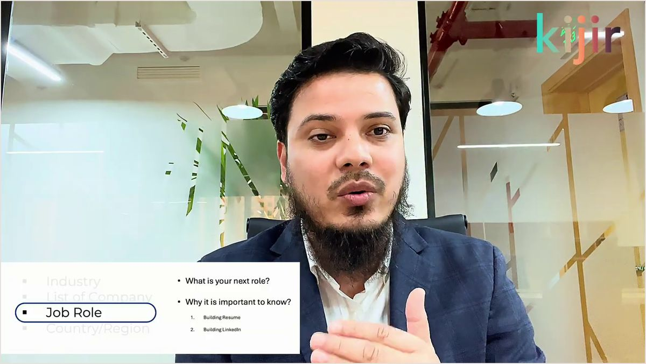
Figure 1.3: Live Expert Session: International Job Hierarchy & Role Matching (Lecture Reference: 13:45)
Figure 1.3 Breakdown: Corporate Hierarchy Alignment Mechanics
1. Standardized Ladder Progression: Specialist ➔ Senior Lead ➔ Manager ➔ Director ➔ Vice President. Identify where your current scope sits internationally and align your target titles accordingly.
2. Bridging Local Designations: If your local title is idiosyncratic, use an explanatory bracket on LinkedIn: e.g., 'Assistant Manager [Lead Cloud Infrastructure Engineer]'. This captures recruiter boolean algorithms while preserving background check fidelity.

Pillar 4: The Visa & Sponsorship Reality Audit (Global Relocation vs. Local Transferable Status)
This is the most critical commercial filter in cross-border job hunting, and failing to comprehend it wastes hundreds of candidate hours: When an international job posting states, "Candidate must possess a transferable visa / valid QID / Iqama / local work permit," it means the company has zero budget or legal quota to sponsor an incoming foreign hire. They will strictly interview candidates currently resident in-country.
If you apply from abroad to local-transfer requisitions, your application is automatically discarded by automated ATS rules. You must filter exclusively for employers explicitly advertising "Global Relocation Provided" or identify organizations whose expat headcount proves an active international visa quota.
1.4 Real-World Case Evidence: The 4 Pillars in Practice & Expat Compensation Architecture
When I successfully executed this 4-pillar methodology to secure an executive relocation offer to Doha with Qatar Insurance Group, I documented the exact structural model on LinkedIn. Examine the summary slide from my live workshop below:
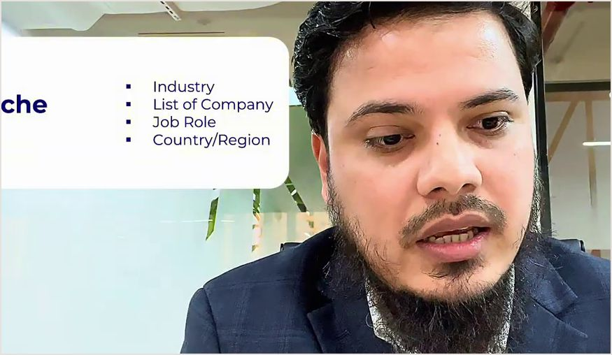
Figure 1.4: The 4 Immutable Pillars of Niche Positioning & Expat Relocation Architecture (Lecture Reference: 05:15)
Figure 1.4 Breakdown: Niche Synchronization & The 70% Living Cost Absorption Model
1. Perfect 4-Pillar Convergence: The live slide demonstrates the mandatory union: Industry (e.g., InsurTech/FinTech), List of Target Companies (Top 30 regional players), Standardized Job Role (AI Product Manager), and Target Region (Qatar/GCC). When all four synchronize, recruiter matchmaking peaks.
2. The 70% Living Cost Absorption Arbitrage: Elite multinational and Gulf enterprise packages absorb the vast majority of family living overhead: housing allowances, schooling tuition grants, private healthcare, and annual flights. Your nominal base salary translates into direct family wealth accumulation.
3. The 'Job First, Move Later' Principle: Never migrate prematurely on visit visas without an executed employment contract. When your inbound digital funnel is properly engineered, legitimate offers, visas, and airline tickets arrive in your hands while you remain comfortably at home.

Video Reference & Live Demo: [Watch Lecture Segment: 05:15 — Expat Relocation Economics]
1.5 Transformation Case Study: How Ariful Transitioned from Generic Coder to Dubai FinTech Lead
To illustrate the tangible power of niche architecture, consider the real transformation of one of my direct executive students, Ariful (name anonymized). Ariful was a software engineer in Dhaka with six years of backend experience, struggling to secure international interviews. His headline read: "Senior Software Engineer | Java, Spring Boot, Python, PHP, Full Stack Developer, Seeking Opportunities".
He had submitted over 400 applications across European and Gulf portals without a single interview. When I audited his background, we discovered that for the prior three years, he had been building payment gateways and core banking integrations for a regional bank. Yet his profile contained zero mentions of 'Banking', 'FinTech', 'PCI-DSS Compliance', or 'Transaction Throughput'! He was marketing himself as a disposable generic developer.
We implemented four immediate architectural changes:
• Headline Overhaul: "Senior FinTech Backend Engineer | Scalable Payment Gateways, High-Throughput Core Banking & Microservices (Java/Spring Boot)"
• Industry Vertical Alignment: Changed LinkedIn official industry from 'Computer Software' to 'Financial Services'.
• Target Company Mapping: Curated a focused target list of 30 GCC digital challenger banks, payment processors, and wealth-tech firms.
• Resume Refactoring: Replaced generic coding tasks with quantifiable metrics: highlighting how his microservices processed 2.5 million daily transactions with 99.99% uptime.
The result? Within 4 weeks, a senior executive headhunter in Dubai reached out via InMail. Following three rounds of technical interviews, Ariful signed an offer yielding a 350% salary increase, complete with full UAE residency and relocation.
1.6 Strategic Playbook: 4 Candidate Personas
STRATEGIC PLAYBOOK: 4 CANDIDATE PERSONAS
1. Fresh Graduate / Junior Candidate (0–2 Years Experience):
• Challenge: Perceived lack of enterprise track record and low employer willingness to sponsor expat visas.
• Niche Focus: Niche specialization in emerging technical frameworks (e.g., LangChain AI, Cloud Kubernetes, FinOps) with public GitHub proof of work.
• Action Item: Target global remote internships and junior contractor roles across high-velocity Western and Gulf start-ups.
2. Western Professional Relocating to the GCC (3–10 Years in US/UK/EU):
• Challenge: Navigating GCC recruiter culture, cultural transition, and understanding tax-free expat contract structuring.
• Niche Focus: Positioning Western corporate governance, enterprise architecture, and scale expertise as an instant acceleration asset for GCC sovereign-backed firms.
• Action Item: Configure 'Recruiters Only' settings to Doha, Dubai, and Riyadh; map target regional enterprises; align salary benchmarks on net take-home terms.
3. Developing World Professional Seeking International Relocation (4–12 Years Experience):
• Challenge: Overcoming regional applicant bias, lack of global brand-name pedigree, and visa quota restrictions.
• Niche Focus: Demonstrating the '10-Day Onboarding' equation through deep vertical specialization and quantifiable business impact metrics.
• Action Item: Build a 50-company target database; replace generic job applications with targeted hiring manager outreach and cold networking.
4. Independent Consultant / B2B Freelancer:
• Challenge: Escaping low-margin freelance platforms and securing high-ticket international retainer contracts.
• Niche Focus: Packaging specialized advisory solutions ($3,000–$10,000/month) solving critical enterprise bottlenecks (e.g., SOC2 compliance, CAC reduction).
• Action Item: Build inbound authority via LinkedIn thought leadership and direct founder-level discovery calls.

1.7 Field Action Audit: The 20-Point Niche Validation Scorecard
Evaluate your current career positioning against the 5 core diagnostic criteria below. Score each category from 1 to 4 points (Maximum: 20 points):
The 20-Point Global Niche Validation Matrix
1. Vertical Exclusivity (1-4 pts): Can a headhunter determine your specific industry vertical within 3 seconds of reading your headline? (1 = Completely Generic; 4 = Absolute Vertical Focus).
2. Target Company Specificity (1-4 pts): Do you maintain an active spreadsheet of 30-50 verified target employers with active expat hiring footprints? (1 = Zero list; 4 = Exhaustive mapped database).
3. Title Standardization (1-4 pts): Does your primary title match international corporate naming standards recognized across LinkedIn Recruiter? (1 = Obscure internal title; 4 = Globally standardized).
4. Quantifiable Metric Proof (1-4 pts): Are your accomplishments quantified in revenue, latency, cost savings, or enterprise scale? (1 = Vague responsibilities; 4 = Strict dollar/percentage metrics).
5. Sponsorship Alignment (1-4 pts): Are you directing applications exclusively to employers with confirmed relocation and visa sponsorship budgets? (1 = Blasting local ads; 4 = Verified global sponsorship).

Scoring Breakdown: 16–20 Points = Elite International Positioning; 11–15 Points = Moderate Competitiveness (Needs Optimization); Below 10 Points = The Generalist Trap (Immediate Re-architecture Mandatory).
Chapter 2: Headhunter Psychology & LinkedIn Recruiter (RPS) Algorithm Decoding
— Deconstructing the $10,000/Seat Enterprise Search Console That Decides Who Gets Headhunted and Who Remains Invisible —
2.1 The Invisible Gatekeeper: How LinkedIn Recruiter (RPS) Actually Works
To win a high-stakes game, you must intimately understand the rules and tools used by the arbiters of that game. The single most pervasive misconception among job seekers globally—whether an engineer in London considering Dubai or a product leader in South Asia aiming for Europe—is assuming that headhunters view LinkedIn through the same free consumer interface that they do.
Enterprise headhunters, executive search directors, and corporate talent acquisition teams at major multinational conglomerates (such as McKinsey, Qatar Airways, PwC, Aramco, or Careem) do not use standard LinkedIn. They operate an enterprise SaaS console known as LinkedIn Recruiter (or Recruiter Professional Services - RPS), which costs corporate subscribers between $8,000 and $12,000+ per license per year.
Inside this high-powered backend, the interface resembles an institutional financial terminal or an e-commerce procurement engine. A headhunter enters 15 to 20 granular search parameters: target geographical relocation radius, exact standardized job designations, years of domain experience, specific software frameworks, language proficiencies, and candidate responsiveness indices. Out of 1 billion global users, the algorithm filters down to a tight shortlist of 20 to 50 profiles. If your profile is not architected to trigger these exact backend filters, you do not exist in the executive recruitment ecosystem.
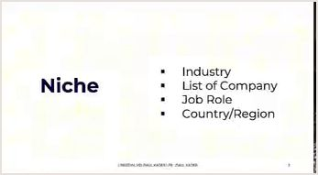
Figure 2.1: The Niche Positioning Foundation for LinkedIn Recruiter Algorithmic Indexing (Lecture Reference: 00:04)
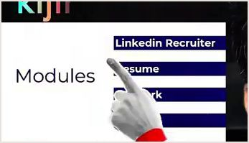
Figure 2.2: The 4-Pillar Executive Curriculum: Profile, Resume, Cold Outreach & Spiritual Sustenance (Lecture Reference: 00:23)
Figures 2.1 & 2.2 Breakdown: The 4 Core Elements of Search Console Indexing
1. Complete Recruiter RPS Alignment: Your profile's hidden backend settings must match the exact taxonomy utilized by corporate talent scouts.
2. Standardized Job Hierarchy: Every historical title in your experience section must conform to international nomenclature.
3. Keyword Proximity & Density: Core skills must appear within the first 3 lines of your headline, summary, and experience bullets.
4. Algorithmic Responsiveness Score: LinkedIn tracks your response speed to InMails. High responsiveness gives your profile preferential rank in future recruiter searches.

Video Reference & Live Demo: [Watch Lecture Segment: 00:04 — Recruiter Console Foundation]
2.2 The Recruiter Search Console & Live Ranking Mechanics
I do not teach theoretical speculation. I hold the official certification from LinkedIn Talent Solutions: the 'Excel with LinkedIn Recruiter Assessment'. I operate the platform from the inside. In my workshops, I conduct live searches across GCC capital cities to demonstrate how algorithm mechanics dictate outcomes.
For example, during a live workshop, when searching for the competitive executive title 'AI Product Manager' in Doha, Qatar, out of thousands of potential candidates across the Middle East, my own profile appeared at the absolute top of the recruiter shortlist! Why? Because every metadata tag—from my current title continuity to my exact location indexing and skill endorsements—was calibrated with surgical precision.
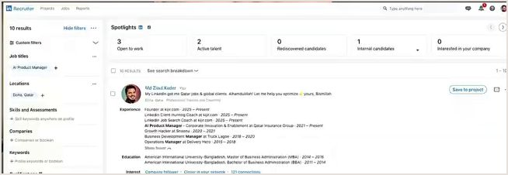
Figure 2.3: Live LinkedIn Recruiter RPS Search: Author's Profile Ranking #1 for 'AI Product Manager' in Doha (Lecture Reference: 01:45)
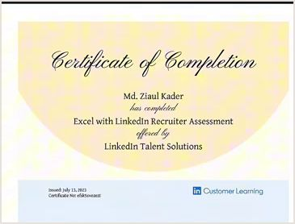
Figure 2.4: Official LinkedIn Talent Solutions Certification: Excel with LinkedIn Recruiter Assessment (Lecture Reference: 03:18)
Figures 2.3 & 2.4 Breakdown: The 3 Ranking Catalysts for Top-Slot Placement
1. Title Exact-Match Weighting: The recruiter search string must match your current job title and primary headline without dilution from generic buzzwords.
2. Geographic Mobility Signals: Explicitly setting target relocation jurisdictions in the 'Open to Work' backend ensures your profile populates regional search pools.
3. Company Brand Association: Highlighting recognizable regional or global enterprise partners (even in local roles) builds instant credibility on the recruiter's preliminary preview card.

Video Reference & Live Demo: [Watch Lecture Segment: 01:45 — Live Recruiter Search Proof]
2.3 Advanced Filter Mechanics: Why 90% of Candidates Are Filtered Out
A senior headhunter in Dubai or Riyadh does not browse casually. When executing an executive assignment, they utilize a cascade of advanced filters to eliminate noise rapidly. Examine the 5 most lethal filters:
The 5 Primary LinkedIn Recruiter Search Filters & Defense Tactics
1. Job Titles (Current vs. Past): Recruiters toggle 'Current Title Only'. If your current position has an obscure title, you are eliminated before page 1 loads. Solution: Align your current title with international standards immediately.
2. Geographic Location & Relocation Willingness: Recruiters select specific hubs (e.g., Doha, Dubai, Riyadh). By default, candidates located outside the region are hidden unless their backend 'Open to Work' preferences explicitly state target countries.
3. Years in Current Position (Job Hopping Filter): Recruiters frequently set minimum tenure to 1-2 years to filter out flight risks. Demonstrate continuous tenure or frame transitions as project milestones.
4. Spoken Languages: For GCC multinational roles, English is the universal business language. Ensure 'English (Full Professional / Native)' is explicitly listed in your profile's language section.
5. Company Headcount / Tier: Recruiters can filter candidates who have worked in companies of 50-500 or 1,000+ employees to ensure enterprise capability.

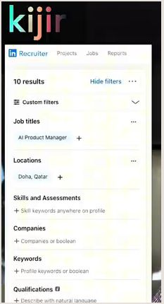
Figure 2.5: The LinkedIn Recruiter Advanced Filter Console: Job Titles, Geography & Industry Matrices (Lecture Reference: 04:08)
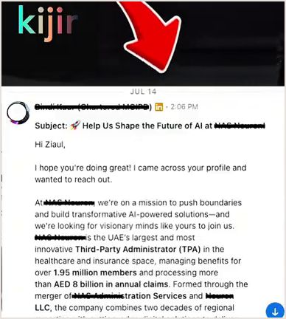
Figure 2.6: Real-World Inbound Proof: Executive Headhunter Outreach Received from Dubai via InMail (Lecture Reference: 04:55)
Look closely at Figure 2.6. This is not a candidate desperately reaching out to a company. This is a Senior Chartered Executive Headhunter based in Dubai messaging me directly on LinkedIn, pitching an exclusive enterprise role. When your digital asset is engineered correctly, inbound recruiter demand becomes automated and effortless.
2.4 Career Ladder Progression & Title Continuity (80% Recruiter Search Trigger)
Eighty percent of corporate recruiters search for candidates by filtering for immediate title continuity. They want to see a logical, upward trajectory where each role represents an expansion of scope and leadership. If your career history shows erratic jumps—e.g., moving from Software Developer to Sales Executive to Operations Specialist—recruiter confidence plummets.
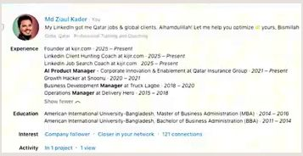
Figure 2.7: The Career Ladder Progression Framework: Upward Scope & Title Continuity (Lecture Reference: 08:58)
Figure 2.7 Breakdown: Career Continuity Optimization Rules
1. Upward Scope Trajectory: Demonstrate expanding responsibility from operational execution to team leadership and P&L accountability.
2. Bridging Cross-Functional Shifts: If you transitioned industries, unify your narrative by emphasizing the consistent problem-solving framework you applied across both domains.
3. Standardizing Historical Titles: Ensure that past titles reflect standardized industry vocabulary while remaining factually honest regarding your core responsibilities.

2.5 The 'Open to Work' Configuration: The Secret 'Recruiters Only' Setting
One of the most consequential strategic decisions you make on LinkedIn is how you configure your 'Open to Work' modal. There are two options: a public green photo frame ('#OpenToWork') or a private backend toggle ('Recruiters Only').
For any professional aiming for high-income international corporate roles, the public green frame is a major strategic blunder. In enterprise recruitment psychology, high-ticket talent is perceived as currently engaged, discreet, and highly valued. The public green banner signals desperation and immediately weakens your salary negotiation leverage. Conversely, the 'Recruiters Only' setting quietly injects your profile into the private search indices of external talent scouts without alerting your current employer.
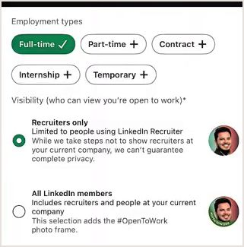
Figure 2.8: Optimal 'Open to Work' Backend Modal Configuration: 'Recruiters Only' Protocol (Lecture Reference: 17:53)

Figure 2.9: Advanced Geographic Relocation Targeting inside LinkedIn Recruiter (Lecture Reference: 18:38)
Figures 2.8 & 2.9 Breakdown: Step-by-Step 'Recruiters Only' Configuration
1. Target Job Titles (Max 5): Enter exactly 5 prioritized, standardized corporate designations (e.g., 'Head of Product', 'Lead AI Engineer', 'Solutions Architect').
2. Target Location Preferences: Select your target geographic hubs (e.g., 'Doha, Qatar', 'Dubai, UAE', 'Riyadh, Saudi Arabia') and explicitly toggle 'Remote' and 'On-site'.
3. Start Date Selection: Choose 'Immediately, I'm actively applying' or 'Flexible, I'm casually looking' to control outreach velocity.
4. Visibility Selection: Strictly choose 'Recruiters only' to protect your confidentiality and preserve maximum negotiation leverage.

2.6 The 4-Pillar Master Roadmap: Profile, Resume, Network & Spiritual Sustenance
A truly resilient international career strategy rests on four synchronized pillars. Examine the master roadmap below:
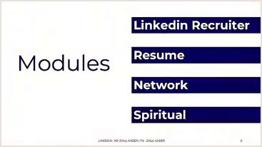
Figure 2.10: The 4-Pillar Master Blueprint: Recruiter RPS, Harvard Resume, Executive Network & Spiritual Anchor (Lecture Reference: 19:35)
Figure 2.10 Breakdown: The 4 Pillars of Comprehensive Career Sovereignty
Pillar 1: LinkedIn Recruiter (RPS) Engine: Transforming your profile from a passive CV into a high-converting inbound search magnet.
Pillar 2: Harvard ATS 1-Page Resume: A concise, metric-dense 'boarding pass' engineered to clear corporate applicant tracking robots with zero friction.
Pillar 3: High-Trust Executive Networking: Bypassing public application queues through warm, value-driven relationships with hiring directors and tier-1 agencies.
Pillar 4: Spiritual Foundation (Barakah & Tawakkul): Anchoring your earthly labor in profound reliance on Allah, late-night prayers (Tahajjud), charity (Sadaqah), and ethical integrity.

2.7 Strategic Playbook: 4 Candidate Personas
STRATEGIC PLAYBOOK: 4 CANDIDATE PERSONAS
1. Fresh Graduate / Junior Specialist:
• Search Reality: Recruiters rarely filter for junior roles via RPS due to volume. Your play is optimizing for specific niche technical skill keywords.
• Strategy: Tag exact libraries and frameworks (e.g., 'PyTorch', 'Next.js', 'PostgreSQL') across your profile to match junior contractor queries.
2. Western Expat Relocating to the GCC (US/UK/EU):
• Search Reality: Regional Gulf headhunters actively seek Western corporate pedigree to lead transformation programs. However, they must know you are open to relocation.
• Strategy: Set 'Open to Work' locations explicitly to Qatar, UAE, and Saudi Arabia; emphasize international compliance, enterprise governance, and multi-region leadership.
3. Developing World Professional Seeking Expat Sponsorship:
• Search Reality: You face heavy competition from local talent pools. You must rank in the top 5% of candidate search results to justify visa sponsorship.
• Strategy: Maintain 100% profile completeness, secure 5+ executive recommendations, and ensure your current title exactly mirrors the target vacancy title.
4. Independent Consultant / B2B Retainer Specialist:
• Search Reality: Corporate decision-makers use LinkedIn to discover advisory and fractional talent for short-term operational interventions.
• Strategy: Position your headline around business transformation and ROI; showcase published case studies in your Featured section.

2.8 Recruiter RPS Compliance Checklist
Execute this 6-point audit before submitting applications:
The 6-Point LinkedIn Recruiter Optimization Audit
[ ] Standardized Title Match: Does your primary headline contain the exact 1-3 target titles commonly queried by recruiters?
[ ] 'Recruiters Only' Mode: Is your 'Open to Work' setting configured privately to target international geographies?
[ ] Keyword Saturation: Are your top 10 hard skills embedded across your headline, summary, and experience sections?
[ ] Standardized Location Tag: Is your profile location aligned either with your current hub or your target relocation market?
[ ] Responsive InMail Behavior: Are you responding to all recruiter messages within 24 hours to maintain a high responsiveness score?
[ ] Clean Headline Copy: Have you eliminated generic descriptors ('Hardworking', 'Enthusiastic', 'Aspiring') from your digital asset?

PART II: LINKEDIN PROFILE ARCHITECTURE (BANNER, HEADLINE, ABOUT & EXPERIENCE)
Chapter 3: Banner & First-Impression Architecture (The 3-Second Visual Hook)
— Converting Profile Visitors into Inbound Headhunter Leads within 3 Seconds —
3.1 The 3-Second Psychological Battle: Your Profile Is a Landing Page
When an executive headhunter in Doha, a managing director in Dubai, or a hiring executive in London lands on your LinkedIn profile, they do not immediately scroll to your education, inspect your grades, or review your historical references. Cognitive psychologists have established that human perception forms an subconscious judgment within the first three seconds (The 3-Second Rule) of encountering a new digital interface: Is this individual an elite, high-value corporate authority, or merely another disposable applicant floating in the talent pool?
In that initial 3-second glance, the viewer's retina is dominated by the upper third of your profile: your Background Banner (Cover Image), your Profile Headshot, and your Primary Headline. I always drill into my executive coaching students: "Your LinkedIn profile is not an online resume; it is your personal corporate landing page. And the background banner represents the most expensive, prime billboard real estate on that landing page!"
Tragically, over 90% of global professionals waste this asset completely. Some leave LinkedIn's default generic gray-blue pattern. Others upload random landscape photographs of mountains, sunsets, or city skylines. Some post irrelevant motivational quotes. To an international corporate talent scout, these choices signal amateurism, a lack of executive branding consciousness, and an unreadiness for elite global compensation.
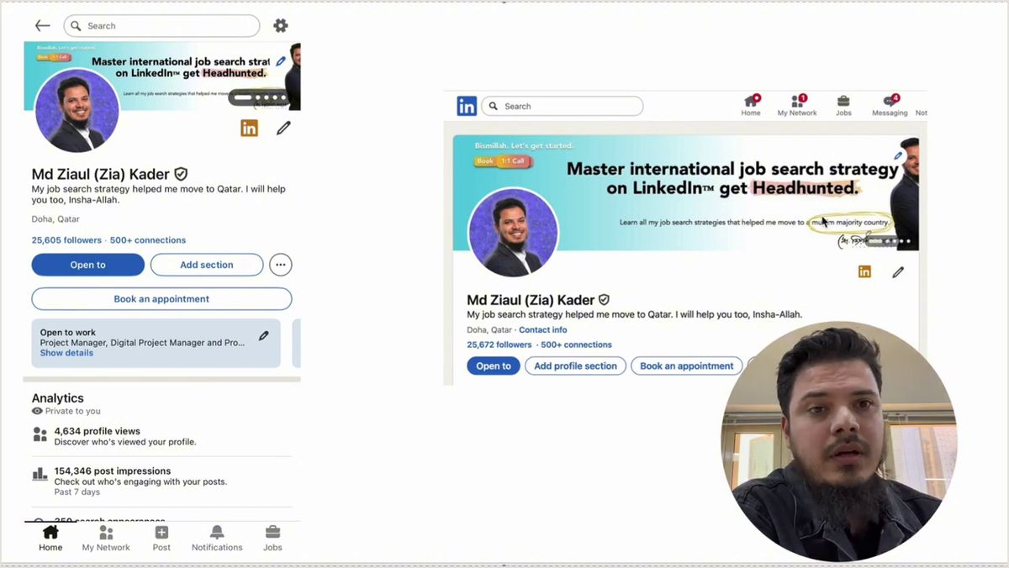
Figure 3.1: The 5 Core Pillars of LinkedIn Banner Architecture & Visual Anatomy (Lecture Reference: 00:50)
Figure 3.1 Breakdown: The 5 Strategic Pillars of Banner Architecture
1. Target Audience Identification (Who You Help): The banner must instantly telegraph the exact enterprise market you serve (e.g., Enterprise FinTech, Sovereign Logistics, Cloud AI).
2. Core Value Proposition (The Transformation): The specific financial, operational, or technical outcome you deliver (e.g., 'Scaling B2B Revenue', 'Cloud Migration & Cost Optimization').
3. Credibility Metrics & Social Proof: Tangible numbers validating your past performance (e.g., '$10M+ ARR Scaled', '50+ Enterprise Deployments', 'Fortune 500 Experience').
4. Authority Badges & Brand Logos: Clean monochrome client or employer logos and verified cloud/industry certification badges.
5. Clear Inbound Call-to-Action (CTA): Guiding the profile visitor to the exact next action: e.g., 'Inquire for Enterprise Advisory', 'DM for Strategy Call'.

Video Reference & Live Demo: [Watch Lecture Segment: 00:50 — Banner Architecture]
3.2 Desktop vs. Mobile Rendering: The Mobile Safe Zone Architecture
The official dimensions for a LinkedIn background banner are 1584 pixels wide by 396 pixels tall (a 4:1 aspect ratio). However, here lies the single most dangerous technical pitfall for amateur designers: Today, over 65% of international corporate recruiters, headhunters, and executive hiring managers view profiles exclusively via mobile devices (iOS/Android).
There is a radical discrepancy between how LinkedIn renders your profile on a desktop monitor versus a mobile smartphone: On desktop, your circular profile headshot sits neatly in the lower-left corner, covering less than 10% of the banner canvas. On mobile, however, the headshot moves upward toward the center-left and swells in relative size, completely eclipsing nearly 35% of the lower-left quadrant! Furthermore, LinkedIn crops roughly 100 to 150 pixels from both the left and right outer margins on smaller mobile screens. If you place critical text or logos on the left or far edges, they will be entirely butchered on mobile devices.
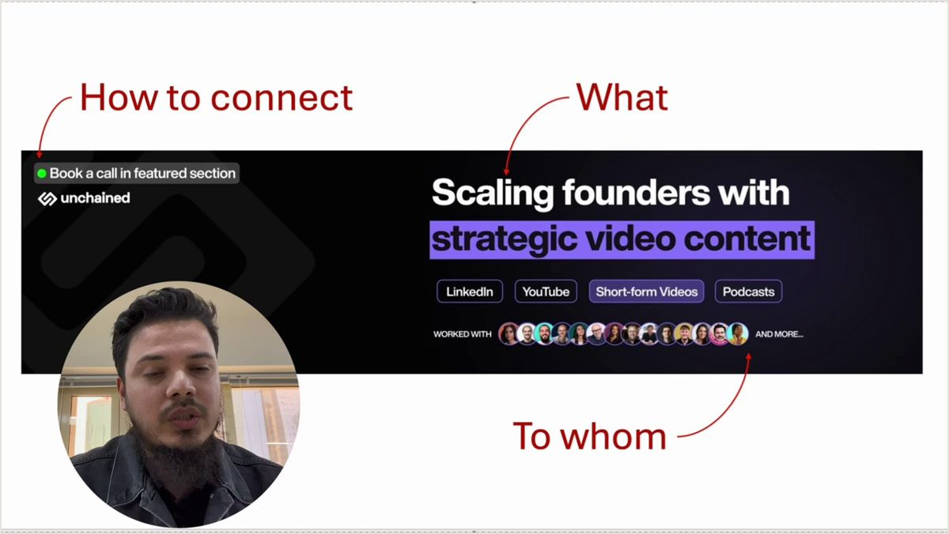
Figure 3.2: Desktop vs. Mobile Layout Discrepancies & Profile Banner Safe-Zone Rules (Lecture Reference: 01:30)
Figure 3.2 Breakdown: The Mobile Safe Zone Engineering Rules
1. Left-Side Zero-Text Buffer: Keep the first 450 pixels of the left-hand banner canvas completely clear of critical copy or logos. This area is obliterated by your profile headshot on mobile.
2. Centralized Right-Sided Copy (The 60% Rule): Concentrate your core value proposition and sub-headline in the right 60% of the canvas.
3. Top and Bottom Margin Padding: Maintain a minimum 50-pixel safety margin from both top and bottom edges to prevent awkward clipping across varying smartphone display ratios.

3.3 Live Candidate Profile Audits & Layout Safe-Zone Case Studies
In my workshops, rather than engaging in theoretical discussions, I project live candidate profiles on screen to dissect common layout mistakes and demonstrate real-time architectural transformations:
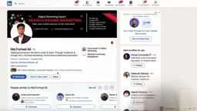
Figure 3.3: Case Study: Live Candidate Profile Audit — Safe-Zone Violations & Desktop Layout Misalignments (Lecture Reference: 07:10)
Figure 3.3 Breakdown: Audit of Farhad Ali's Profile Layout
1. Safe-Zone Occlusion: The candidate positioned key service offerings on the left side, resulting in his profile picture obscuring vital keywords on mobile.
2. Color Contrast Deficiency: Low-contrast typography against busy background textures caused severe eye fatigue for fast-scanning recruiters.
3. Immediate Remedy: Migrate typography strictly to the right safe-zone; apply deep navy background with crisp white and gold typography.

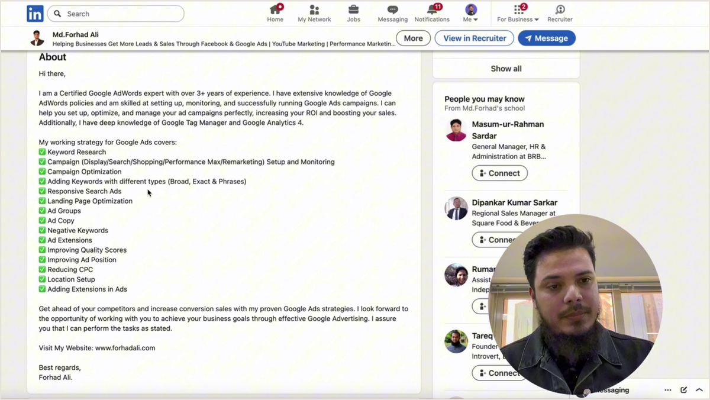
Figure 3.4: Case Study: Live Profile Audit — Value Proposition & Sub-Headline Typography Contrast (Lecture Reference: 10:00)
Figure 3.4 Breakdown: Headline vs. About Section Typography Alignment
1. The 2-Tier Typography Hierarchy: Use a bold primary header font (e.g., Inter, Montserrat, Poppins) paired with a clean sans-serif sub-text (e.g., Calibri, Roboto).
2. Message Density: Limit banner text to a single dominant value statement (8-12 words) plus a supporting 1-line transformation sub-header.

3.4 Social Proof & Authority Badging
Actions speak louder than assertions. When a candidate writes in text, "I am an exceptional engineering leader", it carries zero persuasive weight. However, when the top corner of their banner cleanly showcases recognizable client logos, accredited industry certifications, or verified operational metrics, the viewer's subconscious mind immediately grants institutional trust.
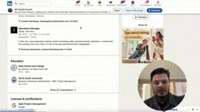
Figure 3.5: Case Study: Transforming Profile Credentials & Certifications into Banner Social Proof (Lecture Reference: 17:00)
Figure 3.5 Breakdown: Audit of Tamzid Hossain's Credentials
1. Credential Extraction: Extract verified certifications (e.g., Google Agile Project Management, AWS, PMP) buried in profile sections and elevate them to visual badges on the banner.
2. Monochrome Brand Strip: Present company or institutional logos in clean monochrome (grayscale or white) to preserve an executive aesthetic without visual clutter.

3.5 Conversion-Driven Inbound Call-to-Action (CTA) Mechanics
What exact action should a visitor take after reviewing your banner? Should they scroll passively, or initiate contact? A premium banner must feature an explicit, low-friction Call-to-Action guiding the visitor toward engagement.

Figure 3.6: Case Study: Integrating Clear Inbound Calls-to-Action (CTA) on Profile Assets (Lecture Reference: 25:30)
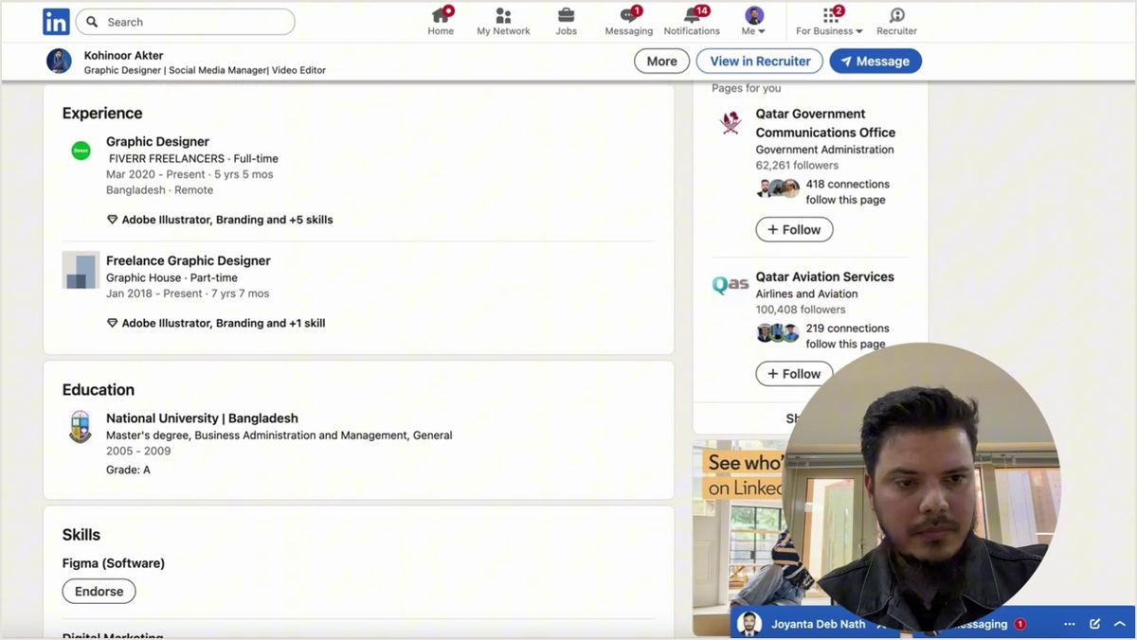
Figure 3.7: Case Study: Comprehensive Profile Alignment & Final First-Impression Architecture (Lecture Reference: 37:20)
Figures 3.6 & 3.7 Breakdown: High-Converting CTA Archetypes
For Corporate Candidates: "Open for Executive Opportunities in Doha / Dubai / Remote | DM for Inquiries"
For B2B Consultants: "Helping FinTechs Scale to $10M ARR | Book a 15-Min Strategy Session in Featured Link"
For Emerging Tech Specialists: "Cloud Infrastructure & Kubernetes Architecture | GitHub & Case Studies Below"

3.6 Professional Headshot Psychology & Visual Integrity
Directly beneath the banner sits your profile photograph—the final seal of personal credibility. In international corporate standards, modesty, gravity, and approachable confidence are paramount. Adhere to these non-negotiable principles:
• High-Resolution Bust Crop (Chest to Head): A crisp, high-definition portrait focused squarely from the mid-chest upward. Selfies, wedding photos with cropped-out companions, or vacation snapshots are entirely unacceptable in corporate executive circles.
• Direct Eye Contact: Look straight down the camera lens. Direct eye contact fosters immediate psychological trust. Avoid sunglasses or side-glances.
• Neutral, Non-Distracting Background: Use a clean studio backdrop (slate gray, soft off-white, or tastefully blurred corporate office interior) that keeps total visual focus on your face.
3.7 Strategic Playbook: 4 Candidate Personas
STRATEGIC PLAYBOOK: 4 CANDIDATE PERSONAS
1. Fresh Graduate / Early Career:
• Banner Focus: Highlighting specialized academic capstones, open-source repositories, and recognized cloud certifications.
• Value Copy: "Building High-Throughput Cloud Applications with Python, Docker & PostgreSQL".
2. Western Professional Relocating to GCC:
• Banner Focus: Emphasizing Western enterprise transformation experience, multi-regional leadership, and readiness for Gulf sovereign mandates.
• Value Copy: "Enterprise Digital Transformation & Strategic Operations | US & European Pedigree | Focused on GCC Expansion".
3. Developing World Professional Seeking International Mobility:
• Banner Focus: Leading with undeniable, quantifiable business impact and international technology standards to overcome regional bias.
• Value Copy: "FinTech Backend Architect | Scaling Payment Systems to 2M+ Daily Transactions | 99.99% Availability".
4. Independent Consultant / B2B Retainer Specialist:
• Banner Focus: Clear, measurable business transformation equation and direct inbound lead magnets.
• Value Copy: "Adding $2M-$5M in Enterprise ARR via Inbound B2B Demand Pipelines | Inquire for Advisory Retainers".

Chapter 4: The High-Converting Headline Formula & Value Proposition (The Headline Architecture)
— Engineering the 220-Character Ad Copy That Dominates Algorithmic Search and Compels Recruiter Clicks —
4.1 The Feed Psychology: Your Headline Is Your Mobile Billboard
If your background banner is your billboard, your LinkedIn headline is your ubiquitous digital business card. Every single action you take across the platform—publishing a post, commenting on an industry leader's analysis, sending a connection request, or appearing in search results—displays only two pieces of information: your profile photo and the first 40 to 60 characters of your headline!
Consider what happens when a top executive or headhunter scrolls through their feed: They see hundreds of comments. The vast majority of professionals display completely lifeless, default titles: "Software Engineer at ABC Company", "Project Manager looking for new opportunities", or "Marketing Executive". These generic lines generate zero cognitive curiosity. They blend into the digital wallpaper.
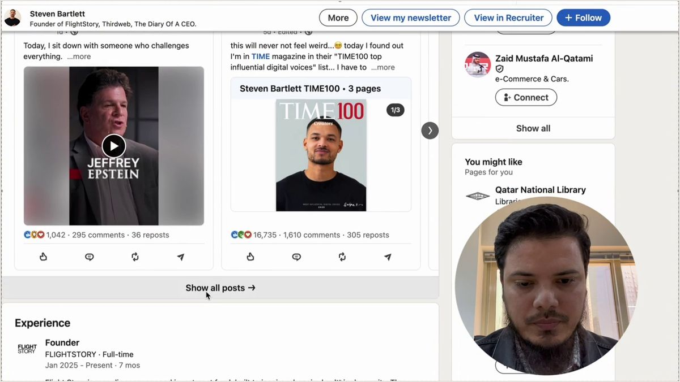
Figure 4.1: Viral Comment Section Leverage & Feed Headline Visibility: Steven Bartlett Case Study (Lecture Reference: 00:50)
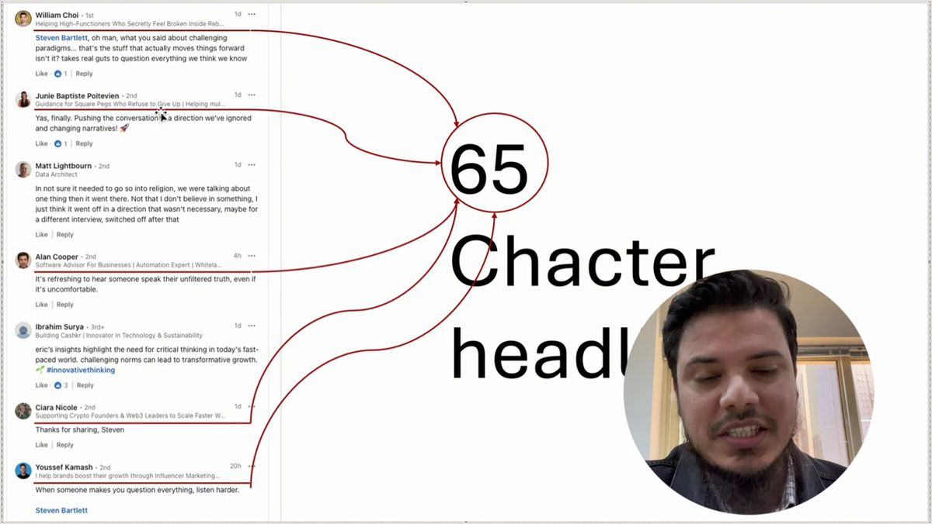
Figure 4.2: Feed Impression Dynamics: How a Magnetic Headline Forces High-Value Profile Clicks (Lecture Reference: 01:50)
Figures 4.1 & 4.2 Breakdown: The 3 Feed Impression Dynamics
1. The 40-Character Front-Load Rule: Only the first 40 to 60 characters appear in mobile comment streams. Your primary corporate title and core value must sit immediately at the beginning.
2. Thoughtful Commenting as Lead Generation: Leaving structured, high-value technical observations on viral industry posts turns your headline into an automated inbound traffic funnel.
3. Curiosity Conversion: When an executive reads an insightful comment and glances at an intriguing headline, they reflexively click through to your master landing page.

Video Reference & Live Demo: [Watch Lecture Segment: 00:50 — Feed Headline Visibility]
4.2 Deconstructing Md Ziaul Kader's Relocation Headline
To observe how authority, direct value, and cultural alignment merge, examine my own live LinkedIn headline that accelerated my international relocation to Qatar Insurance Group:
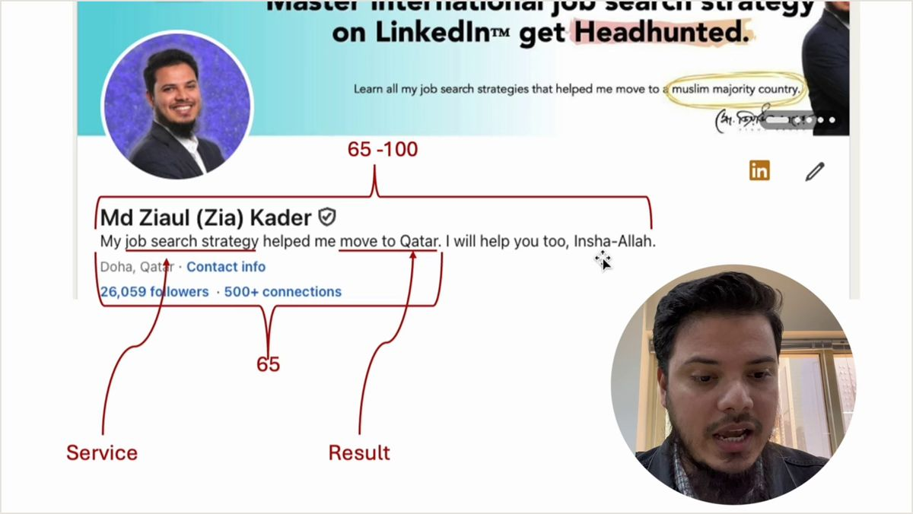
Figure 4.3: Deconstructing Md Ziaul Kader's Qatar Relocation Headline & Positioning Mechanics (Lecture Reference: 02:30)
🔍 Line-by-Line Headline Breakdown: Figure 4.3
"My job search strategy helped me move to Qatar. Let me help you optimize yours, Bismillah"
• Clause 1: Empirical Proof & Incontrovertible Authority ("My job search strategy helped me move to Qatar") — This is not empty theory. I physically executed an international corporate relocation from a developing country to the top financial conglomerate in Doha. Proof precedes persuasion.
• Clause 2: Direct Client/Stakeholder Transformation ("Let me help you optimize yours") — A direct invitation extending value, transitioning from personal accomplishment to serving others.
• Clause 3: Ethical Anchor & Cultural Integrity ("Bismillah") — In the Middle East corporate environment, an overt commitment to Islamic values, humility, and seeking lawful sustenance (Halal Rizq) creates immediate spiritual and cultural trust with executive decision-makers.

4.3 The 3-Variable Slide Formula & The 4-Part Master Headline Architecture
In my live masterclass, I teach an elemental mathematical formula consisting of 3 core variables, which then expands into our comprehensive 4-part enterprise master equation:
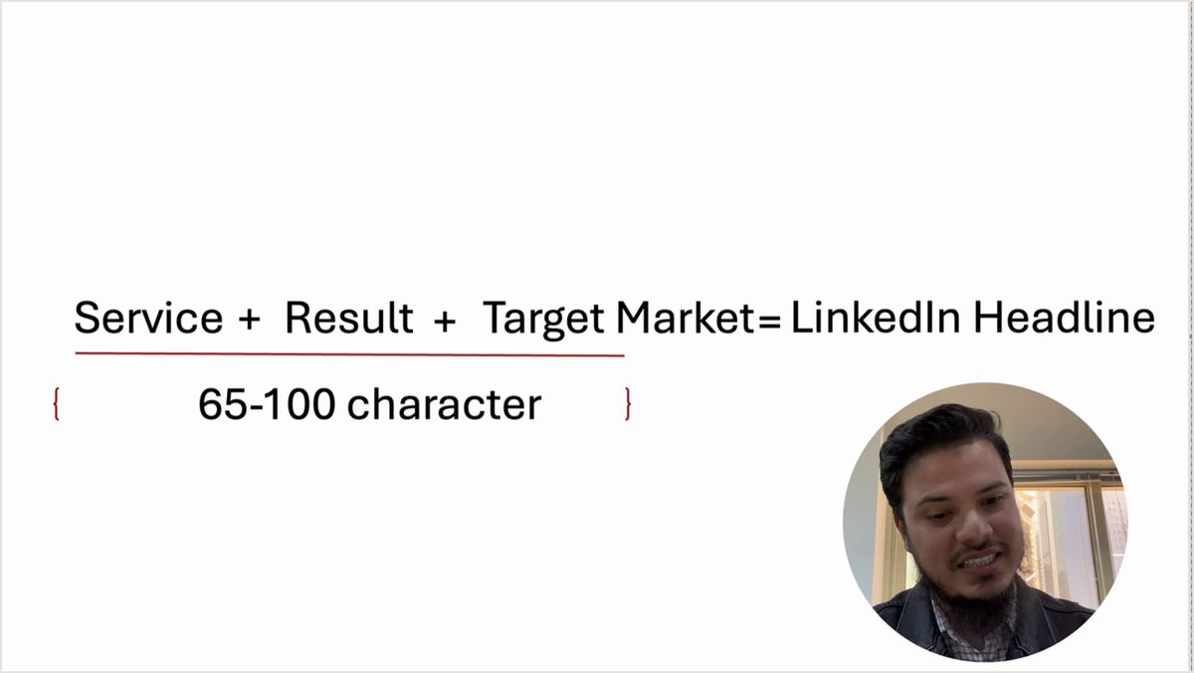
Figure 4.4: The Core 3-Variable Formula Slide (Service + Result + Target Market) & Enterprise Extension (Lecture Reference: 05:30)
Figure 4.4 Breakdown: The Master Headline Equation
• The Core 3-Variable Equation (Slide): Service + Result + Target Market = LinkedIn Headline { 65-100 characters }
• The 4-Part Enterprise Master Architecture: [Primary Target Title] | Helping [Target Audience / Industry] achieve [Measurable Outcome] | [Proof Metric / Credibility Anchor] | [Top 3-4 Core Tech Stack / Skills]
Component 1: Target Title: Exact standardized international designation (e.g., 'Lead Cloud Solutions Architect').
Component 2: Value Transformation: The specific business problem solved (e.g., 'Slashing AWS Cloud Infrastructure Costs by 35%').
Component 3: Proof Anchor: Verified milestone (e.g., 'Managed $40M Annual Enterprise Cloud Spend | Ex-FinTech').
Component 4: Core Tech Keywords: Exact skill tokens for RPS search algorithms (e.g., 'Kubernetes • Terraform • AWS • CI/CD').

4.4 Algorithmic Search Indexing Proof & Character Length Science
LinkedIn permits up to 220 characters in the headline field. However, character density must be strategically apportioned: The first 65 to 100 characters must form a grammatically coherent, punchy value statement for human readers on mobile. The remaining 120 characters should be dedicated to high-intent hard-skill keywords separated by clean vertical pipes (|) or bullets (•).
Figure 4.5 Breakdown: Boolean Search Keywords Ranked by Recruiter Weighting
Tier 1 (Highest Weight): Exact Match Title in Headline + Current Experience Title.
Tier 2 (Secondary Weight): Hard Technical Skills and Industry Verticals in Headline.
Tier 3 (Contextual Weight): Broad methodology tags (e.g., 'Agile', 'Scrum', 'Leadership') which should never displace core technical keywords.

4.5 Strategic Playbook: 4 Ready-to-Deploy Headline Blueprints
STRATEGIC PLAYBOOK: 4 CANDIDATE PERSONAS
1. Software Engineer / Cloud Architect (Senior Backend):
Lead Backend Engineer | Scaling FinTech Microservices & Payment Gateways to 5M+ Daily Transactions | Ex-QIC | Go • Java • Kubernetes • AWS • High-Concurrency Architecture
2. Western Professional Relocating to GCC (Enterprise Operations Director):
Director of Strategic Operations | Optimizing Cross-Border Supply Chains & Slashing Opex by $12M | US Fortune 500 Pedigree | Open for Doha / Dubai / Riyadh Executive Roles
3. Developing World Professional Seeking Expat Sponsorship (Product Lead):
Senior Product Manager [FinTech & Mobility] | Driving $35M GMV Growth via Data-Driven Conversion Funnels | Certified Scrum PO | SQL • Amplitude • User Retention
4. Independent B2B Consultant / Fractional Executive:
Fractional Chief Revenue Officer | Installing Automated Inbound Pipelines for B2B SaaS ($2M-$10M ARR) | $24M Pipeline Generated | HubSpot • Clay • Outbound Architecture

4.6 The 10 Fatal Headline Sins to Eradicate
Audit your headline immediately against these destructive practices:
The 10 Headline Sins Audit
1. The Desperation Badge: Writing 'Actively Seeking New Roles', 'Unemployed', or 'Open to Opportunities'. (Eradicate immediately).
2. The Single Title Dead-End: Writing simply 'Software Engineer' with zero context or vertical specialization.
3. Generic Corporate Cliches: Including words like 'Hardworking', 'Enthusiastic', 'Passionate Learner', or 'Guru'.
4. Localized Company Dependence: Relying on unknown local employer names without explaining their industry relevance.
5. Over-Indexing Buzzwords: Filling 220 characters with a comma-separated list of 30 tools with no coherent value proposition.

Chapter 5: The Enterprise About/Summary Funnel (The About Funnel)
— Architecting the 2,600-Character Executive Pitch That Converts Curious Visitors into Inbound Interviews —
5.1 The 'See More' Psychology: Writing the Irresistible 3-Line Hook
When an executive headhunter or corporate decision-maker clicks on your profile, your banner and headline have done their job: they have created sufficient visual intrigue to earn your profile a visit. Now, the visitor scrolls to your 'About' section. And here lies the critical conversion threshold of the entire digital funnel.
On both desktop and mobile screens, LinkedIn truncates your About section after exactly three lines of text (approximately 150 to 180 characters), followed by a small, unassuming blue hyperlink: '...see more'. If those first three lines read like a dry resume excerpt—e.g., "I am a seasoned professional with 8 years of experience in software development and marketing..."—the recruiter's finger will never click '...see more'. They will bounce off your profile and move to the next candidate.
Your opening three lines must function as a high-stakes journalistic hook. They must articulate a contrarian insight, state an audacious enterprise transformation, or frame your personal philosophy with compelling clarity. You must compel the reader to click '...see more' as an involuntary reflex.
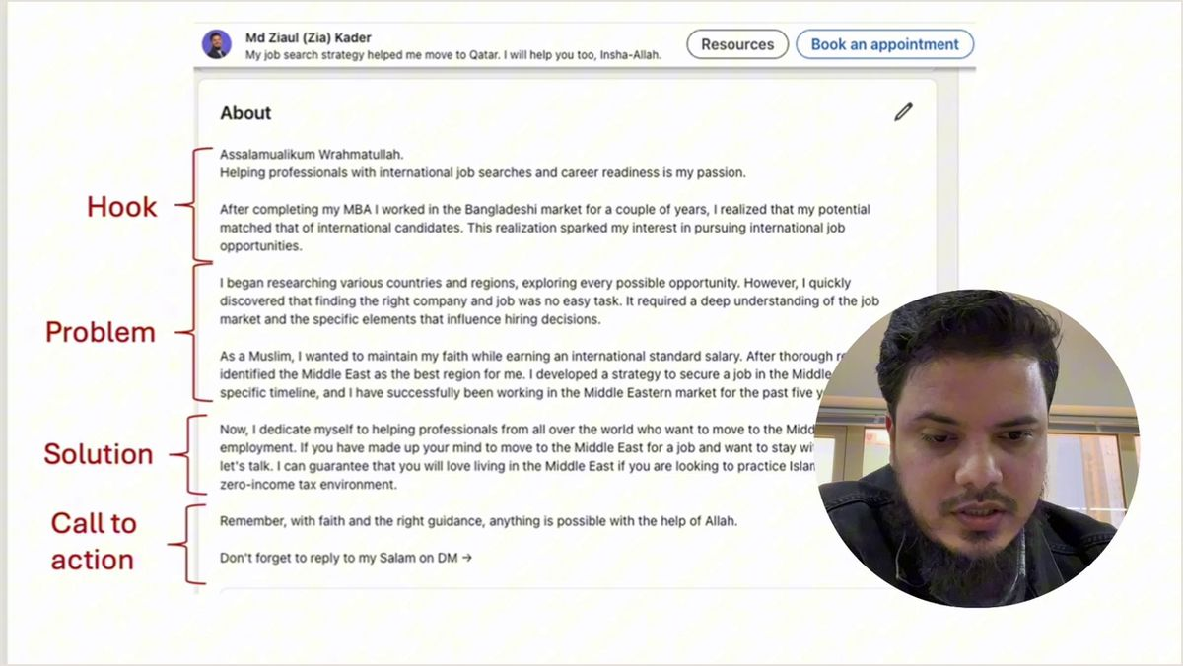
Figure 5.1: The 4-Stage Executive About Architecture: Hook, Problem, Solution & Call to Action (Lecture Reference: 07:00)
Figure 5.1 Breakdown: The 4 Structural Anchors of the About Funnel
1. The Pattern-Interrupt Hook (Lines 1-3): A bold opening thesis that provokes curiosity and demands the '...see more' click.
2. Core Problem & Niche Positioning (Lines 4-10): Clearly defining the specific enterprise friction points, inefficiencies, or growth bottlenecks you resolve.
3. Verified Case Study Evidence (Lines 11-20): Quantifiable metrics, dollar values, and percentage gains demonstrating your proven solutions.
4. Algorithmic Keywords & Direct CTA (Final Lines): Comprehensive technical skill index paired with a clear, low-friction invitation to connect.

Video Reference & Live Demo: [Watch Lecture Segment: 07:00 — The About Funnel Architecture]
5.2 The 5-Part Storytelling Framework & Live Portfolio Audits
A truly world-class executive summary does not read like a list of job descriptions. It weaves technical rigor with an authentic hero's journey. Examine the 5-part storytelling architecture:
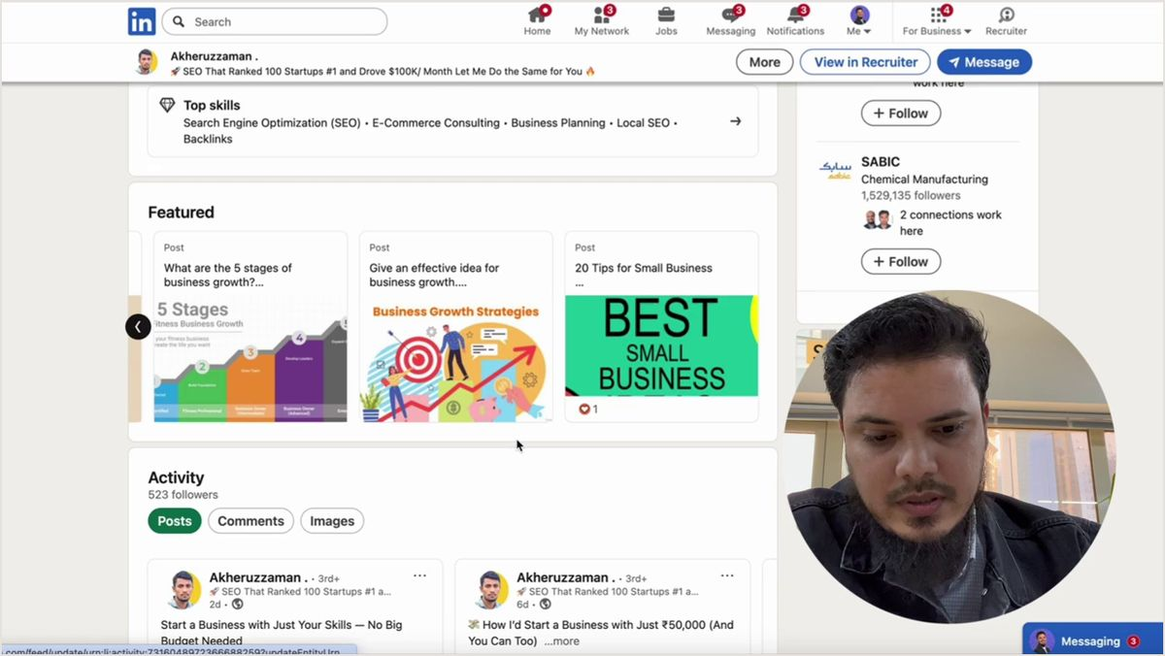
Figure 5.2: Case Study: Auditing Featured Storytelling Assets & Candidate Proof of Work (Lecture Reference: 13:30)
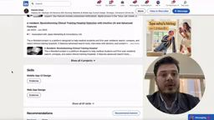
Figure 5.3: Case Study: Converting Raw Academic Projects into High-Value Enterprise Summaries (Lecture Reference: 20:30)
Figures 5.2 & 5.3 Breakdown: The 5-Part Enterprise Summary Framework
Part 1: The Hook & Core Philosophy: Why you do what you do. Your foundational conviction regarding your industry's future.
Part 2: Domain Boundary & Target Audience: Exactly whose problems you solve (e.g., 'I partner with Gulf enterprise banks scaling digital transformation').
Part 3: Quantifiable Track Record (3-5 Bullets): Specific operational milestones formatted in high-contrast bullet points.
Part 4: Methodologies, Tools & Core Competencies: A structured keyword cluster for recruiter search indexing.
Part 5: Direct Inbound Call-to-Action: Professional email and invitation for advisory conversations or executive interviews.

5.3 Measurable Case Studies & Percentile Proof Engineering
Vague assertions destroy credibility. When an applicant writes, "Successfully optimized team performance and reduced costs," an international executive recruiter learns nothing. Did you save $500 or $5,000,000? Every single achievement bullet in your About section must be constructed using the 4-part Case Study Formula:
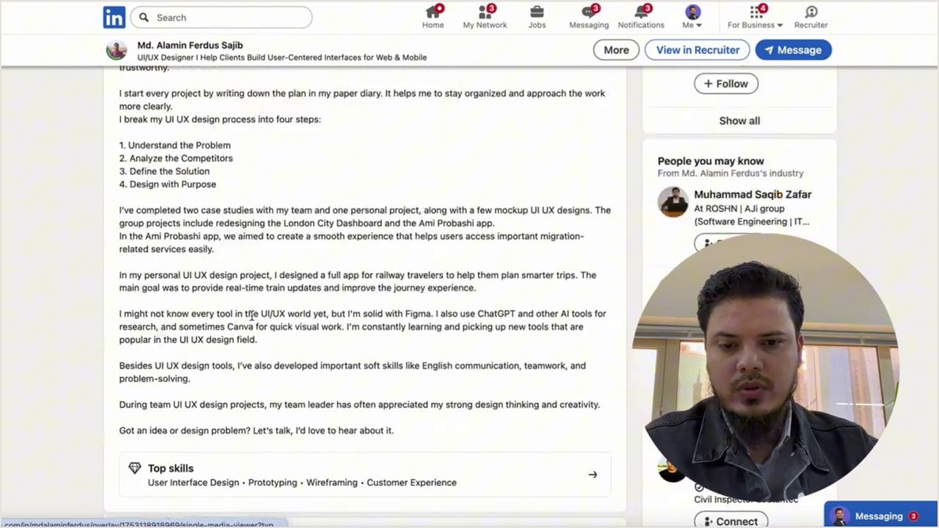
Figure 5.4: Case Study: Auditing Real-World Metric Proof & Quantitative Impact Portfolios (Lecture Reference: 28:40)
Figure 5.4 Breakdown: The 4 Elements of an Irresistible Case Study Bullet
1. Context (The Enterprise Friction): Identify the baseline bottleneck (e.g., 'Customer onboarding churn had escalated to 14% monthly due to manual verification delays').
2. Action (Your Proprietary Intervention): Specify the exact architecture or process engineered (e.g., 'Architected an automated multi-step in-app onboarding engine with automated KYC').
3. Metric (The Measurable Delta): Quantify the outcome (e.g., 'Reduced onboarding latency by 65% and crushed monthly churn to 3.8%').
4. Business ROI (The Commercial Impact): Tie the metric to enterprise balance sheet value (e.g., 'Unlocking $1.8M in retained annual recurring revenue within 9 months').

5.4 Keyword SEO & Direct Inbound Contact Funnel
The conclusion of your About section must accomplish two vital tasks: First, it must provide a clean, exhaustive keyword cluster indexing every technical tool, framework, and certification relevant to your vertical. Second, it must remove all friction for recruiters who wish to contact you outside LinkedIn's native messaging channels.
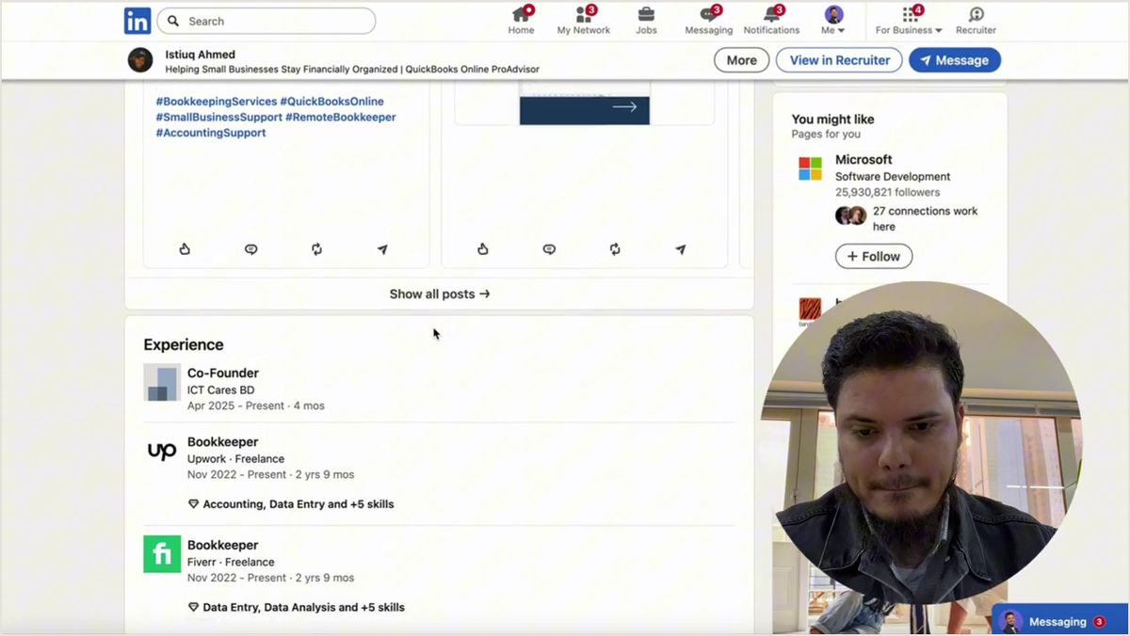
Figure 5.5: Case Study: Technical Keyword Indexing & Inbound Contact Placement (Lecture Reference: 35:40)

Figure 5.6: Case Study: Eliminating Grammatical Flaws & Non-Standard English Drafts (Lecture Reference: 43:30)
Examine Figure 5.6 carefully. In this live audit, candidate Hossain Ahmad had written a summary plagued by broken English, misspelled words ('Gratuated', 'Readymade garmens'), and casual syntax. An international recruiter evaluating candidates for a $100,000+ expat package will immediately disqualify any profile with rudimentary grammatical errors. Your English copy must exude executive polish, structural sophistication, and total grammatical precision.
5.5 Strategic Playbook: 4 Ready-to-Deploy About Templates
STRATEGIC PLAYBOOK: 4 CANDIDATE PERSONAS
1. Early Career / Junior Cloud Engineer:
While most junior engineers focus on passing basic syntax tests, I spent my formative years obsessing over distributed database bottlenecks and microservice resilience.
I engineer fault-tolerant backend cloud architectures utilizing Go, Python, and PostgreSQL. Over the past 2 years, I have architected real-time WebSocket communication pipelines supporting 50,000 concurrent sessions, while automating CI/CD workflows that reduced deployment latency from 45 minutes to under 3 minutes.
Core Competencies: Go • Python • Docker • Kubernetes • PostgreSQL • Redis • Microservices • AWS • CI/CD.
Looking for high-impact engineering talent? Connect with me directly at: myemail@domain.com
2. Western Professional Relocating to GCC (Enterprise Solutions Architect):
Digital transformation without rigorous cost control is fiscal vanity; enterprise cloud migration without governance is an audit disaster.
Over the past 9 years across Tier-1 US and European enterprises, I have orchestrated large-scale digital modernization programs, modernizing legacy ERP architectures and migrating mission-critical workloads to cloud infrastructure across multi-region environments.
Selected Enterprise Impact:
• Slashing Cloud Opex: Architected automated FinOps governance across $18M annual AWS spend, recovering $4.2M in annual recurring waste.
• Sovereign Compliance: Directed end-to-end data localization adhering to European GDPR and Gulf banking compliance standards (QCB/SAMA).
• Team Leadership: Directed cross-functional engineering squads of 35+ engineers across three time zones.
Executive Focus: Open for confidential discussions regarding senior advisory or enterprise architecture mandates across Qatar, UAE, and Saudi Arabia: architect@domain.com
3. Developing World Professional Seeking Expat Sponsorship (Senior Product Lead):
A software feature that users cannot intuitively master within 10 seconds is a customer support ticket waiting to happen.
Over the past 7 years directing product innovation across Southeast Asia and the Middle East, I have specialized in turning fragmented digital user experiences into high-velocity, revenue-generating transaction funnels.
Milestone Highlights:
• Redesigned mobile checkout architecture for a 2.5M-user consumer platform, lifting conversion velocity by 28.4% within 90 days.
• Spearheaded cross-border B2B digital wallet launch across 4 regional markets, capturing $22M GMV in year one.
• Built and trained product design systems utilized across 12 distributed engineering squads.
Core Stack: Product Strategy • FinTech • Mobile Payments • Amplitude • SQL • A/B Testing • Agile Leadership.
Relocation Ready: Available for international on-site sponsorship (Qatar / UAE / Europe): productlead@domain.com
4. Independent B2B Demand Generation Consultant:
Publishing content on LinkedIn without an engineered inbound capture mechanism is pouring champagne into a leaking bucket.
I partner with founders of B2B SaaS and enterprise tech firms ($1M to $10M ARR) to architect automated, predictable inbound client acquisition engines that bypass reliance on paid ads or cold outreach fatigue.
Client Milestones in 2025:
• Generated $3.4M in closed-won enterprise pipeline across 14 client campaigns.
• Delivered an average 4.6x client retainer ROI within 120 days of deployment.
System Architecture: LinkedIn Thought Leadership • Apollo.io • HubSpot • Clay.com • Account-Based Marketing.
Direct Inbound: DM with the keyword 'PIPELINE' or book a 15-minute diagnostic call via the featured link above.

Chapter 6: Experience Section Architecture & The 8 Decoded Frameworks
— Translating Regional Track Records into Global Enterprise Impact, High-Velocity Bullet Formulas & Social Proof Power-Loops —
6.1 The Experience Section: The Headhunter's Ultimate Crucible
Your visual banner arrested the recruiter's scrolling thumb, your headline positioned you as a high-value specialist, and your About narrative earned their intellectual trust. However, when a sovereign fund executive, a Gulf tech enterprise recruiter, or an international talent scout evaluates whether to sponsor your multi-thousand-dollar expat visa, fund your relocation package, or extend a high-ticket remote offer, they place one critical section under an unforgiving forensic microscope: your Experience section.
Empirical recruitment data reveals that professional talent acquisition partners spend nearly 70% of their total profile evaluation time scrutinizing job titles, employer context, institutional pedigree, and quantifiable bullet points in the Experience section. Yet, tragically, the vast majority of professionals from developing economies and even conventional Western mid-tier firms format this section as a passive laundry list of mundane responsibilities. They write entries such as: "Responsible for managing daily software development tasks", "Handled customer support inquiries", or "Assisted marketing team with campaign coordination". In the competitive global theater, passive duty descriptions do not merely fail to impress—they trigger immediate candidate rejection.
▶ Watch Lecture Breakdown: [02:40 - Qatar Corporate Ladder & Experience Strategy]
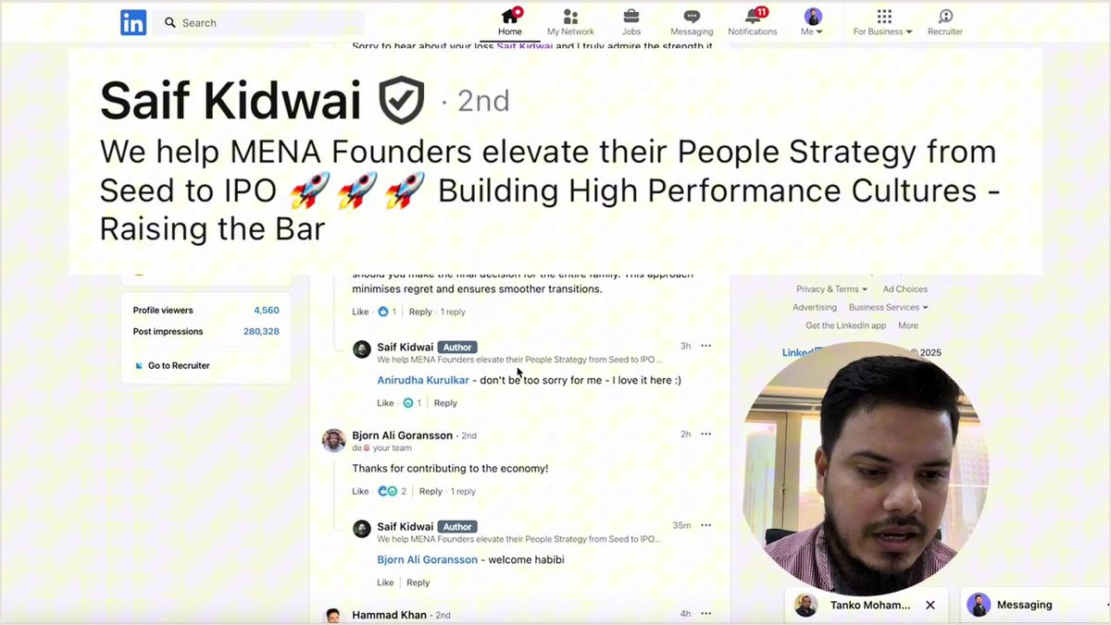
Figure 6.1: Live Architecture of the Qatar Corporate Ladder & International Career Positioning (Lecture Reference: 02:40)
Executive Screen Decode: Career Continuity & Strategic Title Progression
1. Stepwise Trajectory (Career Progression): Notice the logical escalation from regional operations to enterprise leadership: Delivery Hero (Operations) -> Truck Lagbe (Business Development) -> Snoonu Qatar (Growth Hacking) -> Qatar Insurance Group (AI Product Management). Each subsequent role represents a measurable expansion in strategic ownership, capital managed, and enterprise complexity.
2. Bridging Regional Scale into Global Terms: A recruiter in Zurich, London, or Riyadh has rarely heard of domestic champions such as 'Truck Lagbe'. Therefore, the one-line institutional framing must translate regional dominance into global business context: 'Bangladesh's premier venture-backed digital freight logistics platform'. Instantly, cognitive hesitation vanishes and institutional credibility is secured.
3. Title Consistency Across the Corporate Ladder: Titles must reflect canonical industry taxonomy. Avoid idiosyncratic internal designations; adopt standardized executive titles recognized by LinkedIn Recruiter algorithms worldwide.

6.2 Real Enterprise Deconstructions: QIC & Snoonu Qatar
To understand how international enterprise standards operate in practice, let us examine two real case studies from Qatar's top-tier corporate ecosystem: an enterprise FinTech/InsurTech powerhouse (Qatar Insurance Group - QIC) and the Middle East's hyper-growth super-app unicorn (Snoonu).
▶ Watch Masterclass: [04:20 - QIC AI Product Manager Role Deconstruction]
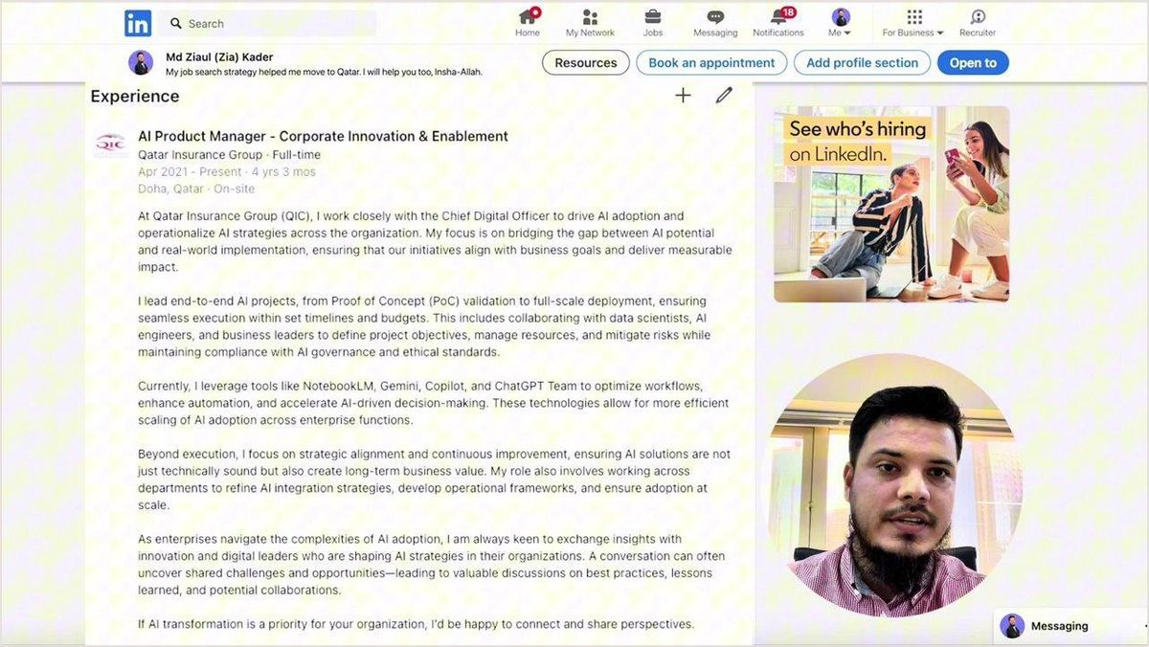
Figure 6.2: Structural Anatomy of the AI Product Manager Role at Qatar Insurance Group (QIC)
▶ Watch Growth Case Study: [08:30 - Snoonu Qatar Growth Hacker Blueprint]
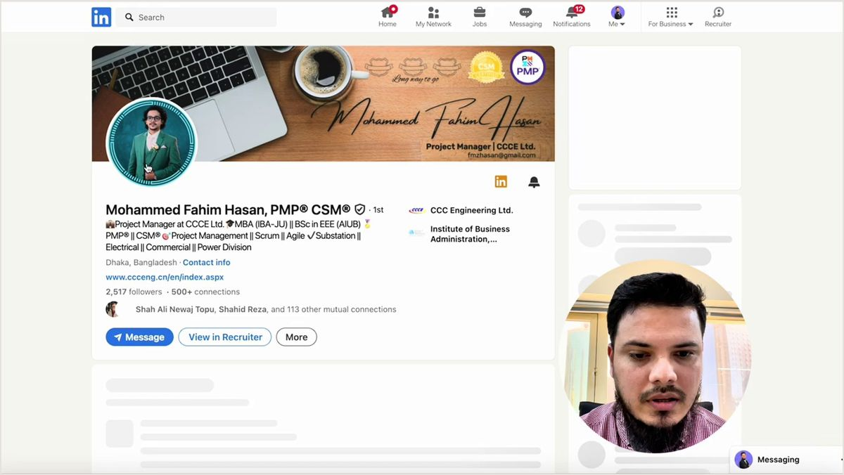
Figure 6.3: Outcome-Driven Growth Architecture at Snoonu Qatar (Lecture Reference: 08:30)
Enterprise Deconstruction: QIC & Snoonu Experience Bullet Blueprint
Institutional Context Bridge: Every role begins with a 1-sentence framing of the company's regional and market dominance: 'Qatar's leading insurance powerhouse managing multi-billion-dollar enterprise assets across the GCC and Europe.'
Algorithmic Metric Density: Bullets strictly avoid generic adjectives ('dynamic', 'hardworking') and lead with quantifiable commercial impact: 'Architected automated AI claims intake pipeline, slashing adjudication cycle times by 64% and processing $42M in annualized transactional volume.'
Cross-Border Stakeholder Orchestration: Highlighting multi-regional leadership: 'Spearheaded agile squads comprising 24 engineers and data scientists across Doha, Dubai, and distributed European engineering hubs.'

6.3 Bridging Emerging-Market Experience to Global Standards: Truck Lagbe & Delivery Hero
A universal obstacle voiced by ambitious professionals in developing nations is: "I have only worked for domestic companies in Dhaka, Lagos, or Lahore. Why would an international recruiter in London, Dubai, or Singapore shortlist me over local applicants?" The reality is transformative: global enterprises do not penalize emerging-market backgrounds; they penalize provincial communication. When you translate localized responsibilities into canonical international enterprise metrics, your emerging-market experience transforms from a perceived liability into an undeniable asset showcasing resilience, frugality, and operational mastery in hyper-growth conditions.
▶ Watch Lecture: [12:20 - Truck Lagbe Global Positioning]

Figure 6.4: Positioning Emerging-Market Domestic Tech Champions for Global Recruiters (Truck Lagbe)
▶ Watch Corporate Continuity: [14:40 - Delivery Hero Operational Scale]
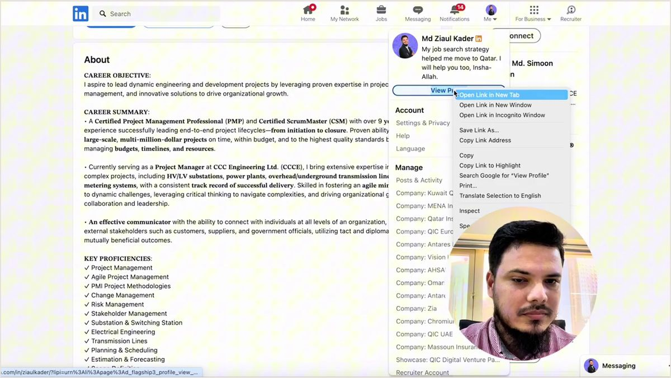
Figure 6.5: Delivery Hero Operations Leadership & Career Continuity Across Scale Transitions
6.4 The 8 Decoded Bullet Point Frameworks
In the international marketplace, every bullet point in your Experience section must function as a self-contained narrative of enterprise victory. To eliminate ambiguity and guarantee world-class linguistic impact, master these 8 battle-tested executive frameworks:
Framework 1: The Classic STAR Methodology (Situation, Task, Action, Result)
Structure: [High-stakes operational friction] -> [Executive mandate] -> [Engineered solution] -> [Measurable business triumph].
Executive Example: Faced with legacy infrastructure outages during regional flash-sales, re-architected payment microservices with Redis clustering and event-driven Kafka queues, achieving 99.99% uptime and zero transaction drops across $14M in holiday GMV.
Framework 2: The Action-Driven CAR Formula (Challenge, Action, Result)
Structure: [Critical enterprise challenge] -> [Strategic intervention] -> [Commercial or technical outcome].
Executive Example: Confronted with 34% user churn on mobile digital wallet onboarding, redesigned biometric KYC verification flows and implemented push notification triggers, retaining 140,000+ monthly active users within 180 days.
Framework 3: The Google XYZ Formula
Structure: Accomplished [X], as measured by [Y], by doing [Z].
Executive Example: Accelerated enterprise feature delivery velocity by 42% (measured by sprint burndown and cycle time) by instituting trunk-based development, automated Docker containerization, and automated regression testing.
Framework 4: Cost & Waste Optimization (Capital Efficiency)
Structure: Reduced [process waste, operational expenditure, or infrastructure costs by X%] through [automation, re-engineering, or architectural audit Z].
Executive Example: Reduced AWS cloud infrastructure burn by $195,000 annually by automating Kubernetes pod auto-scaling, eliminating orphaned EBS volumes, and migrating non-critical workloads to ARM-based Graviton instances.
Framework 5: Commercial Revenue & GMV Expansion
Structure: Drove [revenue or GMV growth by $X or Y%] by conceptualizing, piloting, and rolling out [high-impact commercial product Z].
Executive Example: Generated $4.6M in net new annualized recurring revenue (ARR) across the GCC region by spearheading the end-to-end launch of our B2B embedded insurance API for banking partners.
Framework 6: Cross-Functional Leadership & Global Team Orchestration
Structure: Orchestrated [X distributed team members across Y time zones] to achieve [critical strategic objective Z ahead of schedule].
Executive Example: Directed and aligned 32 cross-functional professionals (software engineers, UX researchers, compliance officers) across 4 time zones, delivering enterprise ERP cloud migration 3 weeks ahead of deadline and 8% under budget.
Framework 7: Regulatory Compliance, Security & Sovereign Governance
Structure: Enforced [international regulatory framework Z] to guarantee [100% audit compliance, zero security breaches, and institutional licensing].
Executive Example: Spearheaded end-to-end data governance protocols under Qatar Central Bank (QCB), GDPR, and ISO 27001 standards, securing formal financial regulatory approval for AI-underwritten micro-lending products.
Framework 8: Zero-to-One Innovation (0-to-1 Product Launch)
Structure: Built and launched [completely new proprietary system Z from scratch] within [timeframe], scaling to [commercial traction and user volume X].
Executive Example: Engineered company's first proprietary AI claims intake engine from zero to production in 14 weeks, automating 72% of Tier-1 motor claims and serving 480,000 policyholders across the Gulf.
6.5 Media Attachments: Tangible Proof of Enterprise Mastery
One of the most potent yet woefully underutilized capabilities on LinkedIn is the ability to attach rich media assets (slide decks, whitepapers, case study PDFs, product demo videos, press features) directly below individual employment entries. In a sea of unverified resumes, media attachments provide tangible, tamper-proof verification of your intellectual authority.
▶ Watch Lecture: [20:40 - Media Attachment Strategy & Architecture]

Figure 6.6: Embedding Rich Media Proof (Decks, Case Studies, and Architecture Whitepapers) in Experience Roles
6.6 Granular Skills Tagging: Powering the Recruiter Search Engine
LinkedIn Recruiter algorithms do not simply search the global Skills section at the bottom of your profile; they evaluate recency, duration, and contextual application. When a talent scout searches for 'Kubernetes' or 'FinTech Product Strategy', the algorithm awards exponentially higher search ranking to candidates who have explicitly tagged those competencies to their recent professional roles. Every career entry should feature up to 5 meticulously curated primary skills directly tied to verified achievements.
▶ Watch Indexing Strategy: [26:00 - Role-Specific Skills Tagging]
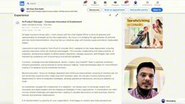
Figure 6.7: Tagging Contextual Skills Directly to Career Roles for Maximum LinkedIn Recruiter Search Indexing
6.7 Education, Global Licenses & Credential Alignment
The Education section must remain crisp, dignified, and uncluttered. For seasoned international professionals, historical secondary school qualifications are superfluous and must be eliminated. Highlight solely your bachelor's and master's degrees, alongside globally recognized professional certifications (e.g., AWS Certified Solutions Architect, PMP, Scrum Alliance, Harvard Executive Education). Aligning internationally recognized credential badges elevates institutional credibility.
▶ Watch Credential Guide: [30:50 - Education & Certification Architecture]

Figure 6.8: Streamlined Education, Professional Licensure, and Global Credential Alignment Rules
6.8 The Recommendation Power-Loop: Securing High-Ticket Social Proof
The ultimate psychological clincher in international executive recruitment is the Recommendations section. When an executive headhunter sees glowing, specific testimonials from former Vice Presidents, Chief Technology Officers, and global clients, any lingering doubt regarding your technical mastery, leadership integrity, or visa relocation risk dissolves completely.
▶ Watch Social Proof Masterclass: [34:00 - The Recommendation Power-Loop]
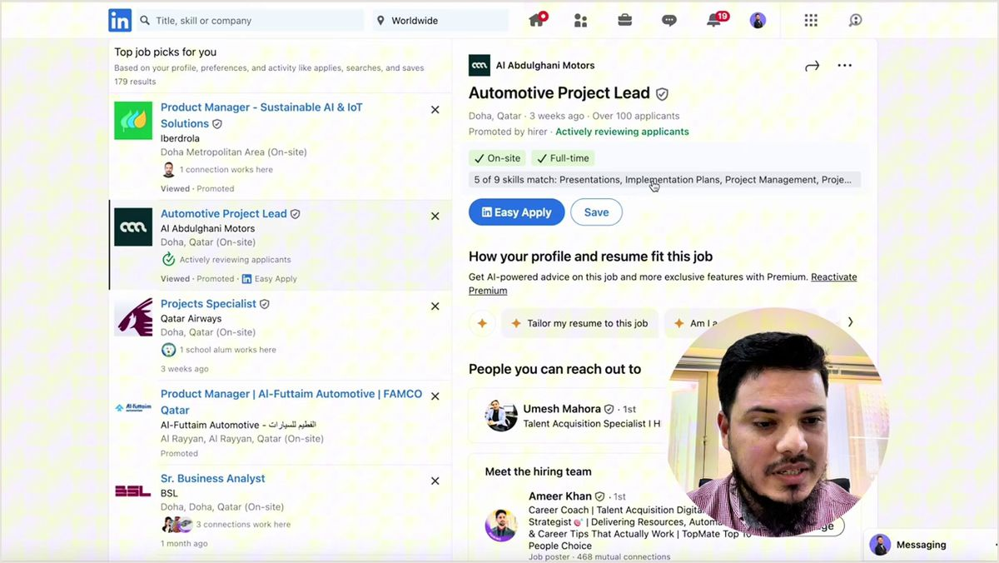
Figure 6.9: Case Study: Global Talent Markets & The Recommendation Social Proof Loop (Lecture Reference: 34:00)
Executive Recommendation Outreach Script (High Conversion)
"Hi [Name],
I hope you are doing great! I am currently updating my professional presence on LinkedIn to reflect my strategic focus on [Target Domain / GCC Enterprise Tech]. Working alongside you on [Specific Project Name] was one of the defining highlights of my career—particularly when we [Mention a Shared Victory, e.g., successfully transitioned payment rails with zero downtime].
Would you be open to writing a brief, 2-3 sentence recommendation highlighting my expertise in [Core Competency, e.g., distributed architecture and agile squad leadership] and how we delivered [Quantifiable Outcome]?
To respect your busy schedule, I have drafted three quick bullet points below that you can freely copy, adapt, or edit as you see fit. Please let me know if this works, and I would be honored to reciprocate with a recommendation for your profile as well!
Warmest regards,
[Your Name]"

6.9 Tailored Experience Models for 4 Strategic Candidate Personas
STRATEGIC PLAYBOOK: 4 CANDIDATE PERSONAS
Persona 1: Developing-Market Junior/Mid Engineer -> International Remote / Expat Relocation
FinTech Velocity Labs (Dhaka) | Senior Backend Engineer
• Developed 14 enterprise RESTful microservices (Python/FastAPI & PostgreSQL) handling 120,000 DAU.
• Slashed database query latency by 52% via Redis cluster caching and read-replica index tuning.
• Engineered automated Docker CI/CD pipelines on AWS ECS, achieving 94% test coverage.
Skills: Python, FastAPI, PostgreSQL, Redis, Docker, AWS ECS
Persona 2: Western Expat Relocating to Gulf -> Tax-Free GCC Executive Compensation
Veritas Supply Chain Solutions (London / Dubai) | Head of Operations — Middle East
• Directed multi-hub regional logistics network overseeing 480 fleet assets and 620 logistics personnel.
• Compressed cross-border GCC customs clearance lead times from 48 hours to <11 hours via automated digital manifesting.
• Reduced damaged inventory claims by 64% through IoT temperature sensors and barcode audit checkpoints.
• Relocation-ready for Doha / Riyadh with deep GCC commercial regulatory expertise.
Skills: Supply Chain Strategy, GCC Cross-Border Logistics, Fleet Operations, P&L Ownership
Persona 3: Senior Executive -> GCC Sovereign & Enterprise Board Leadership
Oryx Global Fintech Holdings (Qatar & Singapore) | Director of Product — Enterprise Payments
• Spearheaded GCC regional digital banking roadmap, scaling active monthly users from 350k to 3.2M in 24 months.
• Orchestrated 5 distributed engineering and product squads (42 engineers, designers, compliance analysts).
• Partnered with Central Bank regulators to launch contactless enterprise QR payment rails ($210M annual GMV).
Skills: Product Strategy, Cross-Functional Leadership, Central Bank Compliance, Fintech Architecture
Persona 4: Independent Remote Consultant -> High-Ticket USD Advisory Retainers
Aegis Cloud Architecture Advisory (Remote) | Principal Cloud & Security Architect
• Conducted end-to-end AWS/Azure zero-trust security audits for 24 high-growth enterprise FinTech scale-ups.
• Engineered automated Terraform infrastructure-as-code scripts, enforcing SOC 2 Type II compliance.
• Prevented high-risk credential leaks across client repositories via automated Vault secrets rotation in CI/CD.
Skills: Cloud Security, AWS IAM, SOC 2 Compliance, Terraform, Zero-Trust Architecture

Chapter 6 Executive Field Checklist: Auditing Your Experience Architecture
[ ] Has every job title been aligned with canonical LinkedIn Recruiter international search keywords?
[ ] For regional/domestic companies, is there a 1-line institutional context bridge establishing scale?
[ ] Does every bullet point lead with a decisive action verb and conclude with quantifiable commercial metrics?
[ ] Have you applied a diverse blend of the 8 Decoded Frameworks (STAR, CAR, XYZ, Cost, Revenue, Leadership)?
[ ] Are at least 2 rich media proof artifacts (PDFs, slide decks, case studies) attached to major roles?
[ ] Are up to 5 role-specific skills tagged directly to recent positions for recruiter algorithmic indexing?
[ ] Have you systematically initiated outreach for at least 3 executive recommendations?

PART III: INTERNATIONAL RESUME ARCHITECTURE, ATS CRACKING & INTERVIEW STRATEGY
Chapter 7: International Resume Architecture & ATS Cracking Blueprint
“An international resume is not an autobiographical chronicle; it is your executive boarding pass to the global interview table.”
7.1 The Fatal Resume Paradox: Why Shortlisted Candidates Get Ghosted
One of the most agonizing experiences in international career expansion occurs when a candidate executes everything correctly on LinkedIn: their optimized headline surfaces on page one of Recruiter search results, an international headhunter initiates contact, and requests their CV. But within 24 hours of emailing the document, deafening silence descends. The headhunter stops responding, the scheduled discovery call evaporates, and the opportunity vanishes. Why does this happen?
The brutal reality is the Fatal Resume Paradox: you successfully hacked the LinkedIn algorithm, but your static resume failed to satisfy modern international enterprise benchmarks. When the corporate talent lead opens a cluttered, 3-to-4 page multi-column document filled with irrelevant autobiographical trivia, zero quantifiable commercial impact, and untranslated provincial company names, they immediately conclude that the candidate lacks enterprise readiness. The candidate is unceremoniously discarded.
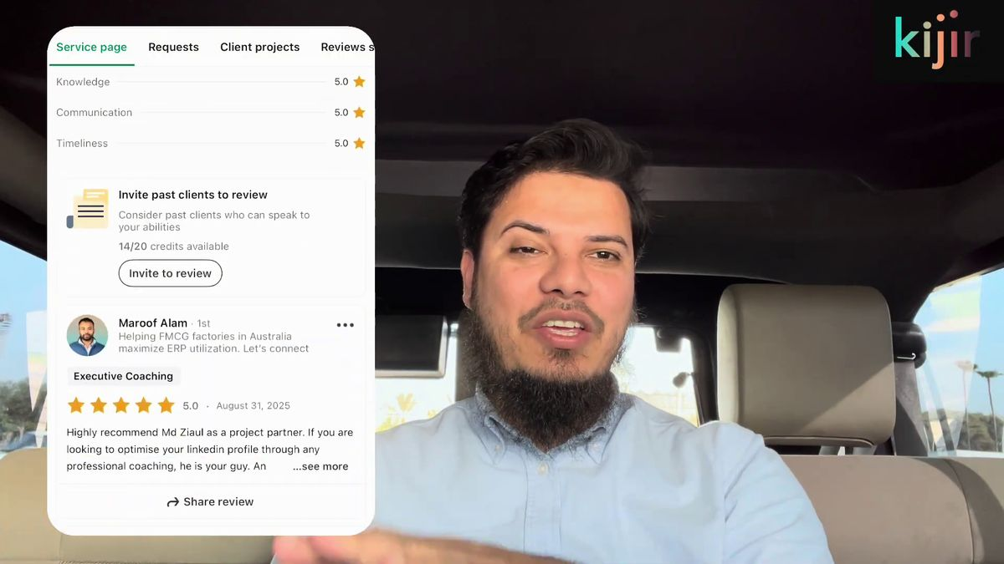
Figure 7.1: International Resume Writing & Executive Candidate Transformation Case Study (Lecture Reference: 00:22)
Figure 7.1 Foundations: The Three Pillars of International Resume Engineering
1. Recruiter Dwell-Time Psychology: An executive headhunter reviews between 50 and 150 resumes daily, dedicating an average of 15 to 20 seconds to the initial triage scan. If your commercial value proposition is not self-evident within the top third of page one, the document is rejected.
2. The Boarding Pass Concept: An airline boarding pass contains zero philosophical essays; it delivers solely critical flight data: passenger name, flight code, gate, and boarding tier. Your resume must serve as an equally streamlined, error-free interview pass.
3. Applicant Tracking System (ATS) Rigor: Global multinational employers and GCC sovereign enterprises process candidate pipelines through ATS engines (Workday, Taleo, Greenhouse, Lever). Elaborate graphics, icons, text boxes, and multi-column tables cause parsing failures, resulting in automatic robotic disqualification.

Video Reference & Lecture Timestamp: [YouTube Reference: 00:22 - The International Resume Blueprint]
7.2 Anti-Bias Resume Architecture: Ruthlessly Eliminating Personal Trivia
In developing nations and conventional regional job markets, traditional CV templates frequently resemble civil registry dossiers: they feature colored passport-sized headshots, father's name, mother's name, marital status, religious affiliation, blood group, and permanent ancestral addresses. In the modern international corporate arena—especially across the Middle East, Western Europe, and North America—submitting such a document guarantees immediate disposal.
International multinational corporations operate under strict Equal Employment Opportunity (EEO) mandates and stringent anti-discrimination governance. When an HR director or hiring manager encounters personal photographs, religious disclosures, or marital declarations, it introduces legal liability and triggers subconscious cognitive biases. To compete globally, your resume must be engineered as an objective, 100% merit-based document stripped of all personal fluff.
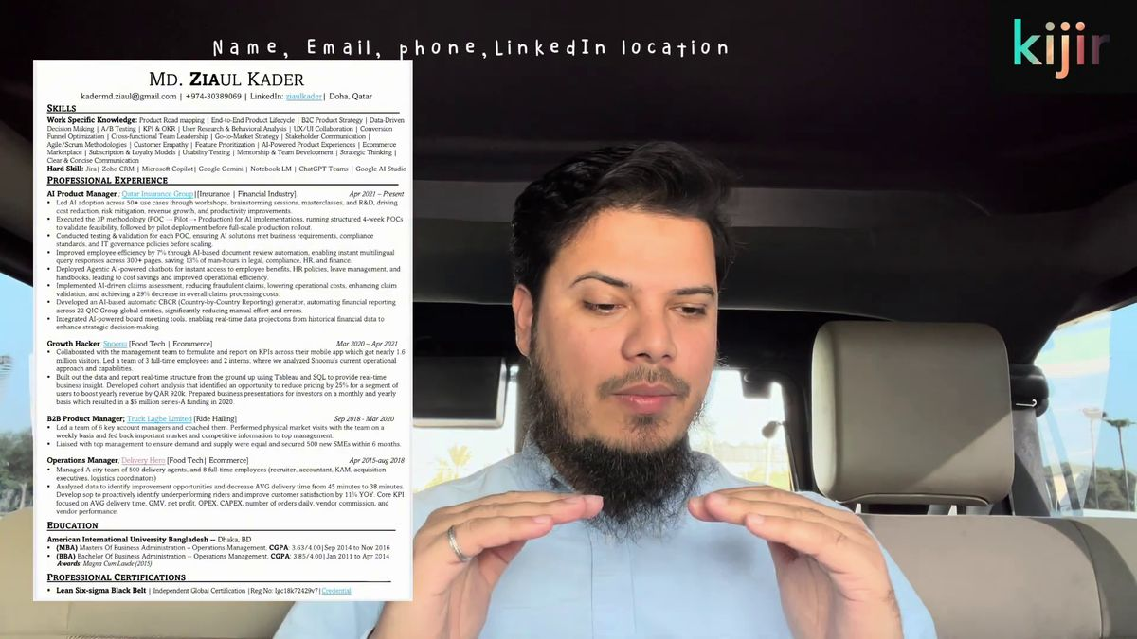
Figure 7.2: Anti-Bias Contact Header Architecture & Strict Personal Data Elimination (Lecture Reference: 02:05)
The Strict Anti-Bias Header Formula (Top of Page 1)
FIRST NAME & LAST NAME (Bold, 16-18pt, Centered)
Canonical Target Title | Core Industry Specialization (11pt, Centered)
Email: professional.email@domain.com | Phone: +Country-Code-Number | Location: City, Country | LinkedIn: linkedin.com/in/vanity-url | GitHub/Portfolio: portfolio.link
❌ What to Ruthlessly Delete:
• NO passport photos or professional headshots
• NO marital status, date of birth, age, or gender
• NO religion, nationality, national ID/passport numbers, or blood group
• NO street addresses or postal codes (City and Country only)

7.3 The Core Competencies Grid: Algorithmic First-Third Indexing
Directly beneath your anti-bias contact header, before any chronological work history, must sit the Core Competencies & Technical Skills grid. This section serves a dual purpose: first, it satisfies the algorithmic keyword-matching scanners of corporate ATS parsers; second, it provides human recruiters with an instantaneous 5-second snapshot of your technical and leadership stack.
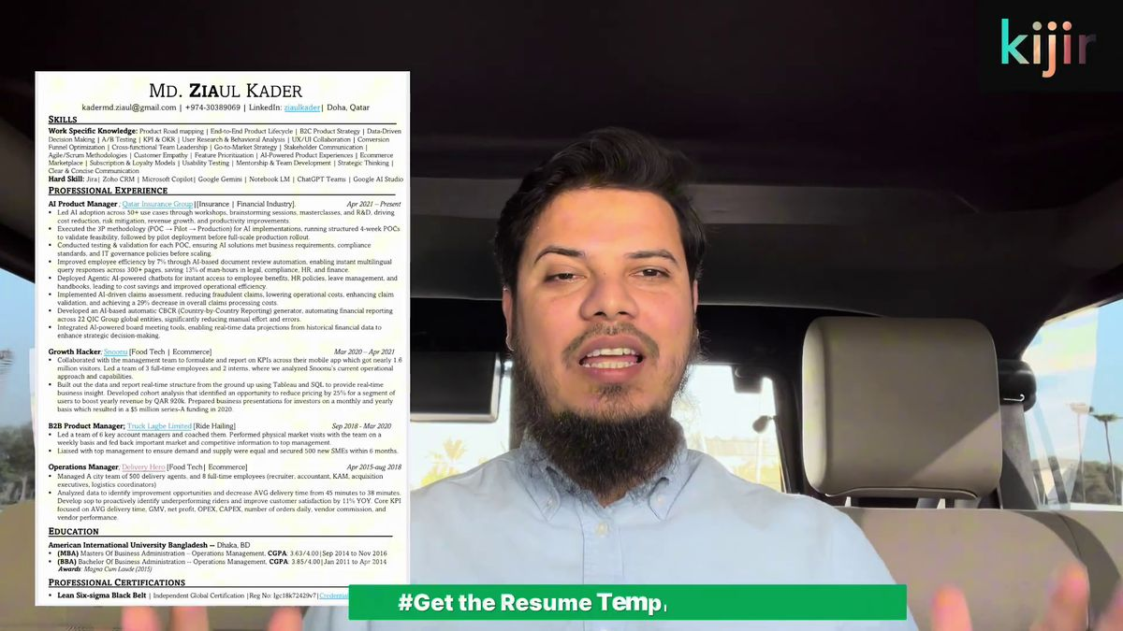
Figure 7.3: Core Skills Grid Layout Engineered for Instant ATS Keyword Extraction (Lecture Reference: 03:20)
7.4 Institutional Context Bridging: Translating Regional Employers
When an executive headhunter in London or Dubai evaluates a candidate whose past employers include 'Pathao', 'Bkash', or 'Chaldal', they have zero innate understanding of whether those enterprises represent a tiny 5-person agency or a multi-million-dollar tech unicorn. Without context, human recruiters instinctively discount regional experience.
To permanently eradicate this cognitive penalty, every single employment entry must lead with a concise 1-sentence Institutional Context Bridge. This bridge articulates the company's enterprise scale, venture funding pedigree, market share, and operational footprint before listing individual achievements.
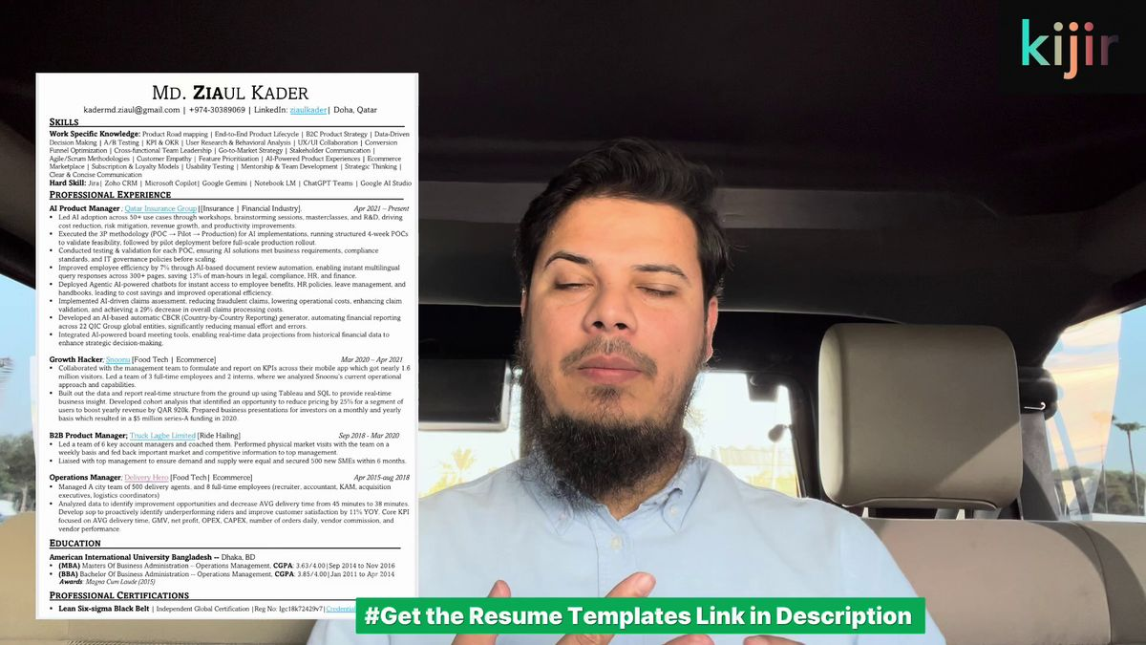
Figure 7.4: Institutional Context Bridging Formula for Regional Tech Champions (Lecture Reference: 04:30)
Institutional Bridging Formulas in Action
• Truck Lagbe: 'Bangladesh's premier venture-backed digital freight brokerage platform, managing 80,000+ registered commercial transport vehicles.'
• Snoonu Qatar: 'The Middle East's premier multi-vertical on-demand super-app, backed by sovereign venture capital and serving 1M+ active regional users.'
• Qatar Insurance Group (QIC): 'The Gulf region's largest multinational insurance and financial services conglomerate, managing $5B+ in enterprise assets across MENA and European markets.'

7.5 High-Impact Bullet Construction: Action, Scope & Quantifiable Impact
In the professional resume, every bullet must adhere to the high-velocity formula: Action Verb + Contextual Scope + Quantifiable Business Impact. Avoid weak verbs such as 'helped', 'assisted', 'handled', or 'worked on'. Lead with decisive leadership verbs: 'Architected', 'Spearheaded', 'Engineered', 'Orchestrated', 'Optimized', or 'Negotiated'.
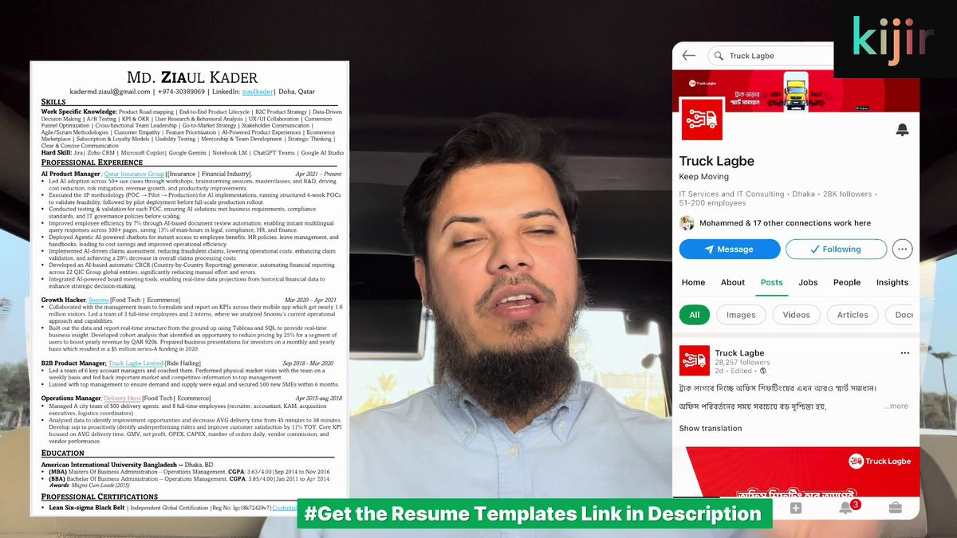
Figure 7.5: Live Resume Walkthrough & High-Velocity Bullet Point Formatting (Lecture Reference: 05:30)
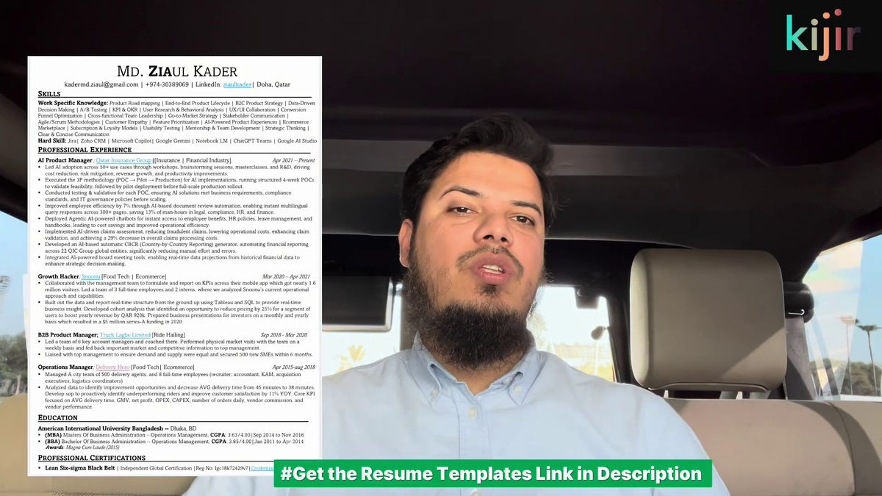
Figure 7.6: Result-Focused Role Deconstructions vs Passive Task Listings (Lecture Reference: 07:10)
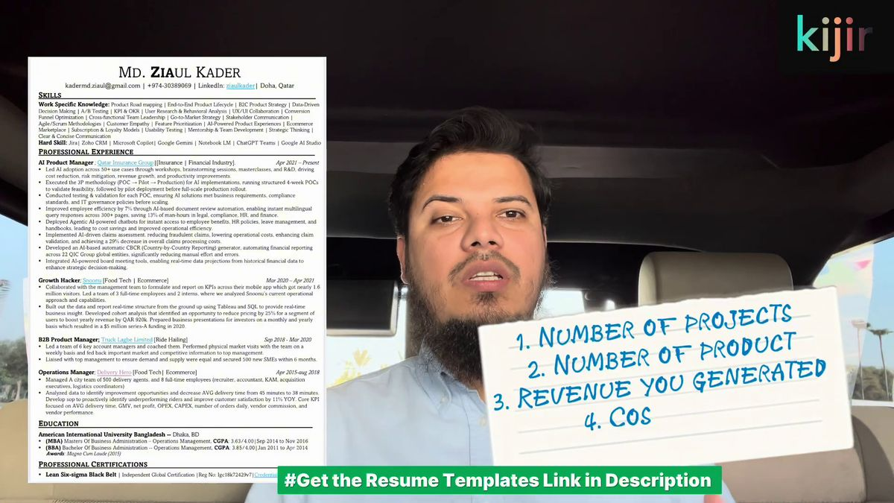
Figure 7.7: Infusing High-Density Quantifiable Metrics ($, %, Scale) into Bullets (Lecture Reference: 08:15)
7.6 Education, Hyperlinking & Credential Verification
Position your Education section cleanly near the base of the resume. Include degree title, institution name, and year of graduation. Where applicable, embed live clickable hyperlinks to your verified digital credentials (e.g., Credly links for AWS, PMP, or Scrum certifications). Ensure all URLs are clean, active, and lead directly to institutional proof.
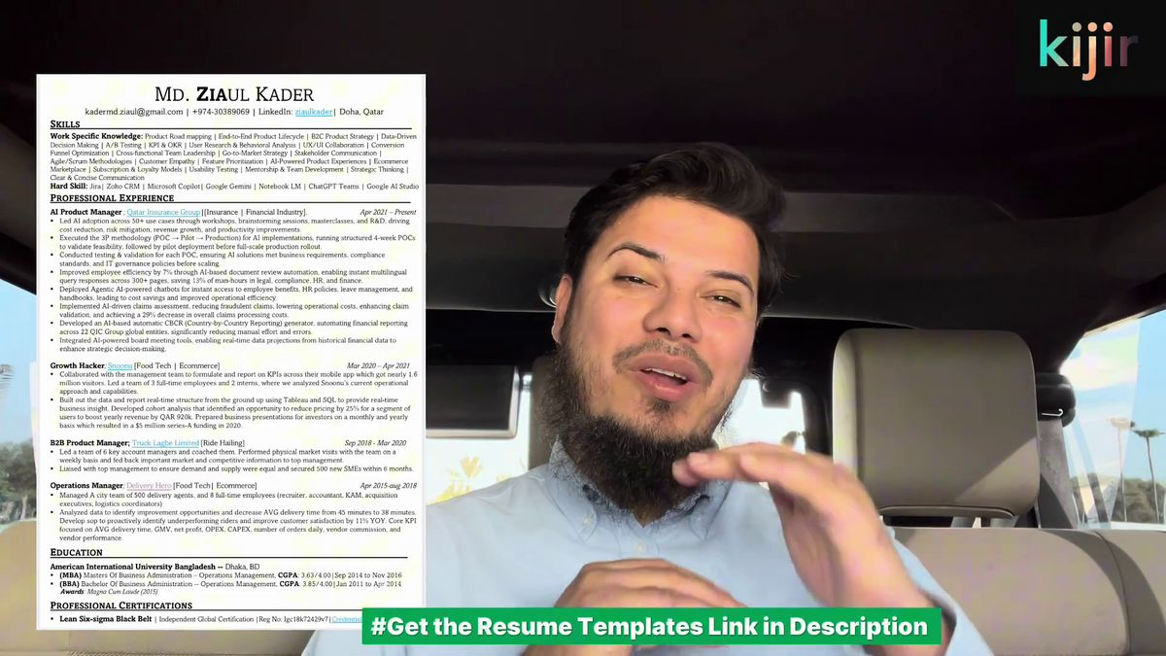
Figure 7.8: Clean Education Structuring and Live Credential Hyperlinking (Lecture Reference: 09:20)
7.7 Strict ATS Formatting Rules: Eliminating Parsing Fatalities
To guarantee that your resume breezes through Workday, Taleo, Greenhouse, and Lever without a single algorithmic parsing error, adhere strictly to these foundational formatting mandates:

Figure 7.9: The Seven Golden Rules of ATS Document Formatting (Lecture Reference: 10:05)
The 7 Unbreakable ATS Rules
1. Single-Column Layout Only: Never use two-column or magazine-style layouts. ATS parsers read horizontally left-to-right, causing multi-column resumes to scramble into gibberish.
2. Zero Text Boxes or Floating Graphics: Never place critical skills or job titles inside floating text frames. Parsers skip floating drawing objects entirely.
3. Standard System Typography: Use canonical universally supported fonts: Calibri, Arial, Helvetica, or Georgia (10-11pt body, 14-16pt headings).
4. Standard Section Headers: Use universally recognized headers: 'Professional Experience', 'Core Competencies', 'Education', 'Certifications'.
5. Clean Chronological Hierarchy: Format entries consistently: Company Name | Job Title | Location | Start Date – End Date.
6. Standard Bullet Formatting: Use standard solid circular bullets (•). Avoid decorative arrows, checkmarks, or star icons.
7. Clean PDF Export: Generate PDF directly from Microsoft Word or Google Docs using standard vector export; avoid rasterized image-based PDF conversions.

7.8 The Boarding Pass Principle & The 1-Page Rule
Unless you possess 12+ years of senior executive experience or hold an extensive academic publication bibliography, your international resume must fit strictly onto a single page (maximum two pages for seasoned Directors and VP-level executives). Every single millimeter of white space must justify its existence through commercial relevance.
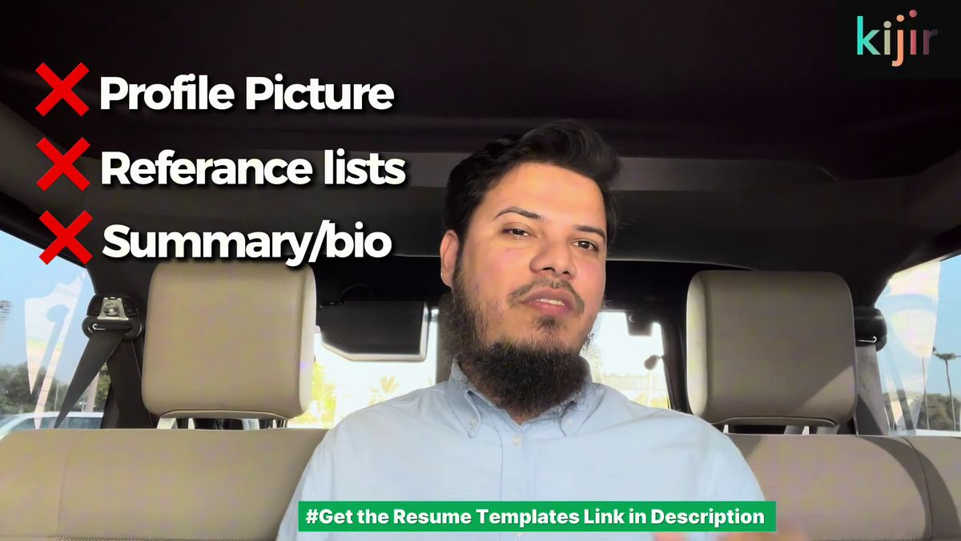
Figure 7.10: The Executive Boarding Pass Principle & 1-Page Space Allocation Rules (Lecture Reference: 12:40)
7.9 The Three Strictly Forbidden Resume Elements
To ensure your document never triggers an immediate red flag, eradicate these three outdated relics completely:
• Forbidden Element 1: Personal Headshot / Photo — Instantly disqualifies candidates under US, UK, and European anti-discrimination laws and creates unconscious bias in Gulf screening.
• Forbidden Element 2: 'References Available Upon Request' — A redundant, space-wasting cliche. International employers assume references will be provided upon formal background checks.
• Forbidden Element 3: Generic Objective Statement / Bio — Outdated 1990s boilerplate ('Seeking a challenging position in a dynamic company...'). Replace entirely with a targeted Core Competencies grid.
7.10 Tailored Resume Models for 4 Strategic Candidate Personas
STRATEGIC PLAYBOOK: 4 CANDIDATE PERSONAS
Persona 1: Developing-Market Junior/Mid Engineer -> International Remote / Expat Relocation
Target Role: Senior Backend Engineer (Python / Distributed Systems)
Context Bridge: 'Engineered high-concurrency microservices for Bangladesh's leading mobile financial ecosystem.'
Sample Bullet: 'Optimized PostgreSQL read-replica query latency by 48%, supporting 1.2M daily active transactions across peak holiday campaigns.'
Skills: Python, FastAPI, PostgreSQL, Redis, Docker, AWS ECS, CI/CD, Kafka
Persona 2: Western Expat Relocating to Gulf -> Tax-Free GCC Executive Compensation
Target Role: Head of Supply Chain & Logistics — Middle East
Context Bridge: 'Directed multi-temperature warehousing and cold-chain distribution across UK and European retail networks.'
Sample Bullet: 'Restructured regional last-mile fulfillment across 3 logistics hubs, slashing cost-per-delivery by 24% while maintaining 99.4% on-time delivery.'
Skills: GCC Customs, Cross-Border Logistics, Cold-Chain Management, P&L Ownership, SAP S/4HANA
Persona 3: Senior Executive -> GCC Sovereign & Enterprise Board Leadership
Target Role: Vice President of Product / Chief Product Officer
Context Bridge: 'Oversaw enterprise FinTech portfolios across Southeast Asia and MENA markets, managing $250M+ in annual GMV.'
Sample Bullet: 'Led 6 agile squads across 4 time zones to launch sovereign digital identity rails, securing 2.8M verified user adoptions in 12 months.'
Skills: Enterprise Product Strategy, Central Bank Governance, Board Stakeholders, Executive P&L
Persona 4: Independent Remote Consultant -> High-Ticket USD Advisory Retainers
Target Role: Principal Cloud Security Architect
Context Bridge: 'Provided fractional cloud security architecture for venture-backed Series A-C tech startups in the US and Europe.'
Sample Bullet: 'Conducted zero-trust IAM and infrastructure-as-code audits for 18 fintech scale-ups, achieving 100% first-pass SOC 2 Type II audit certification.'
Skills: AWS Security, Terraform, Zero-Trust IAM, SOC 2 Compliance, Kubernetes Hardening

Chapter 7 Field Audit Checklist: The 10-Point ATS Resume Test
[ ] Is the resume formatted strictly in a single-column layout without tables or text boxes?
[ ] Have all personal photos, marital status, religion, age, and full residential addresses been eliminated?
[ ] Does the contact header feature a clean vanity LinkedIn URL and professional email?
[ ] Does a prominent Core Competencies grid appear within the top third of Page 1?
[ ] Does every employment entry feature a 1-sentence Institutional Context Bridge?
[ ] Does every bullet point lead with a strong action verb and feature quantifiable metrics ($, %, numbers)?
[ ] Are all URLs to degrees and certifications live and clickable?
[ ] Has the phrase 'References Available Upon Request' been completely deleted?
[ ] Does the document fit strictly on 1 page (or 2 pages for senior directors/executives)?
[ ] Has the file been saved as a clean, text-searchable PDF (CandidateName_TargetRole_Resume.pdf)?

Chapter 8: The 7 Golden Rules of Global Job Hunting, 90-Day Transition Roadmap & The Spiritual Blueprint for Sustenance
— Fusing Precision Execution, Financial Buffer Engineering, Community Service & Divine Sustenance (Rizq) —
In the high-stakes theater of global talent acquisition, technical pedigree and LinkedIn profile optimization constitute merely half of the victory. The defining differentiator of Md Ziaul Kader's executive mentorship lies in the profound synergy between relentless tactical rigor and an unshakeable spiritual foundation anchored in the timeless laws of Divine Sustenance (Rizq).
In this master chapter, we assemble the complete end-to-end framework: the 7 Golden Rules of international job hunting, the systematic 90-Day Transition Roadmap, the financial runway required for cross-border mobility, the compounding power of community service, and the 8 proven spiritual pillars that unlock divine abundance.
8.1 The 7 Golden Rules of Global Job Hunting & Recruiter Psychology
Every single day, thousands of candidates click 'Easy Apply' across international job boards, only to endure demoralizing silence. Many mistakenly assume that landing a sponsored corporate role in Doha, Dubai, London, or Riyadh is an arbitrary lottery. In reality, understanding corporate recruitment economics dismantles this myth: posting a single premium job opening on LinkedIn Recruiter costs an enterprise approximately $500 USD per month. Corporate talent acquisition teams do not invest corporate capital casually; they operate under strict delivery deadlines and aggressive cost-per-hire constraints.
If you approach global recruitment with generic submissions, you remain invisible. To break through the international noise, you must execute these 7 Golden Rules of recruitment discipline:
The 7 Golden Rules of Global Job Hunting
Rule 1: Target Verified Active Openings (The 72-Hour Rule): Submit applications exclusively to openings published within the past 72 hours. Vacancies active for over 30 days have typically concluded their initial candidate shortlisting or exhausted their interview bandwidth. Verify whether the hiring employer holds an active track record of international visa sponsorship.
Rule 2: Algorithmic Skill-Gap Forensic Audit: Extract the top 10 hard skills and technical frameworks specified in the job posting's 'Requirements' section. Compare them forensically against your current resume. Close identified discrepancies immediately by highlighting relevant projects and accredited certifications.
Rule 3: Reverse-Engineer Recent Hires: Navigate to the target employer's LinkedIn 'People' tab. Audit professionals hired into your target role over the preceding 1 to 6 months. Analyze their origin countries, previous career ladders, verified credentials, and headline phrasing to benchmark expectations.
Rule 4: Synchronized Title & Scope Alignment: Align your resume's primary headline and professional summary with the exact canonical title specified in the job posting. Frame all bullet achievements to directly solve the strategic business bottleneck highlighted in the requisition.
Rule 5: Direct Decision-Maker Tracking & Outreach: Never rely solely on automated job portal submissions. Identify the functional decision-maker—such as the Head of Engineering, Director of Product, or VP of Growth—and initiate a high-value, personalized message directly to their inbox.
Rule 6: Target-Market Business Hours Alignment: Schedule all outreach and application submissions to align precisely with the business hours of your target geography. For Gulf markets (Qatar, UAE, Saudi Arabia), transmit messages between 8:00 AM and 10:00 AM Sunday through Thursday so your communication rests at the pinnacle of the executive's morning inbox.
Rule 7: Dignified Follow-Up & Professional Cadence: If an executive does not reply to your initial correspondence, avoid emotional discouragement or frantic messages. Deliver a courteous, value-additive follow-up note exactly 7 days later, reaffirming your domain readiness without desperation.

Video Reference & Lecture Timestamp: [YouTube Reference: 01:13 - The 7 Golden Rules Masterclass]
8.2 The 90-Day International Transition Roadmap
Achieving a global career transition is a systemic campaign, not an erratic sprint. Scattering uncoordinated resumes across arbitrary portals yields fatigue, not contracts. Md Ziaul Kader engineered a structured 90-day transition roadmap designed to transform qualified professionals into world-class, market-ready international candidates.
Examine the official transition architecture below:
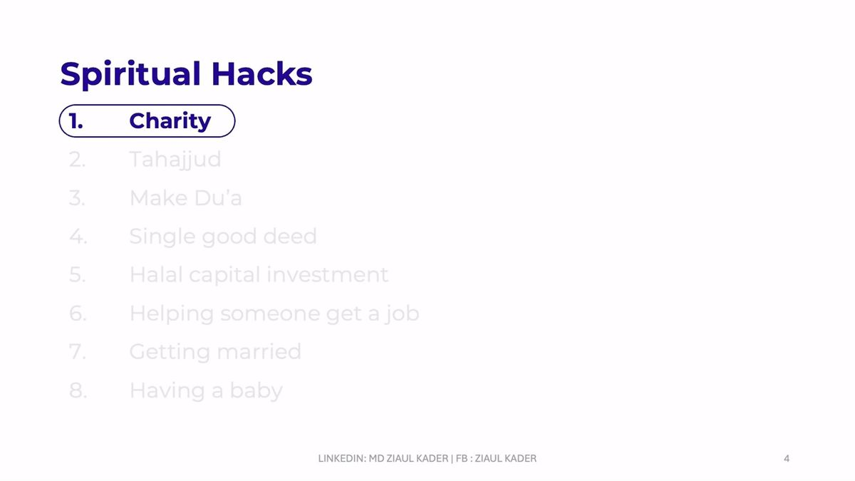
Figure 8.1: The 90-Day International Job Transition Roadmap & Action Plan (Lecture Reference: 04:56)
Figure 8.1: 90-Day Transition Phase Breakdown
Month 1: Foundation, Positioning & Asset Architecture: Dedicate the first 30 days entirely to asset perfection; submit zero applications. Rebuild your LinkedIn profile to 100/100 All-Star status (Banner, Canonical Headline, About Narrative, Experience Bullets). Engineer a single-page Harvard-standard ATS resume. Construct a curated pipeline of 50 high-conviction target enterprises across your focus geography.
Month 2: High-Velocity Targeted Outreach & Algorithmic Visibility: Initiate proactive multi-tier outreach. Connect with boutique domain headhunters, senior university alumni established in your target market, and functional department heads. Deliver a minimum of 10 customized, high-conviction applications weekly paired with direct decision-maker value pitches.
Month 3: Interview Conversion, Value Defense & Offer Closing: Inbound interview inquiries and screening calls materialize. Focus intensely on HR screening alignment, technical case study defense, 5X ROI value anchoring, and cross-border salary negotiation. Forensically audit the formal contract and execute agreements.

Video Reference & Lecture Timestamp: [YouTube Reference: 04:56 - 90-Day Transition Roadmap]
8.3 Financial Readiness, Expat Runway & The Emergency Buffer
A catastrophic blunder frequently committed during international transitions is resigning from current employment prematurely or embarking on an international job hunt with zero liquid savings. Financial scarcity breeds psychological panic. When panic seeps into your tone during executive interviews, recruiters instinctively perceive desperation and retract offers.
A successful sovereign transition demands a robust Financial Safety Net to preserve your negotiating power and peace of mind. Examine the official financial readiness and emergency fund model below:
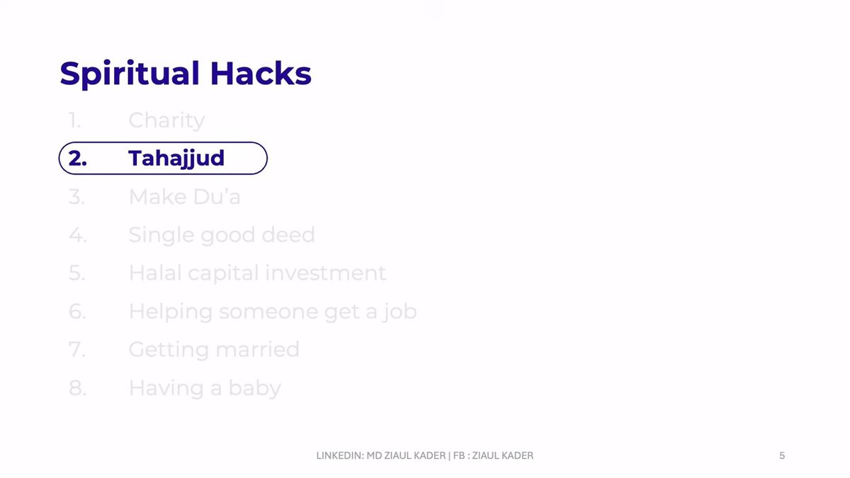
Figure 8.2: Financial Readiness, Expat Budgeting & Emergency Fund Architecture (Lecture Reference: 10:05)
Figure 8.2: Financial Readiness & Expat Budgeting Rules
1. 6-Month Liquid Family Runway: Before initiating an active international campaign, secure a minimum of 6 months of living expenses in an accessible, low-risk account. This reserve eliminates financial anxiety and allows you to negotiate from a position of sovereign strength.
2. Retain Active Employment: Never terminate current employment until a verified international offer letter has been legally executed. Employed candidates possess significantly higher negotiating leverage with global talent acquisition teams.
3. Expat Landing & Initial Setup Capital: Even when the employer covers visa fees and inbound flights, prepare $2,500 to $4,000 USD in liquid capital to cover initial apartment security deposits, utility connections, and living expenses prior to your first monthly payroll.
4. Debt & High-Interest Liability Elimination: Avoid accumulating credit card debt or consumer loans during your transition window. A debt-free posture clears cognitive bandwidth, enabling razor-sharp executive focus.

Video Reference & Lecture Timestamp: [YouTube Reference: 10:05 - Financial Readiness & Budgeting]
8.4 Community Service, Peer Mentorship & Selfless Supplication
Operating as an isolated, self-centered professional restricts your career growth. One of the most potent accelerators of professional blessing is investing time in uplifting peers within your professional ecosystem. Throughout his global journey, Md Ziaul Kader made it an unbreakable rule to never hoard strategic insights; he continuously audited resumes, provided free career coaching to junior colleagues, and shared opportunities openly.
As established in authentic prophetic tradition: "The Almighty remains in aid of His servant as long as the servant remains in aid of his brother." (Sahih Muslim). Examine the community service and blessing-multiplier framework below:

Figure 8.3: Professional Community Service, Peer Review & The Multiplier of Selfless Blessing (Lecture Reference: 12:40)
Figure 8.3: The Three Pillars of Professional Community Service
1. Pro-Bono Resume & Profile Audits: Dedicate one hour weekly to reviewing the LinkedIn profile or resume of a junior colleague. When you invest sincere effort into advancing another's livelihood, Divine providence directs an executive recruiter to your profile.
2. Open Job Sharing & Internal Referrals: When you discover relevant vacancies outside your immediate domain, share them proactively with qualified peers. Facilitating an introduction creates lasting institutional goodwill.
3. The Power of Heartfelt Unspoken Du'a: When you assist another without seeking commercial remuneration, ask solely for their sincere prayers. A supplication made in secret for a brother is answered with angelic affirmation: 'Ameen, and to you the same.'

Video Reference & Lecture Timestamp: [YouTube Reference: 12:40 - Community Service & Blessings]
8.5 The Spiritual Blueprint for Sustenance (Rizq) & The 8 Spiritual Hacks
Many professionals fulfill every worldly requirement—polishing their CVs, mastering technical skills, and submitting applications—yet experience prolonged blockage. In dissecting this spiritual paradox, Md Ziaul Kader articulates the cornerstone philosophy of his journey:
“Consider your current life. If your existing domestic earnings comfortably satisfy your basic personal needs and family sustenance, why would the Almighty grant you the massive expanded provision of an international enterprise income? You must create spiritual scope! You must cultivate sincere commitments: sponsoring vulnerable relatives, funding orphan education, supporting community welfare, and advancing good. When your heart creates valid, noble conduits for surplus wealth, Divine Sustenance (Rizq) descends with breathtaking abundance.”
Examine the foundational slide below, which anchors professional execution in Tawakkul, Tahajjud, and regular Charity:
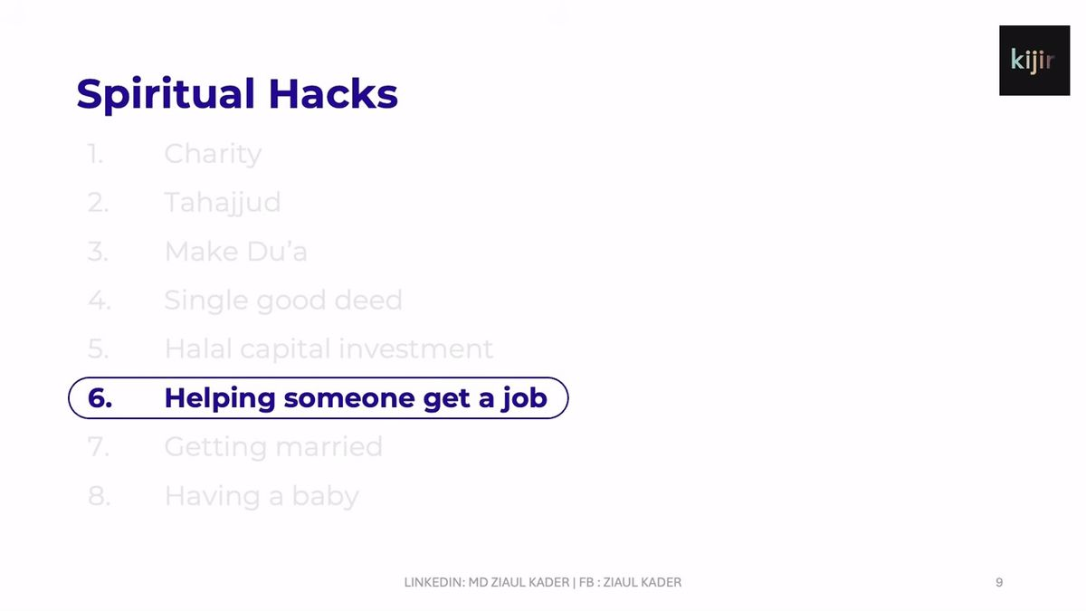
Figure 8.4: The Spiritual Foundation for Halal Sustenance: Tawakkul, Tahajjud & Strategic Charity (Lecture Reference: 14:20)
Synthesized from Md Ziaul Kader's lectures and verified personal experience, here are the 8 Decoded Spiritual Hacks that unlock global career opportunities:
Figure 8.4: The 8 Proven Spiritual Hacks for Global Sustenance (Rizq)
1. Strategic Daily Charity (Sadaqah): The primary key to expanding sustenance. Give charity daily or weekly with deliberate intentionality: 'O Allah, through the blessing of this charity, expand my halal provision, remove all career stagnation, and grant me a high-impact global role.' (Surah Al-Baqarah: 261).
2. The 3 AM Tahajjud Prayer & Supplication in Sujood: Arise in the quiet stillness of the last third of the night when the Creator descends to the nearest heaven, asking: 'Who is calling upon Me, that I may answer him?' Pour your aspirations into prolonged prostration (Sujood), naming your desired international roles and target institutions explicitly.
3. Capitalizing on the 12 Certified Times for Du'a: Anchor your most critical career petitions during the authentic golden windows of acceptance established in the Sunnah (between Adhan and Iqamah, in Sujood, in the final hour of Friday before Maghrib, during rainfall, and while traveling).
4. Perpetual Repentance (Istighfar): Maintain a daily cadence of at least 100 repetitions of Istighfar ('Astaghfirullah'). Sincere repentance purges spiritual impediments and draws rainfalls of divine provision (Surah Nuh: 10-12).
5. Halal Capital & Scope Creation (Creating the Vessel): Formulate clear, noble commitments for prospective surplus earnings: establishing charitable endowments, eliminating generational poverty in your family, and funding noble causes. The Almighty expands the vessel that is destined to nourish others.
6. Selfless Career Assistance to Peers: Assist fellow job seekers without jealousy. Edit resumes, share interview insights, and recommend qualified peers. By actively advancing another's provision, you confirm your firm belief that Rizq is infinite.
7. Honoring Family Ties & Sunnah Marriage: Maintaining kinship bonds and undertaking the sacred responsibility of marriage draws divine expansion (Surah An-Nur: 32). Authentic traditions affirm that honoring family ties elongates life and multiplies wealth.
8. Absolute Reliance (Tawakkul) with Razor-Sharp Focus: Tie your camel with peerless worldly excellence—perfecting your resume, practicing system design, and executing targeted outreach—then surrender the ultimate outcome to the Divine Decree with unshakeable peace.

8.6 The 12 Certified Golden Windows for Accepted Supplication (Du'a)
To maximize the spiritual efficacy of your career transition, concentrate your supplications within the 12 authenticated golden windows taught by the Prophet Muhammad (peace be upon him):
The 12 Certified Moments of Accepted Du'a
1. In Deep Prostration (Sujood): The servant is closest to their Lord while prostrating. Articulate your specific career goals in Sujood.
2. Final Sitting of Daily Prayers: Directly after Tashahhud and Salawat, immediately before concluding the prayer with Tasleem.
3. Between the Adhan and Iqamah: An authentic prophetic window wherein supplications are never turned away.
4. The Final Third of the Night (Tahajjud): When divine mercy descends and requests are directly solicited and fulfilled.
5. The Final Hour of Friday (Before Maghrib): The sacred, fleeting moment on Jumu'ah when prayers are granted.
6. While Fasting, Just Before Iftar: The supplication of the fasting person prior to breaking the fast is directly accepted.
7. During Falling Rain: As mercy descends from the heavens, doors of divine response open wide.
8. Parents' Supplication for Their Children: A parent's sincere prayer for their offspring's career and wellbeing pierces the heavens.
9. The Supplication of the Oppressed (Mazloom): There is zero barrier between the oppressed individual and the Almighty.
10. While Traveling on a Journey (Musafir): The prayer of a traveler is authenticated for rapid acceptance.
11. Supplicating for a Brother in His Absence: Invoking blessings for a peer prompts an appointed angel to declare: 'Ameen, and for you the same.'
12. In Moments of Deep Trial & Distress: Calling upon the Almighty with brokenness and tears when worldly doors appear shut.

Video References & Lecture Timestamps: [01:50 - Charity & Sadaqah] [03:50 - Tahajjud & Crying in Sujood] [05:30 - The 12 Golden Times for Du'a] [14:20 - Tawakkul & Scope Creation]
8.7 Tailored 90-Day Execution & Daily Rhythms for 4 Strategic Personas
STRATEGIC PLAYBOOK: 4 CANDIDATE PERSONAS
Persona 1: Developing-Market Junior/Mid Engineer -> International Remote / Expat Relocation
• Target Hubs: Doha, Dubai, Riyadh, Berlin, Amsterdam.
• 90-Day Action: Month 1 refactor GitHub repo and system design diagrams; Month 2 submit 10 tailored applications weekly with direct VP of Engineering pitches; Month 3 conquer live technical and architecture screens.
• Outreach Strategy: Initiate 5 high-value technical discussions weekly with Engineering VPs.
• Spiritual Routine: Tahajjud at 3 AM with specific company names in Sujood; daily morning Sadaqah.
Persona 2: Western Expat Relocating to Gulf -> Tax-Free GCC Executive Compensation
• Target Hubs: Dubai (DIFC), Abu Dhabi (ADGM), Doha (QFC), Riyadh (KAFD).
• 90-Day Action: Month 1 package regional leadership case studies and audit GCC regulatory frameworks; Month 2 partner with top-tier Gulf executive search firms (Michael Page, Hays, Cooper Fitch); Month 3 negotiate tax-free package and family relocation allowances.
• Outreach Strategy: Engage C-suite decision-makers directly with market expansion whitepapers.
• Spiritual Routine: Friday Jumu'ah final hour supplications; mentoring junior expats seeking Gulf transition.
Persona 3: Senior Executive -> GCC Sovereign & Enterprise Board Leadership
• Target Hubs: Sovereign Wealth Funds (QIA, PIF, ADIA) & GCC Enterprise Banking.
• 90-Day Action: Month 1 assemble executive board dossier and enterprise P&L case studies; Month 2 private advisory dinners and executive networking across regional conferences; Month 3 board interview defense and multi-year executive contract structuring.
• Outreach Strategy: Peer-to-peer executive dialogue with Managing Directors and Board Chairs.
• Spiritual Routine: Daily Istighfar (100x); structuring formal charitable endowments (Waqf) for prospective income.
Persona 4: Independent Remote Consultant -> High-Ticket USD Advisory Retainers
• Target Hubs: US, European, and Gulf tech scale-ups seeking fractional architecture expertise.
• 90-Day Action: Month 1 publish 3 in-depth technical tear-downs on cloud security and cost optimization; Month 2 cold audit 20 venture-backed firms and deliver loom video reviews; Month 3 close 3 high-ticket monthly retainers ($5k-$10k USD).
• Outreach Strategy: Offer actionable architectural diagnoses to CTOs before mentioning retainer services.
• Spiritual Routine: Strict adherence to halal business scope; sharing open contracts with freelance peers.

Chapter 8 Field Execution Checklist: The Sovereign Transition Audit
[ ] Are you targeting strictly verified openings posted within the preceding 72 hours?
[ ] Have you identified the top 10 required skills and bridged all resume gaps?
[ ] Have you reverse-engineered recent hires at your target enterprise via the LinkedIn People tab?
[ ] Is your 90-day campaign structured into clear Month 1, Month 2, and Month 3 milestones?
[ ] Have you verified a 6-month liquid family emergency fund before initiating active moves?
[ ] Are you mentoring at least one junior colleague or peer job seeker weekly?
[ ] Have you established a daily morning Sadaqah habit?
[ ] Are you consistently rising for Tahajjud at 3 AM to make specific petitions in Sujood?
[ ] Have you clearly defined your noble intentions (Scope Creation) for expanded international earnings?
[ ] Have you tied your camel with peerless preparation, placing absolute Tawakkul in the Divine Decree?

PART IV: EXECUTIVE NETWORKING, THOUGHT LEADERSHIP & SOCIAL SELLING
Chapter 9: Executive Networking, Headhunter Outreach & Inbound Referral Funnels
“Networking is not an act of transactional begging; it is the strategic architecture of peer-to-peer value partnerships with executive decision-makers.”
9.1 Fatal Networking Blunders & The Cognitive Mindset Shift
In the pursuit of cross-border career advancement, the single most destructive behavior exhibited by candidates is transactional spamming. When an ambitious professional discovers an international headhunter, a regional director, or an expatriate executive on LinkedIn, they frequently fire off an uncustomized connection request. And the instant the recipient accepts out of professional courtesy, the candidate immediately inundates their inbox with a desperate pitch: "Sir, I am actively seeking an international sponsorship role in Dubai/Doha. Kindly review my attached CV and refer me to your HR department."
Let us be unmistakably clear: transactional begging burns executive bridges instantly. Approaching a complete stranger with an unsolicited demand for employment signals extreme desperation, zero commercial awareness, and a profound misunderstanding of professional etiquette. The recipient reflexively ignores or blocks the candidate.
Executive networking is an intentional two-step value funnel: you must earn attention and establish intellectual trust before introducing commercial discussion. Opportunities are never granted as charity; they are unlocked through demonstrated mutual value.
The 4-Tier Strategic Priority Networking Hierarchy
Tier 1: Former Colleagues & Ex-Company Peers: Colleagues with whom you shared previous professional trenches who have successfully relocated to your target geography. They understand your work ethic intimately and represent your most reliable internal referral advocates.
Tier 2: University & College Alumni Networks: Senior graduates from your alma mater established in target regional hubs. Common institutional heritage creates an immediate emotional affinity; senior alumni inherently take pride in opening doors for disciplined juniors.
Tier 3: Specialized Recruitment Agencies & Retained Headhunters: Boutique search consultants retained by Gulf and multinational enterprises. They maintain active recruitment mandates and corporate budgets, actively seeking high-caliber international candidates to present to their institutional clients.
Tier 4: Functional Department Heads & C-Suite Decision-Makers: Bypassing HR gatekeepers entirely to reach the Vice President of Engineering, Chief Product Officer, or Head of Supply Chain directly with high-value operational diagnoses.

Video Reference & Lecture Timestamp: [YouTube Reference: 09:10 - 4-Tier Networking Hierarchy]
9.2 Multi-Tier Targeting Architecture & Connection Note Formulas
Amateur job seekers blast indiscriminate connection requests without personalized context. In contrast, the sovereign executive categorizes outreach into three synchronized tiers, deploying bespoke, high-conversion correspondence:
High-Conversion Alumni & Peer Connection Note Formulas
• The Senior Alumni Connection Note (Under 300 Characters):
"Hi [Name], I noticed you also graduated from [University] and are currently leading [Domain / Engineering] at [Target Company] in Doha. Really inspired by your cross-border trajectory! Would be honored to connect and follow your professional insights."
• The Post-Acceptance Relationship Nurture (24-48 Hours Later):
"Hi [Name], thank you for connecting! I closely followed your recent team update regarding [Specific Project / Expansion]. Truly impressive execution. Looking forward to engaging with your content here on LinkedIn. Wishing you continued success!"

Video Reference & Lecture Timestamp: [YouTube Reference: 03:50 - Live Candidate Audit & Outreach]
9.3 Partnering with Tier-1 Recruiting Agencies in the Gulf
Across the Middle East and European economic corridors, blue-chip enterprises and sovereign entities routinely outsource critical hiring mandates to specialized recruitment consultancies (e.g., Michael Page, Hays, Cooper Fitch, Robert Half, Adecco, Charterhouse). Understanding headhunter economics is essential: recruitment consultancies charge hiring employers between 15% and 25% of the candidate's annual base salary upon successful placement. They never charge candidate fees.
Consequently, specialized recruitment consultants are constantly hunting for stellar, relocation-ready talent that makes them look exceptional before their corporate clients. When you position your credentials cleanly, headhunters become your most powerful external champions.
The Headhunter Partnership & Inbound Outreach Blueprint
1. Precise Algorithmic Search Query: In the LinkedIn search bar, execute Boolean strings: `"Recruitment Consultant" AND ("Doha" OR "Dubai" OR "Riyadh") AND "[Your Domain, e.g. Technology]"`. Bypass generalist HR administrators; connect exclusively with domain-specialist consultants.
2. Domain Specialization Filtering: Target consultants whose headlines explicitly read 'Technology & Cloud', 'Financial Services', or 'Logistics & Supply Chain'. Generalist recruiters lack the domain context to appreciate deep technical achievements.
3. The High-Velocity Headhunter Pitch Script: "Hi [Name], I noticed you lead Tech & Product placements across the GCC. I am an Enterprise AI Product Manager with 6+ years experience scaling high-concurrency platforms, actively exploring relocation to Doha/Dubai. Sharing my concise 1-page Harvard ATS resume for any matching mandates in your active Q1 pipeline. Would welcome a brief introductory sync if my background aligns."
4. Profile Relocation Signals: Ensure your profile headline or About section embeds clear relocation intent: 'Open to high-impact international opportunities in Qatar / UAE with complete relocation readiness.'

Video Reference & Lecture Timestamp: [YouTube Reference: 08:50 - Headhunter Outreach Architecture]
9.4 Bypassing Gatekeepers: Startup Founders & Accelerator Hubs
While breaking into established sovereign conglomerates involves structured recruitment cycles, the fastest route to a sponsored international offer often lies with venture-backed scale-ups and high-velocity startup founders. Early-stage and Series A/B founders face intense operational pressure, short delivery windows, and zero bureaucratic bloat. They possess total autonomy to interview and hire a world-class operator within 7 days.
Leverage regional ecosystem hubs: Qatar Science & Technology Park (QSTP), Dubai DIFC Innovation Hub, Hub71 Abu Dhabi, and Code Riyadh. Audit freshly funded portfolio ventures, engage constructively with the founders' public posts, and deliver a zero-friction mini-audit.
Founder Outreach & Proactive Value-Audit Methodology
1. Regional Ecosystem Tracking: Monitor monthly funding press releases from Wamda, MAGNiTT, and regional venture capital funds (e.g., Middle East Venture Partners, Shorooq Partners, 500 Global MENA).
2. The Proactive Mini-Audit Pitch: Rather than requesting an interview, deliver an actionable, pro-bono diagnostic audit: 'Congratulations on closing your Series A round! While testing your mobile onboarding flow, I noticed a subtle friction point that may drop conversion by 8-12%. I drafted a quick 3-slide visual fix deck—no strings attached. Happy to send it over if useful.'
3. Direct C-Suite Access: Founders immediately recognize proactive builders. When you demonstrate solutions before asking for compensation, you establish an instant peer dynamic.

Video Reference & Lecture Timestamp: [YouTube Reference: 12:28 - Founder & Accelerator Tracking]
9.5 The 92 Discovery Calls Case Study: Inbound Strategic Conversion
Consider this foundational analogy: If you possess a high-end luxury Mercedes and park it in an impoverished rural village, you can be the greatest salesperson on earth, yet nobody will buy it—not because the vehicle lacks value, but because the audience lacks purchasing capacity and operational demand.
Career positioning operates under the exact same immutable law. The critical variable is who you place yourself in front of. By applying this targeted audience architecture, Md Ziaul Kader secured 92 one-on-one discovery calls in a single month without spending a single dollar on automated advertising. The mechanics of this conversion engine rest entirely on positioning high-value solutions before verified decision-makers.
The Inbound Discovery Engine: Generating 92 Executive 1:1 Calls
1. High-Value Decision Maker Filtering: Focus outreach strictly on executives with hiring budget authority: VP of Engineering, Chief Product Officer, Managing Director.
2. Free Search Mastery Over Paid Bloat: Achieve high-precision targeting using LinkedIn's native search operators and boolean logic without expensive automation tools.
3. Value-First Asynchronous Dialogue: Engage organically around shared industry friction. Never pitch or attach commercial links in message one.
4. Low-Friction Call Transition: Once shared operational challenges are uncovered, transition smoothly: 'We could unpack two or three potential architectural solutions during a brief 15-minute sync. Would Tuesday at 11:00 AM your time work?'

Video Reference & Lecture Timestamp: [YouTube Reference: 04:05 - The 92 Discovery Calls Blueprint]
9.6 Tailored Networking Playbooks for 4 Strategic Personas
STRATEGIC PLAYBOOK: 4 CANDIDATE PERSONAS
Persona 1: Developing-Market Junior/Mid Engineer -> International Remote / Expat Relocation
• Target Decision Makers: Gulf & European Tech Recruiters (Michael Page Tech, Adecco) and VP of Engineering.
• Value Pitch: Open-source contributions, high-concurrency microservice case studies, and live GitHub repos.
• Weekly Quota: 20 personalized connection requests to domain-specialist tech recruiters; 5 direct value notes to Engineering VPs.
Persona 2: Western Expat Relocating to Gulf -> Tax-Free GCC Executive Compensation
• Target Decision Makers: Gulf Managing Directors, Sovereign Wealth Fund Talent Acquisition, and Cooper Fitch / Heidrick & Struggles Partners.
• Value Pitch: Cross-border supply chain harmonization, institutional governance, and UK/European corporate best practices.
• Weekly Quota: 15 executive dialogues with regional C-suite leaders and retained executive search partners.
Persona 3: Senior Executive -> GCC Sovereign & Enterprise Board Leadership
• Target Decision Makers: Board Chairs, Family Office Principals, and C-suite Leadership across QFC, DIFC, and KAFD.
• Value Pitch: Enterprise P&L governance, regional FinTech expansion strategy, and regulatory licensing mastery.
• Weekly Quota: 10 confidential peer exchanges with Managing Directors and regional private equity partners.
Persona 4: Independent Remote Consultant -> High-Ticket USD Advisory Retainers
• Target Decision Makers: Scale-up Chief Technology Officers and Venture Capital Operating Partners.
• Value Pitch: Unsolicited 3-point cloud security and cloud-cost optimization mini-audits demonstrating instant $100k+ savings.
• Weekly Quota: 12 mini-audits delivered directly to scale-up CTOs leading to paid advisory retainers.

Chapter 9 Field Checklist: Executive Outreach & Networking Discipline
[ ] Have you permanently ceased sending uncustomized connection requests or unsolicited CV attachments?
[ ] Have you segmented your outreach into the 4 strategic priority tiers (Colleagues, Alumni, Agencies, Decision-Makers)?
[ ] Are you connecting with domain-specialist recruitment consultants in your specific target cities?
[ ] Does your profile headline or About section explicitly communicate relocation readiness?
[ ] Are you auditing regional startup accelerator portfolios (QSTP, Hub71, DIFC Innovation Hub)?
[ ] Do you lead every executive dialogue with an actionable, pro-bono value observation?
[ ] Are you executing a disciplined weekly cadence of 10 to 20 personalized executive interactions?

Chapter 10: Thought Leadership, Viral Content Strategy & Social Selling Mechanics
— The 10M+ View Content Engine: Dwell-Time Mechanics, PDF Carousels & Inbound Executive Pipeline Generation —
10.1 LinkedIn Algorithm Dynamics & Dwell-Time Mechanics
Many ambitious professionals publish content on LinkedIn only to experience profound discouragement: "I spent hours writing an insightful article, but it only generated four likes!" The underlying failure is algorithmic illiteracy. LinkedIn does not operate like Instagram, TikTok, or Facebook; it does not prioritize vanity reactions or superficial clicks. The single most potent algorithmic signal governing content distribution on LinkedIn is Dwell Time—the precise number of seconds a qualified professional pauses their feed to consume your narrative.
When an executive scrolls through their feed, pauses on your opening headline, and clicks '...see more' to expand your analysis, the LinkedIn algorithm registers high cognitive engagement. It immediately extrapolates that your asset contains premium value, pushing it into the secondary feeds of thousands of enterprise directors, founders, and headhunters across your domain. By mastering this algorithmic reality, Md Ziaul Kader generated over 10 Million authentic content impressions, turning his personal profile into a 24/7 inbound recruiter magnet.

Figure 10.1: The 10M+ Organic Impressions Content Architecture & Viral System (Lecture Reference: 00:45)
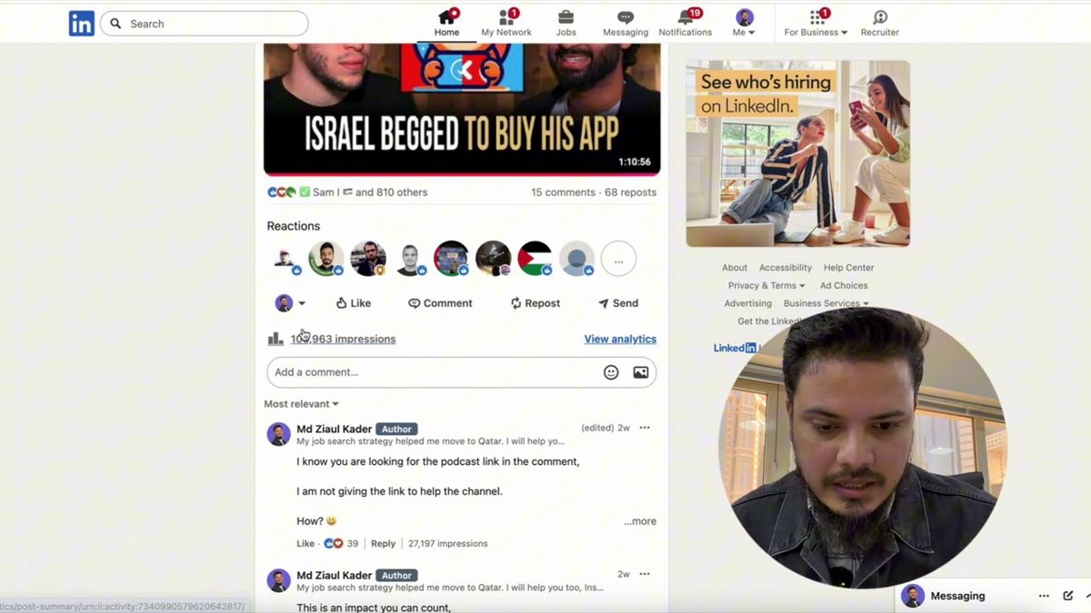
Figure 10.2: LinkedIn Feed Algorithm Mechanics: The Mechanics of Dwell Time (Lecture Reference: 03:20)
Figures 10.1 & 10.2: Dwell-Time Engineering Principles
1. The Expand Threshold ('...see more'): The algorithm tracks the ratio between feed impressions and clicks on '...see more'. Writing a captivating 2-line hook forces readers to expand the post, triggering the primary viral loop.
2. Reader Dwell-Time Duration: The longer a reader remains stationary on your post, the higher the algorithmic trust score assigned to your author profile. Multi-slide visual documents and structured essays naturally maximize dwell time.
3. Executive Reshare Velocity: When a Director or VP reshares your asset with added commentary, your content instantly breaches tier-1 executive networks across regional corporate headquarters.

Video Reference & Lecture Timestamp: [YouTube Reference: 00:45 - 10M Views Blueprint]
10.2 PDF Document Carousels: The Sovereign High-Dwell Visual Asset
Standard text-only posts frequently blend into the visual noise of the LinkedIn feed. The undisputed king of high-dwell LinkedIn engagement is the multi-slide PDF Document Carousel. When an executive clicks through a clean, 6-to-10 slide visual framework, each slide swipe signals active user engagement to the algorithm while multiplying dwell time by 400% to 600% compared to static posts.
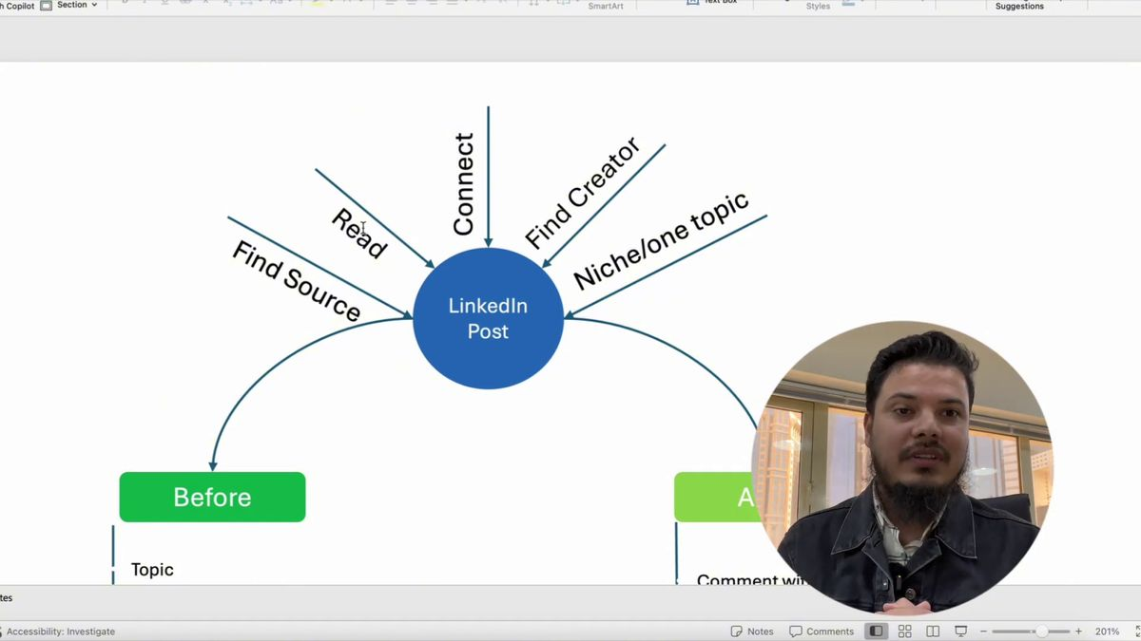
Figure 10.3: High-Converting PDF Carousel Architecture & Multi-Slide Layout Blueprint (Lecture Reference: 08:15)
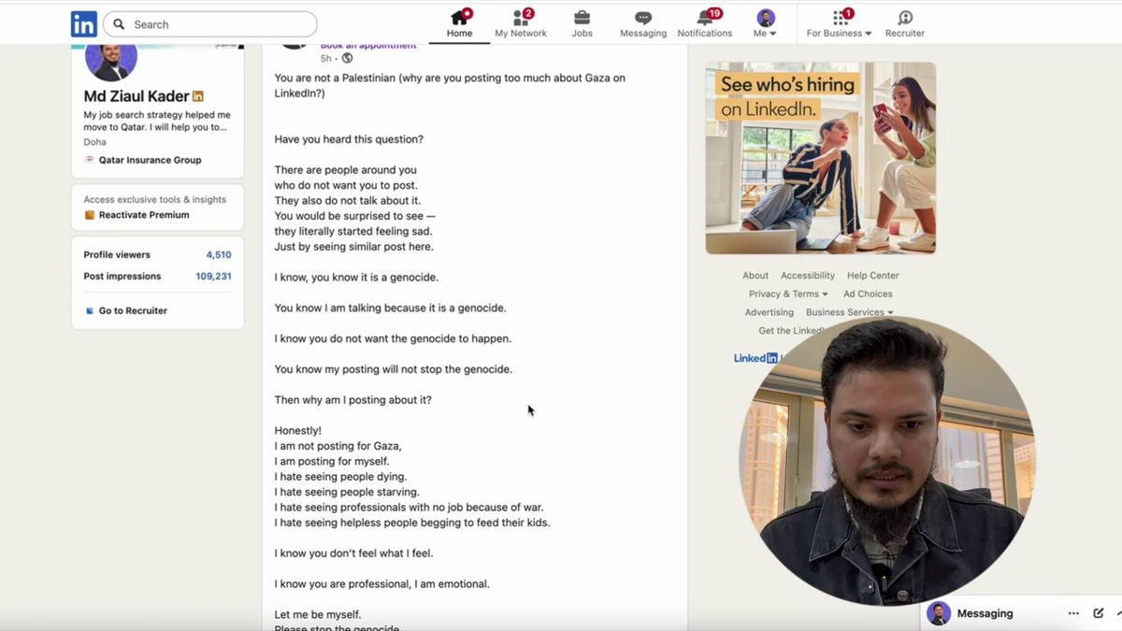
Figure 10.4: Algorithmic Distribution Loops & Comment Section Boosting Mechanics (Lecture Reference: 14:30)
Figures 10.3 & 10.4: The Anatomy of a High-Converting PDF Carousel
Slide 1 (The Visual Hook): Bold headline addressing an urgent enterprise problem: 'The 5 System Architecture Mistakes Causing 99% of Cloud Cost Overruns'.
Slides 2-5 (The Diagnostic Breakdown): Each slide highlights one specific friction point with clean diagrams, minimal typography, and high-contrast visuals.
Slides 6-8 (The Strategic Solution): Present step-by-step actionable remedies, including code snippets, configuration blueprints, or process roadmaps.
Slide 9-10 (The Sovereign Call-to-Action): Invite peer debate and offer a downloadable artifact: 'Comment "AUDIT" below and I will send you the complete Terraform configuration template.'

Video Reference & Lecture Timestamp: [YouTube Reference: 08:15 - PDF Carousel Blueprint]
10.3 The 4 Daily Viral Content Pillars
A common obstacle voiced by creators is: "What should I write about every week?" Random, uncoordinated posting dilutes authority. Sustainable professional brand building demands a recurring content framework structured around 4 strategic pillars:

Figure 10.5: The 4 Daily Viral Content Pillars for Sovereign Authority (Lecture Reference: 01:36)
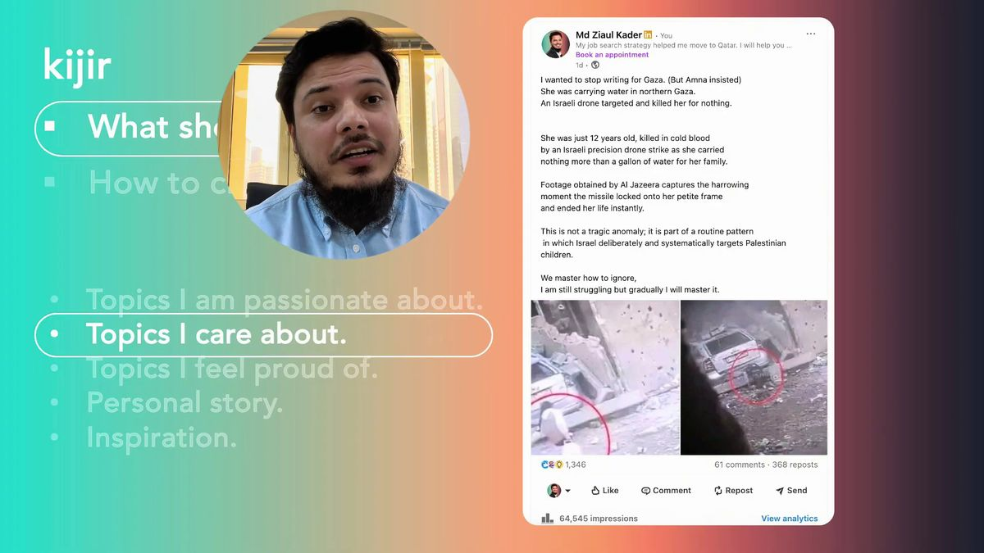
Figure 10.6: Authentic Narrative Architecture & Vulnerable Storytelling Formulas (Lecture Reference: 08:12)
Figures 10.5 & 10.6: The 4 Strategic Content Pillars
Pillar 1: Technical & Industry Deep-Dives (Authority): Deconstruct major enterprise innovations, regional regulatory shifts (e.g., GCC Central Bank fintech mandates), or architectural benchmarks. Establishes indisputable domain mastery.
Pillar 2: Vulnerable Behind-the-Scenes Case Studies (Authenticity): Share personal trials, architectural failures, and hard-won operational lessons: 'How a botched database migration at 2 AM taught me the true value of immutable snapshots.' Human vulnerability builds profound trust.
Pillar 3: Actionable Frameworks & Checklists (Utility): Deliver plug-and-play resources: interview question breakdowns, ATS resume templates, cloud-cost audit checklists. Highly shareable utility assets generate exponential reach.
Pillar 4: Contrarian Thought Leadership (Differentiation): Respectfully challenge mainstream industry consensus: 'Why most agile sprint ceremonies waste 30% of engineering bandwidth—and how to fix it.' Provokes intellectual debate.

Video Reference & Lecture Timestamp: [YouTube Reference: 01:36 - 4 Daily Content Pillars]
10.4 Scroll-Stopping Hook Mechanics & Post Spacing
A brilliant essay with a boring opening line is dead on arrival. On mobile devices, LinkedIn displays exactly the first two lines of text before truncating the post with '...see more'. Your opening sentence must serve as a high-stakes journalistic hook, arresting the thumb within 1.5 seconds.
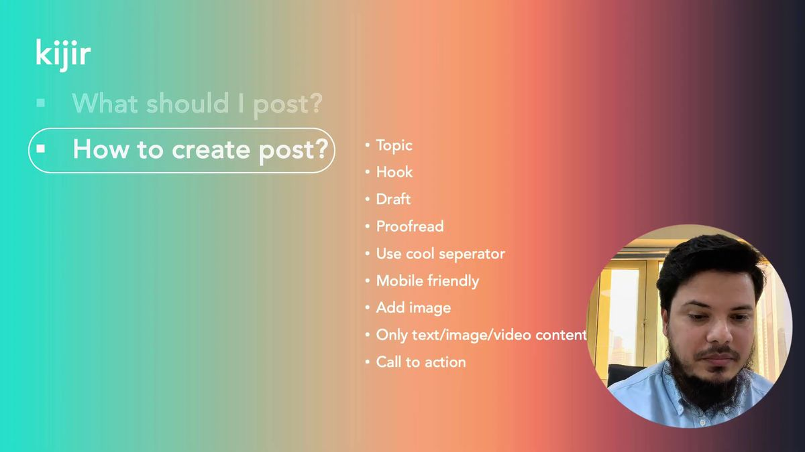
Figure 10.7: The 9-Step Complete Publishing Checklist & Hook Architecture (Lecture Reference: 14:33)
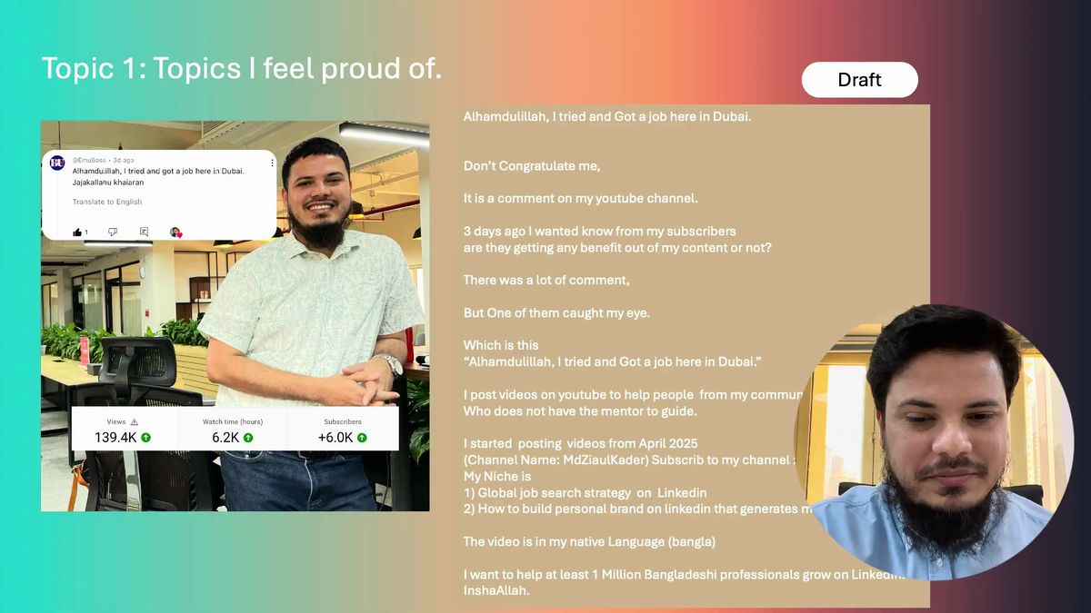
Figure 10.8: Forensic Formatting Decode: Live Viral Post Spacing & Micro-Paragraphs (Lecture Reference: 18:54)
Figures 10.7 & 10.8: Forensic Post Formatting Rules
1. The 120-Character Hook Boundary: The initial two lines must contain fewer than 120 characters total, ensuring the complete premise is visible on mobile displays before the truncation line.
2. Micro-Paragraph Spacing: Never write text blocks exceeding 2 sentences. Massive dense paragraphs induce cognitive fatigue on mobile screens, provoking rapid bounce.
3. Clean Bullet Typography: Utilize clean bullet markers (• or -) with dedicated line breaks to present complex technical comparisons gracefully.

Video Reference & Lecture Timestamp: [YouTube Reference: 18:54 - Viral Post Formatting]
10.5 Social Selling & Converting Comments into Inbound Inquiries
The true commercial transformation of content marketing occurs in the comment section. When an executive, headhunter, or peer leaves a thoughtful observation on your post, never reply with a superficial 'Thanks!'. Treat every comment as the start of an executive dialogue. Respond with a 3-sentence substantive insight and conclude with an open-ended question.
For readers who consistently engage with your insights, initiate a respectful 1:1 direct message: "Hi [Name], I really appreciated your perspective on my analysis of distributed payment architectures! I noticed your engineering team at [Company] is navigating a similar cloud modernization phase..." This natural bridge smoothly converts public readers into private discovery interviews.
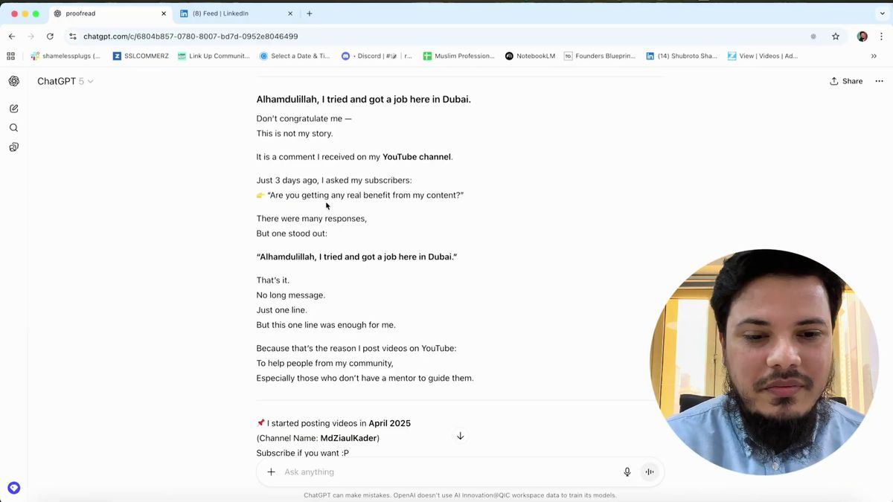
Figure 10.9: AI-Assisted (ChatGPT) Post Proofreading & Editorial Refinement Workflow (Lecture Reference: 23:05)
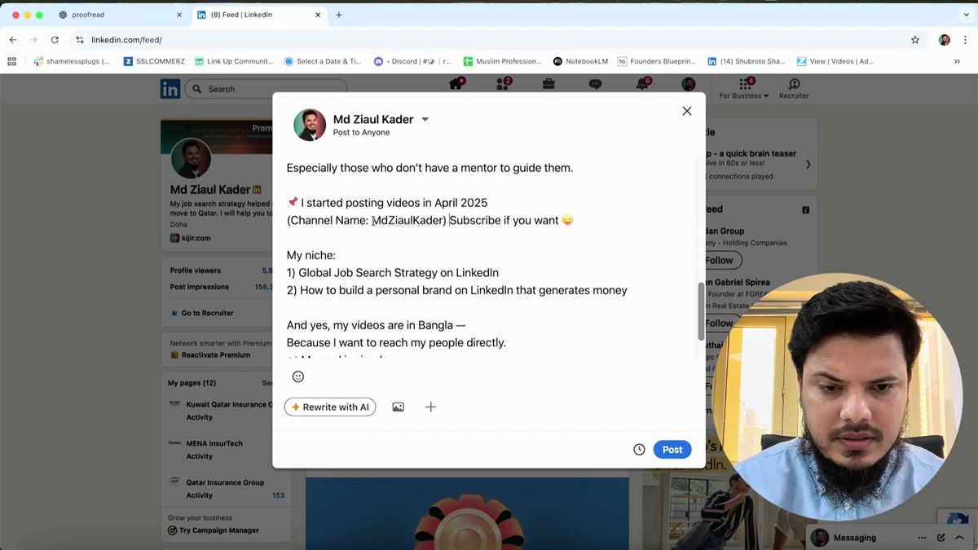
Figure 10.10: Optimal Publishing Windows, Timing Cadence & Final Go-Live Checklist (Lecture Reference: 27:54)
Figures 10.9 & 10.10: Social Selling Execution Rules
1. Golden Target-Market Publishing Windows: Transmit posts between 8:00 AM and 10:00 AM local time in your target market (e.g., 9:00 AM AST Sunday through Thursday for the Gulf region).
2. Comment-to-DM Inbound Bridge: Within 2 hours of post publication, actively respond to every comment to ignite the second wave of algorithmic feed distribution.
3. AI-Assisted Editorial Quality Control: Run drafts through AI proofreading workflows to purge colloquialisms, ensure active voice, and verify executive clarity before hitting publish.

Video Reference & Lecture Timestamp: [YouTube Reference: 27:54 - Publishing Checklist]
10.6 Weekly Content Schedules for 4 Strategic Personas
STRATEGIC PLAYBOOK: 4 CANDIDATE PERSONAS
Persona 1: Developing-Market Junior/Mid Engineer -> International Remote / Expat Relocation
• Monday (Technical Breakdown): 'Why microservice migrations fail at 100K RPS: 3 architectural lessons from scaling Redis clusters.'
• Wednesday (Carousel Case Study): 'How we cut cloud infrastructure expenditure by $16,000/month: A 6-slide system audit.'
• Friday (Personal Growth): 'The costliest architectural blunder I committed as a junior developer—and how it reformed my database indexing philosophy.'
Persona 2: Western Expat Relocating to Gulf -> Tax-Free GCC Executive Compensation
• Monday (GCC Market Teardown): 'Navigating supply chain localization under Saudi Vision 2030: What European logistics operators need to know.'
• Wednesday (Executive Carousel): 'Framework for multi-temperature warehousing in 50°C summer conditions: 7 operational benchmarks.'
• Thursday (Expat Reflection): 'Relocating executive operations from London to Dubai: 3 cultural business nuances that transformed our contract velocity.'
Persona 3: Senior Executive -> GCC Sovereign & Enterprise Board Leadership
• Tuesday (Macroeconomic Governance): 'Central bank digital currency (CBDC) adoption across the GCC: Strategic implications for commercial retail banking.'
• Thursday (Executive Carousel): 'Board-level governance of enterprise AI models: A 5-tier risk management rubric for Chief Risk Officers.'
• Saturday (Strategic Vision): 'The evolution of sovereign tech ecosystems: Why Riyadh and Doha are outpacing traditional Western innovation hubs.'
Persona 4: Independent Remote Consultant -> High-Ticket USD Advisory Retainers
• Monday (Zero-Trust Teardown): '90% of Series B startups leave these 3 AWS IAM permissions exposed: Here is how we remediate them in 2 hours.'
• Wednesday (Utility Carousel): 'The Ultimate SOC 2 Type II Compliance Readiness Checklist: 8 slides for fast-scaling FinTech founders.'
• Friday (Client Case Study): 'How we saved a venture-backed SaaS platform $120k annually by re-architecting Kubernetes auto-scaling.'

Chapter 10 Executive Publishing Checklist
[ ] Does your opening hook fit within 120 characters and compel the reader to click '...see more'?
[ ] Have you formatted the post into micro-paragraphs of 1-2 lines for seamless mobile consumption?
[ ] Are you publishing at least one high-dwell PDF Document Carousel every week?
[ ] Does your weekly publishing schedule balance the 4 pillars (Authority, Authenticity, Utility, Contrarian)?
[ ] Have you eliminated external hyperlinks from the post body (placing them in the first comment)?
[ ] Are you active in the comment section within the first 60 minutes of publication to trigger viral distribution?
[ ] Are you actively bridging high-value commenters into private 1:1 direct message conversations?

PART V: INTERVIEW MASTERY, SALARY NEGOTIATION & EXPAT RELOCATION
Chapter 11: International Interview Mastery, Salary Negotiation & Offer Closing
“An international interview is not an academic examination; it is a high-level commercial negotiation where you establish the commercial return on your sovereign expertise.”
11.1 Qatar Radio QFM 95.3 Live Session: Global Interview Psychology
Following successful resume screening and digital shortlisting, candidates face their most daunting psychological crucible: the international interview table. During a live broadcast at the studios of QFM 95.3 FM in Doha, Qatar, Md Ziaul Kader deconstructed the cognitive mindset of international hiring panels. The fatal mistake committed by countless qualified professionals from emerging economies—and even conventional Western corporate environments—is approaching the interview like a nervous schoolboy reciting theoretical textbooks.
International executive panels have zero interest in generic definitions. They sit across the video screen asking one fundamental commercial question: "If our enterprise invests $6,000 to $12,000 USD monthly—plus family relocation, private health insurance, and sovereign visa sponsorship—will this individual resolve a critical bottleneck worth at least 5X their compensation?" The moment you shift from a passive applicant reciting duties to a strategic partner diagnosing enterprise bottlenecks, the interview ceases to be an examination and transforms into an executive business consultation.
The Three Core Interview Principles (QFM 95.3 Studio Masterclass)
1. Outcome-Driven Business Storytelling: Never recite theoretical frameworks; articulate commercial and technical victories. Every answer must integrate hard metrics: dollars generated, hours automated, latency compressed, or risk mitigated.
2. Executive Screen Presence & Equal Partnership: Maintain direct lens eye contact during virtual video conferences. Speak with steady, measured cadence in clear international business English. Abandon self-effacing deference; present yourself as an equal technical partner.
3. Strategic Reverse Interviewing: When the panel inquires, 'Do you have any questions for us?', never reply in the negative. Seize the opportunity to audit their operational reality: 'What is the single most critical delivery bottleneck your engineering squads must resolve before Q3?'

Video Reference & Lecture Timestamp: [YouTube Reference: 01:15 - QFM Radio Studio Masterclass]
11.2 Handling HR Salary Expectations & Deflection Formulas
During the preliminary screening round, corporate recruiters almost invariably launch the ultimate compensation inquiry: "What is your current salary, and what are your compensation expectations for this position?"
Unprepared candidates universally stumble into one of two fatal traps:
• Trap 1: Disclosing their current regional domestic salary (e.g., "I currently earn 70,000 BDT or $600 USD per month"). The corporate recruiter immediately calibrates an exploitative offer at $1,500 USD—a fraction of the role's approved $7,000 USD international budget.
• Trap 2: Uttering an arbitrary, ungrounded number without market validation, appearing either amateurishly cheap or recklessly disconnected from reality.
The Salary Deflection & Market-Anchoring Formula
1. Protecting Current Earnings (Deflection): "My current compensation reflects the localized domestic cost structure of my home market. For an international appointment carrying these enterprise responsibilities, I prefer to align with your organization's established compensation band for this role."
2. Returning the Initiative to the Recruiter: "Could you share the approved budgetary band allocated for this requisition, ensuring we are fully aligned prior to technical deep-dives?"—Compel the employer to state their budgeted range first.
3. Researched Market Range Anchoring: When compelled to provide figures, state a well-researched range anchored in third-party data (Levels.fyi, Glassdoor GCC): "Based on benchmarked compensation data for Senior Solutions Architects in Doha, similar roles benchmark between 22,000 QAR to 28,000 QAR monthly, depending on full family benefits."

Video Reference & Lecture Timestamp: [YouTube Reference: 04:15 - HR Salary Expectation Handling]
11.3 Value Anchoring: The 5X ROI Justification Framework
The most powerful leverage in compensation negotiation is Value Anchoring. Enterprises do not hire professionals to be generous; they deploy capital to expand profit, capture market share, or eradicate cost inefficiencies. When you demonstrate that your operational impact delivers a minimum 5X return on your compensation package, paying your requested rate becomes the most rational financial decision the executive committee can make.
The 5X Value vs Salary Justification Matrix
1. The Capital Efficiency Ratio (5X ROI): If your cloud architecture audit eliminates $250,000 USD in annualized AWS infrastructure waste, an annual salary of $90,000 USD delivers a direct net dividend of $160,000 USD to the enterprise bottom line.
2. De-Risking the Strategic Roadmap: Frame how your past track record insulates the company from costly delivery delays: 'In my previous deployment, our squad compressed sprint cycle times by 40%. Bringing that architectural blueprint here directly de-risks your Q3 product launch.'
3. The Executive Win-Win Closer: "My focus is not simply securing a competitive salary; my priority is generating multi-fold commercial returns on every dollar invested in this role through streamlined systems, robust uptime, and rapid execution."

Video Reference & Lecture Timestamp: [YouTube Reference: 11:20 - 5X ROI Value Mapping]
11.4 Remote USD vs Gulf Expat Packages: The 7 Pillars of GCC Compensation
Cross-border career opportunities fall into two distinct structural models: 1) International Remote Contracts denominated in USD/EUR while residing in your home country; and 2) Full Expatriate Relocation to the Middle East (Qatar, UAE, Saudi Arabia) or Europe.
In the Arabian Gulf, sovereign tax laws provide a massive financial multiplier: Zero Personal Income Tax. An annual compensation of 300,000 QAR/AED represents 100% net disposable liquid income—unlike Western jurisdictions where up to 45% is consumed by income tax, capital gains tax, and national insurance. Consequently, negotiating a GCC package requires auditing 7 essential pillars beyond basic salary:
The 7 Pillars of a Sovereign Gulf Expat Compensation Package
1. Basic Salary (Minimum 60% of Gross): Ensure base salary constitutes at least 60% to 65% of the total monthly package. End-of-service gratuity and severance calculations are strictly anchored in basic salary under Gulf Labour Law.
2. Family Housing Allowance: Ensure the housing stipend matches current luxury rental rates in prime districts (e.g., The Pearl or West Bay in Doha; Downtown or Dubai Marina in Dubai; KAFD in Riyadh).
3. Transportation / Vehicle Allowance: Allocations for executive vehicle leasing, fuel, and corporate mobility.
4. Comprehensive Family Medical Coverage: Tier-A private health insurance covering candidate, spouse, and dependent children across premier private hospitals.
5. Annual Family Round-Trip Airfare: Annual business or economy flight tickets to your home country for your entire immediate family.
6. Relocation & Initial Settling-In Grant: Corporate coverage of international container shipping, initial 30 days hotel accommodation, and an upfront furnishing stipend ($3,000 - $5,000 USD).
7. End-of-Service Gratuity (EOSB): Mandatory statutory severance calculated as 21 days basic salary per year of service for the first 5 years, escalating to 30 days per year thereafter.

Video Reference & Lecture Timestamp: [YouTube Reference: 25:10 - Family Housing & Expat Compensation]
11.5 Debunking LinkedIn Premium: Free Account Tactical Hacks
Candidates frequently ask: "Is a paid LinkedIn Premium or Sales Navigator subscription mandatory to land an international role?" The empirical answer is an emphatic NO. Over 95% of successful candidates secure international offers using standard, completely free accounts. Understanding organic search indexing renders paid subscriptions largely redundant for individual job seekers.
Free Account Tactical Hacks vs LinkedIn Premium
1. Personalized Connection Notes vs InMail: LinkedIn Premium provides 5 InMail credits per month. A free account enables you to deliver over 100 personalized 300-character connection notes monthly at zero cost!
2. The 'Open Profile' Free Direct Message Loop: Many executive recruiters and talent acquisition leads activate 'Open Profile' status. Any free LinkedIn user can send unlimited direct messages to an Open Profile without consuming credits.
3. Google X-Ray Search for Unlimited Queries: When you hit the monthly commercial search limit on a free account, bypass it via Google: `site:linkedin.com/in/ "VP of Engineering" ("Doha" OR "Dubai") "FinTech"` to browse hundreds of profiles without restriction.
4. Subscription Tier Truth: LinkedIn Career ($39.99/mo) offers minimal utility. Sales Navigator ($99.99/mo) is designed for lead-generation agencies, not individual candidates.

Video Reference & Lecture Timestamp: [YouTube Reference: 21:40 - Free Account Premium Hacks]
11.6 Live 1:1 Founder Deal Closing & High-Ticket Retainers
When consulting directly with venture-backed founders or international tech executives, you are not interviewing for a job; you are closing a high-ticket service engagement. Founders prioritize rapid operational problem resolution over bureaucratic process.
The 1:1 Discovery Call Offer Closing Funnel ($2,000 - $5,000+ Retainers)
1. Diagnostic Listening First: Never pitch upfront. Ask probing questions: 'What is currently the single largest bottleneck holding back your engineering team from shipping on schedule?'
2. Presenting the 90-Day Action Roadmap: 'Here is the 3-phase roadmap we will execute to eliminate this bottleneck and stabilize deployment velocity over the next 90 days.'
3. Unwavering Pricing Conviction: 'For complete end-to-end execution of this roadmap, the advisory retainer is $3,500 USD per month. We can initiate deployment this coming Monday.'
4. Scope Adjustment Over Price Discounting: If the client pushes back on price, never discount your rate; reduce the deliverables scope: 'We can adapt the budget by removing the automated regression suite from Phase 1, adjusting the retainer to $2,500.' Preserves executive dignity.

Video Reference & Lecture Timestamp: [YouTube Reference: 07:45 - 1:1 Founder Offer Closing]
11.7 Tailored Negotiation Scripts for 4 Strategic Personas
STRATEGIC PLAYBOOK: 4 CANDIDATE PERSONAS
Persona 1: Developing-Market Junior/Mid Engineer -> International Remote / Expat Relocation
• HR Initial Salary Query: 'Based on the technical scope of migrating legacy services to Kubernetes and ensuring 99.99% uptime, my benchmark is $90,000 to $110,000 USD for a global remote contract, or 24,000 QAR/month plus family benefits for Doha. I am eager to align with your structured band.'
• Offer Counter-Negotiation: 'Thank you for the preliminary offer of $85,000. Given my track record of slashing database latency by 45% in my last deployment, I am confident I can replicate similar capital savings here. If we can reach $95,000 with annual performance equity, I am ready to sign today.'
Persona 2: Western Expat Relocating to Gulf -> Tax-Free GCC Executive Compensation
• HR Initial Salary Query: 'For overseeing cross-border supply chain operations and cold-chain compliance across the UAE and Saudi Arabia, I benchmark between 35,000 to 42,000 AED/month inclusive of family housing and education allowances.'
• Offer Counter-Negotiation: 'I am delighted by the leadership's strategic roadmap. To make this cross-border family relocation seamless, if we can adjust the annual family education allowance component to 40,000 AED per child, I am prepared to formalize acceptance immediately.'
Persona 3: Senior Executive -> GCC Sovereign & Enterprise Board Leadership
• HR Initial Salary Query: 'My compensation structure aligns with executive P&L stewardship, benchmarked between 55,000 to 70,000 QAR/month with executive bonus participation and sovereign pension parity.'
• Offer Counter-Negotiation: 'The fixed base of 60,000 QAR reflects an equitable foundation. Let us tie the remaining variable component to clear EBITDA and enterprise digital transformation milestones over our 24-month horizon.'
Persona 4: Independent Remote Consultant -> High-Ticket USD Advisory Retainers
• Discovery Call Closing: 'To conduct a complete zero-trust security audit and implement automated SOC 2 compliance across your cloud infrastructure, my fixed monthly advisory retainer is $4,500 USD on a 3-month commitment.'
• Objection Handling: 'If cash runway is a constraint prior to your next funding round, we can execute the core IAM hardening in Phase 1 at $3,000/month, leaving advanced SIEM integration for Phase 2.'

Chapter 11 Executive Field Checklist: Interview & Negotiation Readiness
[ ] Have you rehearsed your outcome-driven business stories with quantifiable metrics ($, %, hours)?
[ ] Have you prepared 3 strategic reverse-interview questions to audit the employer's roadmap?
[ ] Do you have your salary deflection script memorized to prevent premature domestic disclosure?
[ ] Have you researched verified regional compensation benchmarks on Levels.fyi and Glassdoor GCC?
[ ] For Gulf expat offers, have you audited all 7 pillars (Basic, Housing, Transport, Medical, Flights, Gratuity)?
[ ] Is basic salary maintained at a minimum of 60% of total gross compensation?
[ ] Are you leveraging free LinkedIn tactical loops (Open Profile, Google X-Ray) rather than paying for Premium?

Chapter 12: Expat Relocation, Work Visa Pipelines & Account Troubleshooting
— The Sovereign Relocation Manual: Legal Contract Audits, Attestation Pipelines, GCC Onboarding & LinkedIn Account Shielding —
12.1 International Offer Letter Verification & Legal Contract Audit
A long-standing myth prevalent across developing markets asserts that securing a legitimate, sponsored international corporate role is impossible without political nepotism, aristocratic connections, or paying exorbitant fees to shady manpower brokers. Md Ziaul Kader's career trajectory—and the documented relocations of hundreds of professionals mentored across Qatar, the UAE, Saudi Arabia, Europe, and Asia—permanently shatters this misconception. When you establish undeniable merit and execute standard international recruitment protocols, premier global employers fund 100% of your visa processing, relocation freight, and initial expat housing.
However, receiving a formal offer letter must never trigger reckless euphoria. Every single clause must be forensically dissected through an exacting legal lens before signing.
The 4-Point International Contract Legal Audit Checklist
1. Corporate Domain & Institutional Verification: Verify that the offer originates from the company's authenticated corporate email domain, complete with executive signatures and corporate seals. Offers transmitted via free consumer domains (Gmail, Yahoo) are fraudulent.
2. Probationary & Mutual Notice Clauses: Standard international probation spans 3 to 6 months. Verify that notice periods during probation are strictly reciprocal (e.g., 14 to 30 days for either party). Post-probation notice typically benchmarks between 30 and 90 days.
3. Passport Retention Illegality (GCC Labour Law): Under modern Gulf Labour Laws (specifically Qatar Labour Law No. 14 of 2004 and UAE Federal Decree-Law No. 33 of 2021), corporate withholding of an employee's personal passport is strictly illegal and subject to severe criminal penalties. Any clause suggesting passport custody must be contested immediately.
4. Comprehensive Relocation & Visa Sponsorship: Ensure the contract explicitly states that all visa processing costs, work permits, and inbound economy/business flights are fully sponsored by the hiring entity. Legitimate employers never demand upfront processing fees from candidates.

Video Reference & Lecture Timestamp: [YouTube Reference: 01:30 - Global Career Journey & Contract Verification]
12.2 The Sovereign Document Attestation Pipeline
Upon counter-signing the formal employment offer, the statutory visa documentation pipeline begins. A single oversight or clerical discrepancy during this phase can delay work permit issuance by months. To obtain an international work visa, every academic degree and official record must undergo rigorous legalization through both home-country authorities and destination embassies.
The 4 Mandatory Steps of the Document Attestation Pipeline
Step 1: Digital Police Clearance Certificate: Obtain an official, clean Police Clearance Certificate from national police authorities. In most jurisdictions, this document carries a statutory validity of exactly 6 months from the issuance date.
Step 2: Educational Credential Verification: Authenticate primary bachelor's and master's degree certificates through your university registrar, education board, and the Ministry of Education.
Step 3: Ministry of Foreign Affairs (MOFA) Legalization: Submit authenticated educational credentials, marriage certificates, and birth certificates to the national Ministry of Foreign Affairs for official apostille or legalization stamps.
Step 4: Destination Country Embassy Legalization: Submit MOFA-stamped dossiers to the destination nation's consular mission or designated visa processing agency (e.g., Qatar Embassy, UAE Embassy, Saudi Cultural Mission) for final legalization.

Video Reference & Lecture Timestamp: [YouTube Reference: 24:30 - Work Visa Documentation Pipeline]
12.3 GAMCA/Wafid Medical Examinations & Pre-Departure Logistics
Simultaneously with document attestation, the destination government requires a statutory health clearance. For all Gulf Cooperation Council (GCC) member states, expatriates must undergo medical screening via accredited GAMCA (Wafid) diagnostic clinics. Screenings test specifically for infectious diseases, including chest X-rays for pulmonary health and comprehensive blood panels.
The Pre-Departure Logistics & Clearance Checklist
1. GAMCA / Wafid Medical Fitness Certificate: Book your medical appointment strictly through the official Wafid online portal to avoid fraudulent clinics. Securing a definitive 'FIT' report is an absolute statutory prerequisite for entry work visa issuance.
2. National Bureau of Manpower & Emigration Clearance: For professionals relocating from developing nations (e.g., Bangladesh BMET smart clearance card, India POE), obtain formal national exit clearance prior to airport departure.
3. Foreign Currency Endorsement & Dual-Currency Banking: Ensure your passport carries official foreign currency endorsements ($1,500 - $3,000 USD) and travel with an active international debit/credit card to manage initial expenses.
4. The Sovereign Physical Dossier: Assemble an organized leather document binder containing original degrees, attested certificates, signed contract copies, GAMCA medical slips, and multiple passport-size photos for immediate airport and immigration processing.

Video Reference & Lecture Timestamp: [YouTube Reference: 33:20 - Medical Screening & Embassy Legalization]
12.4 The First 90 Days in the Gulf: Cultural Integration & Performance
Stepping off the aircraft in Doha, Dubai, or Riyadh marks the beginning of your real executive test. In modern Gulf corporate environments, you collaborate across multi-ethnic squads comprising professionals from the UK, Egypt, India, Jordan, the Philippines, Lebanon, and across the globe. Your first 90 days establish your institutional reputation and trajectory for rapid advancement.
The First 90 Days Onboarding Playbook
Days 1 to 30 (Active Listening & Cultural Mapping): Bypass premature assertions of authority. Deeply absorb company workflows, codebase standards, stakeholder dynamics, and decision-making hierarchies. Map out key cross-functional allies.
Days 31 to 60 (Securing the Visible Quick Win): Identify a tangible, high-visibility operational problem (e.g., resolving a lingering CI/CD pipeline lag or clarifying ambiguous client reporting). Ship a flawless solution ahead of deadline, earning immediate stakeholder trust.
Days 61 to 90 (Strategic Alignment & 1:1 Cadence): Establish recurring bi-weekly 1:1 syncs with your direct manager. Present quantifiable progress dashboards and actively contribute to the upcoming quarterly strategic roadmap.

Video Reference & Lecture Timestamp: [YouTube Reference: 39:40 - The First 90 Days Expat Blueprint]
12.5 LinkedIn Account Restriction: The Top 10 Fatal Pitfalls
Your LinkedIn profile is the single most valuable intellectual and commercial asset in your career. Yet, through careless practices or reckless software automation, years of brand building can vanish overnight under a permanent algorithmic suspension. Having experienced an account restriction early in his international journey, Md Ziaul Kader identified the 10 fatal behaviors that trigger LinkedIn security suspensions:
Top 10 LinkedIn Account Pitfalls That Trigger Suspensions
1. Unauthorized Third-Party Automation Bots: Deploying scraping browser extensions or auto-connect bots (e.g., Dux-Soup, Octopus) triggers immediate algorithmic detection and profile termination. Rely strictly on organic manual interactions.
2. Extreme Daily Connection Velocity: Transmitting 100+ connection requests in a single 24-hour window flags automated behavior. Cap manual outreach at 15-20 personalized requests daily, staying well under the weekly limit.
3. Copy-Paste Inbox Spamming: Blasting identical text blocks to hundreds of users causes recipients to click 'I don't know this person' or file spam reports, prompting instant restriction.
4. Rapid IP & Geolocation Surges: Switching erratic VPN connections that display you in Dhaka at 10:00 AM, London at 10:30 AM, and Chicago at 11:00 AM triggers an automatic security fraud lock.
5. Pseudonyms & Fake Profile Photography: Using cartoon avatars, company logos, or aliases violates LinkedIn's User Agreement. Your profile name must match your legal passport name exactly.
6. Content Plagiarism & Copyright Violations: Copying viral frameworks or proprietary graphics without author attribution risks formal DMCA takedowns and strikes.
7. Bombarding Inboxes with External Links: Injecting external URLs (WhatsApp, Telegram, or booking links) in the initial connection note triggers spam filters.
8. Operating Duplicate Accounts: Maintaining two personal profiles simultaneously is a direct violation; LinkedIn's algorithms routinely merge or ban both.
9. Black-Market Premium Upgrades: Purchasing cracked Premium or Sales Navigator access from third-party social media resellers triggers immediate permanent bans.
10. Community Standards & Professional Decorum: Engaging in political, sectarian, or hostile flame wars in comments. Maintain dignified, neutral executive conduct at all times.

Video Reference & Lecture Timestamp: [YouTube Reference: 02:15 - Account Ban Prevention Case Study]
12.6 Account Recovery: Identity Verification & Appeal Protocols
If your account encounters a temporary security restriction, avoid panic. Filing erratic appeals or attempting to create a replacement account will compound the crisis. Follow this rigorous recovery protocol to restore your account in 24 to 72 hours:
The Sovereign LinkedIn Account Recovery Protocol
1. Persona Identity Verification: LinkedIn will prompt an automated identity verification screen via Persona. Submit a pristine, high-resolution photograph of your official government passport showing all 4 corners clearly in good lighting. Never submit photocopies.
2. Professional Support Ticket Submission: Open a formal case with LinkedIn Trust & Safety: 'Dear LinkedIn Trust & Safety Team, my profile was inadvertently restricted. I reaffirm my strict commitment to the LinkedIn User Agreement and Professional Community Guidelines. Attached is my official government passport to immediately verify my identity.'
3. Maintain Patient Cadence: Allow 24 to 72 hours for human compliance review. Never attempt to register a new profile during this window, as your device fingerprint and IP address may be flagged.
4. Twitter/X Escalation Channel: If a ticket remains unresolved past 72 hours, submit a polite, public inquiry to @LinkedInHelp on Twitter/X, citing your case ID number. Social support teams frequently expedite stagnant tickets.

Video Reference & Lecture Timestamp: [YouTube Reference: 07:20 - ID Verification & Account Recovery]
12.7 Tailored Relocation & Protection Playbooks for 4 Personas
STRATEGIC PLAYBOOK: 4 CANDIDATE PERSONAS
Persona 1: Developing-Market Junior/Mid Engineer -> International Remote / Expat Relocation
• Technical Asset Backup: Maintain off-platform backups of all personal GitHub repositories, Dockerfiles, and architectural diagrams.
• Work Station & Tax Setup: Upon arrival in the Gulf, secure your local SIM card, Residence Permit (QID/Iqama), and open a local corporate salary account within the first 14 days.
Persona 2: Western Expat Relocating to Gulf -> Tax-Free GCC Executive Compensation
• Contract & NDA Shielding: Ensure all previous proprietary Western IP is cleanly cordoned off under standard non-compete/NDA agreements.
• Family Relocation Coordination: Coordinate international private schooling admissions early (West Bay/Doha or Al Barsha/Dubai have waiting lists) and verify family health coverage portability.
Persona 3: Senior Executive -> GCC Sovereign & Enterprise Board Leadership
• Diplomatic Attestation Cadence: Expedite executive credential attestation via consular VIP fast-track channels.
• Board Governance & 90-Day Vision: Deliver a high-level 100-day institutional transformation memo to the Board within your initial 45 days of tenure.
Persona 4: Independent Remote Consultant -> High-Ticket USD Advisory Retainers
• Account Integrity: Maintain a flawless LinkedIn record by avoiding third-party outreach scraping tools.
• Cross-Border Financial Rails: Establish multi-currency corporate banking rails (e.g., Wise Business, Payoneer, or UAE Free Zone bank accounts) to receive international consulting retainers seamlessly.

Chapter 12 Field Relocation & Compliance Checklist
[ ] Have you audited your employment contract for reciprocal notice periods and illegal passport clauses?
[ ] Have you completed degree attestation through the Ministry of Education and Ministry of Foreign Affairs?
[ ] Have you secured official destination country consular embassy legalization?
[ ] Have you booked and passed your accredited GAMCA/Wafid medical fitness examination?
[ ] Have you assembled your physical leather dossier with 5 sets of notarized copies?
[ ] Have you purged all unauthorized third-party bot extensions from your browser to protect your LinkedIn profile?
[ ] Does your LinkedIn profile legal name match your government passport exactly?
[ ] Have you prepared a clear 30-60-90 day performance roadmap for your first quarter abroad?

Epilogue: The Sovereign Global Professional & Lifelong Roadmap
Alhamdulillah! Across the 12 master chapters of this blueprint, we have meticulously mapped every critical dimension of international career mobility—from dismantling provincial mindsets and mastering the LinkedIn Recruiter search engine, to engineering high-converting banners, headlines, About funnels, and quantifiable experience bullet frameworks.
We have established the single-page Harvard ATS resume standard, unlocked the 7 Golden Rules of global job hunting, constructed the 90-day transition roadmap, and grounded the entire operational system in the timeless spiritual laws of Divine Sustenance (Rizq), Tahajjud, strategic charity, and unshakeable Tawakkul.
Furthermore, we decoded executive headhunter outreach, organic content virality on LinkedIn, high-stakes interview psychology, tax-free Gulf compensation negotiations, statutory document attestation, and LinkedIn account protection.
Remember: this volume is not intended for passive intellectual browsing; it is an executive operating system designed for disciplined, daily implementation. Whether you are an ambitious professional in South Asia, Southeast Asia, or Africa striving to break into high-paying global remote contracts and Gulf expat relocations—or a seasoned Western executive in the United States, United Kingdom, or Europe seeking to relocate your family to the prosperous, safe, tax-free shores of Qatar, the UAE, or Saudi Arabia—this blueprint provides your definitive roadmap.
If you commit just 60 to 90 minutes each day to implementing these frameworks, auditing your assets, and serving your professional community, inbound executive headhunter inquiries will inevitably follow within 90 to 180 days.
May the Almighty bless your sincere endeavors, grant you profound barakah in your halal sustenance, and elevate your professional impact. Ameen.

