Lab 1 — Log Ingestion and Time Synchronization
In this lab, you will configure a centralized syslog collector with rsyslog and synchronize the system clock with chrony. Accurate timestamps and reliable log ingestion are the foundation of every SOC: if logs from two hosts disagree on time by 30 seconds, you cannot correlate an attack across them. By the end, you will understand log levels, log forwarding, and how time drift is detected and corrected (CySA+ 1.1 — Log ingestion, Time synchronization, Logging levels).
Step 1 — Install rsyslog and chrony
apt update && apt install -y rsyslog chrony
systemctl enable --now rsyslog chrony

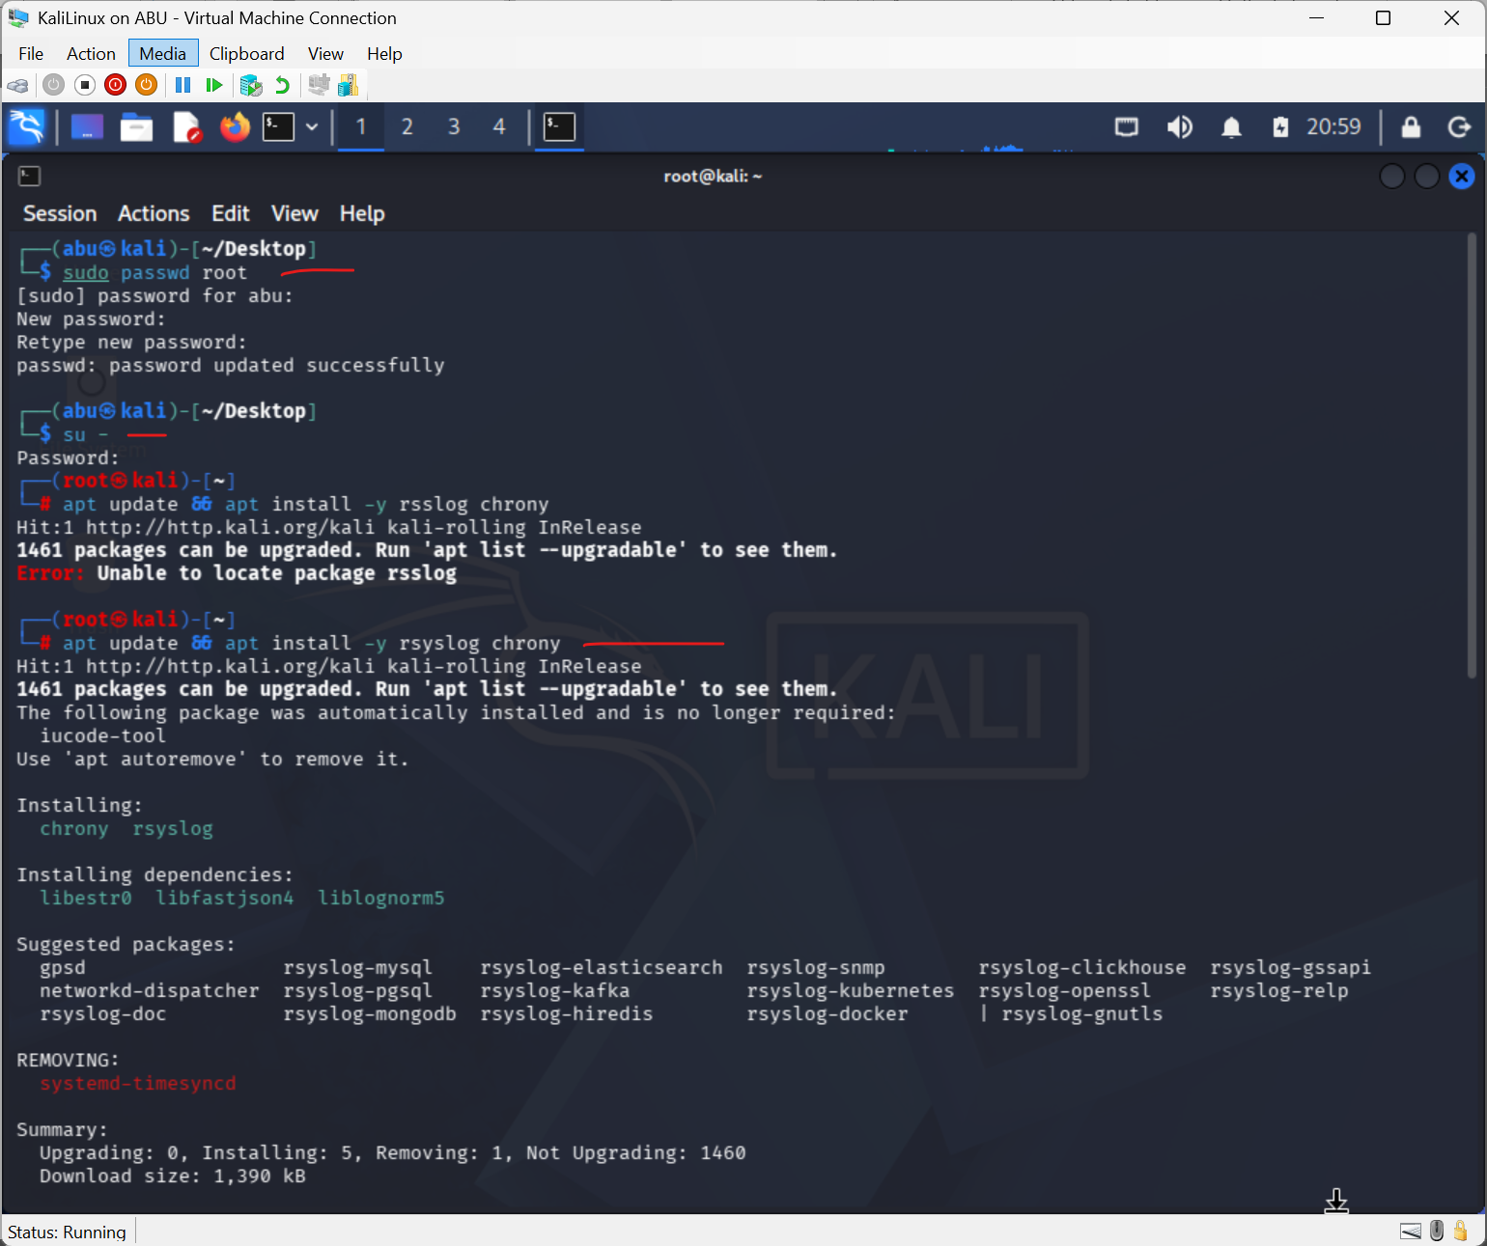

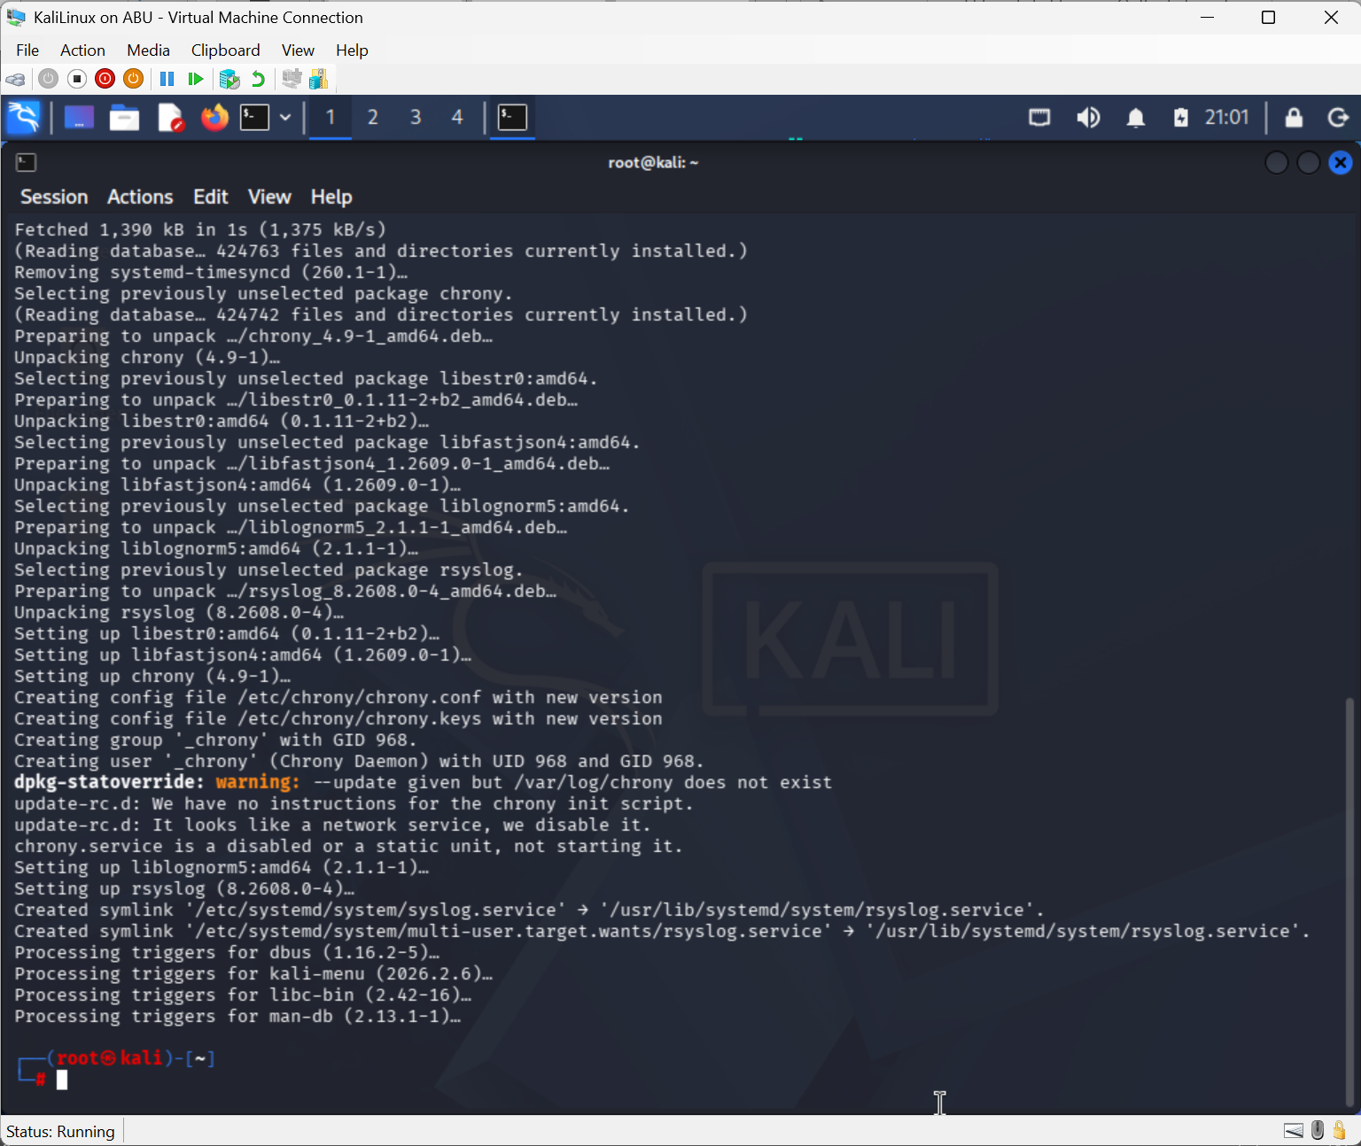

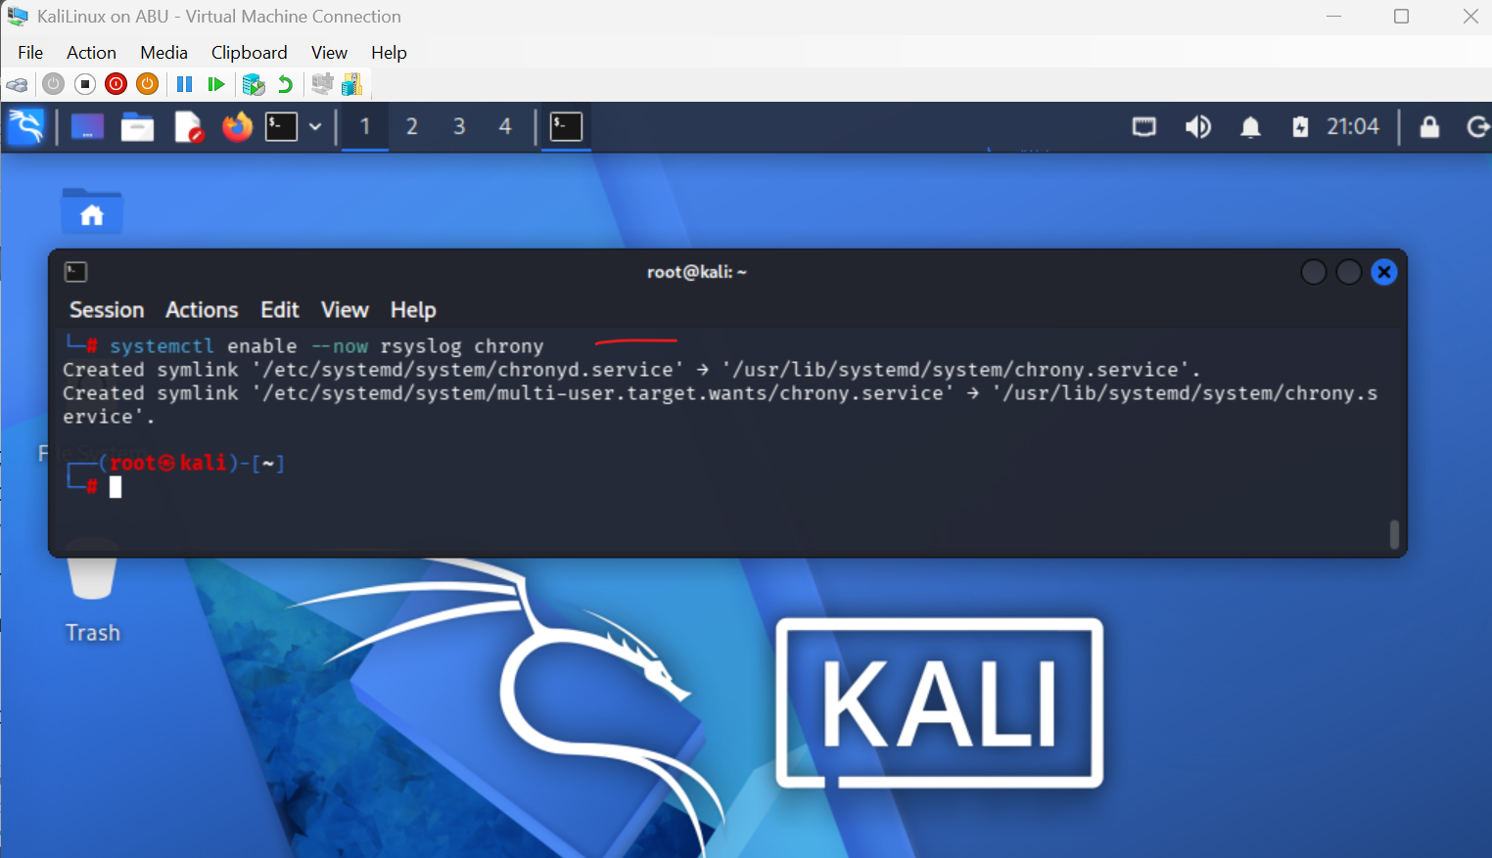

rsyslog is the default Linux syslog daemon. chrony is the modern NTP client; it converges faster than ntpd and tolerates jittery virtual machines.
Step 2 — Verify time synchronization
chronyc tracking
Purpose: Displays the synchronization status and accuracy of your system clock.

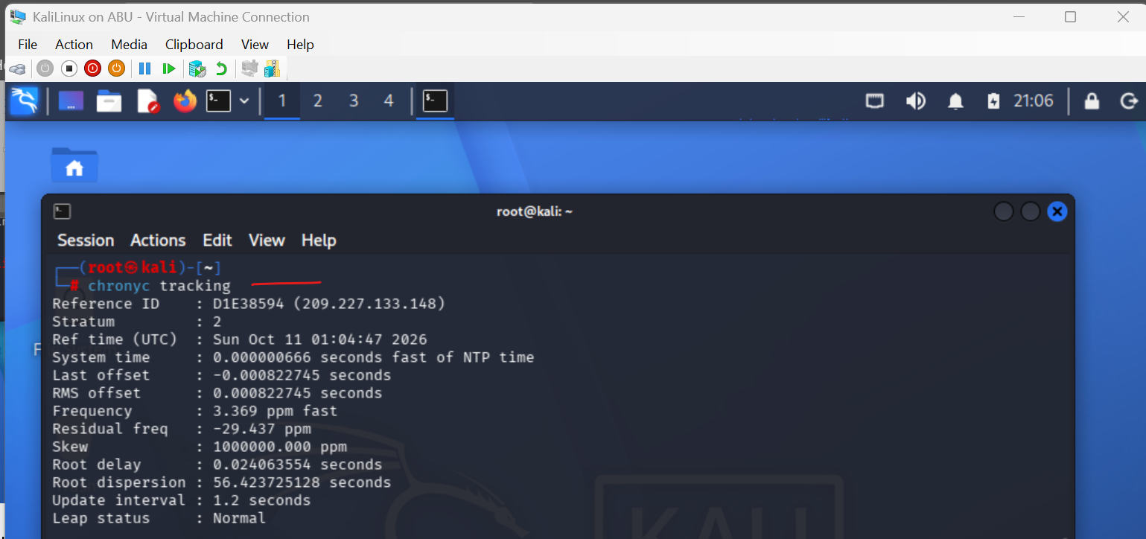
chronyc sources
Purpose: Displays the available time sources Chrony is checking.

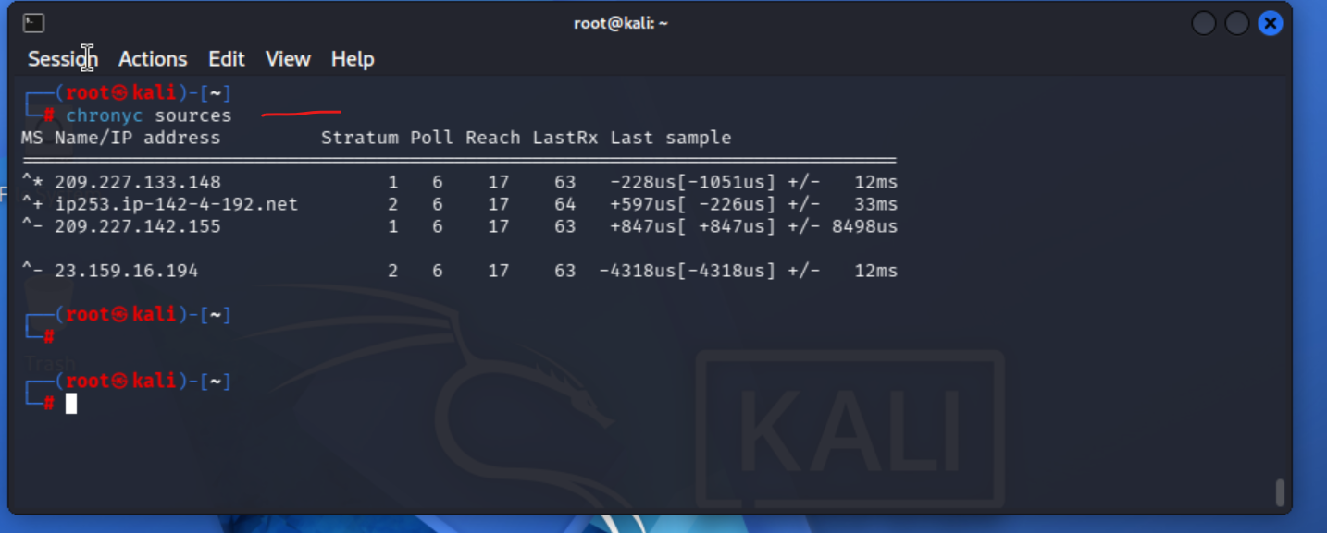

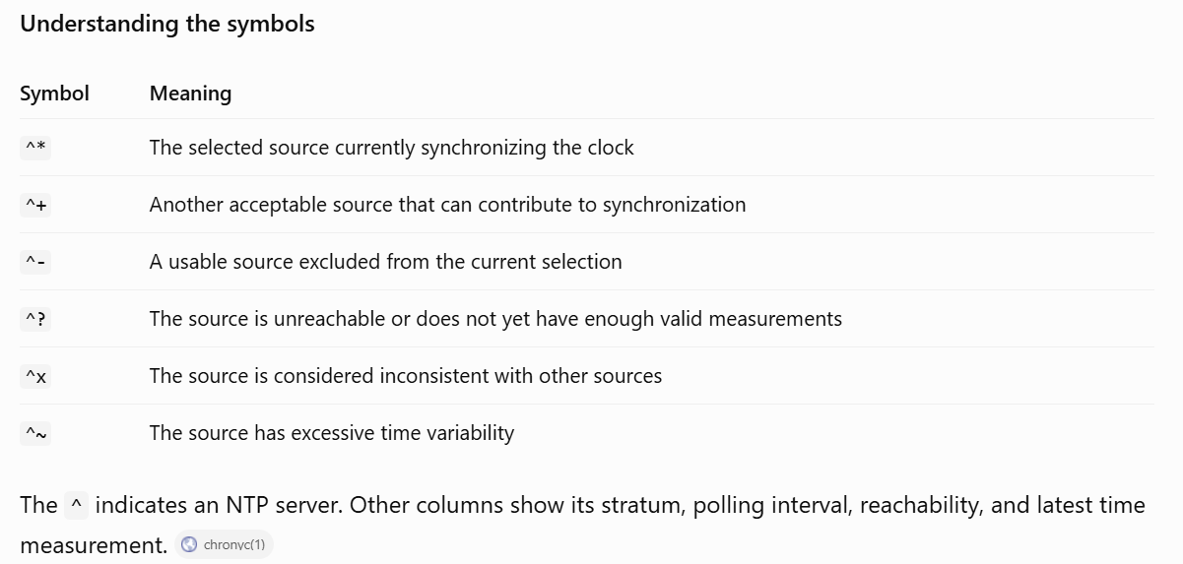
The Stratum field tells you how many hops to a reference clock. Last offset is how far your clock was off at the last update. Anything bigger than 1 second is a SOC red flag — it can defeat Kerberos and log correlation.

Force an immediate sync:
chronyc makestep
Purpose: Immediately corrects the system clock by stepping it to the correct time, rather than gradually adjusting it.
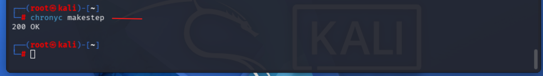

Step 3 — Inspect the rsyslog configuration
cat /etc/rsyslog.conf
Purpose: Displays the main configuration file for the Rsyslog logging service.
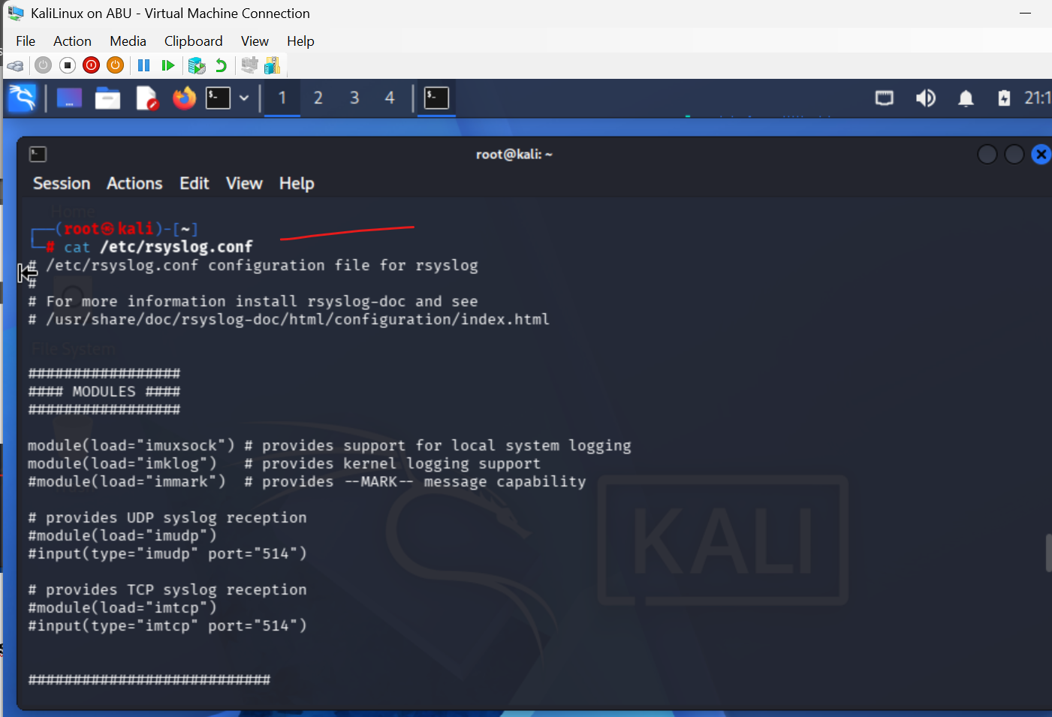
ls /etc/rsyslog.d/
Purpose: Lists additional Rsyslog configuration files in the /etc/rsyslog.d/ directory.
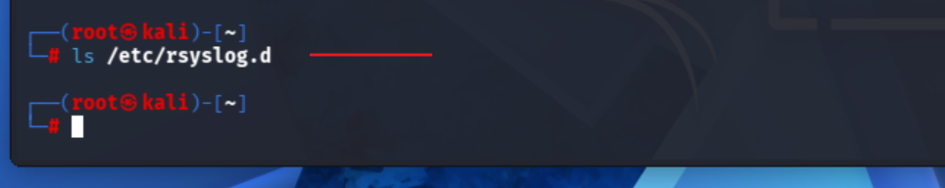
The main file routes messages by facility (auth, cron, kern, mail, daemon, local0–7) and severity (emerg, alert, crit, err, warning, notice, info, debug). These are the eight CySA+ "logging levels" you must memorise.

Step 4 — Generate logs at each severity
logger -p user.info "lab1: info message"
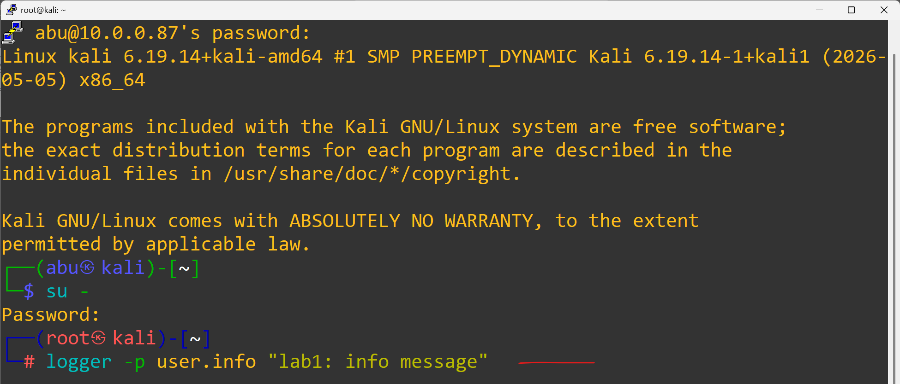
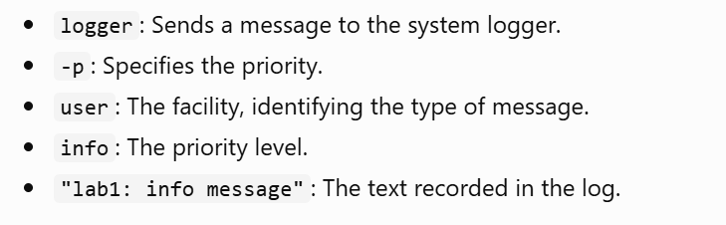

logger -p user.warning "lab1: warning message"
Sends a warning-level message using the user facility.

logger -p user.err "lab1: error message"
Sends an error-level message indicating that a problem occurred.

logger -p auth.crit "lab1: simulated critical auth failure"
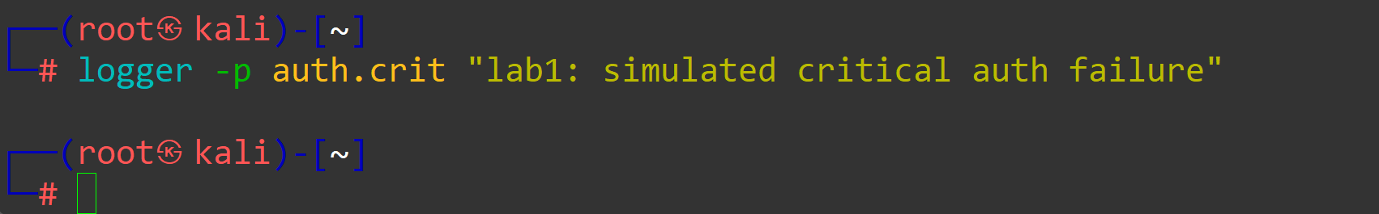
Sends a simulated critical-level authentication message. It does not create an actual authentication failure.
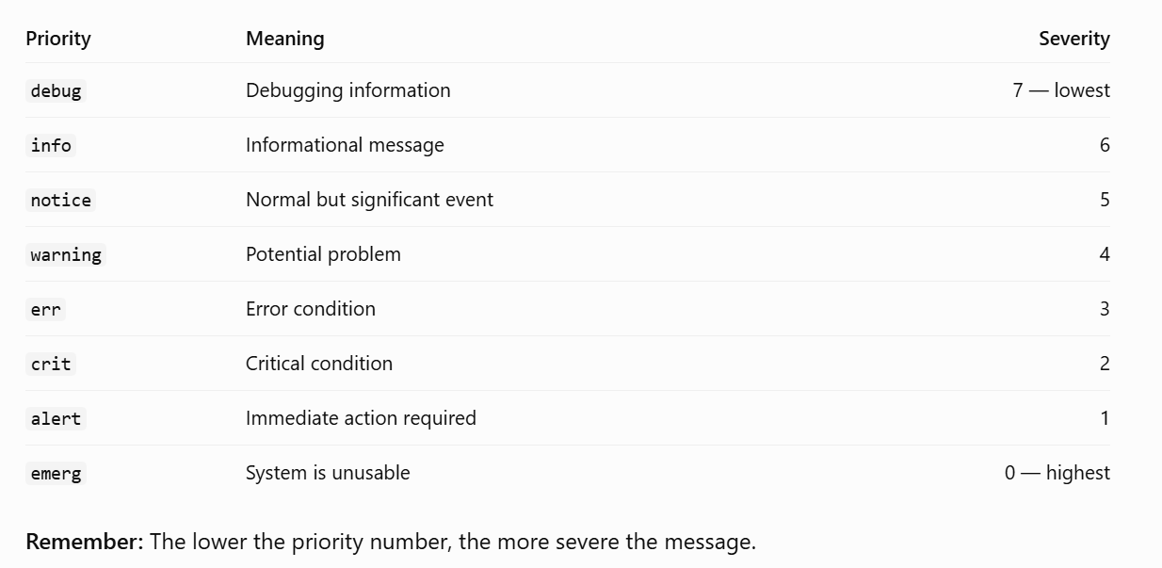
logger is the standard tool to inject a syslog message from the shell. Now read them back:
tail -n 20 /var/log/syslog
Purpose: Displays the last 20 lines of the system log file on Linux systems that use /var/log/syslog.
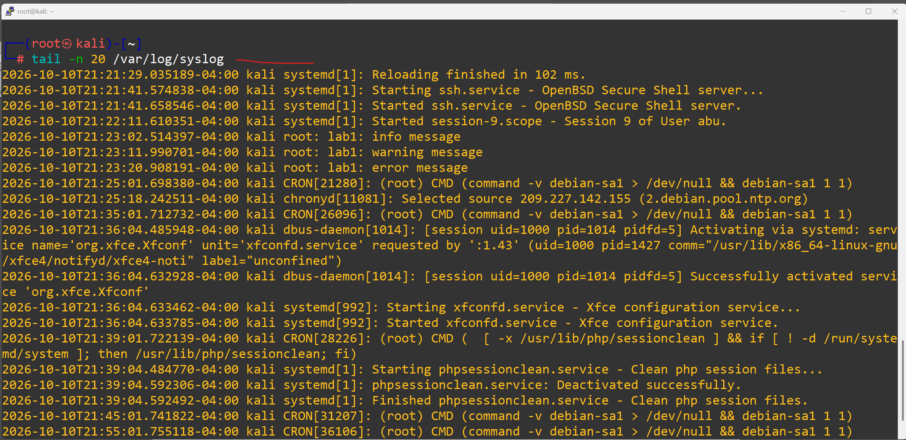
grep lab1 /var/log/syslog
Purpose: Searches the /var/log/syslog file and displays every line containing the text lab1.
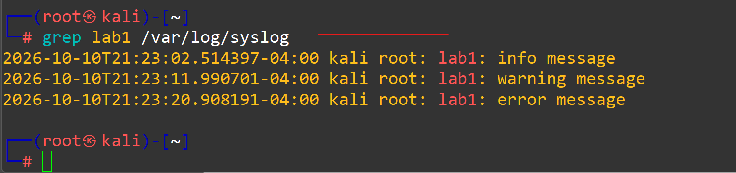

Step 5 — Configure a central collector (loopback test)
This command creates a new Rsyslog configuration file to configure your Linux server as a central log collector. It enables receiving log messages over UDP port 514 and writes received/processed messages to /var/log/central.log.
Edit /etc/rsyslog.d/10-collector.conf:
cat > /etc/rsyslog.d/10-collector.conf <<'EOF'
module(load="imudp")
input(type="imudp" port="514")
*.* /var/log/central.log
EOF
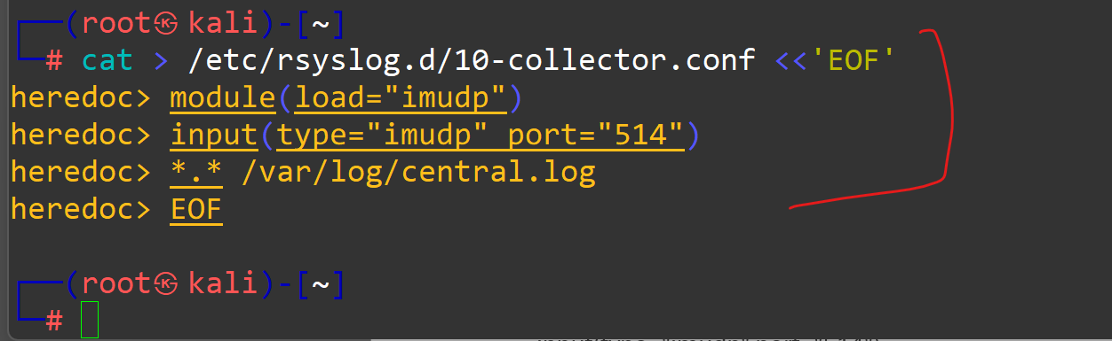

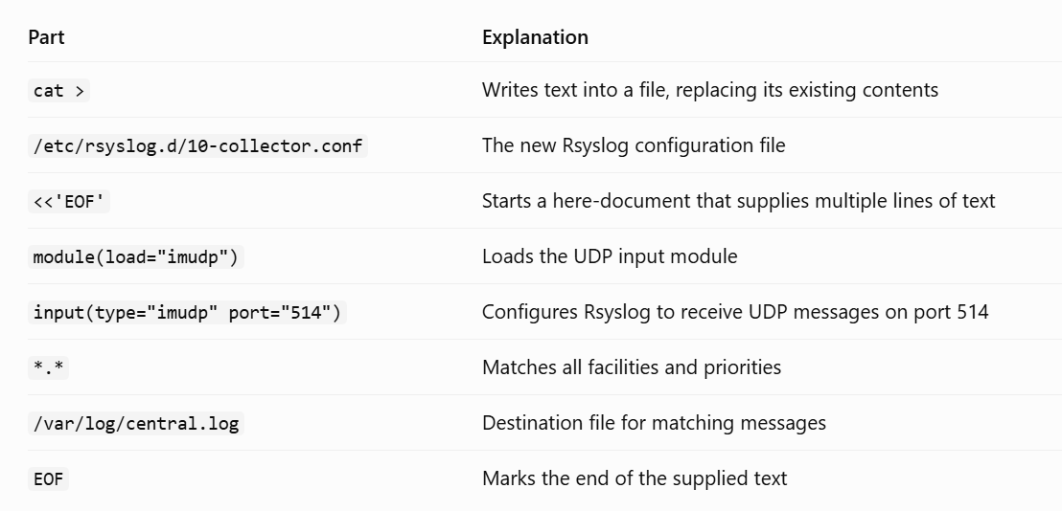

Restarts the Rsyslog service so it can reload your new configuration file, /etc/rsyslog.d/10-collector.conf.
systemctl restart rsyslog
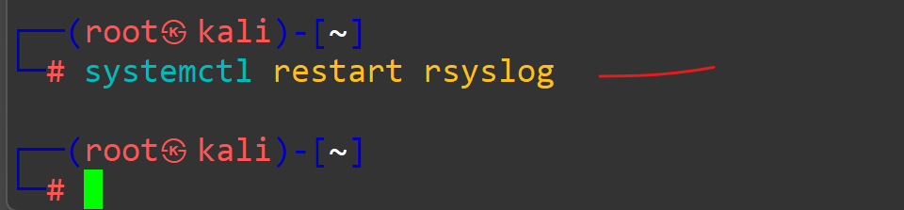
This loads the UDP input module and writes every received message to /var/log/central.log. Now forward local messages to ourselves over UDP:
echo '*.* @127.0.0.1:514' > /etc/rsyslog.d/20-forward.conf
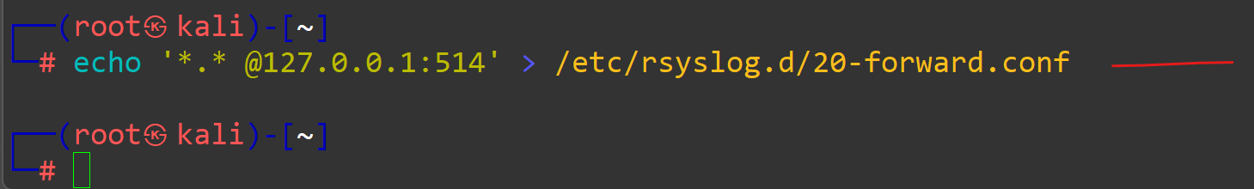
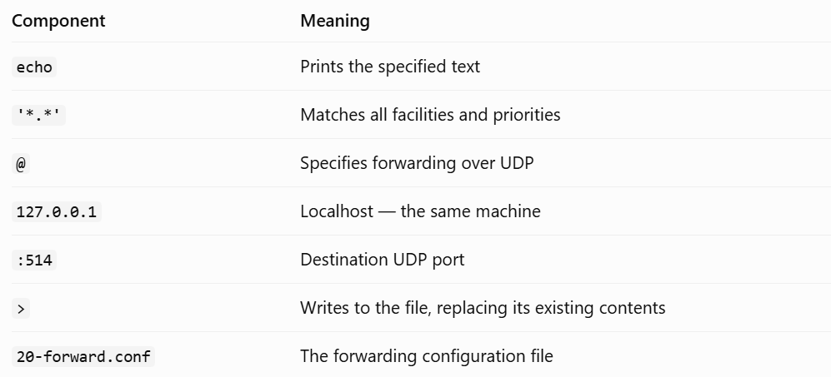

systemctl restart rsyslog
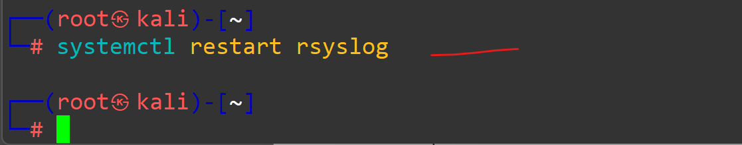
The command sends a test log message with the local0 facility and notice priority. You can use it to test your Rsyslog forwarding configuration.
logger -p local0.notice "lab1: forwarded test"
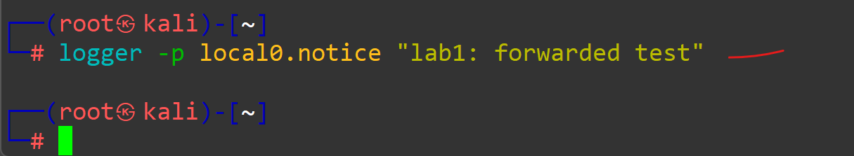
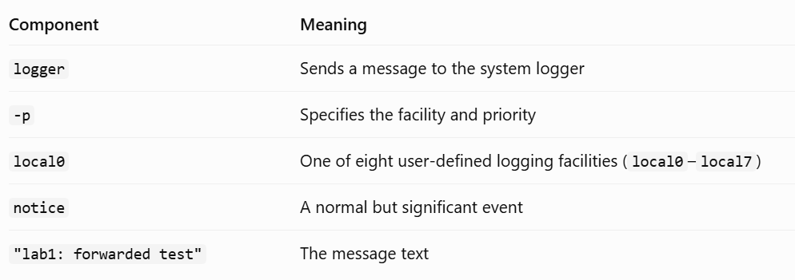
sleep 1
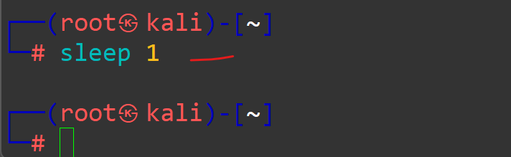
tail /var/log/central.log
Purpose: Displays the last 10 lines of the central log file by default.
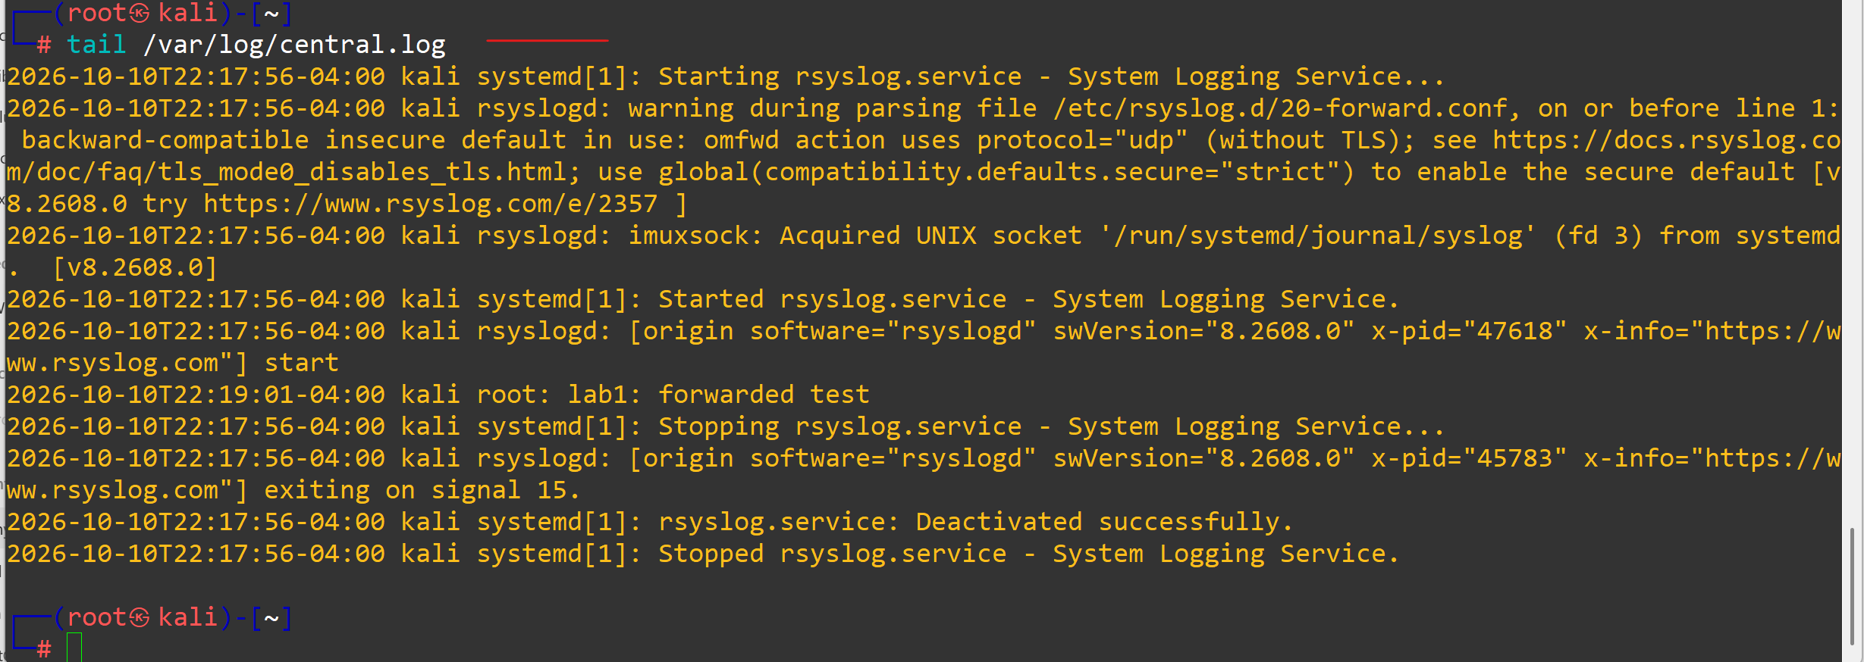
You have just built a one-host SIEM ingestion pipeline.

Step 6 — Confirm receiver is listening
ss -ulnp | grep :514
This command checks whether a process is listening on UDP port 514, which is commonly used for syslog messages in your Rsyslog central logging lab.
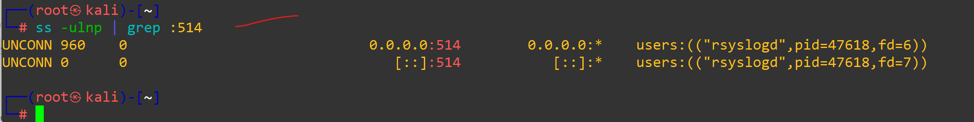
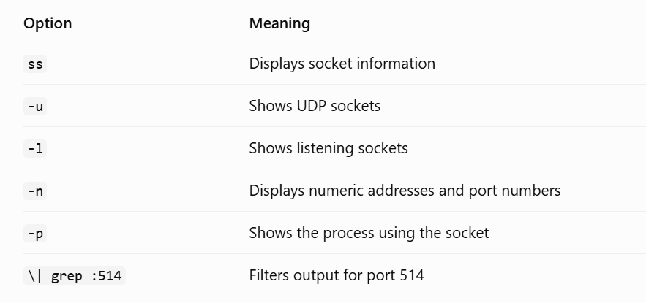
You should see rsyslogd bound to UDP/514.
What you learned
- The 8 syslog severity levels and how to filter on them.
- How to inject messages with logger and follow them in /var/log/syslog.
- How to centralize logs over UDP/514 with rsyslog.
- Why time sync is required before correlation — and how to verify it with chronyc.

