Lab 2 — OS Hardening and System Process Inspection
In this lab you will audit a Linux host with lynis, enable kernel-level auditing with auditd, and inspect running processes, kernel modules, and hardware to spot deviations from a baseline. These are exam-blueprint skills under CySA+ 1.1 (Operating system concepts — system hardening, system processes, hardware architecture, file structure).
Step 1 — Install hardening and audit tools
apt update && apt install -y lynis auditd
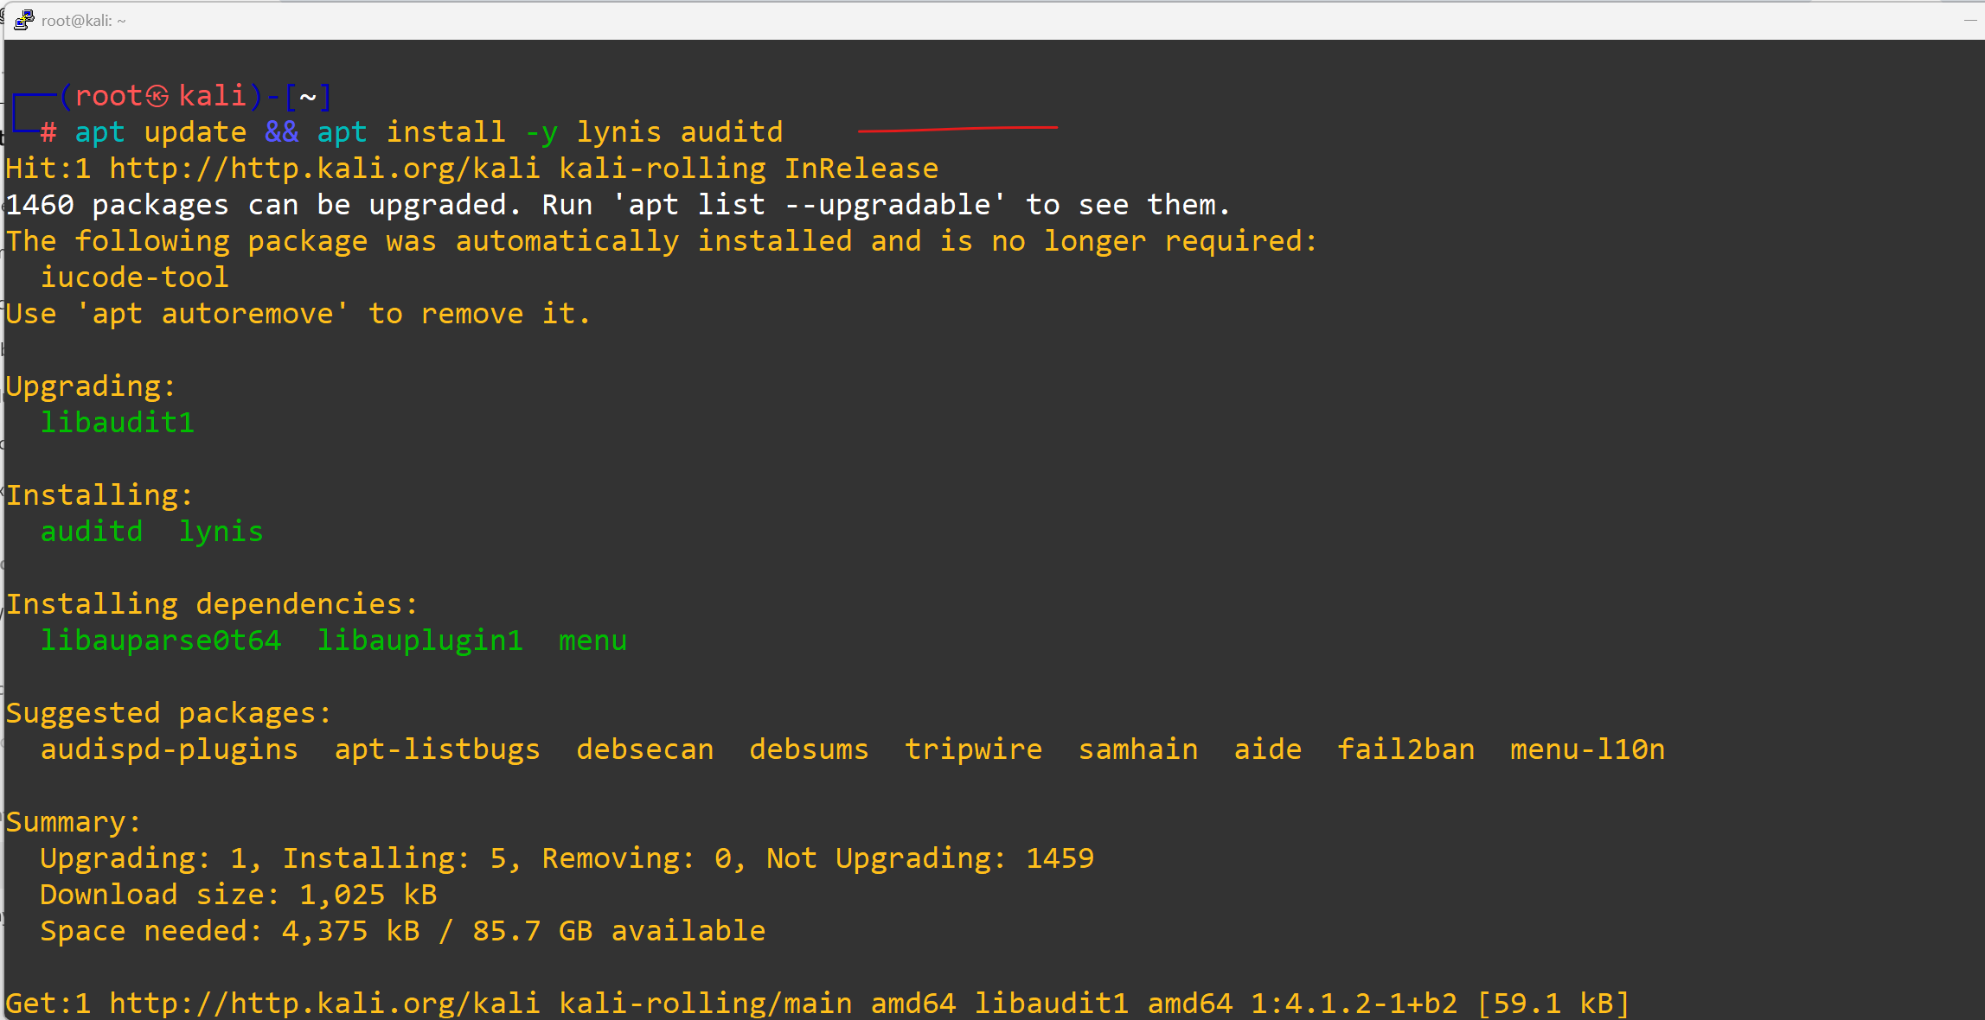
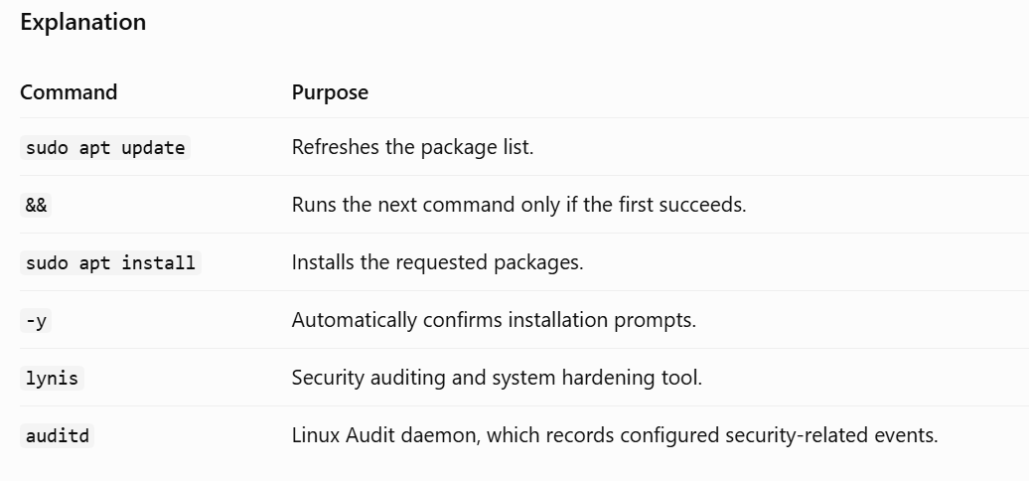
lynis is a free CIS-style hardening scanner. auditd is the Linux audit subsystem that records syscall-level events.
Step 2 — Inspect the file structure and configuration locations
ls /etc | head
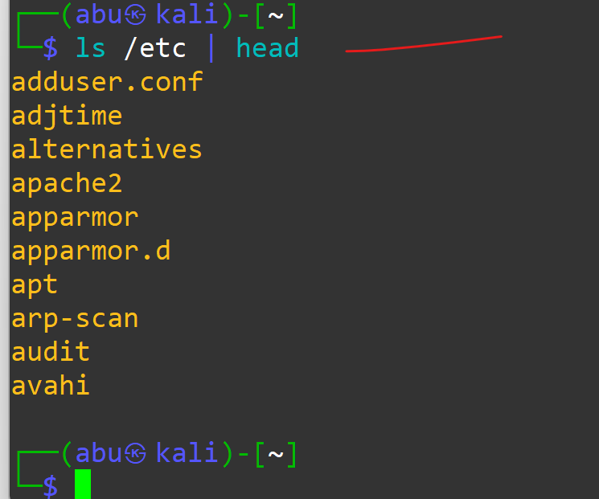
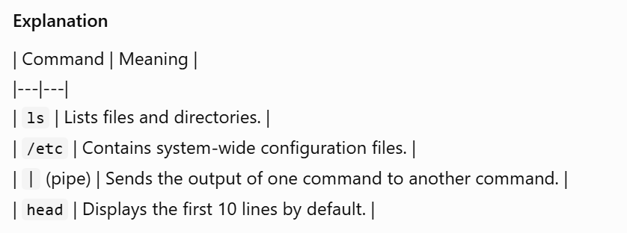
ls /var/log
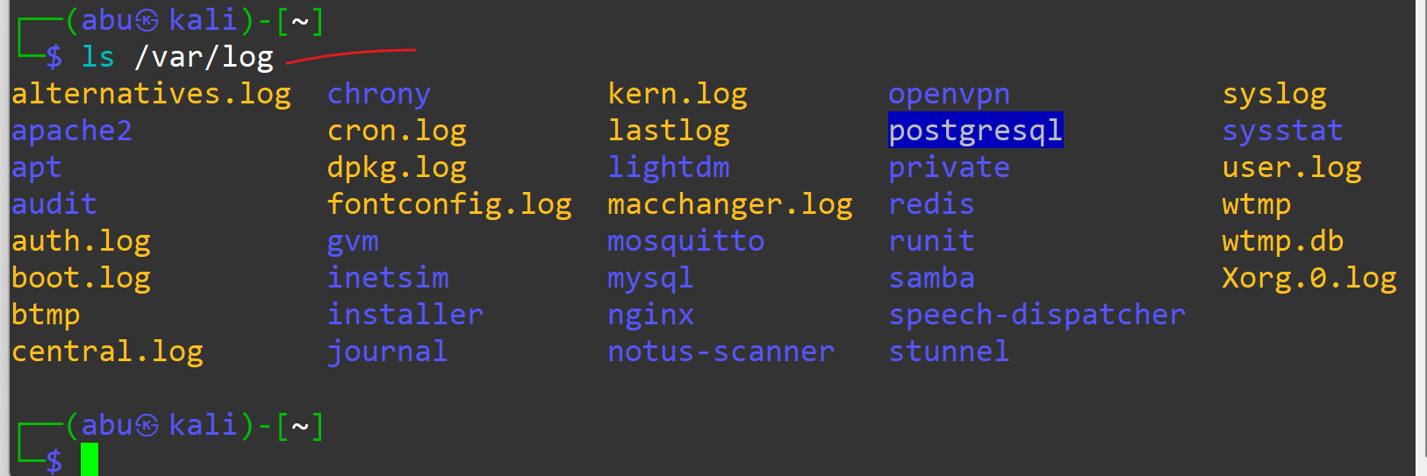
ls /proc/sys/kernel | head
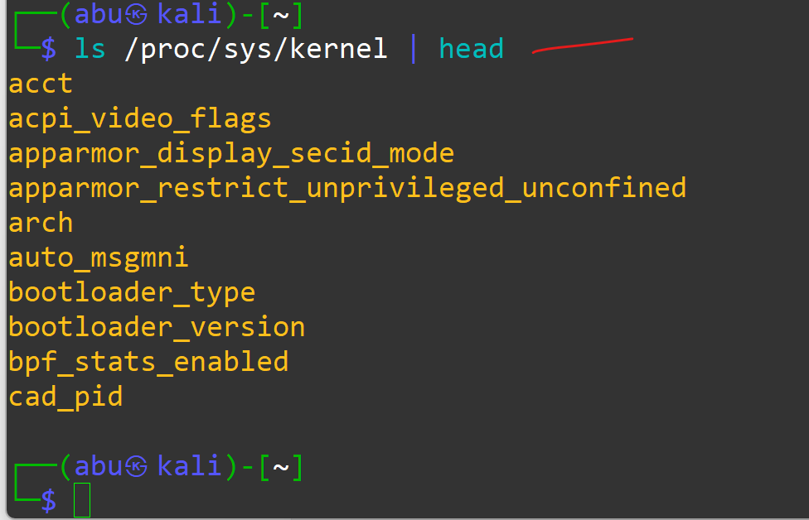
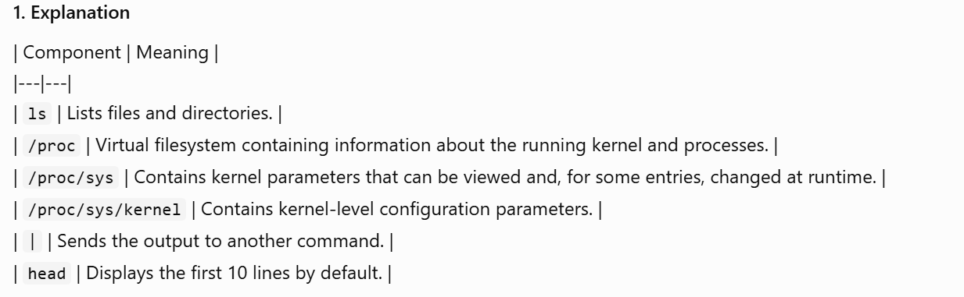
Cyber analysts must know where configuration lives:
- /etc — system configuration files
- /var/log — log files
- /proc/sys and /sys — kernel tunables
- ~/.ssh, ~/.bash_history — per-user artefacts

Step 3 — Enumerate processes (CySA+ "system processes")
ps -ef --forest | head -30
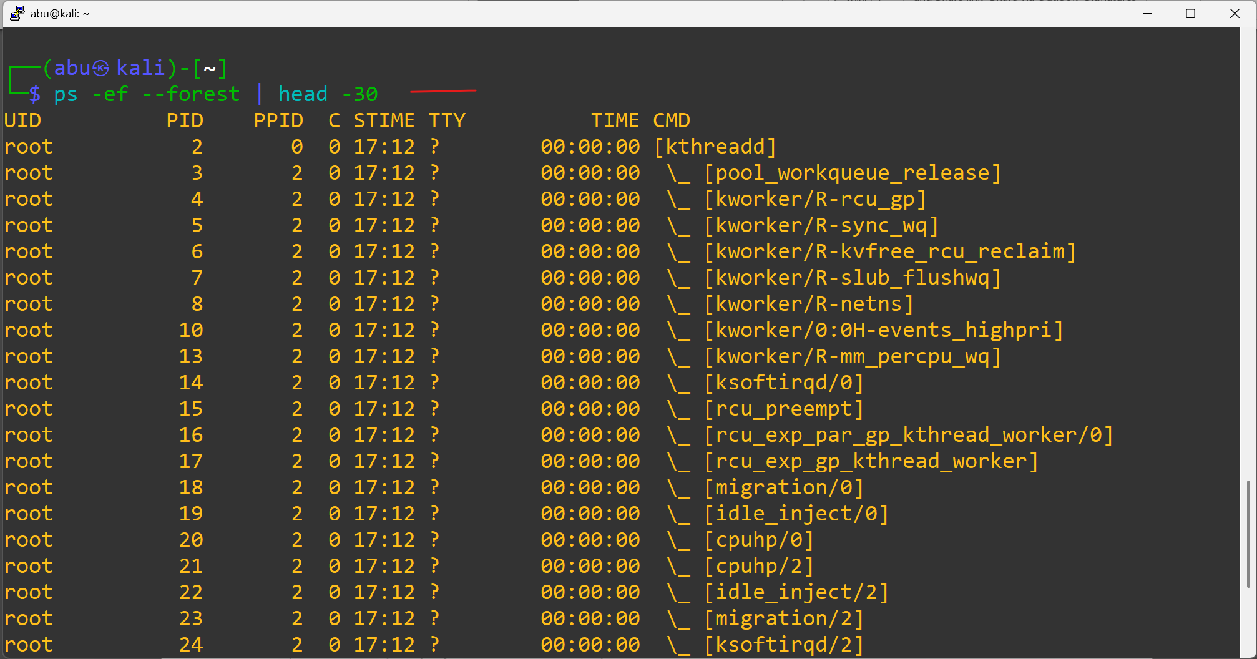
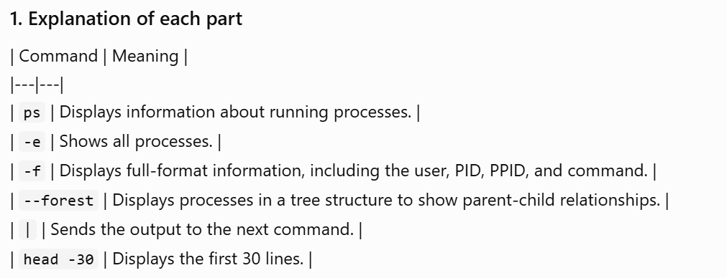
ps -eo pid,user,%cpu,%mem,etime,cmd --sort=-%cpu | head
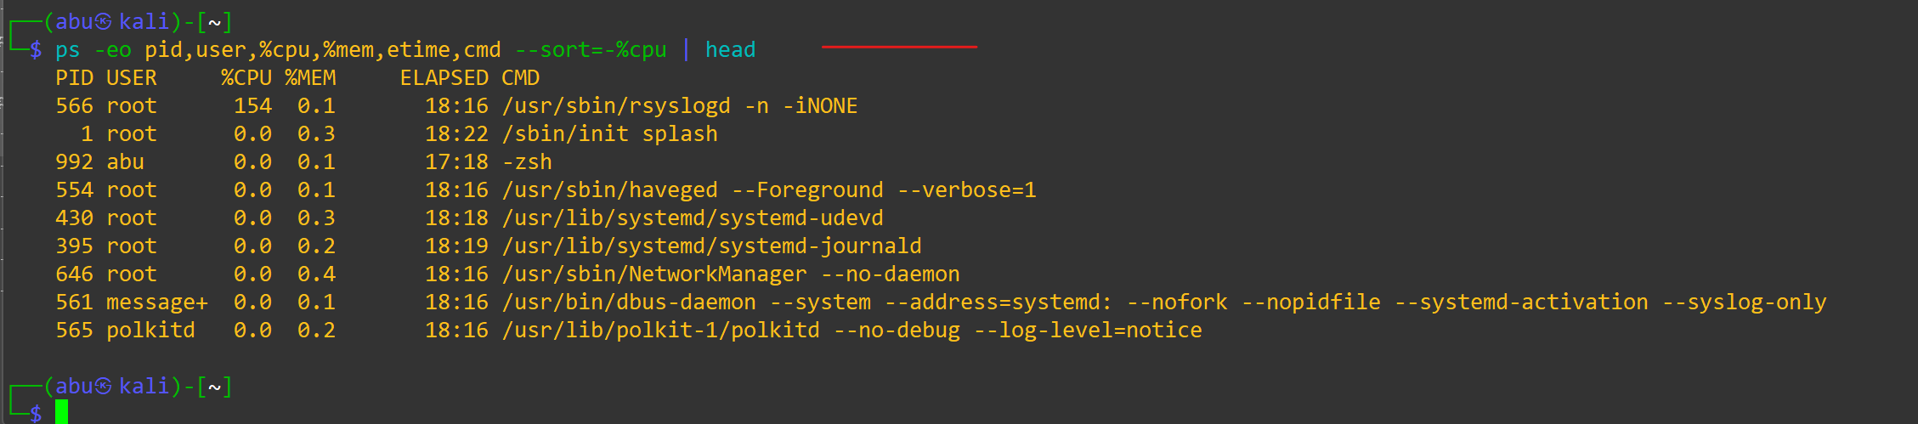
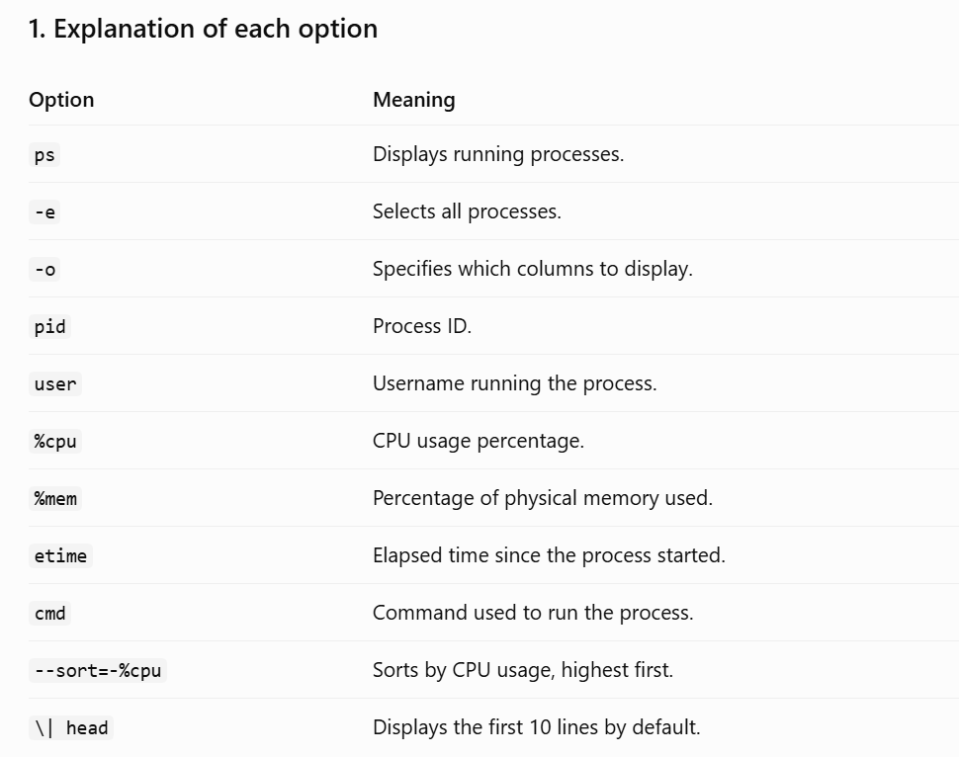
Look for unexpected parents — e.g. bash spawned by httpd is a classic web-shell indicator.
List open network sockets and which process owns them:
ss -tulnp
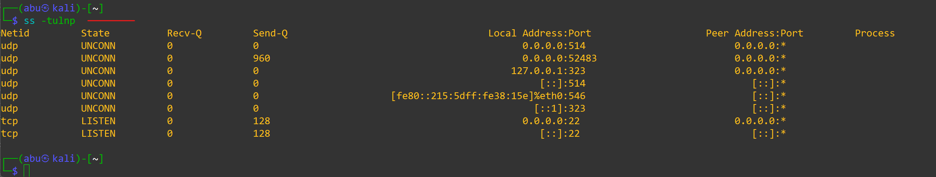
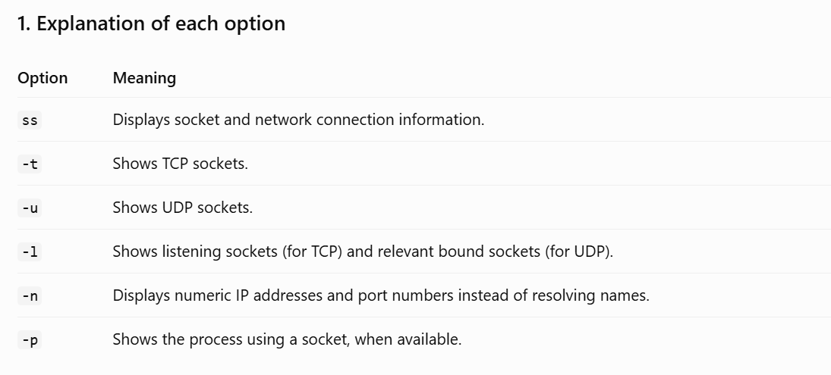
Step 4 — Inspect the hardware architecture
lscpu
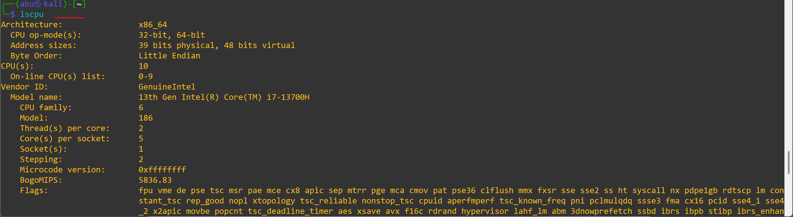
displays information about the CPU (Central Processing Unit) architecture and hardware available to your Linux system.
lsmem 2>/dev/null || free -h
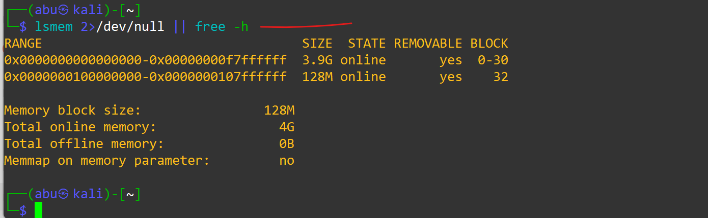
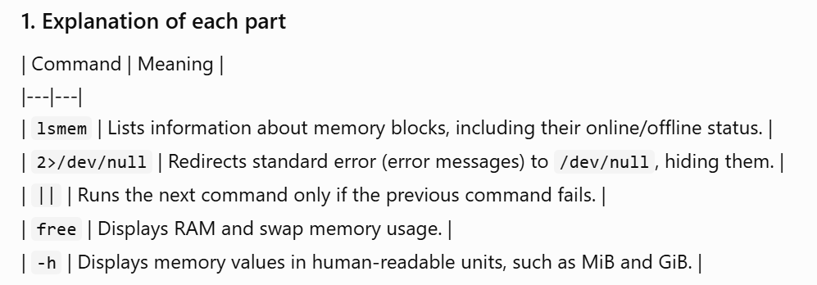
lspci 2>/dev/null | head
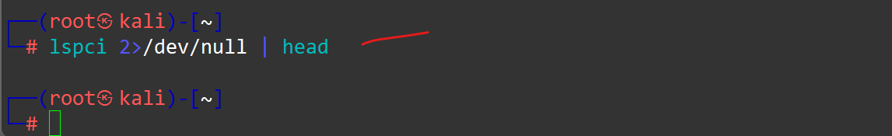
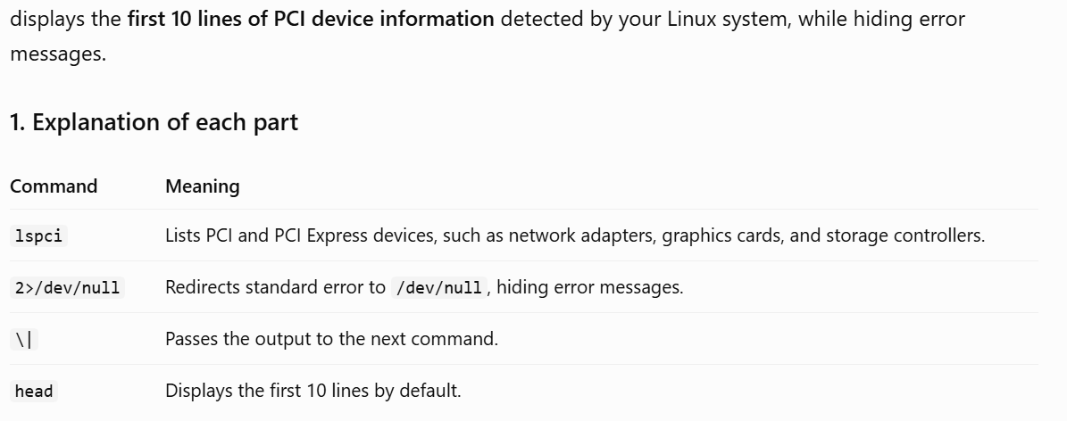
uname -a
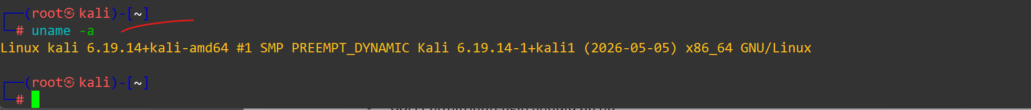
CySA+ expects you to know x86_64 vs ARM, CPU virtualization flags, and how to read uname for kernel version (which CVEs depend on).

Step 5 — Run a Lynis hardening audit
lynis audit system –quick
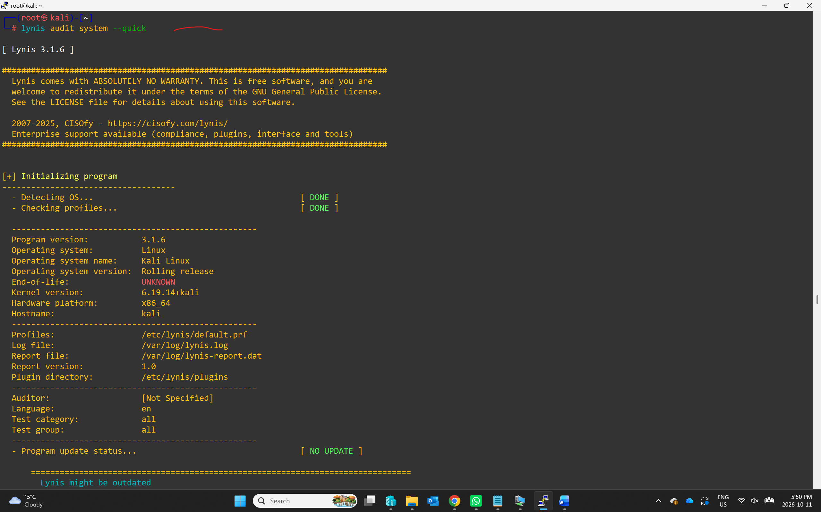
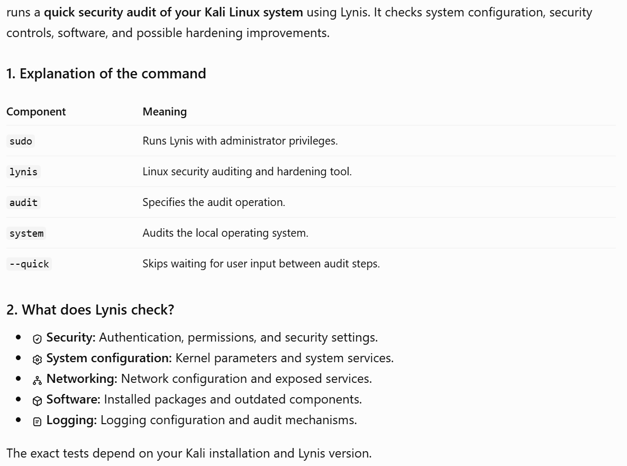
When it finishes, scroll to Suggestions and Hardening index. Common findings:
- SSH PermitRootLogin should be no
- Disable unused filesystems (cramfs, freevxfs)
- Enable process accounting
Read the full report:
less /var/log/lynis.log
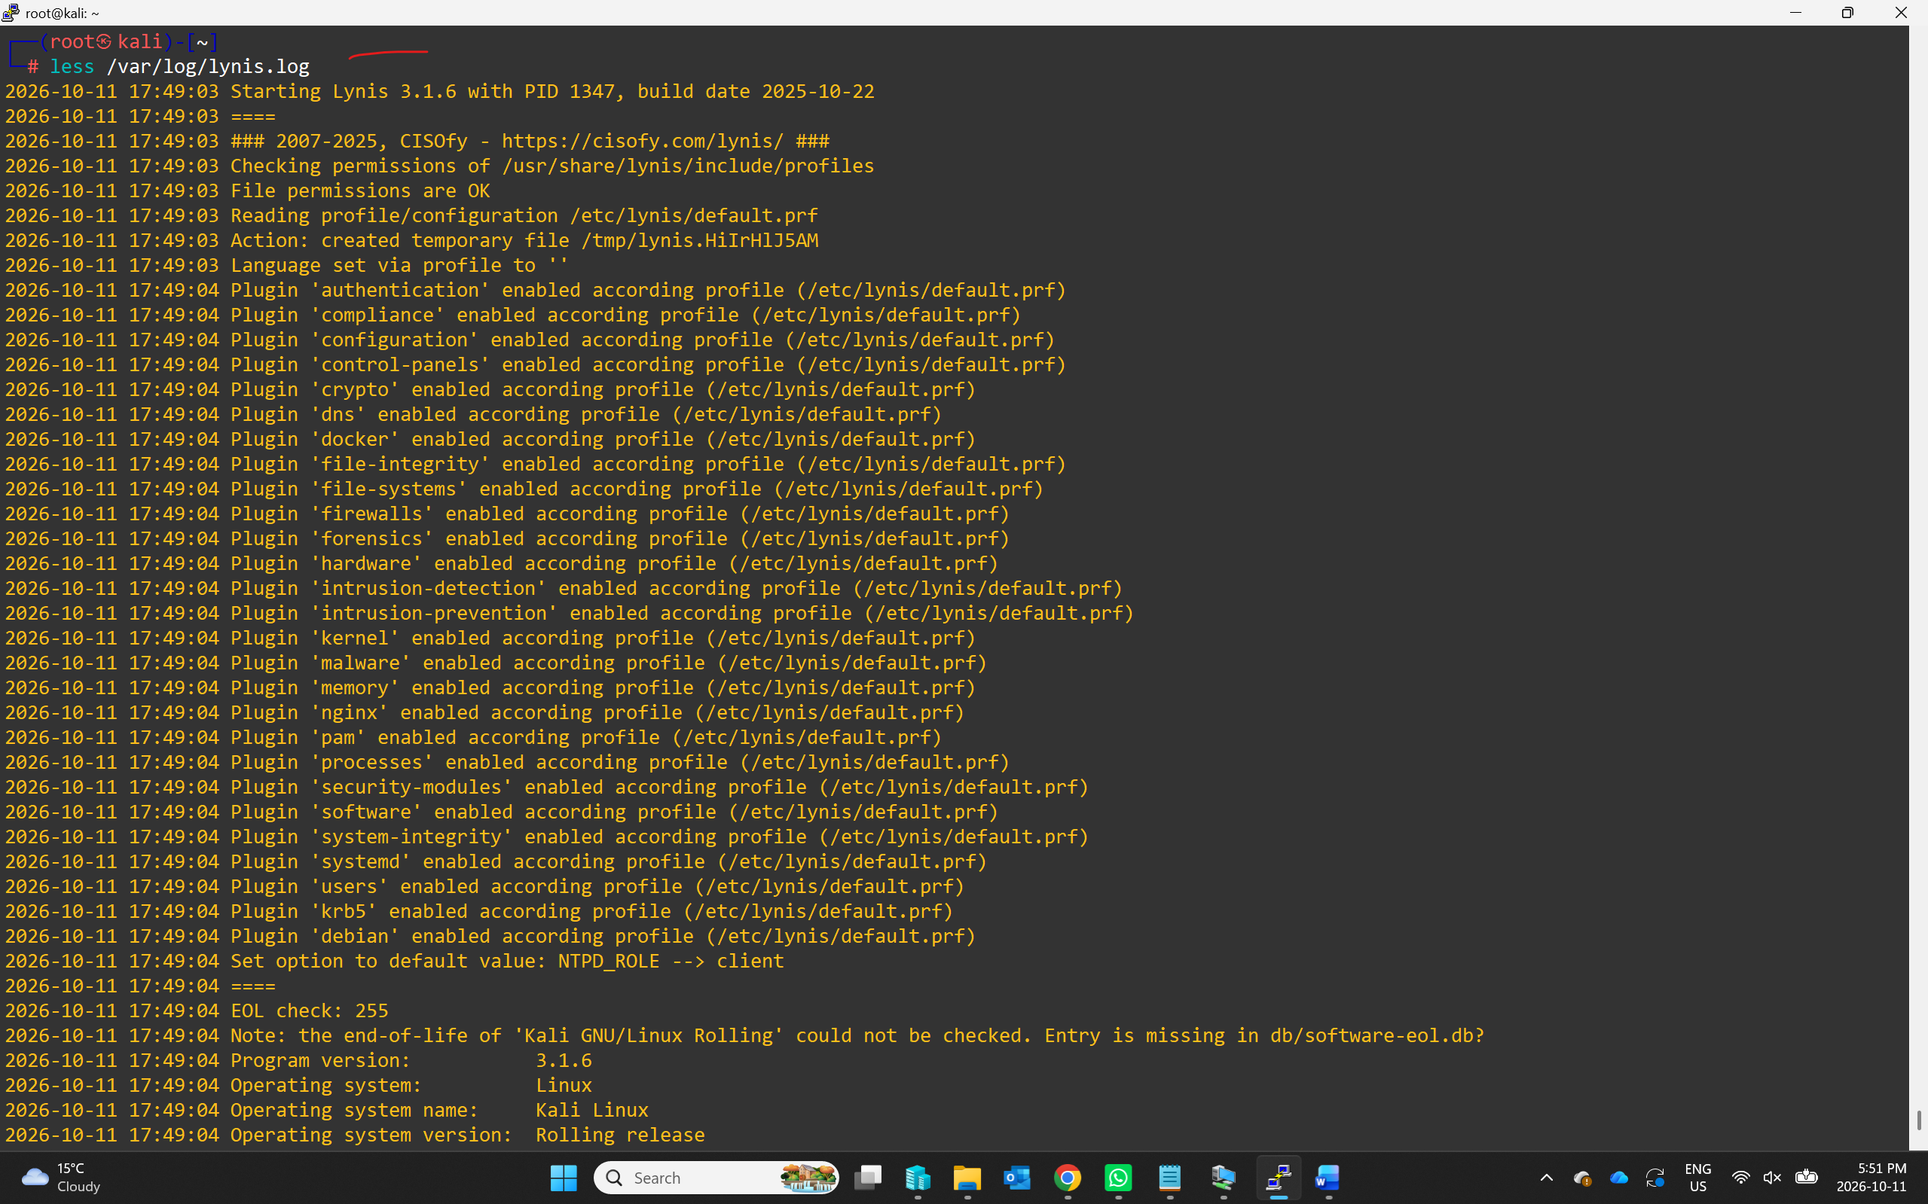

Step 6 — Enable auditd and watch a sensitive file
systemctl enable --now auditd
auditctl -w /etc/passwd -p wa -k passwd_changes
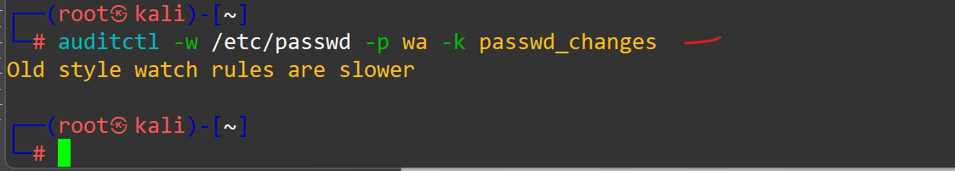
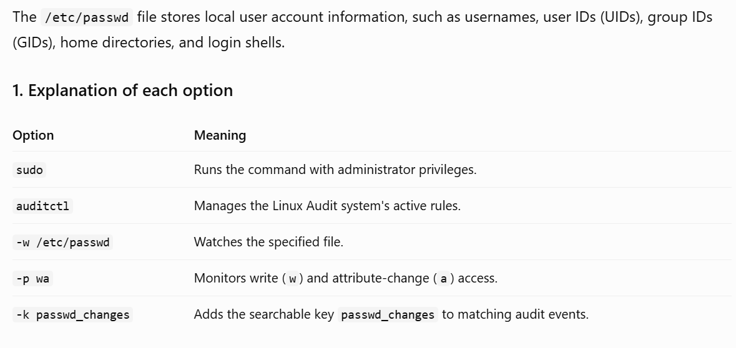
-w adds a watch, -p wa records writes and attribute changes, -k tags events with a key. Now trigger an event:
echo "# test" >> /etc/passwd
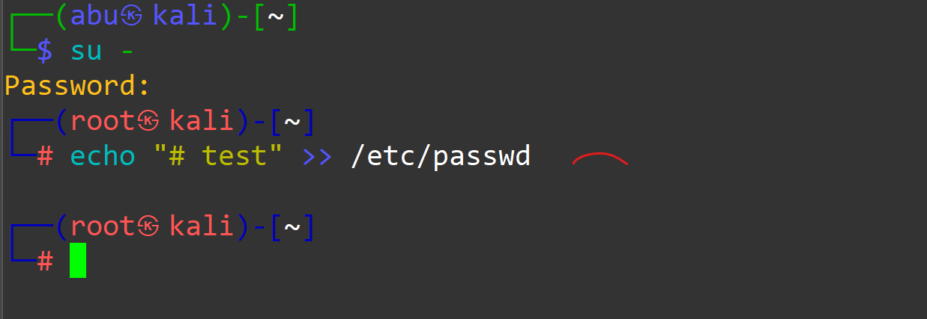
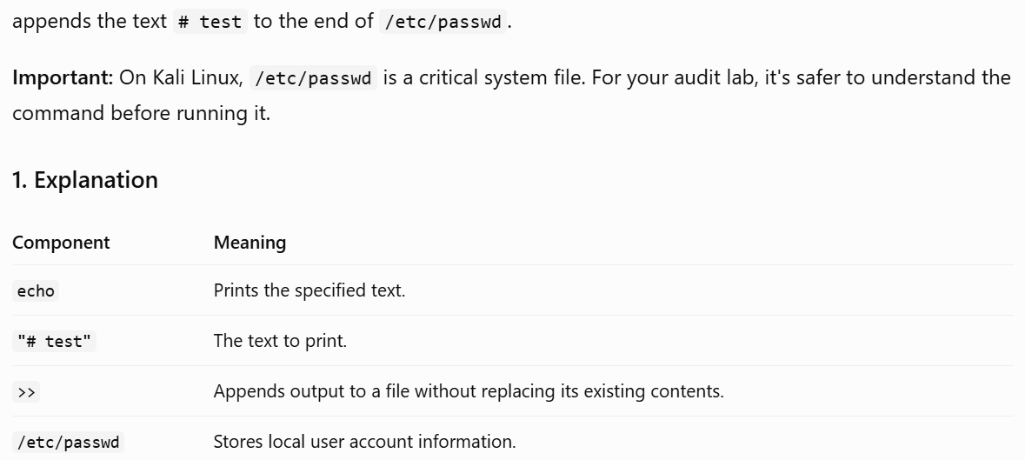
ausearch -k passwd_changes -i | tail [Output is not coming, so use the next command]
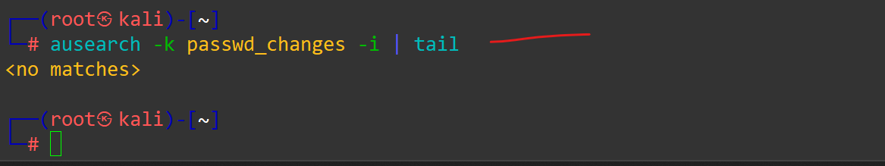
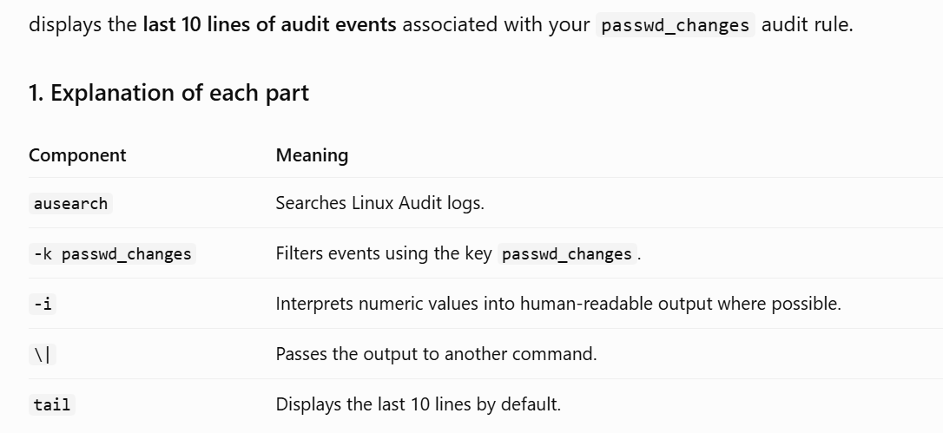
tail -n 30 /var/log/audit/audit.log
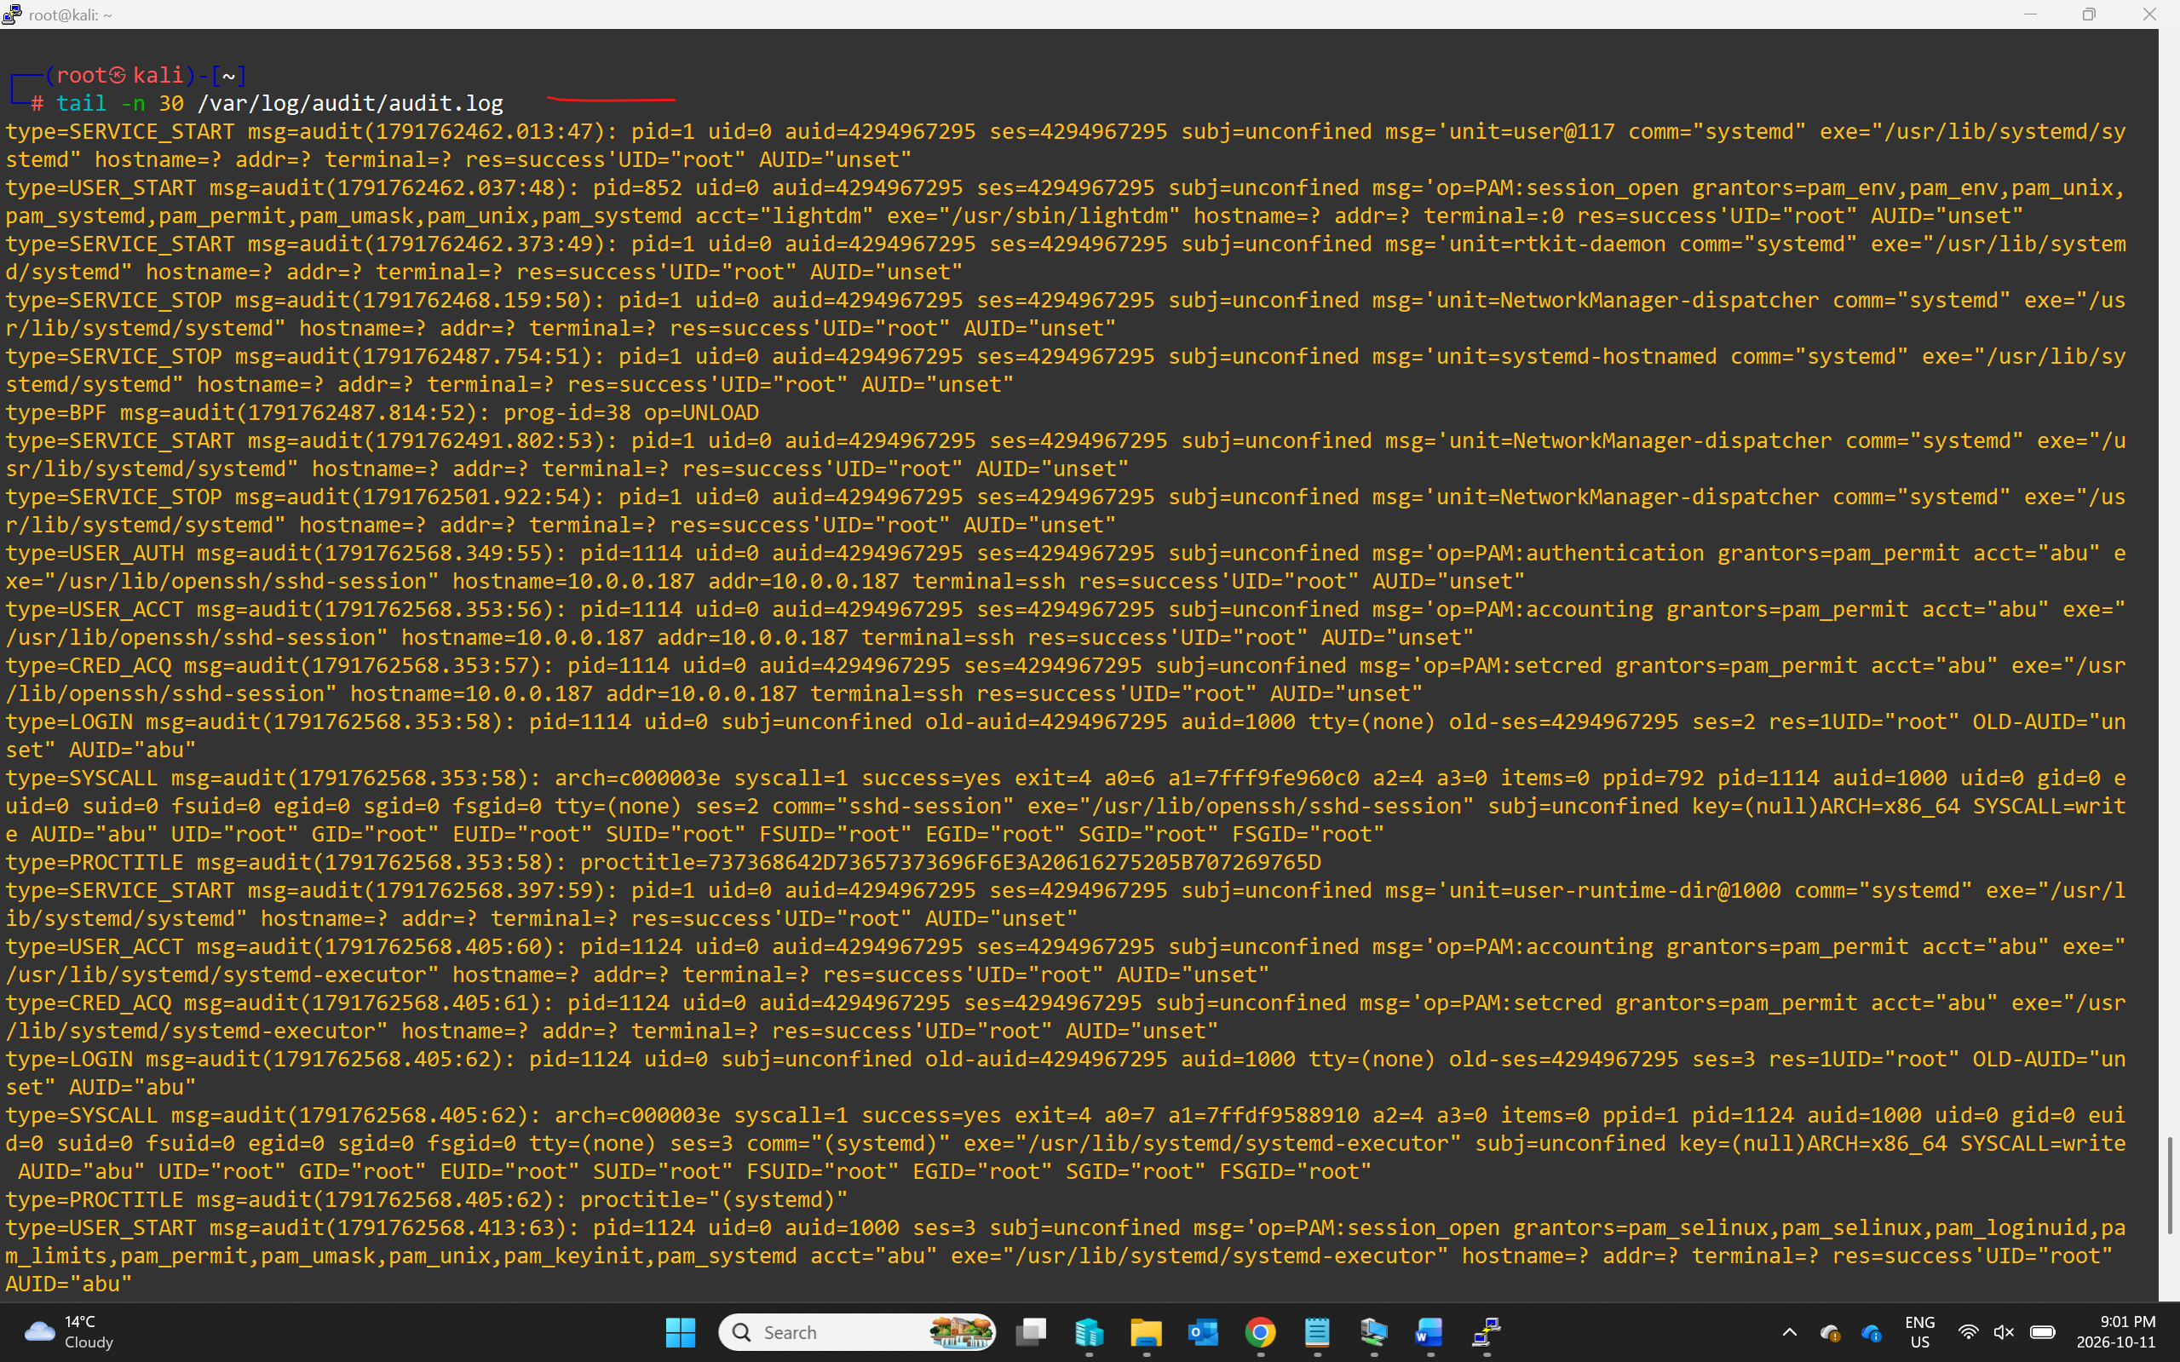

You should see who, when, and which syscall touched the file.

Step 7 — Apply a quick hardening control
Disable an unused service and verify:
systemctl list-unit-files --state=enabled | head
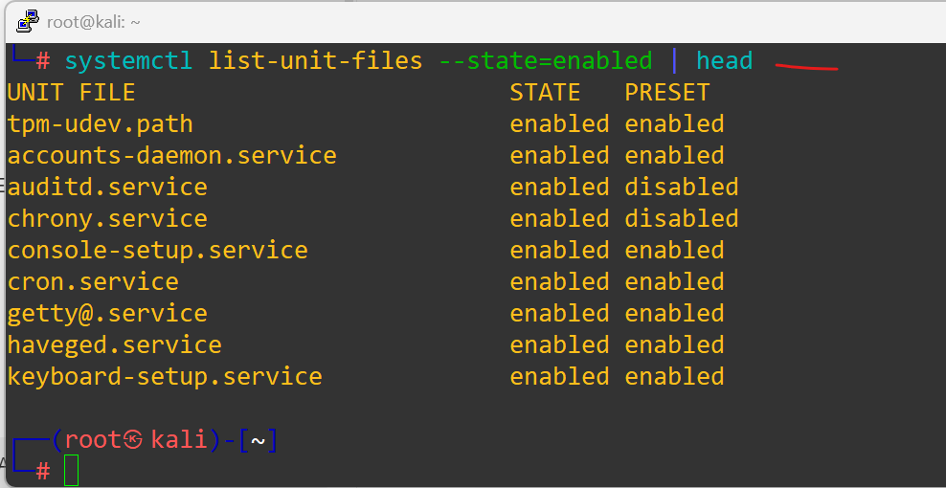
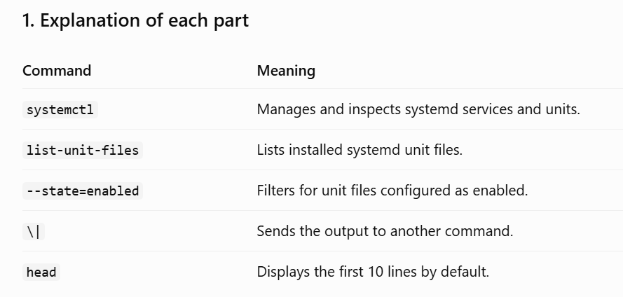
systemctl disable --now cron 2>/dev/null
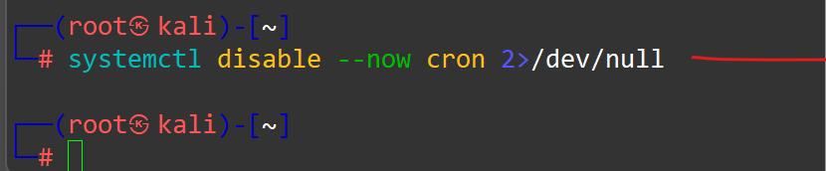
systemctl status cron
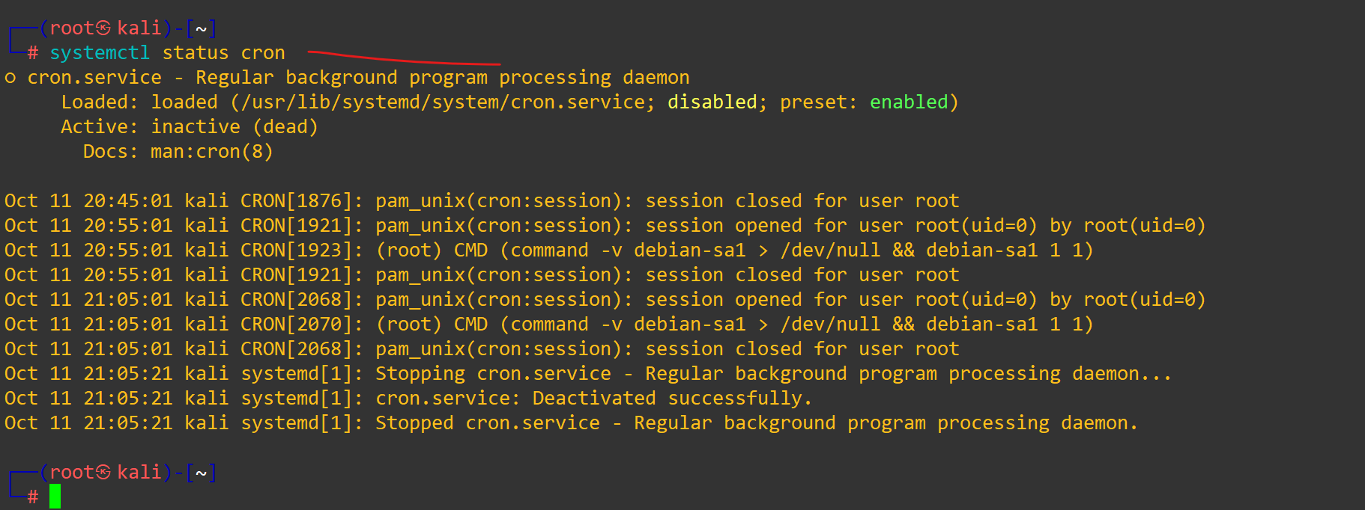
In production you would also: enable a host firewall (Lab 24), set umask 027, and configure /etc/login.defs password policy.

What you learned
- Where Linux configuration, logs, and kernel tunables live.
- How to enumerate processes, sockets, hardware, and kernel.
- How to run a free CIS-style audit with lynis.
- How to write an auditd rule and read the resulting events with ausearch.

