Reasoning Termination, Not Reasoning Capability
Budget forcing on VibeThinker-3B, AIME 2025
Abu Ahmad · 2121725042 · CSE 465 · North South University
The finding
VibeThinker-3B scores 91.4 on AIME 2025 in its paper; we reproduced 80.8. The gap is not weaker reasoning — the model solves the problem and then never writes the answer down. Of 120 sampled attempts, essentially every one that finished was correct, while every one cut off by the token budget scored zero for want of a boxed answer. Across 1,200 sample-budget observations the model volunteered exactly one wrong answer: it states the correct answer or states nothing at all. Interrupting it at the budget and forcing it to commit recovers 7 to 13 points, has never destroyed a correct answer, and costs about five tokens.
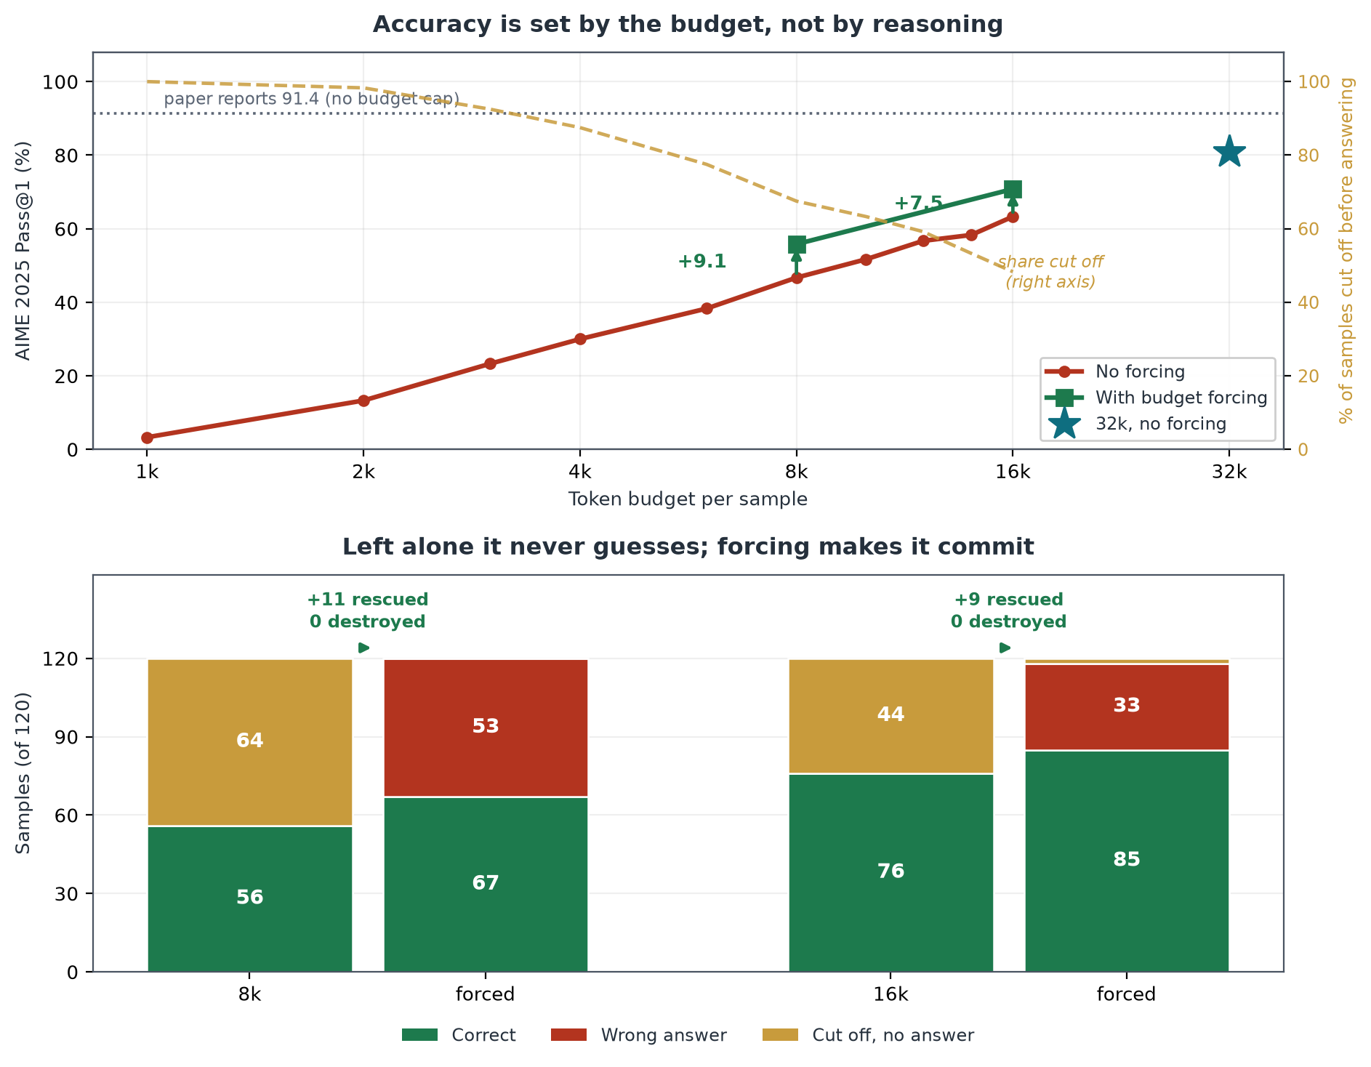
Top: accuracy rises with the token budget as truncation falls — mirror images. Bottom: forcing converts the amber “no answer” block into correct and wrong, and the green never shrinks.
Table 1 · Main result
Budget | No forcing | + Forcing | Gain | McNemar p
4k | 27.5% | 40.8% | +13.3 | —
8k | 46.7% | 55.8% | +9.1 | 0.0026
16k | 63.3% | 70.8% | +7.5 | 0.0077
32k | 80.8% | not run | — | —
Table 2 · Does forcing ever hurt?
Budget | Truncated | Rescued | Damaged | p
8k | 81 | 11 | 0 | 0.0026
16k | 58 | 9 | 0 | 0.0077
Zero damage across 139 interventions. Forcing only ever touches a sample that had already failed.
Table 3 · What the 120 samples are made of
Condition | Correct | Wrong | No answer
8k, no forcing | 56 | 0 | 64
8k, forced | 67 | 53 | 0
16k, no forcing | 76 | 0 | 44
16k, forced | 85 | 33 | 2
The zero column is the finding: left alone, the model never guesses.
All values measured on a Kaggle Tesla T4, float16, vLLM — 30 problems, K = 4, 22.6 GPU-hours. Nothing is estimated. Code and data: github.com/abuahmad369/llm-budget-forcing

