

**NORTH SOUTH UNIVERSITY**

Department of Electrical & Computer Engineering

**LAB REPORT**

Course Name: Computer Organization & Architecture

Course Code: CSE332L

Experiment Number: 03

|  |
| --- |
| Experiment Name:  Design of a 4-bit Universal Shift Register. |

Submitted By

Name: MD. ABU AMMAR

Id: 1821944642

Section: 05

Submitted To

Instructor: Md. Saidur Rahman

|  |  |
| --- | --- |
| Experiment Date: 28-11-2020 | Submission Date: 30-11-2020 |

**Experiment Name:**

Design of a 4-bit Universal Shift Register.

**Objectives:**

* Learn how to design a 4-bit universal shift register.
* Learn the function 0f a universal shift register.
* Learn how to save a data then updated a data doing right shift, left shift, and can keep unchanged the data.

**Circuit Diagram:**

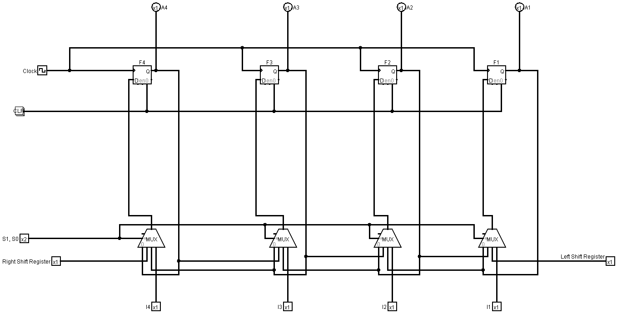

**Function Table:**

|  |  |  |  |  |  |  |  |  |  |  |
| --- | --- | --- | --- | --- | --- | --- | --- | --- | --- | --- |
| S1 | S0 | Operation | I4 | I3 | I2 | I1 | A4 | A3 | A2 | A1 |
| 0 | 0 | No Change | 0 | 1 | 1 | 0 | 0 | 0 | 0 | 0 |
| 0 | 1 | SHR | 1 | 1 | 0 | 0 | Serial Input  (0 or) | 0 | 0 | 0 |
| 1 | 0 | SHL | 1 | 1 | 0 | 0 | 0 | 0 | 0 | Serial Input  (0 or 1) |
| 1 | 1 | Parallel Load | 1 | 1 | 0 | 0 | 1 | 1 | 0 | 0 |

**Discussion:**

After completing the lab, we got the clear idea to build a 4-bit universal shift register and its function. To build this 4-bit universal shift register we used four 4*1MUX and 4 D flipflop. Here each Flipflop saves a 1-bit data and using the clock the has been updated. Moreover, by combining MUX and output of flipflop we implemented 4 operations to this register where the 4 operation being control by the combination of selection pin. Such as for No change operation {(S1, S0) = (0, 0)}, for Right Shift operation {(S1, S0) = (0, 1)}, for Left Shift operation {(S1, S0) = (1, 0)}, and for Parallel Load operation {(S1, S0) = (1, 1)}.

Now if we want describe the function of Universal Shift Register, we can simply say –

* No Change: The previously saved data in flipflops will remain unchanged for every clock cycle.
* Shift Right: For every clock the data of serial input will be updated in MSB and each previously saved data will shift 1-bit from MSB to LSB or will shift right.
* Shift Left: For every clock the data of serial input will be updated in LSB and each previously saved data will shift 1-bit from LSB to MSB or will shift left.
* Parallel Load: In this operation there is no effect of previously saved data rather for every clock the data will be saved as the input given in I4 to I1.

As the global pandemic still going on, we are conducting online classes so all the experiments are doing in online using the desired software so there is no scope of getting error or any obstacle to do the experiment which we used to get in the physical lab classes. So, we get all the output accurately and finished the experiment without any problem.