

**North South University**

Department of Electrical and Computer Engineering

Lab Report-02

Experiment Name: Design of a 2-bit Arithmetic Unit

Course Name: Computer Organization and Architechture

Course Code: CSE332 lab

**Submitted By:**

Name: Sadia Afrin Tamanna

ID:1812030042

Section: 05

**Submitted To :**

Lab Instructor: Md. Saidur Rahman

**Experiment Name:**

Design of a 2-bit Arithmetic unit.

**Objectives:**

In this lab, we are going to learn how to design of a 2-bit Logic unit using two 4*1 multiplexers, two 1 but full adders and NOT gate.

**Circuit Diagram:**

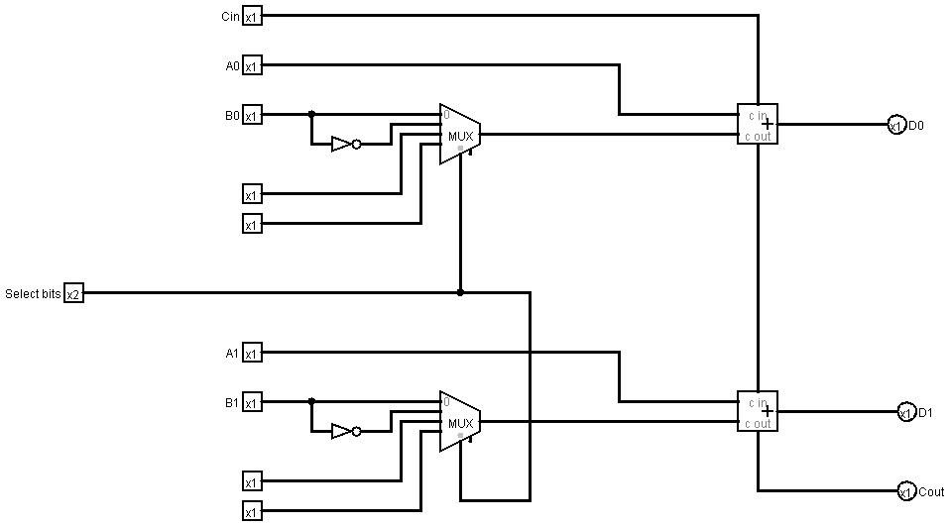

**Function Table:**

|  |  |  |  |  |  |  |  |  |  |  |
| --- | --- | --- | --- | --- | --- | --- | --- | --- | --- | --- |
| S1 | S0 | Cin | A0 | A1 | B1 | B0 | D1 | D0 | Cout | Microoperation |
| 0 | 0 | 0 | 0 | 0 | 0 | 1 | 0 | 1 | 0 | Add |
| 0 | 0 |  | 0 | 1 | 0 | 1 | 0 | 0 | 1 | Add with Carry |
| 0 | 1 | 0 | 1 | 0 | 0 | 0 | 0 | 0 | 1 | Subtract With Borrow |
| 0 | 1 | 1 | 1 | 0 | 1 | 1 | 1 | 0 | 0 | Subtract |
| 1 | 0 | 0 | 1 | 1 | 0 | 1 | 1 | 1 | 0 | Transfer A |
| 1 | 0 | 1 | 0 | 1 | 1 | 0 | 1 | 1 | 0 | Increment A |
| 1 | 1 | 0 | 1 | 1 | 0 | 0 | 1 | 0 | 1 | Decrement A |
| 1 | 1 | 1 | 0 | 1 | 0 | 0 | 1 | 0 | 1 | Transfer A |

**Discussion:**

Doing this lab, we got a clear concept of how to build a 2-bit aithmetic unit. In our previous lab, we learnt how to design a 2-bit logic unit and in this lab we have learnt how to build another part of ALU. We know that ALU is combination of logic unit and arithmetic unit. So, as we completed these two experinments, we have perfomed to build an ALU for the CPU. In this lab we did some operations like, add or subtract with borrow or without borrow, transfer, increment and decrement the first input. We did these operations using two 4*1 multiplexers and two full adders. Also we used two selection pins (S1,S0) and carry input (Cin) to implement different types of these operations like, (0,0,0) for add, (0,1,1) for subtract, and thus for different values of S1,S0,Cin different operations are being selected. We implemented the circuit in logisim and we got all the values correctly from the circuit.